Deliverable 2

Guillem Valls, Sergio Mazzariol

Table of Contents

## Valores propios y ejes dominantes

### Eigenvalues and dominant axes analysis. How many axes we have to interpret according to Kaiser and Elbow’s rule?

Hemos decidido probar como se ve el PCA sin y con la variable pdays, ya que consideramos que es una variable con bastantes missings, aún así aporta información por lo tanto la vamos a considerar.

vars_num_sin_pday = vars_num[-3];  
res2.pca<-PCA(df[,c('duration',vars_num_sin_pday)],quanti.sup=1)

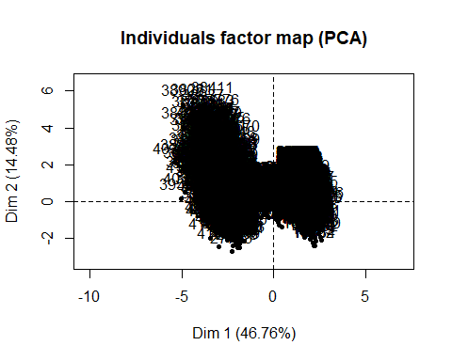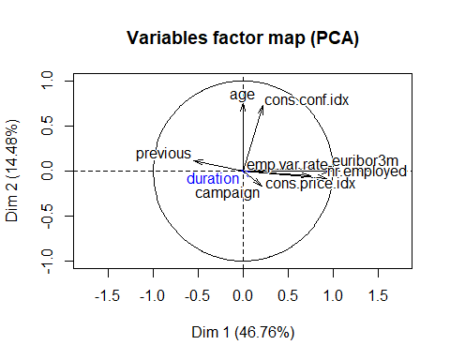

res.pca<-PCA(df[,c('duration',vars_num)],quanti.sup=1)

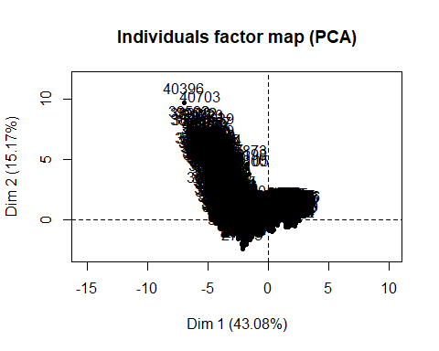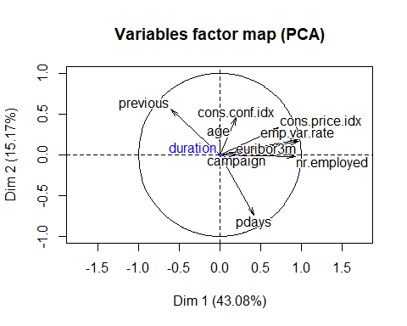

Vemos que con pdays existe una relación inversa con previous, respecto a los dos ejes factoriales, sin pdays se puede ver que la contribución de la variable age con el segundo eje factorial es mayor, ya que gráficamente tiene mayor magnitud además que las variables socio económicas, se ven mejor representadas en el primer eje factorial.

Por la ley de Kaiser, deberíamos utilizar los 3 primeros ejes factoriales, los cuales son mayores a 1. Por la ley de ElBow, al realizar el gráfico podemos ver que la gráfica empieza a ser plana a partir de la 2da dimensión, es decir que se cogen las 2 primeras dimensiones.

Si tomamos en cuenta el criterio del 80% se deberían coger las 4 primeras dimensiones.

Para realizar el futuro análisis, conviene utilizar dimensiones pares, por lo que decidimos solo usar 2.

summary(res.pca,ncp=4,nb.dec=2)

##   
## Call:  
## PCA(X = df[, c("duration", vars_num)], quanti.sup = 1)   
##   
##   
## Eigenvalues  
## Dim.1 Dim.2 Dim.3 Dim.4 Dim.5 Dim.6 Dim.7  
## Variance 3.88 1.36 1.10 0.97 0.83 0.43 0.39  
## % of var. 43.08 15.17 12.28 10.74 9.25 4.82 4.29  
## Cumulative % of var. 43.08 58.24 70.52 81.26 90.50 95.33 99.62  
## Dim.8 Dim.9  
## Variance 0.02 0.01  
## % of var. 0.27 0.12  
## Cumulative % of var. 99.88 100.00  
##   
## Individuals (the 10 first)  
## Dist Dim.1 ctr cos2 Dim.2 ctr cos2 Dim.3  
## 20 | 1.74 | 1.29 0.01 0.55 | 0.44 0.00 0.06 | 0.41  
## 21 | 1.99 | 1.30 0.01 0.42 | 0.18 0.00 0.01 | -0.13  
## 30 | 2.24 | 1.28 0.01 0.33 | 0.90 0.01 0.16 | 1.38  
## 33 | 1.93 | 1.29 0.01 0.44 | 0.73 0.01 0.14 | 1.02  
## 48 | 1.74 | 1.29 0.01 0.55 | 0.47 0.00 0.07 | 0.47  
## 56 | 2.24 | 1.28 0.01 0.33 | 0.90 0.01 0.16 | 1.38  
## 61 | 1.85 | 1.29 0.01 0.48 | 0.67 0.01 0.13 | 0.90  
## 62 | 2.02 | 1.29 0.01 0.41 | 0.78 0.01 0.15 | 1.14  
## 65 | 1.89 | 1.29 0.01 0.46 | 0.70 0.01 0.14 | 0.96  
## 84 | 1.93 | 1.29 0.01 0.44 | 0.73 0.01 0.14 | 1.02  
## ctr cos2 Dim.4 ctr cos2   
## 20 0.00 0.06 | -0.81 0.01 0.22 |  
## 21 0.00 0.00 | -1.06 0.02 0.28 |  
## 30 0.03 0.38 | -0.38 0.00 0.03 |  
## 33 0.02 0.28 | -0.54 0.01 0.08 |  
## 48 0.00 0.07 | -0.79 0.01 0.21 |  
## 56 0.03 0.38 | -0.38 0.00 0.03 |  
## 61 0.01 0.23 | -0.60 0.01 0.10 |  
## 62 0.02 0.32 | -0.49 0.00 0.06 |  
## 65 0.02 0.26 | -0.57 0.01 0.09 |  
## 84 0.02 0.28 | -0.54 0.01 0.08 |  
##   
## Variables  
## Dim.1 ctr cos2 Dim.2 ctr cos2 Dim.3 ctr cos2  
## age | -0.01 0.00 0.00 | 0.35 8.93 0.12 | 0.67 40.10 0.44  
## campaign | 0.21 1.13 0.04 | 0.00 0.00 0.00 | -0.23 4.74 0.05  
## pdays | 0.42 4.63 0.18 | -0.74 40.21 0.55 | 0.28 7.10 0.08  
## previous | -0.60 9.37 0.36 | 0.56 22.84 0.31 | -0.30 8.38 0.09  
## emp.var.rate | 0.96 23.97 0.93 | 0.19 2.54 0.03 | -0.11 1.00 0.01  
## cons.price.idx | 0.72 13.43 0.52 | 0.33 8.11 0.11 | -0.30 8.08 0.09  
## cons.conf.idx | 0.20 1.06 0.04 | 0.46 15.36 0.21 | 0.58 30.44 0.34  
## euribor3m | 0.97 24.20 0.94 | 0.16 1.98 0.03 | -0.01 0.01 0.00  
## nr.employed | 0.93 22.20 0.86 | -0.02 0.03 0.00 | -0.04 0.16 0.00  
## Dim.4 ctr cos2   
## age | 0.28 8.23 0.08 |  
## campaign | 0.93 89.89 0.87 |  
## pdays | 0.04 0.17 0.00 |  
## previous | -0.02 0.05 0.00 |  
## emp.var.rate | -0.06 0.39 0.00 |  
## cons.price.idx | -0.06 0.41 0.00 |  
## cons.conf.idx | -0.04 0.13 0.00 |  
## euribor3m | -0.07 0.51 0.00 |  
## nr.employed | -0.05 0.24 0.00 |  
##   
## Supplementary continuous variable  
## Dim.1 cos2 Dim.2 cos2 Dim.3 cos2 Dim.4 cos2   
## duration | -0.02 0.00 | 0.02 0.00 | 0.00 0.00 | -0.05 0.00 |

plot(res.pca$eig[,1],main="Eigenvalues",type="o", col="blue")

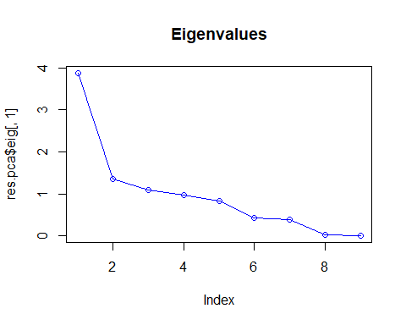

## Individuals point of view: Are they any individuals “too contributive”? To better understand the axes meaning use the extreme individuals. Detection of multivariant outliers and influent data.

Primero graficamos en rp los 15 individuos más contributivos en ambos ejes, luego analizamos los 5 individuos más contributivos en la dimensión 1 y 2. Al ver si estos tienen alguna relación significativa, podemos decir que para los 5 individuos de la dimension 1, vemos que principalmente son gente mayor de 45años, todos han comprado el producto, han sido contactados mediante el móvil, han sido contactados previamente, comprado un producto en una campaña anterior y la duración de la llamada ha sido mayor a los 300s.

Para la dimensión 2 podemos ver prácticamente las mismas características menos la duración que ha sido menor. Cabe destacar sin embargo que hay dos individuos que son muy contributivos en ambos ejes, eso hace pensar que pueden ser posibles outliers pero de igual forma los dejamos en los datos.

plot.PCA(res.pca, choix=c("ind"),cex=0.8,col.ind="grey70",select="contrib15",axes=c(1,2))

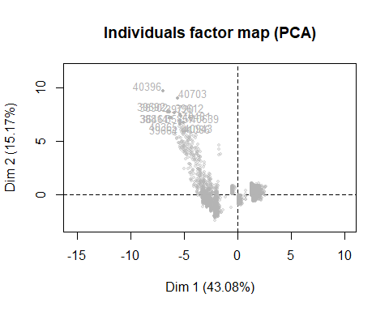

mas_ctr_dim1 <- sort(res.pca$ind$contrib[,1], decreasing = TRUE)[1:5]  
mas_ctr_dim2 <- sort(res.pca$ind$contrib[,2], decreasing = TRUE)[1:5]  
df[names(mas_ctr_dim1),]

## age job marital education  
## 40396 48 job.admin. marital.divorced education.university.degree  
## 39592 24 job.student marital.single education.high.school  
## 38902 83 job.retired marital.divorced education.basic.4y  
## 38814 65 job.retired marital.married education.university.degree  
## 36461 55 job.retired marital.married education.basic.4y  
## default housing loan contact month  
## 40396 default.no housing.no loan.no contact.cellular month.aug  
## 39592 default.no housing.yes loan.no contact.cellular month.may  
## 38902 default.no housing.no loan.no contact.cellular month.nov  
## 38814 default.no housing.no loan.no contact.cellular month.nov  
## 36461 default.no housing.no loan.no contact.cellular month.jun  
## day_of_week duration campaign pdays previous poutcome  
## 40396 day_of_week.thu 172 3 3 6 poutcome.success  
## 39592 day_of_week.wed 258 1 3 5 poutcome.success  
## 38902 day_of_week.tue 242 1 3 3 poutcome.success  
## 38814 day_of_week.fri 226 1 3 3 poutcome.success  
## 36461 day_of_week.tue 553 2 3 4 poutcome.failure  
## emp.var.rate cons.price.idx cons.conf.idx euribor3m nr.employed  
## 40396 -1.7 94.027 -38.3 0.904 4991.6  
## 39592 -1.8 93.876 -40.0 0.672 5008.7  
## 38902 -3.4 92.649 -30.1 0.716 5017.5  
## 38814 -3.4 92.649 -30.1 0.714 5017.5  
## 36461 -2.9 92.963 -40.8 1.262 5076.2  
## y f.job f.season  
## 40396 y.yes f.job.Admin-Managment f.season.Jun-Aug  
## 39592 y.yes f.job.Not-working f.season.Mar-May  
## 38902 y.yes f.job.Entrep-Retired-selfEmpl f.season.Sep-Dec  
## 38814 y.yes f.job.Entrep-Retired-selfEmpl f.season.Sep-Dec  
## 36461 y.no f.job.Entrep-Retired-selfEmpl f.season.Jun-Aug  
## f.education f.age f.duration  
## 40396 f.education.Professional f.age-(40,50] f.duration-(120,180]  
## 39592 f.education.High School f.age-[18,30] f.duration-(180,300]  
## 38902 f.education.Basic f.age-(50,92] f.duration-(180,300]  
## 38814 f.education.Professional f.age-(50,92] f.duration-(180,300]  
## 36461 f.education.Basic f.age-(50,92] f.duration-(300,2.1e+03]  
## f.campaign f.pdays f.previous  
## 40396 f.campaign-(2,20] f.pdays-[0,22] f.previous-(1,6]  
## 39592 f.campaign-[0,1] f.pdays-[0,22] f.previous-(1,6]  
## 38902 f.campaign-[0,1] f.pdays-[0,22] f.previous-(1,6]  
## 38814 f.campaign-[0,1] f.pdays-[0,22] f.previous-(1,6]  
## 36461 f.campaign-(1,2] f.pdays-[0,22] f.previous-(1,6]

df[names(mas_ctr_dim2),]

## age job marital education  
## 40396 48 job.admin. marital.divorced education.university.degree  
## 40703 82 job.retired marital.married education.university.degree  
## 39592 24 job.student marital.single education.high.school  
## 38902 83 job.retired marital.divorced education.basic.4y  
## 39612 52 job.technician marital.married education.university.degree  
## default housing loan contact month  
## 40396 default.no housing.no loan.no contact.cellular month.aug  
## 40703 default.unknown housing.no loan.no contact.cellular month.sep  
## 39592 default.no housing.yes loan.no contact.cellular month.may  
## 38902 default.no housing.no loan.no contact.cellular month.nov  
## 39612 default.no housing.no loan.no contact.cellular month.may  
## day_of_week duration campaign pdays previous poutcome  
## 40396 day_of_week.thu 172 3 3 6 poutcome.success  
## 40703 day_of_week.mon 81 3 3 4 poutcome.success  
## 39592 day_of_week.wed 258 1 3 5 poutcome.success  
## 38902 day_of_week.tue 242 1 3 3 poutcome.success  
## 39612 day_of_week.thu 211 1 3 4 poutcome.success  
## emp.var.rate cons.price.idx cons.conf.idx euribor3m nr.employed  
## 40396 -1.7 94.027 -38.3 0.904 4991.6  
## 40703 -1.1 94.199 -37.5 0.879 4963.6  
## 39592 -1.8 93.876 -40.0 0.672 5008.7  
## 38902 -3.4 92.649 -30.1 0.716 5017.5  
## 39612 -1.8 93.876 -40.0 0.677 5008.7  
## y f.job f.season  
## 40396 y.yes f.job.Admin-Managment f.season.Jun-Aug  
## 40703 y.no f.job.Entrep-Retired-selfEmpl f.season.Sep-Dec  
## 39592 y.yes f.job.Not-working f.season.Mar-May  
## 38902 y.yes f.job.Entrep-Retired-selfEmpl f.season.Sep-Dec  
## 39612 y.yes f.job.Serv-Tech-BlueC f.season.Mar-May  
## f.education f.age f.duration  
## 40396 f.education.Professional f.age-(40,50] f.duration-(120,180]  
## 40703 f.education.Professional f.age-(50,92] f.duration-[5,120]  
## 39592 f.education.High School f.age-[18,30] f.duration-(180,300]  
## 38902 f.education.Basic f.age-(50,92] f.duration-(180,300]  
## 39612 f.education.Professional f.age-(50,92] f.duration-(180,300]  
## f.campaign f.pdays f.previous  
## 40396 f.campaign-(2,20] f.pdays-[0,22] f.previous-(1,6]  
## 40703 f.campaign-(2,20] f.pdays-[0,22] f.previous-(1,6]  
## 39592 f.campaign-[0,1] f.pdays-[0,22] f.previous-(1,6]  
## 38902 f.campaign-[0,1] f.pdays-[0,22] f.previous-(1,6]  
## 39612 f.campaign-[0,1] f.pdays-[0,22] f.previous-(1,6]

## Interpreting the axes: Variables point of view coordinates, quality of representation, contribution of the variables

Al hacer el PCA con la variable target duration como suplementaria, podemos ver que su módulo es prácticamente nulo, esto quiere decir que la variable no se ve representada en niguno de los ejes factoriales.

El eje horizontal está muy relacionado con las variables socio económicas, mirando el cos2 del summary podemos ver que las variables que están mejor representadas con la dimensión 1 son: euribor3m, emp.var.rate, nr.emplyed Para el eje vertical: pdays y previous

Para el eje vertical, podemos decir que está relacionado con las campañas previas.

Al hacer el PCA con la variable target Y como suplementaria, podemos ver que en el gráfico de rp, el factor NO, esta muy cerca del centro, por lo que no se ve representada en estos ejes factoriales. En cambio el factor SI, está a una distancia mayor del centro, aunque poco significativa.

res.pca<-PCA(df[,c('duration',vars_num)],quanti.sup=1)

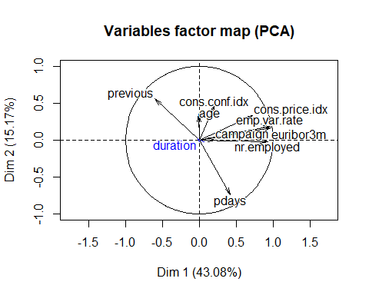

summary(res.pca,ncp=4,nb.dec=2)

##   
## Call:  
## PCA(X = df[, c("duration", vars_num)], quanti.sup = 1)   
##   
##   
## Eigenvalues  
## Dim.1 Dim.2 Dim.3 Dim.4 Dim.5 Dim.6 Dim.7  
## Variance 3.88 1.36 1.10 0.97 0.83 0.43 0.39  
## % of var. 43.08 15.17 12.28 10.74 9.25 4.82 4.29  
## Cumulative % of var. 43.08 58.24 70.52 81.26 90.50 95.33 99.62  
## Dim.8 Dim.9  
## Variance 0.02 0.01  
## % of var. 0.27 0.12  
## Cumulative % of var. 99.88 100.00  
##   
## Individuals (the 10 first)  
## Dist Dim.1 ctr cos2 Dim.2 ctr cos2 Dim.3  
## 20 | 1.74 | 1.29 0.01 0.55 | 0.44 0.00 0.06 | 0.41  
## 21 | 1.99 | 1.30 0.01 0.42 | 0.18 0.00 0.01 | -0.13  
## 30 | 2.24 | 1.28 0.01 0.33 | 0.90 0.01 0.16 | 1.38  
## 33 | 1.93 | 1.29 0.01 0.44 | 0.73 0.01 0.14 | 1.02  
## 48 | 1.74 | 1.29 0.01 0.55 | 0.47 0.00 0.07 | 0.47  
## 56 | 2.24 | 1.28 0.01 0.33 | 0.90 0.01 0.16 | 1.38  
## 61 | 1.85 | 1.29 0.01 0.48 | 0.67 0.01 0.13 | 0.90  
## 62 | 2.02 | 1.29 0.01 0.41 | 0.78 0.01 0.15 | 1.14  
## 65 | 1.89 | 1.29 0.01 0.46 | 0.70 0.01 0.14 | 0.96  
## 84 | 1.93 | 1.29 0.01 0.44 | 0.73 0.01 0.14 | 1.02  
## ctr cos2 Dim.4 ctr cos2   
## 20 0.00 0.06 | -0.81 0.01 0.22 |  
## 21 0.00 0.00 | -1.06 0.02 0.28 |  
## 30 0.03 0.38 | -0.38 0.00 0.03 |  
## 33 0.02 0.28 | -0.54 0.01 0.08 |  
## 48 0.00 0.07 | -0.79 0.01 0.21 |  
## 56 0.03 0.38 | -0.38 0.00 0.03 |  
## 61 0.01 0.23 | -0.60 0.01 0.10 |  
## 62 0.02 0.32 | -0.49 0.00 0.06 |  
## 65 0.02 0.26 | -0.57 0.01 0.09 |  
## 84 0.02 0.28 | -0.54 0.01 0.08 |  
##   
## Variables  
## Dim.1 ctr cos2 Dim.2 ctr cos2 Dim.3 ctr cos2  
## age | -0.01 0.00 0.00 | 0.35 8.93 0.12 | 0.67 40.10 0.44  
## campaign | 0.21 1.13 0.04 | 0.00 0.00 0.00 | -0.23 4.74 0.05  
## pdays | 0.42 4.63 0.18 | -0.74 40.21 0.55 | 0.28 7.10 0.08  
## previous | -0.60 9.37 0.36 | 0.56 22.84 0.31 | -0.30 8.38 0.09  
## emp.var.rate | 0.96 23.97 0.93 | 0.19 2.54 0.03 | -0.11 1.00 0.01  
## cons.price.idx | 0.72 13.43 0.52 | 0.33 8.11 0.11 | -0.30 8.08 0.09  
## cons.conf.idx | 0.20 1.06 0.04 | 0.46 15.36 0.21 | 0.58 30.44 0.34  
## euribor3m | 0.97 24.20 0.94 | 0.16 1.98 0.03 | -0.01 0.01 0.00  
## nr.employed | 0.93 22.20 0.86 | -0.02 0.03 0.00 | -0.04 0.16 0.00  
## Dim.4 ctr cos2   
## age | 0.28 8.23 0.08 |  
## campaign | 0.93 89.89 0.87 |  
## pdays | 0.04 0.17 0.00 |  
## previous | -0.02 0.05 0.00 |  
## emp.var.rate | -0.06 0.39 0.00 |  
## cons.price.idx | -0.06 0.41 0.00 |  
## cons.conf.idx | -0.04 0.13 0.00 |  
## euribor3m | -0.07 0.51 0.00 |  
## nr.employed | -0.05 0.24 0.00 |  
##   
## Supplementary continuous variable  
## Dim.1 cos2 Dim.2 cos2 Dim.3 cos2 Dim.4 cos2   
## duration | -0.02 0.00 | 0.02 0.00 | 0.00 0.00 | -0.05 0.00 |

res.pca<-PCA(df[,c('y',vars_num)],quali.sup=1)

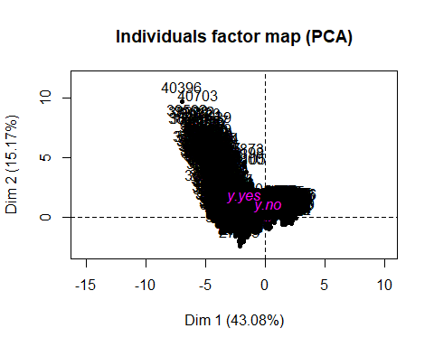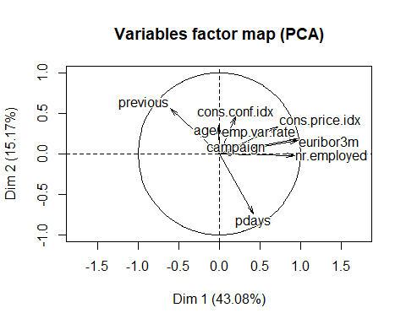

summary(res.pca,ncp=4,nb.dec=2)

##   
## Call:  
## PCA(X = df[, c("y", vars_num)], quali.sup = 1)   
##   
##   
## Eigenvalues  
## Dim.1 Dim.2 Dim.3 Dim.4 Dim.5 Dim.6 Dim.7  
## Variance 3.88 1.36 1.10 0.97 0.83 0.43 0.39  
## % of var. 43.08 15.17 12.28 10.74 9.25 4.82 4.29  
## Cumulative % of var. 43.08 58.24 70.52 81.26 90.50 95.33 99.62  
## Dim.8 Dim.9  
## Variance 0.02 0.01  
## % of var. 0.27 0.12  
## Cumulative % of var. 99.88 100.00  
##   
## Individuals (the 10 first)  
## Dist Dim.1 ctr cos2 Dim.2 ctr cos2 Dim.3  
## 20 | 1.74 | 1.29 0.01 0.55 | 0.44 0.00 0.06 | 0.41  
## 21 | 1.99 | 1.30 0.01 0.42 | 0.18 0.00 0.01 | -0.13  
## 30 | 2.24 | 1.28 0.01 0.33 | 0.90 0.01 0.16 | 1.38  
## 33 | 1.93 | 1.29 0.01 0.44 | 0.73 0.01 0.14 | 1.02  
## 48 | 1.74 | 1.29 0.01 0.55 | 0.47 0.00 0.07 | 0.47  
## 56 | 2.24 | 1.28 0.01 0.33 | 0.90 0.01 0.16 | 1.38  
## 61 | 1.85 | 1.29 0.01 0.48 | 0.67 0.01 0.13 | 0.90  
## 62 | 2.02 | 1.29 0.01 0.41 | 0.78 0.01 0.15 | 1.14  
## 65 | 1.89 | 1.29 0.01 0.46 | 0.70 0.01 0.14 | 0.96  
## 84 | 1.93 | 1.29 0.01 0.44 | 0.73 0.01 0.14 | 1.02  
## ctr cos2 Dim.4 ctr cos2   
## 20 0.00 0.06 | -0.81 0.01 0.22 |  
## 21 0.00 0.00 | -1.06 0.02 0.28 |  
## 30 0.03 0.38 | -0.38 0.00 0.03 |  
## 33 0.02 0.28 | -0.54 0.01 0.08 |  
## 48 0.00 0.07 | -0.79 0.01 0.21 |  
## 56 0.03 0.38 | -0.38 0.00 0.03 |  
## 61 0.01 0.23 | -0.60 0.01 0.10 |  
## 62 0.02 0.32 | -0.49 0.00 0.06 |  
## 65 0.02 0.26 | -0.57 0.01 0.09 |  
## 84 0.02 0.28 | -0.54 0.01 0.08 |  
##   
## Variables  
## Dim.1 ctr cos2 Dim.2 ctr cos2 Dim.3 ctr cos2  
## age | -0.01 0.00 0.00 | 0.35 8.93 0.12 | 0.67 40.10 0.44  
## campaign | 0.21 1.13 0.04 | 0.00 0.00 0.00 | -0.23 4.74 0.05  
## pdays | 0.42 4.63 0.18 | -0.74 40.21 0.55 | 0.28 7.10 0.08  
## previous | -0.60 9.37 0.36 | 0.56 22.84 0.31 | -0.30 8.38 0.09  
## emp.var.rate | 0.96 23.97 0.93 | 0.19 2.54 0.03 | -0.11 1.00 0.01  
## cons.price.idx | 0.72 13.43 0.52 | 0.33 8.11 0.11 | -0.30 8.08 0.09  
## cons.conf.idx | 0.20 1.06 0.04 | 0.46 15.36 0.21 | 0.58 30.44 0.34  
## euribor3m | 0.97 24.20 0.94 | 0.16 1.98 0.03 | -0.01 0.01 0.00  
## nr.employed | 0.93 22.20 0.86 | -0.02 0.03 0.00 | -0.04 0.16 0.00  
## Dim.4 ctr cos2   
## age | 0.28 8.23 0.08 |  
## campaign | 0.93 89.89 0.87 |  
## pdays | 0.04 0.17 0.00 |  
## previous | -0.02 0.05 0.00 |  
## emp.var.rate | -0.06 0.39 0.00 |  
## cons.price.idx | -0.06 0.41 0.00 |  
## cons.conf.idx | -0.04 0.13 0.00 |  
## euribor3m | -0.07 0.51 0.00 |  
## nr.employed | -0.05 0.24 0.00 |  
##   
## Supplementary categories  
## Dist Dim.1 cos2 v.test Dim.2 cos2 v.test   
## y.no | 0.23 | 0.21 0.84 21.77 | -0.08 0.13 -14.15 |  
## y.yes | 1.89 | -1.74 0.84 -21.77 | 0.67 0.13 14.15 |  
## Dim.3 cos2 v.test Dim.4 cos2 v.test   
## y.no -0.01 0.00 -1.74 | 0.01 0.00 1.09 |  
## y.yes 0.07 0.00 1.74 | -0.04 0.00 -1.09 |

## Perform a PCA taking into account also supplementary variables the supplementary variables can be quantitative and/or categorical

Hemos dividido el plot en diferentes partes, para así poder entender y ver mejor el resultado. Para la primera dimensión podemos ver que para los niveles mejor representados son: f.season.jun-aug, f.previous-(0.9,1], y.no, y.yes.

Para la segunda dimsensión, las que se ven mejor representadas son: f.pdays-[0,22],f.pdays-(22,23], f.previous-(1,6]

vars_factorizadas<- c("f.job","f.season","f.education","f.age","f.duration","f.campaign","f.pdays","f.previous","y");  
  
res.pca<-PCA(df[,c('duration',vars_num, "f.job","f.season")],quanti.sup=1, quali.sup = c(11:12))

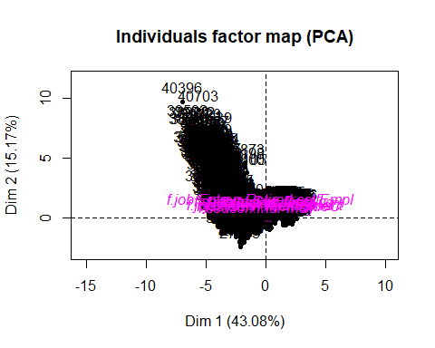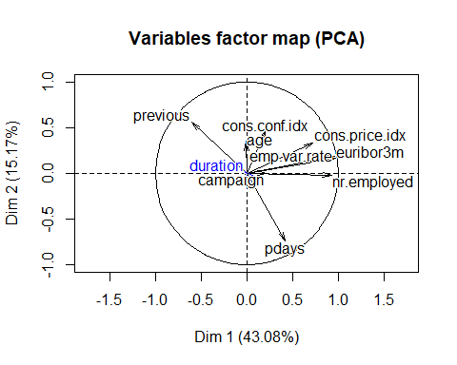

plot.PCA(res.pca,choix="ind",invisible="ind",cex=0.75)

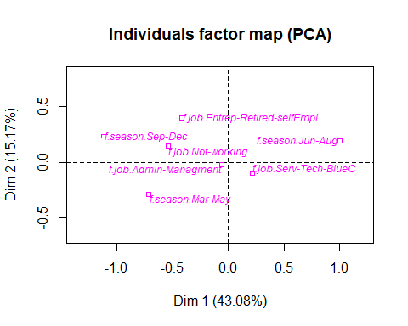

res.pca<-PCA(df[,c('duration',vars_num,"f.education","f.age")],quanti.sup=1, quali.sup = c(11:12))

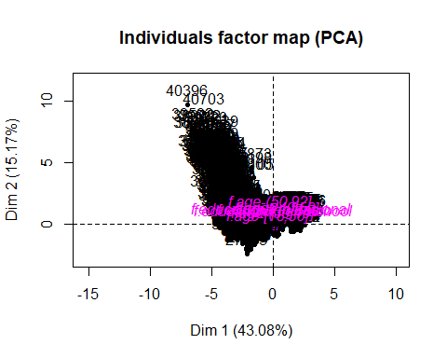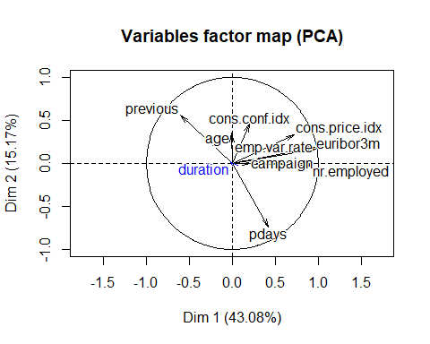

plot.PCA(res.pca,choix="ind",invisible="ind",cex=0.75)

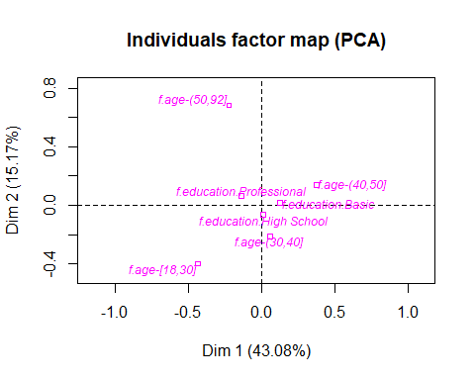

res.pca<-PCA(df[,c('duration',vars_num,"f.pdays","y")],quanti.sup=1, quali.sup = c(11:12))

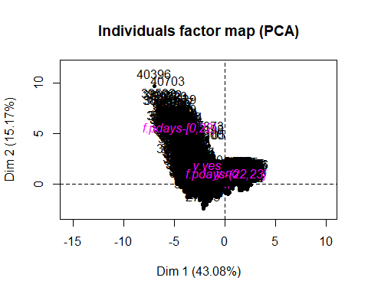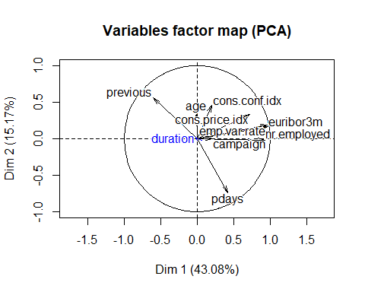

plot.PCA(res.pca,choix="ind",invisible="ind",cex=0.75)

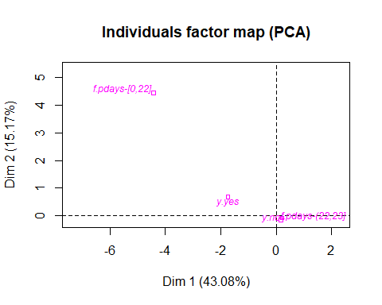

res.pca<-PCA(df[,c('duration',vars_num,vars_factorizadas)],quanti.sup=1, quali.sup = c(11:19),graph=FALSE)  
  
fviz_pca_var(res.pca, col.var = "contrib",gradient.cols = c("#00AFBB", "#E7B800", "#FC4E07"),repel = TRUE)

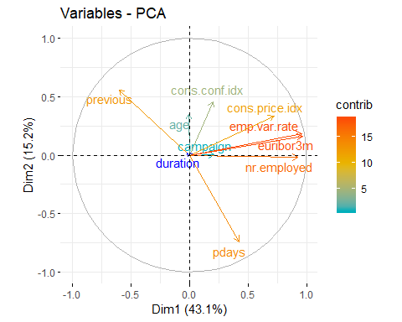

summary(res.pca,dig = 2, nbelements= 30, nbind=3, ncp=2)

##   
## Call:  
## PCA(X = df[, c("duration", vars_num, vars_factorizadas)], quanti.sup = 1,   
## quali.sup = c(11:19), graph = FALSE)   
##   
##   
## Eigenvalues  
## Dim.1 Dim.2 Dim.3 Dim.4 Dim.5 Dim.6  
## Variance 3.877 1.365 1.105 0.966 0.832 0.434  
## % of var. 43.078 15.166 12.276 10.736 9.246 4.823  
## Cumulative % of var. 43.078 58.244 70.521 81.257 90.503 95.326  
## Dim.7 Dim.8 Dim.9  
## Variance 0.386 0.024 0.010  
## % of var. 4.291 0.266 0.116  
## Cumulative % of var. 99.618 99.884 100.000  
##   
## Individuals (the 3 first)  
## Dist Dim.1 ctr cos2 Dim.2 ctr  
## 20 | 1.739 | 1.291 0.009 0.551 | 0.441 0.003  
## 21 | 1.990 | 1.295 0.009 0.424 | 0.184 0.000  
## 30 | 2.240 | 1.284 0.009 0.328 | 0.898 0.012  
## cos2   
## 20 0.064 |  
## 21 0.009 |  
## 30 0.161 |  
##   
## Variables  
## Dim.1 ctr cos2 Dim.2 ctr  
## age | -0.009 0.002 0.000 | 0.349 8.933  
## campaign | 0.210 1.132 0.044 | 0.003 0.001  
## pdays | 0.424 4.633 0.180 | -0.741 40.212  
## previous | -0.603 9.366 0.363 | 0.558 22.836  
## emp.var.rate | 0.964 23.967 0.929 | 0.186 2.544  
## cons.price.idx | 0.722 13.431 0.521 | 0.333 8.109  
## cons.conf.idx | 0.203 1.063 0.041 | 0.458 15.356  
## euribor3m | 0.969 24.202 0.938 | 0.164 1.978  
## nr.employed | 0.928 22.205 0.861 | -0.020 0.030  
## cos2   
## age 0.122 |  
## campaign 0.000 |  
## pdays 0.549 |  
## previous 0.312 |  
## emp.var.rate 0.035 |  
## cons.price.idx 0.111 |  
## cons.conf.idx 0.210 |  
## euribor3m 0.027 |  
## nr.employed 0.000 |  
##   
## Supplementary continuous variable  
## Dim.1 cos2 Dim.2 cos2   
## duration | -0.022 0.000 | 0.017 0.000 |  
##   
## Supplementary categories  
## Dist Dim.1 cos2 v.test   
## f.job.Admin-Managment | 0.125 | -0.061 0.237 -1.532 |  
## f.job.Entrep-Retired-selfEmpl | 1.020 | -0.418 0.168 -5.418 |  
## f.job.Not-working | 0.690 | -0.541 0.615 -5.266 |  
## f.job.Serv-Tech-BlueC | 0.272 | 0.217 0.637 7.570 |  
## f.season.Mar-May | 0.793 | -0.719 0.821 -21.657 |  
## f.season.Jun-Aug | 1.026 | 1.002 0.954 32.508 |  
## f.season.Sep-Dec | 1.257 | -1.125 0.801 -16.040 |  
## f.education.Basic | 0.294 | 0.125 0.181 3.071 |  
## f.education.High School | 0.155 | 0.010 0.005 0.285 |  
## f.education.Professional | 0.255 | -0.140 0.300 -3.384 |  
## f.age-[18,30] | 1.312 | -0.436 0.111 -7.188 |  
## f.age-(30,40] | 0.485 | 0.055 0.013 1.600 |  
## f.age-(40,50] | 0.606 | 0.373 0.380 7.755 |  
## f.age-(50,92] | 1.667 | -0.225 0.018 -3.730 |  
## f.duration-[5,120] | 0.274 | 0.190 0.483 4.596 |  
## f.duration-(120,180] | 0.138 | 0.076 0.299 1.332 |  
## f.duration-(180,300] | 0.222 | -0.180 0.658 -3.418 |  
## f.duration-(300,2.1e+03] | 0.166 | -0.126 0.571 -2.781 |  
## f.campaign-[0,1] | 0.707 | -0.356 0.254 -10.989 |  
## f.campaign-(1,2] | 0.221 | -0.006 0.001 -0.127 |  
## f.campaign-(2,20] | 1.083 | 0.474 0.192 11.738 |  
## f.pdays-[0,22] | 6.580 | -4.417 0.451 -30.206 |  
## f.pdays-(22,23] | 0.239 | 0.161 0.451 30.206 |  
## f.previous-[0,0.9] | 0.543 | 0.487 0.804 43.179 |  
## f.previous-(0.9,1] | 2.787 | -2.633 0.893 -33.713 |  
## f.previous-(1,6] | 6.104 | -4.396 0.519 -26.498 |  
## y.no | 0.231 | 0.212 0.844 21.769 |  
## y.yes | 1.892 | -1.738 0.844 -21.769 |  
## Dim.2 cos2 v.test   
## f.job.Admin-Managment -0.020 0.027 -0.869 |  
## f.job.Entrep-Retired-selfEmpl 0.399 0.153 8.730 |  
## f.job.Not-working 0.143 0.043 2.353 |  
## f.job.Serv-Tech-BlueC -0.101 0.139 -5.958 |  
## f.season.Mar-May -0.288 0.132 -14.633 |  
## f.season.Jun-Aug 0.194 0.036 10.604 |  
## f.season.Sep-Dec 0.234 0.035 5.626 |  
## f.education.Basic 0.015 0.003 0.613 |  
## f.education.High School -0.066 0.180 -3.025 |  
## f.education.Professional 0.062 0.059 2.527 |  
## f.age-[18,30] -0.400 0.093 -11.108 |  
## f.age-(30,40] -0.213 0.193 -10.495 |  
## f.age-(40,50] 0.139 0.053 4.874 |  
## f.age-(50,92] 0.682 0.168 19.031 |  
## f.duration-[5,120] -0.094 0.118 -3.822 |  
## f.duration-(120,180] 0.014 0.010 0.414 |  
## f.duration-(180,300] 0.085 0.147 2.721 |  
## f.duration-(300,2.1e+03] 0.029 0.030 1.081 |  
## f.campaign-[0,1] 0.003 0.000 0.167 |  
## f.campaign-(1,2] 0.014 0.004 0.486 |  
## f.campaign-(2,20] -0.015 0.000 -0.627 |  
## f.pdays-[0,22] 4.435 0.454 51.122 |  
## f.pdays-(22,23] -0.161 0.454 -51.122 |  
## f.previous-[0,0.9] -0.181 0.111 -27.027 |  
## f.previous-(0.9,1] 0.442 0.025 9.534 |  
## f.previous-(1,6] 3.839 0.396 38.998 |  
## y.no -0.082 0.126 -14.153 |  
## y.yes 0.671 0.126 14.153 |

## K-Means Classification

Hemos graficado los grupos separados en 3, 4, 5 y 6 clusters, para los cuales nos parece que gráficamente con 4 clusters los grupos están bien definidos, por lo que decidimos usar 4 clusters los cuales analizaremos seguidamente.

dclu<- res.pca$ind$coord[,1:2]; # los dos ejes  
  
kcla<- kmeans(dclu,4);  
  
df$cluster3 = factor(kmeans(dclu,3)$cluster);  
df$cluster4 = factor(kmeans(dclu,4)$cluster);  
df$cluster5 = factor(kmeans(dclu,5)$cluster);  
df$cluster6 = factor(kmeans(dclu,6)$cluster);  
  
res.pca<-PCA(df[,c('duration',vars_num, "cluster3")],quanti.sup=1, quali.sup = 11, graph=FALSE)  
plot.PCA(res.pca,choix="ind",habillage=11,select=0 ,cex=0.75)

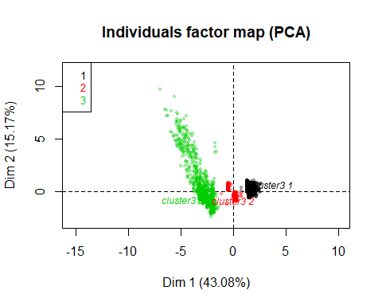

res.pca<-PCA(df[,c('duration',vars_num, "cluster4")],quanti.sup=1, quali.sup = 11, graph=FALSE)  
plot.PCA(res.pca,choix="ind",habillage=11,select=0 ,cex=0.75)

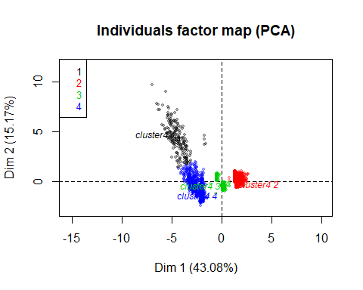

res.pca<-PCA(df[,c('duration',vars_num, "cluster5")],quanti.sup=1, quali.sup = 11, graph=FALSE)  
plot.PCA(res.pca,choix="ind",habillage=11,select=0 ,cex=0.75)

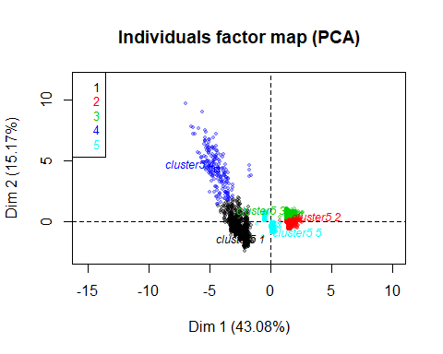

res.pca<-PCA(df[,c('duration',vars_num, "cluster6")],quanti.sup=1, quali.sup = 11, graph=FALSE)  
plot.PCA(res.pca,choix="ind",habillage=11,select=0 ,cex=0.75)

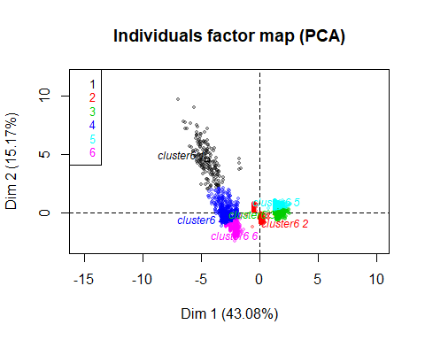

df <- df[,c(1:29, 31)] # guardamos la clasificación en 4 clusters

## Description of clusters

Viendo el chi-square test, podemos saber qué variables se utilizarán para caracterizar nuestros 4 clusters. Viendo las categorías donde el P-value es casi 0 podemos ver que las categorías que cumplen estas caracteristicas son: month (y por extensión también f.season), poutcome, f.pdays, f.previous, contact, y, job(f.job), default, f.age, f.campaign, marital. Ahora veremos que categorías de estas variables son las que caracterizan estos clusters.

Para el catdes del cluster 1, hemos podido ver las categorías que mejor lo definen, la temporada de verano es la que mejor lo caracteriza, f.season.Jun-Aug, tenemos también un poutcome que nos indica que ninguno de los individuos ha sido contactado previamente, podemos ver que y.no representa el 95% de este cluster, han sido contactados en su mayoría por teléfono fijo, también podemos ver que este cluster está ligeramente relacionado con la categoría f.job.Serv-Tech-BlueC. En conclusión podemos decir que este cluster está caracterizado por: - Meses de jun-Ago - No han sido contactados previamente - Han sido contactados más de una vez en la campaña actual - Contactados por teléfono fijo - Trabajo normalmente es, servicio, técnicos o blue collar. - No compraron el producto en su mayoría.

Para el cluster 2, tenemos: - La temporada de mar-may están sobrerepresentadas en este cluster - Han sido contacados en su mayoría por teléfono móvil - No han comprado el producto en campañas anteriores - Han sido contacados en camapañas previas - La categoría student está sobrerepresentada - La aceptación del producto está sobrerepresentada también

Para el cluster 3, tenemos: - Temporada de Sep-Dec - Contactados por móvil en su mayoría - La categoría de job.management está sobrerepresentada - No han adquirido el producto - Una gran cantidad de individuos rechazó el producto (y.no)

Para el cluster 4, podemos ver que aglutina individuos muy bien caracterizados por las siguientes variables: - Han sido contactados previamente f.pdays[0,22] - Han comprado el producto en una campaña previa - Han comprado el producto y.yes - Temporada de Sep-Dec - Han sido contactados por móvil - Una parte importante son job.retired - Una edad de f.age-(50,92]

catdes(df, 30, proba = 0.001)

##   
## Link between the cluster variable and the categorical variables (chi-square test)  
## =================================================================================  
## p.value df  
## month 0.000000e+00 27  
## poutcome 0.000000e+00 6  
## f.season 0.000000e+00 6  
## f.pdays 0.000000e+00 3  
## f.previous 0.000000e+00 6  
## contact 4.750967e-213 3  
## y 3.629487e-144 3  
## job 4.108692e-67 30  
## default 6.986972e-43 3  
## f.age 1.030850e-26 9  
## f.campaign 6.092760e-24 6  
## f.job 1.806095e-19 9  
## marital 1.705029e-16 6  
## f.duration 1.919242e-10 9  
## education 5.661192e-09 18  
## f.education 8.669827e-09 6  
## housing 1.403613e-07 3  
## day_of_week 4.039589e-04 12  
##   
## Description of each cluster by the categories  
## =============================================  
## $`1`  
## Cla/Mod Mod/Cla Global  
## f.pdays=f.pdays-[0,22] 96.5714286 88.947368 3.507014  
## poutcome=poutcome.success 96.1538462 78.947368 3.126253  
## f.previous=f.previous-(1,6] 75.1824818 54.210526 2.745491  
## y=y.yes 21.0332103 60.000000 10.861723  
## f.previous=f.previous-(0.9,1] 15.4255319 45.789474 11.302605  
## f.season=f.season.Sep-Dec 11.1600587 40.000000 13.647295  
## month=month.oct 32.5000000 13.684211 1.603206  
## contact=contact.cellular 5.4011864 91.052632 64.188377  
## default=default.no 4.6954315 97.368421 78.957916  
## job=job.retired 15.7657658 18.421053 4.448898  
## month=month.sep 25.7142857 9.473684 1.402806  
## f.age=f.age-(50,92] 7.4200913 34.210526 17.555110  
## month=month.mar 20.6349206 6.842105 1.262525  
## job=job.student 15.5963303 8.947368 2.184369  
## f.job=f.job.Entrep-Retired-selfEmpl 7.6256499 23.157895 11.563126  
## f.duration=f.duration-(180,300] 6.0550459 34.736842 21.843687  
## poutcome=poutcome.failure 7.3394495 21.052632 10.921844  
## f.education=f.education.Professional 5.4347826 44.736842 31.342685  
## education=education.university.degree 5.4347826 44.736842 31.342685  
## f.job=f.job.Not-working 8.1871345 14.736842 6.853707  
## f.campaign=f.campaign-[0,1] 4.9504950 55.263158 42.505010  
## month=month.jun 1.6233766 5.263158 12.344689  
## f.education=f.education.Basic 2.5046963 21.052632 32.004008  
## f.season=f.season.Mar-May 2.7131783 29.473684 41.362725  
## marital=marital.married 3.0040053 47.368421 60.040080  
## f.age=f.age-(40,50] 1.9952115 13.157895 25.110220  
## f.season=f.season.Jun-Aug 2.5835189 30.526316 44.989980  
## education=education.basic.9y 1.3580247 5.789474 16.232465  
## f.campaign=f.campaign-(2,20] 2.0496894 17.368421 32.264529  
## month=month.jul 1.1560694 5.263158 17.334669  
## month=month.may 1.8452381 16.315789 33.667335  
## f.duration=f.duration-[5,120] 1.7341040 14.210526 31.202405  
## f.job=f.job.Serv-Tech-BlueC 1.9801980 25.263158 48.577154  
## job=job.blue-collar 0.8650519 5.263158 23.166333  
## default=default.unknown 0.4761905 2.631579 21.042084  
## contact=contact.telephone 0.9513151 8.947368 35.811623  
## y=y.no 1.7086331 40.000000 89.138277  
## f.previous=f.previous-[0,0.9] 0.0000000 0.000000 85.951904  
## poutcome=poutcome.nonexistent 0.0000000 0.000000 85.951904  
## f.pdays=f.pdays-(22,23] 0.4361371 11.052632 96.492986  
## p.value v.test  
## f.pdays=f.pdays-[0,22] 1.259643e-281 35.860546  
## poutcome=poutcome.success 3.796871e-240 33.092604  
## f.previous=f.previous-(1,6] 1.553305e-129 24.214815  
## y=y.yes 2.494385e-64 16.934745  
## f.previous=f.previous-(0.9,1] 1.156226e-34 12.280262  
## f.season=f.season.Sep-Dec 3.391033e-20 9.205810  
## month=month.oct 3.163903e-18 8.705424  
## contact=contact.cellular 4.127348e-18 8.675225  
## default=default.no 4.787962e-14 7.537574  
## job=job.retired 2.103831e-13 7.342027  
## month=month.sep 5.701121e-11 6.551371  
## f.age=f.age-(50,92] 1.767166e-08 5.633375  
## month=month.mar 5.214842e-07 5.018235  
## job=job.student 6.469157e-07 4.976658  
## f.job=f.job.Entrep-Retired-selfEmpl 4.357820e-06 4.593544  
## f.duration=f.duration-(180,300] 3.266772e-05 4.154025  
## poutcome=poutcome.failure 3.513520e-05 4.137342  
## f.education=f.education.Professional 8.193961e-05 3.938655  
## education=education.university.degree 8.193961e-05 3.938655  
## f.job=f.job.Not-working 1.066886e-04 3.874854  
## f.campaign=f.campaign-[0,1] 3.261253e-04 3.593612  
## month=month.jun 9.887768e-04 -3.293701  
## f.education=f.education.Basic 6.774908e-04 -3.398530  
## f.season=f.season.Mar-May 5.767248e-04 -3.442331  
## marital=marital.married 3.331185e-04 -3.588083  
## f.age=f.age-(40,50] 4.090062e-05 -4.102332  
## f.season=f.season.Jun-Aug 3.480205e-05 -4.139528  
## education=education.basic.9y 1.044307e-05 -4.407790  
## f.campaign=f.campaign-(2,20] 2.688717e-06 -4.693270  
## month=month.jul 4.872344e-07 -5.031273  
## month=month.may 5.199683e-08 -5.444343  
## f.duration=f.duration-[5,120] 4.101428e-08 -5.486428  
## f.job=f.job.Serv-Tech-BlueC 2.251008e-11 -6.688740  
## job=job.blue-collar 1.081400e-11 -6.795230  
## default=default.unknown 4.787962e-14 -7.537574  
## contact=contact.telephone 4.127348e-18 -8.675225  
## y=y.no 2.494385e-64 -16.934745  
## f.previous=f.previous-[0,0.9] 2.196177e-173 -28.071291  
## poutcome=poutcome.nonexistent 2.196177e-173 -28.071291  
## f.pdays=f.pdays-(22,23] 1.259643e-281 -35.860546  
##   
## $`2`  
## Cla/Mod Mod/Cla Global  
## f.season=f.season.Jun-Aug 87.0824053 68.47635727 44.9899800  
## f.previous=f.previous-[0,0.9] 66.5656330 100.00000000 85.9519038  
## poutcome=poutcome.nonexistent 66.5656330 100.00000000 85.9519038  
## contact=contact.telephone 86.6256295 54.22066550 35.8116232  
## month=month.jul 93.5260116 28.33625219 17.3346693  
## f.pdays=f.pdays-(22,23] 59.2938733 100.00000000 96.4929860  
## month=month.aug 82.3298429 22.03152364 15.3106212  
## y=y.no 61.0161871 95.06129597 89.1382766  
## month=month.jun 83.9285714 18.10858144 12.3446894  
## default=default.unknown 75.8095238 27.88091068 21.0420842  
## f.campaign=f.campaign-(2,20] 67.0807453 37.82837128 32.2645291  
## f.age=f.age-(40,50] 65.5227454 28.75656743 25.1102204  
## f.job=f.job.Serv-Tech-BlueC 62.1699670 52.78458844 48.5771543  
## marital=marital.married 60.8144192 63.81786340 60.0400802  
## housing=housing.no 61.6498464 49.21190893 45.6713427  
## job=job.technician 63.7698898 18.24868651 16.3727455  
## job=job.blue-collar 62.2837370 25.21891419 23.1663327  
## f.education=f.education.Basic 61.1145899 34.18563923 32.0040080  
## job=job.housemaid 72.2689076 3.01225919 2.3847695  
## f.education=f.education.Professional 53.7084399 29.42206655 31.3426854  
## education=education.university.degree 53.7084399 29.42206655 31.3426854  
## f.job=f.job.Not-working 47.6608187 5.70928196 6.8537074  
## month=month.may 53.4523810 31.45359019 33.6673347  
## f.job=f.job.Entrep-Retired-selfEmpl 48.5268631 9.80735552 11.5631263  
## job=job.retired 41.8918919 3.25744308 4.4488978  
## month=month.dec 0.0000000 0.00000000 0.3607214  
## f.age=f.age-[18,30] 48.6206897 14.81611208 17.4348697  
## housing=housing.yes 53.4857986 50.78809107 54.3286573  
## marital=marital.single 49.8936924 24.65849387 28.2765531  
## job=job.student 14.6788991 0.56042032 2.1843687  
## f.campaign=f.campaign-[0,1] 49.6463932 36.88266200 42.5050100  
## month=month.mar 0.0000000 0.00000000 1.2625251  
## month=month.oct 2.5000000 0.07005254 1.6032064  
## month=month.sep 0.0000000 0.00000000 1.4028056  
## default=default.no 52.2588832 72.11908932 78.9579158  
## f.previous=f.previous-(1,6] 0.0000000 0.00000000 2.7454910  
## y=y.yes 26.0147601 4.93870403 10.8617234  
## poutcome=poutcome.success 0.0000000 0.00000000 3.1262525  
## f.season=f.season.Mar-May 43.5077519 31.45359019 41.3627255  
## f.pdays=f.pdays-[0,22] 0.0000000 0.00000000 3.5070140  
## month=month.apr 0.0000000 0.00000000 6.4328657  
## month=month.nov 0.0000000 0.00000000 10.2805611  
## poutcome=poutcome.failure 0.0000000 0.00000000 10.9218437  
## f.previous=f.previous-(0.9,1] 0.0000000 0.00000000 11.3026052  
## contact=contact.cellular 40.8054948 45.77933450 64.1883768  
## f.season=f.season.Sep-Dec 0.2936858 0.07005254 13.6472946  
## p.value v.test  
## f.season=f.season.Jun-Aug 0.000000e+00 Inf  
## f.previous=f.previous-[0,0.9] 3.019215e-293 36.598522  
## poutcome=poutcome.nonexistent 3.019215e-293 36.598522  
## contact=contact.telephone 1.051844e-235 32.782323  
## month=month.jul 1.306801e-149 26.051114  
## f.pdays=f.pdays-(22,23] 4.293494e-67 17.305259  
## month=month.aug 3.823967e-57 15.931608  
## y=y.no 8.988442e-55 15.586531  
## month=month.jun 2.951209e-51 15.060372  
## default=default.unknown 8.402225e-45 14.043849  
## f.campaign=f.campaign-(2,20] 1.196425e-22 9.793857  
## f.age=f.age-(40,50] 4.665985e-12 6.915384  
## f.job=f.job.Serv-Tech-BlueC 5.923144e-12 6.881486  
## marital=marital.married 3.139148e-10 6.291746  
## housing=housing.no 6.199688e-09 5.811280  
## job=job.technician 3.130573e-05 4.163754  
## job=job.blue-collar 6.671792e-05 3.987697  
## f.education=f.education.Basic 1.296174e-04 3.827184  
## job=job.housemaid 6.364492e-04 3.415586  
## f.education=f.education.Professional 7.361711e-04 -3.375741  
## education=education.university.degree 7.361711e-04 -3.375741  
## f.job=f.job.Not-working 2.382353e-04 -3.674586  
## month=month.may 1.335878e-04 -3.819748  
## f.job=f.job.Entrep-Retired-selfEmpl 8.231372e-06 -4.459076  
## job=job.retired 2.872930e-06 -4.679701  
## month=month.dec 2.215519e-07 -5.180281  
## f.age=f.age-[18,30] 2.026128e-08 -5.609755  
## housing=housing.yes 6.199688e-09 -5.811280  
## marital=marital.single 6.116596e-11 -6.540860  
## job=job.student 2.122476e-20 -9.255993  
## f.campaign=f.campaign-[0,1] 1.628849e-20 -9.284227  
## month=month.mar 3.477079e-24 -10.145300  
## month=month.oct 8.502567e-27 -10.716652  
## month=month.sep 8.041008e-27 -10.721815  
## default=default.no 8.402225e-45 -14.043849  
## f.previous=f.previous-(1,6] 2.340302e-52 -15.227016  
## y=y.yes 8.988442e-55 -15.586531  
## poutcome=poutcome.success 1.057860e-59 -16.295757  
## f.season=f.season.Mar-May 8.078887e-61 -16.452266  
## f.pdays=f.pdays-[0,22] 4.293494e-67 -17.305259  
## month=month.apr 1.591937e-125 -23.831058  
## month=month.nov 3.512409e-207 -30.715702  
## poutcome=poutcome.failure 2.239752e-221 -31.760980  
## f.previous=f.previous-(0.9,1] 6.871049e-230 -32.371692  
## contact=contact.cellular 1.051844e-235 -32.782323  
## f.season=f.season.Sep-Dec 8.033924e-278 -35.615604  
##   
## $`3`  
## Cla/Mod Mod/Cla Global  
## f.season=f.season.Sep-Dec 66.079295 100.000000 13.647295  
## month=month.nov 86.549708 98.666667 10.280561  
## contact=contact.cellular 12.425851 88.444444 64.188377  
## job=job.management 17.948718 14.000000 7.034068  
## f.pdays=f.pdays-(22,23] 9.345794 100.000000 96.492986  
## default=default.no 10.076142 88.222222 78.957916  
## y=y.no 9.622302 95.111111 89.138277  
## poutcome=poutcome.failure 14.311927 17.333333 10.921844  
## f.campaign=f.campaign-[0,1] 11.032532 52.000000 42.505010  
## f.duration=f.duration-[5,120] 11.560694 40.000000 31.202405  
## f.previous=f.previous-(0.9,1] 13.829787 17.333333 11.302605  
## f.education=f.education.Professional 11.125320 38.666667 31.342685  
## education=education.university.degree 11.125320 38.666667 31.342685  
## job=job.entrepreneur 16.402116 6.888889 3.787575  
## education=education.basic.4y 5.048544 5.777778 10.320641  
## job=job.retired 2.702703 1.333333 4.448898  
## f.age=f.age-[18,30] 5.747126 11.111111 17.434870  
## job=job.student 0.000000 0.000000 2.184369  
## job=job.blue-collar 5.795848 14.888889 23.166333  
## y=y.yes 4.059041 4.888889 10.861723  
## f.previous=f.previous-(1,6] 0.000000 0.000000 2.745491  
## f.education=f.education.Basic 6.199123 22.000000 32.004008  
## f.campaign=f.campaign-(2,20] 6.211180 22.222222 32.264529  
## poutcome=poutcome.success 0.000000 0.000000 3.126253  
## default=default.unknown 5.047619 11.777778 21.042084  
## f.pdays=f.pdays-[0,22] 0.000000 0.000000 3.507014  
## month=month.apr 0.000000 0.000000 6.432866  
## month=month.jun 0.000000 0.000000 12.344689  
## contact=contact.telephone 2.909905 11.555556 35.811623  
## month=month.aug 0.000000 0.000000 15.310621  
## month=month.jul 0.000000 0.000000 17.334669  
## month=month.may 0.000000 0.000000 33.667335  
## f.season=f.season.Mar-May 0.000000 0.000000 41.362725  
## f.season=f.season.Jun-Aug 0.000000 0.000000 44.989980  
## p.value v.test  
## f.season=f.season.Sep-Dec 0.000000e+00 Inf  
## month=month.nov 0.000000e+00 Inf  
## contact=contact.cellular 4.457861e-34 12.170601  
## job=job.management 4.606444e-08 5.465869  
## f.pdays=f.pdays-(22,23] 4.814305e-08 5.458036  
## default=default.no 8.895002e-08 5.347962  
## y=y.no 3.321039e-06 4.649895  
## poutcome=poutcome.failure 1.761402e-05 4.293170  
## f.campaign=f.campaign-[0,1] 2.207930e-05 4.242754  
## f.duration=f.duration-[5,120] 3.465489e-05 4.140500  
## f.previous=f.previous-(0.9,1] 6.332305e-05 4.000073  
## f.education=f.education.Professional 5.526671e-04 3.453839  
## education=education.university.degree 5.526671e-04 3.453839  
## job=job.entrepreneur 9.628257e-04 3.301170  
## education=education.basic.4y 4.140424e-04 -3.530968  
## job=job.retired 1.504256e-04 -3.790366  
## f.age=f.age-[18,30] 1.055513e-04 -3.877463  
## job=job.student 2.982402e-05 -4.174806  
## job=job.blue-collar 5.480188e-06 -4.545512  
## y=y.yes 3.321039e-06 -4.649895  
## f.previous=f.previous-(1,6] 1.972148e-06 -4.756258  
## f.education=f.education.Basic 9.408844e-07 -4.903616  
## f.campaign=f.campaign-(2,20] 9.107926e-07 -4.909994  
## poutcome=poutcome.success 3.093148e-07 -5.117681  
## default=default.unknown 8.895002e-08 -5.347962  
## f.pdays=f.pdays-[0,22] 4.814305e-08 -5.458036  
## month=month.apr 2.294108e-14 -7.632967  
## month=month.jun 8.435071e-28 -10.928369  
## contact=contact.telephone 4.457861e-34 -12.170601  
## month=month.aug 6.622682e-35 -12.325263  
## month=month.jul 6.599006e-40 -13.221438  
## month=month.may 8.848336e-86 -19.628385  
## f.season=f.season.Mar-May 8.311269e-112 -22.469179  
## f.season=f.season.Jun-Aug 2.151192e-125 -23.818443  
##   
## $`4`  
## Cla/Mod Mod/Cla Global  
## f.season=f.season.Mar-May 53.779070 74.2474916 41.3627255  
## month=month.apr 96.261682 20.6688963 6.4328657  
## contact=contact.cellular 41.367468 88.6287625 64.1883768  
## poutcome=poutcome.failure 78.348624 28.5618729 10.9218437  
## f.previous=f.previous-(0.9,1] 70.744681 26.6889632 11.3026052  
## month=month.may 44.702381 50.2341137 33.6673347  
## y=y.yes 48.892989 17.7257525 10.8617234  
## default=default.no 32.969543 86.8896321 78.9579158  
## f.pdays=f.pdays-(22,23] 30.924195 99.5986622 96.4929860  
## job=job.student 69.724771 5.0836120 2.1843687  
## month=month.mar 79.365079 3.3444816 1.2625251  
## month=month.sep 74.285714 3.4782609 1.4028056  
## marital=marital.single 37.774628 35.6521739 28.2765531  
## f.age=f.age-[18,30] 40.574713 23.6120401 17.4348697  
## f.campaign=f.campaign-[0,1] 34.370580 48.7625418 42.5050100  
## month=month.oct 60.000000 3.2107023 1.6032064  
## housing=housing.yes 32.312800 58.5953177 54.3286573  
## month=month.dec 72.222222 0.8695652 0.3607214  
## housing=housing.no 27.161036 41.4046823 45.6713427  
## f.season=f.season.Sep-Dec 22.466960 10.2341137 13.6472946  
## job=job.technician 22.888617 12.5083612 16.3727455  
## marital=marital.married 27.202937 54.5150502 60.0400802  
## f.campaign=f.campaign-(2,20] 24.658385 26.5551839 32.2645291  
## f.age=f.age-(40,50] 22.984836 19.2642140 25.1102204  
## poutcome=poutcome.success 3.846154 0.4013378 3.1262525  
## f.pdays=f.pdays-[0,22] 3.428571 0.4013378 3.5070140  
## default=default.unknown 18.666667 13.1103679 21.0420842  
## month=month.jun 14.448052 5.9531773 12.3446894  
## y=y.no 27.652878 82.2742475 89.1382766  
## month=month.aug 12.696335 6.4882943 15.3106212  
## month=month.nov 7.797271 2.6755853 10.2805611  
## f.previous=f.previous-[0,0.9] 24.761017 71.0367893 85.9519038  
## poutcome=poutcome.nonexistent 24.761017 71.0367893 85.9519038  
## month=month.jul 5.317919 3.0769231 17.3346693  
## contact=contact.telephone 9.513151 11.3712375 35.8116232  
## f.season=f.season.Jun-Aug 10.334076 15.5183946 44.9899800  
## p.value v.test  
## f.season=f.season.Mar-May 1.214684e-211 31.047983  
## month=month.apr 2.443356e-153 26.378112  
## contact=contact.cellular 7.335999e-138 24.992718  
## poutcome=poutcome.failure 5.641457e-137 24.911094  
## f.previous=f.previous-(0.9,1] 3.761358e-101 21.351684  
## month=month.may 2.068828e-57 15.969971  
## y=y.yes 9.791179e-23 9.814096  
## default=default.no 1.504249e-20 9.292699  
## f.pdays=f.pdays-(22,23] 7.889588e-20 9.114690  
## job=job.student 6.601535e-18 8.621617  
## month=month.mar 5.354652e-16 8.103167  
## month=month.sep 1.931681e-14 7.655096  
## marital=marital.single 7.928406e-14 7.471503  
## f.age=f.age-[18,30] 1.851132e-13 7.359130  
## f.campaign=f.campaign-[0,1] 5.524740e-09 5.830543  
## month=month.oct 2.441289e-08 5.577408  
## housing=housing.yes 7.419015e-05 3.962432  
## month=month.dec 2.959629e-04 3.618808  
## housing=housing.no 7.419015e-05 -3.962432  
## f.season=f.season.Sep-Dec 2.698987e-06 -4.692491  
## job=job.technician 8.712805e-07 -4.918684  
## marital=marital.married 2.090160e-07 -5.191135  
## f.campaign=f.campaign-(2,20] 1.226294e-08 -5.696030  
## f.age=f.age-(40,50] 2.434489e-10 -6.331081  
## poutcome=poutcome.success 4.435265e-17 -8.400779  
## f.pdays=f.pdays-[0,22] 7.889588e-20 -9.114690  
## default=default.unknown 1.504249e-20 -9.292699  
## month=month.jun 1.863347e-21 -9.512388  
## y=y.no 9.791179e-23 -9.814096  
## month=month.aug 1.221397e-33 -12.088058  
## month=month.nov 8.917776e-38 -12.847202  
## f.previous=f.previous-[0,0.9] 4.885281e-80 -18.944683  
## poutcome=poutcome.nonexistent 4.885281e-80 -18.944683  
## month=month.jul 1.393898e-85 -19.605278  
## contact=contact.telephone 7.335999e-138 -24.992718  
## f.season=f.season.Jun-Aug 1.401958e-178 -28.493704  
##   
##   
## Link between the cluster variable and the quantitative variables  
## ================================================================  
## Eta2 P-value  
## pdays 0.833431759 0.000000e+00  
## previous 0.501141537 0.000000e+00  
## emp.var.rate 0.949447313 0.000000e+00  
## cons.price.idx 0.574427755 0.000000e+00  
## euribor3m 0.989874994 0.000000e+00  
## nr.employed 0.866883329 0.000000e+00  
## cons.conf.idx 0.167721928 3.916150e-198  
## campaign 0.027687626 3.757869e-30  
## age 0.008632187 2.197904e-09  
##   
## Description of each cluster by quantitative variables  
## =====================================================  
## $`1`  
## v.test Mean in category Overall mean sd in category  
## previous 45.971997 1.8210526 0.17855711 0.9567373  
## cons.conf.idx 6.937479 -38.2494737 -40.54192385 7.1162952  
## age 5.645279 44.3789474 40.17755511 16.9858634  
## campaign -4.322398 1.7894737 2.51503006 1.2598641  
## cons.price.idx -4.817260 93.3651368 93.56373427 0.8341906  
## emp.var.rate -19.115707 -2.0936842 0.05212425 0.8565304  
## euribor3m -21.054798 0.9672263 3.58457355 0.5121394  
## nr.employed -27.122883 5025.3821053 5165.87569138 51.3340730  
## pdays -64.481704 7.8473684 22.41362725 6.4451425  
## Overall sd p.value  
## previous 0.5020810 0.000000e+00  
## cons.conf.idx 4.6436681 3.991593e-12  
## age 10.4585324 1.649135e-08  
## campaign 2.3588988 1.543422e-05  
## cons.price.idx 0.5793439 1.455430e-06  
## emp.var.rate 1.5774788 1.868722e-81  
## euribor3m 1.7469207 2.066633e-98  
## nr.employed 72.7919889 5.290316e-162  
## pdays 3.1744936 0.000000e+00  
##   
## $`2`  
## v.test Mean in category Overall mean sd in category  
## emp.var.rate 64.85040 1.304588 0.05212425 0.14415633  
## euribor3m 62.64096 4.924314 3.58457355 0.05025276  
## nr.employed 56.70185 5216.408091 5165.87569138 17.23254124  
## cons.price.idx 52.54683 93.936445 93.56373427 0.32429720  
## cons.conf.idx 25.36681 -39.099755 -40.54192385 3.04458233  
## pdays 15.08725 23.000000 22.41362725 0.00000000  
## campaign 11.60168 2.850088 2.51503006 2.73344964  
## previous -29.04787 0.000000 0.17855711 0.00000000  
## Overall sd p.value  
## emp.var.rate 1.5774788 0.000000e+00  
## euribor3m 1.7469207 0.000000e+00  
## nr.employed 72.7919889 0.000000e+00  
## cons.price.idx 0.5793439 0.000000e+00  
## cons.conf.idx 4.6436681 5.863605e-142  
## pdays 3.1744936 1.964506e-51  
## campaign 2.3588988 4.040627e-31  
## previous 0.5020810 1.637199e-185  
##   
## $`3`  
## v.test Mean in category Overall mean sd in category  
## nr.employed 9.115196 5195.713333 5165.875691 1.29710789  
## euribor3m 6.818350 4.120207 3.584574 0.11552217  
## pdays 4.107565 23.000000 22.413627 0.00000000  
## campaign -4.708571 2.015556 2.515030 1.58527328  
## cons.conf.idx -6.997289 -42.003111 -40.541924 0.30057591  
## cons.price.idx -13.833237 93.203342 93.563734 0.06359003  
## Overall sd p.value  
## nr.employed 72.7919889 7.852866e-20  
## euribor3m 1.7469207 9.209193e-12  
## pdays 3.1744936 3.998529e-05  
## campaign 2.3588988 2.494597e-06  
## cons.conf.idx 4.6436681 2.609633e-12  
## cons.price.idx 0.5793439 1.606263e-43  
##   
## $`4`  
## v.test Mean in category Overall mean sd in category  
## previous 12.312403 0.3123746 0.17855711 0.5101781  
## pdays 8.075532 22.9685619 22.41362725 0.5687059  
## age -4.052007 39.2602007 40.17755511 12.0436159  
## campaign -7.780683 2.1177258 2.51503006 1.6827435  
## cons.conf.idx -25.921260 -43.1475585 -40.54192385 5.9781301  
## cons.price.idx -46.092491 92.9856876 93.56373427 0.4315899  
## nr.employed -55.611005 5078.2481605 5165.87569138 38.1020523  
## emp.var.rate -60.712801 -2.0210702 0.05212425 0.5356747  
## euribor3m -63.124684 1.1974843 3.58457355 0.2469009  
## Overall sd p.value  
## previous 0.5020810 7.767580e-35  
## pdays 3.1744936 6.718328e-16  
## age 10.4585324 5.078016e-05  
## campaign 2.3588988 7.213395e-15  
## cons.conf.idx 4.6436681 3.835830e-148  
## cons.price.idx 0.5793439 0.000000e+00  
## nr.employed 72.7919889 0.000000e+00  
## emp.var.rate 1.5774788 0.000000e+00  
## euribor3m 1.7469207 0.000000e+00

## Hierarchical Clustering

Al hacer el HCPC podemos ver que el gráfico de ganancia de inercia nos da la mayoría en dos variables, y luego dos picos más pequeños.

Ahora vemos el clustering no supervisado. Vamos a clasificar estos clusters.

Para el cluster 1:  
- Está caracterizado por personas que han sido contactados previamente  
- Han aceptado el producto  
- Se han contactado en f.season.Sep-Dec  
- Tienen una sobrerepresentación de f.job.Entrep-Retired-selfEmpl  
- Llamadas de duración mayor a 3min

Para el cluster 2:  
- Han sido contactados f.season.Mar-May  
- Han sido contactados en campañas previas  
- Han aceptado el producto (y.yes)

Para el cluster 3:  
- Han sido contactados previamente  
- No han sido contactados en campañas previas  
- Han sido contactados en la temporada de f.season.Jun-Aug  
- Han rechazado el producto  
- Tienen una leve representación de f.job.Serv-Tech-BlueC

Además vemos que los parengones tienen mucho parecido a lo descrito para cada cluster.

Utilizamos el atributo nb.clust=3, después de haber visto que era el mejor corte.

res.pca<-PCA(df[,c('duration',vars_num,vars_factorizadas)],quanti.sup=1, quali.sup = c(11:19), ncp=2, graph=FALSE)  
res.hcpc<-HCPC(res.pca,order=TRUE, nb.clust = 3)

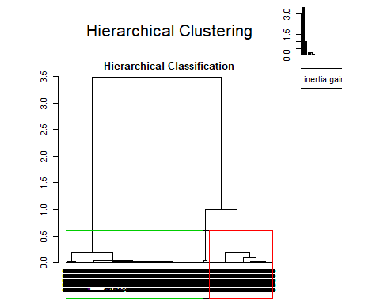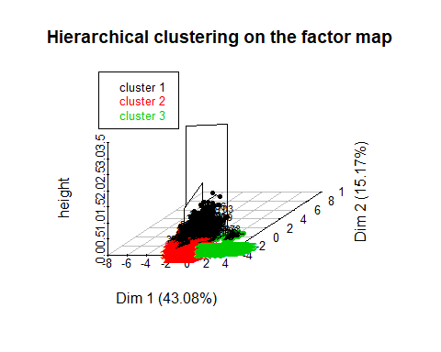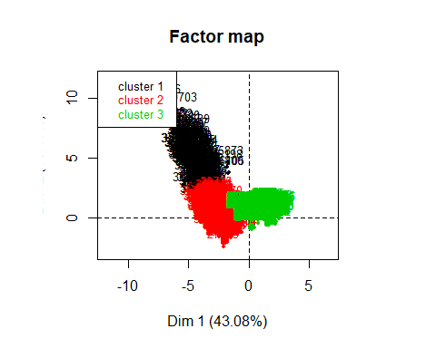

attributes(res.hcpc)

## $names  
## [1] "data.clust" "desc.var" "desc.axes" "call" "desc.ind"   
##   
## $class  
## [1] "HCPC"

summary(res.hcpc$data.clust)

## duration age campaign pdays   
## Min. : 5.0 Min. :18.00 Min. : 1.000 Min. : 0.00   
## 1st Qu.: 103.0 1st Qu.:32.00 1st Qu.: 1.000 1st Qu.:23.00   
## Median : 178.5 Median :38.00 Median : 2.000 Median :23.00   
## Mean : 259.9 Mean :40.18 Mean : 2.515 Mean :22.41   
## 3rd Qu.: 321.0 3rd Qu.:47.00 3rd Qu.: 3.000 3rd Qu.:23.00   
## Max. :2078.0 Max. :92.00 Max. :20.000 Max. :23.00   
## previous emp.var.rate cons.price.idx cons.conf.idx   
## Min. :0.0000 Min. :-3.40000 Min. :92.20 Min. :-50.80   
## 1st Qu.:0.0000 1st Qu.:-1.80000 1st Qu.:93.08 1st Qu.:-42.70   
## Median :0.0000 Median : 1.10000 Median :93.44 Median :-41.80   
## Mean :0.1786 Mean : 0.05212 Mean :93.56 Mean :-40.54   
## 3rd Qu.:0.0000 3rd Qu.: 1.40000 3rd Qu.:93.99 3rd Qu.:-36.40   
## Max. :6.0000 Max. : 1.40000 Max. :94.77 Max. :-26.90   
## euribor3m nr.employed f.job   
## Min. :0.634 Min. :4964 f.job.Admin-Managment :1647   
## 1st Qu.:1.334 1st Qu.:5099 f.job.Entrep-Retired-selfEmpl: 577   
## Median :4.857 Median :5191 f.job.Not-working : 342   
## Mean :3.585 Mean :5166 f.job.Serv-Tech-BlueC :2424   
## 3rd Qu.:4.961 3rd Qu.:5228   
## Max. :5.045 Max. :5228   
## f.season f.education   
## f.season.Mar-May:2064 f.education.Basic :1597   
## f.season.Jun-Aug:2245 f.education.High School :1829   
## f.season.Sep-Dec: 681 f.education.Professional:1564   
##   
##   
##   
## f.age f.duration   
## f.age-[18,30]: 870 f.duration-[5,120] :1557   
## f.age-(30,40]:1991 f.duration-(120,180] : 966   
## f.age-(40,50]:1253 f.duration-(180,300] :1090   
## f.age-(50,92]: 876 f.duration-(300,2.1e+03]:1377   
##   
##   
## f.campaign f.pdays f.previous   
## f.campaign-[0,1] :2121 f.pdays-[0,22] : 175 f.previous-[0,0.9]:4289   
## f.campaign-(1,2] :1259 f.pdays-(22,23]:4815 f.previous-(0.9,1]: 564   
## f.campaign-(2,20]:1610 f.previous-(1,6] : 137   
##   
##   
##   
## y clust   
## y.no :4448 1: 190   
## y.yes: 542 2:1497   
## 3:3303   
##   
##   
##

attributes(res.hcpc$desc.var)

## $names  
## [1] "test.chi2" "category" "quanti.var" "quanti" "call"   
##   
## $class  
## [1] "catdes" "list "

# Factors globally related to clustering partition  
res.hcpc$desc.var$test.chi2

## p.value df  
## f.pdays 0.000000e+00 2  
## f.previous 0.000000e+00 4  
## f.season 3.418306e-239 4  
## y 2.373371e-145 2  
## f.age 4.054913e-27 6  
## f.job 5.294443e-17 6  
## f.campaign 6.236440e-15 4  
## f.duration 2.126018e-09 6  
## f.education 7.523481e-04 4

# Categories over/under represented in each cluster  
res.hcpc$desc.var$category

## $`1`  
## Cla/Mod Mod/Cla Global  
## f.pdays=f.pdays-[0,22] 96.5714286 88.94737 3.507014  
## f.previous=f.previous-(1,6] 75.1824818 54.21053 2.745491  
## y=y.yes 21.0332103 60.00000 10.861723  
## f.previous=f.previous-(0.9,1] 15.4255319 45.78947 11.302605  
## f.season=f.season.Sep-Dec 11.1600587 40.00000 13.647295  
## f.age=f.age-(50,92] 7.4200913 34.21053 17.555110  
## f.job=f.job.Entrep-Retired-selfEmpl 7.6256499 23.15789 11.563126  
## f.duration=f.duration-(180,300] 6.0550459 34.73684 21.843687  
## f.education=f.education.Professional 5.4347826 44.73684 31.342685  
## f.job=f.job.Not-working 8.1871345 14.73684 6.853707  
## f.campaign=f.campaign-[0,1] 4.9504950 55.26316 42.505010  
## f.duration=f.duration-(300,2.1e+03] 4.9382716 35.78947 27.595190  
## f.age=f.age-[18,30] 5.0574713 23.15789 17.434870  
## f.age=f.age-(30,40] 2.8126570 29.47368 39.899800  
## f.education=f.education.Basic 2.5046963 21.05263 32.004008  
## f.season=f.season.Mar-May 2.7131783 29.47368 41.362725  
## f.age=f.age-(40,50] 1.9952115 13.15789 25.110220  
## f.season=f.season.Jun-Aug 2.5835189 30.52632 44.989980  
## f.campaign=f.campaign-(2,20] 2.0496894 17.36842 32.264529  
## f.duration=f.duration-[5,120] 1.7341040 14.21053 31.202405  
## f.job=f.job.Serv-Tech-BlueC 1.9801980 25.26316 48.577154  
## y=y.no 1.7086331 40.00000 89.138277  
## f.previous=f.previous-[0,0.9] 0.0000000 0.00000 85.951904  
## f.pdays=f.pdays-(22,23] 0.4361371 11.05263 96.492986  
## p.value v.test  
## f.pdays=f.pdays-[0,22] 1.259643e-281 35.860546  
## f.previous=f.previous-(1,6] 1.553305e-129 24.214815  
## y=y.yes 2.494385e-64 16.934745  
## f.previous=f.previous-(0.9,1] 1.156226e-34 12.280262  
## f.season=f.season.Sep-Dec 3.391033e-20 9.205810  
## f.age=f.age-(50,92] 1.767166e-08 5.633375  
## f.job=f.job.Entrep-Retired-selfEmpl 4.357820e-06 4.593544  
## f.duration=f.duration-(180,300] 3.266772e-05 4.154025  
## f.education=f.education.Professional 8.193961e-05 3.938655  
## f.job=f.job.Not-working 1.066886e-04 3.874854  
## f.campaign=f.campaign-[0,1] 3.261253e-04 3.593612  
## f.duration=f.duration-(300,2.1e+03] 1.193267e-02 2.514129  
## f.age=f.age-[18,30] 4.007463e-02 2.052979  
## f.age=f.age-(30,40] 2.422784e-03 -3.032822  
## f.education=f.education.Basic 6.774908e-04 -3.398530  
## f.season=f.season.Mar-May 5.767248e-04 -3.442331  
## f.age=f.age-(40,50] 4.090062e-05 -4.102332  
## f.season=f.season.Jun-Aug 3.480205e-05 -4.139528  
## f.campaign=f.campaign-(2,20] 2.688717e-06 -4.693270  
## f.duration=f.duration-[5,120] 4.101428e-08 -5.486428  
## f.job=f.job.Serv-Tech-BlueC 2.251008e-11 -6.688740  
## y=y.no 2.494385e-64 -16.934745  
## f.previous=f.previous-[0,0.9] 2.196177e-173 -28.071291  
## f.pdays=f.pdays-(22,23] 1.259643e-281 -35.860546  
##   
## $`2`  
## Cla/Mod Mod/Cla Global p.value  
## f.season=f.season.Mar-May 53.779070 74.1482966 41.362725 9.639926e-211  
## f.previous=f.previous-(0.9,1] 70.921986 26.7201069 11.302605 8.620072e-102  
## y=y.yes 48.892989 17.7020708 10.861723 1.228275e-22  
## f.pdays=f.pdays-(22,23] 30.965732 99.5991984 96.492986 7.200421e-20  
## f.age=f.age-[18,30] 40.574713 23.5804943 17.434870 2.310583e-13  
## f.campaign=f.campaign-[0,1] 34.464875 48.8309953 42.505010 3.637684e-09  
## f.job=f.job.Not-working 37.134503 8.4836339 6.853707 3.388459e-03  
## f.duration=f.duration-[5,120] 28.066795 29.1917168 31.202405 4.431130e-02  
## f.job=f.job.Serv-Tech-BlueC 28.135314 45.5577822 48.577154 5.209983e-03  
## f.season=f.season.Sep-Dec 22.760646 10.3540414 13.647295 5.972406e-06  
## f.campaign=f.campaign-(2,20] 24.658385 26.5197061 32.264529 9.621448e-09  
## f.age=f.age-(40,50] 22.984836 19.2384770 25.110220 1.946669e-10  
## f.pdays=f.pdays-[0,22] 3.428571 0.4008016 3.507014 7.200421e-20  
## y=y.no 27.697842 82.2979292 89.138277 1.228275e-22  
## f.previous=f.previous-[0,0.9] 24.784332 71.0086840 85.951904 1.676131e-80  
## f.season=f.season.Jun-Aug 10.334076 15.4976620 44.989980 3.526427e-179  
## v.test  
## f.season=f.season.Mar-May 30.981263  
## f.previous=f.previous-(0.9,1] 21.420424  
## y=y.yes 9.791202  
## f.pdays=f.pdays-(22,23] 9.124596  
## f.age=f.age-[18,30] 7.329474  
## f.campaign=f.campaign-[0,1] 5.899879  
## f.job=f.job.Not-working 2.930106  
## f.duration=f.duration-[5,120] -2.011134  
## f.job=f.job.Serv-Tech-BlueC -2.793756  
## f.season=f.season.Sep-Dec -4.527364  
## f.campaign=f.campaign-(2,20] -5.737271  
## f.age=f.age-(40,50] -6.365490  
## f.pdays=f.pdays-[0,22] -9.124596  
## y=y.no -9.791202  
## f.previous=f.previous-[0,0.9] -19.000910  
## f.season=f.season.Jun-Aug -28.542041  
##   
## $`3`  
## Cla/Mod Mod/Cla Global  
## f.previous=f.previous-[0,0.9] 75.21567 97.668786 85.951904  
## f.season=f.season.Jun-Aug 87.08241 59.188616 44.989980  
## f.pdays=f.pdays-(22,23] 68.59813 100.000000 96.492986  
## y=y.no 70.59353 95.065092 89.138277  
## f.age=f.age-(40,50] 75.01995 28.458977 25.110220  
## f.campaign=f.campaign-(2,20] 73.29193 35.725098 32.264529  
## f.job=f.job.Serv-Tech-BlueC 69.88449 51.286709 48.577154  
## f.duration=f.duration-[5,120] 70.19910 33.091129 31.202405  
## f.duration=f.duration-(180,300] 62.66055 20.678171 21.843687  
## f.duration=f.duration-(300,2.1e+03] 63.03558 26.279140 27.595190  
## f.job=f.job.Entrep-Retired-selfEmpl 58.92548 10.293672 11.563126  
## f.job=f.job.Not-working 54.67836 5.661520 6.853707  
## f.campaign=f.campaign-[0,1] 60.58463 38.904027 42.505010  
## f.age=f.age-[18,30] 54.36782 14.320315 17.434870  
## f.previous=f.previous-(1,6] 0.00000 0.000000 2.745491  
## y=y.yes 30.07380 4.934908 10.861723  
## f.pdays=f.pdays-[0,22] 0.00000 0.000000 3.507014  
## f.previous=f.previous-(0.9,1] 13.65248 2.331214 11.302605  
## f.season=f.season.Mar-May 43.50775 27.187405 41.362725  
## p.value v.test  
## f.previous=f.previous-[0,0.9] 6.011990e-240 33.078726  
## f.season=f.season.Jun-Aug 3.447463e-187 29.180312  
## f.pdays=f.pdays-(22,23] 7.182640e-86 19.638980  
## y=y.no 2.742424e-74 18.234602  
## f.age=f.age-(40,50] 8.378911e-15 7.761714  
## f.campaign=f.campaign-(2,20] 1.432305e-13 7.393298  
## f.job=f.job.Serv-Tech-BlueC 8.211297e-08 5.362423  
## f.duration=f.duration-[5,120] 5.127384e-05 4.049743  
## f.duration=f.duration-(180,300] 5.558862e-03 -2.772728  
## f.duration=f.duration-(300,2.1e+03] 3.761527e-03 -2.897497  
## f.job=f.job.Entrep-Retired-selfEmpl 1.078588e-04 -3.872197  
## f.job=f.job.Not-working 4.940469e-06 -4.567300  
## f.campaign=f.campaign-[0,1] 6.903561e-13 -7.181332  
## f.age=f.age-[18,30] 1.568440e-15 -7.971434  
## f.previous=f.previous-(1,6] 6.723232e-67 -17.279410  
## y=y.yes 2.742424e-74 -18.234602  
## f.pdays=f.pdays-[0,22] 7.182640e-86 -19.638980  
## f.previous=f.previous-(0.9,1] 1.915585e-167 -27.580337  
## f.season=f.season.Mar-May 1.553439e-179 -28.570715

# Numeric variables globally related to clustering partition  
res.hcpc$desc.var$quanti.var

## Eta2 P-value  
## pdays 0.833431720 0.000000e+00  
## previous 0.492162105 0.000000e+00  
## emp.var.rate 0.887391268 0.000000e+00  
## cons.price.idx 0.451020756 0.000000e+00  
## euribor3m 0.972756054 0.000000e+00  
## nr.employed 0.859965803 0.000000e+00  
## cons.conf.idx 0.137891619 2.106281e-161  
## campaign 0.018064870 1.813245e-20  
## age 0.008646255 3.945874e-10

res.hcpc$desc.var$quanti

## $`1`  
## v.test Mean in category Overall mean sd in category  
## previous 45.971997 1.8210526 0.17855711 0.9567373  
## cons.conf.idx 6.937479 -38.2494737 -40.54192385 7.1162952  
## age 5.645279 44.3789474 40.17755511 16.9858634  
## duration 2.110371 297.6368421 259.85110220 204.0561577  
## campaign -4.322398 1.7894737 2.51503006 1.2598641  
## cons.price.idx -4.817260 93.3651368 93.56373427 0.8341906  
## emp.var.rate -19.115707 -2.0936842 0.05212425 0.8565304  
## euribor3m -21.054798 0.9672263 3.58457355 0.5121394  
## nr.employed -27.122883 5025.3821053 5165.87569138 51.3340730  
## pdays -64.481704 7.8473684 22.41362725 6.4451425  
## Overall sd p.value  
## previous 0.5020810 0.000000e+00  
## cons.conf.idx 4.6436681 3.991593e-12  
## age 10.4585324 1.649135e-08  
## duration 251.6124483 3.482644e-02  
## campaign 2.3588988 1.543422e-05  
## cons.price.idx 0.5793439 1.455430e-06  
## emp.var.rate 1.5774788 1.868722e-81  
## euribor3m 1.7469207 2.066633e-98  
## nr.employed 72.7919889 5.290316e-162  
## pdays 3.1744936 0.000000e+00  
##   
## $`2`  
## v.test Mean in category Overall mean sd in category  
## previous 12.347248 0.3126253 0.17855711 0.5102106  
## pdays 8.083856 22.9686039 22.41362725 0.5683270  
## age -4.063321 39.2585170 40.17755511 12.0357116  
## campaign -7.817387 2.1162325 2.51503006 1.6821146  
## cons.conf.idx -25.982635 -43.1512358 -40.54192385 5.9749813  
## cons.price.idx -46.161007 92.9853808 93.56373427 0.4313831  
## nr.employed -55.580906 5078.3791583 5165.87569138 38.2446628  
## emp.var.rate -60.699472 -2.0186373 0.05212425 0.5394336  
## euribor3m -63.098140 1.2007649 3.58457355 0.2625532  
## Overall sd p.value  
## previous 0.5020810 5.040624e-35  
## pdays 3.1744936 6.275018e-16  
## age 10.4585324 4.837945e-05  
## campaign 2.3588988 5.393129e-15  
## cons.conf.idx 4.6436681 7.782048e-149  
## cons.price.idx 0.5793439 0.000000e+00  
## nr.employed 72.7919889 0.000000e+00  
## emp.var.rate 1.5774788 0.000000e+00  
## euribor3m 1.7469207 0.000000e+00  
##   
## $`3`  
## v.test Mean in category Overall mean sd in category  
## euribor3m 69.642425 4.81553255 3.58457355 0.2815584  
## emp.var.rate 66.534303 1.11407811 0.05212425 0.4992563  
## nr.employed 64.815247 5213.61292764 5165.87569138 17.5063561  
## cons.price.idx 46.665983 93.83728217 93.56373427 0.3924268  
## cons.conf.idx 22.363260 -39.49118983 -40.54192385 2.9986228  
## pdays 18.255882 23.00000000 22.41362725 0.0000000  
## campaign 9.321541 2.73751135 2.51503006 2.6231360  
## previous -30.559574 0.02331214 0.17855711 0.1508930  
## Overall sd p.value  
## euribor3m 1.7469207 0.000000e+00  
## emp.var.rate 1.5774788 0.000000e+00  
## nr.employed 72.7919889 0.000000e+00  
## cons.price.idx 0.5793439 0.000000e+00  
## cons.conf.idx 4.6436681 8.971345e-111  
## pdays 3.1744936 1.857861e-74  
## campaign 2.3588988 1.146631e-20  
## previous 0.5020810 4.219155e-205

### desc.ind ###  
### C. The description of the clusters by the individuals ###  
names(res.hcpc$desc.ind)

## [1] "para" "dist"

res.hcpc$desc.ind$para # Close to center of gravity

## Cluster: 1  
## 36296 36721 40892 41007 36907   
## 0.03946875 0.05735028 0.13237750 0.21737224 0.22738201   
## --------------------------------------------------------   
## Cluster: 2  
## 30951 36346 36347 36427 36864   
## 0.06134805 0.09336824 0.09336824 0.09552183 0.09624810   
## --------------------------------------------------------   
## Cluster: 3  
## 1467 1752 331 6185 18926   
## 0.01424926 0.01424926 0.01478019 0.01478019 0.01491243

res.hcpc$desc.ind$dist

## Cluster: 1  
## 40396 40703 39592 38902 39612   
## 11.543929 10.404680 9.652239 9.431592 9.270355   
## --------------------------------------------------------   
## Cluster: 2  
## 37956 38026 38148 37904 38051   
## 4.742178 4.688806 4.646346 4.645320 4.644823   
## --------------------------------------------------------   
## Cluster: 3  
## 11696 8484 11485 11056 10761   
## 5.265453 5.246245 5.197173 5.138562 5.009706

## CA analysis for your data should contain your factor version of the numeric target (duration) in K= 7 (maximum 10) levels and 2 factors:

### Eigenvalues and dominant axes analysis. How many axes we have to consider are there any row categories that can be combined/avoided to explain Duration target.

Para experimentar y para que tenga más sentido el análisis de correspondencias, refactorizaremos a 8 niveles la variable duration.

Ahora hacemos el análisis de correspondencias entre nuestra nueva duration factorizada y f.age. Para saber cuantas dimensiones debemos considerar, obtenemos la media de los eigenvalues. Vemos que solamente tiene sentido considerar el primer eje, ya que este es el único valor mayor a la media (kaiser).

Al graficar el CA, podemos ver que los 2 niveles con menores edades, son los que menos representados en ese eje. Para duration, los niveles mejor representados en el eje son los de mayor y menor duración.

Al ejecutar la función del chisq.test podemos ver que el pvalue es muy grande, lo que nos puede decir que la probabilidad de que no tengan relación es muy grande.

### CA - duration vs f.age

# Para duration  
aux2<-c(5,60,120,150,180,240,300,1200,2100) # Niveles "naturales"  
duration_k8<-factor(cut(df$duration,breaks=aux2,include.lowest=T))  
table(duration_k8)

## duration_k8  
## [5,60] (60,120] (120,150] (150,180]   
## 490 1067 496 470   
## (180,240] (240,300] (300,1.2e+03] (1.2e+03,2.1e+03]   
## 606 484 1311 66

levels(duration_k8)<-paste0("f.duration-",levels(duration_k8)) # Hacemos las etiquetas más informativas  
summary(duration_k8)

## f.duration-[5,60] f.duration-(60,120]   
## 490 1067   
## f.duration-(120,150] f.duration-(150,180]   
## 496 470   
## f.duration-(180,240] f.duration-(240,300]   
## 606 484   
## f.duration-(300,1.2e+03] f.duration-(1.2e+03,2.1e+03]   
## 1311 66

res.ca<-CA(table(df$f.age,duration_k8))

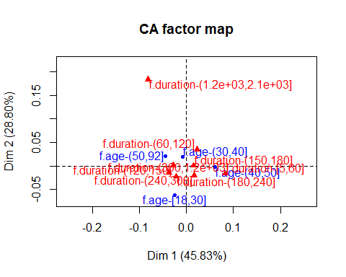

attributes(res.ca)

## $names  
## [1] "eig" "call" "row" "col" "svd"   
##   
## $class  
## [1] "CA" "list"

res.ca$eig

## eigenvalue percentage of variance  
## dim 1 0.0014130984 45.82949  
## dim 2 0.0008880983 28.80273  
## dim 3 0.0007821856 25.36778  
## cumulative percentage of variance  
## dim 1 45.82949  
## dim 2 74.63222  
## dim 3 100.00000

mean(res.ca$eig[,1]) # Mean of eigenvalues

## [1] 0.001027794

sum(res.ca$eig[,1]) # Total inertia

## [1] 0.003083382

# Rows  
res.ca$row

## $coord  
## Dim 1 Dim 2 Dim 3  
## f.age-[18,30] -0.024672376 -0.061587071 0.00515479  
## f.age-(30,40] -0.007883325 0.019128850 0.02866207  
## f.age-(40,50] 0.060905585 -0.002487498 -0.01655528  
## f.age-(50,92] -0.044696383 0.021246627 -0.04658344  
##   
## $contrib  
## Dim 1 Dim 2 Dim 3  
## f.age-[18,30] 7.510490 74.4623554 0.5922851  
## f.age-(30,40] 1.754758 16.4394554 41.9059874  
## f.age-(40,50] 65.916230 0.1749504 8.7985988  
## f.age-(50,92] 24.818522 8.9232388 48.7031287  
##   
## $cos2  
## Dim 1 Dim 2 Dim 3  
## f.age-[18,30] 0.13746379 0.856535696 0.006000512  
## f.age-(30,40] 0.04973439 0.292830101 0.657435510  
## f.age-(40,50] 0.92975389 0.001550884 0.068695230  
## f.age-(50,92] 0.43249165 0.097726640 0.469781706  
##   
## $inertia  
## [1] 0.0007720623 0.0004985776 0.0010018363 0.0008109061

# Columns: the same  
res.ca$col

## $coord  
## Dim 1 Dim 2 Dim 3  
## f.duration-[5,60] 0.08319396 -0.0161245945 2.458294e-02  
## f.duration-(60,120] 0.02249525 0.0348536919 -2.577791e-02  
## f.duration-(120,150] -0.02735408 0.0013898644 1.373241e-02  
## f.duration-(150,180] 0.01565127 0.0006091358 6.835979e-05  
## f.duration-(180,240] -0.02116464 -0.0227191287 4.705510e-02  
## f.duration-(240,300] 0.01669583 -0.0202658085 3.700409e-04  
## f.duration-(300,1.2e+03] -0.03694459 -0.0143453208 -2.112106e-02  
## f.duration-(1.2e+03,2.1e+03] -0.08146358 0.1836311251 1.153212e-01  
##   
## $contrib  
## Dim 1 Dim 2 Dim 3  
## f.duration-[5,60] 48.095757 2.87482957 7.586705e+00  
## f.duration-(60,120] 7.657254 29.24828562 1.816559e+01  
## f.duration-(120,150] 5.263239 0.02162046 2.396431e+00  
## f.duration-(150,180] 1.632767 0.00393518 5.627155e-05  
## f.duration-(180,240] 3.849653 7.05820696 3.437761e+01  
## f.duration-(240,300] 1.913324 4.48550815 1.697988e-03  
## f.duration-(300,1.2e+03] 25.376484 6.08781771 1.498386e+01  
## f.duration-(1.2e+03,2.1e+03] 6.211521 50.21979635 2.248806e+01  
##   
## $cos2  
## Dim 1 Dim 2 Dim 3  
## f.duration-[5,60] 0.8889838 0.033395490 7.762072e-02  
## f.duration-(60,120] 0.2121463 0.509274053 2.785796e-01  
## f.duration-(120,150] 0.7970605 0.002057746 2.008818e-01  
## f.duration-(150,180] 0.9984686 0.001512388 1.904743e-05  
## f.duration-(180,240] 0.1409384 0.162401758 6.966599e-01  
## f.duration-(240,300] 0.4042264 0.595574996 1.985675e-04  
## f.duration-(300,1.2e+03] 0.6767699 0.102037507 2.211926e-01  
## f.duration-(1.2e+03,2.1e+03] 0.1236833 0.628458833 2.478578e-01  
##   
## $inertia  
## [1] 7.645138e-04 5.100466e-04 9.331130e-05 2.310800e-05 3.859799e-04  
## [6] 6.688615e-05 5.298621e-04 7.096744e-04

# Link levels in rows  
plot.CA(res.ca)  
lines(res.ca$row$coord[,1],res.ca$row$coord[,2],lwd=2,col="darkblue")  
lines(res.ca$col$coord[,1],res.ca$col$coord[,2],lwd=2,col="red")

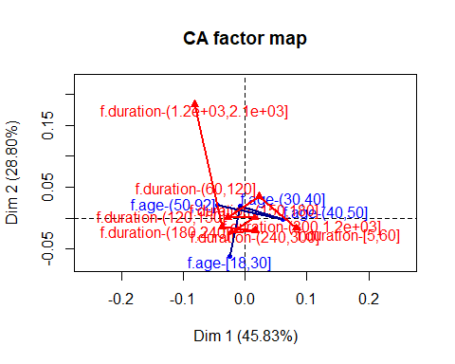

# Phi2 = Intensity of the association Chisq/nbobservations  
sum(res.ca$eig[,1]) # Total Inertia = Phi2

## [1] 0.003083382

# H0: f.duration - f.age independency  
chisq.test(table(df$f.age,duration_k8))

##   
## Pearson's Chi-squared test  
##   
## data: table(df$f.age, duration_k8)  
## X-squared = 15.386, df = 21, p-value = 0.8031

### CA - Education vs f.duration

Para la segunda prueba decidimos utilizar duration junto con education. Para education usaremos la variable original con todos sus niveles menos el nivel illiterate el cual nos puede causar inconvenientes.

Por kaiser vemos que las primeras dos dimensiones están por encima de la media, por lo que son las que cogemos.

Podemos ver que para la primera dimensión los valores más lejanos del centro son los niveles de education.basic_6y, education.university.degree, para la primera dimensión. Para la segunda tenemos, f.duration(150,180], education.professioal.course, esto nos puede decir qué niveles se ven mejor representados en las dimensiones.

#Education  
table(df$education)

##   
## education.basic.4y education.basic.6y   
## 515 271   
## education.basic.9y education.high.school   
## 810 1196   
## education.illiterate education.professional.course   
## 1 633   
## education.university.degree   
## 1564

education_k6<-df$education  
education_k6[which(education_k6=="education.illiterate")]<-"education.basic.4y"  
education_k6=factor(education_k6)  
  
par(cex=0.8)  
res.ca<-CA(table(education_k6,duration_k8))

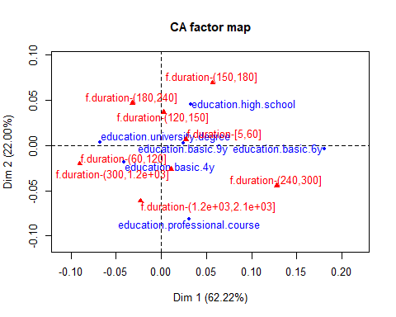

res.ca$eig

## eigenvalue percentage of variance  
## dim 1 3.865234e-03 62.2179391  
## dim 2 1.366656e-03 21.9987982  
## dim 3 7.963697e-04 12.8190136  
## dim 4 1.318112e-04 2.1217398  
## dim 5 5.234014e-05 0.8425093  
## cumulative percentage of variance  
## dim 1 62.21794  
## dim 2 84.21674  
## dim 3 97.03575  
## dim 4 99.15749  
## dim 5 100.00000

mean(res.ca$eig[,1])

## [1] 0.001242482

# Rows  
res.ca$row

## $coord  
## Dim 1 Dim 2 Dim 3  
## education.basic.4y -0.04133205 -0.018121606 -0.058412332  
## education.basic.6y 0.18102401 -0.004110569 0.042729415  
## education.basic.9y 0.02483545 0.002685184 -0.027046691  
## education.high.school 0.03234069 0.045050136 -0.004194745  
## education.professional.course 0.03069724 -0.081359937 0.007155999  
## education.university.degree -0.06774789 0.003779150 0.026186751  
## Dim 4 Dim 5  
## education.basic.4y 0.010678244 -0.012189412  
## education.basic.6y -0.003590873 -0.018490687  
## education.basic.9y -0.022417259 0.003721054  
## education.high.school 0.010664921 0.005274952  
## education.professional.course 0.008039829 0.008059669  
## education.university.degree -0.002700335 -0.001997413  
##   
## $contrib  
## Dim 1 Dim 2 Dim 3 Dim 4  
## education.basic.4y 4.570327 2.48475408 44.3040567 8.9453332  
## education.basic.6y 46.043183 0.06714497 12.4511048 0.5312717  
## education.basic.9y 2.590316 0.08563935 14.9106984 61.8866872  
## education.high.school 6.485648 35.59293113 0.5295743 20.6820512  
## education.professional.course 3.092616 61.44198967 0.8156972 6.2207761  
## education.university.degree 37.217909 0.32754080 26.9888687 1.7338807  
## Dim 5  
## education.basic.4y 29.354847  
## education.basic.6y 35.476433  
## education.basic.9y 4.294194  
## education.high.school 12.741859  
## education.professional.course 15.743551  
## education.university.degree 2.389116  
##   
## $cos2  
## Dim 1 Dim 2 Dim 3  
## education.basic.4y 0.2991135 0.057498362 0.597408243  
## education.basic.6y 0.9371554 0.000483218 0.052214742  
## education.basic.9y 0.3295023 0.003851787 0.390789233  
## education.high.school 0.3233541 0.627439873 0.005439900  
## education.professional.course 0.1217065 0.854941382 0.006613871  
## education.university.degree 0.8658182 0.002694161 0.129359520  
## Dim 4 Dim 5  
## education.basic.4y 0.0199646527 0.0260152290  
## education.basic.6y 0.0003687563 0.0097778938  
## education.basic.9y 0.2684598606 0.0073968422  
## education.high.school 0.0351637465 0.0086023464  
## education.professional.course 0.0083485069 0.0083897596  
## education.university.degree 0.0013755312 0.0007526117  
##   
## $inertia  
## [1] 0.0005905913 0.0018990198 0.0003038576 0.0007752660 0.0009821731  
## [6] 0.0016615026

# Columns: the same  
res.ca$col

## $coord  
## Dim 1 Dim 2 Dim 3  
## f.duration-[5,60] 0.027029115 0.006192711 0.035619391  
## f.duration-(60,120] -0.090112862 -0.020538411 0.017086167  
## f.duration-(120,150] 0.002502632 0.036564696 -0.049483431  
## f.duration-(150,180] 0.056880902 0.069080817 0.004342747  
## f.duration-(180,240] -0.032420109 0.046836380 0.019636428  
## f.duration-(240,300] 0.127883956 -0.044401648 0.030160547  
## f.duration-(300,1.2e+03] 0.010833855 -0.026353481 -0.028797208  
## f.duration-(1.2e+03,2.1e+03] -0.023054621 -0.061622025 -0.029181692  
## Dim 4 Dim 5  
## f.duration-[5,60] 0.0049402640 0.001195881  
## f.duration-(60,120] -0.0054537007 0.003195489  
## f.duration-(120,150] -0.0047413221 0.015186085  
## f.duration-(150,180] -0.0004840916 -0.004166702  
## f.duration-(180,240] 0.0067808780 -0.005449376  
## f.duration-(240,300] -0.0044409552 0.006544906  
## f.duration-(300,1.2e+03] -0.0015812648 -0.007781878  
## f.duration-(1.2e+03,2.1e+03] 0.0922854018 0.011622914  
##   
## $contrib  
## Dim 1 Dim 2 Dim 3 Dim 4  
## f.duration-[5,60] 1.85602333 0.2755485 15.6442142 1.81820805  
## f.duration-(60,120] 44.92226773 6.5999164 7.8385985 4.82496535  
## f.duration-(120,150] 0.01610644 9.7240230 30.5622963 1.69522671  
## f.duration-(150,180] 7.88414319 32.8891869 0.2230549 0.01674558  
## f.duration-(180,240] 3.30236637 19.4930424 5.8800674 4.23634841  
## f.duration-(240,300] 41.03941655 13.9921319 11.0792023 1.45126036  
## f.duration-(300,1.2e+03] 0.79779697 13.3511603 27.3582403 0.49837825  
## f.duration-(1.2e+03,2.1e+03] 0.18187944 3.6749905 1.4143262 85.45886729  
## Dim 5  
## f.duration-[5,60] 0.2683099  
## f.duration-(60,120] 4.1716088  
## f.duration-(120,150] 43.7963518  
## f.duration-(150,180] 3.1242607  
## f.duration-(180,240] 6.8901823  
## f.duration-(240,300] 7.9381048  
## f.duration-(300,1.2e+03] 30.3973777  
## f.duration-(1.2e+03,2.1e+03] 3.4138039  
##   
## $cos2  
## Dim 1 Dim 2 Dim 3  
## f.duration-[5,60] 0.354045576 0.01858477 0.614849014  
## f.duration-(60,120] 0.915064957 0.04753484 0.032897861  
## f.duration-(120,150] 0.001548393 0.33053014 0.605350244  
## f.duration-(150,180] 0.402214863 0.59325319 0.002344522  
## f.duration-(180,240] 0.283613187 0.59192152 0.104045298  
## f.duration-(240,300] 0.847459925 0.10216102 0.047137383  
## f.duration-(300,1.2e+03] 0.068871807 0.40752236 0.486604635  
## f.duration-(1.2e+03,2.1e+03] 0.038426381 0.27452723 0.061565082  
## Dim 4 Dim 5  
## f.duration-[5,60] 1.182758e-02 0.0006930612  
## f.duration-(60,120] 3.351668e-03 0.0011506756  
## f.duration-(120,150] 5.557584e-03 0.0570136422  
## f.duration-(150,180] 2.913267e-05 0.0021582909  
## f.duration-(180,240] 1.240707e-02 0.0080129231  
## f.duration-(240,300] 1.021974e-03 0.0022196981  
## f.duration-(300,1.2e+03] 1.467184e-03 0.0355340175  
## f.duration-(1.2e+03,2.1e+03] 6.157147e-01 0.0097666035  
##   
## $inertia  
## [1] 0.0002026283 0.0018975163 0.0004020629 0.0007576562 0.0004500643  
## [6] 0.0018717928 0.0004477408 0.0001829489

# Link levels in rows  
plot.CA(res.ca)  
lines(res.ca$row$coord[,1],res.ca$row$coord[,2],lwd=2,col="darkblue")  
lines(res.ca$col$coord[,1],res.ca$col$coord[,2],lwd=2,col="red")

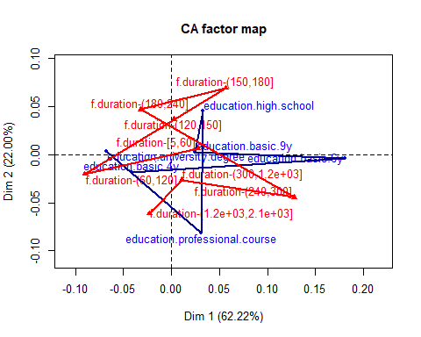

# Phi2 = Intensity of the association Chisq/nbobservations  
sum(res.ca$eig[,1]) # Total Inertia = Phi2

## [1] 0.00621241

chisq.test(table(education_k6,duration_k8))

## Warning in chisq.test(table(education_k6, duration_k8)): Chi-squared  
## approximation may be incorrect

##   
## Pearson's Chi-squared test  
##   
## data: table(education_k6, duration_k8)  
## X-squared = 31, df = 35, p-value = 0.6617

# Traditional analysis  
table(df$y,duration_k8)

## duration_k8  
## f.duration-[5,60] f.duration-(60,120] f.duration-(120,150]  
## y.no 490 1047 481  
## y.yes 0 20 15  
## duration_k8  
## f.duration-(150,180] f.duration-(180,240] f.duration-(240,300]  
## y.no 441 550 431  
## y.yes 29 56 53  
## duration_k8  
## f.duration-(300,1.2e+03] f.duration-(1.2e+03,2.1e+03]  
## y.no 983 25  
## y.yes 328 41

chisq.test(table(df$y,duration_k8))

##   
## Pearson's Chi-squared test  
##   
## data: table(df$y, duration_k8)  
## X-squared = 643.03, df = 7, p-value < 2.2e-16