

**Software Engineering 2: “PowerEnJoy”**

**Requirements Analysis and Specifications Document**

Authors:

Sergio CAPRARA

Soheil GHANBARI

Erica TINTI

Milan, Italy

13/11/2016

**Table of contents**

1. Introduction 3

1.1 Purpose 3

1.2 Description of the given problem 3

1.3 Glossary 4

1.4 Reference Documents 6

2. Overall Description 6

2.1 Product Perspective 6

2.2 Actors 6

2.3 Goals 6

2.4 Assumptions 7

2.5 Stakeholders 9

3. Specific Requirements 9

3.1 Functional Requirements 9

3.2 Scenarios 12

3.3 UML Diagrams 14

3.3.1 Use Cases 14

3.3.2 Class Diagram 21

3.3.3 Sequence Diagram 22

3.3.4 Activity Diagram 23

3.3.5 State Diagram 24

3.4 Proposed System 25

3.5 Non Functional Requirements 26

3.5.1 Interfaces 26

4. Appendices 30

4.1 Alloy Modelling 30

4.1.1 Alloy Code 30

4.1.2 Alloy Model 35

4.1.3 Alloy Result 36

4.2 Used tools 36

# Introduction

## Purpose

The purpose of this document is to provide a description of the system to be developed. It specifies goals of the system, functional and non-functional requirements and assumptions, other than use cases, possible scenarios and UML diagrams. Also, the system has been modelled using Alloy Analyzer and the code is provided with results of the simulation.

The document is addressed to programmers involved in the developing phase and to the client that has to revise the contract basis for the system development.

## Description of the given problem

The aim of PowerEnjoy is to offer a car-sharing service to users, so that they can reserve, use and release electric cars.

The user can register to the PowerEnjoy service by using a mobile application that communicates with a system. To get access to the service the user must provide driving license, ID card and payment details; after system validation, a password will be sent for accessing to the account.

Registered users have complete access to the functions of the application, being allowed to see available cars around them or close to a user specified address and to ask for a reservation. Users are also given the possibility to cancel the reservation.

After the reservation, a one hour time limit is imposed to reach the car, and only once the user gets close, the system unlocks it; the user can enable an option provided to save money. In that case the system designates the place where to park and the user can get a discount if he confirms and parks there.

The user is charged at the end of the rental and the due amount is calculated on the time of the ride; in some cases, depending on the number of passengers, the battery level of the car and the place in which the user parks it, he may get discounts or get some extra charge.

Discounts and extra charge are calculated as follows:

* -10% off if the car has at least two other passengers;
* -20% off if the car is left with more than 50% of the battery;
* -30% if the car is parked and the users plugs it into the power grid;
* +30% if the car is left at more than 3km from the nearest power grid station or with less than 20% of the battery.

The service provided is available in the Italian area and a European driving license is required to register. The system knows the coverage of the service, the valid parking areas (safe areas) and the list of the special parking areas (as a list of coordinates) and accesses users and cars’ locations via their GPS enabled on mobile phones and boards.

Cars that need maintenance for any reason and that are unavailable are not shown on users’ maps.

On the other side, another type of user, operator, has a different access to the service. Their objective is to do interventions and maintenance on cars that are unavailable for the following reasons:

* the car is left with less than 5% of the battery level;
* the car needs maintenance for issues reported through its control unit.

Operators interact with the system through a mobile application providing a login page for their identification, the list of cars in need of maintenance and a function to take them in charge in order to fix the issue. Once the work done, they inform the system and the car becomes available again.

## Glossary

* **Car Sharing:** it is a service of car rental where people can use a car reserving it before, use it, usually for very short periods, and then leave it to a parking.
* **User:** it is a person that is registered to the PowerEnjoy Service. It has to be older than 18, and have a valid driving licence to drive cars. It is allowed to reserve PowerEnjoy car using the PowerEnjoy mobile application.
* **Operator:** it is a person with technical skills, such as a mechanic, that fix PowerEnjoy cars and that take PowerEnjoy cars to a special parking area and plug it at Power Plug when their battery is low. Since they are not PowerEnjoy service user, they can't reserve a car and perform any operation users do.
* **App:** It is the short term we use to define a mobile application.
* **Power Plug:** It is a column with one or more electricity socket where it is possible to plug the car. Each socket has a number written on it and a led, that is green if that plug is available, or it is red if it is not.
* **Safe Area** (also Parking Area): it is parking area that is an area with parking spaces. This spaces are note specially reserved for PowerEnjoy but are shared with all the other divers of the town. We will refer to "Safe area" also with the term "Parking area".
* **Special Parking Area** (also Power Station): it is a parking area reserved exclusively to PowerEnjoy cars where, for each parking space there is a Power Plug where it is possible to plug the parked car. We will refer to "Special parking areas" also with the term "Power Station".
* **Car:** In this document with the word "car" we refer exclusively to PowerEnjoy cars.
* **System:** It's the system that manage all the operation to make the car sharing working, getting information from external system, and interacting with the user’s terminal, that is mobile application and computer boards.
* **Computer Board:** It is a screen present in each PowerEnjoy car. When the user is in the car, the computer board shows information like the position of the car on the map and the messages sent by the system. From the moment when the user get into the car to when he gets out, he uses the computer board to interact with the system.
* **Pin:** It is a symbol on the map to represent the position of something. Usually pins have different symbols depending on what they represent on the map.
* **Save mode:** It is an option that, if activated, show the user some indication to save money during the car renting.
* **Energy Level:** it refers to the level of the battery of a car. It is shown on the car's dashboard.
* **Reservation:** it is a relation that creates between a user and a car that allows the user to start using the car from that moment to 1 hour later. The reservation guarantees that no one else can reserve and use the reserved car till when the reservation doesn't expire.

## Reference Documents

* Specification document: Assignments AA 2016-2017
* IEEE Std 830-1998 IEEE Recommended Practice for Software Requirements Specifications.

# Overall Description

## Product Perspective

The system interfaces with an external Data Collecting System for getting real-time information about cars and Power Plugs status trough API exposed by this system. The Data Collecting System should allow Power Enjoy system to access to cars and Power Plugs information and to set the led on the Power Plug.

For payments, our system interfaces with an external Payment System sending all payment data such as credit cards information and the total amount to be paid. Given these information, the payments system performs the payment and should send a feedback to our system.

## Actors

The actors that partecipate to our system are:

* **User**: it is a person that has registered to our system and has downloaded the app on his phone.
* **Operator**: it is a person, already known by the system, that can access to the list of the cars that have low battery or that need technical assistance.

## Goals

**User goals**

[G1] The user should be able to register to the system.

[G2] Already registered users should be allowed to login.

[G3] The user should be able to find available cars around him.

[G4] The user should see the battery level of a car before making a reservation.

[G5] The user should be able to reserve a car.

[G6] The user should be granted the access to the reserved car once he reaches it.

[G7] The user should be allowed to cancel a reservation.

[G8] The user should be able to access profile and payment method and make changes.

[G9] The user should be informed of the amount he has been charged of.

[G10] After the rental, the user should be able to inform the system that he is leaving the car.

[G11] The user should be able to see all the parking areas.

[G12] The user should be able to see all the special parking areas.

**Operator goals**

[G13] Operators should be allowed to login to the system.

[G14] Operators should be allowed to see the list of cars that need maintenance and their details.

[G15] Operators should be allowed to notify the take in charge of a car and the end of the maintenance.

## Assumptions

* The user interacts with the system using his mobile phone.
* The user has internet access enabled on his phone.
* Each car has GPS sensors (always turned on) providing the right coordinates, sensors to check the number of people sitting, a dashboard showing the status of the battery level and a screen displaying the current charge to users.
* Special parking areas are a subset of safe parking areas and correspond to the ones with power plugs reserved to PowerEnjoy cars exclusively. PowerEnjoy cars can only be charged and plugged in special parking areas.
* Safe parking areas and special parking areas are already defined and identified by coordinates: the system is initialized at start-up time with such a set of areas.
* Only one user at a time can drive a specific car.
* Each car has a maximum number of five seats.
* A car is unavailable for reservations when it has less than 5% of battery level, has technical issues, or it is already in use or reserved by another user. Otherwise, it is available.
* A car that has less than 5% of battery or technical issues needs maintenance.
* Only registrations by users having a European driving licence are supported.
* The car can be driven anywhere in the Italian area.
* User payments are made using credit cards.
* Operators are already registered to the system.
* Discounts can be combined so that their total amount is subtracted to the final charge.
* In case the company receives a fine concerning a bad user behaviour caused by some violation, the user is due to pay it, so the system pays it in advance and then charges the amount to the user.
* The car is ignited using a power button functioning as a Start/Stop button.
* The system can always access to the real-time information of the car, such as its position, the number of people inside it, the battery level, the charging status and control unit information. Depending on this information, the system can manage the status of the car.
* The system can check the availability of power plugs of all special parking areas at any time through a third part system collecting and providing this information. The system can also set the status of a power plug if needed.
* Power plug status can be available or unavailable, identified by the color of a LED on it.
* A user can use a car if and only if he has reserved it in advance.
* A car can be reserved by only one user at a time.
* The system has access to European Union driving licence databases to verify and approve user registration.
* Only registered users can access to system functionalities

## Stakeholders

The stakeholder of this project is PowerEnjoy Company, a new company born from a famous Energy distribution company, that decided to build a car sharing service that would offer a service to the citizens that would be advantageous and at the same time eco-friendly.

# Specific Requirements

## Functional Requirements

**User goals**

[G1] The user should be able to register to the system:

* The user must enter all his personal data, ID card data and driving licence information.
* The system should validate the data entered by asking the external system for driving licence verifications.
* If correct, the system should provide to the user a password to access the service.

[G2] Already registered users should be allowed to login:

* The user should be allowed to enter login information.
* The system should validate entered data and allow the access if all is correct.

[G3] The user should be able to find available cars around him:

* The system can check user coordinates accessing GPS on user's phone.
* The system should provide a map on which available cars are identified by a symbol showing the correct position.

[G4] The user should see the battery level of a car before making a reservation:

* The system should provide information about the car when the user picks one of the available, before reserving it.

[G5] The user should be able to reserve a car:

* The user should be able to select one of the cars to see its status and reserve it.
* The system should make the car unavailable to other users once the user confirms his choice.
* The system should retain the reservation for an hour and cancel it when the time limit is reached. In this case a 1 EUR fee should be charged.

[G6] The user should be granted the access to the reserved car once he reaches it:

* User should be able to notify the system that he has reached the car.
* The system should check user coordinates to compare them with car's ones and unlock it if the distance is less than 10m.

[G7] The user should be allowed to cancel a reservation:

* The system should offer an option to the user to cancel the reservation.
* Once the reservation is cancelled, the user should be able to access again to the map with available cars.

[G8] The user should be able to access profile and payment method and make changes:

* The system should provide a personal profile to the user with his information and give the possibility to apply changes.

[G9] The user should be informed of the amount he has been charged of:

* The system should calculate the total charge after subtracting all the accumulated discounts.
* The system should notify the user about the final amount of the reservation and how it was calculated.

[G10] After the rental, the user should be able to inform the system that he is leaving the car:

* The user should have a way to notify the system he has finished using the car.
* The system should verify the status of the car and check the parking.
* If all is correct the system should lock the car and make it available again.

[G11] The user should be able to see all the parking areas:

* The system should provide a map on which parking areas are identified.

[G12] The user should be able to see all the special parking areas:

* The system should provide a map on which special parking areas are identified by a symbol showing their correct position.

**Operator goals**

[G13] Operators should be allowed to login to the system:

* The operator should be allowed to enter login information.
* The system should validate entered data and allow the access if all is correct.

[G14] Operators should be allowed to see the list of cars that need maintenance and their details:

* The system should provide a list of cars that need maintenance and show all details.

[G15] Operators should be allowed to notify the take in charge of a car and the end of the maintenance:

* The system should provide a way to take in charge a car.
* The operator should be able to notify the system that the maintenance has finished.

## Scenarios

**Scenario 1**

Alice gets out with friends but when she wants to come back home there are no buses, so she decides to take a PowerEnjoy car. She opens the application (she's already logged in) and on the map, she checks for the closest available car. She finds some and she decides to reserve one, that's 10 min from her by feet. When she arrives at the car, she presses the button to pickit up and after a few seconds the car opens. She starts driving. When she arrives home, she parks in the first available parking space and presses the button to notify she's leaving the car. Since that parking space is in a safe are, the reservation is correctly concluded. She closes the door and she waits till the car locks.

**Scenario 2**

Rob should go to a restaurant not easily reachable by public transport. Then he decides to take a PowerEnjoy car. He opens the app and he notifies that the closest available car is 10minutes from him by metro. He decides to take it anyway. Unfortunately, there are some traffic problems with the underground, then he decides to take a bus to get to the car. At that time, there is too much road congestion in his town, and the bus is late. The battery of his mobile phone is low and when he gets off the bus his phone turns off. Now Rob will not be able neither to pick up the car nor to cancel the reservation, then he will pay 1€ fee.

**Scenario 3**

Alex is at the restaurant with his girlfriend, and they're are eating the dessert. He knows they will be out of the restaurant in half an hour, then he decides to have a look at the PowerEnjoy application on his phone. He notices that there is an available car just in front of the restaurant, then he immediately reserves it before someone else do it. When they pay the amount, Alex's girlfriend proposes him to have a walk around there. Then Alex opens again the app and decide to cancel the reservation.

**Scenario 4**

Omer is getting out of work when he noticed that is raining cats and dogs. Then he decided he would prefer to take a PowerEnjoy car to get back home, if there is one nearby. He finds one and he reserve it. In a few minutes, he is near the car, he opens it and he drives home. Unfortunately, he forgot that the credit card he connected to PowerEnjoy is almost empty and when he let the car close, the system notifies him that the payments fails. The application shows him the total amount that he has to pay, the last four number of his credit card and the deadline for the payment. From now till when he pays the amount, he won't no longer able to reserve a car. The day after he put some money into the card connected to PowerEnjoy, he goes into the specific area for missing payment of the application and ask to retry. This time the payment is successful and the system notice him that he is again allowed to reserve a car.

**Scenario 5**

Klarissa is a student and she likes to save money. By night, even if busses are cheaper, she prefers to move by car because she thinks it will be safer. Like every weekend, she's out with her friends, and now it's time to get back home. Her friends don't live far from her, and since they are only in 4, she offers them to bring them all home too, this way she knows she will have the 10% off. She finds a car close to them and she reserve it. The car has the 40% of energy, then she will not receive this kind of discount but anyway it's enough to bring everyone home. When she gets into the car, she activates the save mode, and then she enters his address. The system shows the possible special parking areas close to her destination and she chose one that is just 300mt from home. The computer board inform her that it has reserved the charging columns 4 at the selected special parking area. She drives her friends their own home and then she goes to the selected special parking area and she plug the car in the right energy tower. When she closes the car, she gets notified on her phone that she achieved a total discount of 40%, then she only spent 2€! Not bad!



## UML Diagrams

### **Use Cases**

**Use cases diagram**

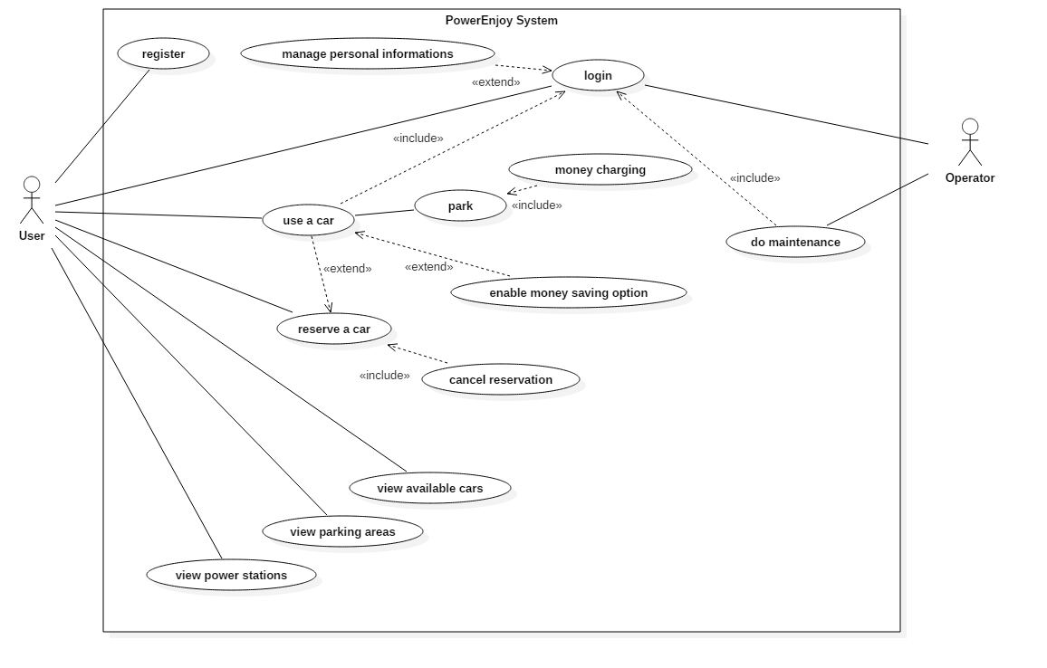

**Use cases description**

**Name**

User registers to the system

**Actors**

User

**Flow of events**

* The user accesses the application on his mobile phone.
* The user fills all the fields, entering his personal data and ID card and driving licence information.
* The user clicks the Confirm Registration button.
* The system validates entered data comparing them with those of the external system and confirms the registration.
* The system sends the password for the login on user email account and mobile phone.

**Exit conditions**

The user is redirected to the login page

**Exceptions**

Entered data for the driving licence is not valid, the system notifies the users and suggests to enter correct data. User is not allowed to register until he enters correct or valid information. The user is already registered

**Name**

User logs in

**Actors**

User

**Entry Conditions**

The user must be already registered to the system

**Flow of events**

* The user opens the loginActivity and enters login data.
* The system validates entered data.

**Exit conditions**

The user has access to the map showing available cars in his area.

**Exceptions**

The user account does not exist, the system notifies the user and suggests to register in case he has not.

**Name**

Manage personal info

**Actors**

User

**Entry Conditions**

The User has been logged in and decided to change the information.

**Flow of events**

* The user Click view the profile
* The user input information if user would like to update profile
* The user click Submit/Update Profile.
* The system notify user by showing a message or through email.

**Exit conditions**

The user has deleted/updated successfully.

**Name**

View available cars on the map

**Actors**

User

**Entry Conditions**

The user is logged in

**Flow of events**

* The system checks user's position using GPS and shows an area around him on the map.
* The application shows a pin corresponding to the position of an available car.
* By clicking on a pin, the details of that car are shown: battery level and position. A button for reserving that car is shown.

**Exit conditions**

The user clicks on the button to reserve a car or on the back button.

**Name**

Use of a car

**Actors**

User

**Entry Conditions**

The user has reserved a car and has reached it within one hour after the reservation.

**Flow of events**

* The user arrives close to the car and notifies the system by clicking the Unlock button.
* The system verifies user position using GPS.
* The system checks the position of the car.
* The system checks the distance and unlocks the car.
* The user opens and starts the car.
* The system checks the number of people inside the car.
* At the end, the user parks the car and stops it.
* The user clicks the End button to inform the system.
* The system validates the position of the car and ensures it is in a safe parking area.
* The user exits the car.
* The system checks car's battery level, distance from special parking areas, charging status (if it is plugged).
* The system calculates the total of the ride and subtracts potential discounts.
* The system entrusts the external payment system to pick up the final amount from the user.
* The system locks the car and marks it as available again.

**Exit conditions**

The system shows the user information about his last trip.

**Exceptions**

The user is not close to the car: the system denies the access to the car and provides a message to the user asking him to get closer in order to unlock. The user is trying to park in a non-safe parking area: the system informs the user that he can't end the reservation and has to move the car in an allowed place. The payment fails due to missing money on the credit card or blocked card. The system receives a failure message and communicates to the user a deadline for the payment and makes the user unable to reserve a car. If the user exceeds the deadline, the system bans the account forever and delegates the problem to a debt collecting company.

**Name**

Allow the user to reserve a car

**Actors**

User

**Entry Conditions**

The user opens the detail of a car on the map

**Flow of events**

* Viewing the details of a car, the user notify that he wants to reserve that car
* The system checks if the car is still available
* The system marks that car as unavailable and start the countdown.
* On the user application sees the countdown, and he can notify that he wants to release the car, or that he arrived close to the car and he want to open it. The car position is still shown.

**Exit conditions**

Countdown starts

**Exceptions**

When the user notifies he want to reserve that car, if it is no longer available a message is shown on the user application.

**Name**

Cancel a reservation

**Actors**

User

**Entry Conditions**

The user views the details of the car he reserved and the countdown

**Flow of events**

* The user notifies that he wants to cancel the reservation of that car
* The system marks that car as available again and stops the countdown
* The user is notified by the system

**Exit conditions**

The user views the map and can reserve another car

**Name**

View Parking Areas

**Actors**

User

**Entry Conditions**

User has logged in.

**Flow of events**

* The user clicks on the button to see parking areas.
* The system shows on the map all the parking areas by highlighting them.

**Exit conditions**

The user has decieded to finish the viewing of parking area by clicking on other buttons.

**Name**

View Power Station

**Actors**

User

**Entry Conditions**

User has logged in.

**Flow of events**

* The user clicks the button to see power stations.
* The system shows on the map all the power stations.
* The user clicks on the pin of one of the areas.
* The system shows a list of the power plugs and their availability.

**Exit conditions**

The user has decided to finished the searching with clicking on other buttons.

**Name**

User chooses money saving mode

**Actors**

User

**Entry Conditions**

The user has entered the car.

**Flow of events**

* The system asks the user for the final destination.
* The user enters the address.
* The system checks entered address and looks for free power plugs in close stations (taking into account the distribution of cars in the city).
* The system shows the result to the user asking for confirmation.
* The user accepts to park in the station selected by the system.
* The system reserves the free power plug.
* The system provides the address and number of the slot reserved for the power supply.

**Exit conditions**

The user sees informations and directions to the slot and the power station.

**Exceptions**

The address entered by the user does not exist or is out of the area: the system informs the user of the error and suggests to retry. The user refuses to park in the suggested station: the system suggests to retry the search to find a better result. No free slots available: the system informs the user that there are no charging slots available, so it suggests the user to retry later.

**Name**

Operator logs in

**Actors**

Operator

**Entry Conditions**

The operator opens the application.

**Flow of events**

* The operator enters login data.
* The system validates entered data.

**Exit conditions**

The operator has access to the list of the cars that need maintenance.

**Exceptions**

The entered data is wrong: the system notifies the operator.

**Name**

Operator does the maintenance on a car.

**Actors**

Operator

**Entry Conditions**

The operator opens the application.

**Flow of events**

* The system provides a list of the cars in need of maintenance.
* The operator chooses a car to fix and notifies the system.
* The system sets the status of the car as assigned.
* The operator reaches the car and fixes it.
* The operator notifies the system that the maintenance has finished.

**Exit conditions**

The car is marked as available by the system.



### **Class Diagram**

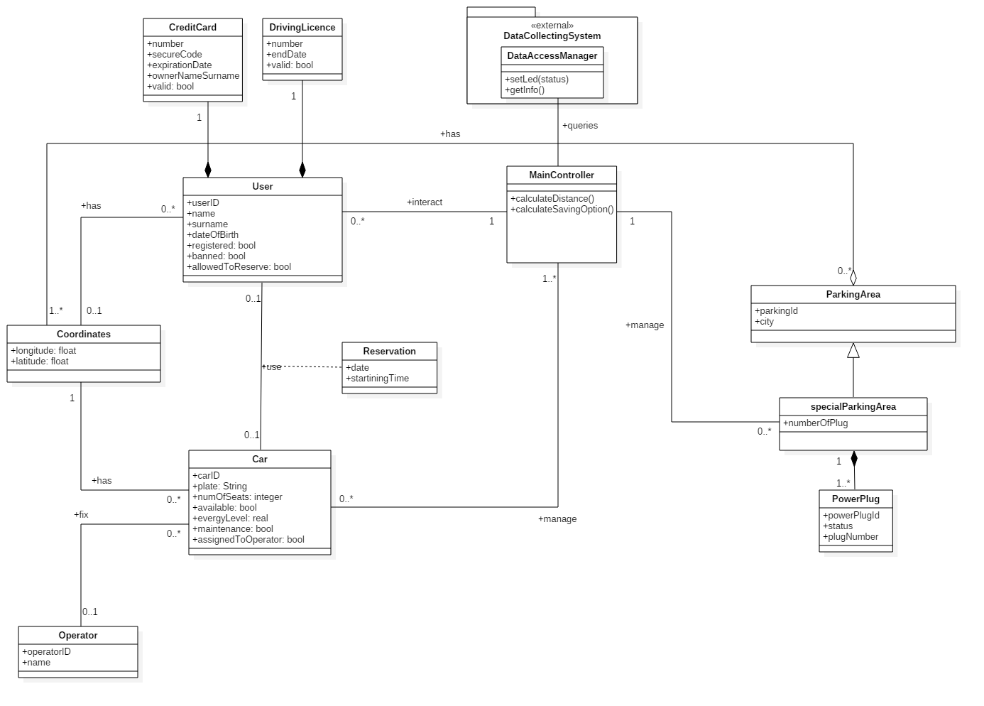

### **Sequence Diagram**

**Start of the use of the car**

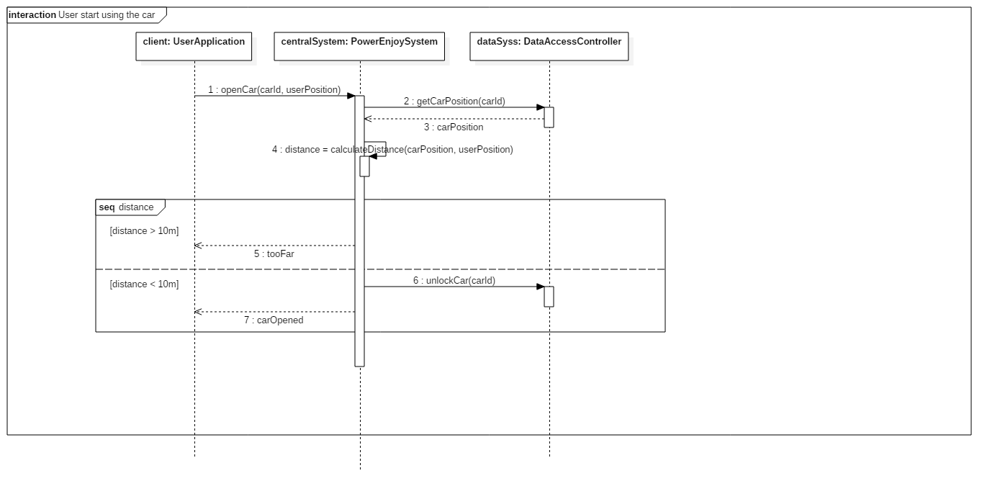

**Money charging**

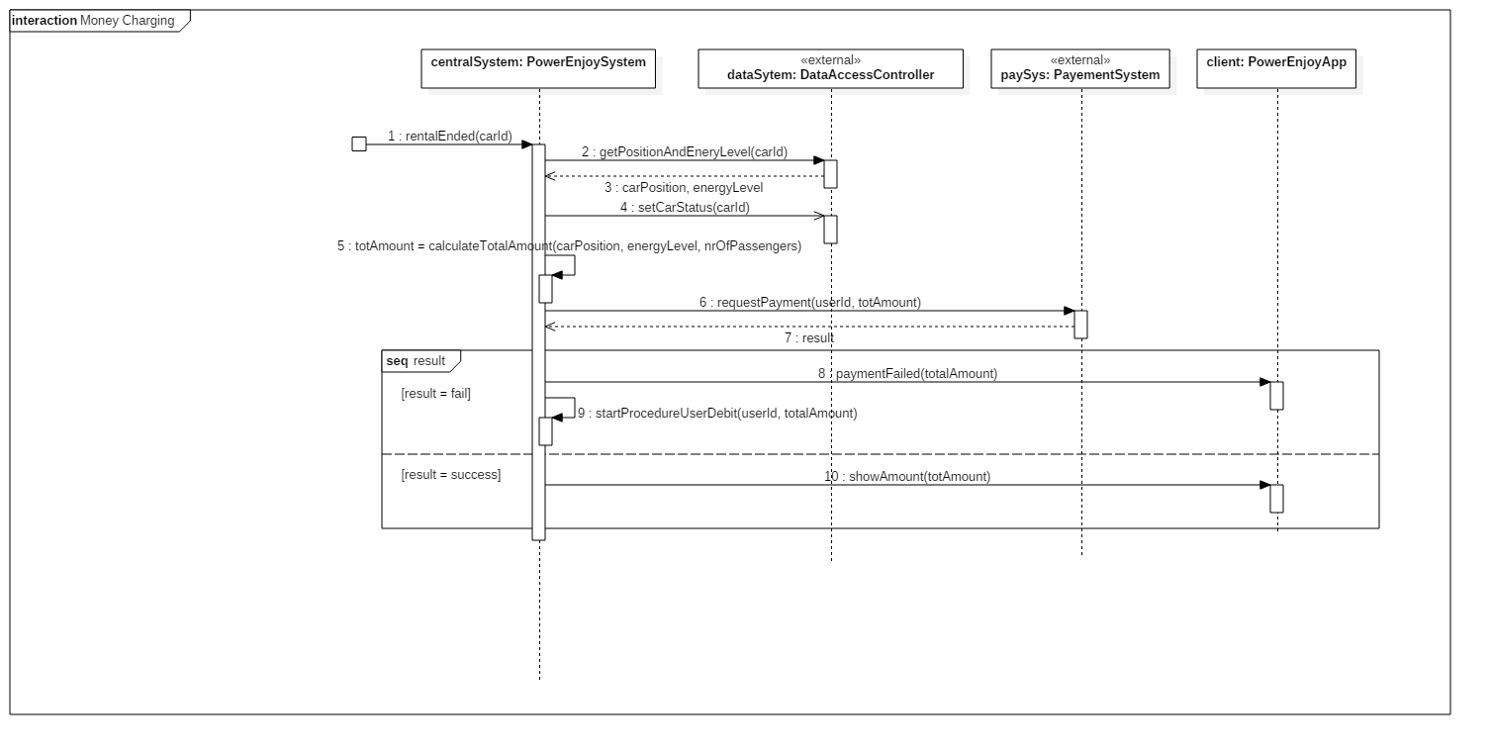

### **Activity Diagram**

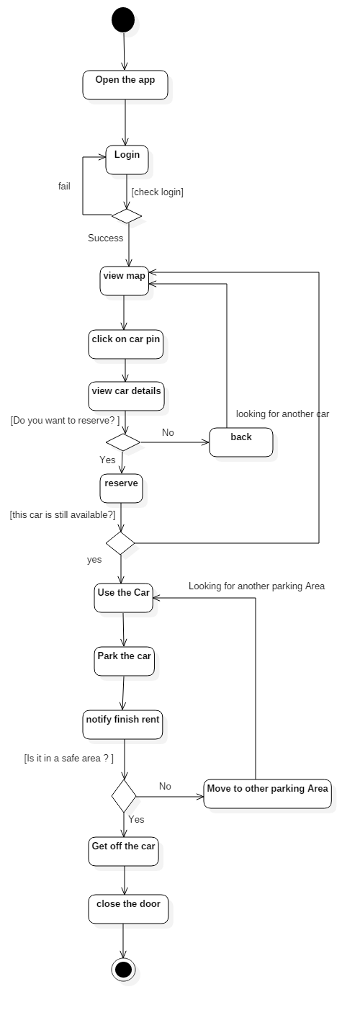

### **State Diagram**

**Car States**

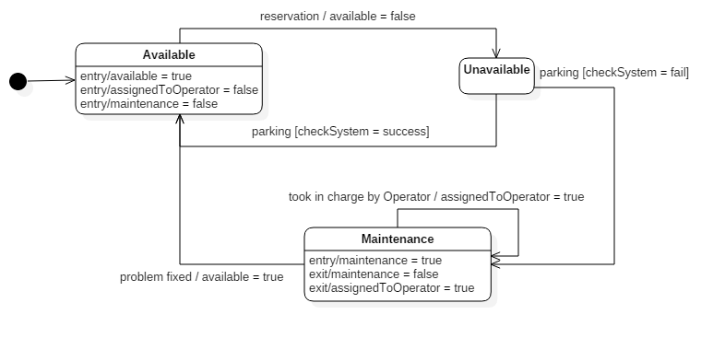

**User States**

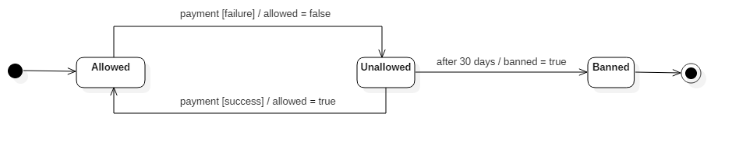

## Proposed System

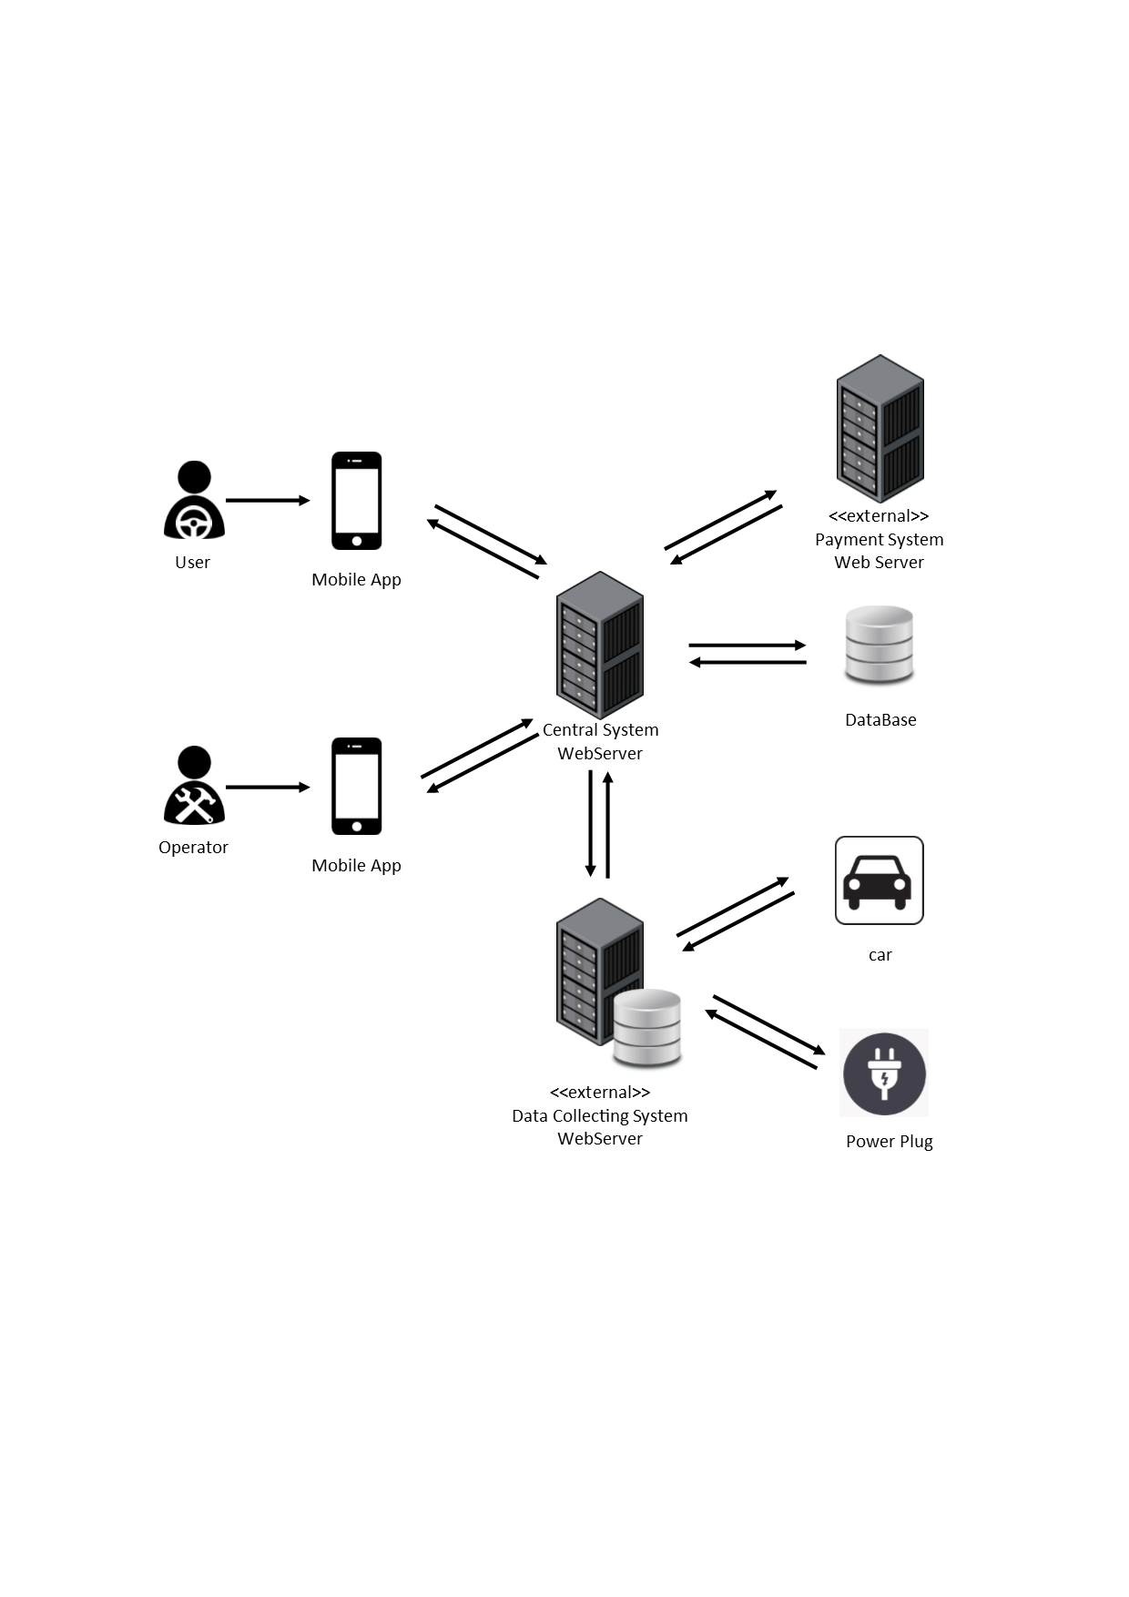

Users and Operators interact with PowerEnjoy System through a mobile application on their smartphones. The PowerEnjoy Central system runs on a WebServer and interacts with the users and operators’ applications, and with two other external Systems: a Payment System for requesting a payment by the user and a Data Collecting System for accessing to cars and power plug information. The PowerEnjoy Central System also queries a database for checking users’ credentials.

## Non Functional Requirements

### **Interfaces**

**User Interfaces**

|  |  |
| --- | --- |
| **Fig. 1** User login | **Fig. 2** User menu |
| **Fig. 3** Map view | **Fig. 4** Car Details |
| **Fig. 5** Reservation countdown | **Fig. 6** Parking Areas view |
| **Fig. 7** Power grid stations view | **Fig. 8** Detail of power grid station |
| **Fig. 9** Final amount charged info |  |

**Operator Interfaces**

|  |  |
| --- | --- |
| **Fig. 10** List of cars with issues | **Fig. 11** Detail of chosen car |

# Appendices

## Alloy Modelling

### **Alloy Code**

open util/boolean

sig Float {}

sig Text {}

abstract sig BatteryLevel {}

sig Low extends BatteryLevel {}

sig High extends BatteryLevel {}

sig Car {

plate: one Text,

seats: Int,

available: one Bool,

batteryLevel: one BatteryLevel,

position: one Coordinates,

maintenance: one Bool,

assocMaintenance: lone Operator,

assignedToOperator: one Bool

} {

seats > 0

seats <= 5

}

sig Coordinates {

longitude: one Float,

latitude: one Float

}

sig Licence {

valid: one Bool

}

sig CreditCard {

valid: one Bool

}

sig FiscalCode {

user: one User

}

sig User {

licence: one Licence,

credit: one CreditCard,

fiscalCode: one FiscalCode,

blocked: one Bool,

banned: one Bool,

position: Coordinates

}

sig Reservation {

user: one User,

car: one Car

} {

user.blocked = False

user.banned = False

user.licence.valid = True

car.available = False

car.batteryLevel = High

car.maintenance = False

}

sig Operator{

assocMaintenance: lone Car

}

one sig PowerEnjoySystem {

users: some User,

operators: some Operator,

cars: some Car,

res: some Reservation,

parkingAreas: some ParkingArea

}

sig ParkingArea{

bounds: set Coordinates,

}

sig SpecialParkingArea extends ParkingArea {

plugs: some PowerPlug

}

sig PowerPlug {

status: one Bool,

plugNumber: Int

}

// FACTS

fact powerEnjoyOwnsAll {

PowerEnjoySystem.users = User

PowerEnjoySystem.operators = Operator

PowerEnjoySystem.cars = Car

PowerEnjoySystem.res = Reservation

PowerEnjoySystem.parkingAreas = ParkingArea

}

fact noReservationWhenMaintenance {

all c:Car | c.maintenance = True => c.available=False

all r: Reservation, c:Car |

c.maintenance = True => r.car != c

all o: Operator, r: Reservation, c:Car |

o.assocMaintenance = c => r.car != c

}

fact noCreditCardwithoutUser {

no c: CreditCard | c not in User.credit

}

fact noBatterywithoutCar {

no b: BatteryLevel | b not in Car.batteryLevel

}

fact allLicencesAreOwned {

User.licence = Licence

}

fact noFiscalCodeWithoutUser {

all f: FiscalCode, u: User |

f = u.fiscalCode <=> u = f.user

}

fact assocMaintenance {

all c:Car, o:Operator |

((o in c.assocMaintenance) <=> (c in o.assocMaintenance))

}

fact userBlockedIfCreditNotValid {

all u: User | u.blocked = True => u.credit.valid = False

}

fact plateIsUniqueForCar {

all c1, c2: Car | c1 != c2 => c1.plate != c2.plate

}

fact usersHaveUniqueFiscalCodeAndLicence {

all u1, u2: User |

u1 != u2 => u1.fiscalCode != u2.fiscalCode

&& u1.licence != u2.licence

}

fact sameReservationDifferentUserAndCar {

all r1, r2: Reservation |

r1 != r2 => r1.user != r2.user && r1.car != r2.car

}

fact lowBatteryCarUnderMaintenanceUnavailable {

all c: Car |

c.batteryLevel in Low => c.maintenance = True

and c.available = False

}

fact noPlugWithoutSpecial {

no p: PowerPlug | p not in SpecialParkingArea.plugs

}

// ASSERTIONS

assert lowbatteryCarCannotBeReserved {

no r: Reservation | r.car.batteryLevel in Low

}

assert lowbatteryCarsAreUnavailable{

all c: Car |

c.batteryLevel in Low => c.available=False

and c.maintenance=True

}

assert UserWithoutCreditCard {

no c: CreditCard | c not in User.credit

}

assert noValidCreditCardWhenTheUserIsBlocked {

all u: User | u.blocked=True => u.credit.valid=False

}

pred show() {

//#PowerEnjoySystem = 1

#ParkingArea = 3

#SpecialParkingArea = 2

#Car = 3

}

run show for 3

check lowbatteryCarCannotBeReserved for 4

check lowbatteryCarsAreUnavailable for 3

check UserWithoutCreditCard for 4

check noValidCreditCardWhenTheUserIsBlocked for 4

### **Alloy Model**

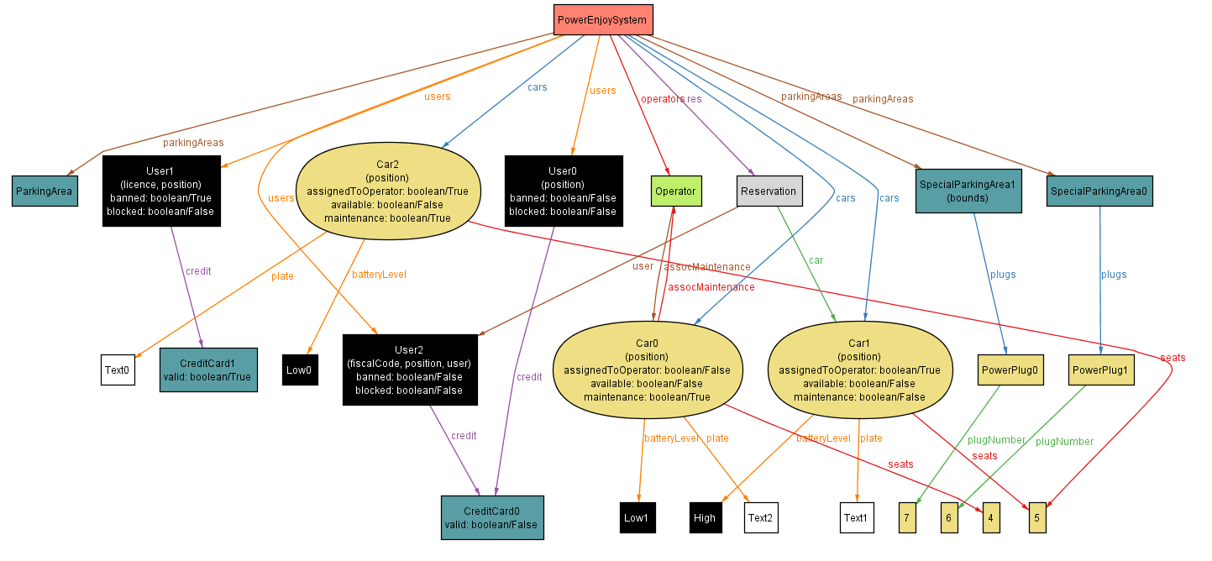

### **Alloy Result**

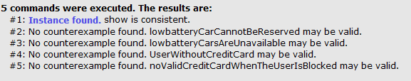

## Used tools

* StarUml: draw of UML diagrams
* git: documentation versioning
* github: online repository
* ReText: writing text and first MarkUp
* Microsoft Word: assembling document and check ortography
* Alloy Analyzer: system modelling
* Balsamiq: drawing mockups
* Asana: progect management - track task

## Hours of work

**Sergio Caprara**

|  |  |
| --- | --- |
| 10/25/2016 | 2 |
| 10/27/2016 | 2 |
| 10/28/2016 | 3 |
| 10/29/2016 | 3 |
| 11/1/2016 | 1 |
| 11/2/2016 | 2.30 |
| 11/3/2016 | 3 |
| 11/4/2016 | 2 |
| 11/5/2016 | 4 |
| 11/6/2016 | 2 |
| 11/7/2016 | 5 |
| 11/8/2016 | 2.30 |
| 11/9/2016 | 4 |
| 11/10/2016 | 1.5 |
| 11/11/2016 | 2.5 |
| 11/12/2016 | 8 |
| 11/13/2016 | 13 |

**Soheil Ghanbari**

|  |  |
| --- | --- |
| 10/25/2016 | 2 |
| 10/26/2016 | 2.30 |
| 10/27/2016 | 1.30 |
| 10/29/2016 | 2.30 |
| 10/30/2016 | 4.30 |
| 11/2/2016 | 3.15 |
| 11/6/2016 | 3.00 |
| 11/9/2016 | 4.30 |
| 11/10/2016 | 2.30 |
| 11/11/2016 | 2.15 |
| 11/12/2016 | 3.45 |
| 11/12/2016 | 11.45 |

**Erica Tinti**

|  |  |
| --- | --- |
| 10/27/2016 | 1.5 |
| 10/28/2016 | 1 |
| 11/2/2016 | 2.5 |
| 11/3/2016 | 1.5 |
| 11/4/2016 | 2 |
| 11/5/2016 | 4 |
| 11/6/2016 | 2 |
| 11/7/2016 | 5.3 |
| 11/8/2016 | 4 |
| 11/9/2016 | 4 |
| 11/10/2016 | 1.5 |
| 11/11/2016 | 2.5 |
| 11/12/2016 | 8 |
| 11/13/2016 | 13 |