

**Software Engineering 2: “PowerEnJoy”**

**Integration Test Plan (V. 1.0)**

Authors:

Sergio CAPRARA

Soheil GHANBARI

Erica TINTI

Milan, Italy

11/01/2017

**Table of contents**

1. Introduction 3

1.1 Revision History 3

1.2 Purpose and Scope 3

1.3 Definitions and Abbreviations 3

1.4 Reference Documents 4

2. Integration Strategy 5

2.1 Entry Criteria 5

2.2 Elements to be Integrated 6

2.3 Integration Testing Strategy 7

2.4 Sequence of Component/Function Integration 8

3. Individual Steps and Test Description 10

3.1 Integration test case I1 10

3.2 Integration test case I2 10

3.3 Integration test case I3 10

3.4 Integration test case I4 11

3.5 Integration test case I5 11

3.6 Integration test case I6 12

3.7 Integration test case I7 13

3.8 Integration test case I8 13

3.9 Integration test case I9 15

3.10 Integration test case I10 16

3.11 Integration test case I11 17

4. Tools and Test Equipment Required 18

4.1 Tools 18

4.2 Test Equipment 18

5. Program Stubs and Test Data Required 19

5.1 Program Stubs and Drivers 19

5.2 Test Data 20

6. Effort Spent 21

# Introduction

## Revision History

|  |  |  |  |
| --- | --- | --- | --- |
| **Version** | **Date** | **Authors** | **Description** |
| 1.0 | 15/01/2017 | S. Caprara, S. Ghanbari, E. Tinti | First release |

## Purpose and Scope

In this document, we are providing details on how the components described in the Design Document will be tested. To ensure that the interaction between them will give the expected results, we are choosing the method to follow and we are keeping in mind that Unit Test will be done before starting the Integration Test phase.

In the following chapters, you will find detailed descriptions of the tests and the name of the tools to be used.

## Definitions and Abbreviations

* **User:** the person registered to the system and allowed to access to its functions.
* **Operator:** a person with technical skills, that fixes car issues.
* **App:** short term used to define a mobile application.
* **Power Plug:** a column with one or more electricity socket where it is possible to charge the car.
* **Safe Area** (or Parking Area): a parking area with parking shared with all the other divers and not especially reserved to PowerEnjoy.
* **Special Parking Area** (or Power Station): a parking area reserved exclusively to PowerEnjoy cars where, for each parking space there is a Power Plug where it is possible to charge a car.
* **Car:** PowerEnjoy car.
* **Reservation:** the relation between a user and a car, that allows the user to start using the car. The reservation guarantees that no one else can reserve and use the reserved car till the end of the rental.
* **DB:** database, the collection of system data.
* **GUI:** Graphic User Interface, the interface that allows the user to interact with the system.
* **RASD:** Requirements Analysis and Specifications Document.
* **DAO:** Data Access Object.
* **DTO:** Data Transfer Object.
* **MVC:** Model-View-Controller, the pattern used for the development.
* **UX:** user experience.
* **GEB:** Green e-Box.

## Reference Documents

The documents used as a reference to provide the design document are:

* Assignments AA 2016-2017.pdf
* Sample Design Deliverable Discussed on Nov. 2.pdf
* IEEE Standard for IT – System Design – Software Design Description
* Structure of the design document
* Paper on the green move project.pdf
* Second paper on the green move project.pdf

# Integration Strategy

## Entry Criteria

Before starting the Integration testing phase, two conditions must meet:

* the Integration Test Plan document should be complete, so that the approach for integration testing will be clear,
* classes and methods involved in the integration tests must be completely developed and unit tested successfully.

In this way we can ensure that the produced results are meaningful and in the meanwhile we can accelerate the process without waiting that each class and method of the component in testing are completed, but at least the minimum amount of functionality to allow the integration work.

## Elements to be Integrated

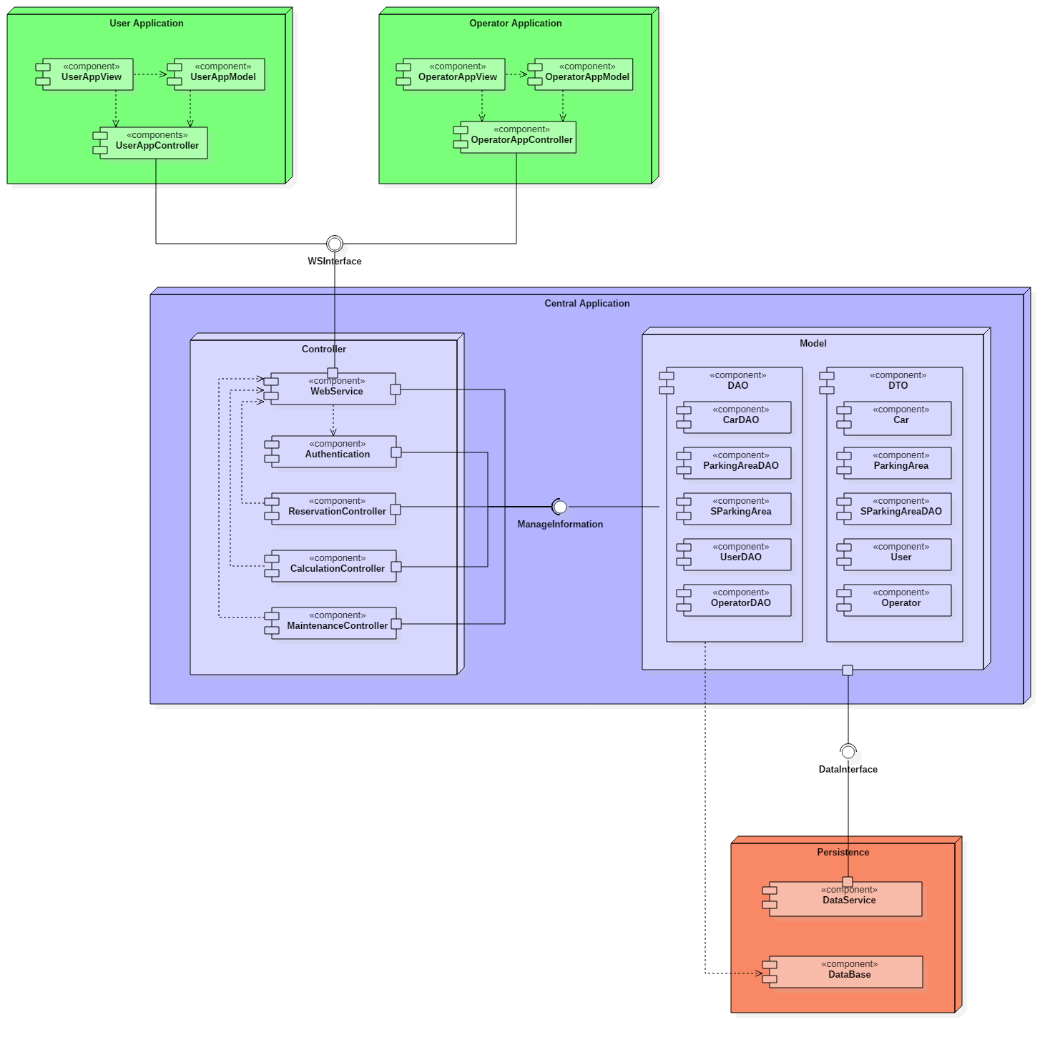

Our system has many components, organised in two levels of granularity.

The higher level of components of our system that need to be integrated are:

* User Application
* Operator Application
* Controller
* Model
* Database

The listed components are divided into lower level components, that will need integration testing.

More in detail, the Controller is composed by WebService, Authentication, Maintenance Controller, Reservation Controller, Calculation Controller.

The Model has DAO components and some Pojo component. The last one doesn’t need to be considered for integration. Note that DAO components won’t be unit tested.

Data low level components are the DataService and the Database.

Concerning the two mobile applications, we will only integrate the User App Controller and Operator App Controller with the rest of the system.

## Integration Testing Strategy

Following the “called by” concept, we defined a component hierarchy having the data components at the bottom, DAO components on a higher level, the controllers upon them and finally the mobile application. The figure in ***$2.4*** shows the diagram obtained.

The bottom-up approach has been chosen for testing the integration among components: tests will proceed starting from the bottom of the hierarchy and moving to the top on each step.

Due to the many critical points of our system, this strategy represents for us a safer way for testing and an easier method for finding and correcting software faults.

This approach will include the use of drivers, as discussed in ***$5.1***, for the case in which a component is ready to be tested and its direct parent is not completely written yet.

## Sequence of Component/Function Integration

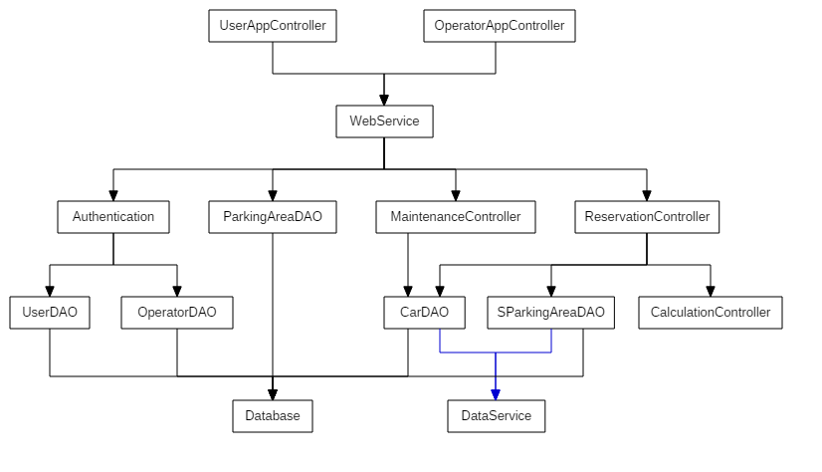

In the following table we provide the list of integration tests required.

|  |  |  |
| --- | --- | --- |
| **ID** | **Integration Test** | **Paragraph** |
| **I1** | UserDAO → Database | 3.1 |
| **I2** | OperatorDAO → Database | 3.2 |
| **I3** | ParkingAreaDAO → Database | 3.3 |
| **I4** | CarDAO → Database  CarDAO → DataService | 3.4 |
| **I5** | SParkingAreaDAO → Database SParkingAreaDAO → DataService | 3.5 |
| **I6** | Authentication → UserDAO  Authentication → OperatorDAO | 3.6 |
| **I7** | MaintenanceController → CarDAO | 3.7 |
| **I8** | ReservationController → CarDAO  ReservationController → SParkingAreaDAO  ReservationController → CalculationController | 3.8 |
| **I9** | WebService → Authentication  WebService → ParkingAreaDAO  WebService → MaintenanceController  WebService → ReservationController | 3.9 |
| **I10** | UserAppController → WebService | 3.10 |
| **I11** | OperatorAppController → WebService | 3.11 |

# Individual Steps and Test Description

The following paragraphs contain the detail of the Test Cases defined in the previous chapter.

## Integration test case I1

|  |  |
| --- | --- |
| **Test Case Identifier** | I1T1 |
| **Test Item(s)** | UserDAO → Database |
| **Input Specification** | User |
| **Output Specification** | The database correctly performs the required action. |
| **Purpose** | Test select, update, insert and delete operations required from the DAO on the database. |
| **Dependencies** | N/A |

## Integration test case I2

|  |  |
| --- | --- |
| **Test Case Identifier** | I2T1 |
| **Test Item(s)** | OperatorDAO → Database |
| **Input Specification** | Operator |
| **Output Specification** | The database correctly performs the required action. |
| **Purpose** | Test select, update, insert and delete operations required from the DAO on the database. |
| **Dependencies** | N/A |

## Integration test case I3

|  |  |
| --- | --- |
| **Test Case Identifier** | I3T1 |
| **Test Item(s)** | ParkingAreaDAO → Database |
| **Input Specification** | ParkingArea |
| **Output Specification** | The database correctly performs the required action. |
| **Purpose** | Test select, update, insert and delete operations required from the DAO on the database. |
| **Dependencies** | N/A |

## Integration test case I4

|  |  |
| --- | --- |
| **Test Case Identifier** | I4T1 |
| **Test Item(s)** | CarDAO → Database |
| **Input Specification** | Car |
| **Output Specification** | The database correctly performs the required action. |
| **Purpose** | Test select, update, insert and delete operations required from the DAO on the database. |
| **Dependencies** | N/A |

|  |  |
| --- | --- |
| **Test Case Identifier** | I4T2 |
| **Test Item(s)** | CarDAO → DataService |
| **Input Specification** | Car |
| **Output Specification** | The information of the required car is provided. |
| **Purpose** | Verify that the DataService can correctly get information on the required car. |
| **Dependencies** | N/A |

## Integration test case I5

|  |  |
| --- | --- |
| **Test Case Identifier** | I5T1 |
| **Test Item(s)** | SParkingAreaDAO → Database |
| **Input Specification** | SpecialParkingArea |
| **Output Specification** | The database correctly performs the required action. |
| **Purpose** | Test select, update, insert and delete operations required from the DAO on the database. |
| **Dependencies** | N/A |

|  |  |
| --- | --- |
| **Test Case Identifier** | I5T2 |
| **Test Item(s)** | SParkingAreaDAO → DataService |
| **Input Specification** | Request for the reservation of a power plug of a certain special parking area. |
| **Output Specification** | The DataService provides the correct response and reserves the designated power plug for the specified power station. |
| **Purpose** | Test the correct reservation of the power plug in the special parking area sent as an input. |
| **Dependencies** | N/A |

## Integration test case I6

|  |  |
| --- | --- |
| **Test Case Identifier** | I6T1 |
| **Test Item(s)** | Authentication → UserDAO |
| **Input Specification** | User |
| **Output Specification** | The DAO correctly verifies information entered for the authentication. |
| **Purpose** | Ensure that the request from the Authentication controller to the DAO receives the right feedback. |
| **Dependencies** | Test Case I1T1 succeeded. |

|  |  |
| --- | --- |
| **Test Case Identifier** | I6T2 |
| **Test Item(s)** | Authentication → OperatorDAO |
| **Input Specification** | Operator |
| **Output Specification** | The DAO correctly verifies information entered for the authentication. |
| **Purpose** | Ensure that the request from the Authentication controller to the DAO receives the right feedback. |
| **Dependencies** | I2T1 succeeded. |

## Integration test case I7

|  |  |
| --- | --- |
| **Test Case Identifier** | I7T1 |
| **Test Item(s)** | MaintenanceController → CarDAO |
| **Input Specification** | Car |
| **Output Specification** | The DAO handles all the incoming requests from the MaintenanceController and can provide the correct answer. |
| **Purpose** | Verify the functions that:   * get the list of cars that need maintenance, * set the status of a car under maintenance, * perform the end of the maintenance request. |
| **Dependencies** | Test Case I4T1 succeeded. |

## Integration test case I8

|  |  |
| --- | --- |
| **Test Case Identifier** | I8T1 |
| **Test Item(s)** | ReservationController → CarDAO |
| **Input Specification** | Car |
| **Output Specification** | The DAO handles all the incoming requests from the ReservationController and can provide the correct answer. |
| **Purpose** | Verify the functions that:   * get the list of the available cars, * set the status of a car in use, * set the status of a car as available after release. |
| **Dependencies** | I4T1 succeeded. |

|  |  |
| --- | --- |
| **Test Case Identifier** | I8T2 |
| **Test Item(s)** | ReservationController → SParkingAreaDAO |
| **Input Specification** | SpecialParking, PowerPlug |
| **Output Specification** | The DAO handles all the incoming requests from the ReservationController and can provide the correct answer. |
| **Purpose** | Verify the functions that:   * get the list of the available power plugs in the special parking areas, * set the status of a power plug and confirm the reservation. |
| **Dependencies** | I5T1 succeeded. |

|  |  |
| --- | --- |
| **Test Case Identifier** | I8T3 |
| **Test Item(s)** | ReservationController → CalculationController |
| **Input Specification** | ReservationInfo |
| **Output Specification** | The CalculationController can provide the expected response to the incoming request. |
| **Purpose** | Verify that the result provided by the CalculationController is correct for the entered parameters. |
| **Dependencies** | N/A |

## Integration test case I9

|  |  |
| --- | --- |
| **Test Case Identifier** | I9T1 |
| **Test Item(s)** | WebService → Authentication |
| **Input Specification** | User or Operator, Request |
| **Output Specification** | The WebService sends the correct request to the Authentication controller and gets the expected response. |
| **Purpose** | Verify that the Authentication controller can correctly verify the entered authentication information for both the user and the operator.  Ensure that the controller can also correctly perform the registration of a new user (new operator not allowed). |
| **Dependencies** | I6T1 and I6T2 succeeded. |

|  |  |
| --- | --- |
| **Test Case Identifier** | I9T2 |
| **Test Item(s)** | WebService → ParkingAreaDAO |
| **Input Specification** | None |
| **Output Specification** | The DAO provides the list of the parking areas. |
| **Purpose** | Test the initialization of the parking areas. The DAO should get the correct information on the database and should return the list of all the parking areas. |
| **Dependencies** | I3T1 succeeded. |

|  |  |
| --- | --- |
| **Test Case Identifier** | I9T3 |
| **Test Item(s)** | WebService → MaintenanceController |
| **Input Specification** | OperatorRequest |
| **Output Specification** | The MaintenanceController correctly interprets the request made by the WebService. |
| **Purpose** | Test the functions through which the operator can:   * take in charge a car for maintenance, * set a car as repaired and ready to use. |
| **Dependencies** | Test Case I7T1 succeeded. |

|  |  |
| --- | --- |
| **Test Case Identifier** | I9T4 |
| **Test Item(s)** | WebService → ReservationController |
| **Input Specification** | UserRequest |
| **Output Specification** | The ReservationController correctly interprets the request made by the WebService. |
| **Purpose** | Test the functions through which the user can:   * request for a reservation, * request a power plug, * release a car. |
| **Dependencies** | I8T1, I8T2, I8T3 succeeded. |

## Integration test case I10

|  |  |
| --- | --- |
| **Test Case Identifier** | I10T1 |
| **Test Item(s)** | UserAppController → WebService |
| **Input Specification** | User, Request |
| **Output Specification** | The WebService dispatches correctly the Request and provides the expected result. |
| **Purpose** | Verify that the Controller can send requests to the WebService and can get the correct response, for the functions to:   * register a new user, * authenticate an already registered user, * reserve a car, * end the use of a car. |
| **Dependencies** | I9T1 and I9T4 succeeded. |

## Integration test case I11

|  |  |
| --- | --- |
| **Test Case Identifier** | I11T1 |
| **Test Item(s)** | OperatorAppController → WebService |
| **Input Specification** | Operator, Request |
| **Output Specification** | The WebService dispatches correctly the Request and provides the expected result. |
| **Purpose** | Verify that the Controller can send requests to the WebService and can get the correct response, for the functions to:   * authenticate an existing operator, * take in charge a car, * end the maintenance of a car. |
| **Dependencies** | I9T1 and I9T3 succeeded. |

# Tools and Test Equipment Required

## Tools

For supporting and automatize Integration Tests we will use 2 testing tools: JUnit and Arquillian.

Junit is a famous Java framework for performing unit tests but it also can be used for performing integration test. In particular, it is useful to easily check the result returned by methods and it will be used by us for writing drivers..

Arquillian is an integration testing framework, available for JVM, that seamlessly integrates with Junit, that we also use for unit test. This framework give the possibility to run test directly in the container, and this guarantees us to perform a more realistic test. Handling all aspects of test execution, Arquillian makes the integration testing phase simpler for example making easier to manage the container lifecycle, deploying the archive to test and capturing results and failures.

Even if we are using some automathed testing tool, we can not avoid to perform manual test too. In particular, manual test is useful to evaluate usability and reactivity of the system by the mobile application, and the interaction with user interface.

## Test Equipment

We have already discussed the fact that our system is based on a client-server architecture.

For testing the central application (consisting in the server side of the system) we will deploy it on a machine explicitly made for working on integration tests and that we define as Testing Server.

The client side consists of the two mobile applications developed for users and operators. The tests will be made using a set of different smartphones, based on the Android and iOS operating systems.

On those devices, we will deploy the mobile applications and the set of tests will be completely run on all of them, by interacting with the Testing Server.

We may consider devices with different versions of the operating system installed, to make sure that the application correctly runs on all of them.

# Program Stubs and Test Data Required

## Program Stubs and Drivers

For the integration testing of our system we decided to adopt a bottom-up approach. Because of this, we won’t need any program stub, but we will only use the drivers listed here:

* **UserDAO Driver**, **ParkingAreaDAO Driver**, **OperatorDAO Driver**: the modules will make calls to the methods of the **UserDAO**, **ParkingAreaDAO** and **OperatorDAO** components, to test their interaction with the **Database**.
* **CarDAO Driver**, **SParkingAreaDAO Driver**: these two modules will invoke the methods exposed by the **CarDAO** and **SParkingAreaDAO** components, for the interaction with the **DataService**. As a recall, the DataService provides a way to make possible the interaction between our system and the system installed on cars and power plugs.
* **Authentication Driver**: the driver module should call the methods of the **Authentication** component to test its interaction with the **UserDAO** and the **OperatorDAO**.
* **MaintenanceController Driver**: this module will invoke the methods exposed by the **MaintenanceController** component to test its interaction with the **CarDAO** component.
* **ReservationController Driver**: this driver will call the methods used by the **ReservationController** component for the interaction with the **CarDAO**, **SParkingAreaDAO** and **CalculationController** components.
* **WebService Driver**: the module should invoke all the methods defined in the **WebService** for the interaction with the **Authentication**, **ParkingAreaDAO**, **MaintenanceController** and **ReservationController** components.
* **UserAppController Driver**, **OperatorAppController Driver**: the drivers will invoke the methods of the **UserAppController** and **OperatorAppController** for their interaction with the **WebService** component.

Drivers are not to be used for testing the integration between **DAO components** and the **Database**.

## Test Data

The Database needs to be filled with meaningful data in order to run tests and tools should be used to avoid wasting time writing one record at a time for all the tables.

**IBM DB2 Test Database Generator** is a tool provided by IBM that can be used for generating data. It allows the definition of:

* the structure of the table,
* constraints on how the data should be generated,
* the output format (SQL, CSV, XML).

Using this tool will be helpful as it will accelerate the testing phase.

Integration tests should also verify the responses of the system in specific cases, such as:

* Null parameters in method call,
* invalid login credentials (User or Operator),
* invalid register information (applies to Users),
* User or Operator with an expired driving licence,
* Car parked outside of the valid Parking Area,
* Reservation of a Car that has already been reserved,
* Payment refused.

More detailed information can be found in the description of the Test Cases, provided in chapter 3.

# Effort Spent

To make this document we have spent:

* Sergio Caprara, 14 hours
* Soheil Ghanbari, 5 hours
* Erica Tinti, 14 hours