**New Codington City Project -   
Use Case Diagram and User Scenarios**

**Project:** New Codington City

**System:** Festival Event Registration System – Release 1

Table of Contents

1 Overview 2

2 Use Case Model – Release 2 3

2.1 Use Case Diagram 3

2.2 Use Case Inventory 4

2.3 Actors 5

3 User Scenarios – Release 2 5

# Overview

This document will show a detailed set of Use Case diagrams to describe interactions between the Use Cases defined for the system and the actors. In addition, Use Cases with human interaction will be organised and sequenced to show the order in which they are performed to complete user tasks.

# Use Case ModeL – Release 1

## Use Case Diagram

**Festival Event Registration System**

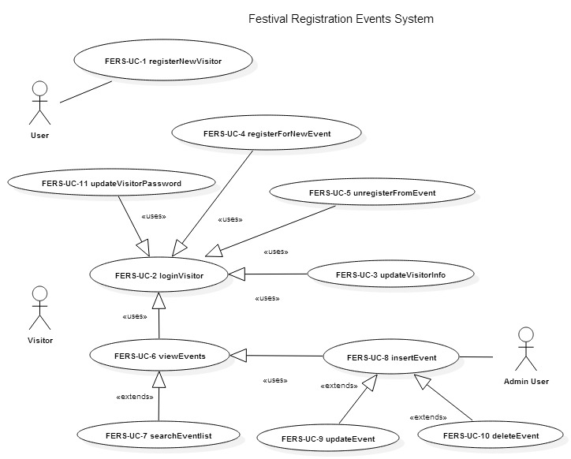

## Use Case Inventory

**Release 1**

|  |  |  |  |
| --- | --- | --- | --- |
| **Use Case ID** | **Use Case Name** | **Description** | **Relationship** |
| **FERS_UC_1** | registerNewVisitor | This Use Case describes the process of a User registering as a Visitor on FERS in order to view, register for and unregister from local events. | None |
| **FERS_UC_2** | loginVisitor | This Use Case describes the process of a Visitor logging into FERS. | None |
| **FERS_UC_3** | updateVisitorInfo | This Use Case describes the process of a logged in Visitor updating their personal information stored on FERS. | A Visitor must be logged in to update their personal information. |
| **FERS_UC_4** | registerForNewEvent | This Use Case describes the process of a logged in Visitor registering for an event. The event has to have seats available and the visitor has to have not registered for it previously. | A Visitor must be logged in to register for an event. |
| **FERS_UC_5** | unregisterFromEvent | This Use Case describes the process of a logged in Visitor unregistering from an event. | The Visitor must be currently registered for the event. |
| **FERS_UC_6** | viewEvents | This Use Case describes the process of a logged in visitor being able to view the list of events in the Festival Portal and also in the Event Catalog pages. | A Visitor must be logged in to view Events. |
| **FERS_UC_7** | searchEventlist | This Use Case describes the process of a logged in visitor being able to view and search the list of events in the Festival Portal and Event Catalog pages. Events can be searched using the search text box and the button. | A Visitor must be logged in to view Events. |
| **FERS_UC_8** | insertEvent | This Use Case describes the process of a logged in admin visitor being able to insert events in the Festival Portal. | An Admin Visitor must be logged in to insert Events. |
| **FERS_UC_9** | updateEvent | This Use Case describes the process of a logged in admin visitor being able to update events in the Festival Portal. | An Admin Visitor must be logged in to update Events. |
| **FERS_UC_10** | deleteEvent | This Use Case describes the process of a logged in admin visitor being able to delete events in the Festival Portal. | An Admin Visitor must be logged in to delete Events. |
| **FERS_UC_11** | updateVisitorPassword | This Use Case describes the process of a logged in Visitor updating their password stored on FERS. | A Visitor must be logged in to update their password. |

## Actors

**Release 1**

|  |  |
| --- | --- |
| **Actor/ System** | **Description** |
| **FERS** | Festival Event Registration System. The system that executes all the operations for visitor and event registration. |
| **User** | A potential customer to the site, but does not have a visitor account and can't log into FERS. Can only register for a visitor account on the site. |
| **Visitor** | A Visitor is a registered user of the website. |
| **Admin User** | An Admin User is an registered user of the website who can insert, update and delete events |

# User Scenarios – Release 2

**Release 1**

|  |  |  |  |
| --- | --- | --- | --- |
| **Scenario** | **Name** | **Persona** | **Description** |
| **FERS_SC_1** | Visit FERS and register to gain access. | John Doe (User) | John visits FERS and realizes the only option is to login or to register. John chooses to register and fills out all of his personal information (including login credentials) to access the site. |
| **FERS_SC_2** | Login to FERS, register for an event. | John Doe (Visitor) | John logs in to FERS. John goes to the main page, where he can see his personal information, the events he has already registered for, and a list of upcoming events. John finds an event that he is interested in and registers. |
| **FERS_SC_3** | Login to FERS, unregister from an event, and register for another event. | John Doe (Visitor) | John logs in to FERS. John goes to the main page, where he can see his personal information, the events he has already registered for, and a list of the upcoming events. John finds an event that he is interested in and realizes the time conflicts with an event he already registered for. John unregisters from the conflicting event and registers for the event he is interested in. |
| **FERS_SC_4** | Login to FERS, update personal information | John Doe (Visitor) | John logs in to FERS. John goes to the main page, where he can see his personal information, and decides he wants to update some of his information. He goes to the Update Visitor information page, makes a few changes in the form and saves them. |
| **FERS_SC_5** | Login to FERS, View Events (in Festival Portal or Event Catalog page) and Search for an Event | John Doe (Visitor) | John logs in to FERS. John goes to the main page, where he can see his personal information, the events he has already registered for, and a list of the upcoming events. John wants to search for an event that he is interested in and uses the search text box/button to search for the event.  John could also use the Search Events list, by clicking on the Events Catalog page and once in Events Catalog page, sees a list of upcoming events. John wants to search for an event that he is interested in and uses the search text box/button to search for the event. |
| **FERS_SC_6** | Login to FERS, View Events (in Festival Portal or Event Catalog page) and Sort the list of Events | John Doe (Visitor) | John logs in to FERS. John goes to the main page, where he can see his personal information, the events he has already registered for, and a list of the upcoming events. John can then sort the event list by using up or down arrows to view a sorted list of events.  John also could use the Sort Events functionality, by clicking on the Events Catalog page and once in the Events Catalog page, sees a list of upcoming events. John can then sort the event list by using up or down arrows to view a sorted list of events. |
| **FERS_SC_7** | Login to FERS, Insert Events (in Festival Portal or Event Catalog page) | John Doe (Admin User) | John logs in to FERS. John goes to the main page, where he can see his personal information, the events he has already registered for, and a list of the upcoming events. John can then sort the event list by using up or down arrows to view a sorted list of events.  John also could use the Add Events functionality, by clicking on the Events Catalog page. John can then view the new inserted event on event list. |
| **FERS_SC_8** | Login to FERS, Delete Events (in Festival Portal or Event Catalog page) | John Doe (Admin User) | John logs in to FERS. John goes to the main page, where he can see his personal information, the events he has already registered for, and a list of the upcoming events. John can then sort the event list by using up or down arrows to view a sorted list of events.  John also could use the Delete Events functionality, by clicking on the Events Catalog page. John can then view the event is deleted on event list. |

**Note**:

* Persona – John Doe is a registered visitor who interacts with the system. Refer to the Personas document.
* User Scenario Steps can also be documented. This will help in creating the Sequence Diagrams. Refer to the Interaction diagram deliverables for the respective Use Cases.