../.models/dae_ssim_v2_masks.keras (deleted)
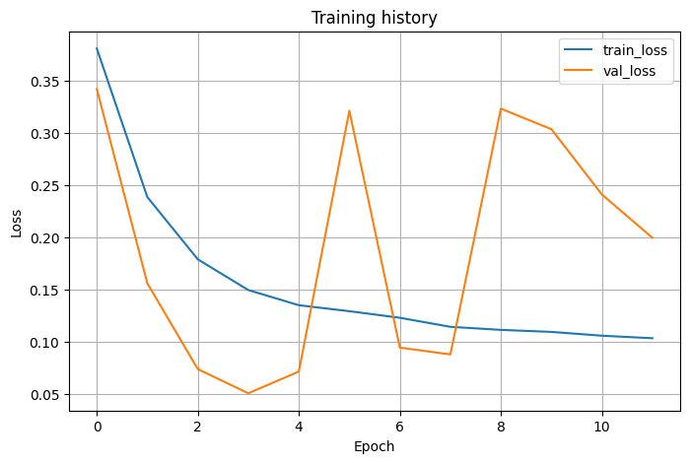
Typo with the val set:
train_ds = create_dataset(train_img_paths, train_mask_paths, shuffle=True,)
val_ds = create_dataset(val_mask_paths, val_mask_paths, shuffle=False,)

../.models/ v2_dae_mae_mask.keras
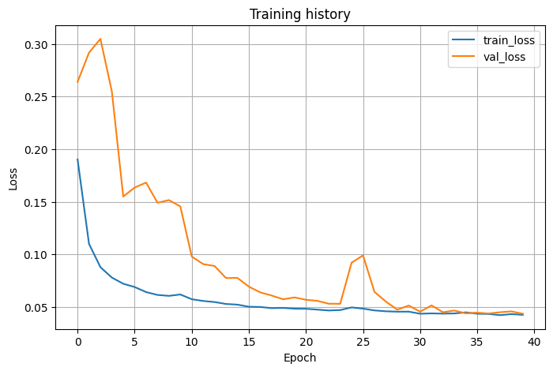

v3_dae_mae_ssim_mask:
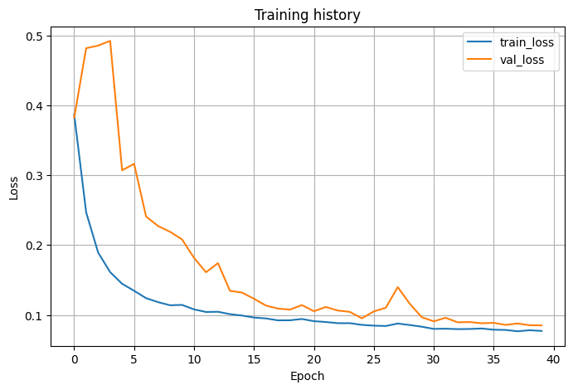

v3_1_dae_mae_mask_ssim_unmask
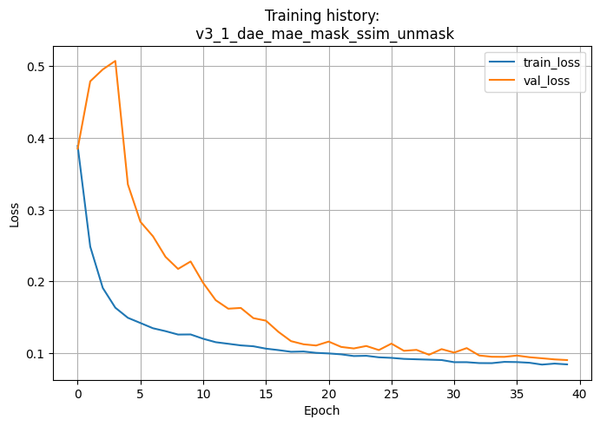

v4_dae_mae_ssim_weight04_mask → weight 0.40
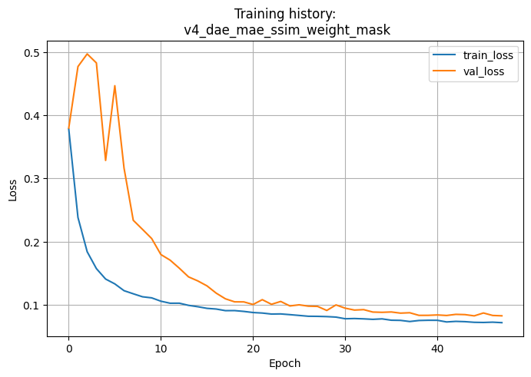

v4_dae_mae_ssim_weight07_mask → weight 0.70
