../.models/dae_ssim_v2_masks.keras
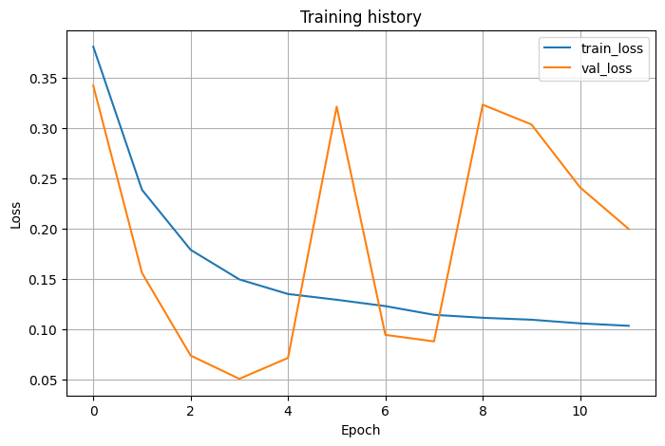
Typo with the val set:
train_ds = create_dataset(train_img_paths, train_mask_paths, shuffle=True,)
val_ds = create_dataset(val_mask_paths, val_mask_paths, shuffle=False,)

../.models/dae_ssim_v2-1_masks.keras
