**Assignment 5 – Programming Fundamentals**

**New Group 6**

**Chun Che Wu  
Sergio Cutrim Gouveia  
Vinicius Picossi Teruel**

**April 14th, 2024**

Following the instructions we created a folder called Java-Assignment5. Inside the folder is our java file as the print shows:

In order now, is the creation of each part of the Assignment according to Instructions (number of items expressed below), above we had item 1 and 2a

Inside the main, we created the public main (Item 2b):

Item 3 requests the creation of Studemt.java which can be seen in the first print we put here, but again it is below:

Item 3a is the public class Student that is in the above print. We also have not created main in this one as requested in item 3b.

Part1: Student.java

Item 1 is creating the 6 private properties.

Item 2 is creating a class with 4 parameters (letters a to d):

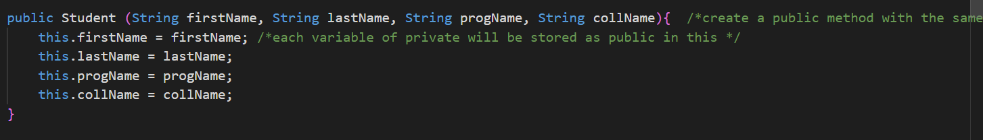

Item 3 is creating a class with 6 parameters (letters a to f):

Item 4 is creating the same one but without parameters:

Item 5 request to create getters and setter for all the class (letters a and b):

We only put the first 2 in here just to exemplify.

Item 6 requests to create a new method to calculate the average of the student:

Item 7 is to create a method to print the user’s grade based on grades from A to F that depend on the value they reached.

Part2 – Main Java

Item 1 a, b, c

We created student 1 with the 4 values, student2 with the 6 values and student3 received each one using setter after it was started as empty.

Item 2 calling the print for each of the 3 students:

Below is the print of the 2 first ones

Item 3 requests to set a new value for mark1 and mark2 for each of the students:

Item 4 is to calculate the average and find a way to print the average of the students:

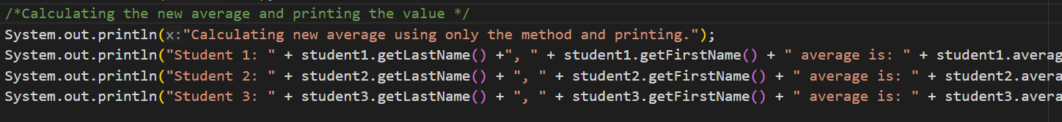

The result of each of the lines:

Item 5 is to create a new student and request the user to input the information and in the end calculate the average and print

And the result for a generic student:

Item 6 requests to encapsulate the code with a try and catch which can be seen in the first print and now the closure with catch:

