Human Task Management Client
for the Android Platform

Sergio Enriquez
Andrew Hays

Contents
Introduction 2
Overview 2
Navigation 2
Application Processes 3
Database organization 3
Web Client 4
User Interface 4
Use Cases 11
Conclusion 12

Introduction
This purpose of the project given to the creators was to create an application that could interface with a Human Task Management (HTM) server via Representation State Transfers (REST). This specific project focused on creating the application using the Android Mobile framework from Google built on top of Oracle's Java SDK. REST requests can be defined as sending an HTTP request (GET, POST, PUT, DELETE, etc.) to a server at a specific URI for the object you are looking for (i.e. /posts/1 might select a post with an id of 1), providing any specific data that may be required for modifying the structure (as in the case of POST and PUT).

The Android project focused on providing a unique and useful User Interface for the end user to be able to view and modify any accounts and tasks that exist on the server. Users are required to pass in credentials to access this data on the server so that all data is secure.

Using REST, caching techniques on the phone, and Android's unique mobile presentation, the creators developed a first-look at what a possible user interface implementation of this project might be. The following sections describe how each area of the application was developed in regards to this project.
The REST application was developed for use on smartphones running the android operating system. It was developed using java and makes use of the android 2.2 development framework. Local data storage is handled by storing this information in a local database using the SQLite library that is included on the standard framework.

Overview
The application is organized around five activities which represent the screens that are presented to the user. Each activity has its own separate GUI screen, menu options, context options pop-up, and may invoke another activity to change the current screen displayed. When the application is run for the first time, the ‘Select User’ activity will be the first to be loaded and displayed. If a user wishes to navigate to a different screen, the current activity will create an ‘Intent’ object containing context data and signal to the operating system that a new activity should be launched to handle this intent.
Should the user switch to a different application, the operating system will send a signal to the application so it can store its current state and context information. Once the application is launched again, it will first check to see if there is context data saved from a previous session, in which case it will restore the application to the state it was before it was closed.

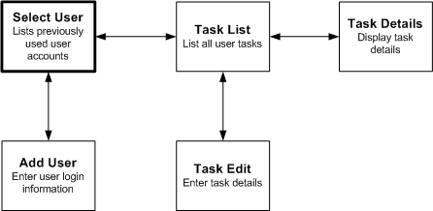
Figure 1

Navigation
With the exception of the user or task editing screens, the activities are based on the use of list items to display information to the user. By clicking on a list item, the application will launch the appropriate activity to display information on this object, and by clicking and holding down on an item, a context menu will be displayed giving the option to edit or delete the selected object. Every screen also includes an respective option menu that can be seen by pressing the ‘menu’ key on the phone.
From the ‘select user’ screen, a user may select a previously used login account or go to the ‘add user’ activity where a new user record can be created by storing the login credentials needed. Once a user is selected, the ‘task list’ activity will be launched in order to display a list of all the cached tasks for this user. From this activity, after clicking on a task item the ‘task details’ activity will be launched in order to display all the stored task information. If the user clicks and holds a selected task item, a context menu will be displayed and it will give the option to delete a task or edit it.
In every activity, a user may return to the original caller by pressing the ‘back’ button on the phone, or by swiping the finger across the screen from right to left. If the user was in the middle of creating a new user or task record, this will discard the current changes. If the user swipes the finger across the screen from left to right while on the user or task list screens, the application will handle this as if the user had clicked on the last previously selected list item.

Application Processes
In order to simplify the application development, a single interface class was created to handle the functions of accessing or modifying the user and task data. The ‘Data Handler’ class is used by the five main activities in the application whenever it is necessary to retrieve a list of cached users or task details, or when one needs to modify these records. Whenever possible this handler will first try to load the data from the local cache by passing on the request to the ‘Database Handler’ class, if the requested data could not be found or the records are too old, then the Data Handler will then pass the request to the ‘Web Client ‘class to retrieve the data from the server and then place it into local storage.
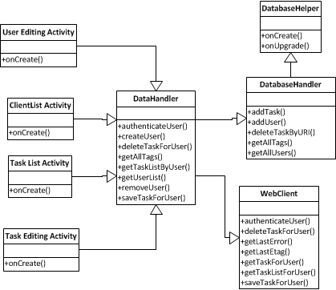
Figure 2

Database organization
The local cache is accesses by the Database Handler class which makes use of the SQLite library that is distributed with the Android OS. When this class is first instantiated it will create an instance of the Database helper class which in turn handless the process of creating the database file and its tables if this is necessary. The database is composed of the following tables:
- User: Stores user login credentials in plain text
- Tasks: Stores the task details
- Tags: Stores a list of unique text tags
- TaskTags: Indicates which tags are used each task
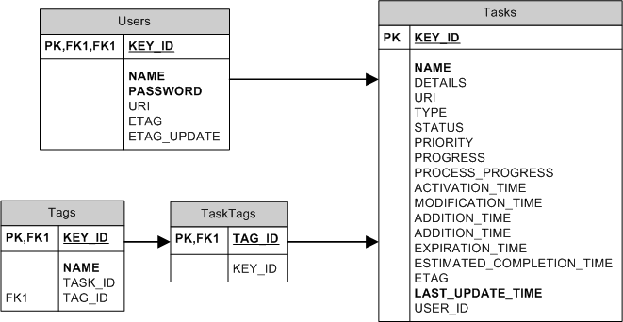
Figure 3

Web Client
The web client handles the job of sending http requests to the web server in order to retrieve the tasks belonging to a user, to create a new task resource, or to delete one. When a GET request is sent to the server the web client will include the user login credentials in the header of this message, and if the server is accessible, an HTTP response will then be received. In the case where there is no network access to the server, a timeout exception will occur and the data handler will be notified of this error. In a similar manner if the login credentials are invalid or if the requested resource does not exist, an error code will be set and the data handler will be notified that the request was completed.
When making a GET request the response body will contain the resource requested in the form of an XML object, and the header will contain an ETAG hash code and last modification date of the resource. This ETAG hash code needs to be passed back to the server when making a PUT request to modify an existing task resource.
When creating a new task resource, the web client will make a POST request and place an XML object with the task details in the body of the message, and If the server accepted this request it will indicate the URI of this new resource on the header of its response message.

User Interface
The user interface is designed using a mixture of Android XML representation along with specifying a few things in Java. Android has a special class called Activity where -- between it and all of its subclasses -- definitions for how pages in the user interface should respond are handled. The bridge between XML definitions and Java classes are handled in a generated class called R.
In this specific project, the first activity handles the account selection menu. Each account that the user has previously registered appears in an Android list. From this screen the user has the opportunity to select an account that was previously registered and bring up the list of tasks for that user, or log in with a new account via the menu button provided on every Android phone. A registration menu is also provided, however the functionality was never added on the server to register new accounts.
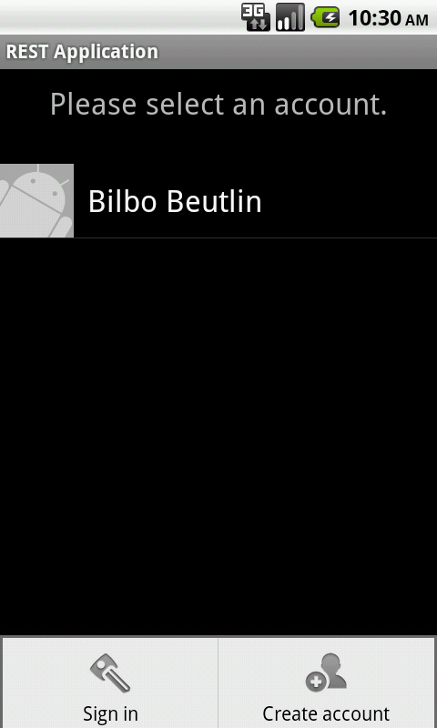
Figure 4

The log in and registration screens are not entirely special or unique from any other form. They simply contain input boxes for a username, password, and URI associated with the account. When the submit button is pressed, the form data is passed to the server and handled using a REST request sent to the server. If the request completes successfully for an HTTP GET request, then the user is considered successfully logged in and the list of tasks for the user shown on the next page. Unfortunately this allows for a couple loopholes that could yield an account “unusable” for the client. For example, if the user passes in a direct link to a task instead of a task list, the user will still authenticate properly. The decision was made not to handle this on the client end however, because there is no way to verify the accuracy of the link, short of a regular expression check on the URI, which is not a safe check since the format for the URIs could be different in a final implementation.
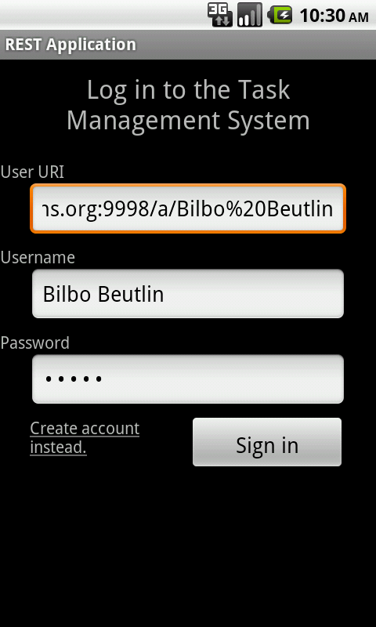
Figure 5
After logging in or selecting an account, the user is brought to the task list screen. From this screen, the user is able to select from any of the tasks that the account has. If the user long-presses (click and hold) on any of the items, a context menu is brought up which allows the user to edit or delete any of the listed tasks. Each item in the list shows the task’s title, priority, and current status. In the activity’s menu are options for filtering by a specific tag, sorting by a certain category of the task such as addition, modification, activation, and expiration dates; progress and process progress; priority; and name are given. If a user selects one of these options, the values are sorted in an ascending manner (alphabetically, numerically, or date-wise, depending on your choice). If the sorting method is selected again, the items are sorted in a descending manner.
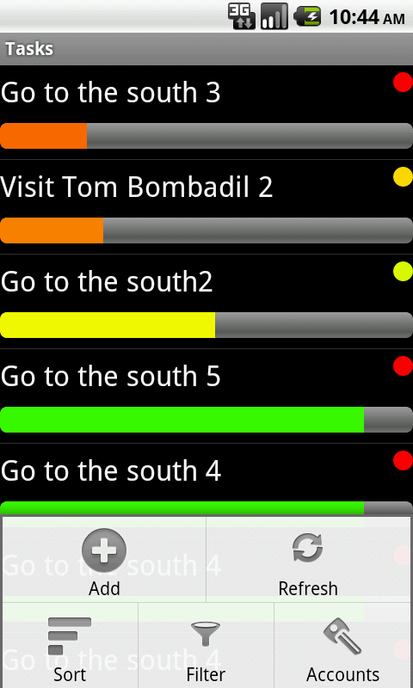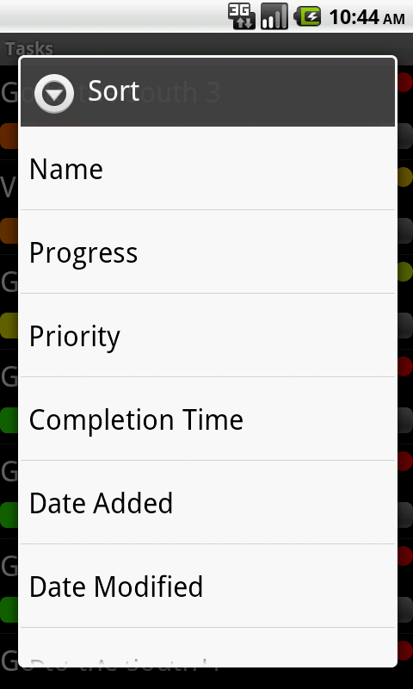
Figure 6
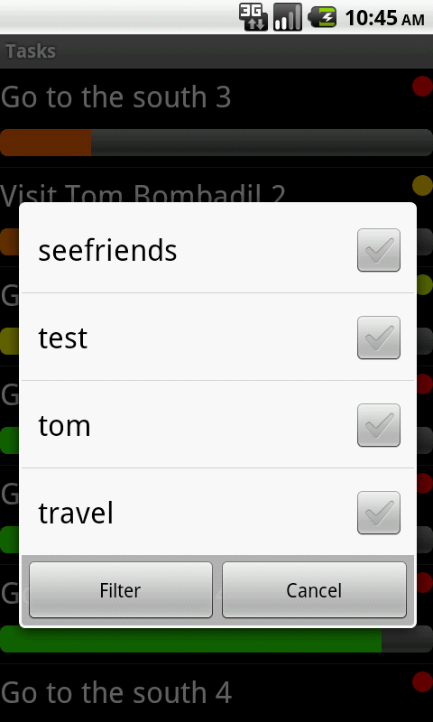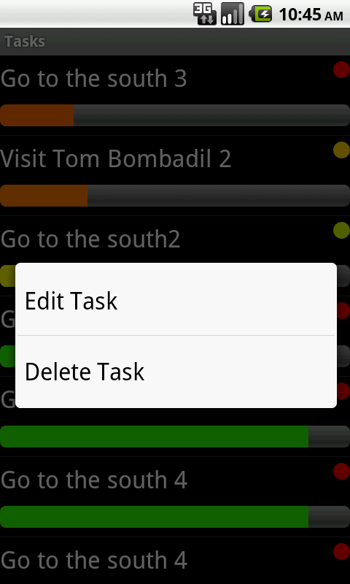
Figure 7

When a user selects an item from the task list, the description of the task is brought up. In this screen, the user can see all of the details for the task that the user might care about. Everything is done in a fairly intuitive format. The progress is shown using both a numeric percentage as well as a progress bar immediately below it to give a visual representation. Apart from this, a “Fuzzy Time” module was also written for each date. This turns dates of the form “Tuesday, July 26, 2011 11:03am” into dates like “3 days ago,” “4 hours ago,” and “6 years from now” which may provide a better context to the reader. From the activity’s menu, a user can edit or delete the task.
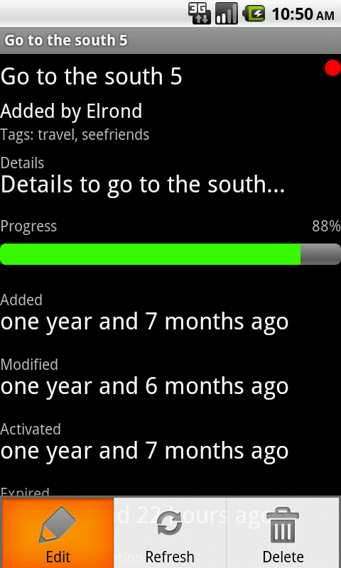
Figure 8

The task’s edit activity was designed to look a lot like the description activity so that the user would be easily familiar with both without having to learn two different representations. In the edit activity, however, the page must obviously use input boxes. The progress bar was replaced with a slider that allows the user to drag the progress to the correct position (for fine-adjustments, an input is also provided). Finally, built-in widgets for selecting dates and times were used to set the dates and times for all of the appropriate values. When the task is saved, it is submitted to the server and the description of the task is brought back up to show the new changes (assuming that all changes were completed successfully).
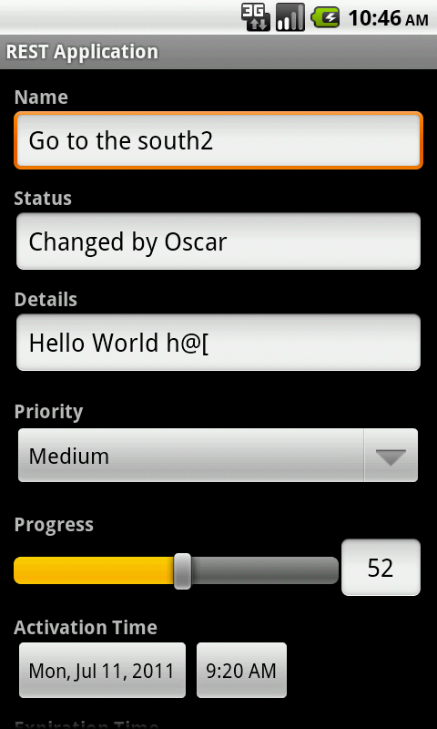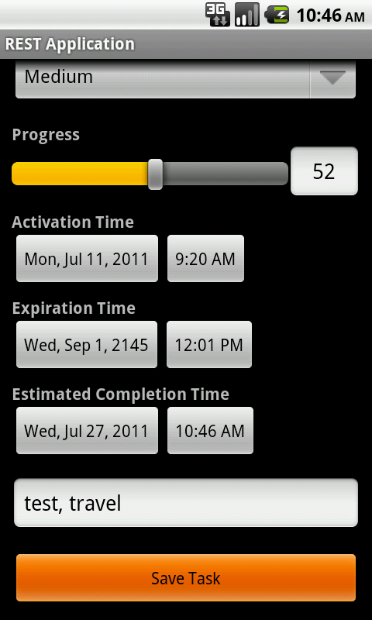
Figure 9
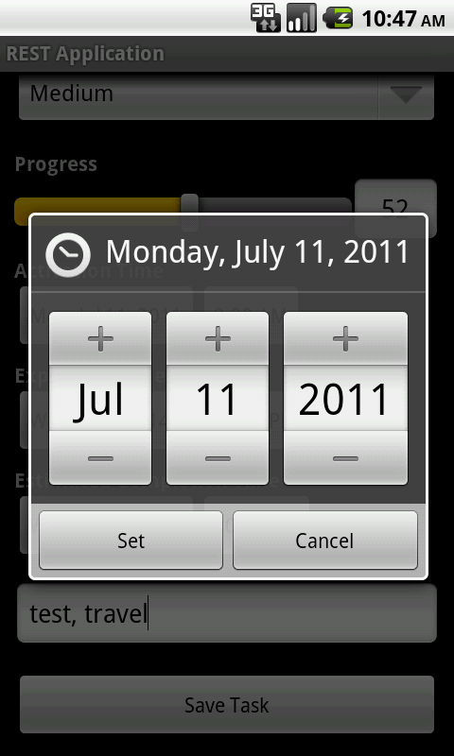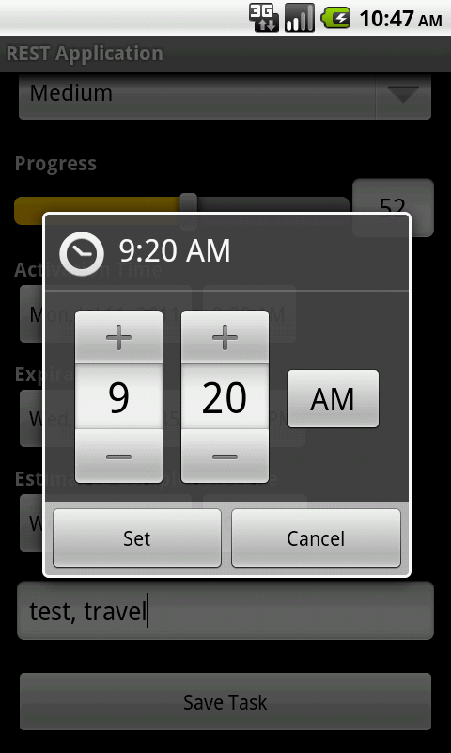
Figure 10

Use Cases
Every user will obviously have different reasons to use such an application. However, this project attempts to highlight what the creators think some of the main use cases of the application will be. While other, more advanced uses of the application may be used, the creators think that the following three cases will represent the most generic base cases. All other cases will more than likely be some sort of a mixture of the following three cases.
In the first case, there is the example of the most basic user. This user only has one account to log into. When logging in, they will have a list of all tasks to be completed. Some of these tasks may be things like “Clean my room before 3pm,” “Prepare notes for Tuesday’s lecture,” or “Prepare for the Firemen’s Banquet this August.” Each of these tasks would have specified due dates, completion progresses, and statuses such as “All toys cleaned up,” “Finished reading chapter three,” or “Purchased the ground beef from the market.” Each task wouldn’t be organized for the user in any specific way through separate accounts, but the user may prefer this method for simplicity’s sake.
In the second case, an example for the “power user” exists. This user may take multiple roles in his or her life and may have multiple accounts to manage each role. For example, a user may have accounts for “Personal,” “Classes and Schoolwork,” and “Work Projects.” Each account would be filled with tasks related to that particular aspect of their life and organized as such. This user may not receive the benefits of the simplicity of keeping all tasks in a single, unified list, but the organization is a bonus that the user may feel outweighs the lack of simplicity.
In the last case, group accounts may exist. For example, everyone working on writing an Android application may wish to add their tasks to the list and share the account with all members of the group. The tasks may contain things like “Finish writing the use cases section of the paper for the project,” with a status of “This section of the paper is complete and just needs someone to look over it and make revisions.” Once that task had been published to the server, all subscribers (people with the “REST Android Application” account) would receive updates on their phones with the appropriate new memos.
While there may be other use cases for this product, the creators believe that most cases will stem from the three previous cases. Users are challenged, however, to come up with their own unique ways to use the product to suit whatever lifestyle they have

Conclusion
This simple android program was built in order to demonstrate the principles of RESTful web application development. Throughout the development process we had opportunity to learn more about android applications, web queries and their respective response codes, and local cache management. An area of deployment that proved particularly difficult was the proper implementation of event handling due to user interaction. This was due to the unfamiliar way in which android structures the GUI layout elements hierarchy and how this affects which GUI events are triggered when the user touches the devices screen. The development of this application was useful programming experience in particular because learning how to handle the large number of possible errors and exceptions when making a web query helps one to better understand how this process works.

