USER MANUAL

IRIS Production Guardian
Production monitoring and AI assisted investigation
This manual explains how to navigate the application, interpret each field, and use the Investigator and RAG Assistant. Screenshots show the live environment on September 12, 2026. Values and answers may change with each query. Screen labels remain in Portuguese; this manual provides their English meaning.
The workflow is Monitor → Investigator → RAG Assistant. Operational changes, such as starting the Production, are performed in the IRIS Management Portal.
Edition 1 • September 12, 2026 • English version
Identification | Description
Application | IRIS Production Guardian
Environment | Local • GUARDIAN namespace
Audience | Operators, support staff, and administrators
Scope | Four screens, indicators, input fields, results, sources, and guidance for unavailable components

Finding information
Access and navigation: page 2. Monitor: pages 3–5. Investigator: pages 6–8. RAG Assistant: pages 9–11. Operational procedure and references: page 12.

1 Access and navigation
On the computer hosting IRIS, open the address below. If prompted to sign in, use your authorized IRIS account.
http://localhost:53773/csp/guardian/Guardian.UI.MonitorPage.cls
The localhost address refers to the computer you are using. From another computer, use the server address supplied by your administrator.
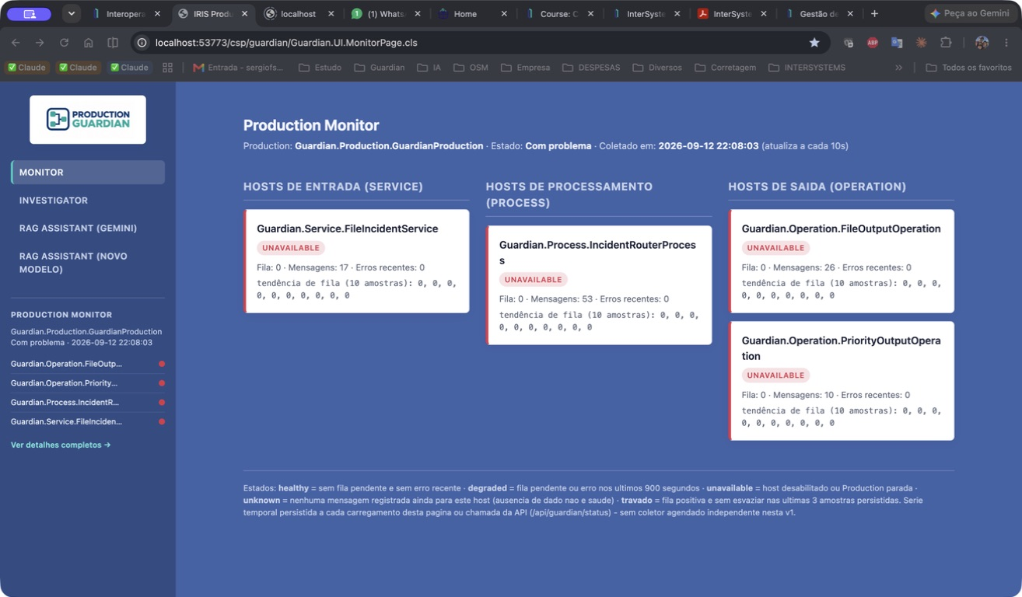
Figure 1. Sidebar menu options. The Production summary appears below them.
Field or element | Meaning and use
Monitor | Opens the full view of components, queues, messages, and errors.
Investigator | Opens the form for investigating a component within a time window.
RAG Assistant (Gemini) | Queries indexed documentation and can use the latest investigation as context.
RAG Assistant (novo modelo) | “New model”: a second query interface. In this edition, it uses the same Gemini backend; an alternative provider is not active.
Sidebar Production Monitor | Shows the Production name, state, collection time, and one row per component.
Colored dot and name | The color summarizes health. Long names may be truncated; hover over a name to see it in full.
Ver detalhes completos | “View full details”: returns to the Monitor screen.

2 Monitor overview
Figure 2. Live Monitor showing the Production as Com problema (Troubled).
Read the screen from left to right: incoming messages, processing, and output. Each card represents a configured component, also called a host. Here, a host does not necessarily mean a physical server.

Reading the example
In the screenshot, FileIncidentService has 17 messages; IncidentRouterProcess, 53; FileOutputOperation, 26; and PriorityOutputOperation, 10. All queue and recent error counts are zero. However, every card is unavailable because the monitored Production is not running normally.
Do not add these counts to calculate the number of incidents. A message involves more than one component, and the history may include responses between them.
The Monitor refreshes every 10 seconds. On other screens, the sidebar is collected when the page loads; it does not refresh continuously while you read a long analysis.

3 Monitor fields and indicators
Field or element | Meaning and use
Production | Exact name of the monitored Production: Guardian.Production.GuardianProduction. This interface has no Production selector.
Estado | “State”: text returned by IRIS, such as Com problema (Troubled). Describes the whole Production, rather than the health badge of an individual host.
Coletado em | “Collected at”: IRIS server date and time when the data was queried. The interface does not display a time zone or convert it to the browser’s local time.
Atualiza a cada 10s | “Refreshes every 10s”: automatic reload interval of the main Monitor screen.
Hosts de entrada (Service) | “Input hosts”: components that receive data to start the flow.
Hosts de processamento (Process) | “Processing hosts”: components that process and route messages.
Hosts de saída (Operation) | “Output hosts”: components that deliver data to a destination.
Card name | Name of the configured Production item. Use the same name when selecting a component in the Investigator.
Health badge | Result of the unavailable, unknown, degraded, and healthy rules explained on the next page.
Fila | “Queue”: pending count in the queried queue at that instant. Zero does not prove that all processing completed successfully.
Mensagens | “Messages”: retained message headers in which the host is the source or target. This is accumulated history, not a rate or a total for the Investigator window.
Erros recentes | “Recent errors”: message headers with errors involving the host, created in the last 900 seconds, or 15 minutes.
Tendência de fila | “Queue trend”: up to 10 stored samples, oldest first. For example, 7, 3, 0 indicates a shrinking queue.
Travado | “Stuck”: additional badge when the last three samples have a positive, nondecreasing queue. Indicates backlog; does not confirm a stuck operating system process.

Samples are stored when the collector runs. One navigation may trigger multiple collections, so three samples do not necessarily represent 30 seconds. This version has no independent scheduled collector.

4 States and flow components
Rules are evaluated in this order. The first matching condition determines the card’s health badge.
State | Rule and interpretation
1 unavailable | The expected Production is not running, or the component is disabled. Check the overall state first, then the host configuration.
2 unknown | The Production is running and the host is enabled, but no messages exist in the available history. There is not enough traffic evidence to classify it as healthy.
3 degraded | The host is enabled, the Production is running, and history exists; the queue is positive or an error occurred within the last 15 minutes.
4 healthy | The host is enabled, the Production is running, history exists, the queue is zero, and there are no recent errors.

An already resolved error can keep a host degraded until it leaves the 15-minute window. The badge does not prove an active failure. Likewise, healthy is not a direct check of every process and external destination.

Roles of the four components
Short name | Role in the project definition
FileIncidentService | Receives .txt files in /durable/guardian/in and uses /durable/guardian/archive for archiving.
IncidentRouterProcess | Processes the incident message and applies the severity routing rule.
FileOutputOperation | Writes normal output to /durable/guardian/out.
PriorityOutputOperation | Writes prioritized output to /durable/guardian/out_priority. The project rule sends MEDIUM, HIGH, and CRITICAL here; other values use normal output.

These paths belong to the IRIS environment. The definition loaded in the Portal may differ; check the effective configuration before operating. PublicHealthProduction is a separate Production and is not tracked by this Monitor.

5 Starting an investigation
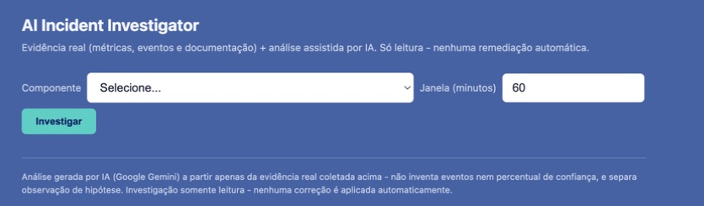
Figure 3. Initial AI Incident Investigator form.
Field or element | Meaning and use
Componente | “Component”: list of hosts in the monitored Production. Select the name shown on the card; its type appears in parentheses.
Selecione... | “Select...”: initial option with no component selected. Choose an item to obtain a result.
Janela (minutos) | “Window (minutes)”: lookback period for events, measured from the query time. The screen defaults to 60 minutes; the form accepts a minimum of 1.
Investigar | “Investigate”: collects current health, up to 20 recent messages within the window, and related documentation, then requests an AI analysis.
Investigando... | “Investigating...”: temporary button state after submission. The button is disabled while the request is processed.
Coletando evidência e analisando com IA... | “Collecting evidence and analyzing with AI...”: processing is underway. Wait for the result to avoid repeated queries.

Example workflow
1. Open Investigator.
2. Select Guardian.Operation.FileOutputOperation.
3. Keep 60 minutes to review the last hour.
4. Click Investigar (Investigate).
5. Read Saúde atual (Current health) and Eventos na janela (Events in window) before assessing Análise (Analysis).
To broaden the search, use 1440 minutes for one day, for example. The window changes the retrieved events; it does not change accumulated Messages or the fixed 15-minute Recent errors window.
An investigation does not start, stop, enable, or repair components. Its result is saved for contextual use by the RAG Assistant; this interface does not yet provide a browsable list of previous investigations.

6 Reading investigation results
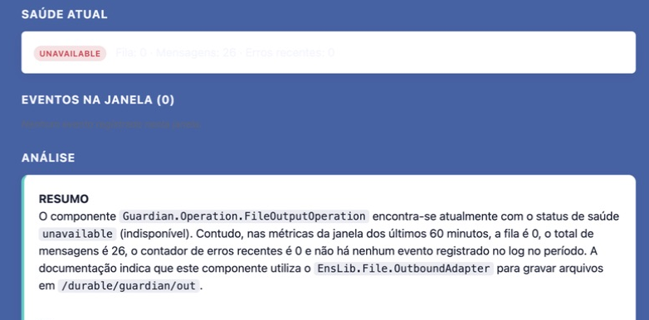
Figure 4. Live result for FileOutputOperation with a 60-minute window.
Field or element | Meaning and use
Saúde atual | “Current health”: repeats the Monitor collector’s classification and metrics: badge, Queue, Messages, and Recent errors.
Eventos na janela (N) | “Events in window (N)”: messages retrieved for the component during the period. At most 20, newest first; not necessarily the full period total.
Nenhum evento registrado nesta janela | “No events recorded in this window”: no matching messages were retrieved in the interval. Does not mean the component has never processed data.
msg # and date/time | When events exist, shows the message header identifier and creation time.
Source → target | Shows who sent and who received the message, identifying the part of the flow involved.
sucesso or error text | “Success” or a readable error, based on the header status. The error text helps locate the cause and relevant documentation.

The event list comes from message history. It does not replace the full Event Log in the IRIS Portal. In the screenshot, N = 0 and Messages = 26 are compatible: history exists, but no records fall within the last hour.

7 Analysis and related documentation
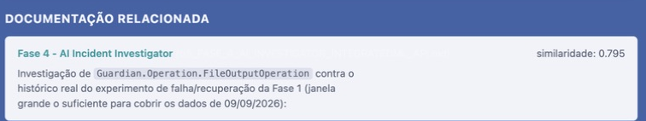
Figure 5. Documentation retrieved to support the investigation.
Field or element | Meaning and use
Análise | “Analysis”: AI text based on retrieved health, events, and documents. May contain incorrect interpretations; verify against the displayed data.
Resumo e observações | “Summary and observations”: case summary and facts the model identifies in the evidence.
Hipóteses | “Hypotheses”: possible explanations, not confirmed causes.
Lacunas | “Gaps”: missing information needed to complete the diagnosis.
Próximos passos sugeridos | “Suggested next steps”: proposed checks. None run automatically.
Documentação relacionada | “Related documentation”: indexed excerpts selected to support the case. The screen reports when none are found.
Source title | Name of the document from which the excerpt was retrieved.
Source in parentheses | Source identifier or filename. A text reference, not necessarily a clickable link.
similaridade | “Similarity”: proximity score between the query and excerpt, displayed to three decimal places. Not the probability that the analysis is correct.
Source text | Retrieved excerpt, which may contain historical examples. An error described there does not prove the same error is happening now.

Note on the live example: the analysis called the metrics “Últimos 60 min” (Last 60 minutes). The actual rules are: Queue and health are current; Messages is accumulated; Recent errors covers 15 minutes; only events follow the selected 60-minute window.

8 Using the RAG Assistant
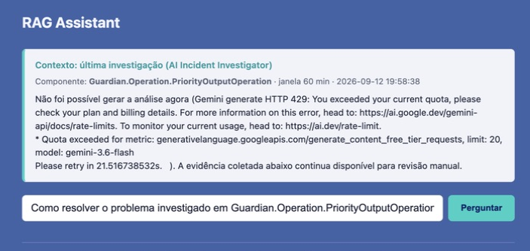
Figure 6. RAG context from an earlier investigation that recorded a quota error.
Field or element | Meaning and use
Contexto: última investigação | “Context: latest investigation”: optional block reusing the most recent investigation saved in the environment. Check that it matches the case you want to query.
Componente | “Component”: host investigated in the saved result. May differ from the host you intend to query now.
janela and date/time | “Window” and timestamp: investigation period and recording time; these do not indicate a new collection of events.
Block summary | Shows up to 600 characters of the analysis, with internal scrolling when needed. The query uses the full saved text.
Pergunte sobre o projeto... | “Ask about the project...”: question field. May contain a suggestion based on the component in the latest investigation; you can edit it.
Perguntar | “Ask”: sends the question to AI with retrieved documents and, when present, the latest investigation.
Perguntando... and loading indicator | “Asking...”: the query is processing. Simply opening the page with a suggested question does not submit it.

Example: “What does unavailable mean in the Monitor, and what should I check before starting the Production?” Ask specific questions and check sources before acting on advice.

9 RAG answers and failures
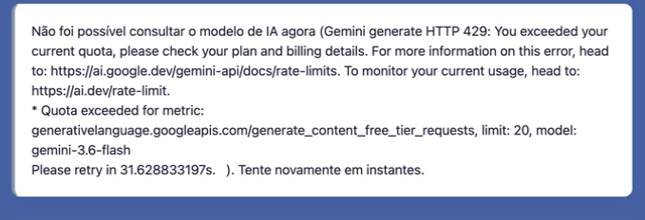
Figure 7. A live query returned HTTP 429 from Gemini.
Field or element | Meaning and use
Answer | Text produced from the available context. The interface displays the answer after submission; it is not a chat with a full conversation history.
Fontes usadas | “Sources used”: lists document excerpts when an answer is not abstained and sources were retrieved. Title, filename, similarity, and text mean the same as on page 8.
Threshold 0.58 | Reference for the low-similarity abstention rule. An initial heuristic, not a quality guarantee or confidence percentage.
Não sei or insufficient context | “I don’t know”: without sufficiently similar documents or an investigation to support the query, the system may abstain. Rephrase the question or review the indexed knowledge base.
Não foi possível consultar o modelo de IA agora | “Unable to query the AI model right now”: the AI call failed. The message shows the actual error; it does not automatically mean the Production stopped.
HTTP 429 and quota exceeded | In the example, the provider reports a usage limit exceeded. Check the quota with the integration owner and follow the service’s retry guidance.

When a saved investigation exists, the RAG Assistant may answer using it even without documents above the threshold. Therefore, missing “Fontes usadas” alone does not mean there is no context at all.
The footer’s statement about not inventing information describes intended behavior. Check the answer: AI may make mistakes or repeat a misleading interpretation from a previous investigation.

10 The new model option
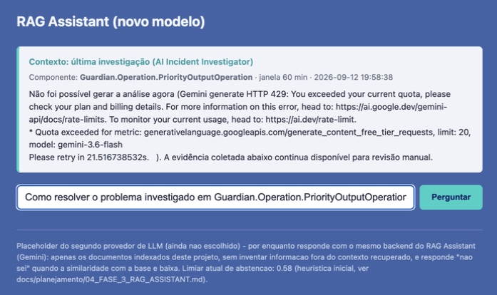
Figure 8. Second RAG option available in the menu.
In this edition, RAG Assistant (novo modelo) is a second page using the same query logic and Gemini provider as the main option. The footer states that the second provider has not yet been chosen.
Field or element | Meaning and use
Title and selected menu item | Identify the second page. They do not prove that the model has changed.
Investigation context | Uses the same latest investigation saved in the environment.
Question and Perguntar button | Work as in the Gemini option, including an automatic suggestion and explicit submission.
Answer and Fontes usadas | Follow the same generation, retrieval, and abstention rules.
Second provider footer | Explains that this option is provisional and shares the current backend.

Switching to this option does not resolve an exhausted Gemini quota. Unavailability of the same provider may affect both pages. Use the main option as your operational reference until an alternative provider has actually been configured.

11 Procedure for unavailable
1. Open Monitor and verify the Production name, Estado (State), and collection time. If all hosts are unavailable, start with the overall state. If only one is unavailable, also check whether it is enabled.
2. Open the Management Portal at http://localhost:53773/csp/sys/UtilHome.csp. Select GUARDIAN and go to Interoperabilidade → Configurar → Production (Interoperability → Configure → Production). Check Guardian.Production.GuardianProduction.
3. Review the Event Log and component states to identify why the Production is Com problema (Troubled). The Monitor alone does not reveal the cause. Starting, stopping, and enabling are administrative actions in the Portal.
4. In Investigator, select the affected component and a window covering the issue. Review events and documentation excerpts. If no events appear, broaden the interval and consult Portal logs.
5. In RAG, verify the component and timestamp of the latest investigation, write a specific question, and validate the advice against the sources. An AI failure does not prevent reading data already displayed.
6. After an operational correction, return to Monitor and watch the overall state, queue, and messages. Recent errors can keep degraded for up to 15 minutes; do not resend messages merely to change a card’s color.

Reading cautions
An open screen proves application access, not a running Production. A zero queue does not prove delivery. An experiment document is not a current event. Similarity is not confidence. Samples are not necessarily evenly spaced. Refreshing a URL containing a question or investigation parameters may run the query again.

References and version
Screenshots captured on September 12, 2026, in the local environment. Field definitions checked in Guardian.UI.MonitorPage, InvestigatorPage, RAGPage, RAGAltPage, and Shared; rules in Guardian.Monitor.StatusCollector, Guardian.Investigator.EvidenceCollector, and Guardian.RAG.Query; flow in GuardianProduction and IncidentRoutingRule.
Project files: src/Guardian/UI; src/Guardian/Monitor/StatusCollector.cls; src/Guardian/Investigator/EvidenceCollector.cls; src/Guardian/RAG/Query.cls. Review the documented behavior whenever these classes or the Production configuration change.

