MINISTRY OF EDUCATION AND SCIENCE OF UKRAINE
INSTITUTE OF PHYSICS AND TECHNOLOGY
NATIONAL TECHNICAL UNIVERSITY OF UKRAINE
“IGOR SIKORSKY KYIV POLYTECHNIC INSTITUTE”

APPROVED BY
Deputy Director
for scientific and pedagogical work

IPT Igor Sikorsky Kyiv Polytechnic Institute
Lytvynova T.
30.05.2018

Algebra and Geometry

Work Program

for students preparing the first (Bachelor) level of higher education "Bachelor" in the speciality 125 Cybersecurity

113 Applied mathematics

Approved by methodical commission
IPT Igor Sikorsky Kyiv Polytechnic Institute
Protocol № 6 /2018 of May 24, 2018
Head of Methodical Commission

Smirnov S.

24.05. 2018

Kyiv – 2018

The work program of the credit module "Algebra and Geometry 1. Analytic Geometry" for students preparing the first (Bachelor) level of higher education "Bachelor" in the speciality125 Cybersecurity, 113 Applied mathematics, according to the full-time form of study is compiled accordingly to the program of the subject "Algebra and Geometry".

Developer of the work program:

candidate of physical and mathematical sciences
Khmelnytskyi Mykola Olexiyovych

The work program is approved at the session of the information security department Protocol № 5 /2018 of April 25, 2018

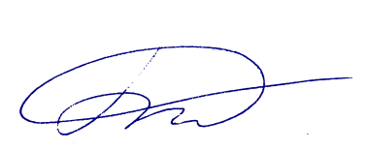
Acting head of the department

__________________ associate professor Grayvoronskiy M. V.

25.04. 2018

The work program is approved at the session of the mathematical methods of information security department Protocol № 4 /2018 of April 17, 2018

Acting head of the department
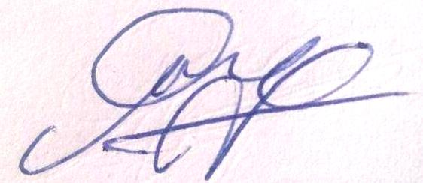
____________ full professor Savchuk M.M.

17.04. 2018.

© Igor Sikorsky Kyiv Polytechnic Institute, 2018

