1 f
2 f
3 t
4 f
5 t
6 f
7 t
8 t
_______
1 f
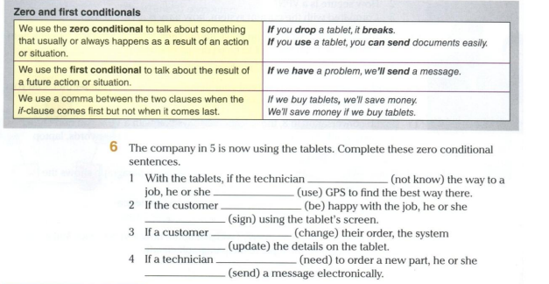
2 e
3 j
4 h
5 c
6 i
7 b
8 g
9 d
10 a
_________
pag 24 ej 6
1 doesn’t know, uses
2 is, signs
3 changes, update
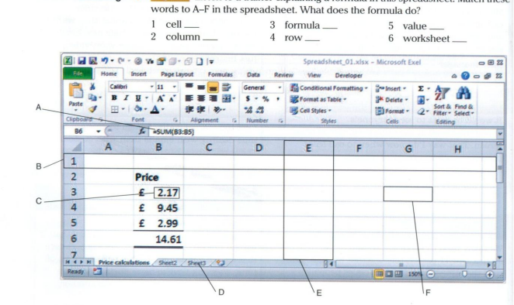
4 needs, sends

_____
pag 28 ej 4
1 f
2 e
3 a
4 b
5 c
6 d
Listening part:

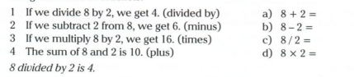
__________
pag 28 ej 2
1 c
2 b
3 d
4 a

