Kanji Study App

Memory

By Sergio Páramo
Table of Contents
1. Group members: 3
2. App selection: 4
3. Project explanation: 5
4. Colors: 6
5. Styles: 7
5.1 textStyle 7
5.2 ItemsStyle 7
5.3 AppTheme.Launcher 7
5.4 textInputEditText 7
5.5 textInputLayoutStyle 8
5.6 ButtonStyle 8
5.7 ItemsStyleBorder 8
6. Architecture and navigation diagram: 9
7. Patterns used: 10
8. Problems found / Solutions adopted 11
9. How would I improve the app 12
10. Final considerations: 13

1. Group members:

1. Sergio Páramo (employee of the month)

2. App selection:

Kanji Study is an app that contains all the Japanese Kanjis and Kanas on a database system created and designed to self-learners and presented in an intuitive user interface to interact, listen, and learn through the process.

I chosed this app because I’m interested in the Japanese language and (with my humble knowdlege) I could create a basic but functional app that can be used to learn basic Japanese.

Although I have not cloned any particular app, I have taken references and ideas about the design of various apps to learn Japanese

3. Project explanation:

This project was created in order to provide the users with a friendly and easy-to-use mobile app to learn and practise their japanese on a daily basis.

To achieve my objectives I made some research about some similar apps and the features that shared in common. I created a database from scratch with all the data necessary to study and also designed a unified user layout architecture from scratch.

4. Colors:

colorPrimary = #fafafa
colorPrimaryDark = #3700B3
colorAccent = #1976d2
colorBlue = #1976d2
colorWhite = #fafafa
colorBlack = #333333
backgroundGreyColour = #d8d8d8
fontBlackColour = #333333
colorYellow = #ffff00

5. Styles:

5.1 textStyle
fontFamily = verdana
android:textSize = 36sp
android:textStyle = bold
android:textColor = @color/colorWhite>
background = @color/colorBlack

5.2 ItemsStyle
android:textSize = 35dp
android:textStyle = bold
android:foreground = @drawable/custom_ripple_effect
android:clickable = true
android:textColor = @color/colorWhite background = @color/colorBlack

5.3 AppTheme.Launcher
android:windowBackground = @drawable/launch_screen

5.4 textInputEditText
android:background = #4000
android:textColor = #FFF

5.5 textInputLayoutStyle
android:textColorHint = #fff

5.6 ButtonStyle
android:textSize">25dp</item>
android:textStyle">bold</item>

android:clickable = true
android:focusable = true
android:textColor = @color/colorBlack
color = @color/colorBlack

5.7 ItemsStyleBorder
android:background = @drawable/border
android:textSize = 30dp
android:textStyle = bold
android:foreground = @drawable/custom_ripple_effect
android:clickable = true
android:focusable = true
android:textColor = @color/colorWhite

6. Architecture and navigation diagram:

From navgraph:
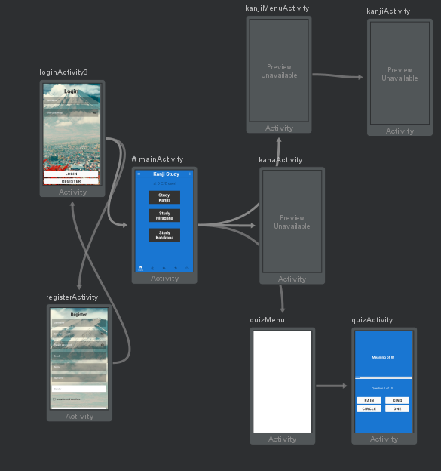

7. Patterns used:

These are some of the patters and components that I used in order to create my app, some of them weren’t familiar to me and it wasn’t easy to implement them. But through the process I learned and got familiar day by day and I managed to integrate all of them.

Layout design
Material components
Adapters
Recycler view
Bottom navigation bar
Navigation drawer
Navigation graph

8. Problems found / Solutions adopted

Problem:
Lack of design pattern or style (since it’s not a clone and I’m not good at designing)

Solution:
Designed a basic style-schema along with Material component design

Problem:
Old Navigation schema poor in UX-friendly basis

Solution:
Implement bottom and navigation drawer

Problem:
Lack of resources to retrieve the data to display

Solution:
Created a database from scratch with kanjis and kana

Problem:
Activity schema compatibility problems with bottom-navigation bar and navigation drawer

Solution:
Added multiple layouts according to each activity

9. How would I improve the app

The kanji and kana section would change a lot in an user experience point of view if it had a grid layout to display more elements without having to scroll so the screen could be more optimized.

Also it would be essential to implement a new layout that displayed new information from the chosen item (kanji or kana) in a different format with bigger size so the user could study it by separate.

Within the Kanji Menu section I would implement a method to move between the different levels that integrate the Kanji Database with something like a slide function to get rid of the icons (but it works and gets the job done)

Finally, I consider that the app would look like even better if it had a forgot-password button that allowed the registered user to restore his/her password.

10. Final considerations:

Developing an app by myself has been quite challenging specially when at the very beginning I wasn’t familiar with some of the concepts used through the course.

I think that if I was going to work alone I had to choose something that motivated me and kept me working hard without external help that’s the reason I chosed this topic since I really like the Japanese language.

During the development of the app I found myself working on something I liked and having the freedom to implement new things, putting in practice concepts learned but also (and more important) fail and learn from my mistakes.

The final product could not be an astonishing app that delights all its users but the small team that has work on the project has put all the efforts to deliver a competitive and humble app with enough functionalities to satisfy the first objectives.

I have enjoyed doing this project not only for the result of the product but for all the knowdlege I could apply into something useful.

Kanji Study development team.

