EstCrimen

Sergio Solano

26 de marzo de 2018

## [1] "10. ESTADISTICAS OCTUBRE 31 2013.xlsx"  
## [1] "10. ESTADISTICAS OCTUBRE 31 DE 2017.xls"  
## [1] "10. ESTADISTICO OCTUBRE 2014.xls"  
## [1] "11. ESTADISTICA A NOVIEMBRE DE 2015.xls"  
## [1] "11. ESTADISTICAS NOVIEMBRE 30 DE 2017.xls"  
## [1] "11. ESTADISTICAS NOVIEMBRE DE 2016.xls"  
## [1] "11. ESTADISTICO NOVIEMBRE 2014.xlsx"  
## [1] "12. ESTADISTICA A DICIEMBRE DE 2015.xls"  
## [1] "12. ESTADISTICAS DICIEMBRE 31 DE 2017.xls"  
## [1] "12. ESTADISTICAS DICIEMBRE DE 2016.xls"  
## [1] "12. ESTADISTICO DICIEMBRE 2014.xlsx"  
## [1] "1. ESTADISTICAS ENERO 2015.xlsx"  
## [1] "1. ESTADISTICAS ENERO 31 DE 2018.xls"  
## [1] "1. ESTADISTICAS ENERO DE 2017.xls"  
## [1] "2. ESTADISTICAS FEBRERO 28 DE 2017.xls"  
## [1] "2. ESTADISTICAS FEBRERO 28 DE 2018.xls"  
## [1] "3. ESTADISTICAS MARZO 31 DE 2017.xls"  
## [1] "4. ESTADISTICA A ABRIL 30 DE 2015.xlsx"  
## [1] "4. ESTADISTICAS ABRIL 30 DE 2017.xls"  
## [1] "5. ESTADISTICA A MAYO DE 2016.xls"  
## [1] "6. ESTADISTICA A JUNIO DE 2015.xlsx"  
## [1] "7. ESTADISTICA A JULIO DE 2015.xlsx"  
## [1] "7. ESTADISTICAS JULIO 31 DE 2017.xls"  
## [1] "8. ESTADISTICAS AGOSTO 2013.xlsx"  
## [1] "8. ESTADISTICAS AGOSTO 31 DE 2017.xls"  
## [1] "9. ESTADISTICA A SEPTIEMBRE DE 2015.xlsx"  
## [1] "9. ESTADISTICAS SEPTIEMBRE 30 DE 2013.xlsx"  
## [1] "9. ESTADISTICAS SEPTIEMBRE 30 DE 2017.xls"  
## [1] "AAA ESTADISTICAS JULIO 31 2013.xlsx"  
## [1] "ESTADISTICA A ABRIL DE 2016.xls"  
## [1] "ESTADISTICA A AGOSTO DE 2015.xlsx"  
## [1] "ESTADISTICA A ENERO DE 2016.xls"  
## [1] "ESTADISTICA A FEBRERO 28 DE 2015.xlsx"  
## [1] "ESTADISTICA A FEBRERO DE 2016.xls"  
## [1] "ESTADÍSTICA A MARZO 31 DE 2015.xlsx"  
## [1] "ESTADISTICA A MARZO DE 2016.xls"  
## [1] "ESTADISTICA A MAYO 31 DE 2015.xlsx"  
## [1] "ESTADISTICA ENERO 2014.xls"  
## [1] "ESTADÍSTICAS ABRIL 2014.xls"  
## [1] "ESTADISTICAS AGOSTO DE 2016.xls"  
## [1] "ESTADÍSTICAS DICIEMBRE 2013.xlsx"  
## [1] "ESTADÍSTICAS FEBRERO 2014.xls"  
## [1] "ESTADISTICAS JULIO 2014.xls"  
## [1] "ESTADISTICAS JULIO DE 2016.xls"  
## [1] "ESTADÍSTICAS JUNIO 2014.xls"  
## [1] "ESTADÍSTICAS JUNIO 30 DEL 2017.xlsx"  
## [1] "ESTADISTICAS JUNIO DE 2016.xls"  
## [1] "ESTADÍSTICAS MARZO 2014.xls"  
## [1] "ESTADISTICAS MAYO 2014.xls"  
## [1] "ESTADISTICAS MAYO 31 DE 2017.xls"  
## [1] "ESTADISTICAS OCTUBRE DE 2016.xls"  
## [1] "ESTADISTICAS SEPTIEMBRE DE 2016.xls"  
## [1] "ESTADISTICO AGOSTO 2014.xls"  
## [1] "ESTADÍSTICO SEPTIEMBRE 2014.xls"  
## [1] "NOVIEMBRE 2013.xls"

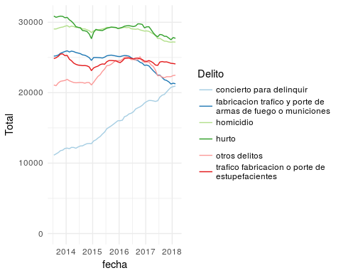 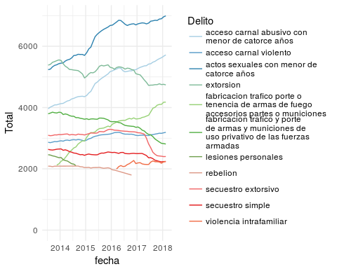 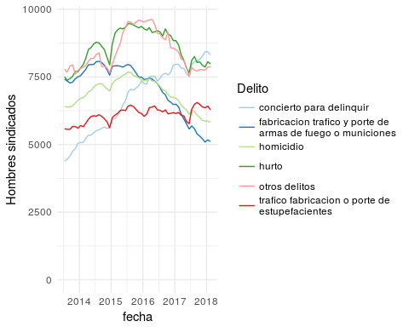

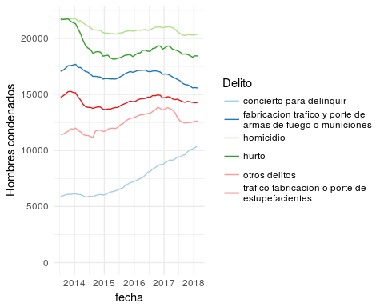

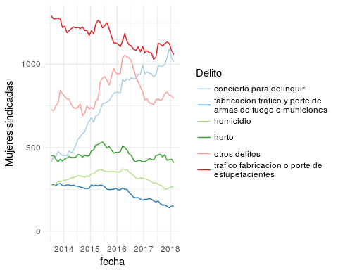

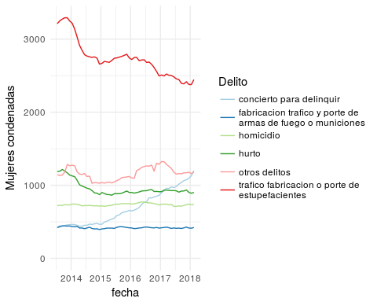

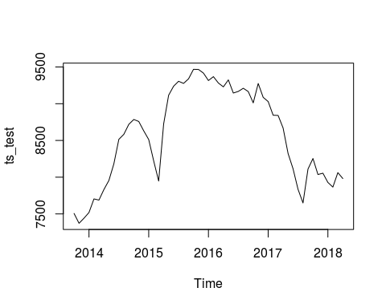

## level slope epsilon   
## 37524.1531 227.3702 0.0000

## Transitional variance: 37524.15   
## Slope variance: 227.3702   
## Observational variance: 0   
## Initial level of mu: 7506   
## Initial level of lambda: 0

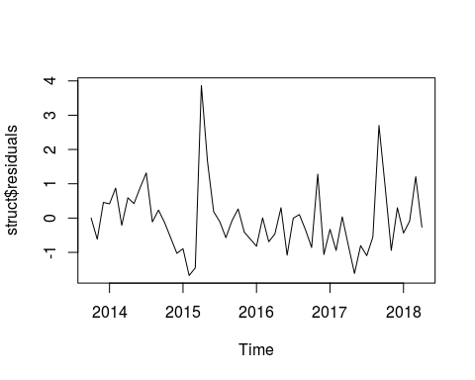

## $pred  
## Qtr1 Qtr2 Qtr3 Qtr4  
## 1975 29.84194 34.41014 39.30815 43.02779  
## 1976 46.18808 48.56947 50.44866 51.86064  
## 1977 52.94295 53.75521 54.37019 54.83150  
##   
## $se  
## Qtr1 Qtr2 Qtr3 Qtr4  
## 1975 9.00655 11.25606 13.43389 14.51516  
## 1976 15.25538 15.65611 15.90158 16.03792  
## 1977 16.11764 16.16229 16.18785 16.20220

## [1] 29.84194 34.41014 39.30815 43.02779 46.18808 48.56947 50.44866  
## [8] 51.86064 52.94295 53.75521 54.37019 54.83150

## [1] 9.00655 11.25606 13.43389 14.51516 15.25538 15.65611 15.90158  
## [8] 16.03792 16.11764 16.16229 16.18785 16.20220

## $pred  
## [1] 29.84194 34.41014 39.30815 43.02779  
##   
## $se  
## [1] 9.00655 11.25606 13.43389 14.51516  
##   
## $pred  
## [1] 46.18808 48.56947 50.44866 51.86064  
##   
## $se  
## [1] 15.25538 15.65611 15.90158 16.03792  
##   
## $pred  
## [1] 52.94295 53.75521 54.37019 54.83150  
##   
## $se  
## [1] 16.11764 16.16229 16.18785 16.20220

## Success! abstol and log-log tests passed at 16 iterations.  
## Alert: conv.test.slope.tol is 0.5.  
## Test with smaller values (<0.1) to ensure convergence.  
##   
## MARSS fit is  
## Estimation method: kem   
## Convergence test: conv.test.slope.tol = 0.5, abstol = 0.001  
## Estimation converged in 16 iterations.   
## Log-likelihood: 4.064946   
## AIC: -0.129891 AICc: 1.975372   
##   
## Estimate  
## R.R 0.0141  
## U.U 0.0564  
## Q.Q 0.0136  
## x0.x0 7.9532  
## Initial states (x0) defined at t=0  
##   
## Standard errors have not been calculated.   
## Use MARSSparamCIs to compute CIs and bias estimates.

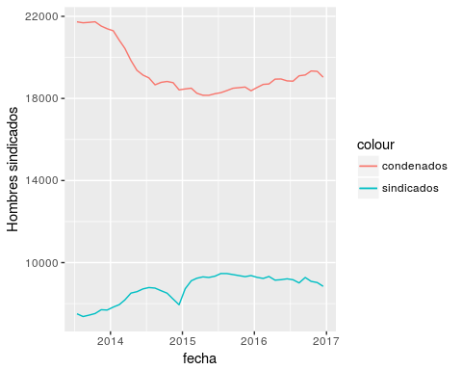

## Success! Converged in 596 iterations.  
## Function MARSSkfas used for likelihood calculation.  
##   
## MARSS fit is  
## Estimation method: BFGS   
## Estimation converged in 596 iterations.   
## Log-likelihood: -579.4359   
## AIC: 1180.872 AICc: 1184.643   
##   
## Estimate  
## R.r11 3.88e+03  
## R.r12 2.58e+04  
## R.r22 2.72e+05  
## B.b1 9.87e-01  
## B.b2 6.31e-02  
## B.b4 9.69e-01  
## U.u1 1.40e+02  
## U.u2 -2.09e+00  
## Q.q11 2.73e+04  
## Q.q12 -2.79e+04  
## Q.q22 2.86e+04  
## Initial states (x0) defined at t=0  
##   
## Standard errors have not been calculated.   
## Use MARSSparamCIs to compute CIs and bias estimates.

## $Z  
## [,1]  
##   
## $A  
## [,1]  
##   
## $R  
## [,1]  
## r11 3884.626  
## r12 25763.582  
## r22 271566.027  
##   
## $B  
## [,1]  
## b1 0.98722311  
## b2 0.06308148  
## b4 0.96872211  
##   
## $U  
## [,1]  
## u1 140.432494  
## u2 -2.092041  
##   
## $Q  
## [,1]  
## q11 27292.80  
## q12 -27862.05  
## q22 28583.58  
##   
## $x0  
## [,1]  
##   
## $V0  
## [,1]  
##   
## $G  
## [,1]  
##   
## $H  
## [,1]  
##   
## $L  
## [,1]

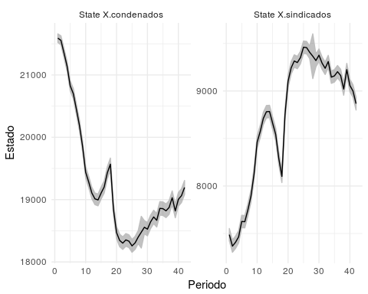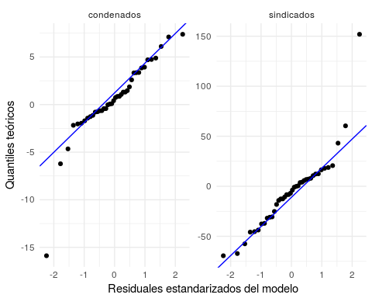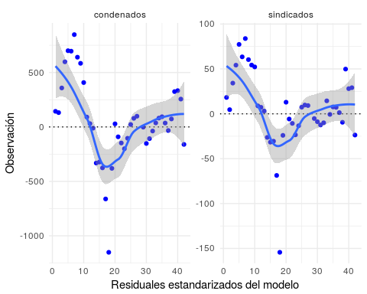

## % latex table generated in R 3.4.4 by xtable 1.8-2 package  
## % Sun Jun 10 15:13:02 2018  
## \begin{table}[ht]  
## \centering  
## \begin{tabular}{rr}  
## \hline  
## & x \\   
## \hline  
## b1 & 0.99 \\   
## b2 & 0.06 \\   
## b4 & 0.97 \\   
## u1 & 140.43 \\   
## u2 & -2.09 \\   
## q11 & 27292.80 \\   
## q12 & -27862.05 \\   
## q22 & 28583.58 \\   
## \hline  
## \end{tabular}  
## \end{table}

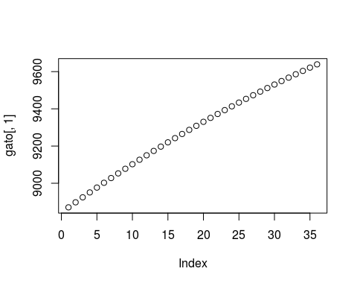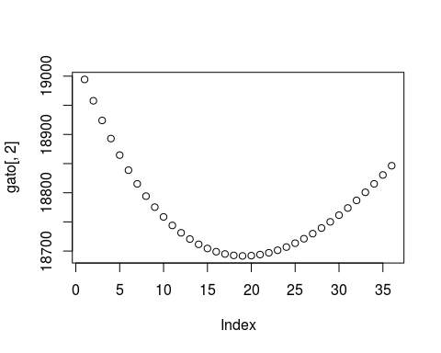

## % latex table generated in R 3.4.4 by xtable 1.8-2 package  
## % Sun Jun 10 15:13:02 2018  
## \begin{table}[ht]  
## \centering  
## \begin{tabular}{rlrr}  
## \hline  
## & Periodo & Sindicados & Condenados \\   
## \hline  
## V1 & 2017-01-15 & 8870.00 & 18994.00 \\   
## V2 & 2017-02-15 & 8898.00 & 18958.00 \\   
## V3 & 2017-03-15 & 8924.00 & 18924.00 \\   
## V4 & 2017-04-15 & 8951.00 & 18893.00 \\   
## V5 & 2017-05-15 & 8977.00 & 18865.00 \\   
## V6 & 2017-06-15 & 9003.00 & 18839.00 \\   
## V7 & 2017-07-15 & 9028.00 & 18815.00 \\   
## V8 & 2017-08-15 & 9053.00 & 18794.00 \\   
## V9 & 2017-09-15 & 9078.00 & 18775.00 \\   
## V10 & 2017-10-15 & 9102.00 & 18759.00 \\   
## V11 & 2017-11-15 & 9126.00 & 18744.00 \\   
## V12 & 2017-12-15 & 9150.00 & 18731.00 \\   
## V13 & 2018-01-15 & 9174.00 & 18721.00 \\   
## V14 & 2018-02-15 & 9197.00 & 18712.00 \\   
## V15 & 2018-03-15 & 9220.00 & 18704.00 \\   
## V16 & 2018-04-15 & 9242.00 & 18699.00 \\   
## V17 & 2018-05-15 & 9265.00 & 18695.00 \\   
## V18 & 2018-06-15 & 9287.00 & 18693.00 \\   
## V19 & 2018-07-15 & 9309.00 & 18692.00 \\   
## V20 & 2018-08-15 & 9330.00 & 18692.00 \\   
## V21 & 2018-09-15 & 9351.00 & 18694.00 \\   
## V22 & 2018-10-15 & 9372.00 & 18697.00 \\   
## V23 & 2018-11-15 & 9393.00 & 18701.00 \\   
## V24 & 2018-12-15 & 9413.00 & 18707.00 \\   
## V25 & 2019-01-15 & 9434.00 & 18713.00 \\   
## V26 & 2019-02-15 & 9453.00 & 18721.00 \\   
## V27 & 2019-03-15 & 9473.00 & 18730.00 \\   
## V28 & 2019-04-15 & 9493.00 & 18739.00 \\   
## V29 & 2019-05-15 & 9512.00 & 18750.00 \\   
## V30 & 2019-06-15 & 9531.00 & 18761.00 \\   
## V31 & 2019-07-15 & 9549.00 & 18774.00 \\   
## V32 & 2019-08-15 & 9568.00 & 18787.00 \\   
## V33 & 2019-09-15 & 9586.00 & 18801.00 \\   
## V34 & 2019-10-15 & 9604.00 & 18815.00 \\   
## V35 & 2019-11-15 & 9622.00 & 18830.00 \\   
## V36 & 2019-12-15 & 9639.00 & 18846.00 \\   
## \hline  
## \end{tabular}  
## \end{table}

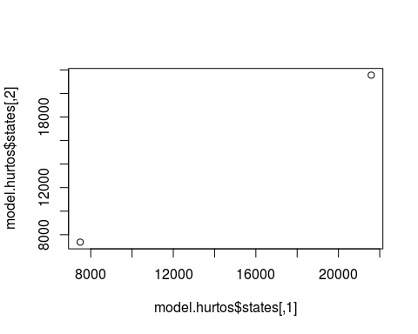

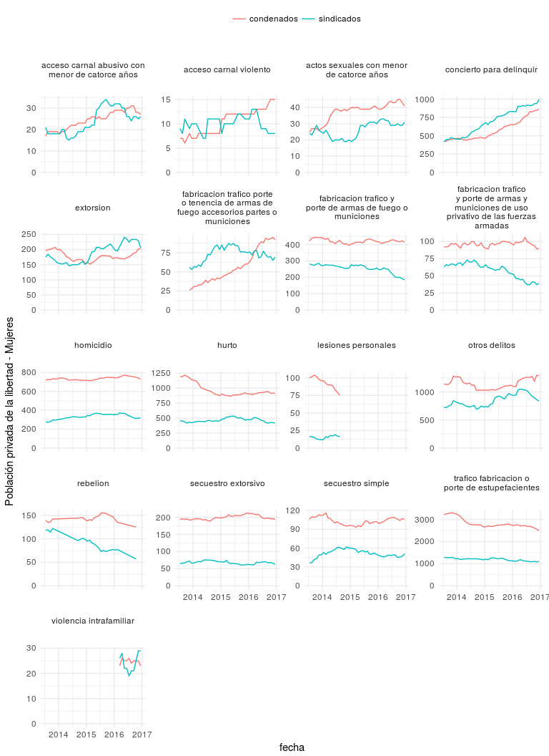

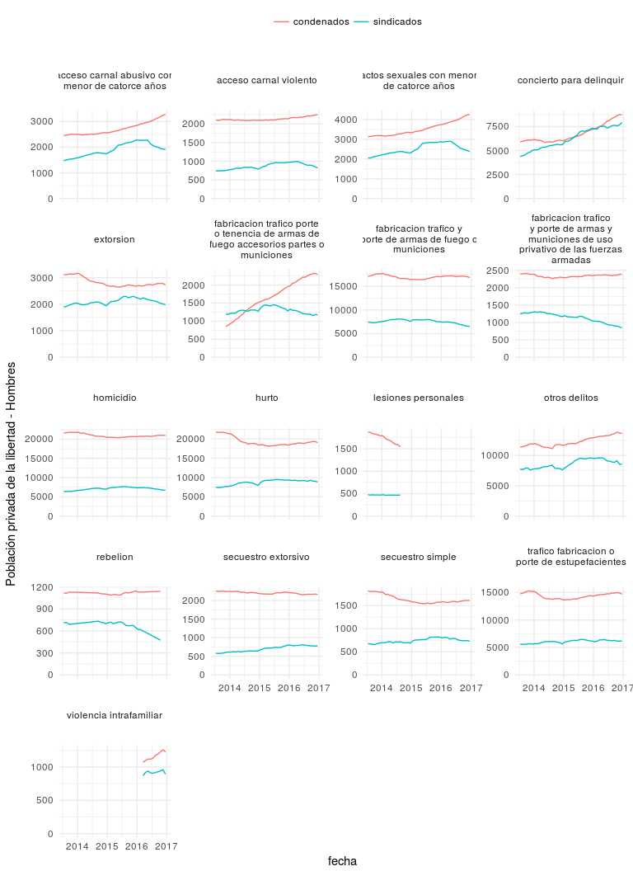

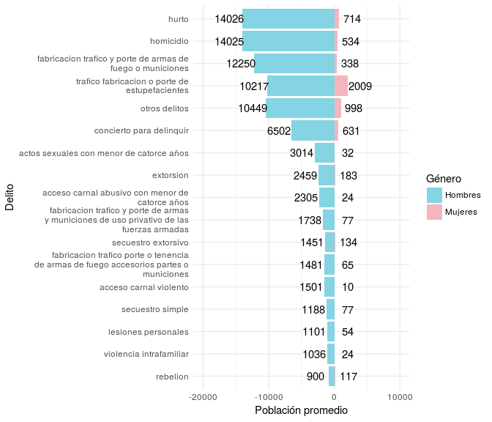

### DUMMY 2014

## Success! Converged in 529 iterations.  
## Function MARSSkfas used for likelihood calculation.  
##   
## MARSS fit is  
## Estimation method: BFGS   
## Estimation converged in 529 iterations.   
## Log-likelihood: -568.744   
## AIC: 1163.488 AICc: 1168.841   
##   
## Estimate  
## R.R11 9.48e+04  
## R.R12 9.81e+04  
## R.R22 1.09e+05  
## B.b1 9.87e-01  
## B.b2 4.31e-02  
## B.b4 9.80e-01  
## U.u1 1.60e+02  
## U.u2 4.52e+00  
## Q.q11 3.37e+04  
## Q.q12 -3.11e+04  
## Q.q22 2.87e+04  
## C.X.sindicados -4.37e+01  
## C.X.condenados -1.65e+02  
## Initial states (x0) defined at t=0  
##   
## Standard errors have not been calculated.   
## Use MARSSparamCIs to compute CIs and bias estimates.

## $Z  
## [,1]  
##   
## $A  
## [,1]  
##   
## $R  
## [,1]  
## R11 94817.73  
## R12 98053.30  
## R22 108601.75  
##   
## $B  
## [,1]  
## b1 0.9868024  
## b2 0.0430937  
## b4 0.9802668  
##   
## $U  
## [,1]  
## X.sindicados -43.68055  
## X.condenados -165.47494  
## u1 159.96059  
## u2 4.52188  
##   
## $Q  
## [,1]  
## q11 33710.90  
## q12 -31117.11  
## q22 28726.86  
##   
## $x0  
## [,1]  
##   
## $V0  
## [,1]  
##   
## $G  
## [,1]  
##   
## $H  
## [,1]  
##   
## $L  
## [,1]

