2017 Baby weaning

IL, RSU, SU

Table of Contents

# Data analysis

Data extracted was tabulated in a google sheet. Then exported as csv file and imported in R (R Core Team (2017). R: A language and environment for statistical computing. R Foundation for Statistical Computing, Vienna, Austria. URL <https://www.R-project.org/>.)

The package meta was used for the meta-analysis. The heterogenicity between studies was checked with Tau2. A funnel plot was used to detect publication bias. We grouped the comparison and outcomes to compare studies. A random effect meta-analysis using odds-ratio as outcome was performed with a DerSimonian and Lard method (add reference DerSimonian 1986) . A forest plot was used to visualize the association between the exposure to specific risk factors and the outcome.

Risk factors were grouped in reports focused to drink, food or breastfeeding and outcomes were severe early-childhood caries (s-ECC), white spot lesions (WSL) or caries measured in ICDAS>0.

# Paquetes

# Dataset

# df <- read_csv("https://docs.google.com/spreadsheets/d/e/2PACX-1vR2cxtO3yvM7-qsEibr9s5dsWh-JCsItf0Vi1GkmKcxv9MxFqwLcbpoQdjEeAVWOpq7Q7EPzznqzdB0/pub?gid=0&single=true&output=csv")  
  
df <- read_csv("2017-weaning.csv")

## Parsed with column specification:  
## cols(  
## id = col_character(),  
## `Risk factor` = col_character(),  
## Comparison = col_character(),  
## Outcome = col_character(),  
## `Group A - Protector` = col_character(),  
## `Group B - Risk factor` = col_character(),  
## `Events in A` = col_integer(),  
## `Total in A` = col_integer(),  
## `Events in B` = col_integer(),  
## `Total in B` = col_integer()  
## )

df <- mutate(df, Groups = paste(Comparison, Outcome))  
df <- df %>%   
 filter(!str_detect(id, "Un Lam et al")) #avoid Un Lam papers

## Data cleaning

# ANALYSIS

## Breastfeeding and s-ECC

### Selection of papers

df_b_ecc <- df %>%  
 filter(Groups == "Breastfeed S-ECC")

meta1 <- metabin(`Events in A`, `Total in A`,   
 `Events in B`, `Total in B`,   
 data = df_b_ecc, #change this line   
 sm="OR", method.tau = "DL",   
 comb.fixed = FALSE,   
 studlab = id)

### Bias

funnel.meta(meta1,   
 studlab = TRUE)

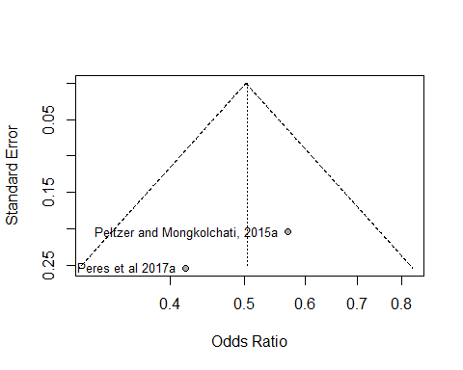

### Heterogeneity

Baujat B, Mahé C, Pignon JP, Hill C (2002), A graphical method for exploring heterogeneity in meta-analyses: Application to a meta-analysis of 65 trials. Statistics in Medicine, 30, 2641–2652.

baujat.meta(meta1,   
 yscale = 10, xmin = 2, ymin = 2,   
 cex.studlab = .55)

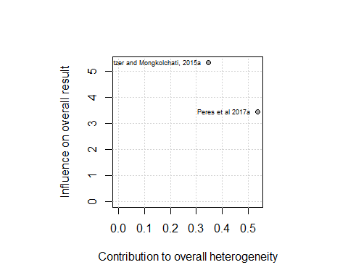

### Meta-analysis

meta1 <- metabin(`Events in A`, `Total in A`,   
 `Events in B`, `Total in B`,   
 data = df_b_ecc,   
 sm="OR", method.tau = "DL",   
 comb.fixed = FALSE,   
 studlab = id)

summary(meta1)

## Number of studies combined: k = 2  
##   
## OR 95%-CI z p-value  
## Random effects model 0.5046 [0.3693; 0.6895] -4.29 < 0.0001  
##   
## Quantifying heterogeneity:  
## tau^2 = 0; H = 1.00; I^2 = 0.0%  
##   
## Test of heterogeneity:  
## Q d.f. p-value  
## 0.88 1 0.3480  
##   
## Details on meta-analytical method:  
## - Mantel-Haenszel method  
## - DerSimonian-Laird estimator for tau^2

meta1

## OR 95%-CI %W(random)  
## Peltzer and Mongkolchati, 2015a 0.5690 [0.3812; 0.8492] 60.8  
## Peres et al 2017a 0.4190 [0.2545; 0.6897] 39.2  
##   
## Number of studies combined: k = 2  
##   
## OR 95%-CI z p-value  
## Random effects model 0.5046 [0.3693; 0.6895] -4.29 < 0.0001  
##   
## Quantifying heterogeneity:  
## tau^2 = 0; H = 1.00; I^2 = 0.0%  
##   
## Test of heterogeneity:  
## Q d.f. p-value  
## 0.88 1 0.3480  
##   
## Details on meta-analytical method:  
## - Mantel-Haenszel method  
## - DerSimonian-Laird estimator for tau^2

#### Forest plot

forest.meta(meta1, # layout = "JAMA", # JAMA layout is more simple   
 comb.fixed = FALSE,  
 # LEFT  
 label.left = "Breastfeeding 1-23 mo",   
 col.label.left = "darkgreen",   
 # RIGHT  
 label.right = "No Breastfeeding or >24 mo BF",  
 col.label.right = "darkred")

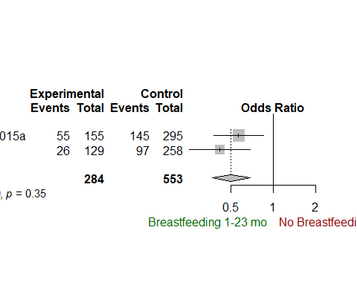

## Sugary drinks and s-ECC

### Selection of papers

df_b_ecc <- df %>%  
 filter(Groups == "Drink S-ECC")  
df_b_ecc

## # A tibble: 2 × 11  
## id `Risk factor`  
## <chr> <chr>  
## 1 Peltzer and Mongkolchati, 2015b Introduction to soft drinks  
## 2 Peltzer and Mongkolchati, 2015c Sleeps with bottle at 30 months  
## # ... with 9 more variables: Comparison <chr>, Outcome <chr>, `Group A -  
## # Protector` <chr>, `Group B - Risk factor` <chr>, `Events in A` <int>,  
## # `Total in A` <int>, `Events in B` <int>, `Total in B` <int>,  
## # Groups <chr>

meta1 <- metabin(`Events in A`, `Total in A`,   
 `Events in B`, `Total in B`,   
 data = df_b_ecc, #change this line   
 sm="OR", method.tau = "DL",   
 comb.fixed = FALSE,   
 studlab = id)

### Bias

funnel.meta(meta1,   
 studlab = TRUE)

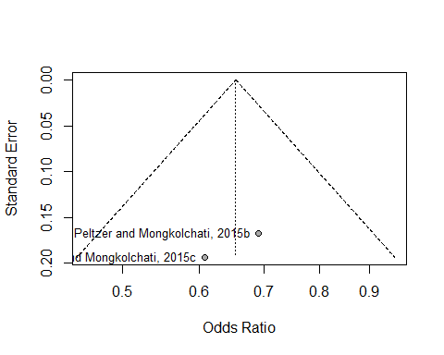

### Heterogeneity

Baujat B, Mahé C, Pignon JP, Hill C (2002), A graphical method for exploring heterogeneity in meta-analyses: Application to a meta-analysis of 65 trials. Statistics in Medicine, 30, 2641–2652.

baujat.meta(meta1,   
 yscale = 10, xmin = 1, ymin = 1,   
 studlab = TRUE ,   
 cex.studlab = .55)

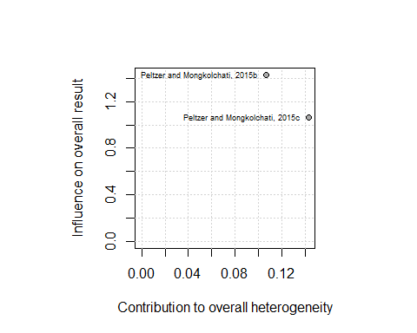

### Meta-analysis

meta1 <- metabin(`Events in A`, `Total in A`,   
 `Events in B`, `Total in B`,   
 data = df_b_ecc,   
 sm="OR", method.tau = "DL",   
 comb.fixed = FALSE,   
 studlab = id)

summary(meta1)

## Number of studies combined: k = 2  
##   
## OR 95%-CI z p-value  
## Random effects model 0.6544 [0.5107; 0.8384] -3.35 0.0008  
##   
## Quantifying heterogeneity:  
## tau^2 = 0; H = 1.00; I^2 = 0.0%  
##   
## Test of heterogeneity:  
## Q d.f. p-value  
## 0.25 1 0.6172  
##   
## Details on meta-analytical method:  
## - Mantel-Haenszel method  
## - DerSimonian-Laird estimator for tau^2

meta1

## OR 95%-CI %W(random)  
## Peltzer and Mongkolchati, 2015b 0.6911 [0.4981; 0.9589] 57.3  
## Peltzer and Mongkolchati, 2015c 0.6082 [0.4163; 0.8885] 42.7  
##   
## Number of studies combined: k = 2  
##   
## OR 95%-CI z p-value  
## Random effects model 0.6544 [0.5107; 0.8384] -3.35 0.0008  
##   
## Quantifying heterogeneity:  
## tau^2 = 0; H = 1.00; I^2 = 0.0%  
##   
## Test of heterogeneity:  
## Q d.f. p-value  
## 0.25 1 0.6172  
##   
## Details on meta-analytical method:  
## - Mantel-Haenszel method  
## - DerSimonian-Laird estimator for tau^2

#### Forest plot

df_b_ecc

## # A tibble: 2 × 11  
## id `Risk factor`  
## <chr> <chr>  
## 1 Peltzer and Mongkolchati, 2015b Introduction to soft drinks  
## 2 Peltzer and Mongkolchati, 2015c Sleeps with bottle at 30 months  
## # ... with 9 more variables: Comparison <chr>, Outcome <chr>, `Group A -  
## # Protector` <chr>, `Group B - Risk factor` <chr>, `Events in A` <int>,  
## # `Total in A` <int>, `Events in B` <int>, `Total in B` <int>,  
## # Groups <chr>

forest.meta(meta1, # layout = "JAMA", # JAMA layout is more simple   
 comb.fixed = FALSE,  
 # LEFT  
 label.left = "No sugary drinks",   
 col.label.left = "darkgreen",   
 # RIGHT  
 label.right = "Sugary drinks",  
 col.label.right = "darkred")

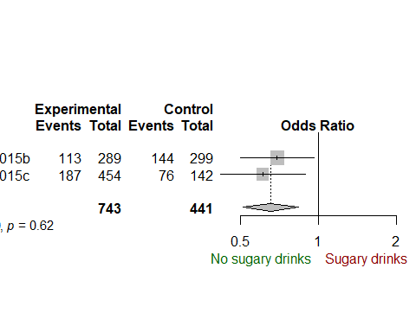

## Food White and spot lesions

### Selection of papers

df_b_ecc <- df %>%  
 filter(Groups == "Food White spot lesions")

meta1 <- metabin(`Events in A`, `Total in A`,   
 `Events in B`, `Total in B`,   
 data = df_b_ecc, #change this line   
 sm="OR", method.tau = "DL",   
 comb.fixed = FALSE,   
 studlab = id)

### Bias

funnel.meta(meta1,   
 studlab = TRUE)

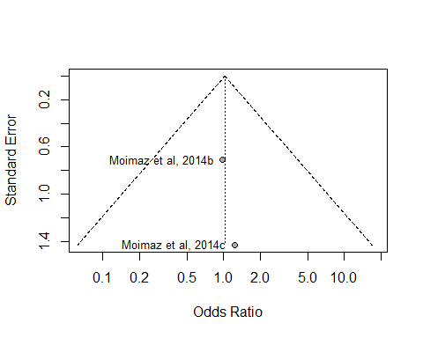

### Heterogeneity

Baujat B, Mahé C, Pignon JP, Hill C (2002), A graphical method for exploring heterogeneity in meta-analyses: Application to a meta-analysis of 65 trials. Statistics in Medicine, 30, 2641–2652.

baujat.meta(meta1,   
 yscale = 10, xmin = 1, ymin = 1,   
 studlab = TRUE ,   
 cex.studlab = .55)

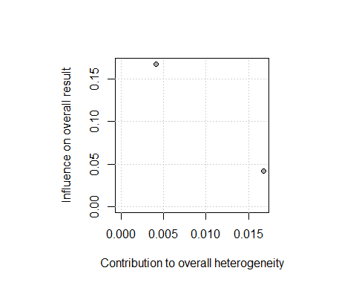

### Meta-analysis

meta1 <- metabin(`Events in A`, `Total in A`,   
 `Events in B`, `Total in B`,   
 data = df_b_ecc,   
 sm="OR", method.tau = "DL",   
 comb.fixed = FALSE,   
 studlab = id)

summary(meta1)

## Number of studies combined: k = 2  
##   
## OR 95%-CI z p-value  
## Random effects model 1.0207 [0.2926; 3.5611] 0.03 0.9744  
##   
## Quantifying heterogeneity:  
## tau^2 = 0; H = 1.00; I^2 = 0.0%  
##   
## Test of heterogeneity:  
## Q d.f. p-value  
## 0.02 1 0.8851  
##   
## Details on meta-analytical method:  
## - Mantel-Haenszel method  
## - DerSimonian-Laird estimator for tau^2

meta1

## OR 95%-CI %W(random)  
## Moimaz et al, 2014b 0.9750 [0.2415; 3.9358] 80.2  
## Moimaz et al, 2014c 1.2286 [0.0742; 20.3554] 19.8  
##   
## Number of studies combined: k = 2  
##   
## OR 95%-CI z p-value  
## Random effects model 1.0207 [0.2926; 3.5611] 0.03 0.9744  
##   
## Quantifying heterogeneity:  
## tau^2 = 0; H = 1.00; I^2 = 0.0%  
##   
## Test of heterogeneity:  
## Q d.f. p-value  
## 0.02 1 0.8851  
##   
## Details on meta-analytical method:  
## - Mantel-Haenszel method  
## - DerSimonian-Laird estimator for tau^2

#### Forest plot

forest.meta(meta1, # layout = "JAMA", # JAMA layout is more simple   
 comb.fixed = FALSE,  
 # LEFT  
 label.left = "No sugary snacks",   
 col.label.left = "darkgreen",   
 # RIGHT  
 label.right = "Sugary snacks",  
 col.label.right = "darkred")

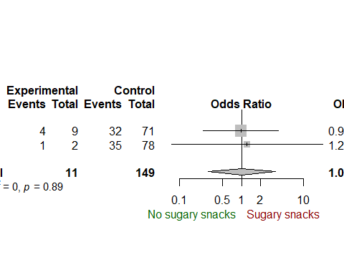

# References

citation()

##   
## To cite R in publications use:  
##   
## R Core Team (2017). R: A language and environment for  
## statistical computing. R Foundation for Statistical Computing,  
## Vienna, Austria. URL https://www.R-project.org/.  
##   
## A BibTeX entry for LaTeX users is  
##   
## @Manual{,  
## title = {R: A Language and Environment for Statistical Computing},  
## author = {{R Core Team}},  
## organization = {R Foundation for Statistical Computing},  
## address = {Vienna, Austria},  
## year = {2017},  
## url = {https://www.R-project.org/},  
## }  
##   
## We have invested a lot of time and effort in creating R, please  
## cite it when using it for data analysis. See also  
## 'citation("pkgname")' for citing R packages.

citation(package = "tidyverse")

##   
## To cite package 'tidyverse' in publications use:  
##   
## Hadley Wickham (2017). tidyverse: Easily Install and Load  
## 'Tidyverse' Packages. R package version 1.1.1.  
## https://CRAN.R-project.org/package=tidyverse  
##   
## A BibTeX entry for LaTeX users is  
##   
## @Manual{,  
## title = {tidyverse: Easily Install and Load 'Tidyverse' Packages},  
## author = {Hadley Wickham},  
## year = {2017},  
## note = {R package version 1.1.1},  
## url = {https://CRAN.R-project.org/package=tidyverse},  
## }

citation(package = "stringr")

##   
## To cite package 'stringr' in publications use:  
##   
## Hadley Wickham (2017). stringr: Simple, Consistent Wrappers for  
## Common String Operations. R package version 1.2.0.  
## https://CRAN.R-project.org/package=stringr  
##   
## A BibTeX entry for LaTeX users is  
##   
## @Manual{,  
## title = {stringr: Simple, Consistent Wrappers for Common String Operations},  
## author = {Hadley Wickham},  
## year = {2017},  
## note = {R package version 1.2.0},  
## url = {https://CRAN.R-project.org/package=stringr},  
## }

citation(package = "meta")

##   
## To cite package 'meta' in publications use:  
##   
## Guido Schwarzer (2007), meta: An R package for meta-analysis, R  
## News, 7(3), 40-45.  
##   
## A BibTeX entry for LaTeX users is  
##   
## @Article{,  
## title = {meta: {A}n {R} package for meta-analysis},  
## author = {Guido Schwarzer},  
## journal = {R News},  
## year = {2007},  
## volume = {7},  
## number = {3},  
## pages = {40--45},  
## }  
##   
## URL https://cran.r-project.org/doc/Rnews/Rnews_2007-3.pdf