2017 Repair dental restorations

IM, RSU, SU

Table of Contents

Data extracted was tabulated in a google sheet. Then exported as csv file and imported in R (R Core Team (2017). R: A language and environment for statistical computing. R Foundation for Statistical Computing, Vienna, Austria. URL <https://www.R-project.org/>.)

Data cleaning and organization was done with package tidyverse (Hadley Wickham (2017). tidyverse: Easily Install and Load the 'Tidyverse'. R package version 1.2.1. <https://CRAN.R-project.org/package=tidyverse>).

The package meta (Guido Schwarzer (2007), meta: An R package for meta-analysis, R News, 7(3), 40-45.) was used for the meta-analysis. A funnel plot was used to detect publication bias. The heterogenicity between studies was checked with I2 and visualized with a Baujat plot (Baujat B, Mahé C, Pignon JP, Hill C (2002), A graphical method for exploring heterogeneity in meta-analyses: Application to a meta-analysis of 65 trials. Statistics in Medicine, 30, 2641–2652.). We grouped the studies with same intervention and control and considered any adverse outcome. A random effect meta-analysis using odds-ratio as outcome was performed with a Mantel-Haenzel method. A forest plot was used to visualize the overall effect of the interventions, with a 95% confidence interval.

# Paquetes

# Dataset

df <- read_csv("https://docs.google.com/spreadsheets/d/e/2PACX-1vRSKuBlcQTVJK2fZyZ4Nvf4SwSqVrxcfAGhNhl6dWHU9W39oppE4Pl4lcPy-0CRGRTqQQ0IHwFgfrY8/pub?gid=0&single=true&output=csv")

## Parsed with column specification:  
## cols(  
## Comparison = col_character(),  
## Material = col_character(),  
## firstAuthor = col_character(),  
## year = col_character(),  
## paper = col_character(),  
## quality = col_character(),  
## intervention_a = col_character(),  
## intervention_b = col_character(),  
## EvA = col_character(),  
## TotalA = col_character(),  
## EvB = col_character(),  
## TotalB = col_character(),  
## Outcome = col_character(),  
## Comments = col_character()  
## )

## Data cleaning

glimpse(df)

## Observations: 55  
## Variables: 14  
## $ Comparison <chr> "Sealants vs no-treatment Kz", "Sealants vs rep...  
## $ Material <chr> "Composite", NA, NA, "Composite", NA, NA, "Comp...  
## $ firstAuthor <chr> "Gordan", "Gordan", NA, "Gordan", "Gordan", NA,...  
## $ year <chr> "2009", "2011", NA, "2009", "2011", NA, "2009",...  
## $ paper <chr> "a", NA, NA, "b", NA, NA, "f", "g", NA, "b", "b...  
## $ quality <chr> NA, NA, NA, NA, NA, NA, NA, NA, "--------------...  
## $ intervention_a <chr> "Sealant", "Sealant", NA, "Sealant", "Sealant",...  
## $ intervention_b <chr> "No-treatment", "Replacement", NA, "No-treatmen...  
## $ EvA <chr> "2", NA, NA, "0", NA, NA, "7", "1", "----------...  
## $ TotalA <chr> "7", NA, NA, "7", NA, NA, "11", "11", "--------...  
## $ EvB <chr> "5", NA, NA, "1", NA, NA, "5", "1", "----------...  
## $ TotalB <chr> "13", NA, NA, "13", NA, NA, "13", "13", "------...  
## $ Outcome <chr> "MA", NA, NA, "SC", NA, NA, "MA", "SC", "------...  
## $ Comments <chr> NA, "SC-secondary caries", "PS-postoperative se...

Clean dataset from empty rows, strange symbols, etc

df <- df %>% filter(str_detect(df$Comparison, "vs"),   
 trimws(EvA) != "",   
 !str_detect(EvA, "\\?"),   
 !str_detect(EvA, "%") )

## Warning: package 'bindrcpp' was built under R version 3.4.2

df$firstAuthor <- str_trim(df$firstAuthor, "right")

Select only relevant columns

df <- df %>% select(Comparison:Outcome) %>%   
 select(-quality)

create a new column id

df <- mutate(df, id = paste(firstAuthor, ", ", year, paper))

## Dataset clean

Converting factors to numeric variables

glimpse(df)

## Observations: 33  
## Variables: 13  
## $ Comparison <chr> "Sealants vs no-treatment Kz", "Sealants vs no-...  
## $ Material <chr> "Composite", "Composite", "Composite", "Composi...  
## $ firstAuthor <chr> "Gordan", "Gordan", "Gordan", "Gordan", "Gordan...  
## $ year <chr> "2009", "2009", "2009", "2009", "2011", "2011",...  
## $ paper <chr> "a", "b", "f", "g", "b", "b", "b", "d", "e", "f...  
## $ intervention_a <chr> "Sealant", "Sealant", "Refinishing", "Refinishi...  
## $ intervention_b <chr> "No-treatment", "No-treatment", "No-treatment",...  
## $ EvA <chr> "2", "0", "7", "1", "1", "1", "1", "0", "0", "1...  
## $ TotalA <chr> "7", "7", "11", "11", "14", "14", "14", "14", "...  
## $ EvB <chr> "5", "1", "5", "1", "7", "7", "7", "7", "1", "1...  
## $ TotalB <chr> "13", "13", "13", "13", "19", "19", "19", "14",...  
## $ Outcome <chr> "MA", "SC", "MA", "SC", "MA", "SC", "TS", "MA",...  
## $ id <chr> "Gordan , 2009 a", "Gordan , 2009 b", "Gordan...

df$EvA <- as.integer(df$EvA)  
df$TotalA <- as.integer(df$TotalA)  
df$EvB <- as.integer(df$EvB)  
df$TotalB <- as.integer(df$TotalB)  
  
df <- df %>%   
 mutate(groups = paste(Comparison, Outcome))

summary(df)

## Comparison Material firstAuthor   
## Length:33 Length:33 Length:33   
## Class :character Class :character Class :character   
## Mode :character Mode :character Mode :character   
##   
##   
##   
## year paper intervention_a   
## Length:33 Length:33 Length:33   
## Class :character Class :character Class :character   
## Mode :character Mode :character Mode :character   
##   
##   
##   
## intervention_b EvA TotalA EvB   
## Length:33 Min. : 0.000 Min. : 7.0 Min. : 0.00   
## Class :character 1st Qu.: 1.000 1st Qu.:14.0 1st Qu.: 1.00   
## Mode :character Median : 2.000 Median :15.0 Median : 2.00   
## Mean : 4.455 Mean :20.7 Mean : 5.03   
## 3rd Qu.: 7.000 3rd Qu.:20.0 3rd Qu.: 7.00   
## Max. :45.000 Max. :66.0 Max. :35.00   
## TotalB Outcome id groups   
## Min. :13.00 Length:33 Length:33 Length:33   
## 1st Qu.:14.00 Class :character Class :character Class :character   
## Median :19.00 Mode :character Mode :character Mode :character   
## Mean :21.94   
## 3rd Qu.:22.00   
## Max. :58.00

Create groups for comparisons

Any intervention (Sealant, Refinishing or Repair) vs grouped comparison and grouped outcome

df <- mutate(df, groups = paste( intervention_b, Outcome))  
table(df$groups)

##   
## No-treatment all parameters No-treatment MA   
## 1 6   
## No-treatment SC No-treatment SR   
## 6 1   
## No-treatment TS Replacement all parameters   
## 3 1   
## Replacement MA Replacement SC   
## 5 5   
## Replacement TS   
## 5

# 1. No-treatment MA (6)

## Data selection

data_meta <- df %>%   
 filter(groups == "No-treatment MA")

meta1 <- metabin(EvA, TotalA,   
 EvB, TotalB,   
 data = data_meta,   
 sm="OR", method.tau = "DL",   
 comb.fixed = FALSE,   
 studlab = paste(firstAuthor, year, intervention_a))

## Bias

funnel.meta(meta1,   
 studlab = TRUE)

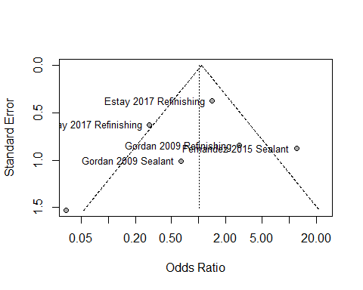

## Heterogeneity

baujat.meta(meta1,   
 yscale = 10, xmin = 3, ymin = 10,   
 cex.studlab = .50)

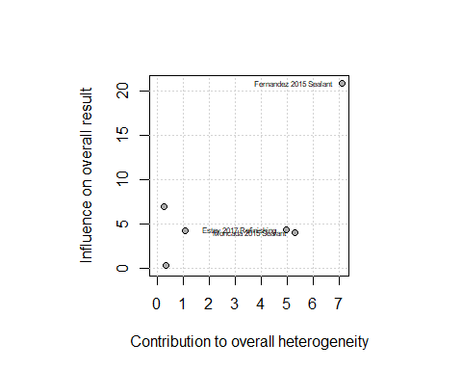

## Meta-analysis and forest plot

summary(meta1)

## Number of studies combined: k = 6  
##   
## OR 95%-CI z p-value  
## Random effects model 1.0181 [0.3054; 3.3946] 0.03 0.9767  
##   
## Quantifying heterogeneity:  
## tau^2 = 1.5285; H = 1.95 [1.29; 2.95]; I^2 = 73.8% [40.2%; 88.5%]  
##   
## Test of heterogeneity:  
## Q d.f. p-value  
## 19.10 5 0.0018  
##   
## Details on meta-analytical method:  
## - Mantel-Haenszel method  
## - DerSimonian-Laird estimator for tau^2  
## - Continuity correction of 0.5 in studies with zero cell frequencies

meta1

## OR 95%-CI %W(random)  
## Gordan 2009 Sealant 0.6400 [0.0880; 4.6554] 14.8  
## Gordan 2009 Refinishing 2.8000 [0.5321; 14.7350] 16.8  
## Moncada 2015 Sealant 0.0345 [0.0017; 0.6894] 9.8  
## Estay 2017 Refinishing 0.2864 [0.0836; 0.9813] 19.6  
## Fernandez 2015 Sealant 12.0000 [2.1471; 67.0674] 16.4  
## Estay 2017 Refinishing 1.4082 [0.6730; 2.9464] 22.6  
##   
## Number of studies combined: k = 6  
##   
## OR 95%-CI z p-value  
## Random effects model 1.0181 [0.3054; 3.3946] 0.03 0.9767  
##   
## Quantifying heterogeneity:  
## tau^2 = 1.5285; H = 1.95 [1.29; 2.95]; I^2 = 73.8% [40.2%; 88.5%]  
##   
## Test of heterogeneity:  
## Q d.f. p-value  
## 19.10 5 0.0018  
##   
## Details on meta-analytical method:  
## - Mantel-Haenszel method  
## - DerSimonian-Laird estimator for tau^2  
## - Continuity correction of 0.5 in studies with zero cell frequencies

forest.meta(meta1,   
 comb.fixed = FALSE,  
 sortvar = year,   
 # LEFT  
 label.left = "Seal or ref.",   
 col.label.left = "darkgreen",   
 # RIGHT  
 label.right = "No treatment",  
 col.label.right = "darkred")

## Warning: Unknown or uninitialised column: '.subset'.

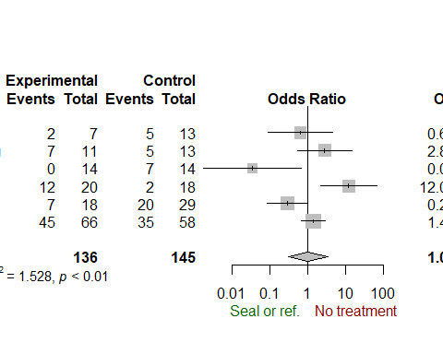

# 2. No-treatment SC (6)

## Data selection

data_meta <- df %>%   
 filter(groups == "No-treatment SC")  
data_meta

## # A tibble: 6 x 14  
## Comparison Material firstAuthor year paper  
## <chr> <chr> <chr> <chr> <chr>  
## 1 Sealants vs no-treatment Kz Composite Gordan 2009 b  
## 2 Refinishing vs no-treatment Kz Composite Gordan 2009 g  
## 3 Sealants vs no-treatment Ag Amalgam Moncada 2015 e  
## 4 Refinishing vs no-treatment Kz Composite Estay 2017 k  
## 5 Sealants vs no-treatment Kz Composite Fernandez 2015 b  
## 6 Refinishing vs no-treatment Ag Amalgam Estay 2017 h  
## # ... with 9 more variables: intervention_a <chr>, intervention_b <chr>,  
## # EvA <int>, TotalA <int>, EvB <int>, TotalB <int>, Outcome <chr>,  
## # id <chr>, groups <chr>

meta1 <- metabin(EvA, TotalA,   
 EvB, TotalB,   
 data = data_meta,   
 sm="OR", method.tau = "DL",   
 comb.fixed = FALSE,   
 studlab = paste(firstAuthor, year, intervention_a))

## Bias

funnel.meta(meta1,   
 studlab = TRUE,   
 cex.studlab = .55)

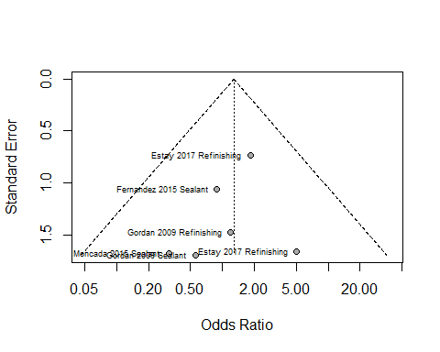

## Heterogeneity

baujat.meta(meta1,   
 yscale = 10, xmin = 3, ymin = 10,   
 cex.studlab = .50)

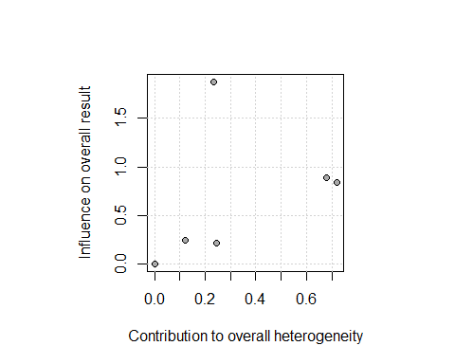

## Meta-analysis and forest plot

summary(meta1)

## Number of studies combined: k = 6  
##   
## OR 95%-CI z p-value  
## Random effects model 1.286 [0.4991; 3.3137] 0.52 0.6024  
##   
## Quantifying heterogeneity:  
## tau^2 = 0; H = 1.00 [1.00; 1.26]; I^2 = 0.0% [0.0%; 36.7%]  
##   
## Test of heterogeneity:  
## Q d.f. p-value  
## 2.00 5 0.8487  
##   
## Details on meta-analytical method:  
## - Mantel-Haenszel method  
## - DerSimonian-Laird estimator for tau^2  
## - Continuity correction of 0.5 in studies with zero cell frequencies

meta1

## OR 95%-CI %W(random)  
## Gordan 2009 Sealant 0.5556 [0.0200; 15.4620] 8.1  
## Gordan 2009 Refinishing 1.2000 [0.0663; 21.7233] 10.7  
## Moncada 2015 Sealant 0.3103 [0.0116; 8.2917] 8.3  
## Estay 2017 Refinishing 5.0571 [0.1952; 131.0509] 8.5  
## Fernandez 2015 Sealant 0.8889 [0.1119; 7.0614] 20.9  
## Estay 2017 Refinishing 1.8333 [0.4372; 7.6869] 43.6  
##   
## Number of studies combined: k = 6  
##   
## OR 95%-CI z p-value  
## Random effects model 1.286 [0.4991; 3.3137] 0.52 0.6024  
##   
## Quantifying heterogeneity:  
## tau^2 = 0; H = 1.00 [1.00; 1.26]; I^2 = 0.0% [0.0%; 36.7%]  
##   
## Test of heterogeneity:  
## Q d.f. p-value  
## 2.00 5 0.8487  
##   
## Details on meta-analytical method:  
## - Mantel-Haenszel method  
## - DerSimonian-Laird estimator for tau^2  
## - Continuity correction of 0.5 in studies with zero cell frequencies

forest.meta(meta1,   
 comb.fixed = FALSE,  
 sortvar = year,   
 # LEFT  
 label.left = "Seal or refinishing",   
 col.label.left = "darkgreen",   
 # RIGHT  
 label.right = "No treatment",  
 col.label.right = "darkred")

## Warning: Unknown or uninitialised column: '.subset'.

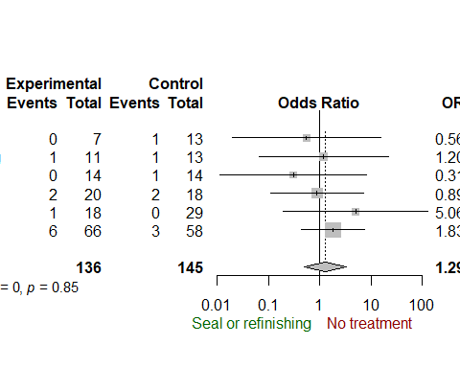

# 3. No-treatment TS (3)

## Data selection

data_meta <- df %>%   
 filter(groups == "No-treatment TS")  
data_meta

## # A tibble: 3 x 14  
## Comparison Material firstAuthor year paper  
## <chr> <chr> <chr> <chr> <chr>  
## 1 Sealants vs no-treatment Ag Amalgam Moncada 2015 f  
## 2 Refinishing vs no-treatment Kz Composite Estay 2017 l  
## 3 Refinishing vs no-treatment Ag Amalgam Estay 2017 i  
## # ... with 9 more variables: intervention_a <chr>, intervention_b <chr>,  
## # EvA <int>, TotalA <int>, EvB <int>, TotalB <int>, Outcome <chr>,  
## # id <chr>, groups <chr>

meta1 <- metabin(EvA, TotalA,   
 EvB, TotalB,   
 data = data_meta,   
 sm="OR", method.tau = "DL",   
 comb.fixed = FALSE,   
 studlab = paste(firstAuthor, year, intervention_a))

## Bias

funnel.meta(meta1,   
 studlab = TRUE,   
 cex.studlab = .55)

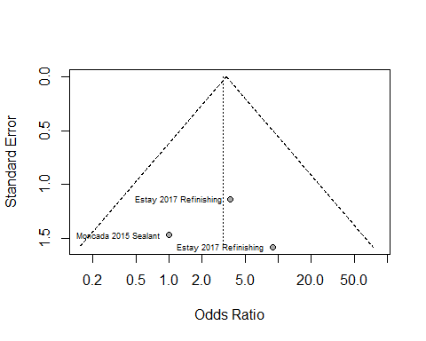

## Heterogeneity

baujat.meta(meta1,   
 yscale = 10, xmin = 3, ymin = 10,   
 cex.studlab = .50)

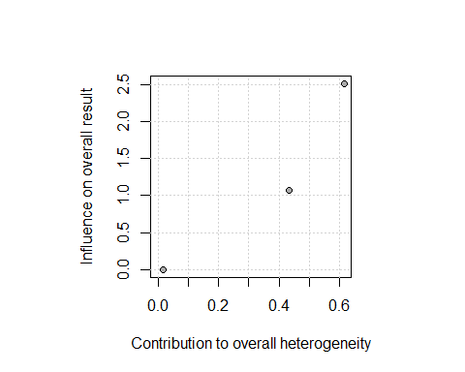

## Meta-analysis and forest plot

summary(meta1)

## Number of studies combined: k = 3  
##   
## OR 95%-CI z p-value  
## Random effects model 3.1616 [0.6856; 14.5791] 1.48 0.1400  
##   
## Quantifying heterogeneity:  
## tau^2 = 0; H = 1.00 [1.00; 2.27]; I^2 = 0.0% [0.0%; 80.6%]  
##   
## Test of heterogeneity:  
## Q d.f. p-value  
## 1.07 2 0.5850  
##   
## Details on meta-analytical method:  
## - Mantel-Haenszel method  
## - DerSimonian-Laird estimator for tau^2  
## - Continuity correction of 0.5 in studies with zero cell frequencies

meta1

## OR 95%-CI %W(random)  
## Moncada 2015 Sealant 1.0000 [0.0563; 17.7510] 28.2  
## Estay 2017 Refinishing 8.9394 [0.4045; 197.5585] 24.4  
## Estay 2017 Refinishing 3.6774 [0.3992; 33.8804] 47.4  
##   
## Number of studies combined: k = 3  
##   
## OR 95%-CI z p-value  
## Random effects model 3.1616 [0.6856; 14.5791] 1.48 0.1400  
##   
## Quantifying heterogeneity:  
## tau^2 = 0; H = 1.00 [1.00; 2.27]; I^2 = 0.0% [0.0%; 80.6%]  
##   
## Test of heterogeneity:  
## Q d.f. p-value  
## 1.07 2 0.5850  
##   
## Details on meta-analytical method:  
## - Mantel-Haenszel method  
## - DerSimonian-Laird estimator for tau^2  
## - Continuity correction of 0.5 in studies with zero cell frequencies

forest.meta(meta1,   
 comb.fixed = FALSE,  
 sortvar = year,   
 # LEFT  
 label.left = "Seal or refinish",   
 col.label.left = "darkgreen",   
 # RIGHT  
 label.right = "No treatment",  
 col.label.right = "darkred")

## Warning: Unknown or uninitialised column: '.subset'.

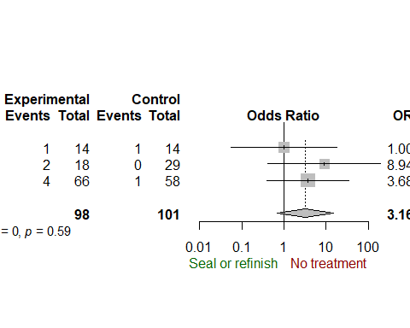

# 4. Replacement MA (5)

## Data selection

data_meta <- df %>%   
 filter(groups == "Replacement MA")  
data_meta

## # A tibble: 5 x 14  
## Comparison Material firstAuthor year paper  
## <chr> <chr> <chr> <chr> <chr>  
## 1 Repair vs replacement Ag Amalgam Gordan 2011 b  
## 2 Sealants vs replacement Ag Amalgam Moncada 2015 a  
## 3 Repair vs replacement Kz Composite Estay 2017 d  
## 4 Repair vs replacement Ag Amalgam Estay 2017 a  
## 5 Repair vs replacement Kz Composite Gordan 2009 c  
## # ... with 9 more variables: intervention_a <chr>, intervention_b <chr>,  
## # EvA <int>, TotalA <int>, EvB <int>, TotalB <int>, Outcome <chr>,  
## # id <chr>, groups <chr>

meta1 <- metabin(EvA, TotalA,   
 EvB, TotalB,   
 data = data_meta,   
 sm="OR", method.tau = "DL",   
 comb.fixed = FALSE,   
 studlab = paste(firstAuthor, year, intervention_a))

## Bias

funnel.meta(meta1,   
 studlab = TRUE,   
 cex.studlab = .55)

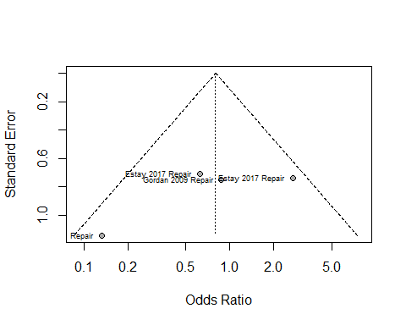

## Heterogeneity

baujat.meta(meta1,   
 yscale = 10, xmin = 3, ymin = 10,   
 cex.studlab = .50)

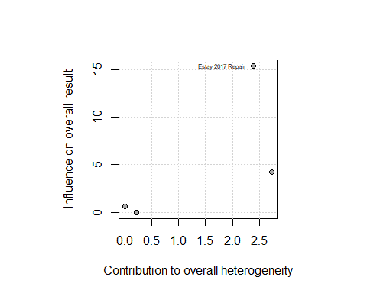

## Meta-analysis and forest plot

summary(meta1)

## Number of studies combined: k = 4  
##   
## OR 95%-CI z p-value  
## Random effects model 0.7996 [0.2774; 2.3052] -0.41 0.6789  
##   
## Quantifying heterogeneity:  
## tau^2 = 0.5096; H = 1.34 [1.00; 2.31]; I^2 = 44.1% [0.0%; 81.3%]  
##   
## Test of heterogeneity:  
## Q d.f. p-value  
## 5.37 3 0.1467  
##   
## Details on meta-analytical method:  
## - Mantel-Haenszel method  
## - DerSimonian-Laird estimator for tau^2

meta1

## OR 95%-CI %W(random)  
## Gordan 2011 Repair 0.1319 [0.0141; 1.2354] 16.1  
## Moncada 2015 Sealant NA 0.0  
## Estay 2017 Repair 0.6222 [0.1554; 2.4920] 28.9  
## Estay 2017 Repair 2.7045 [0.6384; 11.4576] 27.7  
## Gordan 2009 Repair 0.8750 [0.2020; 3.7907] 27.3  
##   
## Number of studies combined: k = 4  
##   
## OR 95%-CI z p-value  
## Random effects model 0.7996 [0.2774; 2.3052] -0.41 0.6789  
##   
## Quantifying heterogeneity:  
## tau^2 = 0.5096; H = 1.34 [1.00; 2.31]; I^2 = 44.1% [0.0%; 81.3%]  
##   
## Test of heterogeneity:  
## Q d.f. p-value  
## 5.37 3 0.1467  
##   
## Details on meta-analytical method:  
## - Mantel-Haenszel method  
## - DerSimonian-Laird estimator for tau^2

forest.meta(meta1,   
 comb.fixed = FALSE,  
 sortvar = year,   
 # LEFT  
 label.left = "Seal or repair",   
 col.label.left = "darkgreen",   
 # RIGHT  
 label.right = "No treatment",  
 col.label.right = "darkred")

## Warning: Unknown or uninitialised column: '.subset'.

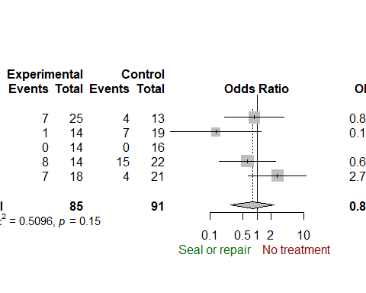

# 5. Replacement SC (5)

## Data selection

data_meta <- df %>%   
 filter(groups == "Replacement SC")  
data_meta

## # A tibble: 5 x 14  
## Comparison Material firstAuthor year paper  
## <chr> <chr> <chr> <chr> <chr>  
## 1 Repair vs replacement Ag Amalgam Gordan 2011 b  
## 2 Sealants vs replacement Ag Amalgam Moncada 2015 b  
## 3 Repair vs replacement Kz Composite Estay 2017 e  
## 4 Repair vs replacement Ag Amalgam Estay 2017 b  
## 5 Repair vs replacement Kz Composite Gordan 2009 d  
## # ... with 9 more variables: intervention_a <chr>, intervention_b <chr>,  
## # EvA <int>, TotalA <int>, EvB <int>, TotalB <int>, Outcome <chr>,  
## # id <chr>, groups <chr>

meta1 <- metabin(EvA, TotalA,   
 EvB, TotalB,   
 data = data_meta,   
 sm="OR", method.tau = "DL",   
 comb.fixed = FALSE,   
 studlab = paste(firstAuthor, year, intervention_a))

## Bias

funnel.meta(meta1,   
 studlab = TRUE,   
 cex.studlab = .55)

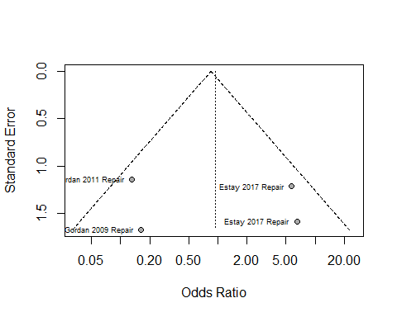

## Heterogeneity

baujat.meta(meta1,   
 yscale = 10, xmin = 3, ymin = 10,   
 cex.studlab = .50)

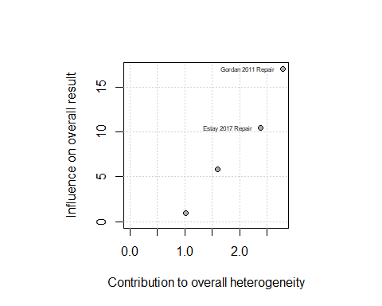

## Meta-analysis and forest plot

summary(meta1)

## Number of studies combined: k = 4  
##   
## OR 95%-CI z p-value  
## Random effects model 0.9363 [0.1065; 8.2309] -0.06 0.9526  
##   
## Quantifying heterogeneity:  
## tau^2 = 2.9848; H = 1.61 [1.00; 2.78]; I^2 = 61.4% [0.0%; 87.1%]  
##   
## Test of heterogeneity:  
## Q d.f. p-value  
## 7.77 3 0.0511  
##   
## Details on meta-analytical method:  
## - Mantel-Haenszel method  
## - DerSimonian-Laird estimator for tau^2  
## - Continuity correction of 0.5 in studies with zero cell frequencies

meta1

## OR 95%-CI %W(random)  
## Gordan 2011 Repair 0.1319 [0.0141; 1.2354] 28.7  
## Moncada 2015 Sealant NA 0.0  
## Estay 2017 Repair 5.7273 [0.5312; 61.7487] 27.6  
## Estay 2017 Repair 6.5152 [0.2925; 145.1132] 22.4  
## Gordan 2009 Repair 0.1634 [0.0062; 4.3051] 21.3  
##   
## Number of studies combined: k = 4  
##   
## OR 95%-CI z p-value  
## Random effects model 0.9363 [0.1065; 8.2309] -0.06 0.9526  
##   
## Quantifying heterogeneity:  
## tau^2 = 2.9848; H = 1.61 [1.00; 2.78]; I^2 = 61.4% [0.0%; 87.1%]  
##   
## Test of heterogeneity:  
## Q d.f. p-value  
## 7.77 3 0.0511  
##   
## Details on meta-analytical method:  
## - Mantel-Haenszel method  
## - DerSimonian-Laird estimator for tau^2  
## - Continuity correction of 0.5 in studies with zero cell frequencies

forest.meta(meta1,   
 comb.fixed = FALSE,  
 sortvar = year,   
 # LEFT  
 label.left = "Seal or repair",   
 col.label.left = "darkgreen",   
 # RIGHT  
 label.right = "No treatment",  
 col.label.right = "darkred")

## Warning: Unknown or uninitialised column: '.subset'.

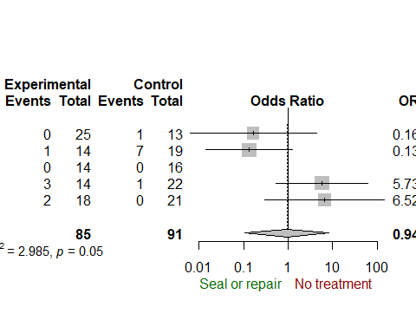

# 6. Replacement TS (5)

## Data selection

data_meta <- df %>%   
 filter(groups == "Replacement TS")  
data_meta

## # A tibble: 5 x 14  
## Comparison Material firstAuthor year paper  
## <chr> <chr> <chr> <chr> <chr>  
## 1 Repair vs replacement Ag Amalgam Gordan 2011 b  
## 2 Sealants vs replacement Ag Amalgam Moncada 2015 c  
## 3 Repair vs replacement Kz Composite Estay 2017 f  
## 4 Repair vs replacement Ag Amalgam Estay 2017 c  
## 5 Repair vs replacement Kz Composite Gordan 2009 e  
## # ... with 9 more variables: intervention_a <chr>, intervention_b <chr>,  
## # EvA <int>, TotalA <int>, EvB <int>, TotalB <int>, Outcome <chr>,  
## # id <chr>, groups <chr>

meta1 <- metabin(EvA, TotalA,   
 EvB, TotalB,   
 data = data_meta,   
 sm="OR", method.tau = "DL",   
 comb.fixed = FALSE,   
 studlab = paste(firstAuthor, year, intervention_a))

## Bias

funnel.meta(meta1,   
 studlab = TRUE,   
 cex.studlab = .55)

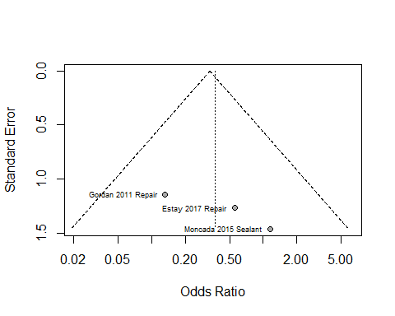

## Heterogeneity

baujat.meta(meta1,   
 yscale = 10, xmin = 3, ymin = 10,   
 cex.studlab = .50)

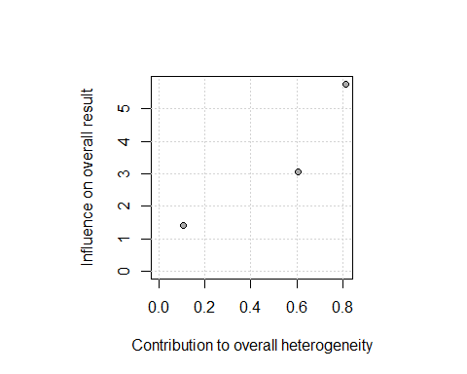

## Meta-analysis and forest plot

summary(meta1)

## Number of studies combined: k = 3  
##   
## OR 95%-CI z p-value  
## Random effects model 0.369 [0.0875; 1.5561] -1.36 0.1745  
##   
## Quantifying heterogeneity:  
## tau^2 = 0; H = 1.00 [1.00; 2.73]; I^2 = 0.0% [0.0%; 86.5%]  
##   
## Test of heterogeneity:  
## Q d.f. p-value  
## 1.55 2 0.4617  
##   
## Details on meta-analytical method:  
## - Mantel-Haenszel method  
## - DerSimonian-Laird estimator for tau^2

meta1

## OR 95%-CI %W(random)  
## Gordan 2011 Repair 0.1319 [0.0141; 1.2354] 41.4  
## Moncada 2015 Sealant 1.1538 [0.0654; 20.3419] 25.2  
## Estay 2017 Repair NA 0.0  
## Estay 2017 Repair 0.5588 [0.0464; 6.7269] 33.5  
## Gordan 2009 Repair NA 0.0  
##   
## Number of studies combined: k = 3  
##   
## OR 95%-CI z p-value  
## Random effects model 0.369 [0.0875; 1.5561] -1.36 0.1745  
##   
## Quantifying heterogeneity:  
## tau^2 = 0; H = 1.00 [1.00; 2.73]; I^2 = 0.0% [0.0%; 86.5%]  
##   
## Test of heterogeneity:  
## Q d.f. p-value  
## 1.55 2 0.4617  
##   
## Details on meta-analytical method:  
## - Mantel-Haenszel method  
## - DerSimonian-Laird estimator for tau^2

forest.meta(meta1,   
 comb.fixed = FALSE,  
 sortvar = year,   
 # LEFT  
 label.left = "Seal or repair",   
 col.label.left = "darkgreen",   
 # RIGHT  
 label.right = "No treatment",  
 col.label.right = "darkred")

## Warning: Unknown or uninitialised column: '.subset'.

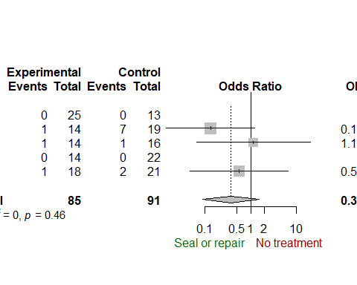

# Citations

citation()

##   
## To cite R in publications use:  
##   
## R Core Team (2017). R: A language and environment for  
## statistical computing. R Foundation for Statistical Computing,  
## Vienna, Austria. URL https://www.R-project.org/.  
##   
## A BibTeX entry for LaTeX users is  
##   
## @Manual{,  
## title = {R: A Language and Environment for Statistical Computing},  
## author = {{R Core Team}},  
## organization = {R Foundation for Statistical Computing},  
## address = {Vienna, Austria},  
## year = {2017},  
## url = {https://www.R-project.org/},  
## }  
##   
## We have invested a lot of time and effort in creating R, please  
## cite it when using it for data analysis. See also  
## 'citation("pkgname")' for citing R packages.

citation(package = "tidyverse")

##   
## To cite package 'tidyverse' in publications use:  
##   
## Hadley Wickham (2017). tidyverse: Easily Install and Load the  
## 'Tidyverse'. R package version 1.2.1.  
## https://CRAN.R-project.org/package=tidyverse  
##   
## A BibTeX entry for LaTeX users is  
##   
## @Manual{,  
## title = {tidyverse: Easily Install and Load the 'Tidyverse'},  
## author = {Hadley Wickham},  
## year = {2017},  
## note = {R package version 1.2.1},  
## url = {https://CRAN.R-project.org/package=tidyverse},  
## }

citation(package = "meta")

##   
## To cite package 'meta' in publications use:  
##   
## Guido Schwarzer (2007), meta: An R package for meta-analysis, R  
## News, 7(3), 40-45.  
##   
## A BibTeX entry for LaTeX users is  
##   
## @Article{,  
## title = {meta: {A}n {R} package for meta-analysis},  
## author = {Guido Schwarzer},  
## journal = {R News},  
## year = {2007},  
## volume = {7},  
## number = {3},  
## pages = {40--45},  
## }  
##   
## URL https://cran.r-project.org/doc/Rnews/Rnews_2007-3.pdf