http://ejkiva.duckdns.org:8080/eJkiva/

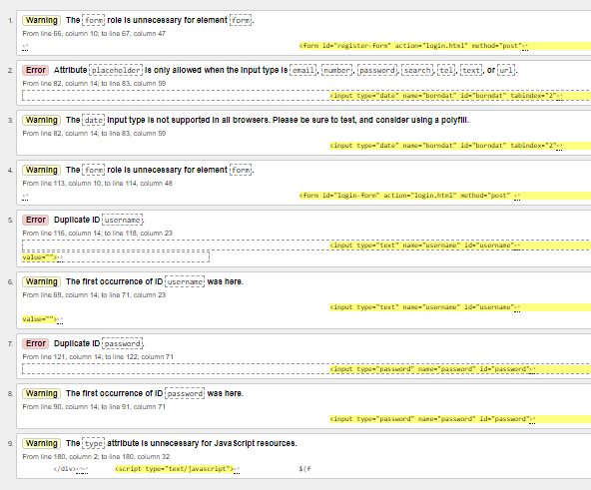

http://ejkiva.duckdns.org:8080/eJkiva/customer.html

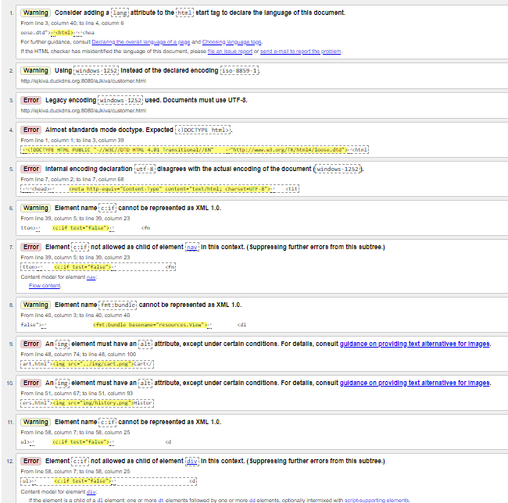

http://ejkiva.duckdns.org:8080/eJkiva/customer/product.html

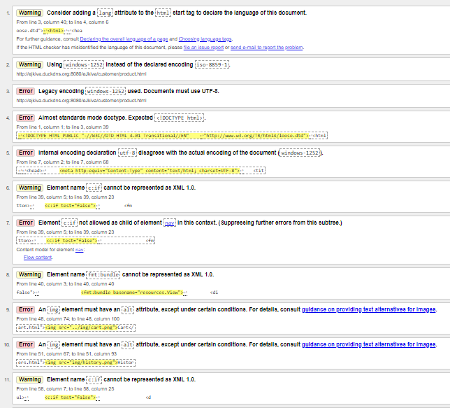

http://ejkiva.duckdns.org:8080/eJkiva/customer/cart.html

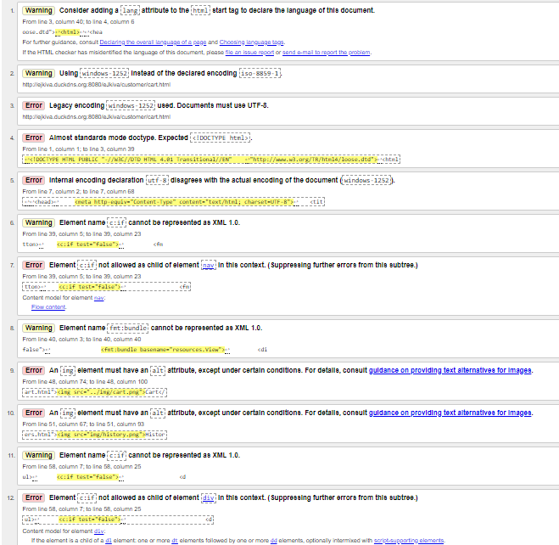

http://ejkiva.duckdns.org:8080/eJkiva/operator.html

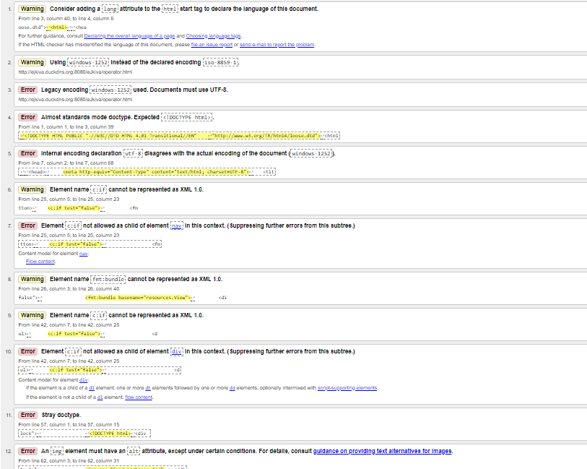

<http://ejkiva.duckdns.org:8080/eJkiva/operator/orders.html>

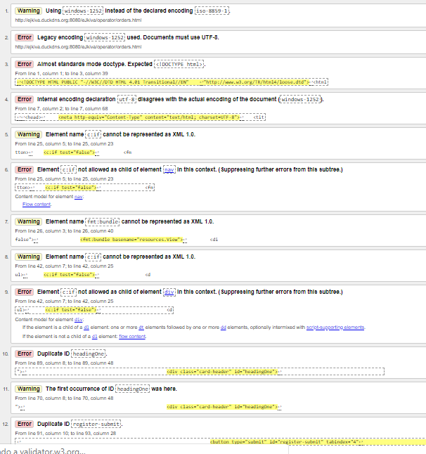

http://ejkiva.duckdns.org:8080/eJkiva/operator/warehouse.html

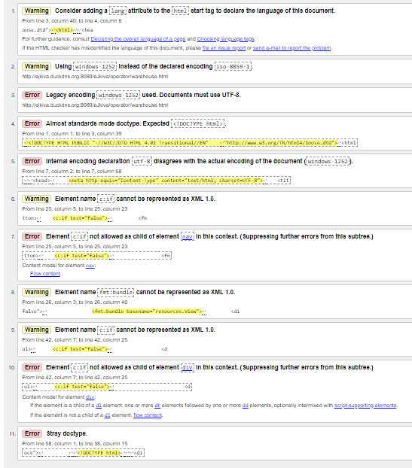

<http://ejkiva.duckdns.org:8080/eJkiva/manager.html>

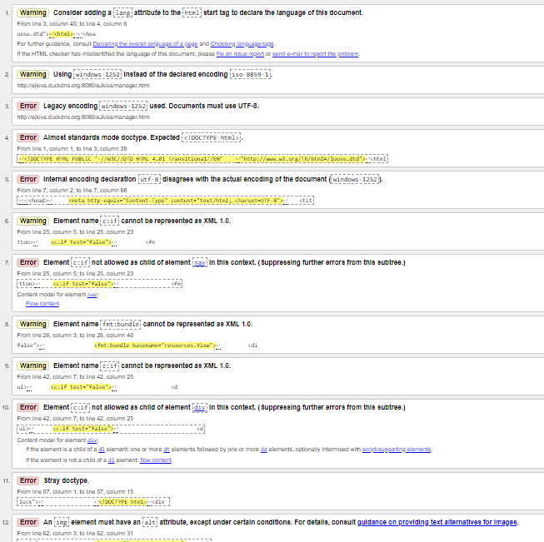

http://ejkiva.duckdns.org:8080/eJkiva/manager/history.html

