Event tests

Sending/receiveing in the same machine; thread period = 0.1 ms; expected time for 5000 events 0,5 seconds; achieved time is ~ 5 seconds; 3.5 seconds lost in push_change_event executions (2 events pushed at each thread cycle).

The test code:

controls04:/siciliarep/projects/ctmachine/TEST/EventTest> python test.py

Tango 9 + ZMQ on SuSE Leap (single host) benchmarking (preliminary results)

Sending events for periods of 5 seconds at increasing frequency (100 Hz, 200, 300, …)

The values sent are the expected timestamps for each value in an ideal world.

Blue and pink lines show values from the Emitter (desired frequency vs achieved).

Black and blue lines show values from the Receiver. (received events and deviation from ideal)

Using a timestamp queue

NOTE: THESE TESTS WORK AS LONG AS NO POLLING THREAD IS ACTIVE; if the polling for State() is active at 3 seconds the trends become full of exceptions.

Tango7

- At f>200Hz the Emitter is not able to send enough events per second.
- At f>800Hz events start to get lost (receiver queue differs from emitters)

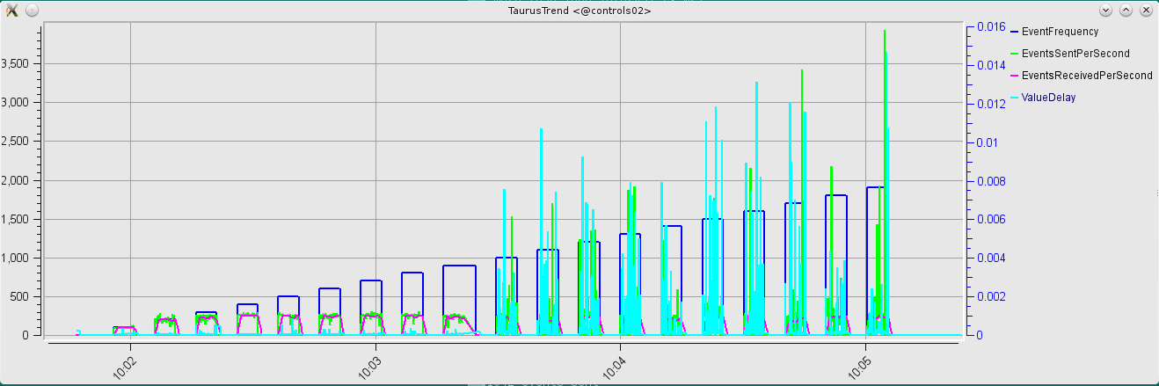
Tango8

- At f>1KHz we start to see the first delays above 100 ms between emitter and receiver

- The performance rapidly degrades and at 1.2 Khz (~400 attributes at 3Hz) is unusable (the machine start to became unresponsive).

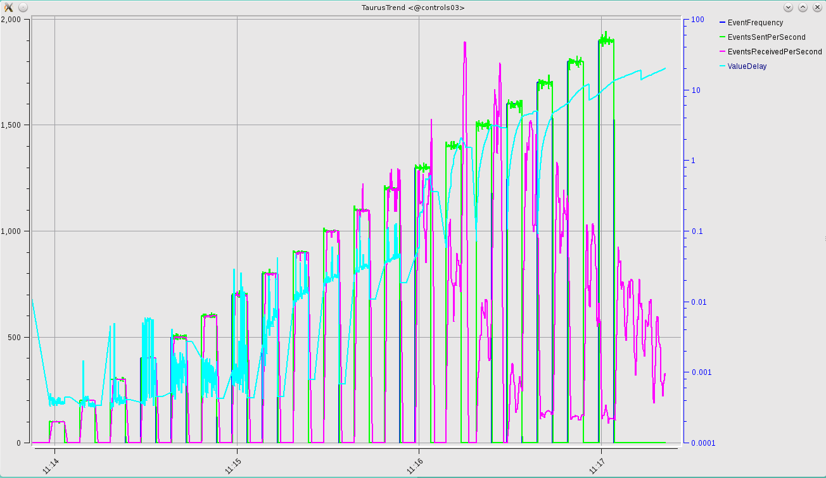
Tango 9

- The improve in performance is impressive; until f>1500 works like a charm; and even above it is much more stable than Tango 8.

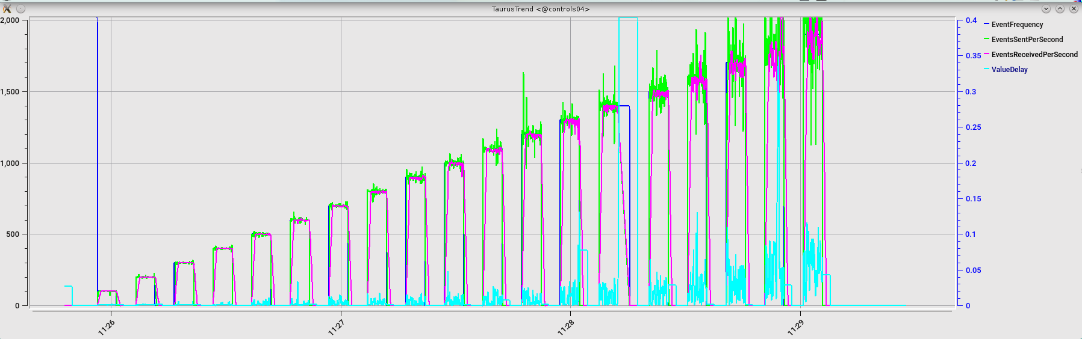
Now Tango 9 sending array events (DevDouble[10]); it seems to perform better, which is a nonsensse!

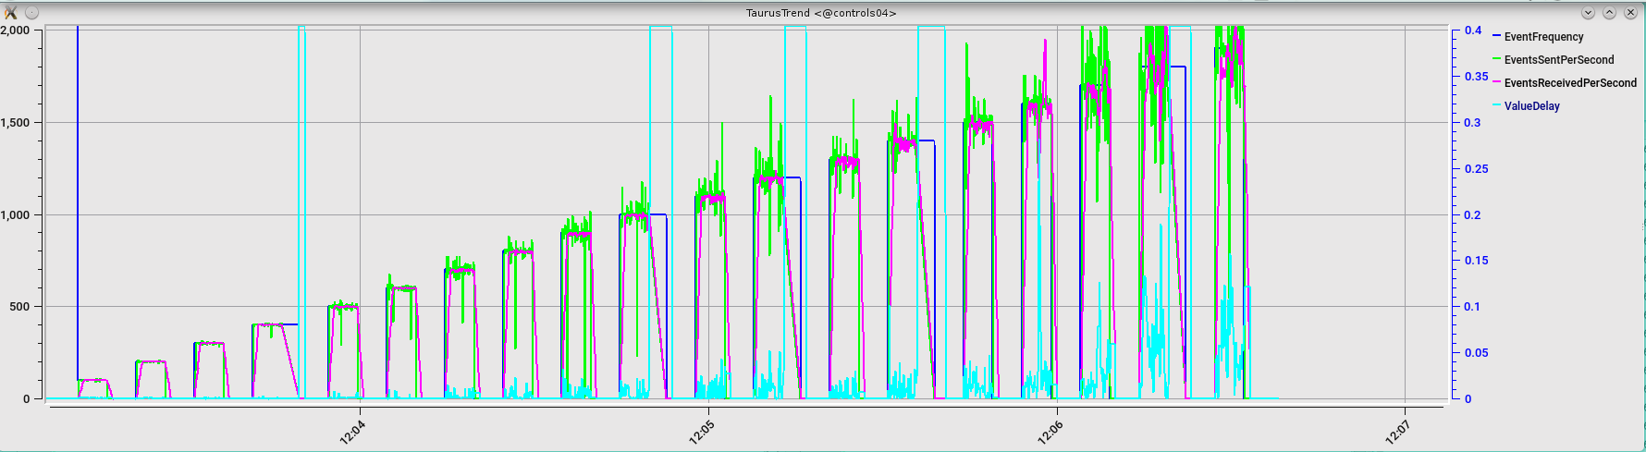
Apart of that, the exceptions in the client continue to happen around 400 Hz; the exception affecte attributes in both devices; so it seems a problem related to the taurus polling buffer. To removed them I enabled jive-based events to all attributes shown in trend.

With arrays=100; now we can see a degrading patter similar to what happened on T8.

But, this time there's no exceptions in the trend and there's no value delay until 1KHz; performance still looks much better than in Tango8.

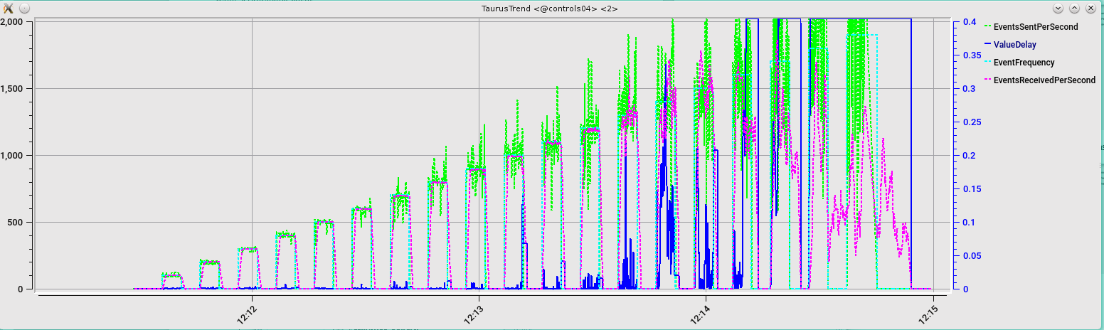

A new screenshot for T9 with 1 attribute (why it's so different from the first screenshots!?)

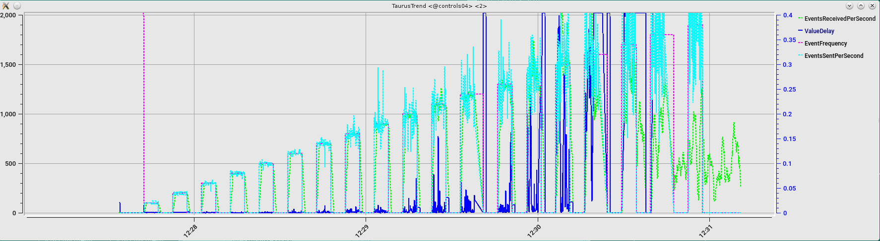
Now plotting with a pure event based trends; degradation is there; no timeouts.

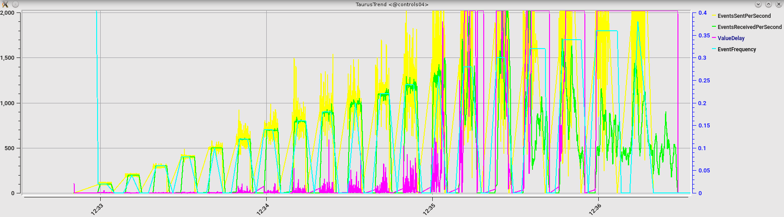
Now with pure client polling:

So, the way we obtain the values from the devices is clearly affecting the test itself. We have a problem with Taurus polling and event frequencies between 200 and 500 Hz; these issues disappear between 500 and 1000 and then the whole performance degrades above 1 Khz.

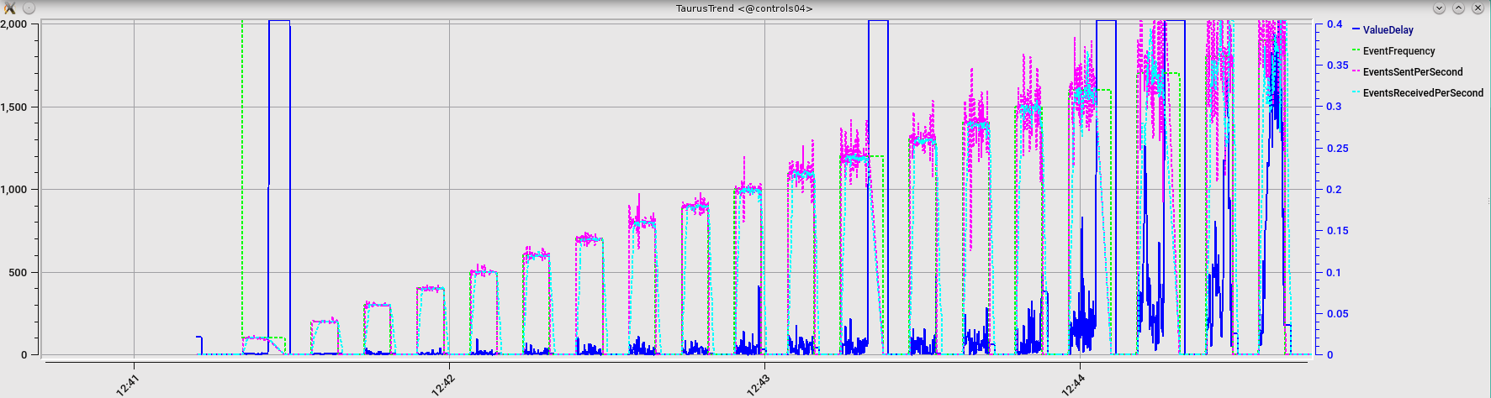
Same load now distributed in 3 emitter servers show a similar pattern

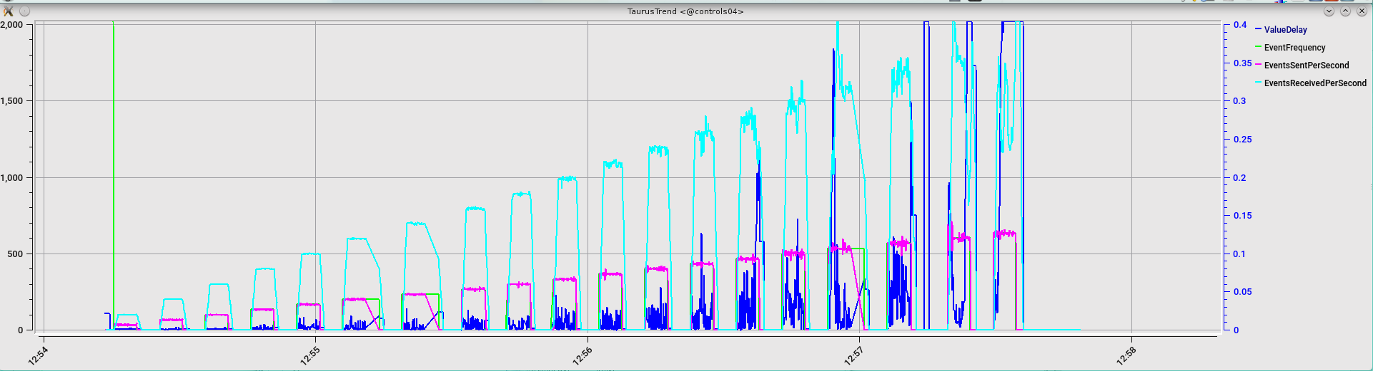
Now, putting all 3 emitters in the same servers:

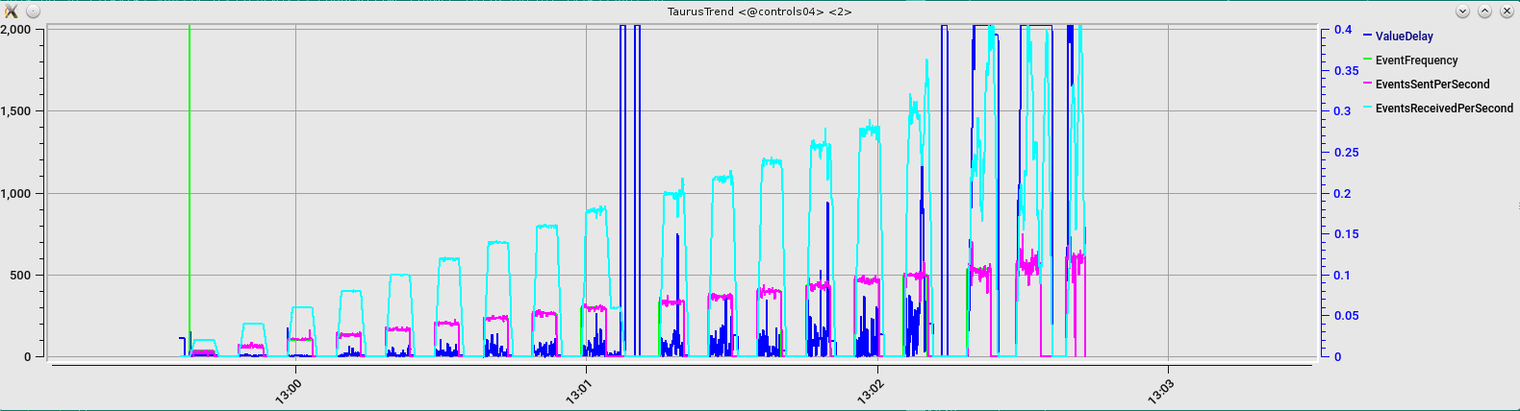

This test is just pushing one attribute ; but comparing the usage (average_delay/event period). It shows that channel usage starts to struggle at 600 Hz

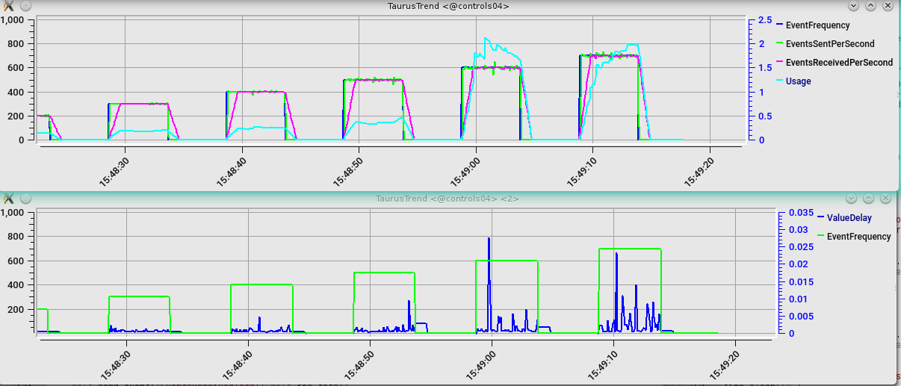

Same data on Tango 9 showing the whole rank from 100 Hz to 2000 Hz

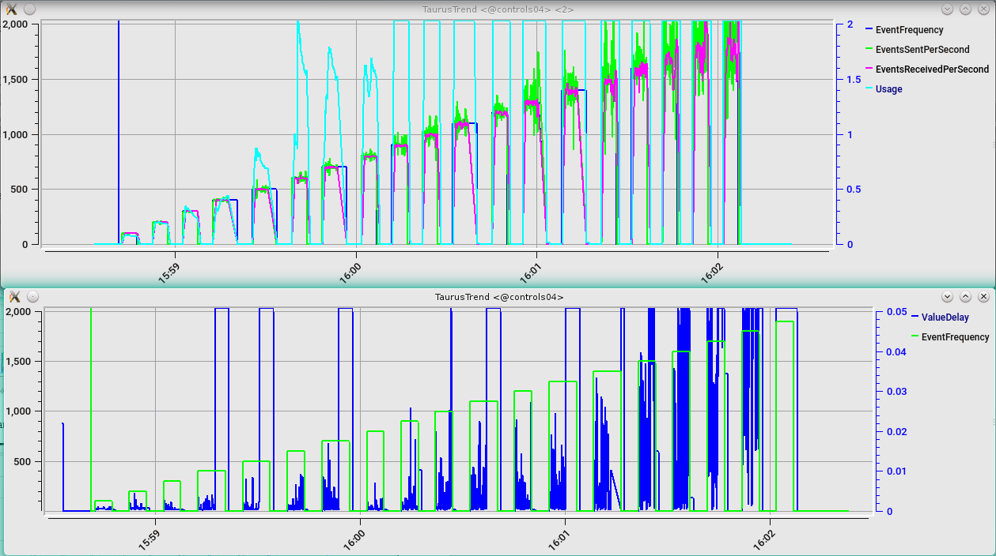

In comparison, in Tango 8 is practically the same (cut at 500 Hz):

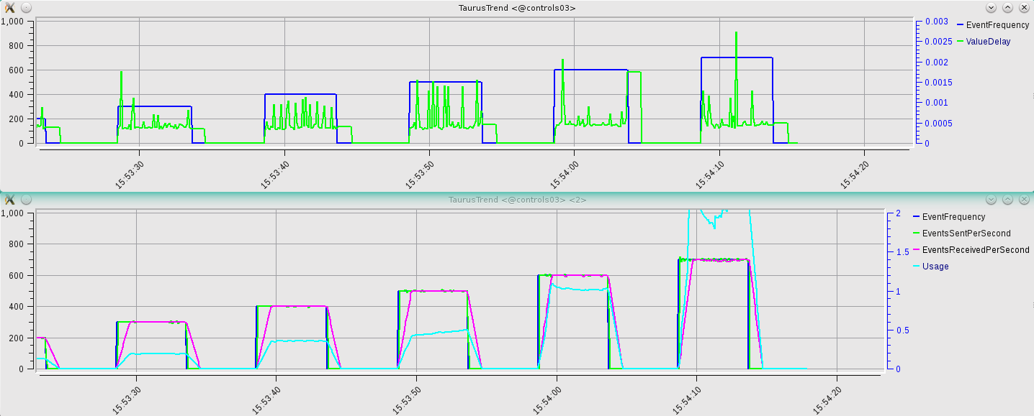

While in Tango7 it was much worse (100 Hz):

