A Data-Intensive Platform for S&P 500 Investment Screening and Reinforcement-Learning-Based Portfolio Optimization
Sergiu Buhatel
sergiubuhatel@cmail.carleton.ca
Abstract—Individual investors lack accessible tools that combine large-scale fundamental screening with quantitative portfolio construction. This paper presents the design and implementation of a full-stack, data-intensive application that (1) ingests and models price history, valuation, and financial-statement data for the S&P 500 universe in a document-oriented database (ArangoDB); (2) lets a user search and filter companies by profitability, debt, and valuation indicators and assemble a candidate investment pool; (3) trains a Proximal Policy Optimization (PPO) reinforcement-learning agent, formulated as a Markov Decision Process over historical daily returns, to recommend a long-only portfolio allocation that balances expected return against volatility; and (4) trains a per-asset Long Short-Term Memory (LSTM) network to forecast short-horizon prices. The system runs on an asynchronous architecture (Flask, Celery, Redis) that streams task progress to a React/Redux-Saga frontend over WebSockets, and is fully containerized with Docker Compose. On a pilot pool of ten large-capitalization stocks, the trained RL policy produced an allocation with an estimated annualized return of 23.2%, volatility of 12.4%, and Sharpe ratio of 1.88 over the training window, demonstrating the pipeline end to end; we outline the larger-scale, held-out backtest against equal-weight and mean-variance baselines planned for the full evaluation.
Index Terms—reinforcement learning, portfolio optimization, stock screening, ArangoDB, LSTM, data-intensive applications, proximal policy optimization, financial time series
I. INTRODUCTION
Modern equity markets generate data at a scale and heterogeneity that make investment analysis a genuine data-intensive application in the sense used throughout this course: daily price time series for hundreds of companies, irregularly structured financial-statement data (income statement, balance sheet, cash flow) that varies in the fields available per issuer, and derived analytics (ratios, forecasts, portfolio metrics) that must be recomputed as new data arrives. Retail investors are typically offered one half of this problem at a time: static screening tools that filter companies by valuation or profitability metrics, or robo-advisors that allocate a portfolio using a fixed mean-variance model, but rarely both together, and rarely backed by an adaptive, learned allocation policy.
This paper describes a system that closes that gap end to end: a screening layer over normalized company/sector/industry/fundamental data, a mechanism for turning a screened result set into a named candidate pool, a reinforcement-learning agent that learns a risk-aware allocation over that pool from historical returns, and a complementary per-stock LSTM price forecaster. The contributions of this work are: (1) a document-oriented data model for heterogeneous, evolving per-ticker financial records, with sector/industry modeled as first-class, independently queryable entities; (2) an asynchronous ingestion and model-training pipeline (Celery/Redis) that streams live progress to the browser over WebSockets rather than blocking or silent polling; (3) a Markov Decision Process formulation of long-only portfolio allocation trained with Proximal Policy Optimization; (4) a per-asset LSTM price forecaster evaluated with held-out RMSE/MAE; and (5) a working, containerized, full-stack implementation (Flask, ArangoDB, Redis, Celery, React/Redux-Saga) evaluated on live market data pulled from Yahoo Finance.
The remainder of this paper is organized as follows. Section II surveys related work in portfolio theory, reinforcement learning for trading, deep learning for price forecasting, and data management for data-intensive applications. Section III describes the system architecture and data model. Section IV details the proposed RL formulation and the LSTM forecaster. Section V reports a pilot evaluation. Section VI concludes and outlines the full evaluation plan.
II. RELATED WORK
A. Portfolio Theory and Fundamental Screening
Markowitz's mean-variance framework [1] remains the classical baseline for portfolio construction, choosing weights that minimize variance for a given expected return. Practical screening tools typically stop at filtering a universe by valuation and quality ratios (P/E, ROE, debt-to-equity) without a subsequent optimization step; this project treats screening as the first stage of a pipeline that ends in an explicit, learned allocation.
B. Reinforcement Learning for Portfolio Management
Jiang et al. [2] proposed a model-free deep RL framework (the Ensemble of Identical Independent Evaluators) that outputs portfolio weights directly from a convolutional/recurrent network over historical price tensors, trained with a reward tied directly to portfolio return. This work adopts the same weights-as-policy-output idea but with a simpler flat-vector policy over a rolling window of returns, trained with Proximal Policy Optimization (PPO) [3], and a reward that explicitly penalizes trailing volatility rather than optimizing return alone, to bias the agent toward the low-risk/high-return portfolios this system is meant to recommend.
C. Deep Learning for Price Forecasting
Fischer and Krauss [4] showed that LSTM networks can produce more accurate directional forecasts of S&P 500 constituent returns than momentum-based and memory-free benchmarks, framing the problem as cross-sectional return classification. This system instead trains one LSTM per ticker as a direct multi-step regressor over raw closing prices; Section V reports that this simpler formulation is materially harder to fit well at low training budgets, consistent with the broader finding in [4] that naive price-level regression is a weak baseline compared to return- or direction-based formulations.
D. Data Management for Data-Intensive Applications
This project applies data-modeling and pipeline-design principles from Kleppmann [5] directly: a document database (ArangoDB) was chosen over a rigid relational schema because financial-statement coverage genuinely varies by issuer (not every company reports every line item), which document storage tolerates without schema migrations; and the import/training workload is treated as an asynchronous, queue-driven pipeline (Celery over Redis) rather than a synchronous request, reflecting the batch/stream-processing separation of concerns discussed in [5]. The broader context of algorithms and architectures for large-scale data analytics follows Li et al. [6].
III. SYSTEM ARCHITECTURE
Fig. 1 shows the system's five runtime components. A React/Redux-Saga frontend issues REST calls and joins per-task Socket.IO rooms; a Flask backend exposes the REST API and a Socket.IO server; Redis serves as both the Celery message broker and the Socket.IO pub/sub transport (the two roles are kept on separate logical Redis databases to avoid connection-pool interference); a Celery worker executes the three long-running jobs (bulk data import, PPO training, LSTM training) outside the request/response cycle; and ArangoDB persists all documents.
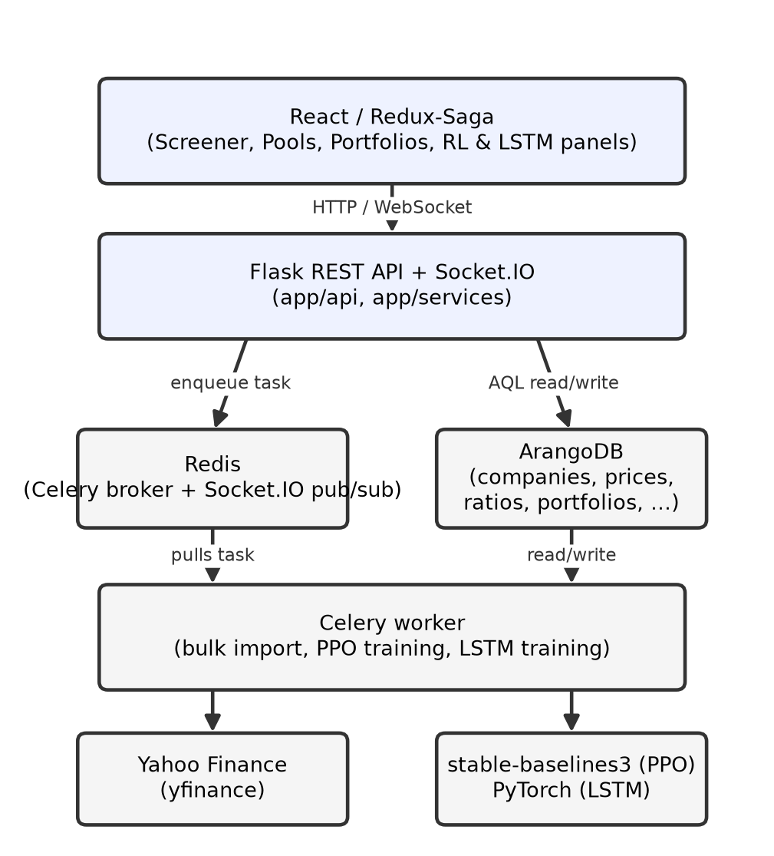
Fig. 1. System architecture and data/control flow.
A. Data Model
Ten ArangoDB document collections model the domain: companies (ticker-keyed profile), stock_prices (one document per ticker-day), stock_stats (latest valuation/market snapshot), financial_ratios (profitability/debt ratios derived from the income statement and balance sheet), sectors and industries (normalized, independently searchable entities rather than free-text fields on companies), pools (a named ticker subset saved off a screener search), portfolios (holdings with weights and computed risk/return metrics), rl_runs (PPO training metadata), and price_predictions (stored LSTM forecasts). Sector and industry names containing characters ArangoDB keys disallow (spaces, '&') are slugified for the document key while the original readable string is retained for display and filtering.
B. Asynchronous Processing and Real-Time Progress
All three long-running operations (importing hundreds of tickers from Yahoo Finance, training a PPO agent, training an LSTM) are dispatched as Celery tasks; the API returns a task identifier immediately. Progress is pushed to the browser over a Socket.IO room named after the task id, with a REST polling endpoint kept as a fallback if the socket connection drops. On the frontend, a Redux-Saga generator races an eventChannel wrapping the socket against the polling fallback, dispatching whichever resolves first.
C. Frontend
The frontend is organized as one Redux slice/saga pair per feature (companies, pools, portfolios, RL, predictions), with Redux-Saga (rather than thunks) chosen specifically because the RL/LSTM flows are event streams, not single request/response calls, which a saga's generator-based control flow expresses directly.
IV. PROPOSED REINFORCEMENT LEARNING APPROACH
A. MDP Formulation
Given a candidate pool of N tickers, let r_t in R^N be the vector of daily fractional returns on day t. The state at time t is the flattened window of the last W days of returns, [r_{t-W}, ..., r_{t-1}], concatenated with the current portfolio weights w_{t-1}. The action is a real-valued vector a_t in R^N, mapped to long-only weights via softmax: w_t = softmax(a_t), so weights are always non-negative and sum to one. The reward is r^T_t w_t - lambda * sigma_t, where sigma_t is the trailing standard deviation of the portfolio's own returns over the same window and lambda (risk_aversion) is a user-supplied coefficient; this directly encodes the low-risk/high-return objective rather than optimizing return alone.
B. Training
The environment is implemented as a Gymnasium Env and trained with PPO from stable-baselines3 [7] using its default MLP policy. Training walks sequentially through the pool's historical daily returns; at inference time, the trained policy is applied to the most recent W-day window to produce today's recommended allocation, which is saved as a portfolio together with its estimated annualized return, volatility, and Sharpe ratio (computed from the pool's own historical daily returns under the resulting fixed weights).
C. LSTM Price Forecaster
For an individual ticker, closing prices are min-max scaled and split chronologically 80/20 into train/test. A single-layer LSTM (PyTorch) with a linear head is trained to predict the next day's scaled close from the preceding seq_len days, evaluated on the held-out 20% via RMSE/MAE after inverse-scaling, and then used to recursively forecast forecast_days trading days ahead (each prediction is fed back in as the newest point in the sliding window).
V. EVALUATION
This section reports a pilot run exercising the full pipeline end to end on live data; it is intended to validate correctness and illustrate the outputs, not as the final evaluation. The pool comprised ten large-capitalization tickers (AAPL, MSFT, GOOGL, AMZN, NVDA, META, JPM, XOM, JNJ, PG) with two years of daily history imported from Yahoo Finance. PPO was trained for 3,000 timesteps with risk_aversion = 1.0 and a 30-day window -- a small budget chosen for a fast pilot run rather than a converged policy.
TABLE I. Pilot PPO-recommended allocation (annualized return 23.2%, volatility 12.4%, Sharpe ratio 1.88).
Ticker | Weight
XOM | 10.62%
JPM | 10.53%
JNJ | 10.40%
AAPL | 10.06%
NVDA | 10.31%
PG | 9.92%
AMZN | 9.72%
GOOGL | 9.57%
META | 9.54%
MSFT | 9.33%

The near-uniform weights in Table I are expected at this training budget: with only 3,000 timesteps the policy has barely moved from its randomly-initialized starting point, and the resulting metrics mostly reflect the pool's own diversification rather than a converged, differentiated allocation. This is presented as a correctness check of the pipeline (data to environment to trained policy to saved portfolio) rather than a claim about the RL formulation's investment merit; Section VI outlines the larger training budget and baseline comparison needed to evaluate that.
The LSTM forecaster was similarly pilot-tested on AAPL and GOOGL with a reduced budget (10-15 epochs). Held-out RMSE was approximately $114 (AAPL) and $127 (GOOGL) against prices in the $190-$330 range -- a poor fit, consistent with [4]'s observation that direct price-level regression is a weak formulation at low training budgets; the model was, in effect, still learning to track the recent mean rather than genuine dynamics. Full-scale training (more epochs, and potentially return-based rather than price-level targets) is planned before drawing any forecasting conclusions.
VI. CONCLUSION AND FUTURE WORK
This paper presented the design and a working implementation of a data-intensive platform that unifies fundamental screening, candidate-pool construction, reinforcement-learning-based portfolio allocation, and per-asset price forecasting over the S&P 500 universe, built on ArangoDB, Celery/Redis, Flask, and React/Redux-Saga with live WebSocket progress reporting. The pilot run in Section V validated the pipeline end to end on live market data.
The planned full evaluation (course Stage 4) will: (1) train PPO for substantially more timesteps across pools of varying size, sector composition, and risk_aversion settings; (2) benchmark the resulting portfolios against equal-weight and mean-variance (Markowitz [1]) baselines on a held-out time period, using annualized return, volatility, Sharpe ratio, and maximum drawdown; (3) train the LSTM forecaster to convergence and compare price-level versus return-based target formulations, following the direction suggested by [4]; and (4) run the full 503-ticker import to evaluate the screening layer at full S&P 500 scale.
REFERENCES
[1] H. M. Markowitz, "Portfolio Selection," The Journal of Finance, vol. 7, no. 1, pp. 77-91, 1952.
[2] Z. Jiang, D. Xu, and J. Liang, "A Deep Reinforcement Learning Framework for the Financial Portfolio Management Problem," arXiv preprint arXiv:1706.10059, 2017.
[3] J. Schulman, F. Wolski, P. Dhariwal, A. Radford, and O. Klimov, "Proximal Policy Optimization Algorithms," arXiv preprint arXiv:1707.06347, 2017.
[4] T. Fischer and C. Krauss, "Deep learning with long short-term memory networks for financial market predictions," European Journal of Operational Research, vol. 270, no. 2, pp. 654-669, 2018.
[5] M. Kleppmann, Designing Data-Intensive Applications. Sebastopol, CA, USA: O'Reilly Media, 2017.
[6] K.-C. Li, A. Cuzzocrea, L. T. Yang, and H. Jiang, Eds., Big Data: Algorithms, Analytics, and Applications. Boca Raton, FL, USA: CRC Press, 2015.
[7] A. Raffin, A. Hill, A. Gleave, A. Kanervisto, M. Ernestus, and N. Dormann, "Stable-Baselines3: Reliable Reinforcement Learning Implementations," Journal of Machine Learning Research, vol. 22, no. 268, pp. 1-8, 2021.

