Sergiu Buhatel

BlazingSQL on NVIDIA DGX A100

Table of Contents

1. Introduction 1

1 Installation 1

2 Run 2

2.1 Launch 2

2.2 Stop 2

2.3 Copy files 3

2.4 Copy files 3

2.5 GPUs usage 4

3 References 4

# Introduction

BlazingSQL is a SQL database that leverages the usage of GPUs instead of the CPUs.

This document describes the minimal steps to install and run BlazingSQL on NVIDIA DGX A100 machine.

# Installation

Pull the image to the machine

docker pull rapidsai/blazingsql-dev:0.16-cuda11.0-devel-ubuntu18.04-py3.8

Check if the image was already pulled

docker images

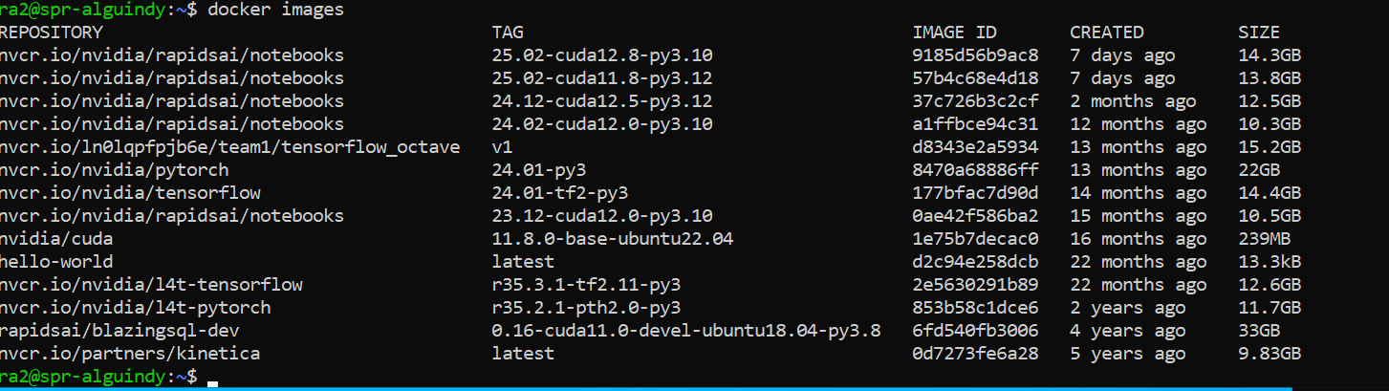

# Run

## Launch

docker run --gpus all -v /home/ra2:/mnt/data -it --rm rapidsai/blazingsql-dev:0.16-cuda11.0-devel-ubuntu18.04-py3.8 bash

/home/ra2 is a directory on the machine, and /mnt/data is a mount inside the running container.

The above command line can be store in a .sh file, for easy usage. For example, is stored inside /home/ra2/blazingsql/run_blazingsql.sh

Can be launched

cd /home/ra2/blazingsql

./run_blazingsql.sh

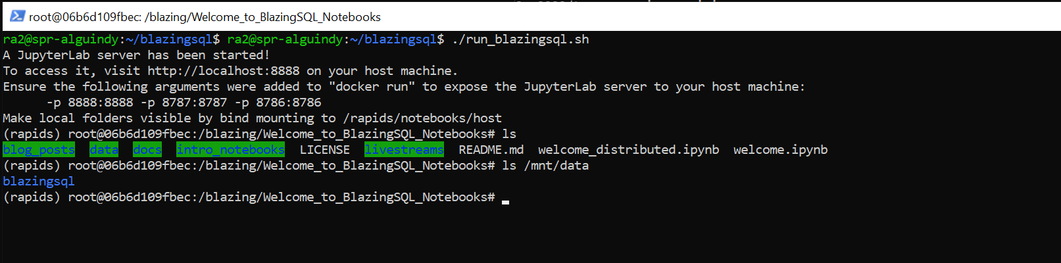

As we can see, /mnt/data inside the running container, is mirroring /home/ra2 on the machine.

## Stop

To exit the running container, type exit.

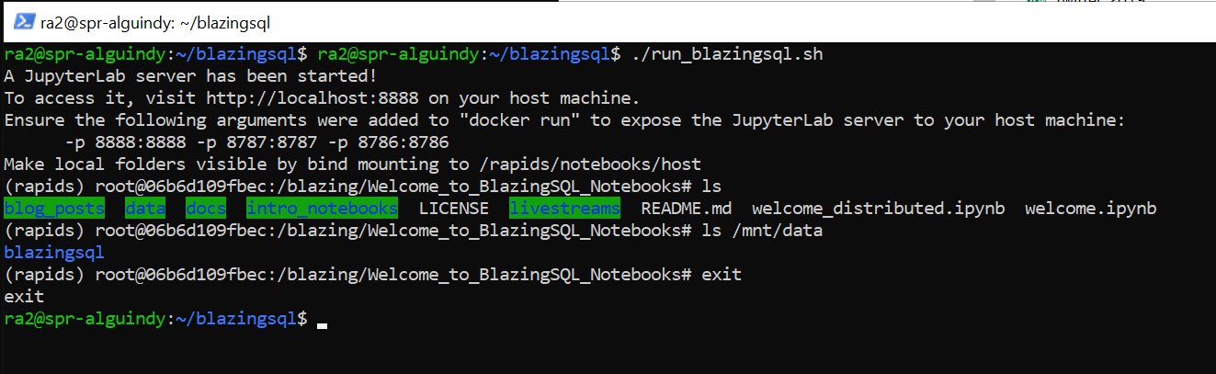

Another way is to find the running container in a different command shell and stop it explicitly.

docker ps

docker kill <container id>

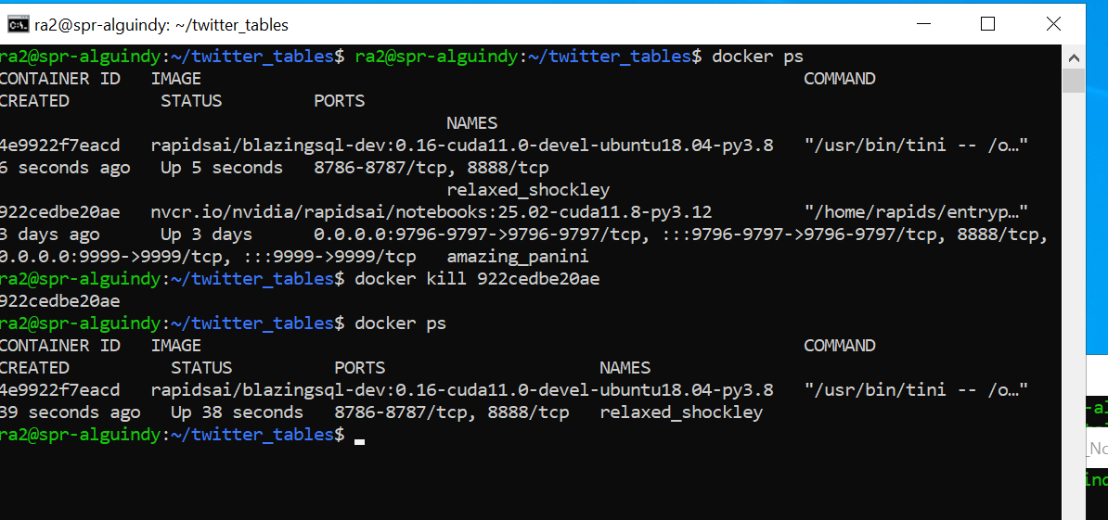

## Copy files

To copy files from Windows machine to Nvidia DGX machine, open a command prompt on windows and change directory to the directory containing the files you want to copy.

cd C:\Research\serg\Twitter_tables

scp * ra2@10.128.20.12:/home/ra2/twitter_tables

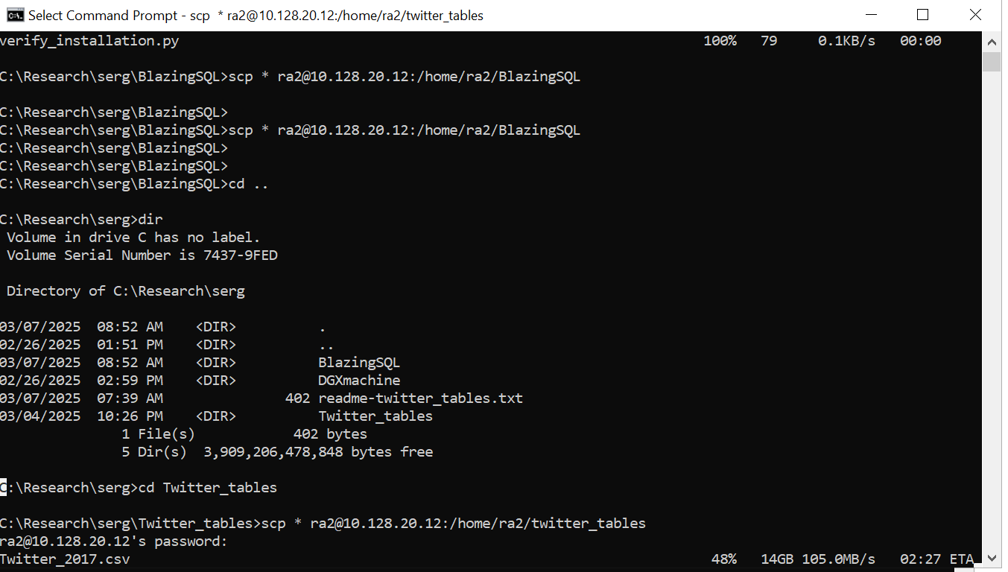

## GPUs usage

To continuously check GPUs usage, open a shell command and type:

watch -n 1 nvidia-smi

Press Ctrl/C to exit.

## Import data

There is an issue running the imported full file of fixed_Twitter_2017.csv. The select is hanging. The total number of lines for fixed_Twitter_2017.csv is 35.5 million.

cd /home/ra2/twitter_tables

wc -l fixed_Twitter_2017.csv

38514699 fixed_Twitter_2017.csv

I created a file including the first 21 million records, and the import and select respond right away. As soon as I pass the 22 million records, the select is hanging. For that reason, I created Twitter_2017_first_21_mil.csv and put it into this directory: /home/ra2/smaller_twitter_tables. Bellow is how to import the file and run it.

cd /home/ra2/smaller_twitter_tables

wc -l Twitter_2017_first_21_mil.csv

21000000 Twitter_2017_first_21_mil.csv

# Launch BlazingSQL

cd /home/ra2/blazingsql

./run_blazingsql.sh

# Once on BlazingSQL is launched, the # prompt will appeared

# Change directory to the mounted directory that contains the import code and the twitter files

cd /mnt/data/smaller_twitter_tables/

# Import and run query. Specify as the first parameter the csv to be imported and as the second parameter

# the table that needs to be created.

python run_query.py Twitter_2017_first_21_mil.csv Twitter_2017_first_21_mil

## run_query.py

import time

import argparse

from blazingsql import BlazingContext

import cudf # RAPIDS cuDF for GPU-accelerated dataframes

# Command-line argument parser

parser = argparse.ArgumentParser(description="Load a CSV file into BlazingSQL and query it.")

parser.add_argument("file", help="Path to the CSV file.")

parser.add_argument("table", help="Name of the table to create.")

args = parser.parse_args()

bc = BlazingContext()

start_time = time.time()

bc.create_table(args.table, args.file)

end_time = time.time()

print(f"Time taken to load the file: {end_time - start_time} seconds")

query = f"SELECT 'AFL' AS AFL, screen_name4, COUNT(*) AS numConnections" \

f" FROM {args.table}" \

f" WHERE screen_name4 <> 'AFL'" \

f" AND tweet_text LIKE '%AFL%'" \

f" GROUP BY screen_name4"

#query = f"SELECT \"AFL\", screen_name4, count(*) as numConnections FROM {args.table} " \

# f"WHERE screen_name4!= 'AFL' AND tweet_text REGEXP '\\$\\bAFL\\$' group by screen_name4"

result = bc.sql(query)

print(result)

# References

<https://hub.docker.com/r/rapidsai/blazingsql-dev>

<https://towardsdatascience.com/intro-to-blazingsql-in-5-minutes-172162d3a95/>

<https://developer.nvidia.com/blog/beginners-guide-to-querying-data-using-sql-on-gpus-in-python/>