Sergiu Buhatel, Research Assistant – Computing/ML
Network Viewer

Table of Contents
1 Introduction 2
2 GitHub 2
3 Build 2
4 Run 2
5 Data 3
5.1 Raw Data 3
5.2 Active Data 4
6 Features 4
7 Layout and Topologies 7
7.1 Topologies (edge structure) 7
7.2 Layouts (node positioning) 8
7.3 Combinations (Topology + Layout) 8
8 References 9

Introduction

GitHub
Code is store in GitHub at:
https://github.com/sergiubuhatel/ra2/tree/main/network-viewer

Build
On the 134.117.176.72 machine, the code is stored at:
C:\Research\serg\network-viewer

Open a command prompt, and get dependencies:
cd C:\Research\serg\network-viewer
npm install

This will bring all the dependencies into a directory called node_modules. This step will be done once, so no need to be done again each time.

Run
Open a command prompt, and get dependencies:
cd C:\Research\serg\network-viewer
npm run start

If asked if you want to run on a different port as on the existing port 3000 something else is running, type ‘y’.
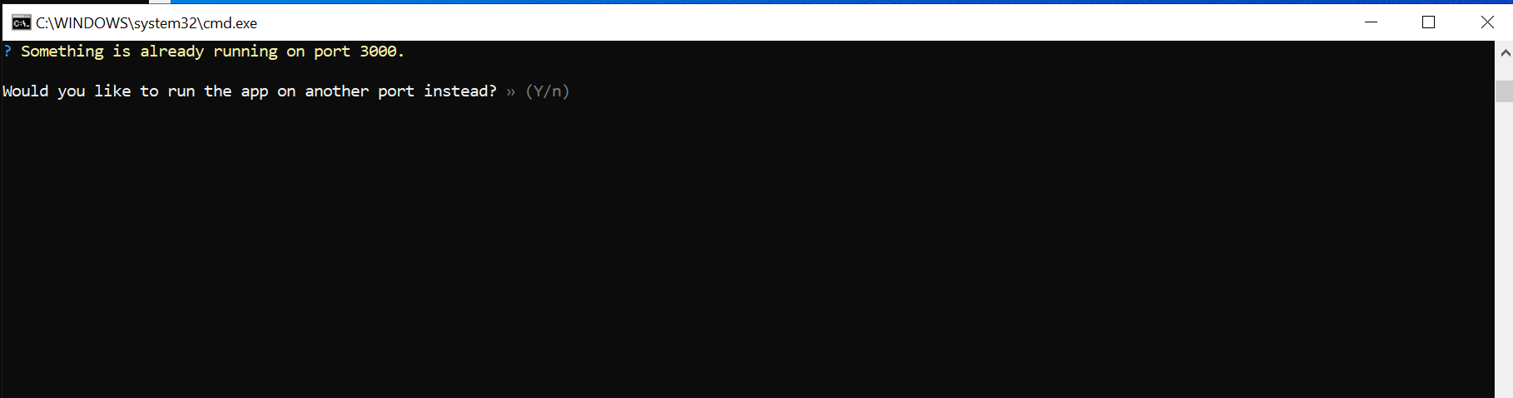

At this point, browser will start automatically:
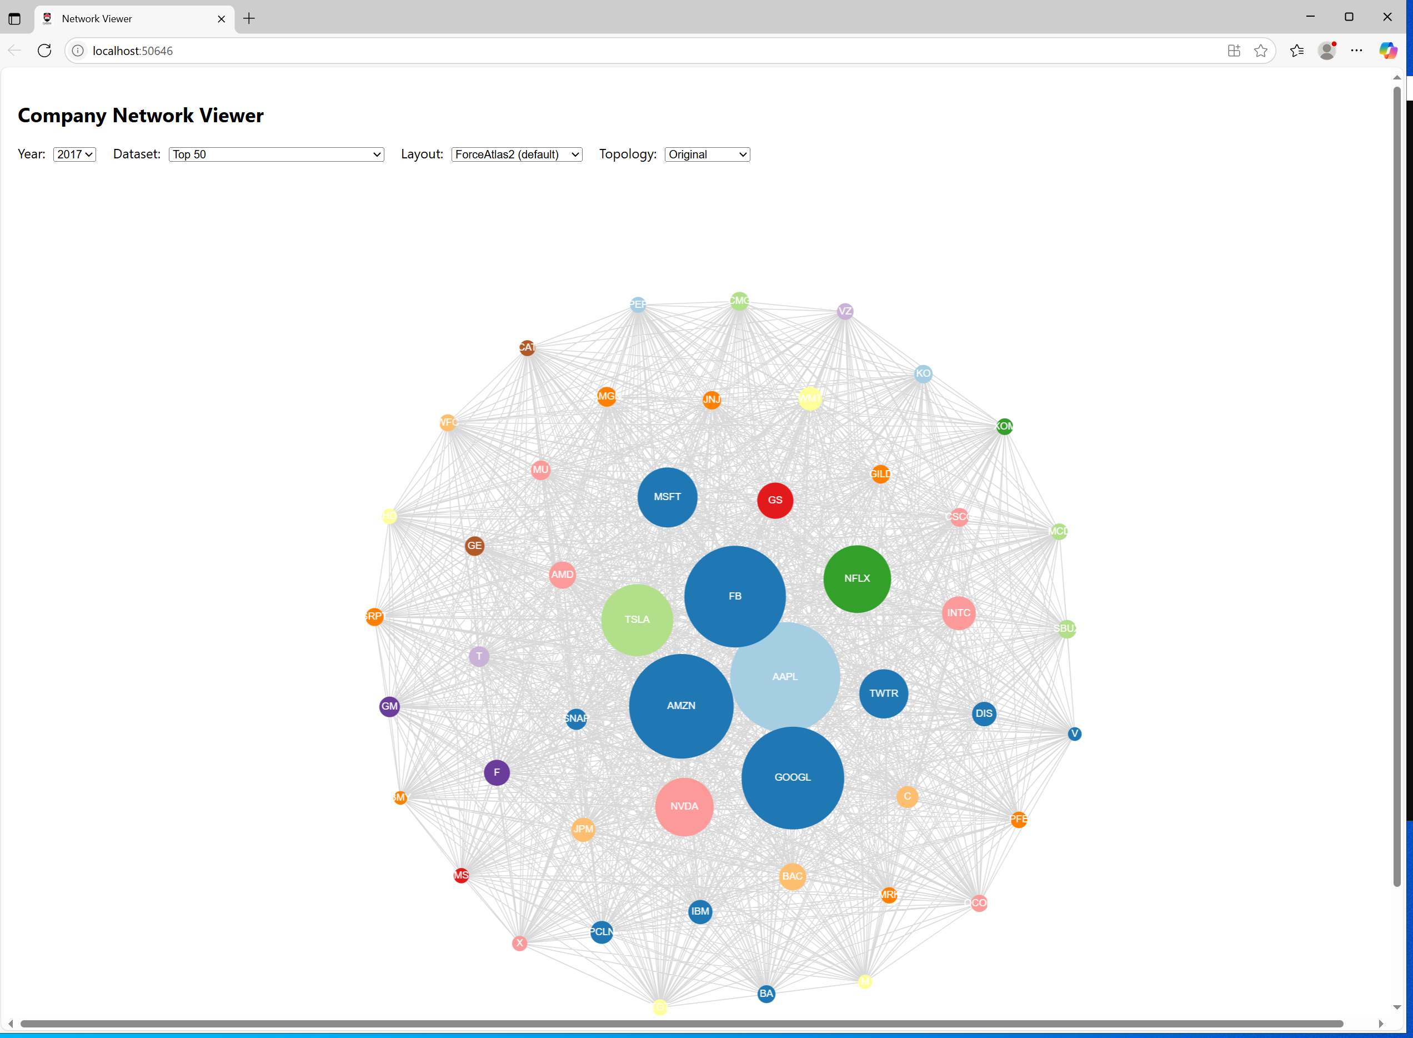

Data

Raw Data
The raw data is stored as CSV files for each year from 2017 to 2023.
For example, in 2017 the files are:
- 2017_industries.csv
- 2017_Network.csv
- Top50_2017.csv
- Top100_2017.csv
- Top200_2017.csv

Similarly, in 2018 the files are:
- 2018_industries.csv
- 2018_Network.csv
- Top50_2018.csv
- Top100_2018.csv
- Top200_2018.csv

In general, the data follows the structure:
<year>/<year>_industries.csv
<year>/<year>_Network.csv
<year>/Top50_<year>.csv
<year>/Top100_<year>.csv
<year>/Top200_<year>.csv

The only exception is 2023, where Top50_2023.csv and Top100_2023.csv are missing, and the available file is named with a lowercase prefix: top200_2023.csv.

Active Data
This is the data that the application is using. It is stored under “.\public\data” directory

Features
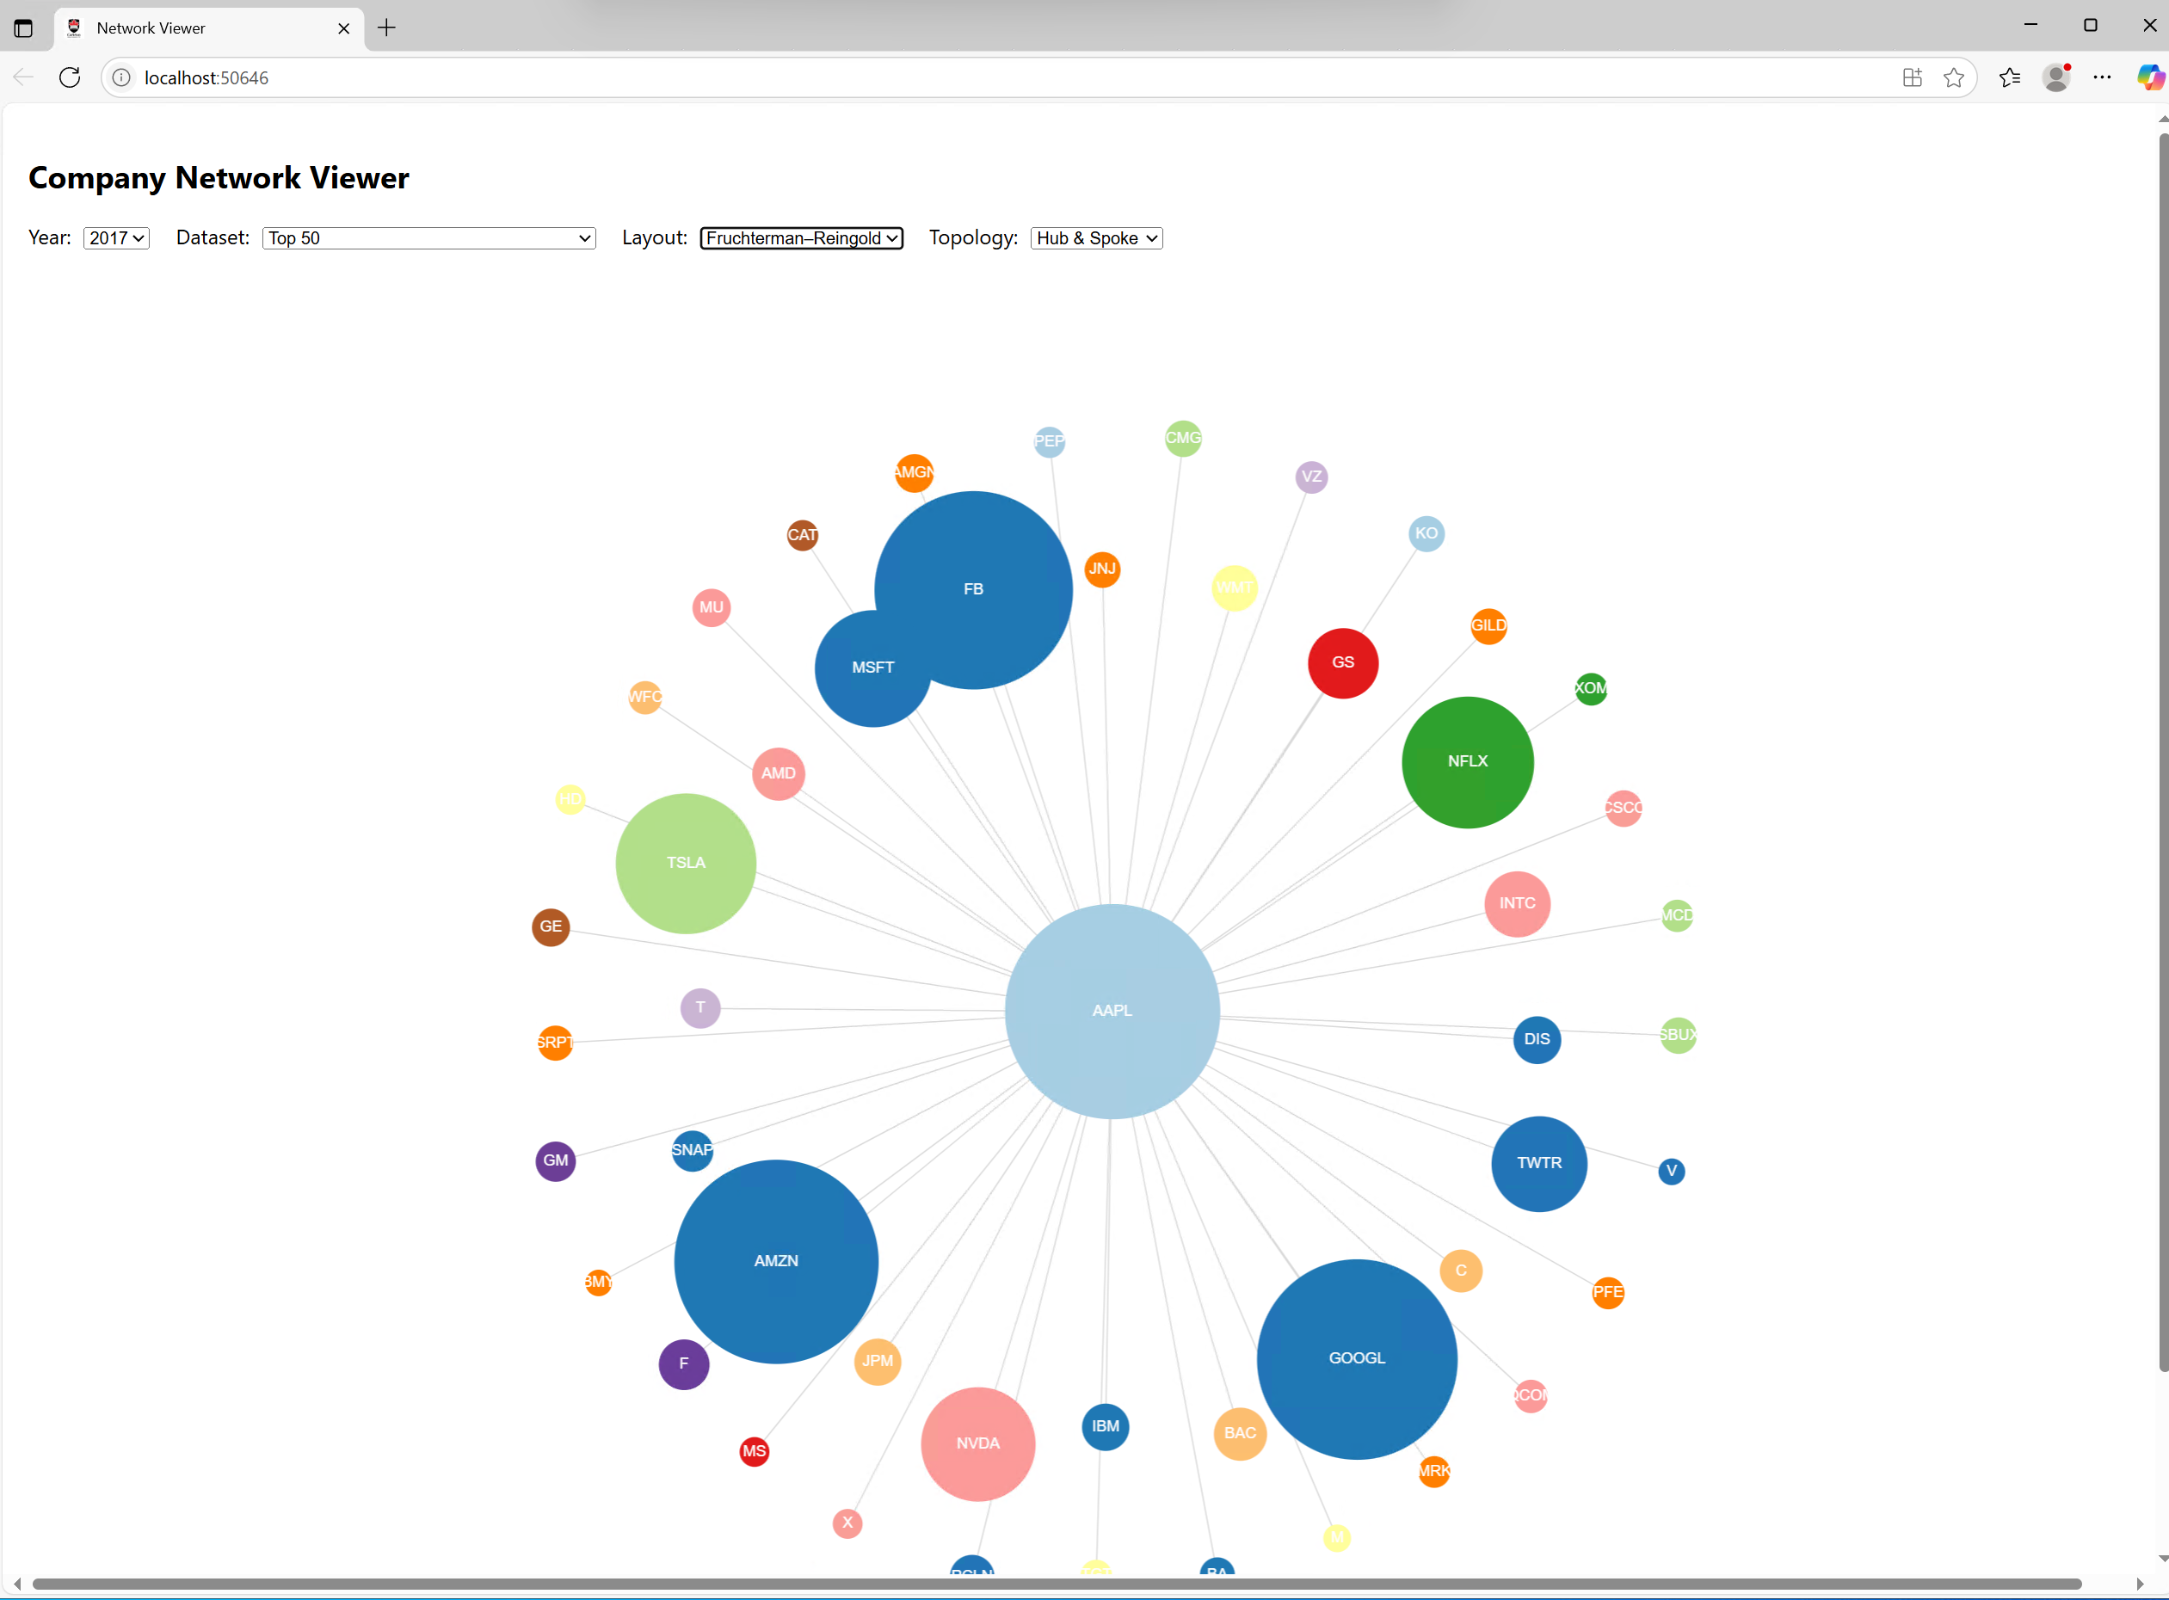

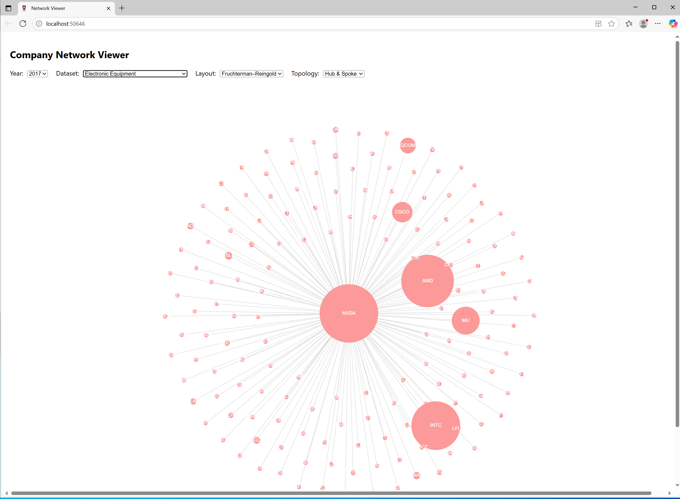

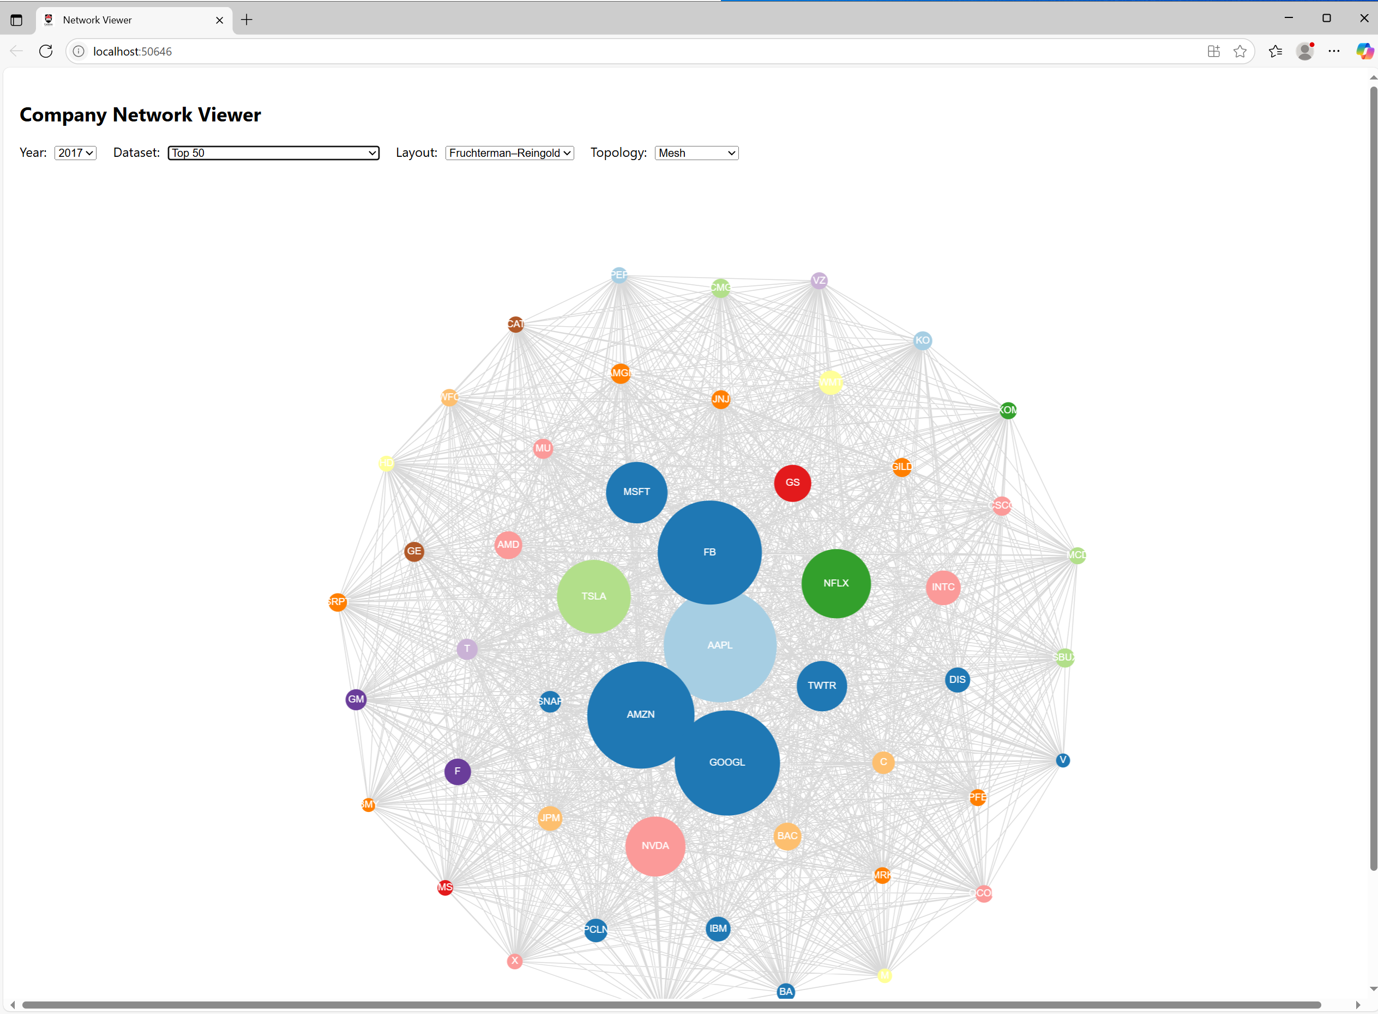

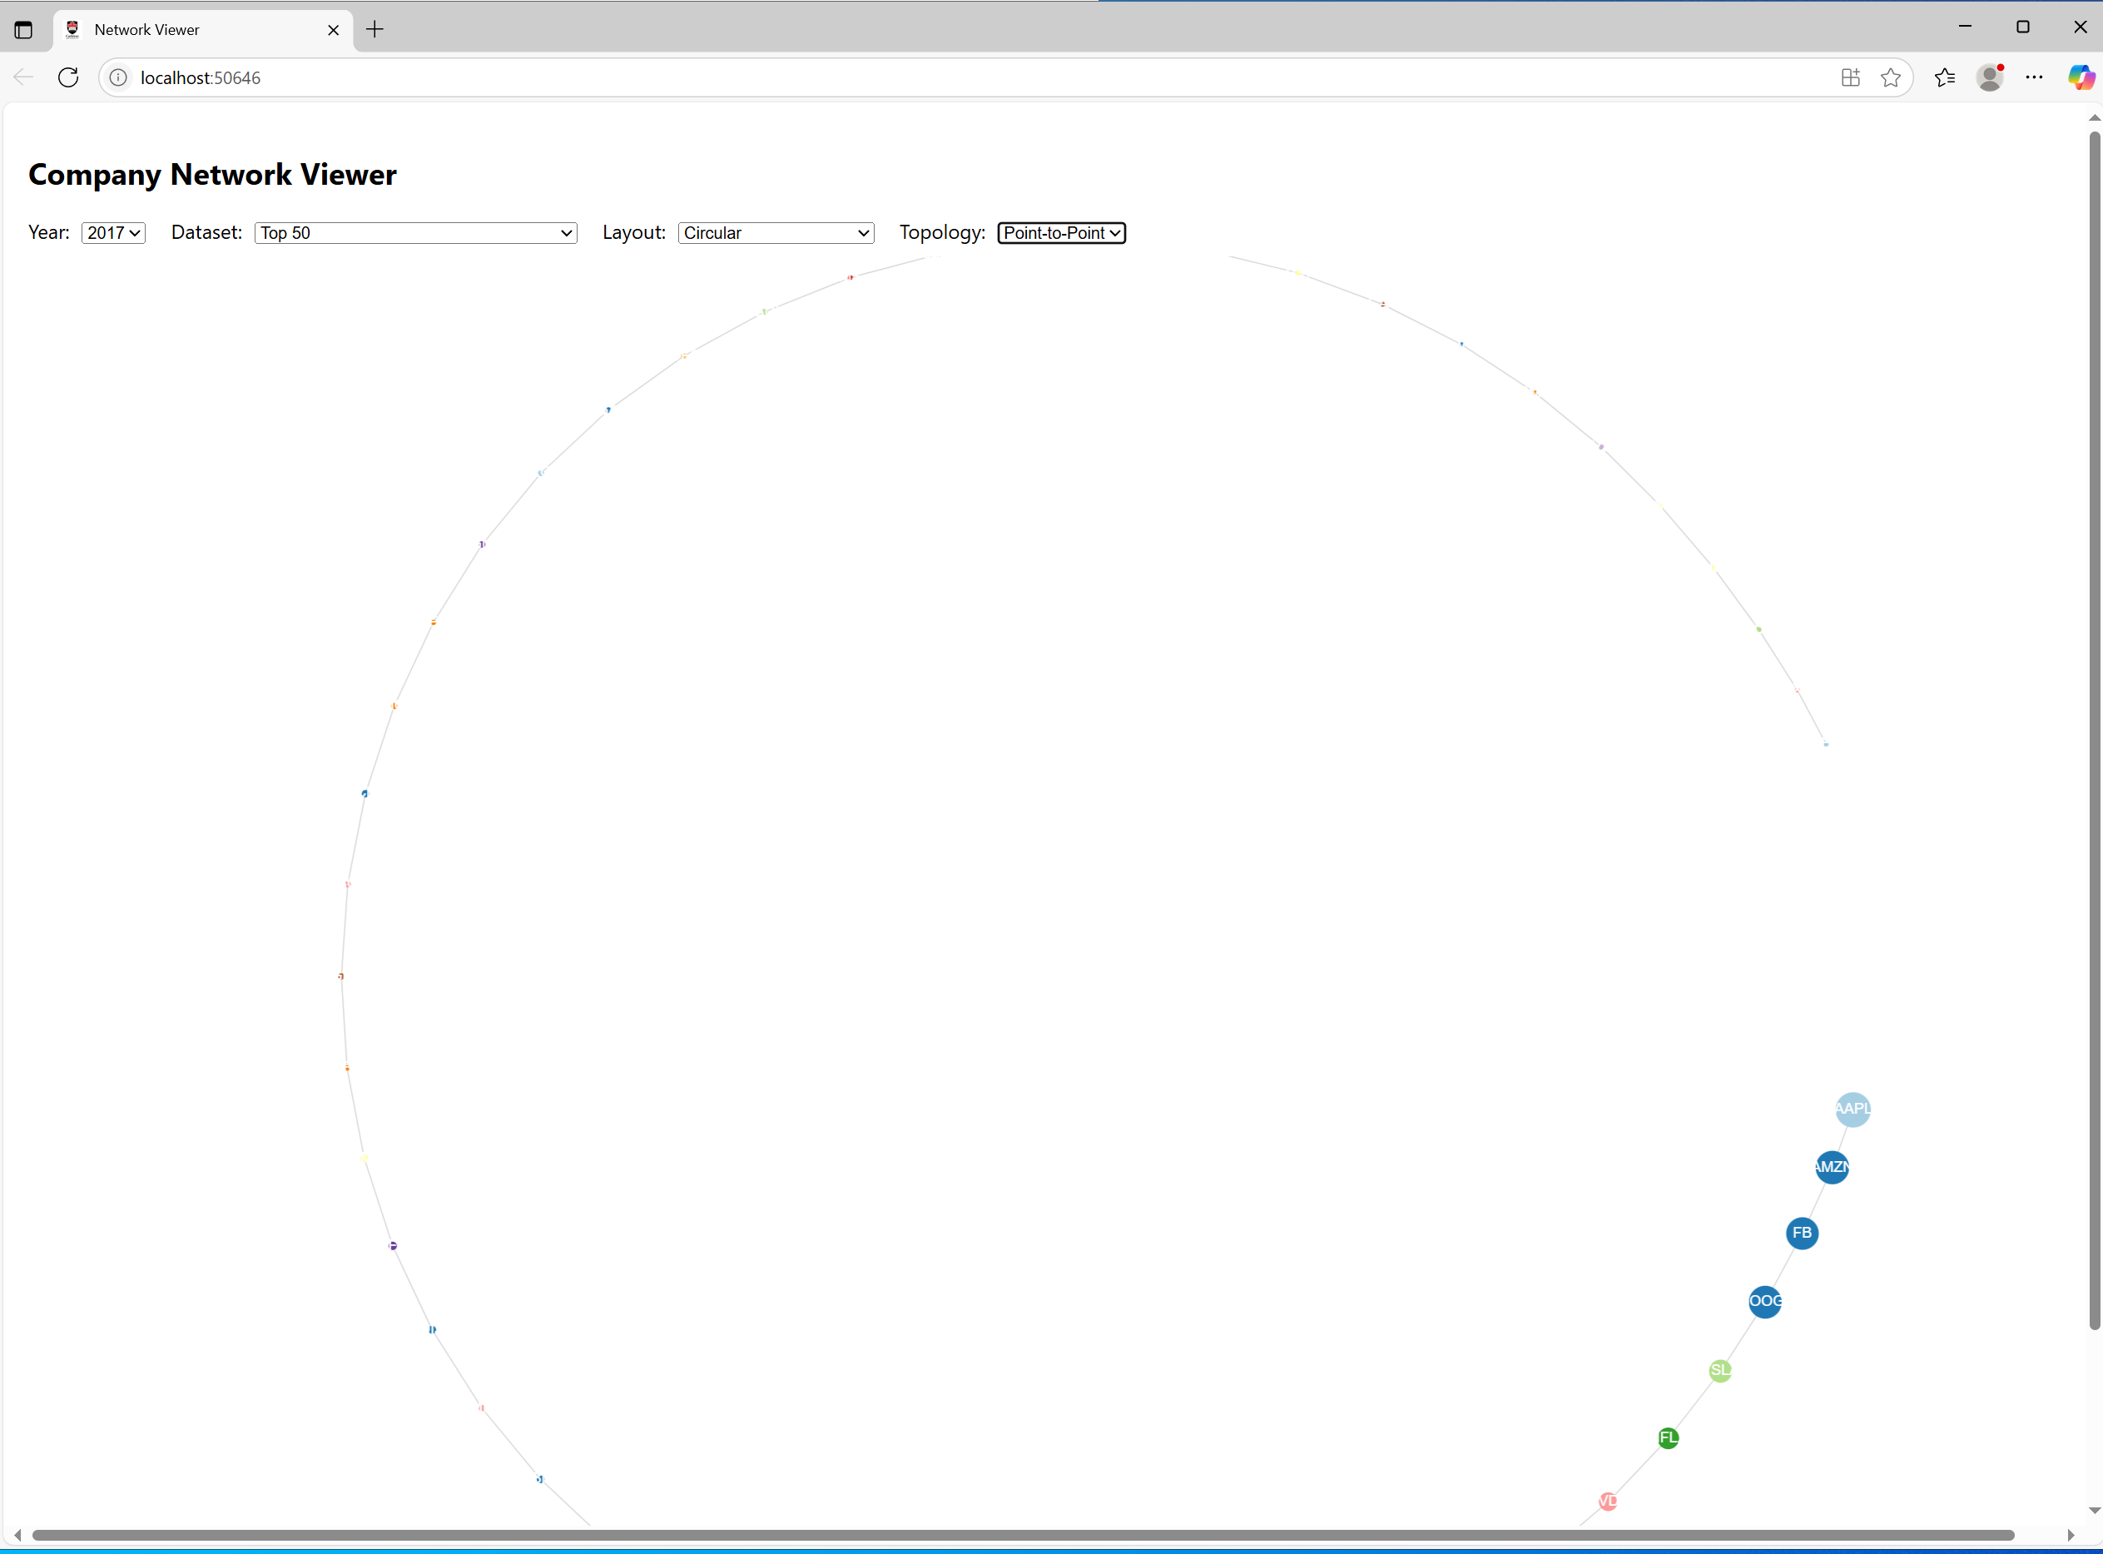

Layout and Topologies
This is a description of layouts and topologies:

Topologies (edge structure)
These define how nodes are connected (which links exist).
- Original
  - Uses the real dataset connections.
  - Edges = actual relationships (e.g., correlations, co-occurrence, etc.).
- Hub & Spoke / Star
  - One central node connects to all others.
  - Useful to highlight a “most important” node (you’re picking it by highest eigenvector centrality).
- Mesh
  - Every node is connected to every other node.
  - Maximal connectivity, edges grow quadratically with node count.
- Point-to-Point
  - Nodes are linked in a chain (A → B → C → …).
  - Useful for linear/sequential processes.

Layouts (node positioning)
These define where nodes are placed visually, independent of edges.
- ForceAtlas2 (default)
  - The built-in force-directed layout of react-force-graph-2d.
  - Tries to keep connected nodes close and spread the graph evenly.
  - Organic look, like a cluster cloud.
- Fruchterman–Reingold
  - Another force-directed algorithm (slightly different balance between attraction/repulsion).
  - Nodes repel each other, edges act like springs.
  - Often produces more symmetrical layouts than ForceAtlas2.
- Circular
  - Places nodes evenly around a circle.
  - Great for comparing edge density across topologies.
  - Removes randomness and ensures consistent visual structure.
- Random
  - Places nodes at random positions.
  - Only useful as a baseline — shows how much the layout matters.

Combinations (Topology + Layout)
This is where it gets interesting — the same topology can look very different depending on the layout.
- Original + ForceAtlas2
  - Most “natural” visualization of your real data.
  - Clusters emerge organically.
- Original + Circular
  - Same real edges, but evenly spaced nodes.
  - Useful to reveal if edges are concentrated between certain groups.
- Hub-Spoke + Fruchterman
  - Central hub node fixed in the middle, others orbit around.
  - Emphasizes a single key influencer.
- Hub-Spoke + Circular
  - Hub at one spot, others around a circle.
  - Looks like a classic star diagram.
- Mesh + Circular
  - Nodes around a ring, every node connected to every other.
  - Creates a dense “hairball” of edges.
- Mesh + Fruchterman
  - Nodes repel but remain linked to everyone — often collapses into a ball of edges.
- Point-to-Point + Circular
  - Nodes around a circle, connected sequentially.
  - Looks like a polygon.
- Point-to-Point + Fruchterman
  - Nodes spread into a squiggly line, possibly bending into curves.

In short:
- Topology defines the network structure.
- Layout defines the visual projection.
- Combining them gives you a way to experiment with “what if” scenarios and separate data reality from visualization choices.

References

