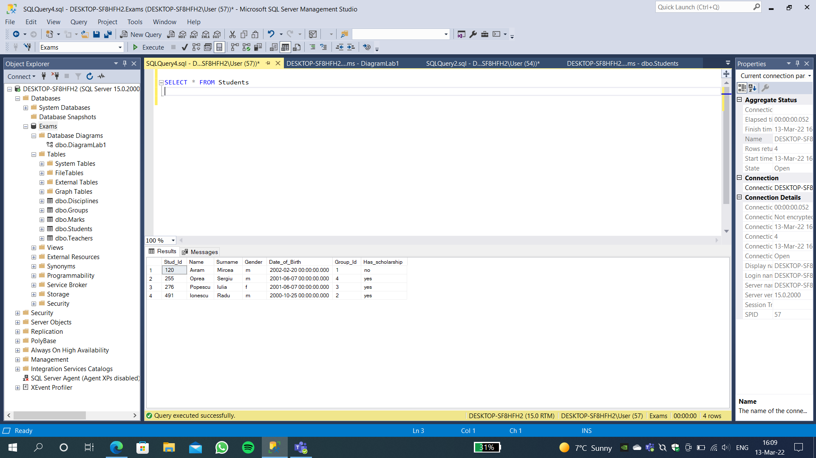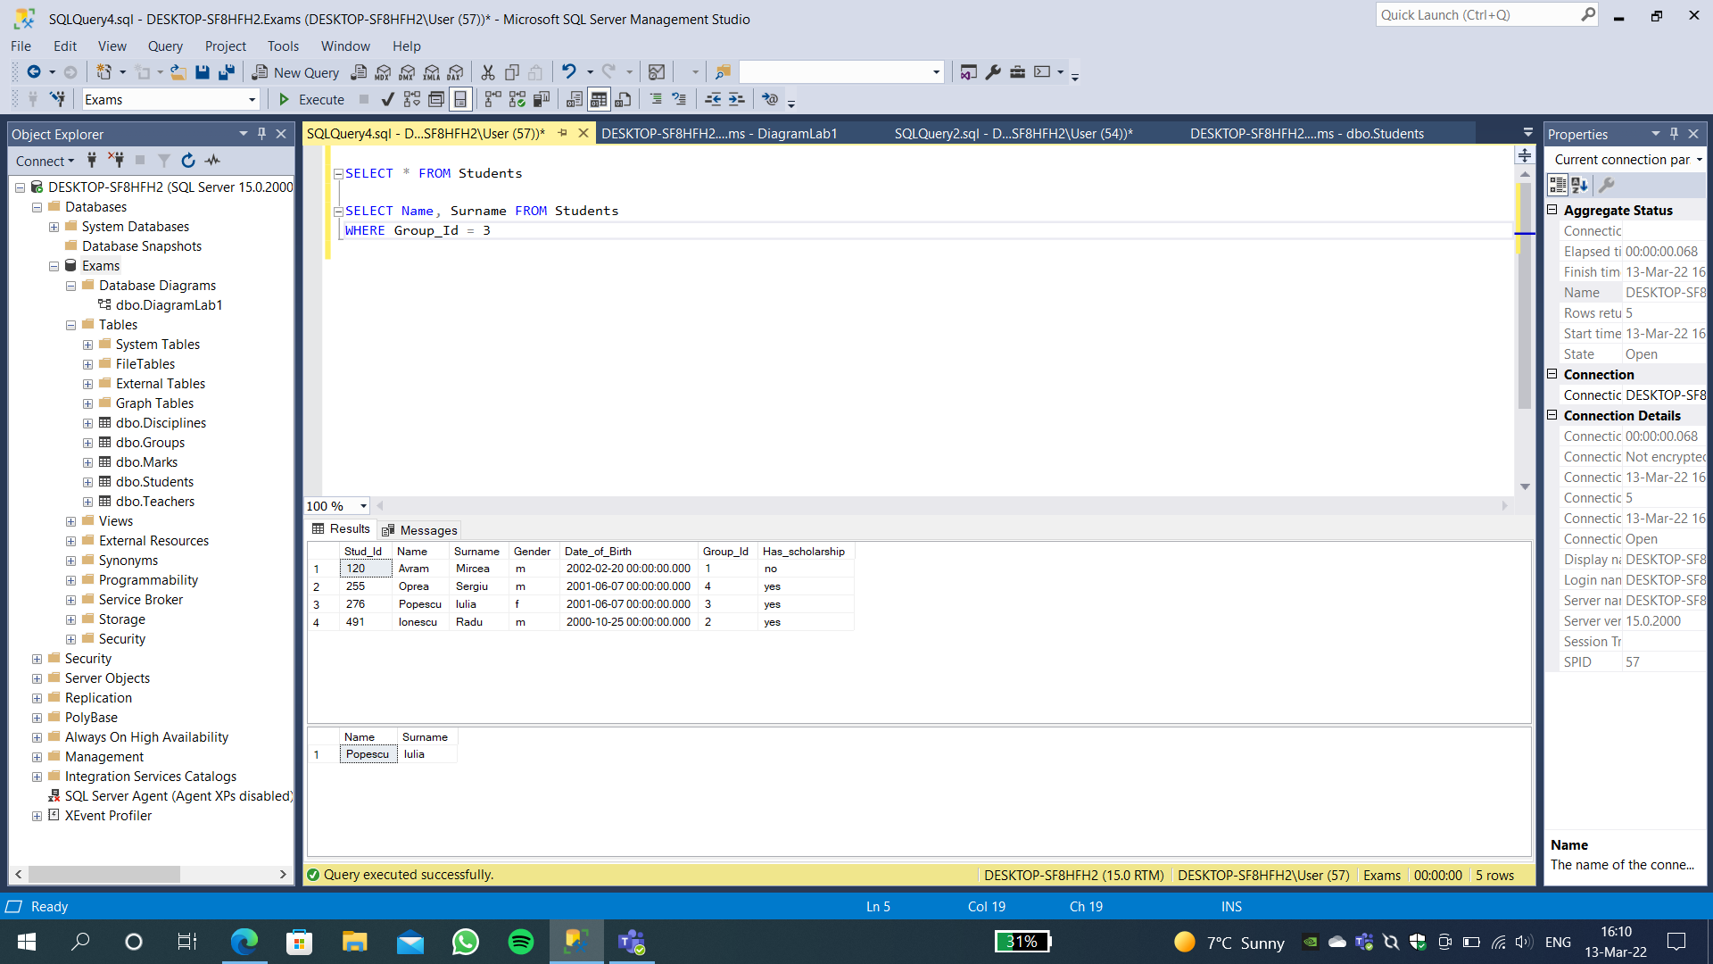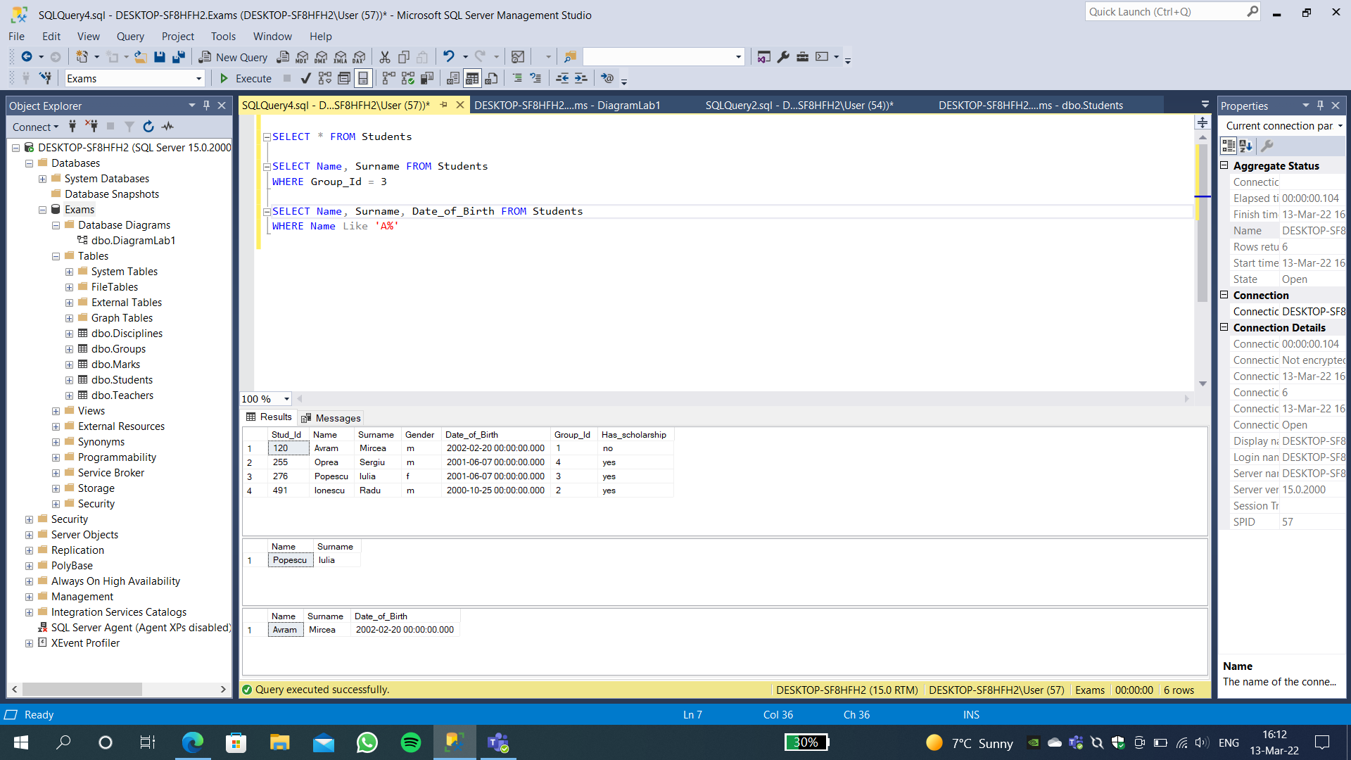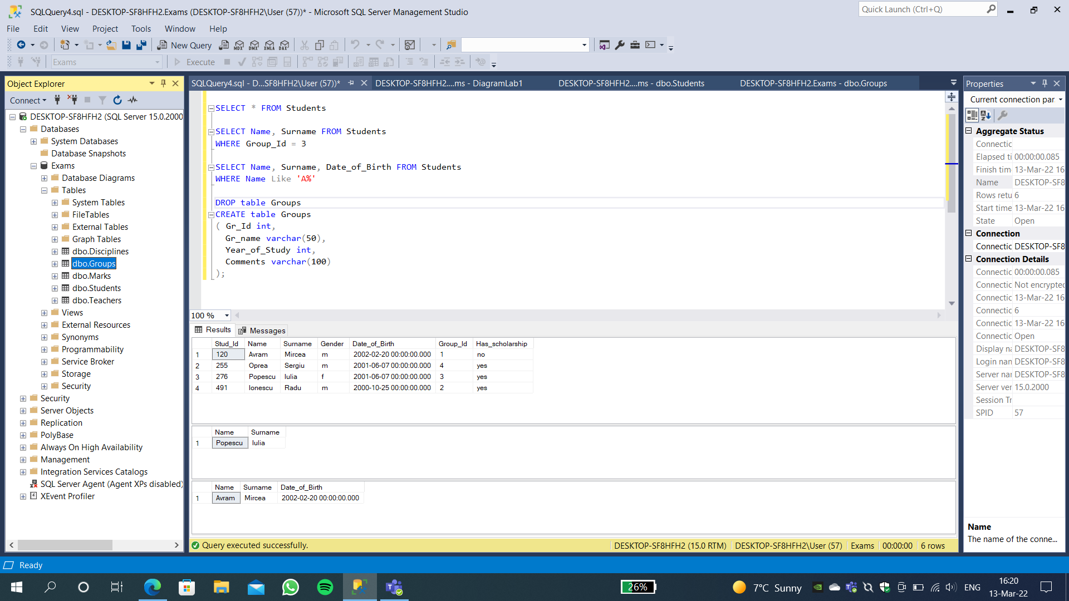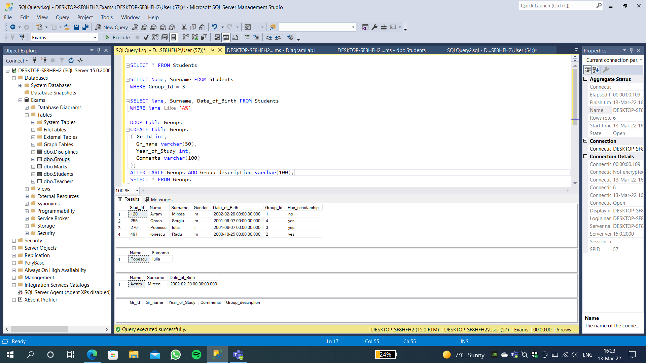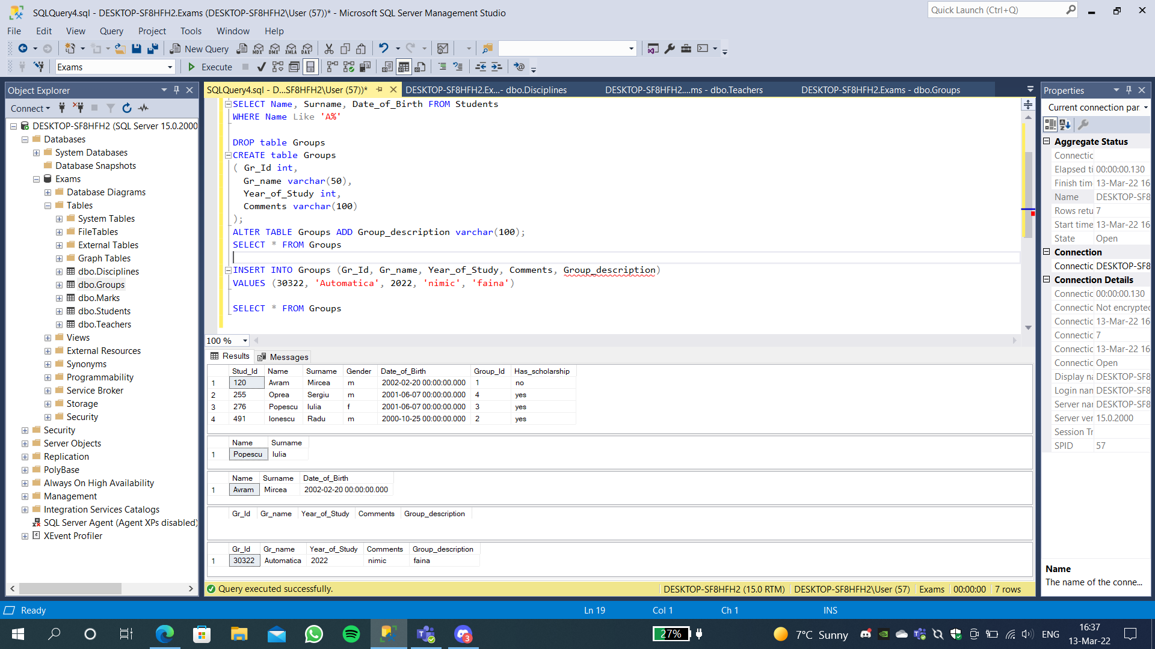

The Query I wrote in order to insert and modify the structure of the db, the code might not be complete because I had to erase the lines which introduce the same data repeatedly while I wanted to check some instructions, that is due to the duplicate restrictions that some data has specified in the tasks.

SELECT * FROM Students

SELECT Name, Surname FROM Students

WHERE Group_Id = 3

SELECT Name, Surname, Date_of_Birth FROM Students

WHERE Name Like 'A%'

DROP table Groups

CREATE table Groups

( Gr_Id int,

Gr_name varchar(50),

Year_of_Study int,

Comments varchar(100)

);

ALTER TABLE Groups ADD Group_description varchar(100);

SELECT * FROM Groups

INSERT INTO Groups (Gr_Id, Gr_name, Year_of_Study, Comments, Group_description)

VALUES (3, 'Automatica', 2022, 'nimic', 'faina')

INSERT INTO Groups (Gr_Id, Gr_name, Year_of_Study, Comments, Group_description)

VALUES (2, 'Calculatoare', 2022, '.', 'grupa')

INSERT INTO Groups (Gr_Id, Gr_name, Year_of_Study, Comments, Group_description)

VALUES (1, 'Mecanica', 2022, 'Haha', 'XD')

SELECT * FROM Groups

SELECT * FROM Teachers

SELECT * FROM Disciplines

INSERT INTO Marks(Student_Id, Teacher_Id, Disc_Id, Mark, Date_of_Exam)

VALUES (276, 625, 521, 4, 13/10/2022)

SELECT * FROM Marks