Tema Lab 4 – Oprea Sergiu-Daniel_30332

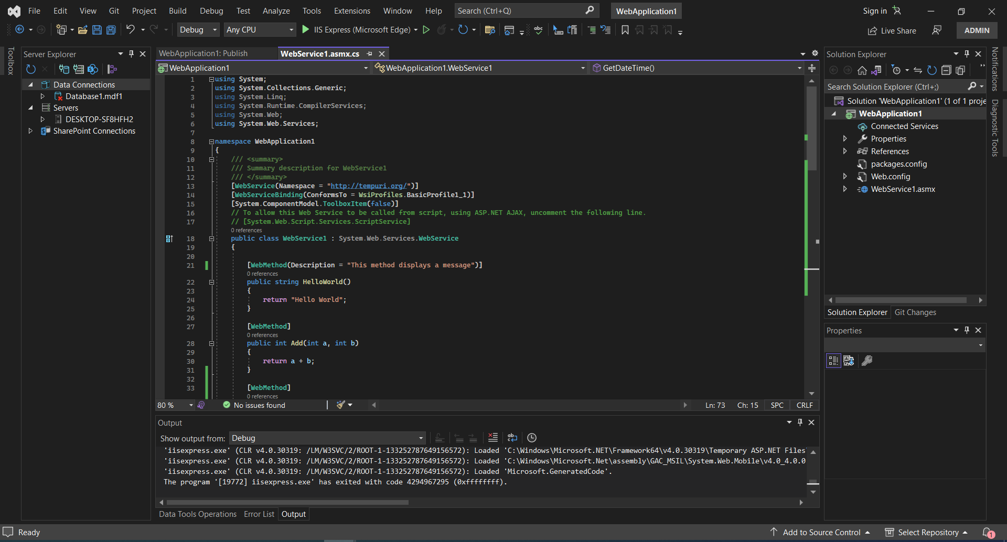Ex. 1

