FIVE WAYS TO SAVE ENERY

This App will help a few simple tips to save energy consumed by electrical devices consume daily. In the main screen you can see I diversified by the type of electrical device, which are the best tricks or tips for each item.

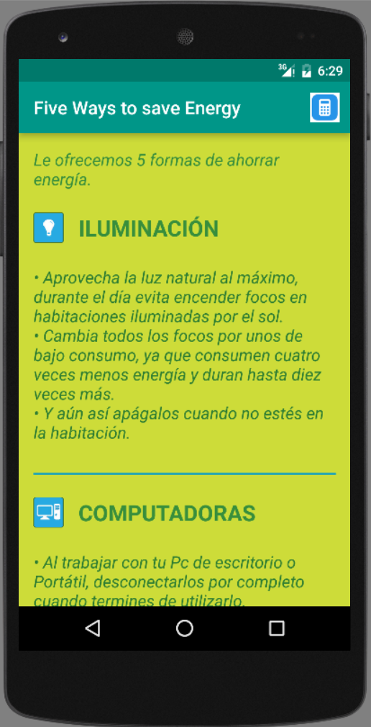
EneryPrice Calculator:
add to this app a consumption calculator to help you to know the price of their daily energy consumption.

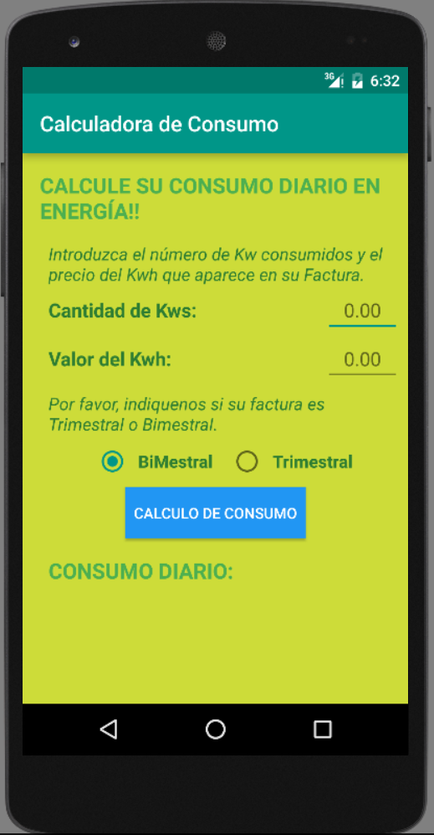

Requires

- Android SDK http://developer.android.com
- Java JDK 1.8 or greater
- Android Studio -> Device: Android 4.2 Jelly Bean or newer

How to Use this App:

Using Android Studio
- First you need to download this project with this url: https://github.com/sergius76/5WaysToSaveEnergy.git
- Download the project in .zip format.
- Decompress the .zip file and import it in Android Studio with the option "Open an existing Android Studio project"

