Setup request from client to server

Ip address
Ip address internet protocol address is a unique numerical identifier for every device or network that connects to the internet. Assigned by an internet provider ISP.

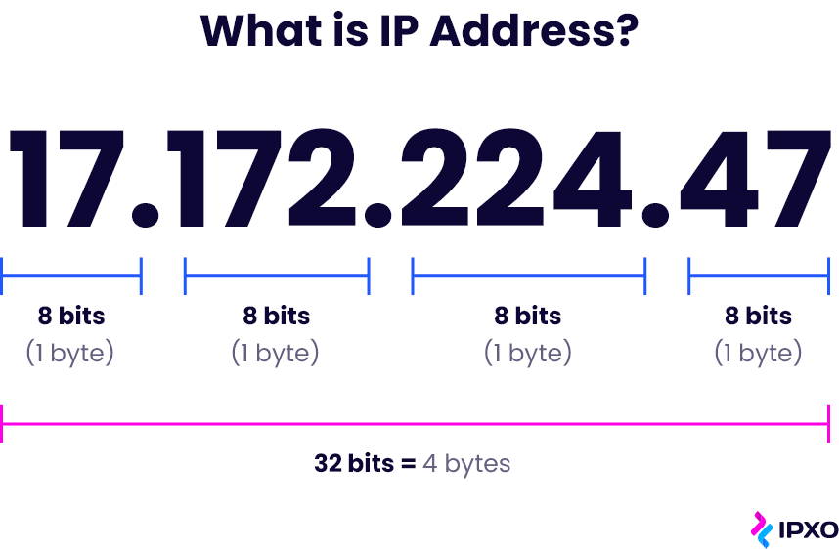

Netmask
https://wiki.teltonika-networks.com/view/What_is_a_Netmask%3F#:~:text=A%20Netmask%20is%20a%2032,is%20the%20assigned%20network%20address.
Netmask is a 32-bit "mask" used to divide an IP address into subnets and specify the network's available hosts. In a netmask, two bits are always automatically assigned. For example, in 255.255. 225.0, "0" is the assigned network address.

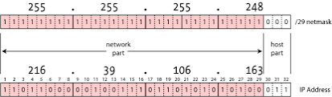

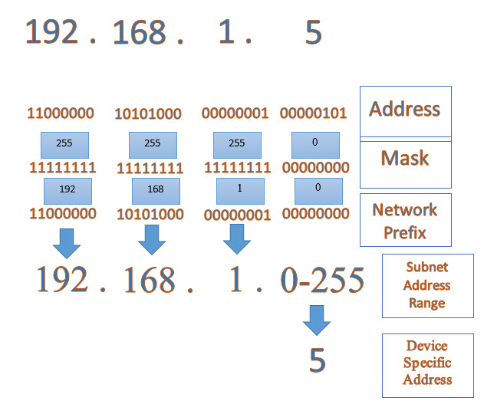

To determine the number of hosts a netmask can support, use the following formula.
2^(# of zeroes) - 2

Default gateway
The default gateway is the path used to pass information when the device doesn’t know where the destination is. More directly, a default gateway is a router that connects your host to remote network segments. It’s the exit point for all the packets in your network that have destinations outside your network.

https://en.wikipedia.org/wiki/Default_gateway

A gateway is a network node that serves as an access point to another network, often involving not only a change of addressing, but also a different networking technology. More narrowly defined, a router merely forwards packets between networks with different network prefixes. The networking software stack of each computer contains a routing table that specifies which interface is used for transmission and which router on the network is responsible for forwarding to a specific set of addresses. If none of these forwarding rules is appropriate for a given destination address, the default gateway is chosen as the router of last resort. The default gateway can be specified by the route command to configure the node's routing table and default route.

In a home or small office environment, the default gateway is a device, such as a DSL router or cable router, that connects the local network to the Internet. It serves as the default gateway for all network devices.

Enterprise network systems may require many internal network segments. A device wishing to communicate with a host on the public Internet, for example, forwards the packet to the default gateway for its network segment. This router also has a default route configured to a device on an adjacent network, one hop closer to the public network.

DNS server
https://www.cloudflare.com/learning/dns/what-is-a-dns-server/
A DNS (Domain Name System) server is a computer or network device that translates domain names into IP addresses. When a user types a domain name into a web browser, the browser sends a request to a DNS server to look up the IP address associated with that domain name. The DNS server then responds with the IP address, allowing the user's browser to connect to the website.
DNS servers play a critical role in the functioning of the internet because they help route internet traffic and facilitate communication between devices. There are two types of DNS servers: authoritative DNS servers and recursive DNS servers. Authoritative DNS servers are responsible for storing the official DNS records for a domain, while recursive DNS servers perform queries on behalf of clients to look up domain names and return IP addresses.
There are many DNS servers available on the internet, including public DNS servers like Google DNS and OpenDNS, as well as private DNS servers that can be used within a corporate network. DNS servers can also be configured to provide additional security features, such as DNSSEC (DNS Security Extensions), which helps prevent DNS spoofing attacks.

The Domain Name System (DNS) is the phonebook of the Internet. When users type domain names such as ‘google.com’ or ‘nytimes.com’ into web browsers, DNS is responsible for finding the correct IP address for those sites. Browsers then use those addresses to communicate with origin servers or CDN edge servers to access website information. This all happens thanks to DNS servers: machines dedicated to answering DNS queries.

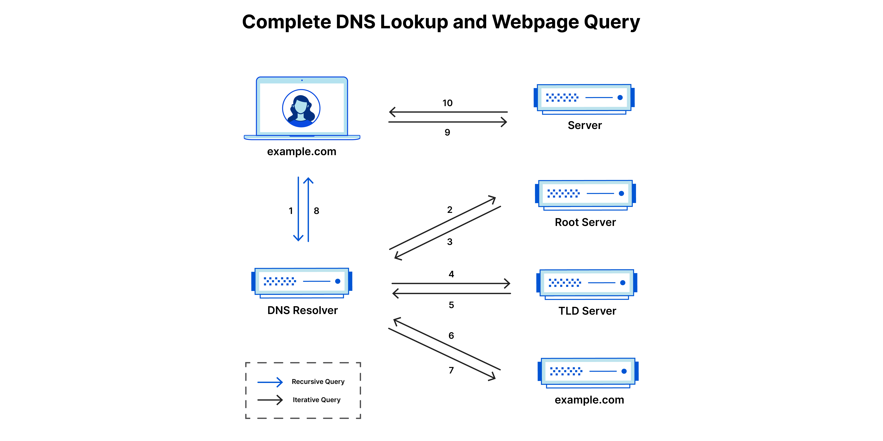

DNS record types (A, AAAA, MX)
https://www.site24x7.com/learn/dns-record-types.html

DNS (Domain Name System) is a hierarchical distributed naming system for computers, services, or other resources connected to the internet or a private network. There are several types of DNS record types. Below are some of the most commonly used types:
- A Record (Address Record): This type of record maps a domain name to an IP address. For example, if you type in the URL of a website, the DNS server will look up the corresponding A record for that domain and return the IP address associated with it.
- AAAA Record (IPv6 Address Record): This record type maps a domain name to an IPv6 address. It is used for websites or services that support IPv6, which is the newer version of the Internet Protocol.
- MX Record (Mail Exchange Record): This record type specifies the mail server responsible for accepting email messages on behalf of a particular domain name. This is important for email delivery, as the MX record ensures that email messages are routed to the correct destination.
- CNAME Record (Canonical Name Record): This record type is used to create an alias for a domain name. For example, you can use a CNAME record to point www.example.com to example.com.
- TXT Record (Text Record): This record type is used to store arbitrary text data associated with a domain name. It can be used for various purposes such as domain verification, email authentication, and more.
These are just a few examples of DNS record types. There are many others, including SRV, NS, PTR, and more.

DHCP
DHCP (Dynamic Host Configuration Protocol) is a network protocol used to automatically assign IP addresses and other network configuration parameters to devices on a network.
When a device connects to a network, it sends out a DHCP request, asking for an IP address and other configuration parameters. The DHCP server on the network then responds with an available IP address and any other necessary configuration information, such as subnet mask, default gateway, and DNS server addresses.
DHCP helps simplify network administration, as it eliminates the need to manually configure network settings on each device. It also allows for more efficient use of IP addresses, as devices are only assigned an IP address when they are connected to the network and released when they are disconnected.
DHCP can be used on both wired and wireless networks, and can be configured to assign a fixed IP address to a device, known as a DHCP reservation. This can be useful for devices that require a consistent IP address, such as printers or servers.

TCP vs UDP: Differences between the protocols

avast.com/c-tcp-vs-udp-difference#:~:text=The%20main%20difference%20between%20TCP,reliable%20but%20works%20more%20quickly.
The main difference between TCP (transmission control protocol) and UDP (user datagram protocol) is that TCP is a connection-based protocol and UDP is connectionless. While TCP is more reliable, it transfers data more slowly. UDP is less reliable but works more quickly. This makes each protocol suited to different types of data transfers.

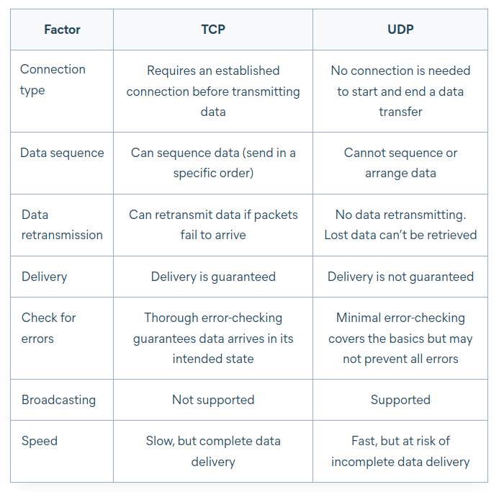

TCP (Transmission Control Protocol) and UDP (User Datagram Protocol) are two transport layer protocols used in computer networking.
TCP is a connection-oriented protocol that provides reliable, ordered, and error-checked delivery of data between applications running on hosts on a network. It guarantees the delivery of all data and ensures that data is received in the order in which it was sent. TCP achieves this by establishing a virtual connection between the sender and receiver, and using a series of handshakes to ensure that both ends are ready to exchange data.
On the other hand, UDP is a connectionless protocol that provides unreliable, unordered, and unchecked delivery of data between applications running on hosts on a network. It does not guarantee delivery or order of data and has no mechanism for error-checking or retransmission of lost data. Instead, it simply sends packets of data to the destination without establishing a connection or verifying that the data has been received.
TCP is typically used for applications that require reliable and ordered delivery of data, such as email, file transfers, and web browsing. UDP, on the other hand, is used for applications that require low latency and where data loss is acceptable, such as online gaming, video streaming, and voice-over-IP (VoIP) applications.

WebRTC vs WebSockets: What are the key differences?
- WebSocket provides a client-server computer communication protocol, whereas WebRTC offers a peer-to-peer protocol and communication capabilities for browsers and mobile apps.
- While WebSocket works only over TCP, WebRTC is primarily used over UDP (although it can work over TCP as well).
- WebSocket is a better choice when data integrity is crucial, as you benefit from the underlying reliability of TCP. On the other hand, if speed is more important and losing some packets is acceptable, WebRTC over UDP is a better choice.
- WebRTC is primarily designed for streaming audio and video content. It is possible to stream media with WebSockets too, but the WebSocket technology is better suited for transmitting text/string data using formats such as JSON.

When to use WebRTC?
WebRTC is a good choice for the following use cases:
- Audio and video communications, such as video calls, video chat, video conferencing, and browser-based VoIP.
- File sharing apps.
- Screen sharing apps.
- Broadcasting live events (such as sports events).
- IoT devices (e.g., drones or baby monitors streaming live audio and video data).

When to use WebSockets?
We can broadly group Web Sockets use cases into two distinct categories:
- Realtime updates, where the communication is unidirectional, and the server is streaming low-latency (and often frequent) updates to the client. Think of live score updates or alerts and notifications, to name just a few use cases.
- Bidirectional communication, where both the client and the server send and receive messages. Examples include chat, virtual events, and virtual classrooms (the last two usually involve features like live polls, quizzes, and Q&As). WebSockets can also be used to underpin multi-user synchronized collaboration functionality, such as multiple people editing the same document simultaneously.

When to use WebRTC and WebSocket together?
WebSockets and WebRTC are complementary technologies. As mentioned before, WebRTC allows for peer-to-peer communication, but it still needs servers, so that these peers can coordinate communication, through a process called signaling. Generally, signaling involves transferring information such as media metadata (e.g., codecs and media types), network data (for example, the host’s IP address and port), and session-control messages for opening and closing communication.
A key thing to bear in mind: WebRTC does not provide a standard signaling implementation, allowing developers to use different protocols for this purpose. The WebSocket protocol is often used as a signaling mechanism for WebRTC applications, allowing peers to exchange network and media metadata in realtime.
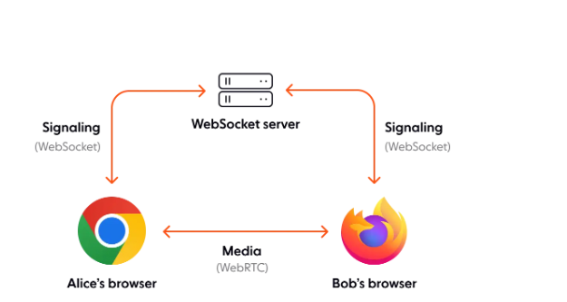

HTTP uses TCP or UDP
HTTP (Hypertext Transfer Protocol) is a protocol used for transmitting data over the internet and it uses TCP (Transmission Control Protocol) as its underlying transport layer protocol.
HTTP relies on TCP to provide a reliable, ordered, and error-checked delivery of data between the web server and client. When a client sends an HTTP request to a web server, TCP establishes a virtual connection between the client and server and ensures that the data is transmitted correctly and in the correct order. This connection is maintained until the transmission of the data is complete, at which point the connection is closed.
TCP is used by HTTP to ensure that all data is delivered in the correct order and without errors, making it suitable for transmitting web pages, images, and other data that require reliability and consistency.

DNS uses UDP
DNS (Domain Name System) primarily uses the User Datagram Protocol (UDP) as its transport layer protocol for DNS queries and responses.
When a client sends a DNS query to a DNS server, the query is encapsulated into a UDP datagram and sent to the DNS server's port 53. The DNS server then responds with a UDP datagram containing the requested information, which is sent back to the client's IP address and port number.
UDP is used for DNS queries because it is faster and more efficient than TCP, as it does not require a virtual connection to be established before data can be transmitted. Additionally, most DNS queries are small in size and can easily fit within a single UDP datagram, further reducing the overhead of using TCP.
However, UDP does not provide reliable delivery or congestion control, which means that packets may be lost or dropped if there is congestion on the network. To mitigate this, DNS servers can use techniques such as packet retransmission, caching, and load balancing to ensure that queries are handled quickly and efficiently.

TCP socket

https://www.howtouselinux.com/post/tcp-socket

A TCP socket is a software endpoint in a network communication that uses the Transmission Control Protocol (TCP) as its transport protocol. It allows two endpoints (such as a client and a server) to establish a reliable, two-way communication channel over a network.
In a TCP connection, a socket is identified by a unique combination of the local IP address, local port number, remote IP address, and remote port number. When a socket is created, it is assigned a unique socket descriptor that the application uses to refer to the socket in subsequent communication.
TCP sockets provide a reliable, ordered, and error-checked stream of data between the endpoints. The protocol uses a three-way handshake to establish the connection, and provides flow control and congestion control mechanisms to ensure efficient data transmission.
TCP sockets are widely used in network programming, particularly for client-server applications. The programming interfaces for TCP sockets are available in many programming languages, and they provide a rich set of functions for sending and receiving data, setting socket options, and handling errors.

NAT
NAT (Network Address Translation) is a technology used to allow multiple devices on a private network to share a single public IP address. NAT works by mapping the private IP addresses of devices on the internal network to the public IP address of the router that connects the network to the internet.
When a device on the private network sends a request to the internet, the NAT device replaces the private IP address of the device with its own public IP address, and records the original private IP address and port number. When the response is received, the NAT device uses this mapping to route the response back to the appropriate device on the internal network.
Host-only only permits network operations with the Host OS.
NAT mode will mask all network activity as if it came from your Host OS, although the VM can access external resources.
Bridged mode replicates another node on the physical network and your VM will receive it's own IP address if DHCP is enabled in the network.

ICMP
ICMP (Internet Control Message Protocol) is a network protocol used to send error messages and operational information about network conditions between routers, hosts, and other network devices. ICMP is typically used for troubleshooting and diagnostic purposes, and is an integral part of the IP protocol suite.
ICMP messages are typically sent by routers or other network devices when an error condition is encountered, such as when a packet cannot be delivered to its destination. ICMP messages are also used to test network connectivity, such as through the use of the ping command, which sends an ICMP echo request message to a remote device and waits for an ICMP echo reply message in response.
Some common types of ICMP messages include:
- Echo Request: Used to test network connectivity by sending a message to a remote device and waiting for a response.
- Echo Reply: Sent in response to an Echo Request message.
- Destination Unreachable: Sent by a router or other device when it is unable to deliver a packet to its destination.
- Time Exceeded: Sent by a router or other device when a packet has been discarded due to a time-to-live (TTL) value that has been exceeded.
ICMP is an essential protocol for maintaining the health and efficiency of a network, and is used extensively in network troubleshooting and diagnostics.

Setup access to the server

SSH

SSH (Secure Shell) is a cryptographic network protocol used for secure remote login and command execution over an unsecured network. It provides secure encrypted communications between two untrusted hosts over an insecure network. SSH is typically used by system administrators to manage remote servers, as well as by developers to securely transfer files and run commands on remote machines.
To use SSH, you need to have an SSH client installed on your computer and an SSH server running on the remote machine that you want to connect to. Here are the basic steps to use SSH:
- Install an SSH client: There are several SSH clients available for different operating systems. Some popular SSH clients include OpenSSH, PuTTY, and WinSCP.
- Connect to the remote server: To connect to a remote server via SSH, you need to know the server's IP address or hostname and have the appropriate login credentials (usually a username and password). You can use the following command to connect to an SSH server:
cssCopy code
ssh username@remote-server
Replace "username" with your username on the remote server and "remote-server" with the IP address or hostname of the server.
- Authenticate and login: After you run the above command, you will be prompted to enter your password (if required) to authenticate and login to the remote server. Once you are logged in, you can run commands on the remote server or transfer files using SSH.
SSH provides many additional features and options, such as public-key authentication, port forwarding, and tunneling. You can refer to the SSH documentation or the documentation of your SSH client for more information on how to use these features.

SSH port forwarding
https://linuxize.com/post/how-to-setup-ssh-tunneling/

SSH port forwarding, also known as SSH tunneling, is a method of securely transmitting data between a local client computer and a remote server over an unsecured network, such as the internet.
SSH port forwarding allows a user to access a service or resource that is only available on a remote server through a secure SSH connection. The user establishes an SSH connection to the remote server, and then sets up a port forwarding rule that redirects traffic from a specific port on the local machine to a specific port on the remote machine. This allows the user to access the service or resource on the remote machine as if it were running locally.
There are three types of SSH port forwarding:
- Local Port Forwarding. - Forwards a connection from the client host to the SSH server host and then to the destination host port.
- Remote Port Forwarding. - Forwards a port from the server host to the client host and then to the destination host port.
- Dynamic Port Forwarding. - Creates a SOCKS proxy server that allows communication across a range of ports.

RSA and AES

RSA (Rivest–Shamir–Adleman) is a public-key cryptosystem that is widely used for secure data transmission.
In a public-key cryptosystem, the encryption key is public and distinct from the decryption key, which is kept secret (private). An RSA user creates and publishes a public key based on two large prime numbers, along with an auxiliary value. The prime numbers are kept secret. Messages can be encrypted by anyone, via the public key, but can only be decoded by someone who knows the prime numbers.[1]

The security of RSA relies on the practical difficulty of factoring the product of two large prime numbers, the "factoring problem". Breaking RSA encryption is known as the RSA problem. Whether it is as difficult as the factoring problem is an open question.[3] There are no published methods to defeat the system if a large enough key is used.

RSA and AES are two different cryptographic algorithms used for encryption and decryption.

RSA is a public key cryptography algorithm named after its inventors Ron Rivest, Adi Shamir, and Leonard Adleman. It uses a pair of keys, a public key and a private key, for encryption and decryption. The public key can be freely distributed and is used for encrypting messages, while the private key is kept secret and is used for decrypting messages. RSA is commonly used for key exchange, digital signatures, and secure communication.
typescript
AES, on the other hand, is a symmetric key cryptography algorithm, which means the same key is used for both encryption and decryption. It was developed by the US National Institute of Standards and Technology (NIST) and is considered a very secure encryption algorithm. AES uses a block cipher, which means it breaks the data to be encrypted into blocks of a fixed size, and applies the encryption algorithm to each block in turn.

RSA is typically used for encrypting small amounts of data, such as keys used for symmetric encryption. AES is used for encrypting larger amounts of data, such as entire files or hard drives. In some cases, both algorithms can be used together for added security. For example, AES can be used to encrypt the data, and RSA can be used to encrypt the AES key used to encrypt the data.

What key is used to sign electronic signature
As the name implies, the private key is not shared and is used only by the signer to sign documents electronically. The public key is openly available and used by those who need to validate the signer's electronic signature.

Cyphering, encoding and hashing
Online tools
https://emn178.github.io/online-tools/sha256.html

base64
Base64 is a binary-to-text encoding scheme that represents binary data in an ASCII string format. In other words, it is a way to convert binary data into a string of ASCII characters that can be transmitted over a text-based medium, such as email or HTML.
Base64 encoding works by dividing the original data into 6-bit blocks, and then representing each 6-bit block as a single ASCII character from a set of 64 characters. These 64 characters include uppercase and lowercase letters, digits, and two special characters, which are usually + and /. A padding character (=) is used if the number of bytes in the original data is not divisible by three.
Base64 encoding is often used in email systems to transmit attachments, since email systems are designed to handle text-based content rather than binary data. It is also commonly used in web applications to transmit binary data as a string in a URL or in a web form.
To encode data in Base64, you can use various software or programming language libraries that support Base64 encoding. To decode Base64-encoded data, you can use similar tools or libraries that support Base64 decoding.

Md5
MD5 (Message Digest 5) is a cryptographic hash function that produces a fixed-size, 128-bit hash value from any input data. It was invented by Ronald Rivest in 1991 and is widely used in cryptography and computer security.
MD5 takes an input message of any length and produces a fixed-size output of 128 bits. The output, or hash value, is a unique digital fingerprint of the input message, which is used for integrity checking, digital signatures, and other security applications.
MD5 is a one-way function, meaning that it is impossible to recover the original input message from the hash value. However, given an input message, it is easy to calculate the corresponding MD5 hash value. This makes MD5 useful for password storage, where the password is hashed and the hash value is stored instead of the plain text password.
MD5 has been shown to be vulnerable to collision attacks, which means that it is possible to find two different input messages that produce the same hash value. Because of this, MD5 is no longer considered a secure hash function for cryptographic purposes. Other hash functions like SHA-2 and SHA-3 are recommended for new applications that require secure hash functions.

SHA-2
SHA-2 (Secure Hash Algorithm 2) is a family of cryptographic hash functions that produce a fixed-size output in various bit lengths, including 224, 256, 384, and 512 bits. SHA-2 was developed by the National Security Agency (NSA) and published by the National Institute of Standards and Technology (NIST) in 2001 as a successor to SHA-1.
Like MD5 and SHA-1, SHA-2 is a one-way function that produces a unique digital fingerprint of the input message. However, SHA-2 is designed to be more secure than its predecessors, and is considered to be a stronger cryptographic hash function.
SHA-2 uses a series of mathematical operations to transform the input message into a fixed-size output of the desired bit length. The output is designed to be highly sensitive to any changes in the input message, meaning that even a small change in the input message will produce a completely different output.
SHA-2 is commonly used in various security applications, such as digital signatures, message authentication codes (MACs), and password storage. It is also used in the SSL/TLS protocol to provide secure communication over the internet.
It is important to note that SHA-2 is not immune to all attacks, and in some cases, collision attacks have been demonstrated. However, compared to its predecessors like MD5 and SHA-1, SHA-2 is considered to be a much more secure cryptographic hash function.

Sha1
SHA-1 (Secure Hash Algorithm 1) is a cryptographic hash function that produces a fixed-size, 160-bit hash value from any input data. It was developed by the National Security Agency (NSA) and published by the National Institute of Standards and Technology (NIST) in 1995.
Like other hash functions, SHA-1 takes an input message of any length and produces a unique digital fingerprint of the input message. This fingerprint, or hash value, can be used for data integrity checking, digital signatures, and other security applications.
SHA-1 is a one-way function, meaning that it is impossible to recover the original input message from the hash value. However, given an input message, it is easy to calculate the corresponding SHA-1 hash value.
In recent years, SHA-1 has been shown to be vulnerable to collision attacks, where two different input messages produce the same hash value. Because of this, SHA-1 is no longer considered a secure hash function for cryptographic purposes. It is recommended to use more secure hash functions like SHA-2 or SHA-3 for new applications that require secure hash functions.
However, SHA-1 is still secure for HMAC

HMAC
HMAC (sometimes expanded as either keyed-hash message authentication code or hash-based message authentication code) is a specific type of message authentication code (MAC) involving a cryptographic hash function and a secret cryptographic key. As with any MAC, it may be used to simultaneously verify both the data integrity and authenticity of a message.

SHA-256
SHA-256 (Secure Hash Algorithm 256) is a cryptographic hash function that produces a fixed-size output of 256 bits from any input data. It is a member of the SHA-2 family of hash functions, which were developed by the National Security Agency (NSA) and published by the National Institute of Standards and Technology (NIST) in 2001.
SHA-256, like other cryptographic hash functions, takes an input message of any length and produces a unique digital fingerprint of the input message. This fingerprint, or hash value, is used for a variety of security purposes, such as data integrity checking, digital signatures, and password storage.
SHA-256 is designed to be a secure hash function, meaning that it is resistant to various cryptographic attacks, including collision attacks. It uses a series of mathematical operations to transform the input message into a fixed-size output of 256 bits, which is designed to be highly sensitive to any changes in the input message.
SHA-256 is widely used in various security applications, such as SSL/TLS certificates, digital signatures, and blockchain technology. It is considered to be a strong cryptographic hash function and is recommended for new applications that require secure hash functions.

SHA-2 is considered technically better than SHA-1
due to several reasons:
- Longer output size: SHA-2 produces a larger hash output than SHA-1. SHA-1 produces a 160-bit output, while SHA-2 has different output sizes, including 224, 256, 384, and 512 bits. The larger output size of SHA-2 makes it more resistant to collision attacks, where two different input messages can produce the same hash output.
- Stronger security properties: SHA-2 is designed with stronger security properties than SHA-1. It uses more rounds of hashing and more complex mathematical operations, which makes it more difficult for attackers to find collisions or other weaknesses.
- Resistance to length extension attacks: SHA-2 is resistant to length extension attacks, a type of attack that can be used to extend the length of a hash value without knowing the original input. SHA-1 is vulnerable to this type of attack, which can compromise its security.
- NIST recommended: SHA-2 is the recommended hash function by NIST, while SHA-1 is deprecated due to its known vulnerabilities.
Overall, SHA-2 is considered to be a stronger and more secure hash function than SHA-1, and it is recommended for use in new applications that require secure hashing.

Unicode
Unicode is a character encoding standard that was designed to support the representation of all known characters from all writing systems in the world. It is a universal character set that assigns unique code points to each character, regardless of the platform, program or language.
Unicode includes characters from a wide range of writing systems, including Latin, Greek, Cyrillic, Arabic, Hebrew, Chinese, Japanese, Korean, and many more. Each character is assigned a unique code point, which is a number that represents that character.
The Unicode standard defines different encoding forms to represent these characters in binary form. The most commonly used Unicode encoding forms are UTF-8, UTF-16, and UTF-32. These encoding forms provide a way to represent Unicode characters as sequences of bytes that can be stored and transmitted over computer networks.
UTF-8 is a variable-length encoding that uses between 1 and 4 bytes to represent each character, depending on the character's code point value. It is the most commonly used Unicode encoding form on the internet because it is compatible with ASCII and supports all Unicode characters.
UTF-16 is a fixed-length encoding that uses 2 bytes to represent each character. It is commonly used in Windows-based systems and supports all Unicode characters.
UTF-32 is a fixed-length encoding that uses 4 bytes to represent each character. It is rarely used because it consumes more memory and storage space than the other encoding forms.
Unicode has become the de facto standard for character encoding, and its use has become essential in modern computing systems, including web applications, mobile applications, operating systems, databases, and more.

JWT
JWT (JSON Web Token) is a standard for representing claims securely between two parties. It is used for authentication and authorization purposes in web applications and APIs.
A JWT is a self-contained token that consists of three parts: a header, a payload, and a signature. The header and payload are JSON objects that are base64-encoded and concatenated with a period. The signature is calculated by applying a hashing algorithm to the encoded header and payload, along with a secret key that is known only to the issuer and recipient of the token.
The header of a JWT contains metadata about the token, such as the algorithm used for signing the token. The payload contains the claims or statements that are being made about the authenticated user or entity. These claims can include information such as the user's name, email address, and roles.
JWTs are used for stateless authentication and authorization in web applications and APIs. When a user logs in to an application, the server generates a JWT and sends it back to the client. The client then includes the JWT in subsequent requests to the server, which can use the claims in the token to verify the user's identity and authorization.
JWTs provide several benefits over traditional authentication mechanisms such as session cookies. They are portable, meaning that they can be used across different systems and technologies. They are also self-contained, meaning that they do not require the server to store session information or perform database lookups to authenticate users. Finally, they can be validated using public key cryptography, which allows the server to verify the authenticity of a token without knowing the secret key used to sign it.

Analyze algorithic complexity of the code

Big O natition
Big O notation is used to classify algorithms according to how their running time or space requirements grow as the input size grows. On the chart below you may find most common orders of growth of algorithms specified in Big O notation.
https://www.bigocheatsheet.com/

Time complexity is defined as the amount of time taken by an algorithm to run, as a function of the length of the input. It measures the time taken to execute each statement of code in an algorithm.

Space complexity refers to the total amount of memory space used by an algorithm/program, including the space of input values for execution. Calculate the space occupied by variables in an algorithm/program to determine space complexity.
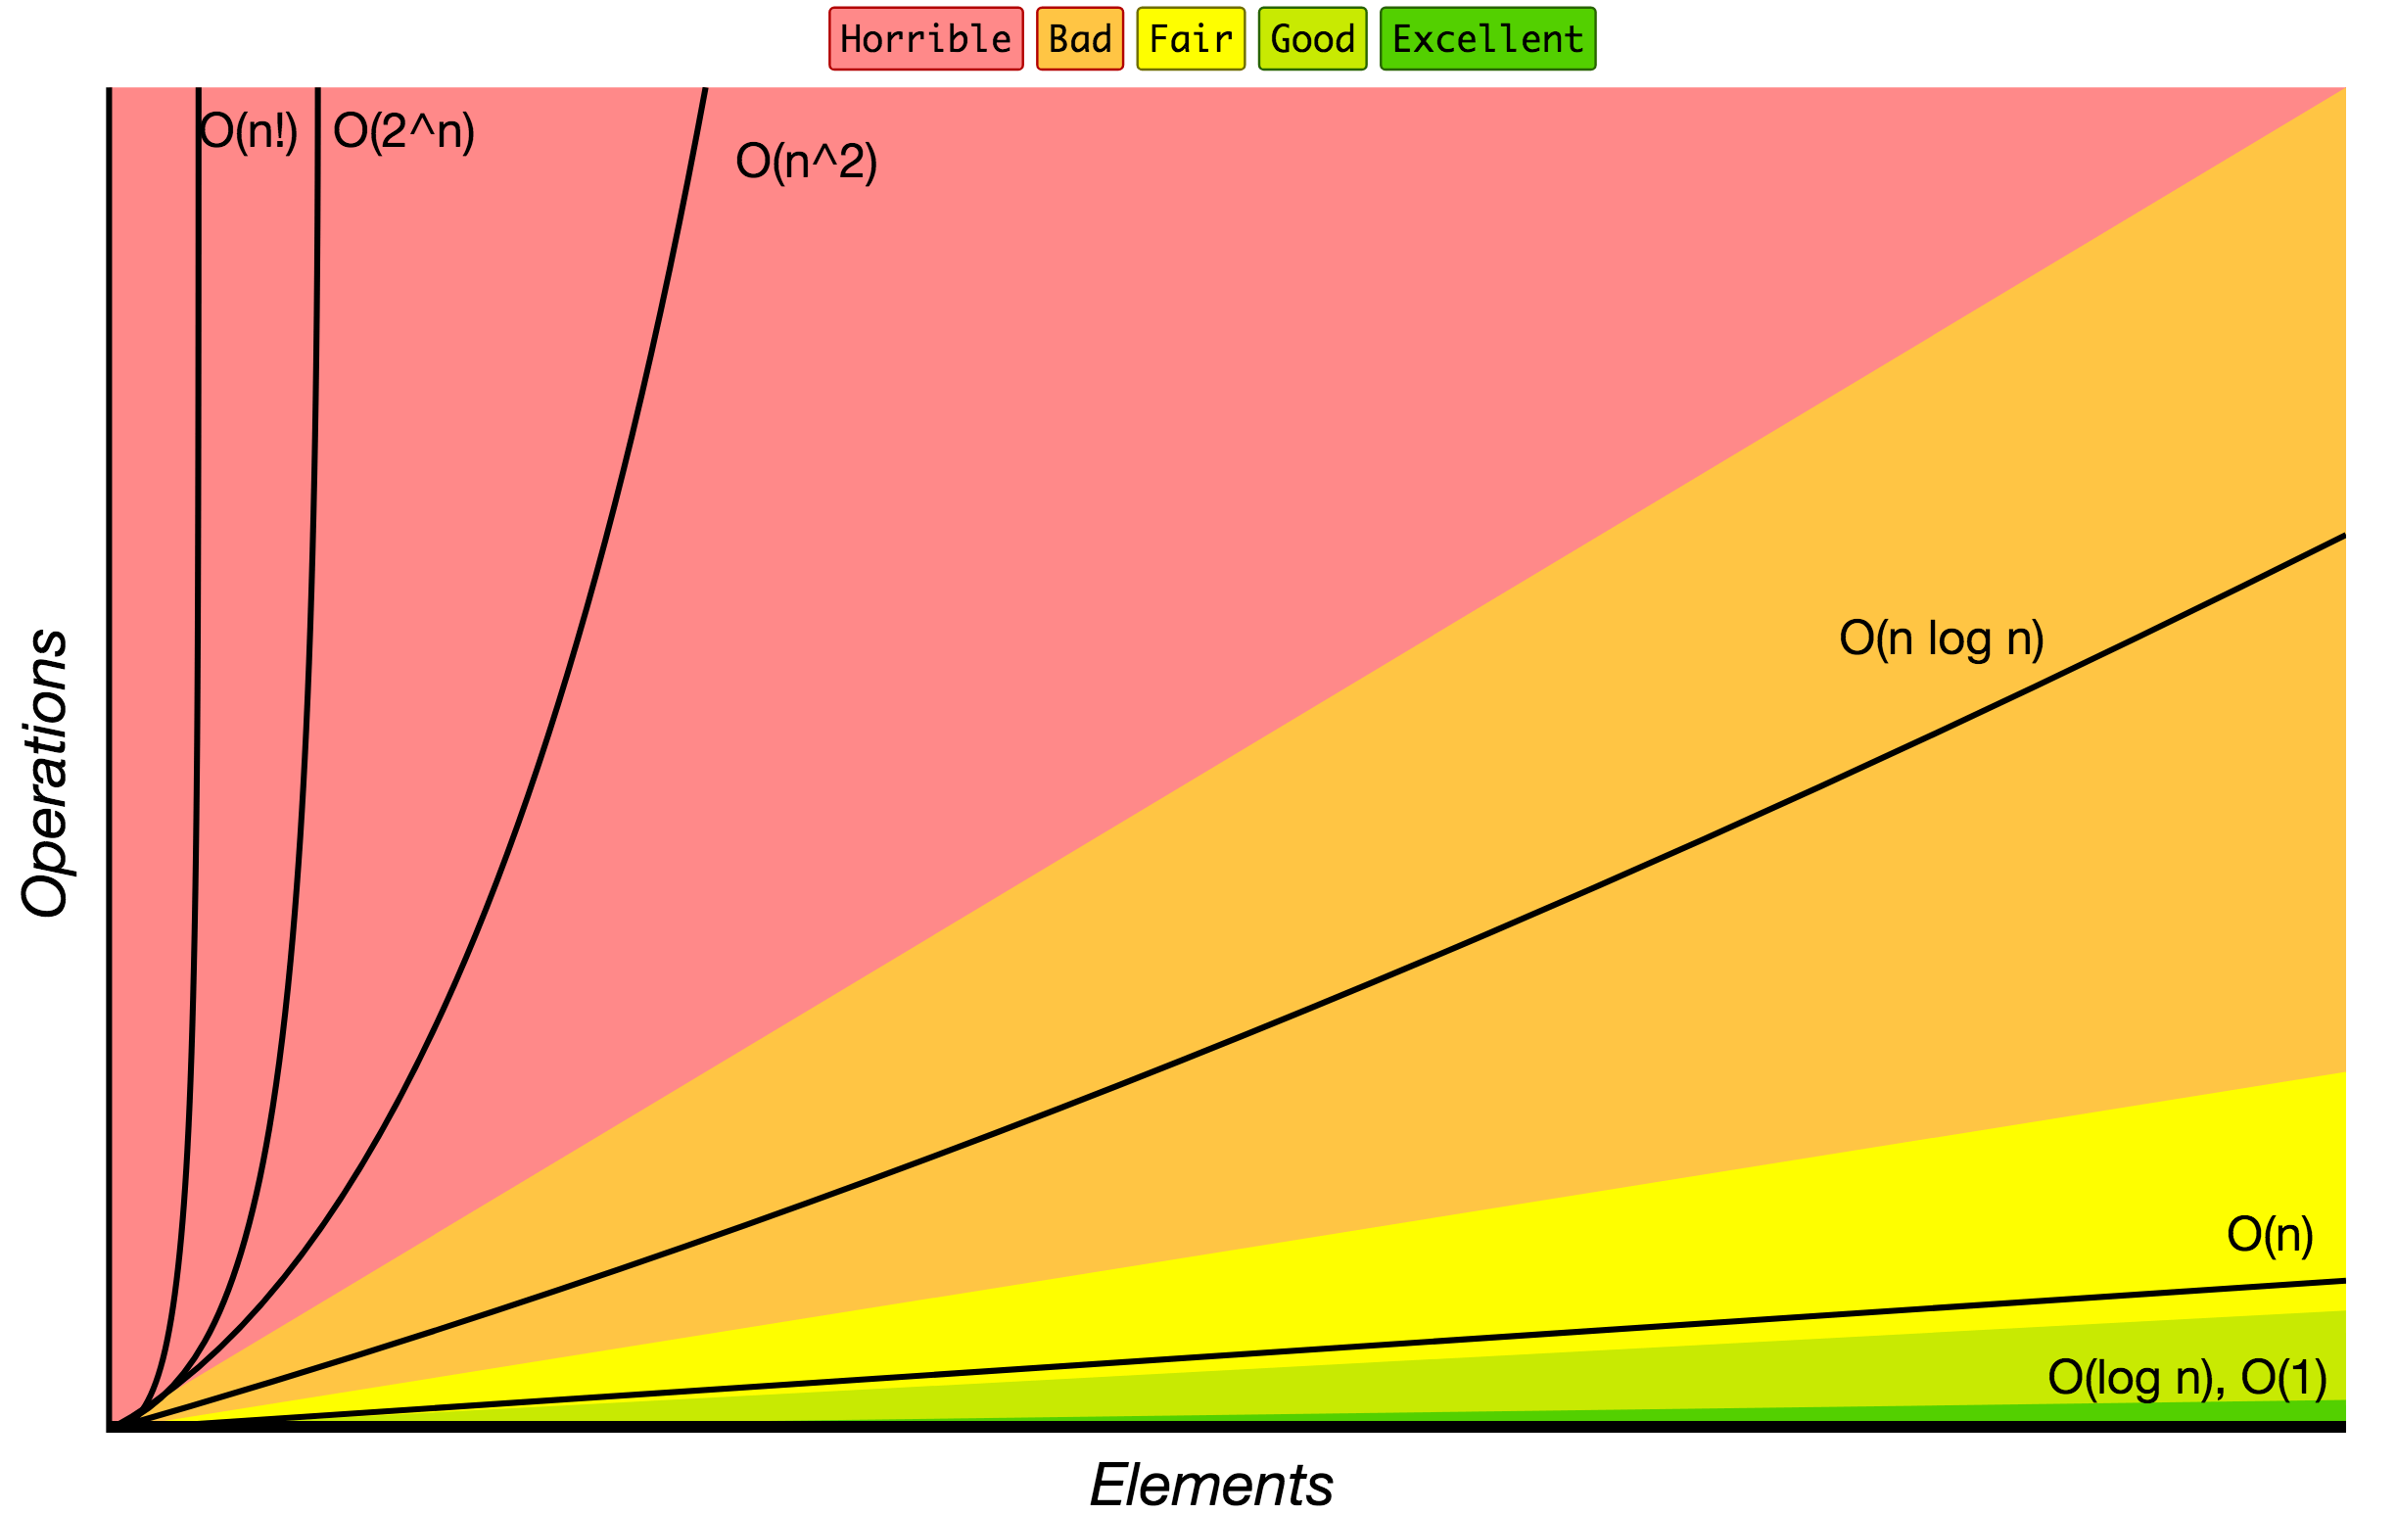

Why o(n^2) could perform faster than o(n*long(n))
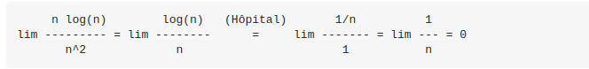

Work with dbs

Index in dbs
In the context of databases, there are several types of indexes. The most common types of indexes are:
- Primary Index: A primary index is a type of index that is created on a primary key column in a table. It is used to enforce the uniqueness of the primary key column and to speed up queries that use the primary key column in the WHERE clause.
- Secondary Index: A secondary index is a type of index that is created on a non-primary key column in a table. It is used to speed up queries that use the non-primary key column in the WHERE clause.
- Clustered Index: A clustered index is a type of index that determines the physical order of data in a table. It is created on a primary key column, and it sorts the table's data based on the values in that column. This can speed up queries that involve sorting or grouping.
- Non-Clustered Index: A non-clustered index is a type of index that does not affect the physical order of data in a table. It is created on a non-primary key column and provides a separate index structure that points to the physical locations of the rows in the table.
- Unique Index: A unique index is a type of index that ensures that no two rows in a table have the same value in the indexed column(s). It can be created on one or more columns in a table.
- Full-Text Index: A full-text index is a type of index that is used to enable full-text search capabilities in a database. It is created on one or more columns that contain text data, and it allows users to search for specific words or phrases within that data.
- Spatial Index: A spatial index is a type of index that is used to enable spatial data operations, such as geographic information system (GIS) queries. It is created on columns that contain spatial data types, such as point, line, or polygon.

Inverted index
An inverted index is a type of data structure that is commonly used in search engines to facilitate efficient full-text search. It is called an inverted index because it inverts the relationship between words and documents.
In a typical document database, each document is associated with a set of words or terms that describe its content. In an inverted index, instead of storing documents and their associated words, the index stores a list of words and their associated documents.
Each entry in the inverted index contains a word and a list of document IDs where that word appears. When a user searches for a word or phrase, the search engine looks up the term in the inverted index and retrieves a list of documents that contain the word. The search engine can then rank the documents by relevance and return them to the user.
Inverted indexes are useful for full-text search because they allow the search engine to quickly identify documents that contain specific words or phrases, even in large collections of documents. They can also be used to perform other types of text analysis, such as identifying common terms or generating word clouds.

Vulnerabilities and methods of protection

xss
Links:
https://owasp.org/www-community/attacks/xss/

XSS (Cross-Site Scripting) is a type of security vulnerability that allows an attacker to inject malicious code into a web page viewed by other users. The attacker can exploit this vulnerability to steal sensitive information, such as login credentials, credit card numbers, or personal information, from unsuspecting users.
There are two main types of XSS attacks:
- Stored XSS: The attacker injects malicious code that is permanently stored on the server, and is executed whenever the affected page is viewed by a user. This type of attack can have a long-lasting impact, as the malicious code can continue to execute even after the initial attack is detected and removed.
- Reflected XSS: The attacker injects malicious code that is immediately reflected back to the user, typically as part of a search query or form submission. The user's browser then executes the code, which can steal sensitive information or perform other malicious actions.
To prevent XSS attacks, web developers should follow best practices for input validation and output encoding. Here are some specific techniques to prevent XSS attacks:
- Use input validation: Validate all user input, including form submissions, URL parameters, and cookies. This can help prevent attackers from injecting malicious code into your application.
- Use output encoding: Encode all user input before it is displayed on the page. This can help prevent attackers from executing malicious code in the user's browser.
- Use a Content Security Policy (CSP): A CSP is a security mechanism that allows you to specify which resources can be loaded on your web page, and can help prevent XSS attacks.
- Use HTTPS: HTTPS encrypts data between the server and the user's browser, which can help prevent attackers from intercepting sensitive information.
By implementing these techniques, you can help prevent XSS attacks and protect your users' sensitive information.

HTML sanitizer
An HTML sanitizer is a tool that can be used to remove potentially dangerous HTML elements and attributes from user-generated content to prevent security vulnerabilities, such as XSS attacks. Sanitizing HTML is important because user-generated content can contain malicious code that could be executed by the user's browser, putting them and other users at risk.
There are several open-source HTML sanitizers available for use in web applications, such as:
- DOMPurify: A JavaScript library that can be used to sanitize HTML on the client-side.
- HTMLPurifier: A PHP library that can be used to sanitize HTML on the server-side.
- Bleach: A Python library that can be used to sanitize HTML on the server-side.
HTML sanitizers typically work by parsing the HTML content and removing any elements and attributes that are not considered safe. They may also perform additional checks to ensure that the remaining HTML is well-formed and does not contain any other security vulnerabilities.
When using an HTML sanitizer, it is important to understand its limitations and to ensure that it is being used correctly. Sanitizers may not catch all potential security vulnerabilities, and it is still important to follow best practices for input validation and output encoding to protect against other types of attacks.

CSRF
CSRF (Cross-Site Request Forgery) is a type of security vulnerability that allows an attacker to trick a user into unknowingly performing actions on a website that they did not intend to perform. This can allow an attacker to perform actions such as changing a user's password, making unauthorized purchases, or deleting content.
A CSRF attack typically involves the following steps:
- The attacker creates a website or email that contains a malicious link or form that performs an action on the target website.
- The user visits the attacker's website or opens the email, which causes the malicious action to be performed on the target website without their knowledge.
To prevent CSRF attacks, web developers should follow best practices for user authentication and authorization. Here are some specific techniques to prevent CSRF attacks:
- Use anti-CSRF tokens: Anti-CSRF tokens are unique tokens that are generated for each user session, and are included in forms and URLs to prevent CSRF attacks. When a form is submitted, the server checks that the token is valid before performing the requested action.
- Use the HTTP Referer header: The HTTP Referer header contains the URL of the page that linked to the current page, and can be used to ensure that requests are coming from a trusted source.
- Use same-site cookies: Same-site cookies are cookies that are only sent to the same domain that created them, and can be used to prevent CSRF attacks.
- Use HTTP methods correctly: Use the correct HTTP methods (GET, POST, PUT, DELETE, etc.) for each action, and ensure that the server is configured to reject requests that use the wrong method.
By implementing these techniques, you can help prevent CSRF attacks and protect your users' sensitive information.

SQL injection

SQL injection is a type of security vulnerability that allows an attacker to inject malicious SQL code into an application's database query, allowing the attacker to execute unauthorized actions on the database. This can allow an attacker to access or modify sensitive data, such as login credentials, credit card numbers, or personal information.
SQL injection attacks typically occur when user input is not properly validated or sanitized before being used in a database query. Here are some examples of SQL injection attacks:
- Login bypass: An attacker can inject a malicious SQL statement that bypasses the application's login authentication, allowing the attacker to gain access to the system without valid credentials.
- Data theft: An attacker can inject a malicious SQL statement that retrieves sensitive data from the database, such as usernames, passwords, or credit card numbers.
- Data modification: An attacker can inject a malicious SQL statement that modifies data in the database, such as changing a user's password or deleting records.
To prevent SQL injection attacks, web developers should follow best practices for input validation and parameterized queries. Here are some specific techniques to prevent SQL injection attacks:
- Use parameterized queries: Parameterized queries use placeholders for user input, which are then filled in with sanitized user input by the database engine. This prevents SQL injection attacks by ensuring that user input is not directly concatenated into the SQL statement.
- Use prepared statements: Prepared statements are similar to parameterized queries, but are compiled by the database engine for improved performance.
- Use input validation and sanitization: Validate and sanitize all user input before using it in a database query. This can help prevent SQL injection attacks by removing any malicious code that may have been injected.
- Use least privilege: Ensure that database users only have the minimum necessary permissions to perform their tasks, and limit the ability of the application to perform dangerous database actions.
By implementing these techniques, you can help prevent SQL injection attacks and protect your application's sensitive data.

IDOR
IDOR (Insecure Direct Object Reference) is a type of security vulnerability that occurs when an application allows a user to access or modify resources that they should not have access to. This can occur when an application relies on user-supplied input, such as a numeric ID, to retrieve or manipulate a resource, and does not properly validate that the user has permission to access that resource.
IDOR vulnerabilities can be particularly dangerous because they can allow an attacker to access sensitive information or perform unauthorized actions, such as modifying or deleting data.
Here are some examples of IDOR vulnerabilities:
- Unauthorized access to data: An attacker can modify the ID parameter of a URL to access sensitive data that they should not have access to, such as another user's private information.
- Unauthorized modification of data: An attacker can modify the ID parameter of a URL to modify data that they should not be able to modify, such as changing the status of an order or deleting a record.
To prevent IDOR vulnerabilities, web developers should follow best practices for authorization and access control. Here are some specific techniques to prevent IDOR vulnerabilities:
- Use indirect object references: Instead of relying on user-supplied input to directly access resources, use a mapping layer that maps user input to the actual resource. This can help prevent IDOR vulnerabilities by ensuring that the user only has access to the resources that they are authorized to access.
- Use access control checks: Validate that the user has permission to access or modify the resource before allowing them to do so. This can be done by checking the user's role or permissions against the resource they are attempting to access.
- Use unpredictable object references: Use randomly generated or hashed object references instead of predictable IDs that can be easily guessed by attackers.
By implementing these techniques, you can help prevent IDOR vulnerabilities and protect your application's sensitive data.

Http vs https
HTTP (Hypertext Transfer Protocol) and HTTPS (HTTP Secure) are both protocols used to transfer data over the internet. The main difference between the two is that HTTPS is a secure version of HTTP, which means that all data exchanged between the server and the client is encrypted, making it more difficult for attackers to intercept and steal sensitive information.
Here are some key differences between HTTP and HTTPS:
- Security: HTTPS is more secure than HTTP because all data exchanged between the server and the client is encrypted using SSL/TLS encryption. This makes it more difficult for attackers to intercept and steal sensitive information, such as login credentials, credit card numbers, and personal information.
- Authentication: HTTPS provides a higher level of authentication than HTTP because it requires a valid SSL/TLS certificate to establish a secure connection between the server and the client. This helps prevent man-in-the-middle attacks and ensures that the client is communicating with the intended server.
- Performance: HTTPS can be slower than HTTP because of the overhead of SSL/TLS encryption and decryption. However, advances in technology have reduced this overhead, and the difference in performance is often negligible.
- SEO: Google has stated that HTTPS is a ranking signal in their search algorithm, which means that sites that use HTTPS may rank higher in search results than sites that use HTTP.
In summary, HTTPS is more secure and provides a higher level of authentication than HTTP. While HTTPS can be slower than HTTP, advances in technology have reduced this overhead, and the difference in performance is often negligible.

SSL/TSL encryption
SSL (Secure Sockets Layer) and TLS (Transport Layer Security) are cryptographic protocols that provide security and privacy for communications over the Internet. SSL was developed by Netscape Communications Corporation in the 1990s, and TLS is its successor, which was standardized by the Internet Engineering Task Force (IETF).
SSL/TLS encryption works by using a combination of symmetric and asymmetric encryption. The symmetric encryption algorithm is used to encrypt the data, and the asymmetric encryption algorithm is used to encrypt the key used for the symmetric encryption.
When a client and server establish an SSL/TLS connection, they first negotiate the encryption algorithms and cryptographic parameters to use for the session. They then exchange digital certificates to authenticate each other's identity. The digital certificate is issued by a trusted third-party, called a Certificate Authority (CA), and contains the server's public key.
Once the client verifies the server's digital certificate and establishes the session key using asymmetric encryption, it can send encrypted data to the server using the symmetric encryption algorithm. The server can decrypt the data using the session key and send a response back to the client using the same encryption method.
SSL/TLS encryption is widely used to secure sensitive data such as credit card numbers, passwords, and other personal information transmitted over the internet, and is considered essential for secure communication on the web.

