**RUN AS ADMIN!**

Created new certificate

https://stapp.space/working-on-iisexpress-with-custom-domain-and-ssl-on-443/

netsh http add sslcert ipport=0.0.0.0:8443 certhash=1141bc7d2ad1d56b1338d19e52ccfd3b4f35b701 appid={214124cd-d05b-4309-9af9-9caa44b2b74a}

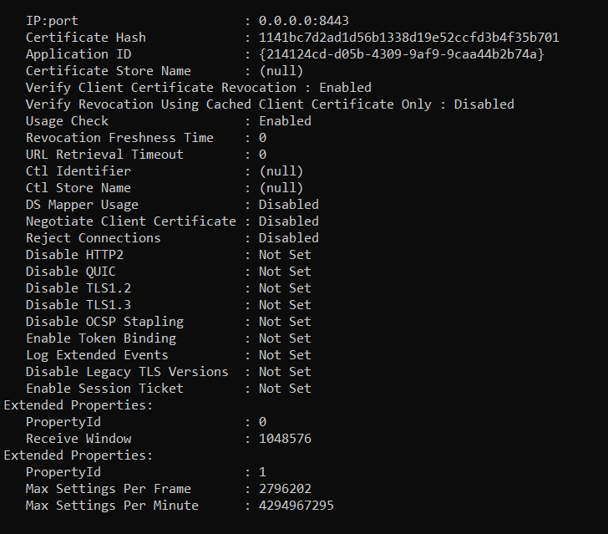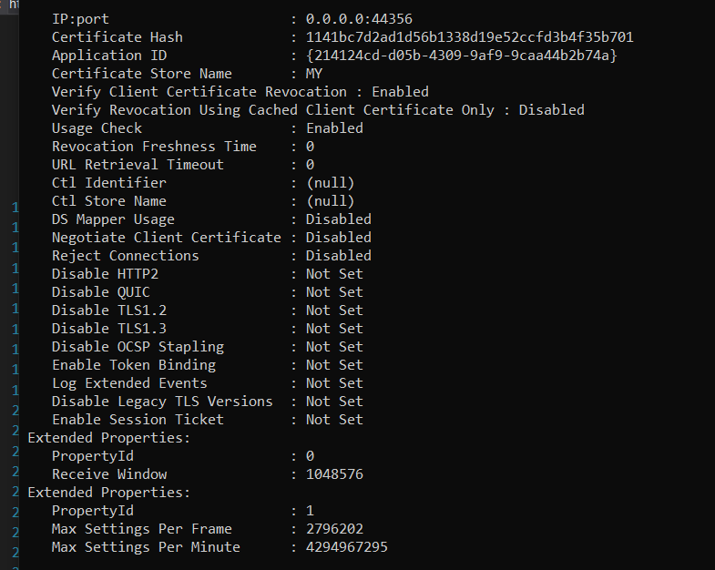

Custom domain url in IIS Express with Visual Studio 2013

C:\Windows\System32\drivers\etc

<https://www.locktar.nl/programming/custom-domain-url-in-iis-express-with-visual-studio-2013/>

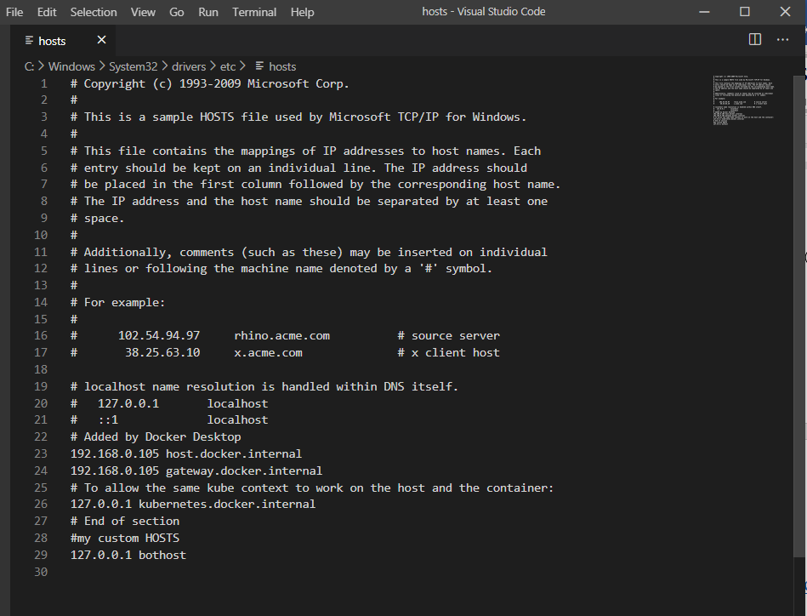

created new sef signed certificate

<https://docs.microsoft.com/en-us/windows/win32/seccrypto/makecert>

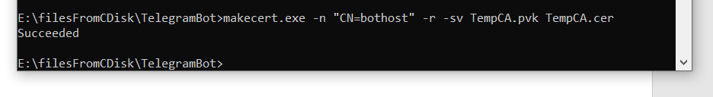

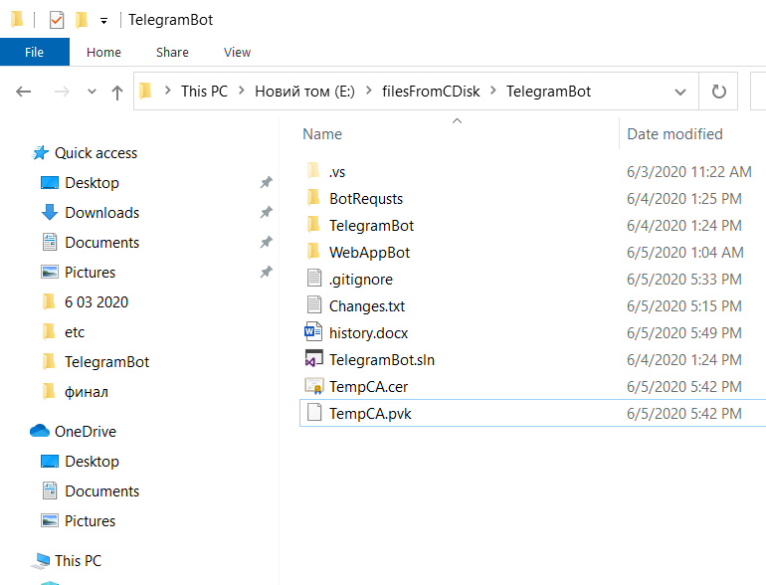

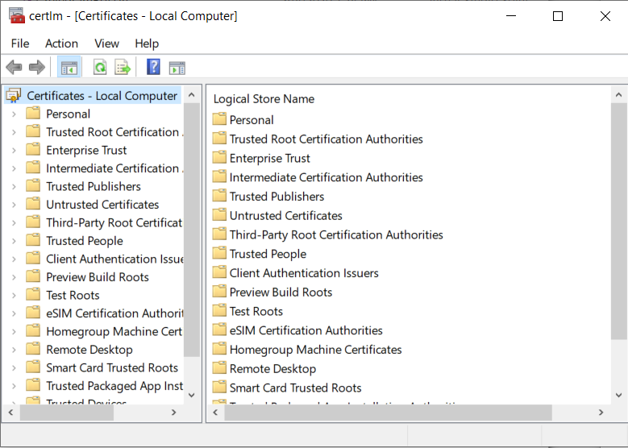

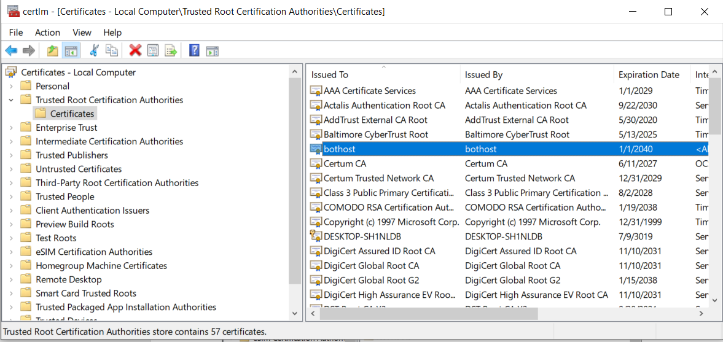

<https://hostadvice.com/how-to/how-to-install-the-wisa-windows-iis-sql-asp-net-stack/>

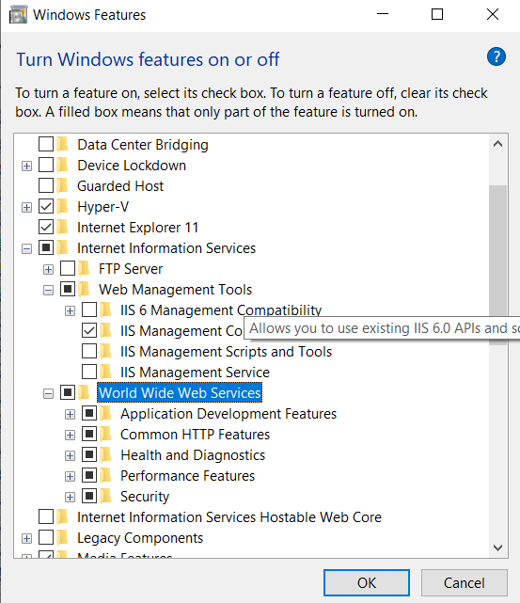

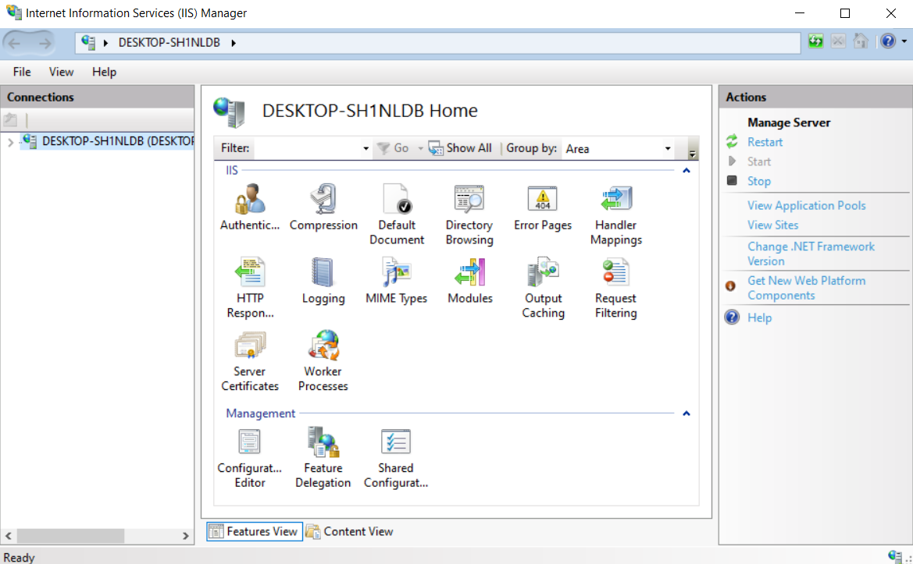

MMC.EXE

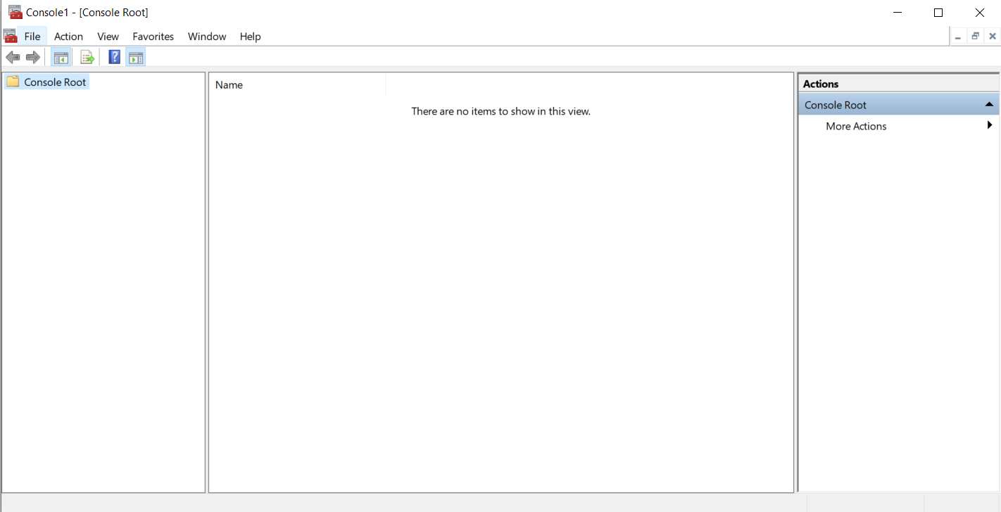

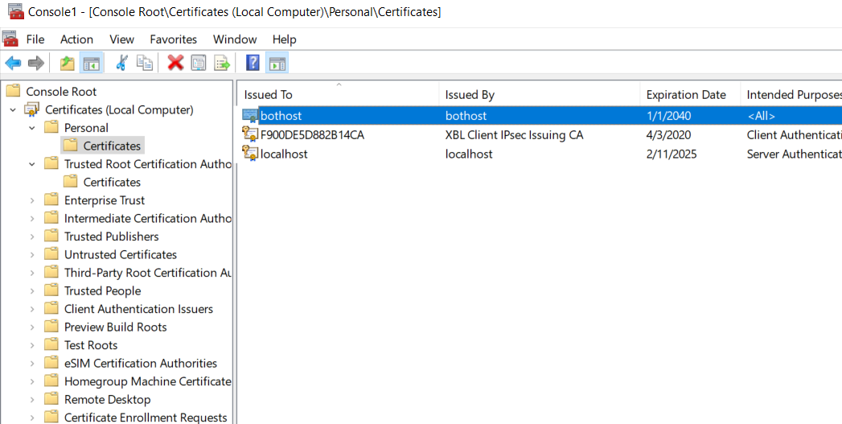

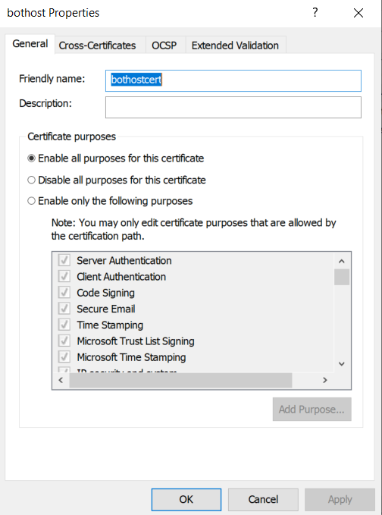

Specify friendly name and import to iis

Enter the same friendly name when importing

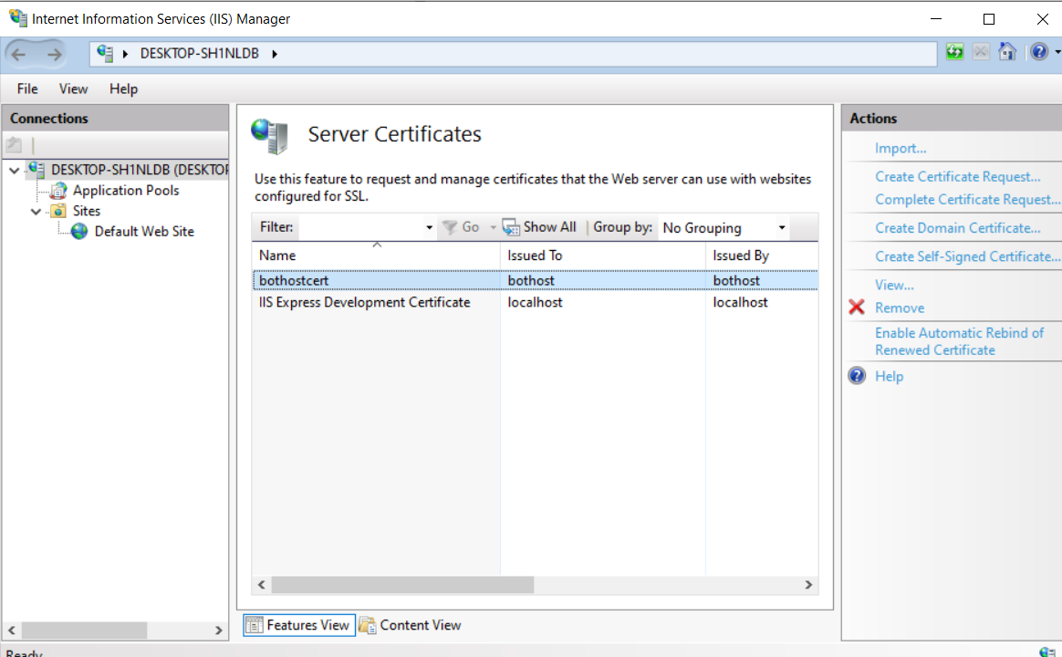

By binding 8443 port in iis manager to custom certificate it disappears from

netsh http show sslcert

Finaly

This explains how to make pfx file from pvk and cer

<https://docs.vmware.com/en/VMware-vRealize-Operations-for-Published-Applications/6.5/com.vmware.v4pa.admin_install/GUID-99401445-F994-44D9-A594-109E01CCC372.html>

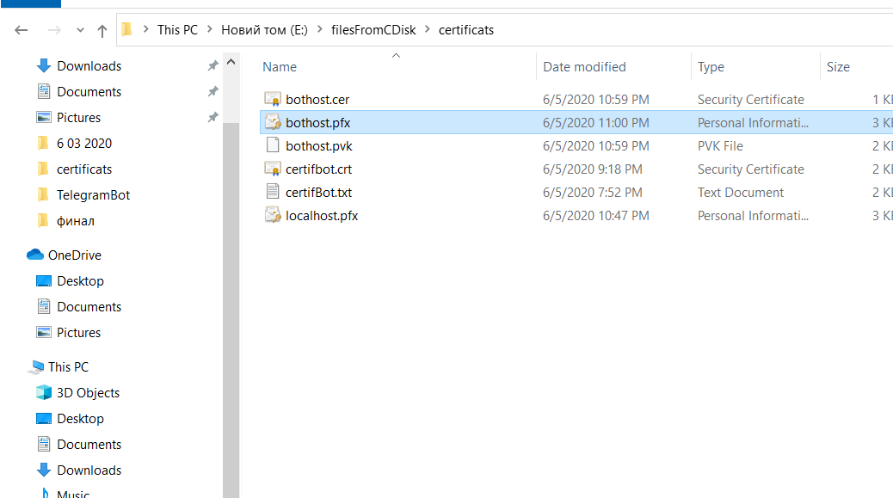

pvk2pfx -pvk HOSTNAME.pvk -spc HOSTNAME.cer -pfx HOSTNAME.pfx

Add this certificate to netsh

netsh http add sslcert ipport=0.0.0.0:8443 certhash=ed19026798f4989aaf15e81f9bbf041fd95a11f4 appid="{214124cd-d05b-4309-9af9-9caa44b2b74a}"

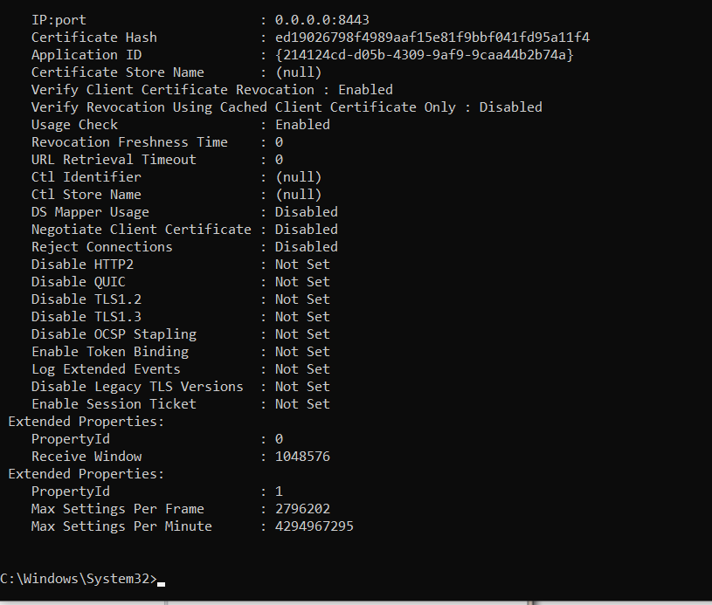\

Netsh http commands

<https://docs.microsoft.com/en-us/windows/win32/http/add-sslcert>

Working with SSL at Development Time is easier with IISExpress

<https://www.hanselman.com/blog/WorkingWithSSLAtDevelopmentTimeIsEasierWithIISExpress.aspx>

delete netsh certificate

netsh http delete sslcert ipport=0.0.0.0:8443

Creating self signed certificates with makecert.exe for development

<https://blog.jayway.com/2014/09/03/creating-self-signed-certificates-with-makecert-exe-for-development/>

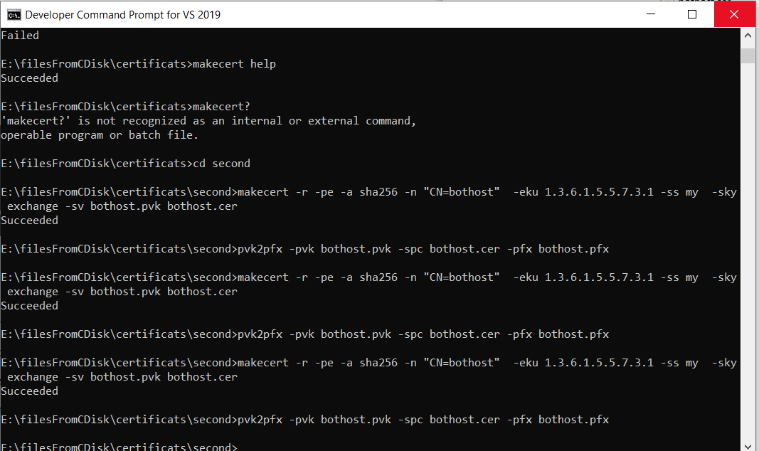

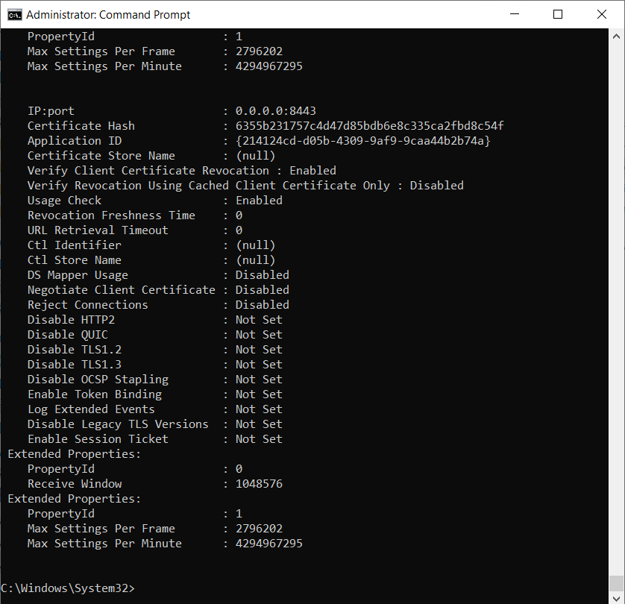

Last certificate hash

6355b231757c4d47d85bdb6e8c335ca2fbd8c54f

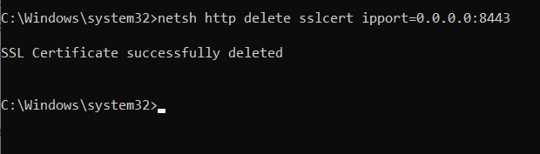

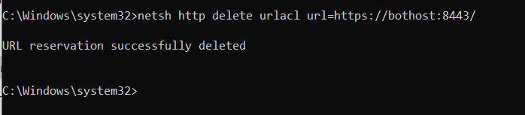

To reset add again

<https://www.jerriepelser.com/blog/using-ngrok-with-aspnet-core/>

to start properly ngrok

ngrok http https://localhost:5001 -host-header="localhost:5001"

ngrok http <http://bothost:8443> -host-header="bothost:8443"

good httpclient explanation

<https://carldesouza.com/httpclient-getasync-postasync-sendasync-c/>

this solved the problem

<https://github.com/TelegramBots/Telegram.Bot/issues/865>

helpful link to send image

<https://ru.stackoverflow.com/questions/814153/%D0%9F%D0%BE%D1%87%D0%B5%D0%BC%D1%83-telegram-%D0%B1%D0%BE%D1%82-%D0%BD%D0%B5-%D0%BE%D1%82%D0%BF%D1%80%D0%B0%D0%B2%D0%BB%D1%8F%D0%B5%D1%82-%D0%B8%D0%B7%D0%BE%D0%B1%D1%80%D0%B0%D0%B6%D0%B5%D0%BD%D0%B8%D0%B5>

another c# tutorial

<https://o7planning.org/ru/10535/csharp-streams-tutorial-binary-streams-in-csharp>

SOURCE

.NET Core в действии: пишем бота для telegram.

///TODO:

methods to implement

<https://github.com/python-telegram-bot/python-telegram-bot/wiki/Code-snippets#post-a-text-message-with-markdown-formatting>

<https://gosha20777.github.io/code/2018/04/02/dotnetcore-bot/>

**RUN Visual Studio as ADMIN!**

Can be implemented in vscode

Update

09.10.2020

1.

ngrok http <http://bothost:8443> -host-header="bothost:8443"

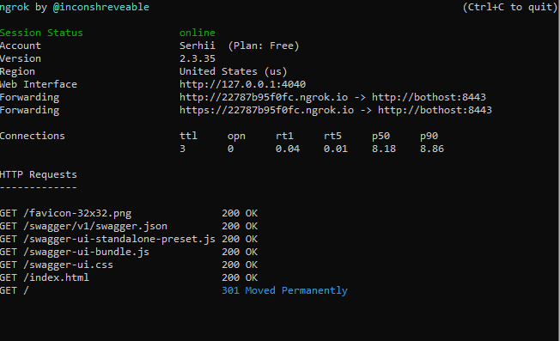

2.

Paste ngrok link <https://22787b95f0fc.ngrok.io> to bot settings

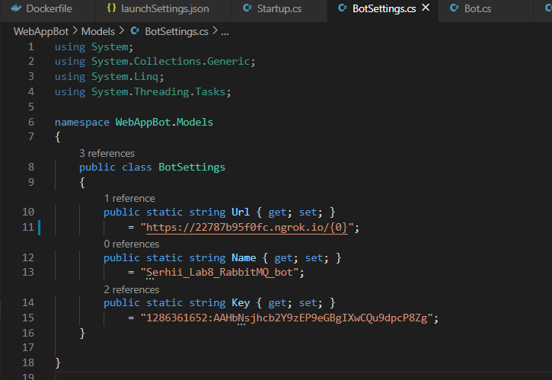

Build image and run container

Docker support

docker build -t second_web_app_bot .

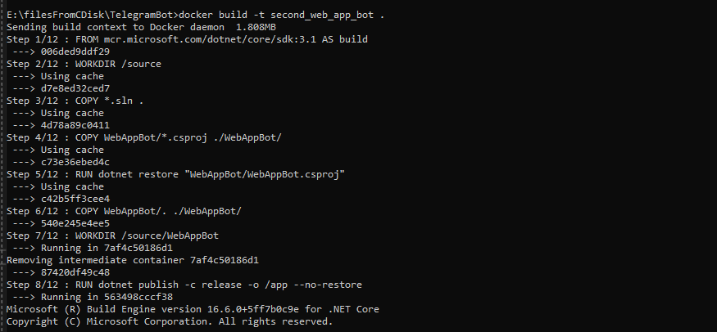

docker run -it --rm -p 8443:80 --name second_web_app_bot_sample second_web_app_bot

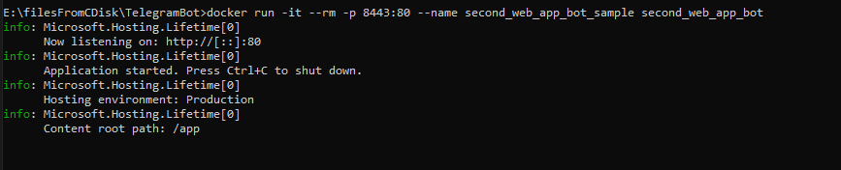

docker image rm second_web_app_bot

ngrok

<http://127.0.0.1:4040/inspect/http>

Образы Docker для ASP.NET Core

<https://docs.microsoft.com/ru-ru/aspnet/core/host-and-deploy/docker/building-net-docker-images?view=aspnetcore-3.1>