НАЦІОНАЛЬНИЙ ТЕХНІЧНИЙ УНІВЕРСИТЕТ УКРАЇНИ
«КИЇВСЬКИЙ ПОЛІТЕХНІЧНИЙ ІНСТИТУТ»
ФАКУЛЬТЕТ ІНФОРМАТИКИ І ОБЧИСЛЮВАЛЬНОЇ ТЕХНІКИ
КАФЕДРА ОБЧИСЛЮВАЛЬНОЇ ТЕХНІКИ

Лабораторна робота №6
з дисципліни «Архітектура комп’ютерів 2»

Виконав:
студент 3 курсу
групи ІО-81
Герасименко Сергій

Перевірив:
Каплунов А. В.

Київ 2020 р
Результат роботи
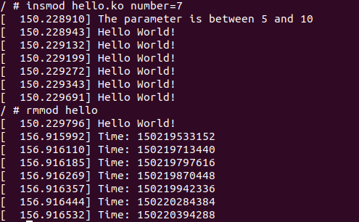

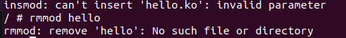

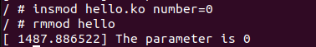
Лістинг програми
/*
* Copyright (c) 2017, GlobalLogic Ukraine LLC
* All rights reserved.
*
* Redistribution and use in source and binary forms, with or without
* modification, are permitted provided that the following conditions are met:
* 1. Redistributions of source code must retain the above copyright
* notice, this list of conditions and the following disclaimer.
* 2. Redistributions in binary form must reproduce the above copyright
* notice, this list of conditions and the following disclaimer in the
* documentation and/or other materials provided with the distribution.
* 3. All advertising materials mentioning features or use of this software
* must display the following acknowledgement:
* This product includes software developed by the GlobalLogic.
* 4. Neither the name of the GlobalLogic nor the
* names of its contributors may be used to endorse or promote products
* derived from this software without specific prior written permission.
*
* THIS SOFTWARE IS PROVIDED BY GLOBALLOGIC UKRAINE LLC ``AS IS`` AND ANY
* EXPRESS OR IMPLIED WARRANTIES, INCLUDING, BUT NOT LIMITED TO, THE IMPLIED
* WARRANTIES OF MERCHANTABILITY AND FITNESS FOR A PARTICULAR PURPOSE ARE
* DISCLAIMED. IN NO EVENT SHALL GLOBALLOGIC UKRAINE LLC BE LIABLE FOR ANY
* DIRECT, INDIRECT, INCIDENTAL, SPECIAL, EXEMPLARY, OR CONSEQUENTIAL DAMAGES
* (INCLUDING, BUT NOT LIMITED TO, PROCUREMENT OF SUBSTITUTE GOODS OR SERVICES;
* LOSS OF USE, DATA, OR PROFITS; OR BUSINESS INTERRUPTION) HOWEVER CAUSED AND
* ON ANY THEORY OF LIABILITY, WHETHER IN CONTRACT, STRICT LIABILITY, OR TORT
* (INCLUDING NEGLIGENCE OR OTHERWISE) ARISING IN ANY WAY OUT OF THE USE OF THIS
* SOFTWARE, EVEN IF ADVISED OF THE POSSIBILITY OF SUCH DAMAGE.
*/

#include <linux/init.h>
#include <linux/module.h>
#include <linux/kernel.h>
#include <linux/moduleparam.h>
#include <linux/printk.h>

#include <linux/types.h>

#include <linux/ktime.h>
#include <linux/slab.h>

struct head_list {
struct head_list *next;
ktime_t time;
};

MODULE_AUTHOR("Serhii Popovych <serhii.popovych@globallogic.com>");
MODULE_DESCRIPTION("Hello, world in Linux Kernel Training");
MODULE_LICENSE("Dual BSD/GPL");

static struct head_list *head;

static int number = 1;
module_param(number,uint,S_IRUGO);
MODULE_PARM_DESC(number, "The amount of number to print hello world");

static int __init initter(void)
{
uint i = 0;

struct head_list *key1, *key2;

head = kmalloc(sizeof(struct head_list *), GFP_KERNEL);

key1 = head;

if(number == 0) {
printk(KERN_WARNING "The parameter is 0");
}else if(number >=5 && number <= 10) {
printk(KERN_WARNING "The parameter is between 5 and 10");
} else if(number > 10) {
printk(KERN_ERR "The parameter is greater than 10");
return -EINVAL;
}

for(i = 0; i < number; i++){
key1->next = kmalloc(sizeof(struct head_list), GFP_KERNEL);
key1->time = ktime_get();
pr_info("Hello World!");
key2 = key1;
key1 = key1->next;
}

if (number != 0) {
kfree(key2->next);
key2->next = NULL;
}

return 0;
}

static void __exit exitter(void)
{
struct head_list *key;

while (head != NULL && number != 0) {
key = head;
pr_info("Time: %lld", key->time);
head = key->next;
kfree(key);
}
pr_info("");
}
module_init(initter);
module_exit(exitter);

