Blind Match Race Instructions :

Admin instructions to create new race:

0 First you need check that your GPS and Network on

1 Sign in with username admin and password admin

2 Set date and time for race to begin and enter unique event number

3 Click on button “Set”

4 On the screen you can see the buttons of buoy’s not available you need to wait until app get your location

5 Now you can place buoys on place that you stay right now

6 You can press back and it will bring you to screen for set date and time and event so you can make one more race when you finish just press Done

Admin Example

2 1

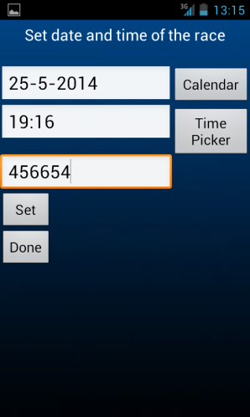 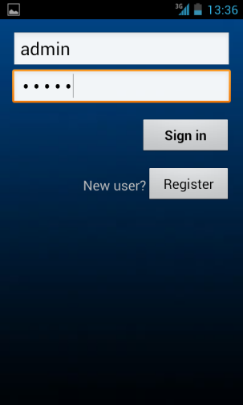

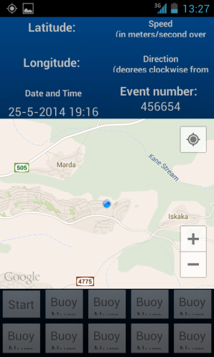 4

User instructions:

0 Turn on GPS and Network

1 Enter your name and password if its your first use click register

2 Now you can enter event number or choice random race(the app finds closest race to your location)

3 After choice of the race appears menu window , the click on Open Map button will show you map screen, your bout will appears in blue color and opponents in yellow(also you can see your speed , latitude , longitude ,and buoys)

4 After finish the race you can create KML File to see your race on Google Earth it will be created on your device at “BlindMatchRace\KMLFiles

5 To exit race press “Log Out”

User Example

1 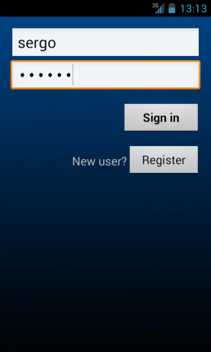 2 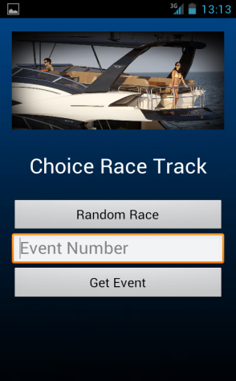

3 3

