**Feedback**

1. It is possible to import movie without title.

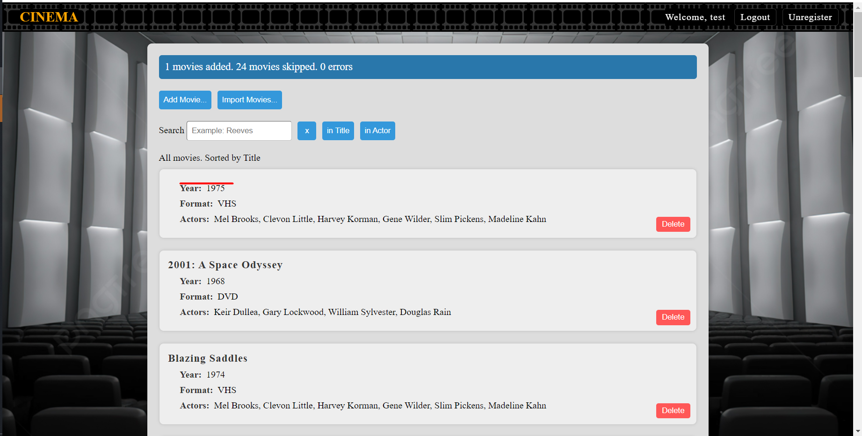

1. Incorrect sorting of letters «Ї» and «І» (Ukrainian alphabet).

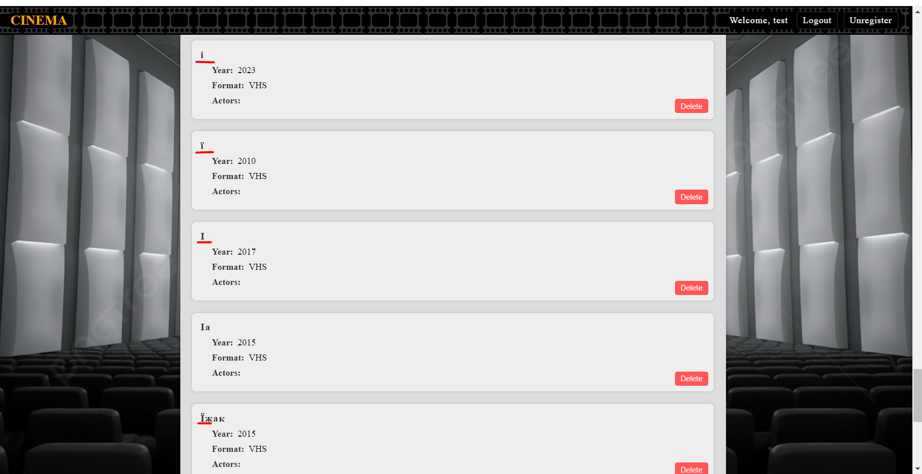

1. It is possible to import movie with any year range.

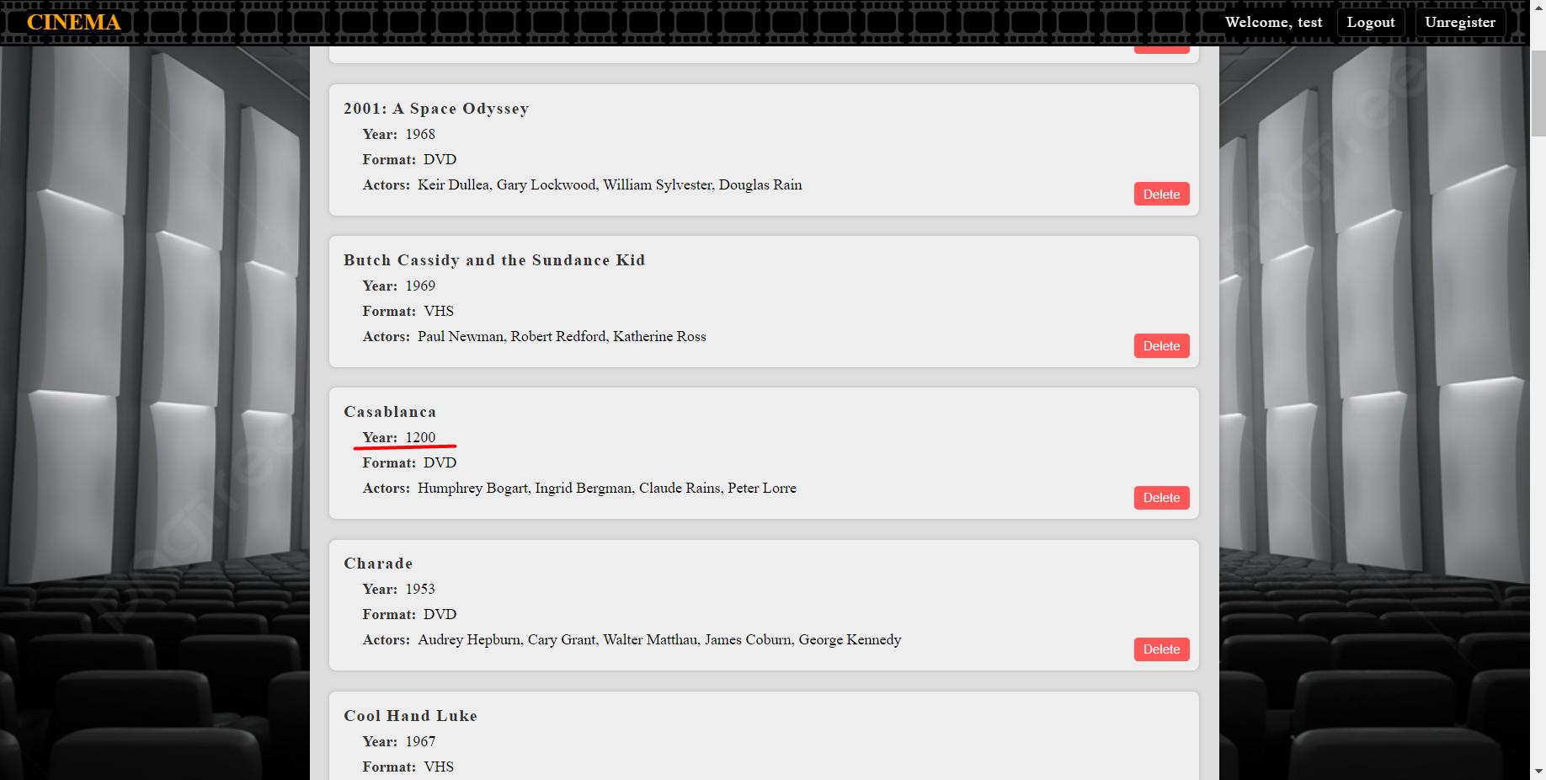

1. Cross-Site Scripting (XSS) vulnerability.

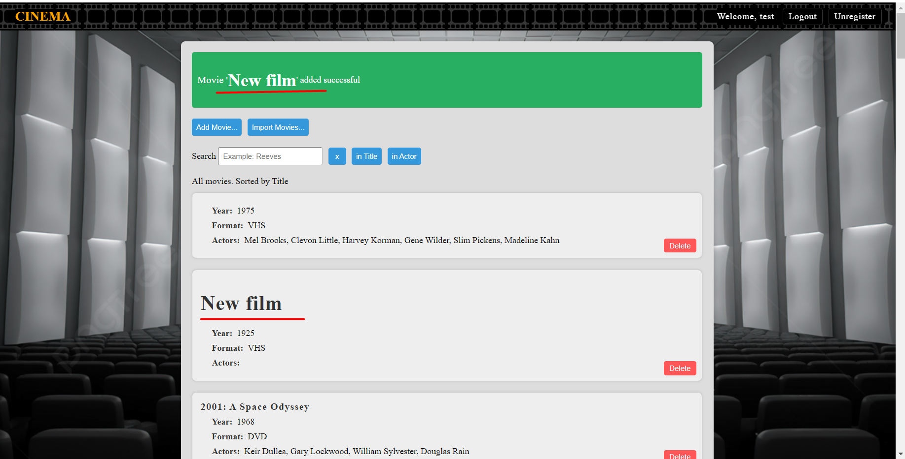

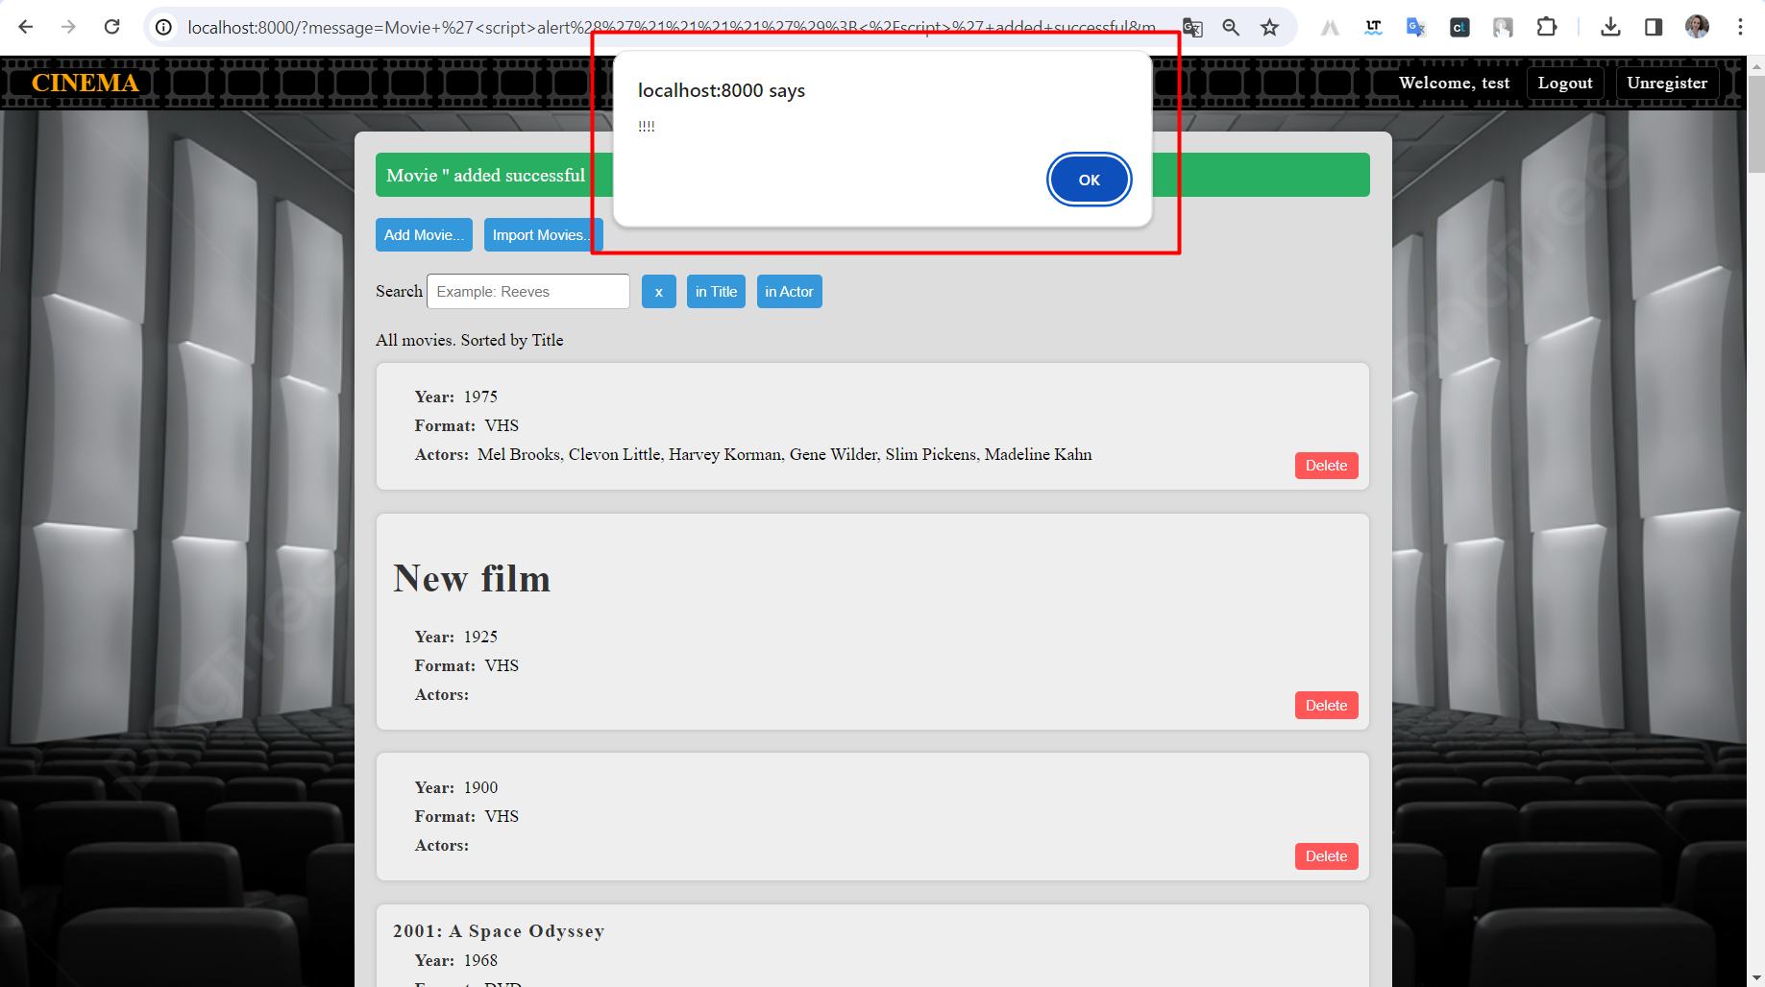

1. For me, as a user, it would be good to not display empty fields or add a dash in them.

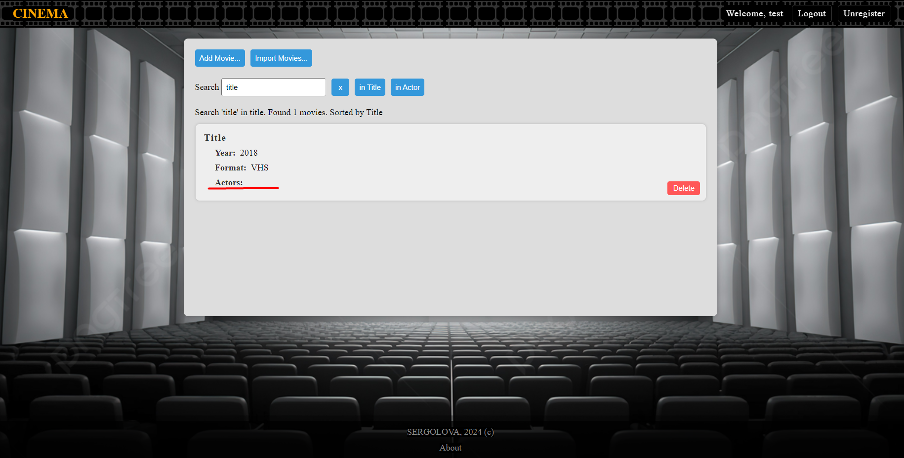

1. The long film's title exceeds the card's dimensions.

