**VPN connection – setup manual**

Mac OS X > 10.7

**I. Installation of VPN client (Cisco Anyconnect)**

1) Download CiscoAnyConnect client (http://public.edss.ee/software/Mac/VPN/anyconnect-macosx-i386-4.2.00096-k9.dmg)

2) Install the Application as usual

3) Uncheck all except "VPN" on the Installation Type screen

**II. Auto-configuration scenario (you should have priviliged(admin) rights )**

1) Download auto-configuration script using browser - http://public.edss.ee/software/Mac/VPN/vpn.zip

2) Click "Open"

3) Enter access credentials for download your organization configuration data:   
 *company name, login, password*

4) Enter privileged password to continue the scenario.

5) Launch Cisco Anyconnect client

**III. VPN Connect**

1) Click "Connect"

2) Enter VPN username (You will need enter once)

3) Enter VPN password (You will need enter each time you are connecting)

4) Click "Accept" when you see information message

5) Enjoy! Your are connected!

**VPN connection – setup manual**

Windows 8, Windows 10

**I. Installation of VPN client (Openconnect)**

1) Download VPN Installer client - http://public.edss.ee/software/Windows/VPN/VPN.exe

2) Run VPN.exe file.

3) Follow Installation Wizard instructions.

4) Enter access credentials for download your organization configuration data:  *company name, login, password*

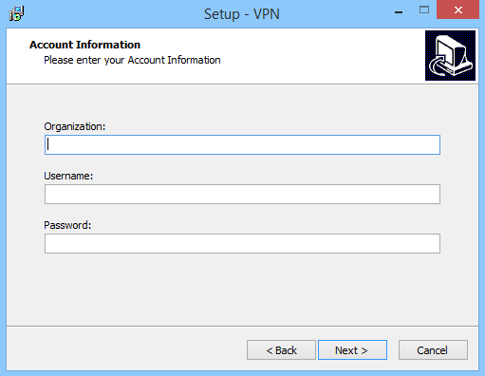

5) After it click Install button

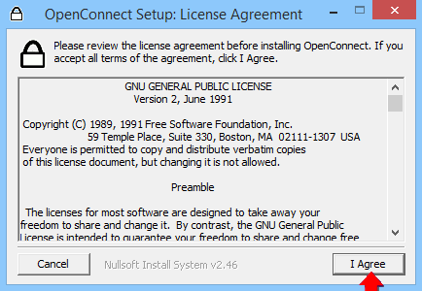6) In new window click “I Agree” button

7) Then click “Install” button

8) Wait until all components will be installed

9) A OpenVPN TAP Installation windows will be opened

10) Click “Next” button, then “I Agree” button

11) In new windows leave all settings as is and click “Next” button

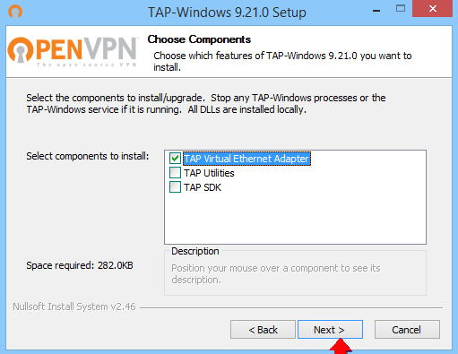

12) After it click “Install” button, wait until process will be finished

13) Press “Finish” button for OpenVPN TAP.

14) Press “Close” button for OpenConnect

15) Press “Finish” button for common Installation

**II. VPN Connect**

1) On Users Desktop find VPN icon

2) Double click on it

3) In a new windows press “Connect” button

4) A Certificate message can occur, click “The information is accurate”



5) Enter your VPN password

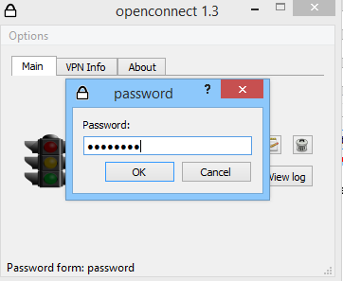

6) Wait until windows shows message: “Connected” and will be minimized to tray automatically

7) Enjoy! Your are connected!