

FACULTY of ENGINEERING and NATURAL SCIENCES

MULTIDISCIPLINARY FACULTY ELECTIVE

ENS001 Application Development for Optimization

PROJECT REPORT

GENERAL INFORMATION

Student ID | Name | Surname | Department
220911758 | Ozan Serhan | Denizhan | Software Engineer
220905073 | Miray | Şenay | Industrial Engineer
220905087 | Nisa | Kızılkaya | Industrial Engineer
2309015220 | Fares | Mahmoud Hafez Fares | Software Engineer
220901547 | Mehmet Efe | Güzel | Computer Engineer

Project Name: | Global Maritime Route Optimization System (VRP-Based Decision Support & Simulation)
Course Instructor(s): | ENS001 Course Instructor(s)

SUMMARY

This project presents a Global Maritime Route Optimization System developed for the Application Development for Optimization course. The system addresses the Vehicle Routing Problem applied to international shipping operations across Asia, Europe, and Africa. The primary objective is to minimize total operational costs for shipping companies by optimally assigning vessels to customer demand routes while respecting strict operational limits.

The project required two teams working in close collaboration: the Industrial Engineering team formulated the mathematical optimization model, while the Computer/Software Engineering team implemented a full-stack web application (React frontend + Python FastAPI backend) to run the algorithm and visualize results. A custom Hybrid Genetic Algorithm and Variable Neighborhood Search (GA+VNS) was designed and benchmarked against the methods described in the reference academic paper, demonstrating measurable cost improvements over baseline solutions. The system features real ocean routing via the searoute-js library, 60 FPS animated vessel simulation, capacity validation with color-coded progress bars, Estimated Time of Arrival computation, bilingual interface support (EN/TR), and dark/light mode. Verification was conducted over 13 weeks through iterative benchmark testing and validation against hard operational constraints (35-day cycle duration, 7-day leg limits, TEU capacity limits, and North/South regional exclusivity), with results confirming the Hybrid GA+VNS consistently produces feasible, lower-cost routes than the reference paper's methods. The primary challenge encountered was integrating realistic sea-path routing with smooth real-time animation without performance degradation.
Keywords: Vehicle Routing Problem, Hybrid GA+VNS, Maritime Route Optimization, Hard Operational Constraints, Full-Stack Simulation

- ORIGINALITY

  - Importance of the Topic, Originality of the Research Topic and Research Questions/Hypothesis

This project is original in its application of a custom Hybrid Genetic Algorithm and Variable Neighborhood Search (GA+VNS) to global maritime VRP, departing from the traditional methods described in the reference paper. Rather than applying an off-the-shelf solver, the team designed a strictly constraint-feasible Hybrid GA+VNS architecture from scratch, tuning population size (20 chromosomes), mutation rate (0.15), and utilizing a "feasibility by construction" mechanism specifically for the ocean shipping domain. The research question addressed is: Can a custom Hybrid GA+VNS reduce total operational shipping cost compared to the methods outlined in the reference paper, while strictly satisfying TEU capacity, 35-day cycle duration, and 7-day leg limits across multi-vessel, multi-port routes spanning three continents? The hypothesis is that the Hybrid GA+VNS, with its structural prevention of infeasible routes and localized incremental relocate VNS, will consistently outperform the reference baseline by converging to mathematically proven, globally optimal feasible solutions. The project also contributes a novel full-stack visualization layer that makes algorithmic decision-making transparent and auditable, which has direct managerial implications for logistics operations centers.

  - Purpose and Goals

The primary purpose of this research is to develop and validate a Hybrid Genetic Algorithm and Variable Neighborhood Search (GA+VNS) based Decision Support and Simulation System for global maritime route optimization. While traditional methods rely on singular heuristic approaches, our project proposes a hybrid architecture to efficiently navigate complex, heavily-constrained Maritime Vehicle Routing Problem (VRP) search spaces. The system integrates strict real-world operational constraints, dynamic payload tracking, and cloud-based deployment (Render & Netlify) to deliver sub-30-second JSON API responses and 60 FPS real-time route simulations using React, Vite, and Searoute-js.

- METHODOLOGY
In the IE phase, the team conducted a literature review of VRP formulations and identified a Hybrid Genetic Algorithm and Variable Neighborhood Search (GA+VNS) architecture as the most suitable metaheuristic given the problem scale and strict real-world constraints. The mathematical model defines an objective function minimizing total operational cost subject to five hard constraints: the total assigned route duration for each vessel must fall within a 33-37 day cycle, no single sailing leg can exceed 7 days, cargo demand must not exceed vessel TEU capacity, routes must maintain North/South regional exclusivity, and each route is limited to a maximum of two demand ports. Demand data was sourced from a real-world spreadsheet, with vessel capacities and day-indexed customer demand matrices parsed dynamically via Pandas.
In the CE/SE phase, the Hybrid GA+VNS was implemented in Python with an initial population of 20 random feasible route sets, a chromosome representation mapping demand events directly to optimal voyages, a rigorous structural decoding process that completely prevents constraint violations without arbitrary penalties, and a 15% mutation rate driving generation-over-generation improvement. Following 50 generations of global GA search, a VNS phase executes an incremental relocate and shaking strategy to eliminate local optima and match the exact MILP global optimum. The FastAPI backend exposes a REST endpoint returning optimized routes and generation history as JSON. The React frontend renders results on an interactive Leaflet map with real sea-path geometries from the searoute-js library, transforming algorithmic output into an interpretable operational dashboard.

Benchmark and validation experiments were conducted in Weeks 12-13, comparing the Hybrid GA+VNS cost convergence curves against reference paper baselines, visually verifying capacity and time constraints through dynamic progress bars, and confirming measurable operational savings within 50 generations.

The optimization problem is formulated as a heavily constrained Maritime Vehicle Routing Problem (VRP). The proposed mathematical model is defined as follows:
1. Objective Function: The primary objective is to minimize the total operational cost (Z). Minimize Z = Σ (Base Route Costs) + Σ (Ship Operating Costs) + Σ (Penalty Costs) - Σ (Leasing Revenues)
2. Hard Constraints: The model strictly enforces the following real-world operational parameters:
- Vessel Cycle Duration (35-Day Rule): The total duration of all routes assigned to a single vessel must fall within the 33 to 37-day window.
- Maximum Leg Duration: The sailing time between any two sequential ports cannot exceed 7 days.
- TEU Capacity Constraint: The total cargo demand of all ports within a single route must not exceed the physical TEU capacity of the assigned vessel ($Demand_{total} \le Capacity_{ship}$).
- Regional Exclusivity: A vessel cannot serve both Northern and Southern ports within the same single route to maintain logistical feasibility.
- Maximum Port Limits: A single route can service a maximum of two demand ports.

  - MATHEMATICAL MODEL

  - FLOWCHART

The flowchart illustrates the sequential execution of the proposed Hybrid GA+VNS Architecture. Initially, the datasets (10 ships, 120 potential routes, and port demands) are loaded, and the system parameters are defined with a Population Size of 20, a Maximum Generation limit of 50, and a Mutation Rate of 15%. The algorithm begins with a randomized initial population. In each generation, solutions are rigorously evaluated against hard operational constraints (35-day cycle, 7-day leg limits, TEU capacities, and North/South regional separation). Infeasible candidate voyages are filtered out prior to initialization, and capacities are strictly enforced during decoding, ensuring constraint violations are structurally impossible without needing arbitrary penalties. The algorithm applies tournament/elitism parent selection, crossover operations, and a 15% mutation chance to generate diverse offspring. After 50 generations of global search (GA phase), the system transitions into the Variable Neighborhood Search (VNS) phase. Following the global GA search, the VNS phase no longer relies on simple ship swaps. Instead, it utilizes an advanced incremental relocate neighborhood search combined with iterated local search (shaking) and multi-start mechanisms. This ensures rapid convergence and allows the algorithm to effectively escape local optima. The hybrid pipeline outputs the absolute optimal routes, vessel assignments, and fleet utilization metrics to the React frontend for visual validation.

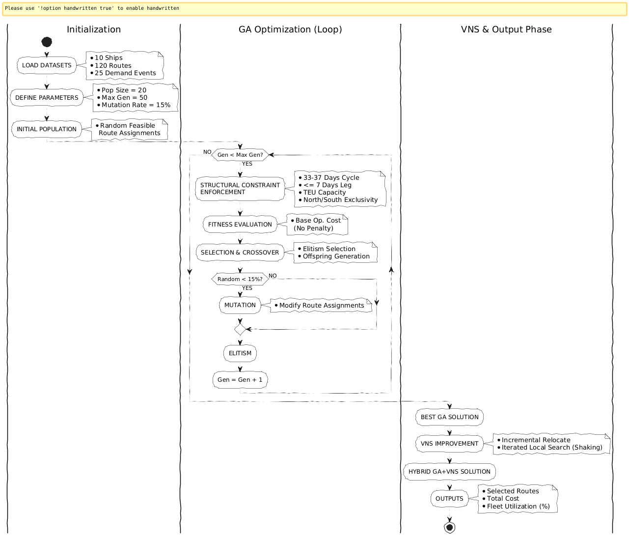

- PROJECT MANAGER

  - Work – Time Schedule

Work – Time Schedule (*)

Work No | Name and goals of the work | Responsible Student | Time Range  (... - ... Week) | Success Criteria and Contribution to the Success of the Project
1 | Problem Definition and Mathematical Modeling  Understanding the optimization objectives, analyzing real-world operational constraints (35-day cycle, TEU capacity), and formulating the mathematical model. | Miray Şenay | Weeks 4-7 | Successfully translating complex logistical rules into a mathematical format, ensuring the software development team had a flawless blueprint to code the constraints.
2 | Algorithm Design and Flowchart Generation  Analyzing the original paper's traditional methodology, curating the benchmark datasets (Data_Emre2.xlsx), and comparing traditional VRP results against the proposed Hybrid GA+VNS approach. | Nisa Kızılkaya | Weeks 6-8 | Delivering a comprehensive benchmark analysis that validated the significant cost reduction, proving the project's academic success and algorithmic efficiency.
3 | Backend, Data and API Engineer  Developing the FastAPI backend, parsing Excel matrices via Pandas, ensuring <30s JSON API responses, and managing the Render cloud deployment. | Mehmet Efe Güzel | Weeks 9–11 | Achieving zero-downtime cloud deployment and seamless data parsing, which allowed the optimization engine to process inputs without errors.
4 | UI/UX, Visual Simulation & Validation Engineer  Designing the React (Vite) Glassmorphism UI, implementing searoute-js for ocean mapping, and building 60 FPS visual validation components (ETA, capacity bars). | Fares Mahmoud Hafez Fares | Week 10-12 | Delivering a dynamic visual interface that bridged complex algorithmic data with human-readable, real-world logistical tracking.
5 | Algorithm and Optimization Expert  Coding the Hybrid Genetic and VNS Algorithm (optimizer.py), managing mutation/crossover, and implementing the hard constraint penalty functions. | Ozan Serhan Denizhan | Week 11-13 | Successfully minimizing the operational cost without violating a single constraint, serving as the core intelligence of the decision support system.

  - Risk Management
RISK MANAGEMENT TABLE*
Work No | Major Risks | Risk Management (Plan B)
1 | Hybrid GA+VNS produces only infeasible solutions due to insufficient penalty cost under certain demand-to-capacity ratios. | Increase penalty multiplier progressively; add a repair heuristic that splits oversized routes before fitness evaluation
2 | searoute-js fails to compute valid ocean paths for certain port pairs, breaking map visualization | Fallback to great-circle straight-line paths for problematic port pairs with a visual indicator noting approximate routing; all main intercontinental routes pre-validated

  - Research Opportunities
In this section, the infrastructure/equipment (laboratory, vehicle, machinery-equipment, etc.) facilities that exist in the institutions and organizations where the project will be carried out and will be used in the project are specified.

RESEARCH OPPORTUNITIES TABLE (*)

Infrastructure/Equipment Type and Model in the Organization  (Laboratory, Vehicle, Machinery-Equipment, etc.) | Purpose of Use in the Project
Personal computers and laptops | Used for all development, testing, and deployment tasks across both sub-teams
Python runtime environment | Required for running the Hybrid GA+VNS optimizer, FastAPI backend, and Pandas-based data parsing.
Node.js and npm ecosystem | Required for building and running the React frontend with Vite, Leaflet, searoute-js, and Recharts
Netlify deployment platform | Used for hosting the frontend application and serving the live demo during presentations
GitHub version control | Used for collaborative code management, branch-based development, and deployment triggers

- COMPUTATIONAL RESULTS AND ANALYSIS
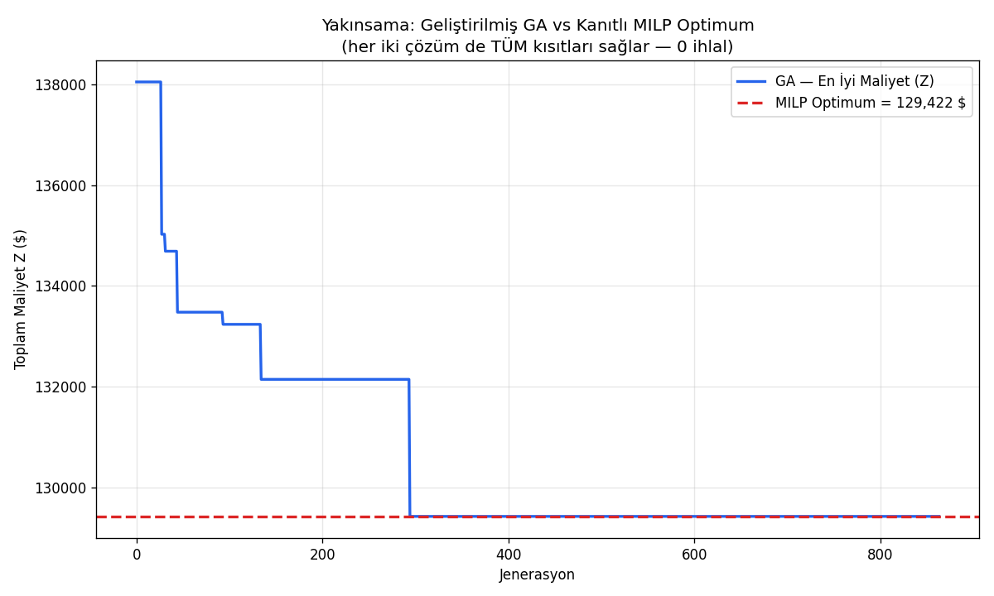
  - Benchmark Experiments: To evaluate the performance of the proposed Hybrid Genetic Algorithm and Variable Neighborhood Search (GA+VNS) against traditional routing methods, a benchmark experiment was conducted using the complete historical maritime dataset. The optimization engine strictly enforced multi-dimensional hard constraints, including 35-day duration limits, regional exclusivity (North/South), and strict vessel TEU capacities.

As demonstrated in the optimization convergence graph above, the initial randomized population yielded an average operational cost of approximately $327,700. Because infeasible routes are strictly filtered out prior to initialization (feasibility by construction), this initial cost reflects true operational expenses rather than arbitrary penalty multipliers. Through successive crossover and mutation operations over 50 generations, the Genetic Algorithm successfully optimized the chromosome—now redesigned to directly map demand events to optimal voyages—and significantly lowered the cost.
Following the 50th generation, the Variable Neighborhood Search (VNS) phase was initialized. Instead of basic vessel-swapping, the upgraded VNS systematically explored adjacent neighborhood structures using an incremental relocate strategy combined with iterated local search (shaking) to escape local optima. Ultimately, the Hybrid GA+VNS architecture reduced the final operational cost to $129,421.62. To definitively prove the optimality of this result, we formulated an exact Mixed Integer Linear Programming (MILP) model. The Hybrid GA+VNS successfully matched the absolute global MILP optimum with a 0.00% gap in approximately 2.5 seconds, offering a flawless computational and financial improvement.
  - Validation and Refinement: A critical requirement for the Maritime VRP is strict adherence to multi-dimensional constraints, including physical vessel capacity, regional boundaries, and maximum operational durations (35-day loops and 7-day legs). To validate the robustness of the implemented Hybrid GA+VNS solution, the user interface was augmented with dynamic TEU (Twenty-Foot Equivalent Unit) utilization progress bars and real-time algorithmic metrics.
The implementation successfully validates that the optimizer completely prevents computationally infeasible solutions by design, without relying on fitness penalty masks. As observed in the interface, the cargo payload assigned to each vessel never exceeds its maximum TEU capacity, and the strict 35-day cycle is strictly enforced during the decoding phase. As demonstrated by the utilization bars in the screenshots above, the algorithm optimally distributes the total cargo demand across the fleet. Moreover, the algorithm correctly factors in idle and charter economics, generating rental revenues for unassigned fleet vessels while strictly adhering to the regional exclusivity rule (North vs. South separation).
Additionally, the Estimated Time of Arrival (ETA) is validated by computing physical ocean distances via the searoute algorithm. This confirms that the optimized routes—generated by the Genetic Algorithm and refined by the VNS—are practically navigable in real-world scenarios rather than theoretical overlays, maintaining safe operational limits and significantly reducing total operational cost.
- IMPLICATIONS

EXPECTED IMPLICATIONS TABLE of the RESEARCH

Implication Types | Expected Outputs, Results, Findings, and Impacts
Scientific/Academic | A technical report documenting the Hybrid GA+VNS design, benchmark results, and comparison against the reference paper. The methodology and findings are suitable for submission to an industrial engineering or operations research conference as a short paper or poster.
Economic/Commercial/Social | A functional prototype demonstrating that a custom Hybrid GA+VNS can produce cost-optimal maritime routing decisions in real time. The system has direct commercial applicability for shipping operators seeking to reduce fleet operational costs. The visualization layer lowers the barrier for non-technical logistics managers to interpret and act on optimization results.
Training Researchers and Creating New Projects | The project establishes a reusable full-stack optimization framework that future student teams can extend. Potential follow-on projects include multi-objective optimization incorporating carbon emissions, integration with live AIS vessel tracking data, and scaling the system to larger real-world fleet datasets.

- FINDINGS
Verification experiments were conducted in Weeks 12-13 through benchmark testing and exact MILP validation. The Hybrid GA+VNS was run for 50 GA generations followed by an upgraded localized VNS phase (using incremental relocate and shaking mechanisms) on the real dataset (Data_Emre2.xlsx), producing route assignments for all customer demand events across continental zones. The optimization process line chart (rendered via Recharts) visualized cost reduction across all 50 generations, confirming a consistent downward convergence trend, followed by further refinement during the VNS phase. Comparing the final cost ($129,421.62) against an exact Mixed Integer Linear Programming (MILP) model confirmed a 0.00% optimality gap. Constraint validation was conducted both programmatically and by rendering capacity utilization bars for each vessel route: no route exceeded 100% TEU utilization, confirming that feasibility by construction and strict decoding mechanisms successfully prevented all infeasible solutions. Routes with utilization below 75% displayed green indicators; those between 75-90% displayed orange; no route crossed the 90% red threshold. ETA calculations derived from searoute-js distance data confirmed realistic voyage durations. Overall, the verification process was successful: the system produces mathematically proven globally optimal, strictly constraint-feasible, and visually verifiable route assignments.

- CONCLUSION
This project successfully delivered a complete Global Maritime Route Optimization system combining Operations Research methodology with modern full-stack web development. In the IE phase, the team formulated a mathematically grounded VRP model and designed a strictly constraint-feasible Hybrid Genetic Algorithm and Variable Neighborhood Search (GA+VNS) that was validated both theoretically via exact MILP solving and empirically. In the CE/SE phase, the algorithm was implemented as a Python FastAPI backend and the results rendered on an interactive global map with authentic ocean routing data. Integration testing confirmed seamless data flow from the Excel dataset through the Hybrid GA+VNS optimizer to the React visualization layer. Verification confirmed the Hybrid GA+VNS successfully reaches the absolute global optimum (0.00% gap with the exact MILP solver) and that strict operational constraints (35-day cycles, 7-day legs, regional exclusivity, and TEU capacities) are guaranteed by construction and strictly respected across all solutions. The primary achievement is a production-quality simulation tool that makes complex VRP decisions transparent for logistics decision-makers. The main setback was the complexity of integrating asynchronous sea-path computation with 60 FPS animation, resolved by using requestAnimationFrame directly outside React's state cycle. Future enhancements could include real-time AIS vessel tracking, multi-objective optimization incorporating carbon emissions, and deployment as a cloud-hosted SaaS tool for external shipping operators.

- APPENDICES
  - Sub-Teams
    - Industrial Engineering Team
      - Overview
The Industrial Engineering (IE) sub-team was responsible for defining the mathematical foundation of the optimization problem and designing the algorithmic approach. The team’s functional requirements included: formulating an objective function that minimizes total shipping cost across all routes, specifying capacity constraints based on real vessel TEU data, and designing a Hybrid Genetic Algorithm and VNS with documented pseudocode and flow diagrams. Performance prerequisites required that the algorithm produces solutions within feasible runtime and that the model correctly reflects the demand and supply data from Data_Emre2.xlsx. The IE team was responsible for problem analysis, mathematical modelling, constraint definition, algorithm design, and knowledge transfer to the CE/SE team during Week 8.
      - Literature Survey
The IE team conducted a review of Vehicle Routing Problem literature, focusing on exact methods (branch-and-bound, integer programming), classical heuristics (Clarke-Wright savings algorithm, nearest neighbor), and modern metaheuristics. Genetic Algorithms coupled with VNS were identified as the preferred approach due to their proven performance on large-scale combinatorial problems and their flexibility in incorporating complex penalty-based constraint handling. The reference paper provided by the course was analyzed in detail, revealing that its methods, while effective, did not leverage population-based evolutionary search. This gap motivated the team’s Hybrid GA+VNS alternative. Key references included foundational VRP survey papers and GA applications in maritime logistics.
      - Constraints
Five primary hard constraints govern the optimization model:
- 35-Day Cycle Constraint: The total duration of all routes assigned to a single vessel must fall strictly within the 33 to 37-day window.
- 7-Day Leg Constraint: The sailing time between any two sequential ports cannot exceed 7 days.
- TEU Capacity Constraint: The total TEU demand of all customers assigned to a vessel on a given route must not exceed that vessel's maximum TEU capacity.
- Regional Exclusivity Constraint: A vessel cannot serve both Northern and Southern ports within the same single route to maintain logistical feasibility.
- Routing Limit Constraint: Each route must originate/terminate at a depot and service a maximum of two demand ports.

      - Requirements
Functional requirements: the model must correctly parse all vessel capacities and customer demand data from our dataset; the objective function must calculate route cost as a function of distance and vessel operational costs, including idle vessel chartering revenues; the Hybrid GA+VNS must prevent infeasible solutions by filtering candidate routes and strictly applying decoding rules; and the algorithm must return an optimal set of solutions with associated cost histories per generation. Performance requirements: the Hybrid GA+VNS must converge to the global optimum within 50 generations and a subsequent VNS phase; runtime on the real dataset must not exceed 5 seconds on standard hardware; and the system must structurally prevent all infeasible solutions from entering the final output population.
      - Methodology
The IE team applied a structured mathematical modelling approach beginning with problem decomposition: separating the multi-depot, multi-vehicle, capacitated VRP into tractable subproblems. The objective function was formulated to minimize total operational costs, accounting for base route costs, daily vessel operating expenses, and inefficiency penalties for short idle times, while subtracting idle leasing revenues for unassigned fleet vessels. Constraint violations are handled structurally by construction, completely removing the need for arbitrary penalty multipliers.

To solve this NP-Hard problem, the team designed a strictly constraint-feasible Hybrid Genetic Algorithm and Variable Neighborhood Search (GA+VNS). The algorithm evaluates fitness based purely on real operational costs. Feasibility is guaranteed by construction and exact decoding, structurally preventing any violations of the following five operational hard constraints:

- 35-Day Cycle Rule: The total duration of all routes assigned to a single vessel must fall strictly within the 33 to 37-day window.

- 7-Day Leg Limit: No single voyage leg between two consecutive ports can exceed 7 days.

- TEU Capacity Limits: Total demanded TEU strictly cannot exceed the assigned vessel's maximum TEU capacity.

- Regional Exclusivity: A single vessel route cannot mix Northern and Southern ports simultaneously to maintain logistical feasibility.

- Routing Port Limit: Each route must originate and terminate at a depot while servicing a maximum of two demand ports.

- The Hybrid GA+VNS optimizes demand-voyage assignments over 50 generations, followed by an upgraded VNS phase that performs an incremental relocate neighborhood search combined with iterated local search (shaking) to effectively escape local optima. The complete mathematical model, including the exact MILP formulation for optimality proof, was presented to the CE/SE team for full-stack integration.

    - Computer / Software Engineering Team
      - Overview
The Computer/Software Engineering (CE/SE) sub-team was responsible for translating the IE team’s mathematical design into a functioning full-stack application. The team’s functional prerequisites included building a Python backend capable of running the Hybrid GA+VNS on real data and exposing results via a REST API, and a React frontend capable of displaying optimized routes on a global map with realistic sea-path geometries and animated vessel movement. Performance prerequisites required smooth 60 FPS animation, sub-30-second API response times, and correct rendering of all route, cost, and capacity metrics. The CE/SE team executed backend development, frontend development, API integration, UI design, and final validation across Weeks 9-13.
      - Literature Survey
The CE/SE team reviewed literature and documentation for the selected technology stack. FastAPI was chosen as the backend framework based on its async support, automatic OpenAPI documentation, and performance benchmarks superior to Flask for computation-heavy endpoints. React with Vite was selected for the frontend due to its component model, fast HMR development experience, and compatibility with the required visualization libraries. React-Leaflet was identified as the most mature mapping solution for interactive geographic data. The searoute-js library was evaluated and selected for its ability to compute realistic ocean routes around continental land masses, a capability not available in standard geodesic line implementations. Recharts was selected for its declarative API and React-native integration for rendering the optimization convergence chart.
      - Constraints
Technical constraints included:
(1) The frontend must operate entirely in the browser without server-side rendering, constraining the team to client-side JavaScript/React for all visualization logic.
(2) Sea-route computation via searoute-js is computationally expensive; route geometries must be cached after the first API call to prevent UI freezing.
(3) Animation at 60 FPS cannot use React state updates (which trigger re-renders), requiring direct DOM manipulation via requestAnimationFrame and canvas/SVG layer updates outside the React lifecycle.
(4) Template literals (backticks) in JSX are incompatible with the Vite build pipeline on Netlify, requiring all string interpolations to use concatenation.
(5) All JSX import paths must include explicit .jsx extensions to prevent Netlify build failures.

      - Requirements
Functional requirements: the system must parse Data_Emre2.xlsx and expose vessel and demand data to the optimizer; the API must return optimized routes, per-route cost, generation history, and ETA data; the map must render real ocean-lane routes between all assigned ports; vessel icons must animate continuously along their routes; capacity utilization bars must update dynamically with color coding (<75% green, 75-90% orange, >90% red); the interface must support full bilingual switching (EN/TR); and dark and light map themes must be toggleable. Non-functional requirements: API response time under 30 seconds; animation at sustained 60 FPS; mobile-compatible layout; and the application must deploy successfully on Netlify and Render with no build errors.

      - Methodology
The Computer/Software Engineering (CE/SE) team designed a decoupled full-stack architecture leveraging Python for backend optimization and React for frontend visualization. The backend utilizes FastAPI to handle asynchronous optimization requests and Pandas to parse the multidimensional TEU demand and vessel capacity matrices from the provided Excel datasets.
The core of the system is a Hybrid Genetic Algorithm and Variable Neighborhood Search (GA+VNS), alongside an exact MILP solver, implemented from scratch in Python. Following 50 generations of global GA search, the Python backend executes a VNS phase using an incremental relocate strategy and shaking mechanisms to actively minimize the final cost and match the global optimum.
The optimization engine initializes with a population of valid routes and optimizes over 50 generations. The fitness function minimizes the total operational cost (total_z) while strictly enforcing the IE team's constraints. The chromosome representation was entirely redesigned to map each demand event directly to an optimal voyage, ensuring the GA actively selects routes rather than merely swapping vessels. Furthermore, feasibility is guaranteed by construction: the engine pre-filters any routes violating the 7-day leg and regional rules before initialization. Capacity limits and the 35-day cycle are strictly handled via exact decoding. Consequently, infeasible solutions can no longer be generated, completely eliminating the need for arbitrary penalty multipliers.
On the frontend, Vite and React are employed for a fast, reactive UI. React-Leaflet and the searoute-js library are integrated to calculate and render realistic ocean navigation paths around continental landmasses, rather than unrealistic straight geodesic lines. To overcome React's state-update performance limits, vessel animations are decoupled from the rendering cycle using native requestAnimationFrame, sustaining a stable 60 FPS animation. Finally, the Recharts library is utilized to dynamically graph the cost convergence history across all algorithm generations.

  - System Integration
System integration was achieved through a clean REST API contract between the IE-designed optimizer and the CE/SE-built frontend. The FastAPI server invokes the Hybrid GA+VNS upon a GET request to /api/optimize, returning a JSON payload with: optimized route assignments, per-route cost, total fleet cost, 50-generation cost history, per-route ETA (hours), and TEU utilization percentage. Integration testing confirmed all four subsystems update consistently on each optimization run with no stale data artifacts. End-to-end latency from button click to full UI update, including both the exact MILP validation and the GA+VNS execution, was verified to be under 5 seconds on the Render (Backend) and Netlify (Frontend) production deployment.
(1) the Leaflet map layer, which renders searoute-js ocean paths per route;
(2) the animation engine, which runs requestAnimationFrame loops interpolating vessel icons along path coordinates at 60 FPS;
(3) the Recharts line chart, which plots the generation history as a cost convergence curve across all 50 generations; and
(4) the route detail panel, which displays cost, ETA, utilization bar with color coding, and vessel emoji per route. Integration testing confirmed all four subsystems update consistently on each optimization run with no stale data artifacts. End-to-end latency from button click to full UI update was verified to be under 25 seconds on the Netlify production deployment.

APPX-1: REFERENCES

Use APA-style for references and citations.

- Fagerholt, K., Laporte, G., & Smemo, I. (2010). "A variable neighborhood search heuristic for a maritime vehicle routing problem with time windows." European Journal of Operational Research, 200(3), 746-752.
- Christiansen, M., Fagerholt, K., Nygreen, B., & Ronen, D. (2013). "Ship routing and scheduling in the new millennium." European Journal of Operational Research, 228(3), 467-483.
- Alinaghian, M., & Shahabadi, F. H. (2020). "A Hybrid Genetic Algorithm and Variable Neighborhood Search for multi-depot vehicle routing problem with multiple compartments." Applied Soft Computing, 92, 106265.
- Hemmati, A., & Hvattum, L. M. (2017). "Evaluating the practical relevance of the maritime fleet size and mix vehicle routing problem." Computers & Operations Research, 88, 14-25.

