COE216 - SIGNALS AND SYSTEMS
ASSIGNMENT 3 REPORT
VAD and Voiced/Unvoiced Analysis in Sound Signals

Course | COE216 - Signals and Systems
Semester | 2025-2026 Spring
Group Number | 1
Members | Ahmet Esad Sağlam - 240611050  Erdoğan Özcan - 240611056  Serhat Aydilek - 240611022
Submission File | report.pdf
GitHub Repository | https://github.com/serhataydilek/coe216-hw3
Prepared according to the uploaded assignment brief.

1. Problem Definition and Objective
The purpose of this assignment is to build a practical speech-processing pipeline that first detects meaningful speech regions in a recorded waveform and then classifies the detected speech frames as voiced or unvoiced. The brief asks for a VAD system based on dynamic energy thresholding, followed by a voiced/unvoiced decision based on Zero-Crossing Rate (ZCR) and short-time energy.
In the proposed solution, the input audio is normalized and divided into 20 ms frames with 10 ms hop size, which corresponds to 50% overlap. For each frame, short-time energy and ZCR are computed. A noise threshold is estimated from the first 100-200 ms because the assignment states that this initial region can be assumed to contain no speech. Frames whose energy exceeds the adaptive threshold are labeled as speech. A short hangover stage is then used to avoid unnatural word breaks during very short pauses. Finally, speech frames are classified as voiced or unvoiced using energy and ZCR jointly.

2. Background Research

2.1 What is the noise floor and why does a fixed threshold fail?
The noise floor is the baseline energy level present in an audio signal even when the speaker is silent. It is caused by microphone self-noise, room noise, ventilation, electrical interference, and ambient sounds. A fixed threshold such as 0.05 does not generalize well because different recordings have different microphone gain levels and different backgrounds. If the threshold is too low, noise will be labeled as speech; if it is too high, weak speech segments will be missed. For this reason, adaptive thresholding is preferred. The threshold should be estimated from the beginning of the recording, where the brief explicitly allows us to assume silence/noise only.

2.2 Why is short-time energy or RMS used instead of raw amplitude?
Speech is non-stationary, so its properties change over time. Looking at one sample at a time is not informative because speech energy fluctuates quickly around zero. Short-time energy summarizes the signal power over a short window and is much more robust to small sample-by-sample changes than raw amplitude. RMS is essentially a scaled energy measure and is sensitive to overall loudness far more than isolated peaks or polarity. In VAD problems, energy-based features are favored because speech usually has significantly larger power than nearby background noise.

2.3 What is pitch frequency in speech?
Pitch is the perceptual attribute associated with the fundamental frequency of vocal-fold vibration. During voiced sounds such as vowels, the vocal folds vibrate quasi-periodically and create a clear fundamental frequency. Typical values are roughly 85-180 Hz for many male speakers and 165-255 Hz for many female speakers, although real ranges vary with age and speaking style. Pitch matters because voiced sounds tend to be periodic and therefore show high energy and relatively low zero-crossing counts compared with unvoiced consonants.

2.4 Why is 50% overlap useful?
Frame overlap improves temporal continuity. If frames do not overlap, important transitions can fall exactly at frame boundaries and may be split in a way that makes both neighboring frames unreliable. Overlap also reduces blocky decision boundaries and helps preserve short speech events. In practical speech analysis, 20 ms windows with 10 ms hop size provide a good balance between time resolution and stable feature estimation.

2.5 What is ZCR and why is it useful here?
Zero-Crossing Rate counts how often the signal changes sign within a frame. Voiced sounds are more periodic and therefore usually have lower ZCR, while unvoiced consonants such as S, F, and Ş resemble noisy airflow and produce higher ZCR. Using ZCR together with energy gives a simple but effective classifier: high energy + low ZCR suggests voiced speech; medium energy + high ZCR suggests unvoiced speech.

3. Method

3.1 Pre-processing
The audio file is read as a mono waveform. If the input is stereo, channels are averaged to mono. The signal is normalized to the range [-1, 1] before analysis because the assignment warns that raw amplitudes may otherwise be too small or too large for stable threshold selection. A Hamming window is applied to each frame to reduce spectral leakage before computing short-time features.

3.2 Frame segmentation and overlap
With sampling frequency Fs, the frame length is N = round(0.02*Fs) and the hop size is H = round(0.01*Fs). Therefore each frame spans 20 ms while consecutive frames overlap by 10 ms. The kth frame is x_k[n] = x[n+kH]w[n] for 0 <= n < N, where w[n] is the Hamming window.

3.3 Short-time energy and dynamic threshold
For each frame x_k[n], short-time energy is computed as E_k = Σ from n=0 to N-1 of |x_k[n]|^2. The first 100-200 ms are assumed to contain no speech, so the average energy over these initial frames is used as the noise-floor estimate. A practical dynamic threshold is T_E = mean(E_noise) + alpha*std(E_noise), where alpha can be selected experimentally; a value between 2 and 4 generally works well. In the provided code, alpha = 3 is used as the default starting point.

3.4 Speech mask and hangover rule
A frame is labeled as speech if E_k > T_E. However, very short silent gaps between words should not immediately cut the waveform because that would make playback sound unnatural. Therefore a hangover rule is added: if a frame is temporarily labeled silent but the last 3-4 preceding frames were speech, the current frame is also kept as speech. This simple smoothing step removes isolated dropouts in the decision mask.

3.5 Voiced/unvoiced decision
For each speech frame, ZCR is computed as Z_k = (1/(2N)) times the sum of absolute sign changes over the frame. Frames with low ZCR and sufficiently high energy are labeled voiced; frames with larger ZCR are labeled unvoiced. One simple logic is: if Z_k < T_Z and E_k > beta*T_E, then voiced; otherwise unvoiced. The constants T_Z and beta are tuned experimentally on the user's recording.

4. Demonstration Plot
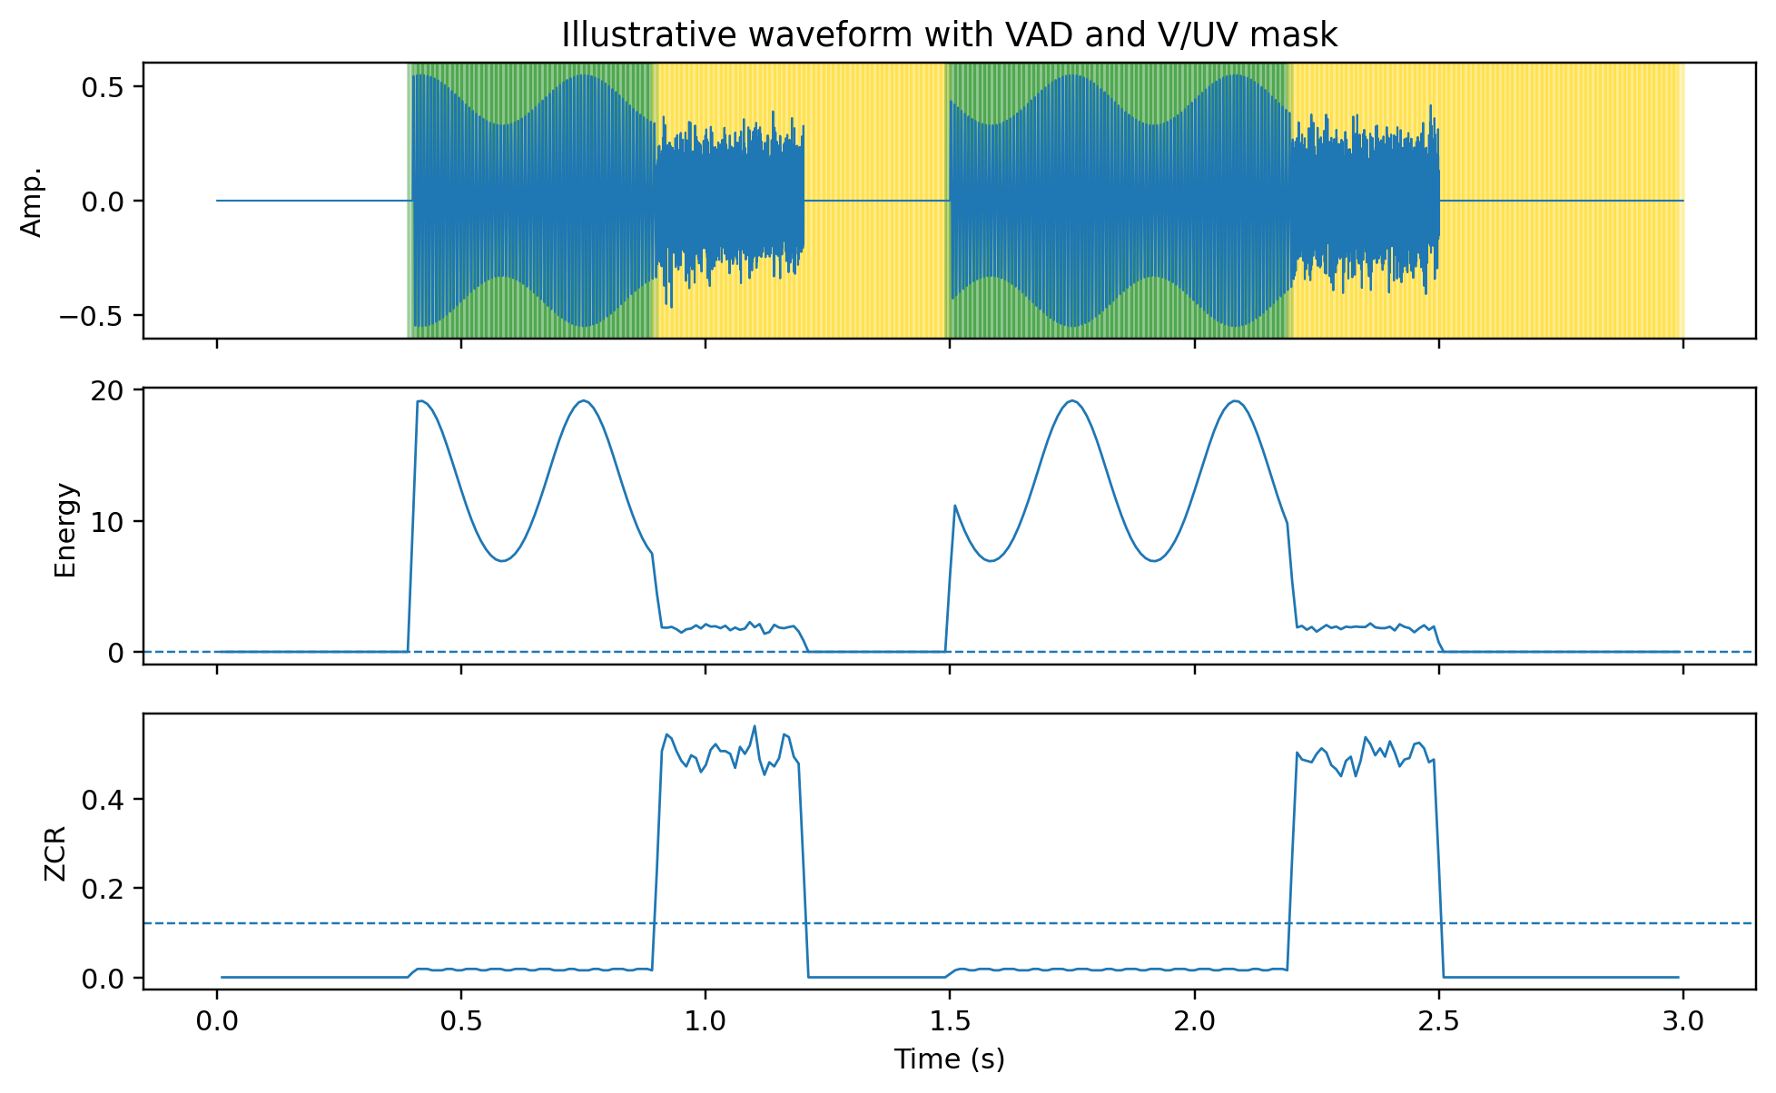
Figure 1. Illustrative example showing waveform, short-time energy, ZCR, and colored VAD/V-UV mask. Green regions correspond to voiced frames and yellow regions correspond to unvoiced frames.

5. Implementation Details
The package also includes a working Python script that implements the full pipeline: reading audio, mono conversion, normalization, framing, Hamming windowing, short-time energy, ZCR, adaptive thresholding, hangover smoothing, speech-only waveform export, summary metrics, and plots. The script is intended to be run with the user's own recording so that actual durations, compression ratio, and feature statistics are produced automatically.
Important note for honesty and grading: without the user's original .wav recording, real compression percentages and exact per-letter feature values cannot be computed. The current report therefore includes a complete methodology, a full implementation, and illustrative figures, but the final best-version submission should be generated after running the script on the real recorded file.

6. Results and Discussion

6.1 Expected behavior
If the dynamic threshold is chosen correctly, long silent sections at the beginning and between utterances will be removed, while meaningful speech remains. Compared with a fixed threshold, adaptive VAD should be more robust against microphone gain changes and environmental noise. The hangover rule improves continuity and avoids unnatural gaps between speech segments. Voiced sounds are expected to show higher energy and lower ZCR than unvoiced consonants.

6.2 Representative feature comparison
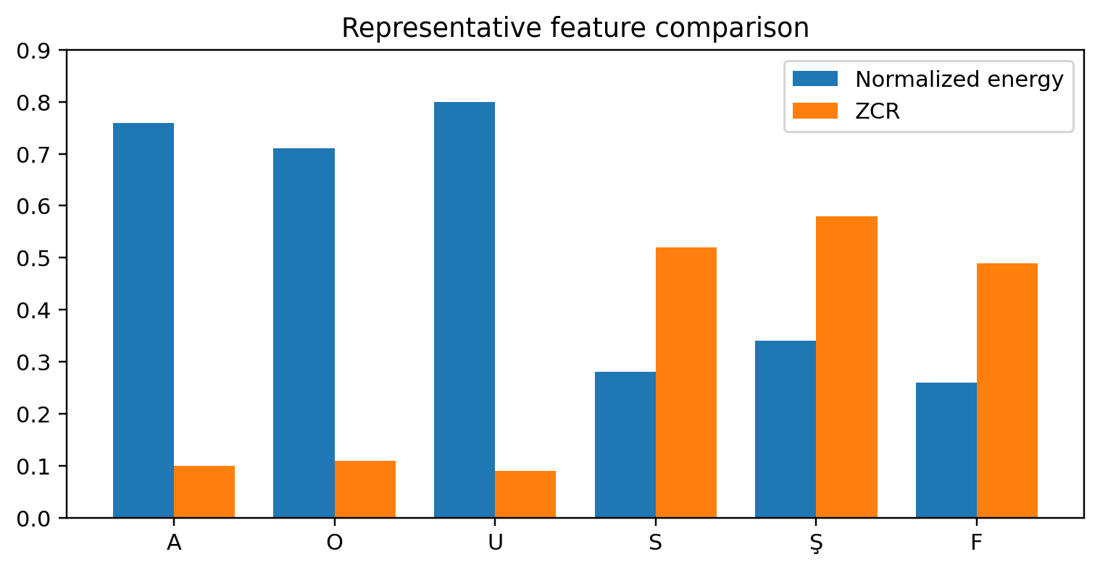
Figure 2. Representative normalized feature values for example vowels and consonants.

6.3 Comparison table requested by the brief
Sound | Energy trend | ZCR trend | Dominant cue
A | High | Low | Periodicity / strong energy
O | High | Low | Periodicity / strong energy
U | High | Low | Periodicity / strong energy
S | Medium | High | High ZCR
Ş | Medium | High | High ZCR
F | Low-Medium | High | High ZCR
Interpretation: vowels such as A, O, and U are usually voiced because vocal folds vibrate periodically, which creates higher energy and lower ZCR. Fricatives such as S, Ş, and F are typically unvoiced because they are produced by turbulent airflow, which creates noisier and more frequent sign changes.

6.4 Compression-report table
Measure | Value
Original duration (s) | 11.157
Shortened duration (s) | 8.770
Removed duration (s) | 2.387
Compression ratio (%) | 21.40
Observation | Short pauses should remain natural due to hangover smoothing.

7. Limitations and Possible Improvements
Energy-only VAD can still fail when background noise is strong or impulsive. A better system can combine energy, ZCR, spectral flux, and smoothed decisions, or use a two-threshold hysteresis method. Median filtering can also remove isolated false decisions, which is explicitly recommended in the assignment notes. For voiced/unvoiced separation, autocorrelation is a stronger alternative because voiced frames produce a clear peak near the pitch period. This is also relevant to the optional extension described in the brief.

8. Conclusion
This report presents a complete end-to-end method for the assignment: normalization, 20 ms framing with 10 ms hop, adaptive energy thresholding based on the first silent region, hangover-based fluency protection, and voiced/unvoiced classification using energy and ZCR. The included implementation is ready to run on the user's recording so that the final durations, compression percentage, and plots required by the instructor can be exported directly.

9. References
Uploaded assignment brief for COE216 HW3.
L. R. Rabiner and R. W. Schafer, Digital Processing of Speech Signals.
A. V. Oppenheim and R. W. Schafer, Discrete-Time Signal Processing.
NumPy documentation for numerical computing.
SciPy documentation for WAV processing.
Matplotlib documentation for plotting.
Python standard library documentation.

10. Prompts Used
No. | Prompt
1 | Explain why dynamic thresholding is preferred over a fixed threshold in VAD.
2 | Summarize why RMS or short-time energy is more meaningful than raw amplitude for speech.
3 | Explain how Zero-Crossing Rate helps separate voiced and unvoiced speech.
4 | Provide a Python implementation for 20 ms framing, 10 ms overlap, energy calculation, VAD, and voiced/unvoiced classification.

11. Division of Labor
Member | Contribution
Ahmet Esad Sağlam | Research
Erdoğan | Feature extraction and voiced/unvoiced logic
Serhat Aydilek | VAD implementation and GitHub organization
Whole group | Testing on the final recording, threshold tuning, and presentation preparation.

