CENG3004: Software Engineering

SEMSY

Design Document

08/06/2026

Team Members:

Ercüment Sezer Kartal (230709020) (SME)

Nehir Yılmaz (220709081)

Abdullah Özdemir (220709002)

Serhat Tay (220709054)

İbrahim Çinğay (210709018)

1. Overview
SEMSY is a web-based Point of Sale (POS) and Enterprise Resource Planning (ERP) system for small and medium-sized cafés and restaurants. It connects a public QR ordering interface, an authenticated kitchen/cashier workspace, a manager dashboard, a Node.js checkout service, and Firebase cloud services in one real-time operational platform.
The system digitizes the complete restaurant flow: customers browse a stock-aware menu and place orders; kitchen staff receive and fulfil them; cashiers process full or partial payments and table transfers; managers maintain products, recipes, and inventory while reviewing revenue, consumption, and waste analytics. The design reduces order transcription errors, keeps ingredient-level stock visible, and provides a shared operational state to all connected users.
The primary customer is a café or restaurant operator serving dine-in tables and takeaway orders. End users are Customers, Staff, and Managers. The present implementation uses React 19 and TypeScript for the frontend, Express 5 and the Firebase Admin SDK for checkout processing, Firebase Authentication for identity, and Firebase Realtime Database for persistence and live synchronization.
Design baseline: This document is based on SEMSY FİNAL ANALYSE.docx and was cross-checked against the current source tree. Where the analysis describes an intended guarantee that the code does not yet fully enforce, the current limitation and the target mitigation are both stated.

2. Design Goals
The design goals translate the SRS requirements into architectural concerns. They also provide criteria for accepting future refactoring and deployment decisions.
Goal's Concern | Related Requirement Identifier | Description
DG-1 Data consistency | FR-2, FR-3, FR-4; NR-2, NR-3 | Keep order creation, order numbering, and ingredient stock changes consistent. Production checkout must serialize stock validation and decrement, not only commit the final multi-path write atomically.
DG-2 Real-time operations | FR-5, FR-12, FR-13, FR-15; NR-1 | Propagate order, menu, and inventory changes promptly to every active role through Firebase listeners with deterministic cleanup on unmount.
DG-3 Least-privilege security | FR-7; NR-8 | Authenticate Staff and Managers and enforce authorization in Firebase rules and backend commands. Client route guards remain a usability layer, not the security boundary.
DG-4 Modular maintainability | FR-8-FR-18; NR-6 | Separate customer ordering, staff operations, manager administration, checkout processing, and data access so changes remain locally understandable and testable.
DG-5 Mobile and role-oriented usability | FR-1, FR-6, FR-18; NR-4, NR-5 | Provide a Turkish, mobile-first customer flow and task-focused staff/manager interfaces with clear status, warning, and confirmation feedback.
DG-6 Failure containment | NR-2, NR-6, NR-7 | Fail requests without partial writes, preserve recoverable user input, unsubscribe listeners, and make independently deployed subsystems restartable.
DG-7 Scalable reporting | FR-13, FR-15, FR-17; NR-7 | Support growing order history through indexed queries, bounded subscriptions, server-side aggregation, and paginated reporting instead of permanently downloading the full dataset.

3. System Models
The following models revise the analysis-level diagrams using the implemented TypeScript interfaces, React modules, Express endpoint, and Firebase data paths. Diagrams show both structural ownership and the most important runtime interactions.

3.1 Class Diagrams
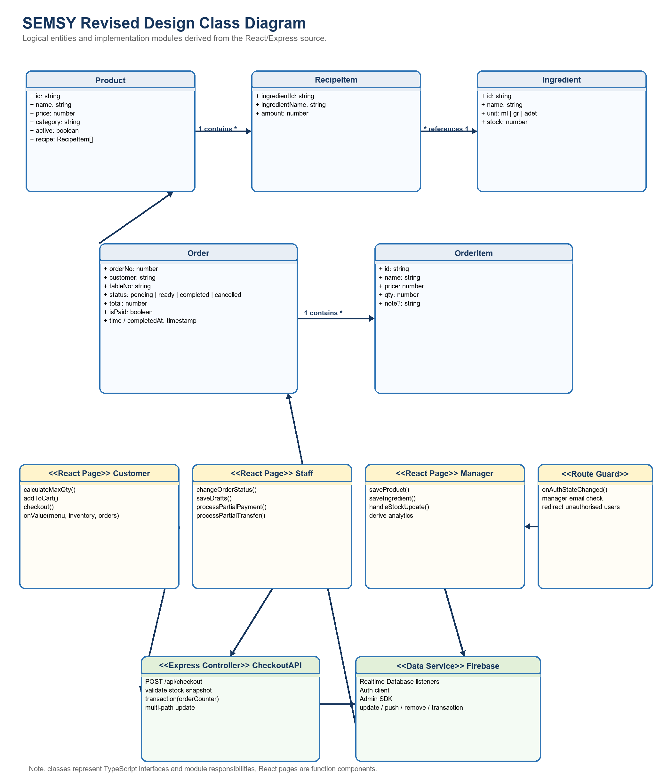
Figure 1. Revised design class diagram linking domain entities, React modules, checkout logic, and Firebase access.
Product, RecipeItem, Ingredient, Order, and OrderItem correspond directly to the interfaces in semsy-app/src/types/index.ts. CustomerPage, StaffPage, ManagerPage, ProtectedRoute, CheckoutAPI, and FirebaseGateway represent module responsibilities rather than instantiated domain objects.

3.2 Sequence Diagrams
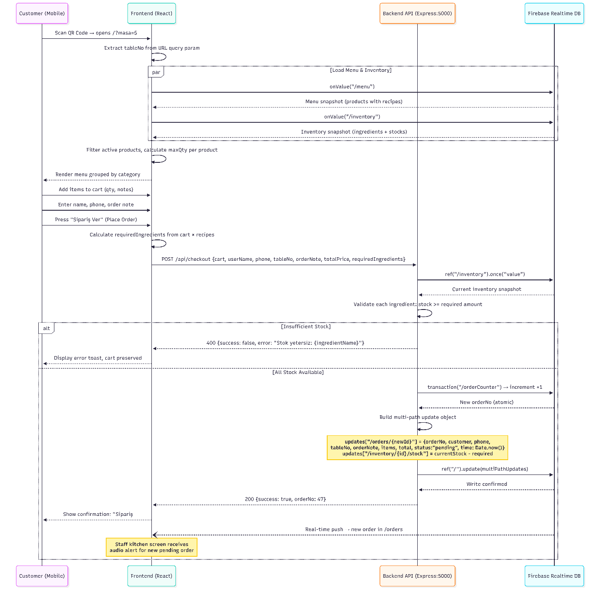
Figure 2. Customer checkout: real-time reads, server validation, order-number transaction, and multi-path commit.
Concurrency note: The displayed write is atomic, but the current stock snapshot and validation occur before the write and are not protected by a stock transaction. Two simultaneous requests can therefore validate the same quantity. Section 6.1 defines the target transactional design.
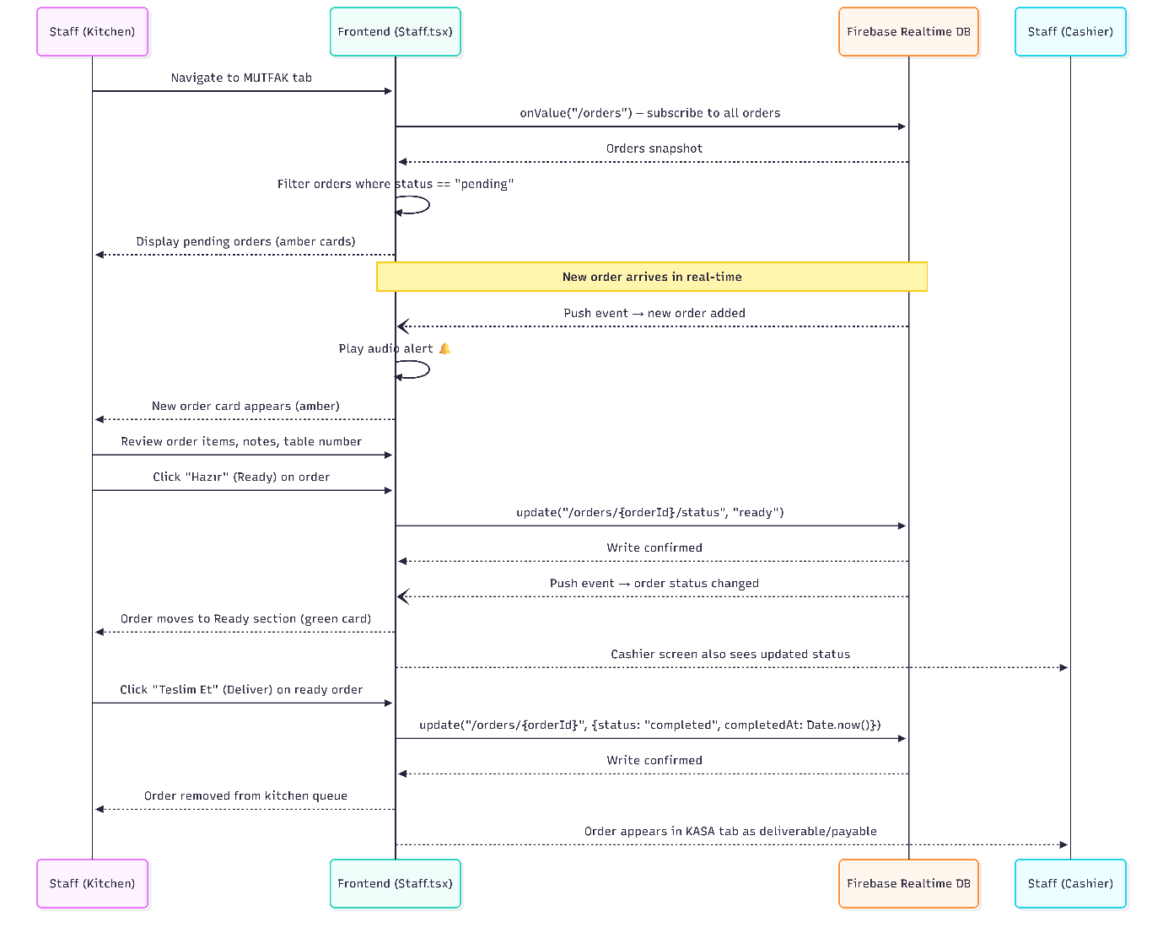
Figure 3. Kitchen sequence for receiving, preparing, marking ready, and completing an order.
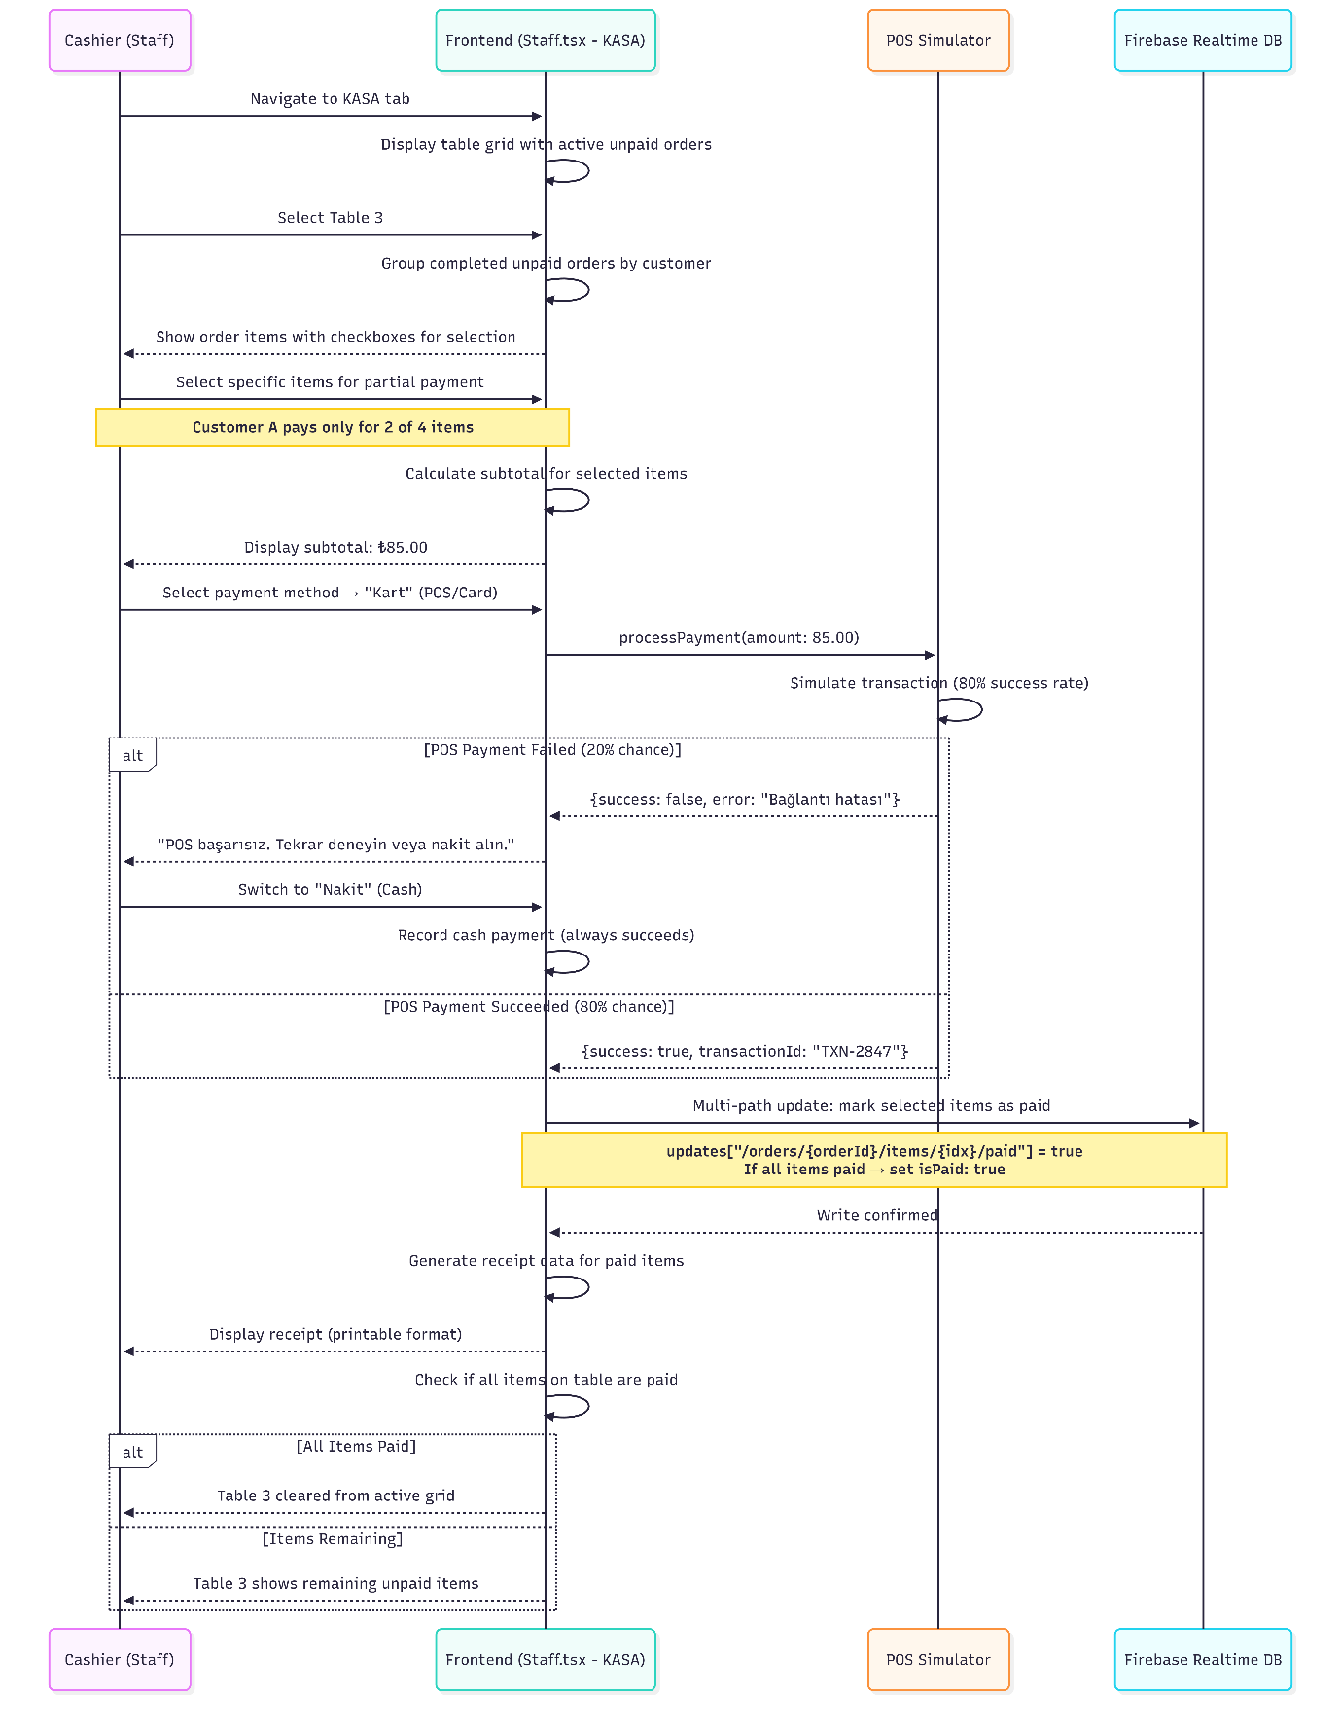
Figure 4. Cashier partial-payment sequence with POS failure recovery and receipt generation.
In the current Staff.tsx implementation, a partial payment is represented by creating a paid split order and reducing or deleting the original unpaid order. A production payment service should execute the complete split as one idempotent backend command.

3.3 Activity Diagrams
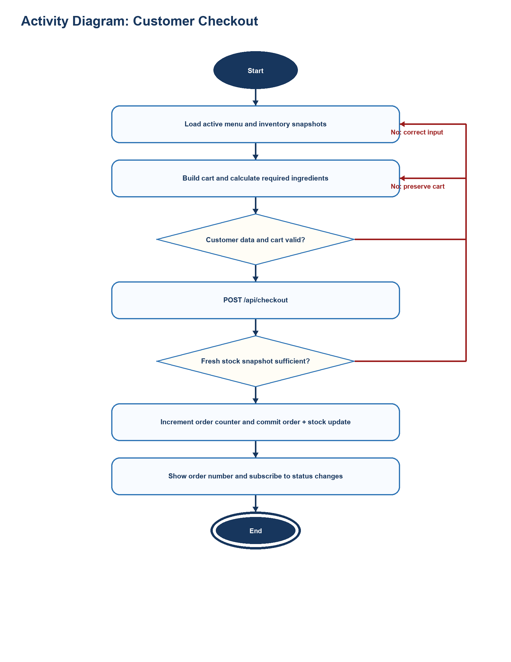
Figure 5. Revised checkout activity including validation and failure loops.
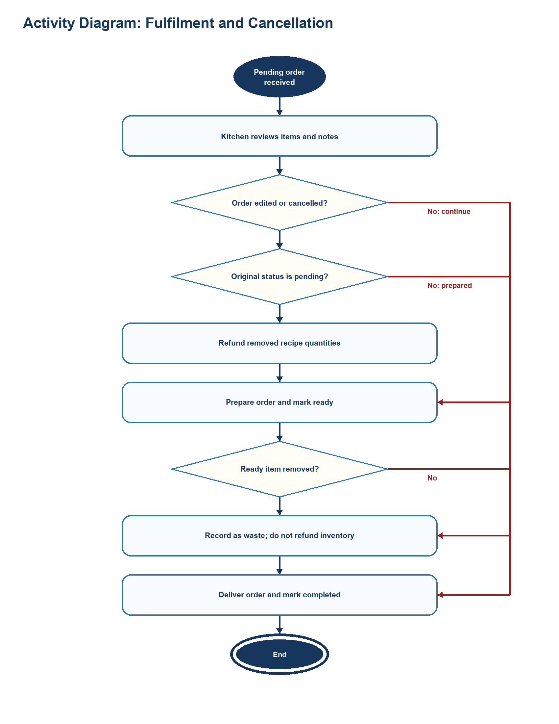
Figure 6. Fulfilment activity and the pending-refund versus ready-waste rule.
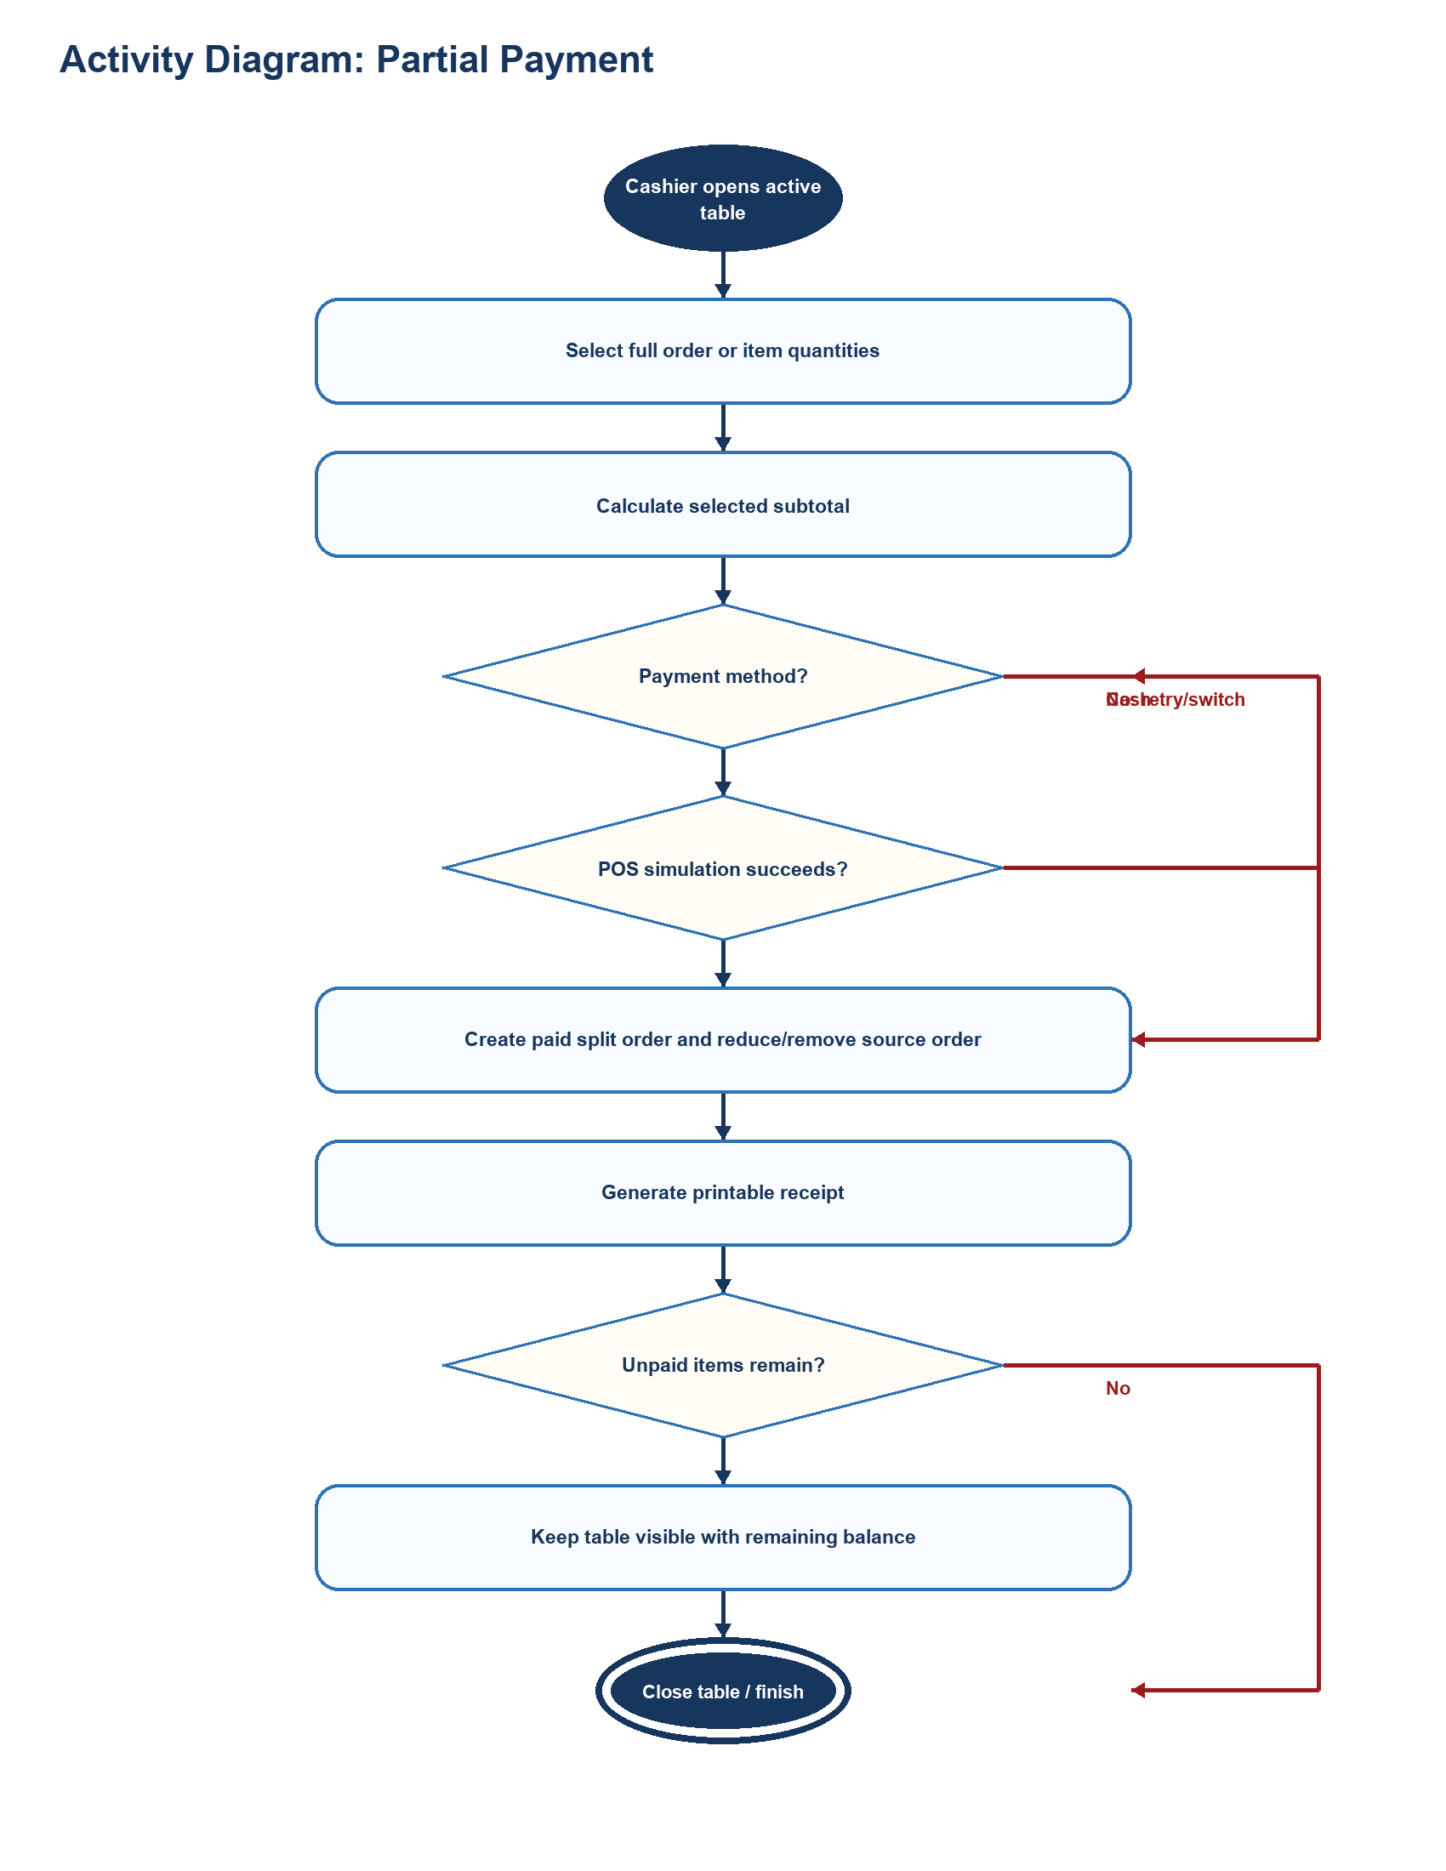
Figure 7. Partial-payment activity and the remaining-balance decision.

3.4 Statechart Diagrams
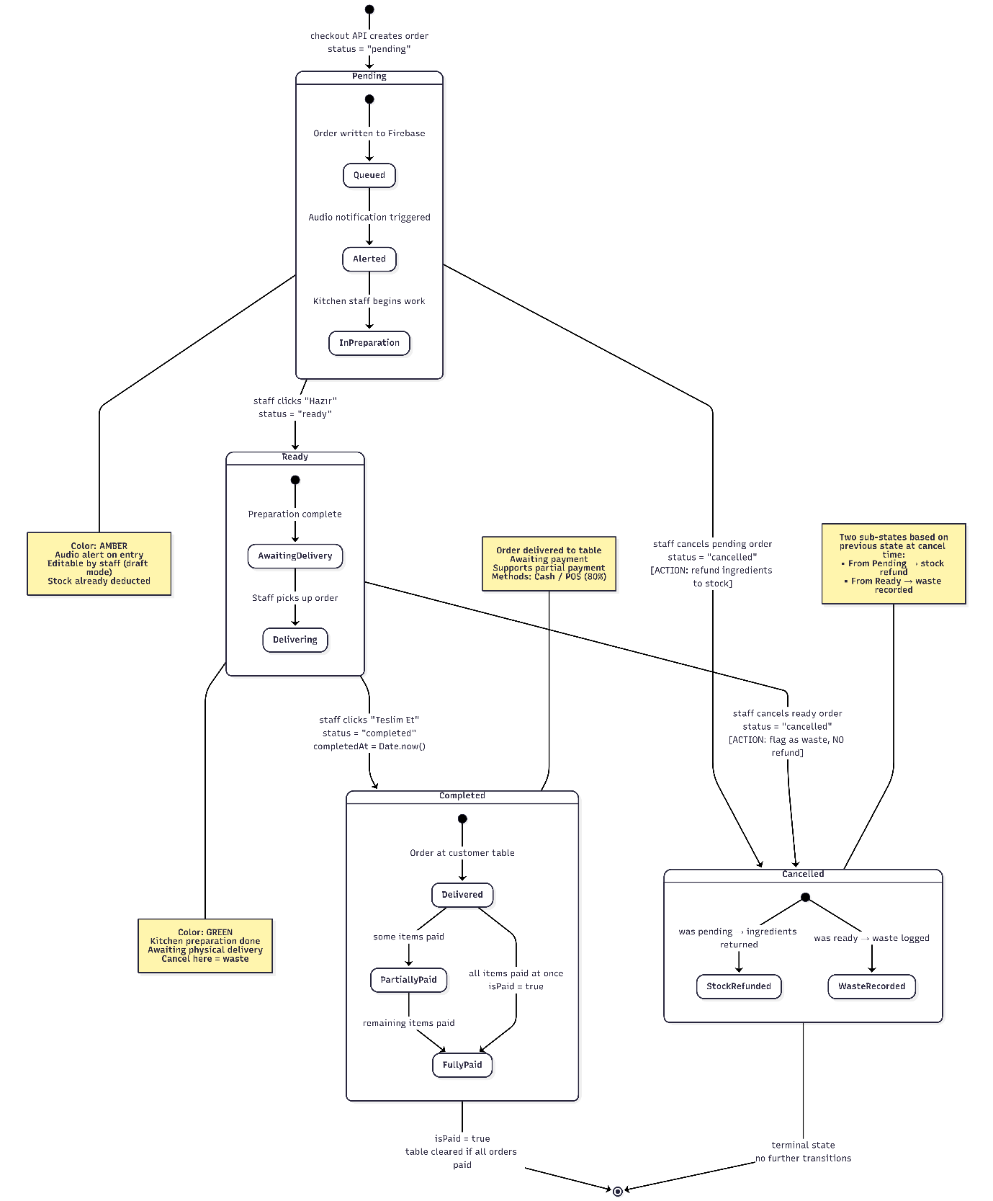
Figure 8. Order state machine from creation through fulfilment, payment, cancellation, and waste handling.
Transition | Trigger | Design Effect
pending -> ready | Kitchen accepts completion of preparation | Status update is pushed to all listeners.
ready -> completed | Staff delivers the order | completedAt is recorded.
pending -> cancelled | Unprepared items removed/cancelled | Recipe quantities are refunded to inventory.
ready -> cancelled | Prepared items removed/cancelled | No stock refund; quantities are treated as waste.
completed + unpaid -> paid | Cash/POS payment succeeds | isPaid becomes true or paid items are split into a paid order.

4. Subsystem Decomposition
SEMSY uses a client-heavy component architecture. React pages own presentation and much of the operational logic, the Express service owns checkout creation, and Firebase provides identity, persistent JSON storage, and real-time event propagation.
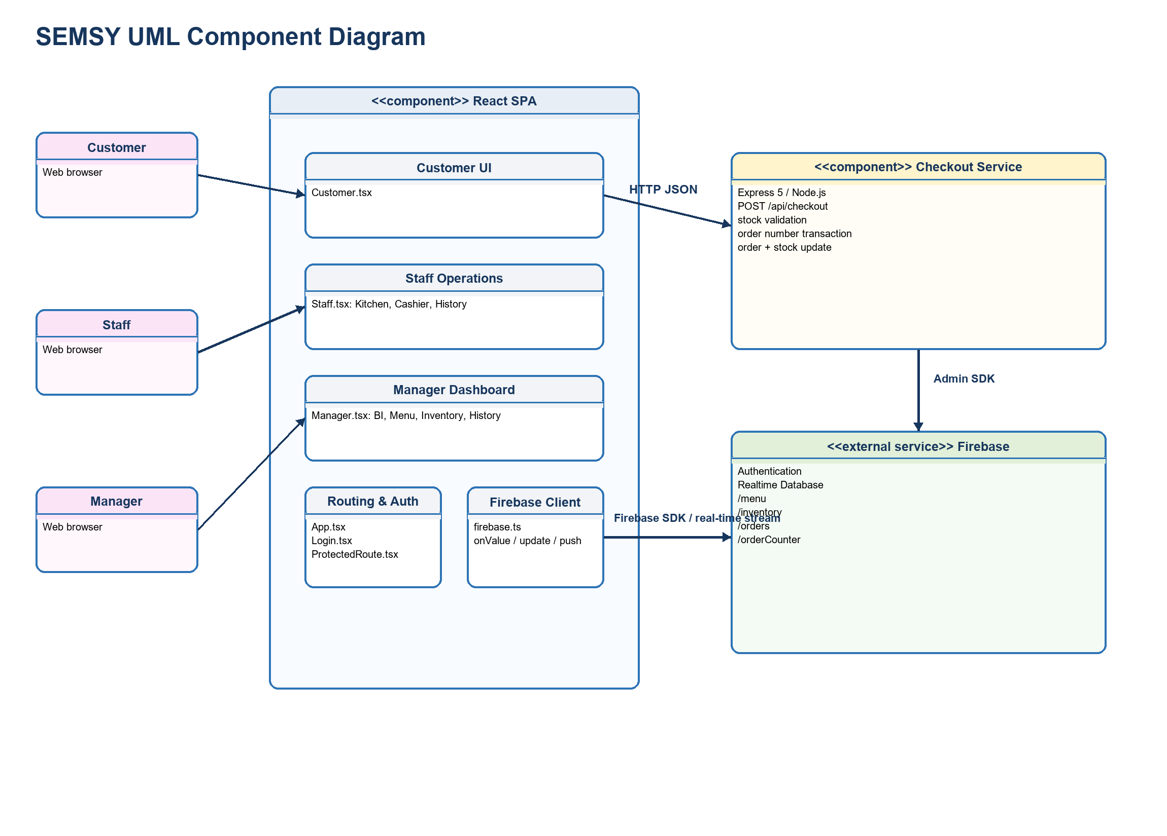
Figure 9. Component decomposition and external service boundaries.
Component | Implementation | Classes / Modules | Responsibility
Customer Ordering | Customer.tsx | Customer page; Product, Ingredient, OrderItem, Order interfaces | Menu/inventory subscriptions, cart, notes, stock-aware quantities, checkout request, table order status.
Authentication & Routing | App.tsx; Login.tsx; ProtectedRoute.tsx; firebase.ts | App router; Login page; ProtectedRoute; Firebase client | Route mapping, Firebase sign-in state, manager-route guard, shared SDK initialization.
Staff Operations | Staff.tsx | Staff page; kitchen, cashier, draft editor, payment, transfer, receipt modules | Order fulfilment, editing/cancellation, stock refund/waste, payments, transfers, printing, alerts.
Manager Administration | Manager.tsx | Manager page; product, ingredient, stock, analytics, history modules | Menu/BOM CRUD, inventory CRUD, BI metrics, waste analysis, advanced filters.
Checkout Service | semsy-backend/server.js | Express application; checkout controller; Firebase Admin adapter | Fresh stock read, order counter transaction, order construction, order/stock multi-path update.
Domain Model | types/index.ts and Firebase JSON records | Ingredient, RecipeItem, Product, OrderItem, Order | Shared data contract used across UI and persistence.
Cloud Data & Identity | Firebase managed services | Realtime Database; Firebase Authentication | Persistent state, live listeners, credential verification, server timestamps.

Recommended boundary: All state-changing Staff and Manager operations should migrate behind authenticated backend command endpoints. Direct client reads can remain where Firebase rules safely permit them; privileged writes should not depend on client-side route checks.

5. Hardware / Software Mapping
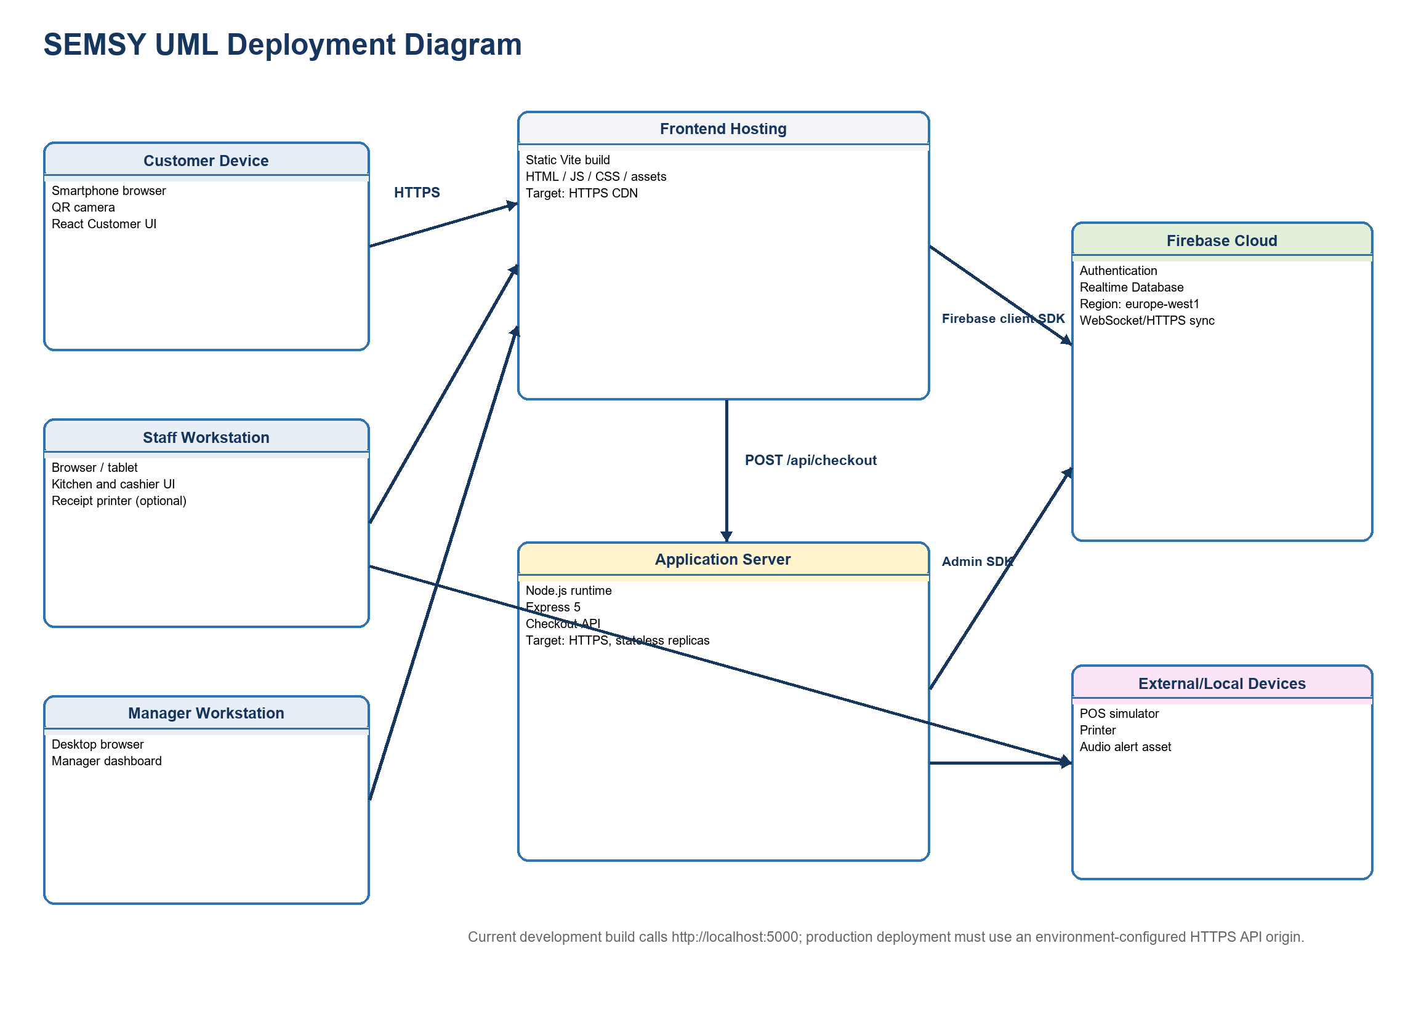
Figure 10. Deployment mapping for browser clients, frontend hosting, application server, Firebase, and local devices.
Node | Hardware | Software Artifact | Communication
Customer device | Smartphone browser and camera | React Customer UI | HTTPS to frontend; Firebase stream; HTTPS checkout API
Staff workstation | Tablet/desktop browser; optional receipt printer and speakers | React Staff UI | Firebase stream and writes; browser print/audio
Manager workstation | Desktop/laptop browser | React Manager UI | Firebase stream and administrative writes
Frontend hosting | Static hosting/CDN | Vite production build | Serves HTML, JavaScript, CSS, icons, and images over HTTPS
Application server | Node.js host or container | Express 5 checkout service on configurable port | HTTPS JSON API; Firebase Admin SDK
Firebase cloud | Google managed service, europe-west1 database | Authentication and Realtime Database | TLS, WebSocket/HTTPS synchronization, persistent JSON
External/local integrations | Printer, speakers, simulated POS | window.print(), audio URL, POS simulation | Browser/device APIs; replace simulator with certified payment integration in production

The current frontend hardcodes http://localhost:5000/api/checkout. This is valid only for local development when the browser can reach a backend on the same host. Production builds require an environment-controlled API base URL, HTTPS, health checks, a restricted CORS allowlist, and secrets supplied through the deployment platform rather than source files.

6. Other Design Concerns

6.1 Concurrency
Browser tabs, Firebase listeners, and Express requests execute concurrently. React state updates are single-threaded per browser context, but multiple clients can update the same Firebase paths at the same time. The order counter is correctly protected by a Firebase transaction; several other operations are currently read-modify-write sequences using absolute values.
Resource | Current Mechanism | Race / Failure | Target Design
Checkout stock | Backend reads /inventory, validates, then writes absolute decremented stock values. | Two requests can validate the same snapshot and overwrite each other's stock result. | Use a Firebase transaction covering a reservation/stock ledger, or move checkout to a trusted transactional Cloud Function. Reject transaction retries when any ingredient becomes insufficient.
Pending-item refund | Staff.tsx calculates refunds from the latest local inventory snapshot. | Concurrent stock changes can be overwritten. | Submit a backend refund command that uses transactions/increment operations and records an audit event.
Partial payment | The client pushes a paid split order, then removes or updates the original order in a loop. | Failure between writes can duplicate, lose, or misstate items. | Use one idempotent backend command and one multi-location update with a payment operation ID.
Partial transfer | The client pushes moved items, then removes or updates source orders. | Interruption can leave duplicate items across tables. | Execute the split and table reassignment in one backend transaction/multi-path update.
Menu/inventory editing | Managers write records directly from the client. | Concurrent edits use last-write-wins with no conflict signal. | Add updatedAt/version fields, validation rules, and optimistic concurrency checks.

Backend commands should be idempotent. The client supplies an operation ID; the server records completed IDs and safely returns the prior result on retry. This is especially important because a network timeout does not prove that a Firebase write failed.

6.2 Data Management
Firebase Realtime Database is the persistent store. Data is organized as denormalized JSON under /menu, /inventory, /orders, and /orderCounter. Product recipes and order items are embedded arrays. Embedding preserves the price, name, quantity, and note observed at transaction time, which is appropriate for receipts and historical reports.
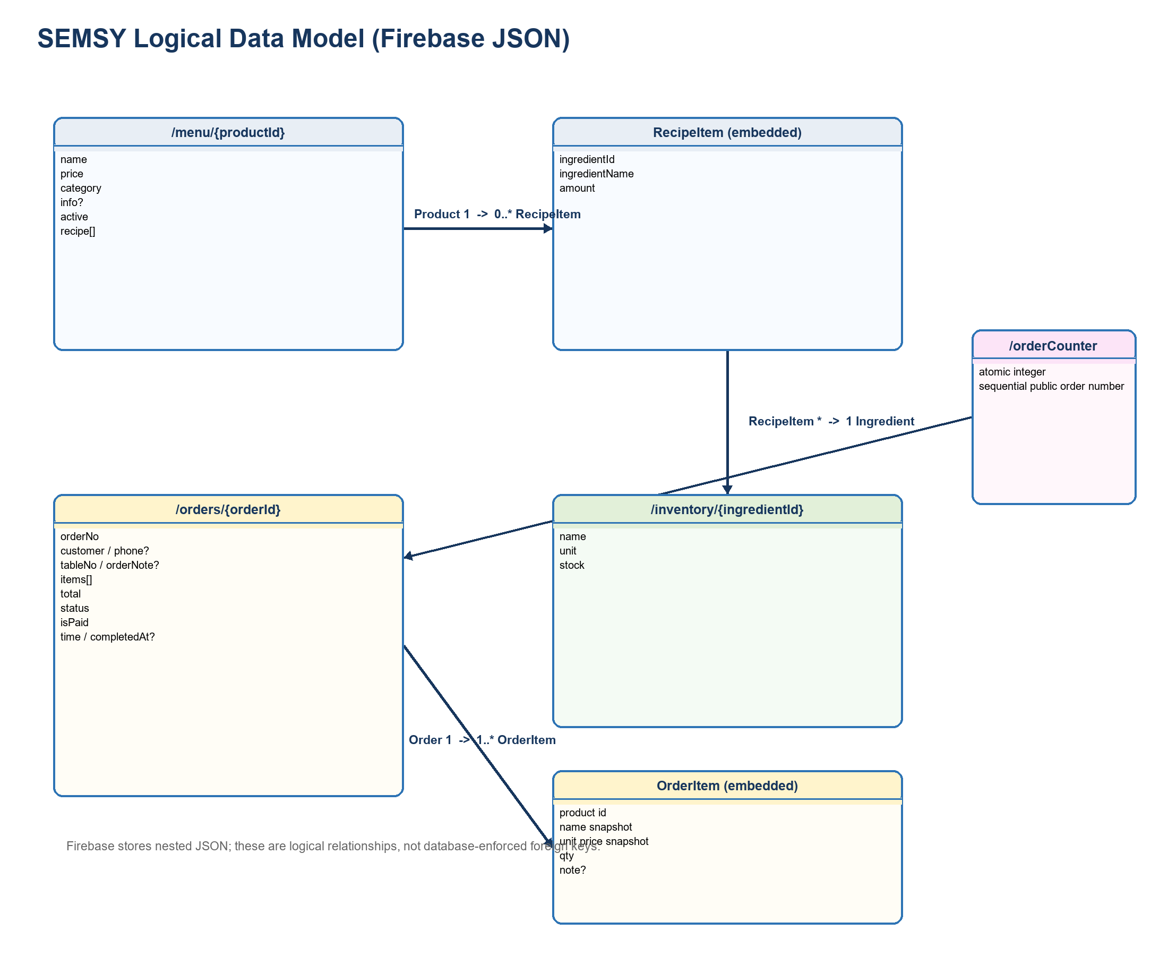
Figure 11. Logical entity relationships mapped to Firebase paths and embedded records.
- Validation: reject negative stock, prices, quantities, missing names, invalid status transitions, unknown ingredient IDs, and malformed table identifiers at the trusted boundary.
- Referential integrity: deleting an ingredient currently can leave recipe references behind. Before deletion, query and block or migrate every affected Product recipe.
- Indexing: define Firebase .indexOn rules for time, status, tableNo, isPaid, and any compound query strategy used by reports.
- Retention: retain completed/cancelled orders for financial and waste analysis; define an archival period and export policy appropriate to the operator and local law.
- Privacy: customer names, phone numbers, and notes are personal data. Minimize collection, restrict reads, define deletion periods, and avoid exposing full order history to public clients.
- Analytics: current dashboards derive metrics in the browser from the complete order set. Introduce scheduled aggregates or server-side reporting when history volume becomes material.

6.3 Global Resource Handling
Firebase Authentication identifies Staff and Managers. ProtectedRoute blocks unauthenticated navigation and checks a hardcoded manager email list. This is useful for user experience but is not an authorization boundary because browser code can be modified and direct database calls can bypass React routing. Authorization must be enforced by Firebase Security Rules and authenticated backend endpoints, preferably using custom role claims.
Actor | Menu | Inventory | Orders | Payments / Transfers | Analytics | Authentication
Customer | R active | R availability only | C via checkout; R own table status | - | - | Public session
Staff | R | R; U only through approved refund flow | R/U lifecycle; cancel/edit | C/U full or partial payment; transfers | R operational history | Firebase authenticated
Manager | C/R/U/D | C/R/U/D | R; operational corrections by policy | R | R all analytics/history | Firebase auth + manager role claim
Checkout service | R recipe validation | R/U transactional stock | C order | - | Write audit/metrics | Admin SDK service identity

Legend: C = create, R = read, U = update, D = delete. The table describes the target enforcement policy; the current code still performs several privileged writes directly from the browser.
- Move the Firebase Admin service-account credential out of the repository, rotate the exposed key, and inject credentials through the deployment secret store.
- Replace wildcard CORS with explicit production origins and validate request bodies server-side.
- Record actor UID, operation ID, timestamp, before/after values, and reason for inventory, cancellation, transfer, and payment events.
- Use custom claims or a server-maintained role record instead of a hardcoded manager email list.

6.4 Boundary Conditions

6.4.1 Initialization
- Frontend: load the Vite bundle, initialize Firebase from configuration, mount BrowserRouter, and parse ?masa={tableNo}; absent table numbers default to Paket.
- Customer: subscribe to menu, inventory, and orders; filter table-specific active orders; initialize an empty cart and loading state.
- Staff/Manager: wait for Firebase Authentication, enforce the requested route, then register role-specific menu, inventory, and order listeners.
- Backend: load deployment credentials and database URL, initialize the Firebase Admin SDK, configure JSON/CORS middleware, register POST /api/checkout, and start the configured port.
- Production readiness: fail startup if required secrets or URLs are missing; expose liveness/readiness checks and structured startup logs.

6.4.2 Termination
- React components unsubscribe every onValue listener in their useEffect cleanup functions.
- User logout calls Firebase signOut and returns to the login route; it does not terminate the backend or other clients.
- The frontend, backend, and Firebase service can terminate independently. Browser termination abandons only local unsent state; committed Firebase writes persist.
- The backend should stop accepting new requests on shutdown, complete bounded in-flight work, close resources, and then exit. The current server does not yet implement explicit graceful shutdown handlers.

6.4.3 Failure
Failure | Current/Expected Behaviour | Recovery Design
Frontend cannot reach checkout API | Show connection error and keep cart data so the customer can retry. | Health check, environment-correct API URL, exponential retry only after user confirmation.
Firebase listener disconnects | Firebase SDK reconnects; UI retains last snapshot. | Show stale/offline state and prevent unsafe writes until synchronized.
Stock becomes insufficient | Backend returns HTTP 400; order is not committed. | Refresh inventory, identify unavailable items, let customer adjust the cart.
Request times out after commit | Client cannot know whether the write succeeded. | Idempotency key plus order-status lookup before retry.
Partial payment/transfer write fails | Current multi-step client flow may be partially applied. | Move operation to a single authenticated backend command.
Firebase or backend node outage | Live operations pause; existing clients cannot safely mutate shared state. | Managed service monitoring, restart policy, alerting, backups, and documented manual restaurant fallback.

7. Standards Used
Standard | Scope | Application to SEMSY
IEEE 1016-2009 | Software Design Descriptions | Structure and content of this design document.
UML 2.5.1 | Unified Modeling Language | Class, sequence, activity, state, component, and deployment notation.
ISO/IEC 25010:2011 | System and software quality models | Quality goals for reliability, security, usability, maintainability, and performance.
RFC 8259 | JSON | API payloads and Firebase data representation.
HTTP/1.1 semantics and REST conventions | Web API interaction | Status codes, JSON requests, idempotent command design, and HTTPS transport.
OWASP Top 10 (2021) / ASVS | Web application security | Authorization, validation, secrets, logging, and secure deployment controls.
WCAG 2.2 AA | Web accessibility | Keyboard access, contrast, focus, labels, touch targets, and non-colour status cues.
ECMAScript / TypeScript | Frontend and backend language standards | Typed interfaces, module boundaries, and JavaScript runtime behaviour.
KVKK and privacy-by-design principles | Personal-data handling in Türkiye | Purpose limitation, access control, retention, and minimization for names/phones/notes.

8. Risk Matrix
Description | Prevention Measures Taken | Probability | Impact | Plan B
Concurrent checkout oversells stock | Implement transactional reservation/stock ledger; concurrency tests | Medium | Critical | Pause affected products, reconcile inventory and orders, notify staff, and deploy transactional checkout.
Privileged browser writes bypass role intent | Firebase Security Rules, custom claims, backend commands | Medium | Critical | Disable writes, rotate rules, audit order/inventory history, and restore from logs/backups.
Service-account key exists in project workspace | Remove from source control, rotate key, secret-store injection | High | Critical | Revoke the key immediately, issue a new least-privilege credential, and review access logs.
Partial payment or transfer is only partly applied | Single idempotent backend transaction | Medium | Major | Reconcile source/split orders using operation IDs and cashier audit records.
Hardcoded localhost API or permissive CORS breaks production/security | Environment-based HTTPS URL and origin allowlist | High | Major | Roll back frontend config, route through approved API gateway, and publish corrected build.
Ingredient deletion breaks recipes | Dependency check and soft-delete/deactivation | Medium | Major | Restore ingredient, migrate recipes, hide affected products until repaired.
Large order history slows manager/browser clients | Indexes, pagination, bounded listeners, aggregate records | Medium | Moderate | Restrict date range, archive old records, and compute reports server-side.
Firebase/backend outage interrupts restaurant service | Monitoring, restart policy, backups, offline operating procedure | Medium | Major | Switch to manual order tickets and reconcile when service returns.
No automated test or CI suite detects regressions | Unit, integration, security-rule, and concurrency tests in CI | High | Major | Freeze release, perform scripted smoke tests, and revert the faulty version.
Payment simulator is mistaken for production payment processing | Clear environment labelling and certified provider integration | Medium | Major | Disable card option outside demo mode and accept approved manual payment only.

9. Glossary
Term | Definition
POS | Point of Sale; the cashier and payment workflow that closes customer balances.
ERP | Enterprise Resource Planning; integrated management of orders, inventory, and reporting.
BOM / Recipe | The ingredient identifiers and quantities required to produce one unit of a menu product.
Realtime Database | Firebase JSON database that pushes changes to subscribed clients.
Atomic multi-path update | A Firebase write that commits changes to several paths together or commits none of them.
Transaction | A retried read-modify-write operation that commits only against a current value.
Idempotency key | A client-generated operation identifier that prevents a retried command from applying twice.
Order lifecycle | The pending, ready, completed, cancelled, and paid conditions of an order.
Waste | Ingredients consumed by prepared items that are cancelled after preparation and therefore not returned to stock.
Runway | Estimated days until stock depletion based on current quantity and average consumption.
Route guard | Frontend component that redirects users based on Firebase authentication and requested role.
Security Rules | Server-enforced Firebase policy controlling which authenticated identities may read or write each path.
Custom claim | Server-issued role data embedded in a Firebase authentication token.
AOV | Average Order Value; total paid revenue divided by completed paid orders.
Split order | A new paid or transferred order record created from selected items of an existing order.

10. References
- SEMSY FİNAL ANALYSE.docx, Software Requirements Specification and analysis models, 13 May 2026.
- SEMSY source code in semsy-app/ and semsy-backend/, inspected 8 June 2026.
- IEEE Std 1016-2009, IEEE Standard for Information Technology - Systems Design - Software Design Descriptions.
- Object Management Group, Unified Modeling Language (UML), Version 2.5.1.
- IETF RFC 8259, The JavaScript Object Notation (JSON) Data Interchange Format.
- OWASP Top 10:2021 and OWASP Application Security Verification Standard.
- React documentation, https://react.dev/.
- Firebase Realtime Database, Authentication, Security Rules, and Admin SDK documentation, https://firebase.google.com/docs/.
- Express documentation, https://expressjs.com/.
- TypeScript documentation, https://www.typescriptlang.org/docs/.
- Web Content Accessibility Guidelines (WCAG) 2.2, W3C.

11. Appendix

Appendix A - Requirement Traceability
Requirement(s) | Design Element | Implementation Evidence
FR-1, FR-6; NR-4, NR-5 | Customer Ordering component; Figures 1, 2, 5 | Customer.tsx
FR-2, FR-3, FR-4; NR-2, NR-3 | Checkout Service; Figures 2 and 10; Sections 6.1-6.2 | server.js; firebase.ts
FR-5, FR-12; NR-1, NR-6 | Staff Operations and live listeners; Figures 3 and 6 | Staff.tsx
FR-7; NR-8 | Authentication & Routing; Section 6.3 access matrix | Login.tsx; ProtectedRoute.tsx
FR-8, FR-10, FR-18 | Cashier/payment design; Figures 4 and 7 | Staff.tsx
FR-9 | Transfer command responsibility; Sections 4 and 6.1 | Staff.tsx
FR-11 | Fulfilment/cancellation activity and order state model | Staff.tsx; Manager.tsx
FR-13 | Manager Dashboard component and reporting deployment | Manager.tsx
FR-14 | Product, RecipeItem, Ingredient class and data models | Manager.tsx; types/index.ts
FR-15 | Data model, analytics component, and UI evidence | Manager.tsx
FR-16 | Staff draft editor responsibility | Staff.tsx
FR-17 | Manager history filtering responsibility | Manager.tsx
NR-7 | Deployment, bounded-data, and scalability design | Sections 5, 6.2, and Risk Matrix

Appendix B - Production Hardening Backlog
Priority | Action | Concern
P0 | Rotate and remove the Firebase Admin service-account key; use a deployment secret store. | Security
P0 | Enforce Firebase rules/custom claims and move privileged Staff/Manager writes behind authenticated APIs. | Security
P0 | Make checkout stock validation and decrement transactional; add high-contention concurrency tests. | Consistency
P1 | Create idempotent payment, cancellation/refund, and transfer commands with audit records. | Reliability
P1 | Configure API URL, database URL, port, and CORS origins through validated environment variables. | Deployment
P1 | Add schema validation, status-transition validation, and soft-delete/dependency checks. | Data integrity
P1 | Add unit, integration, Firebase-rules, and end-to-end tests to CI. | Quality
P2 | Add structured logs, metrics, health checks, alerts, backups, and recovery drills. | Operations
P2 | Add indexed/paginated history and precomputed reporting aggregates. | Performance
P2 | Perform WCAG 2.2 AA review and separate Turkish strings into a localization resource. | Usability

Appendix C - Implemented Interface Evidence
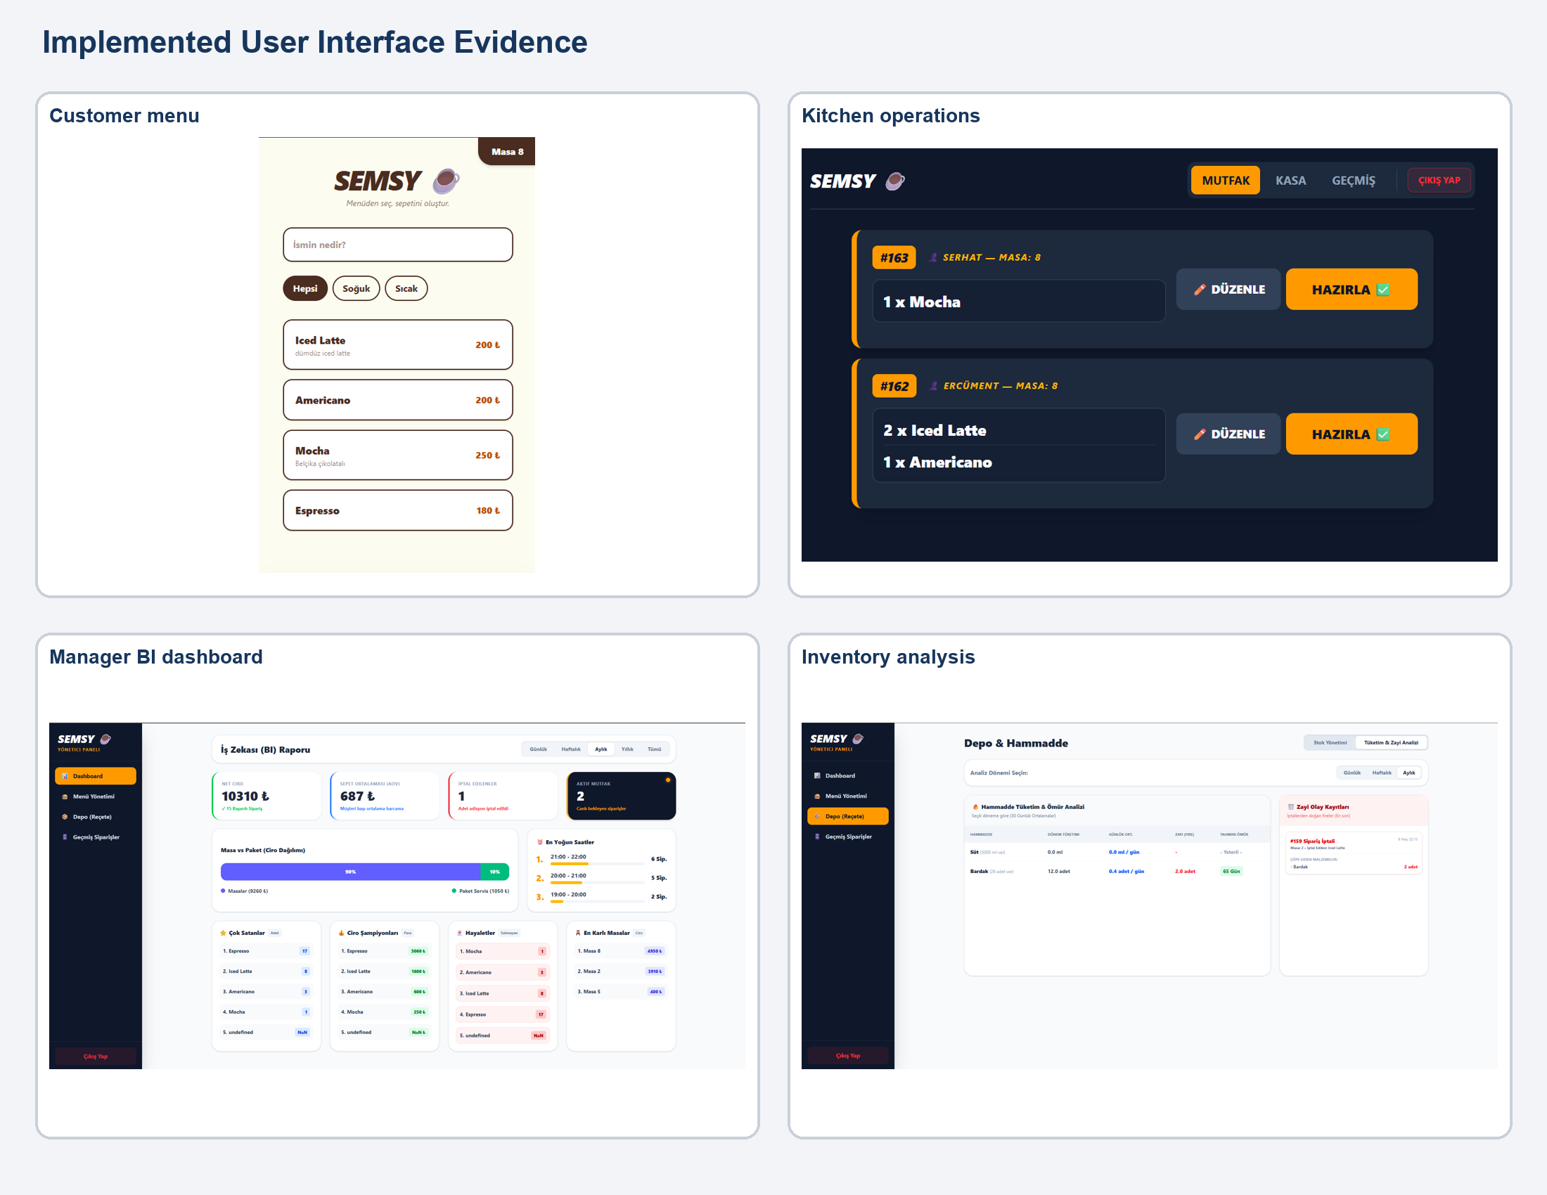
Figure 12. Screens from the implemented customer, staff, and manager interfaces.

Appendix D - Assumptions and Constraints
- The current repository is an academic/prototype implementation; no Firebase Security Rules, deployment manifests, CI pipeline, or automated tests were present in the inspected workspace.
- Verification on 8 June 2026: npm run build completed successfully with a JavaScript chunk-size warning; npm run lint reported 20 errors, principally explicit any types, unused variables, and React purity violations caused by Date.now() calls during Manager rendering.
- Firebase Realtime Database remains the selected persistence technology for this design revision.
- The POS module is a simulator and does not process real cardholder data.
- Table numbers are user-provided URL data in the current implementation; production QR codes should use validated table identifiers or signed tokens.
- The manager email whitelist currently contains admin@semsy.com and should be replaced by server-enforced role assignment.
- All user-facing strings remain Turkish unless a future internationalization requirement is approved.

Examples: Reliability, Modifiability, Maintainability, Understandability, Adaptability, Reusability, Efficiency, Portability, Traceability of Requirements, Fault Tolerance, Backward-Compatibility etc.. Check class slides for examples.
The non-functional requirement identifiers from Analysis/Software Requirements Document
Actors should correspond to actors in uses cases from Analysis Document..
Classes should correspond to classes in Section 3.1.

