Exploring Synthetic Label-Aligned Multimodal Fusion for Breast Cancer Classification Under Data Scarcity

CMU601 Project Report
BSc Computer Science Year 3
Birmingham Newman University
Student name: Serhii Sotskyi
Student number: 2303991
Supervisor: Dr Adnan Qureshi
Date of submission: 1 May 2026
File name: CMU601_Project_Report

Declaration of Originality
I declare that this report is my own work except where sources, datasets, software libraries, project artefacts or generative AI support are explicitly acknowledged. The work is submitted for CMU601 Project and has not been submitted for another award. Any use of AI assistance is declared in the appendix and the academic responsibility for checking accuracy, citations and final wording remains with the student.
Student number: 2303991 Signature: Date: 01/05/2026

Proforma

Proforma summary
Module code: CMU601 Project
Assessment: Project dissertation report
Project title: Exploring Synthetic Label-Aligned Multimodal Fusion for Breast Cancer Classification Under Data Scarcity
Student name: Serhii Sotskyi
Student number: 2303991
Supervisor: Dr Adnan Qureshi
Main-body word count: Approximately 8,600 words, excluding front matter, bibliography and appendices
Clinical status: Exploratory academic project only; not a clinical diagnostic tool

Acknowledgements
I would like to acknowledge the academic supervision and module support provided for CMU601 Project, the public dataset creators whose work made this investigation possible, and the open-source software communities behind Python, PyTorch, scikit-learn, FastAPI, Next.js and related tools.

Abstract
This dissertation investigates synthetic label-aligned multimodal fusion for breast cancer classification under data scarcity. The project uses two independent public datasets: BreaKHis histopathology images and the Wisconsin Diagnostic Breast Cancer tabular dataset. Because the datasets do not describe the same patients, the study is framed as a methodological exploration rather than a clinically validated multimodal diagnostic system. The work preserves an existing Wisconsin tabular branch as a frozen comparator, builds the BreaKHis image branch using patient-level splitting, and evaluates synthetic same-label and random-pairing fusion experiments. The BreaKHis split removed patient overlap between train, validation and test sets. The final image model achieved patient-level accuracy of 0.769 and ROC-AUC of 0.889, while the Wisconsin branch reported accuracy of 0.96 and ROC-AUC of 0.997. Same-label synthetic early fusion reached perfect repeated-seed metrics, but random-pairing controls showed that this should be interpreted as artificial label alignment rather than clinical multimodal complementarity. The dissertation concludes that synthetic pairing is useful for testing fusion workflows and explaining methodological risks, but future work requires real matched multimodal patient data, external validation, calibration improvement and stronger interpretability before any clinical claims can be made.

Table of Contents
Table of Contents
Declaration of Originality 2
Proforma 3
Proforma summary 3
Acknowledgements 4
Abstract 5
Table of Contents 6
Declaration of Originality 8
List of Figures 9
Glossary 10
Glossary summary 10
Chapter 1: Introduction 11
1.1 Focus of the dissertation 11
1.2 Motivation and problem overview 11
1.3 Research aims and questions 12
1.4 Proposed solution and dissertation structure 12
Chapter 2: Preparation 13
2.1 Literature review strategy 13
2.2 Breast cancer AI and histopathology context 13
2.3 Wisconsin tabular diagnosis context 13
2.4 Data scarcity, imbalance and leakage 13
2.5 Transfer learning and model selection 14
2.6 Multimodal fusion and synthetic pairing 14
2.7 Evaluation, calibration and reporting standards 14
2.8 Research and development methodology 14
2.9 Design methodology and ethical position 15
2.10 Gap analysis and preparation conclusion 15
Chapter 3: Implementation 15
3.1 Repository and artefact structure 15
3.2 BreaKHis data preparation 16
3.3 Image model implementation 16
3.4 Wisconsin branch implementation 17
3.5 Synthetic pairing and fusion implementation 17
3.6 Web app and transfer-ready artefacts 18
3.7 Version control, testing hooks and reproducibility 18
3.8 Implementation traceability and quality controls 18
Chapter 4: Evaluation 19
Leakage audit summary 19
4.1 Testing methodology 19
4.2 Leakage audit and split evaluation 19
4.3 Corrected BreaKHis image-model results 20
BreaKHis patient-level metrics 20
4.4 Wisconsin tabular comparator results 22
4.5 Synthetic fusion results 23
Selected synthetic fusion metrics 23
4.6 Joint model comparison 24
Joint model comparison summary 24
4.7 Discussion against literature 25
4.8 Limitations 25
4.9 Evaluation conclusion 26
4.10 Broader evaluation of validity and reliability 26
Chapter 5: Conclusions 27
5.1 Main findings 27
5.2 Answers to the research questions 27
5.3 Recommendations and future work 27
5.4 Closing conclusion 27
5.5 Reflective learning and dissertation closure 28
Bibliography 28
Appendices 33
Appendix A: Project Artefact Map 33
Project artefact map 33
Appendix B: Ethics and Data Handling 33
Ethics Approval Certificate 33
Appendix C: Usage of Generative AI Tools 34
Appendix D: Supporting Project Evidence 35
Appendix E: Literature Review 35
Appendix F: Data Sets 35

Declaration of Originality
I declare that this report is my own work and that all sources, datasets, software libraries and external support used during the project have been acknowledged. The experiments, analysis and conclusions presented in this dissertation were conducted by me.

List of Figures
Figure 1: Example BreaKHis histopathology tiles used to ground the image-classification branch.
Figure 2: Leakage audit showing why image-level splitting was replaced by patient-level splitting.
Figure 3: BreaKHis model-development comparison across patient-level experiments.
Figure 4: BreaKHis patient-level confusion matrix on the holdout test set.
Figure 5: BreaKHis patient-level ROC curve.
Figure 6: BreaKHis calibration plot for probability reliability discussion.
Figure 7: Synthetic fusion experiment comparison across pairing and model families.
Figure 8: Joint model accuracy comparison across unimodal and exploratory fusion results.

Glossary

Glossary summary
BreaKHis: Breast Cancer Histopathological image dataset used for the image branch.
WDBC: Wisconsin Diagnostic Breast Cancer dataset used for the tabular branch.
ROC-AUC: Area under the receiver operating characteristic curve.
F1-score: Harmonic mean of precision and recall.
ECE: Expected calibration error, used to assess confidence reliability.
Synthetic pairing: Artificial pairing of independent records by class label or random control.
Early fusion: Combining features before classification.
Late fusion: Combining probabilities or decisions after separate classifiers.

Chapter 1: Introduction

1.1 Focus of the dissertation
Breast cancer classification is a demanding computer science problem because diagnostic decisions depend on heterogeneous evidence rather than a single clean signal. Medical image data can show morphology, staining patterns and tissue-level structure, while tabular diagnostic data can describe engineered measurements such as radius, texture, concavity and symmetry. Recent reviews of breast cancer AI show sustained interest in both deep learning and conventional machine learning, but they also show that reported performance depends heavily on dataset design, evaluation protocol and clinical context (Javaeed and Schuh, 2025; Nassif et al., 2022). This dissertation, therefore, treats breast cancer AI as an applied machine-learning investigation, not as a clinical validation study.
The project explores whether synthetic label-aligned pairing of two independent public datasets can provide a useful framework for studying multimodal fusion when a true matched multimodal dataset is unavailable. The image branch uses BreaKHis histopathology data, while the tabular branch uses the Wisconsin Diagnostic Breast Cancer dataset. The central issue is that the two datasets do not describe the same patients. That prevents a genuine clinical multimodal model from being claimed. The work is instead framed as a methodological exploration: it builds and evaluates unimodal baselines, constructs controlled synthetic pairings, compares early and late fusion, and uses random pairing as a control condition.
This framing is important because multimodal medical AI is often presented as a natural improvement over unimodal modelling, yet genuine multimodal datasets are difficult to obtain, especially for undergraduate-scale projects. Multimodal surveys describe strong potential where multiple data streams complement each other, but they also emphasise alignment, missingness, validation and interpretation as persistent obstacles (Dimitri, 2022; Li et al., 2025; Jandoubi and Akhloufi, 2025). The dissertation responds to that gap by asking what can and cannot be learned when the data are not naturally matched. The result is intentionally cautious: the work can test engineering behaviour under artificial pairing, but it cannot prove clinical multimodal benefit.

1.2 Motivation and problem overview
The practical motivation came from a common project constraint. The available evidence sources were valuable but fragmented: a Wisconsin tabular model branch already existed, BreaKHis supplied a rich histopathology image dataset, and the project later included a web app workspace for presenting the results. None of these resources, however, supplied one patient-level table containing both tabular diagnostic features and matching histopathology images. Without such correspondence, a model that combines both modalities could easily become misleading if it is described as a real patient-level multimodal classifier.
A second motivation was evaluation quality. Early exploration of BreaKHis showed that a naive image-level split leaks patient identity across training, validation and test partitions. BreaKHis includes multiple images per patient and magnification level, so randomising images rather than patients can place highly related samples in different subsets. Data leakage is a recognised threat to reproducibility in machine-learning science, because it can inflate apparent model performance while hiding the true generalisation task (Kapoor and Narayanan, 2023).
The overall problem can be summarised as follows. Breast cancer AI studies often report high metrics, but high metrics are not enough when dataset construction is weak, samples are not independent, or the modelling claim exceeds the evidence. The dissertation, therefore, investigates a narrower question: under data scarcity, can synthetic label-aligned pairing be useful as an exploratory engineering framework, and what safeguards are required to stop the results from being over-interpreted? This problem is suitable for a technically competent reader because it combines data engineering, model development, experimental design, software implementation and critical evaluation.

1.3 Research aims and questions
The aim of the dissertation is to design, implement and evaluate a controlled breast-cancer classification workflow that compares unimodal baselines with exploratory synthetic multimodal fusion. The contribution is not a deployed clinical diagnostic system. It is a reproducible project pipeline showing how independent image and tabular datasets can be handled responsibly, how leakage can be identified and corrected, and how synthetic fusion results should be interpreted when the underlying patient correspondence is artificial.
The objectives are: first, to document and preserve the existing Wisconsin tabular branch as a frozen published comparator; second, to rebuild the BreaKHis image branch around patient-level splitting; third, to produce image-model metrics and supporting error analysis; fourth, to create synthetic same-label and random-pairing datasets; fifth, to compare tabular-only, image-only, early-fusion and late-fusion experiments across repeated seeds; and finally, to package the evidence in a form that can be explained through a written report and supporting demo artefacts.
The research questions are: RQ1, how can independent BreaKHis image data and Wisconsin tabular data be prepared as defensible unimodal baselines? RQ2, how does patient-level splitting affect the reliability of BreaKHis evaluation compared with image-level splitting? RQ3, how do image-only, tabular-only, early-fusion and late-fusion models compare under synthetic same-label and random-pairing conditions? RQ4, what limits prevent synthetic pairing results from being interpreted as clinically valid multimodal evidence? These questions deliberately combine implementation and evaluation because the quality of the results depends on the quality of the data preparation.

1.4 Proposed solution and dissertation structure
The proposed solution has four connected branches. The first is a Wisconsin Diagnostic Breast Cancer branch. It keeps the existing tabular notebook and artefacts unchanged, then summarises the published metrics and integration contract. The second is a corrected BreaKHis image branch. It parses patient identifiers from filenames, creates train, validation and test splits at patient level, trains a ResNet18-based image classifier, and evaluates the model using accuracy, precision, recall, F1-score, ROC-AUC, Brier score and expected calibration error. The third branch constructs synthetic pairs from independent data sources. Same-label pairing matches benign with benign and malignant with malignant; random pairing deliberately breaks this alignment to provide a control. The fourth branch compares early fusion, where features are combined before classification, with late fusion, where model probabilities are combined after separate unimodal predictions.
Chapter 2 prepares the work by reviewing the literature, datasets, research methodology and design choices. Chapter 3 explains the implemented software and experimental workflow. Chapter 4 evaluates the leakage audit, image model, tabular comparator, synthetic fusion experiments, testing procedures and limitations. Chapter 5 concludes by answering the research questions, summarising the contribution, and identifying future work with real matched multimodal datasets.

Chapter 2: Preparation

2.1 Literature review strategy
The preparation stage used the supplied reference file as the main literature base. Its 54 sources cover breast cancer AI, BreaKHis histopathology, Wisconsin tabular diagnosis, data scarcity, leakage, transfer learning, multimodal fusion, calibration, uncertainty and reporting guidance. This was appropriate because the dissertation is applied and methodological: sources needed to justify concrete project decisions by providing a detached survey.
The review was organised around six themes: breast cancer AI context, histopathology image classification, tabular WDBC-style diagnosis, data quality and leakage, multimodal fusion, and evaluation standards. Each group supports a design choice. For example, leakage literature justifies patient-level splitting, transfer-learning sources support the ResNet18 image branch, and multimodal reviews frame the limits of synthetic pairing (Javaeed and Schuh, 2025; Nassif et al., 2022; Li et al., 2025).

2.2 Breast cancer AI and histopathology context
Breast cancer AI includes radiology, pathology, cytology, clinical records and engineered diagnostic features. Reviews show strong interest in machine learning and deep learning, but also repeated concerns about validation, bias, data quality and clinical translation (Jiang et al., 2024; Haq et al., 2025). This dissertation follows that caution by treating model results as project evidence, not as clinical proof.
Histopathology is relevant because tissue images contain visual patterns that can support benign-versus-malignant classification. BreaKHis is a standard public benchmark with multiple magnification levels and diagnostic classes (Spanhol et al., 2016). Its structure also creates the key evaluation problem: multiple images can come from the same patient. Therefore, an image-level random split can leak patient information and inflate performance.
This point is important for the marker because it changes how the image result should be judged. The project does not claim to reproduce the best BreaKHis literature score. It claims to produce a more defensible local baseline by making the patient, rather than the image, the independent evaluation unit.

2.3 Wisconsin tabular diagnosis context
The Wisconsin Diagnostic Breast Cancer dataset provides the tabular branch. It contains engineered nuclear measurements such as radius, texture, perimeter, smoothness, concavity and symmetry, derived from digitised fine needle aspirate images (Street, Wolberg and Mangasarian, 1993; Wolberg, Mangasarian, Street and Street, 1993). These features are often highly predictive in supervised breast cancer classification.
The local project already contained a Wisconsin branch, so it was preserved as a frozen comparator rather than retrained. This keeps its provenance clear. Its reported accuracy of 0.96 and ROC-AUC of 0.997 are useful for comparison, but they do not validate synthetic fusion because the Wisconsin samples are not the same patients as the BreaKHis images.
Keeping the Wisconsin branch frozen also protects the comparison from silent optimisation. If the branch had been retuned after seeing fusion outcomes, its role as a comparator would be weaker. The dissertation, therefore, treats it as inherited evidence with clear provenance.

2.4 Data scarcity, imbalance and leakage
Medical machine-learning projects often face small datasets, costly labels and class imbalance. Oversampling methods such as SMOTE and Borderline-SMOTE show possible responses to imbalance, while recent medical reviews warn that resampling must be handled carefully (Chawla et al., 2002; Han, Wang and Mao, 2005; Salmi et al., 2024). In this project, however, leakage was the more urgent issue.
The initial BreaKHis image-level split placed patients across train, validation and test subsets. The corrected split partitioned by patient identifier instead. This matters because leakage can create strong but non-reproducible machine-learning results (Kapoor and Narayanan, 2023). Augmentation was kept as a training aid only; it did not replace the need for independent patient-level evaluation.

2.5 Transfer learning and model selection
The BreaKHis image branch used a ResNet18-based approach because it was feasible and supported by standard tooling. Residual networks are established CNN backbones, and transfer learning is widely used in medical imaging when labelled data and compute are limited (He et al., 2016; Kora et al., 2022; Kim et al., 2022).
Transfer learning is not automatically optimal. Medical-image feature reuse depends on the target data, pretraining domain and evaluation protocol (Matsoukas et al., 2022; Chae and Kim, 2023). More advanced alternatives, such as DenseNet, attention models and vision transformers are relevant future work, but ResNet18 was sufficient for a corrected patient-level baseline.

2.6 Multimodal fusion and synthetic pairing
Multimodal fusion combines different evidence sources, commonly through feature-level early fusion or probability/decision-level late fusion (Dimitri, 2022; Pei et al., 2023; Li et al., 2025). This distinction fits the project because the synthetic workflow compares concatenated features with probability averaging under the same pairing conditions.
The critical limitation is that the datasets are independent. Same-label pairing creates artificial benign-benign and malignant-malignant records, but it does not create patient correspondence. Random pairing was therefore included as a control. Recent multimodal medical-AI literature supports this caution: fusion claims depend on real alignment, validation and applicability, not only high metrics (Jandoubi and Akhloufi, 2025; Kaczmarczyk et al., 2024).
The same-label condition is still useful because it tests whether the implementation can combine class-consistent evidence without breaking the pipeline. The random condition is equally important because it shows whether high performance survives when artificial label agreement is removed. Together, they turn a risky synthetic setup into a controlled methodological experiment.

2.7 Evaluation, calibration and reporting standards
Evaluation in medical AI cannot rely on accuracy alone. The project reports precision, recall, F1-score, ROC-AUC, Brier score and expected calibration error. Calibration is important because probability outputs can be discriminative but unreliable as confidence estimates (Sambyal et al., 2023; Karimi and Gholipour, 2023).
Reporting guidance such as CLAIM 2024, TRIPOD+AI, PROBAST+AI, STARD-AI and DECIDE-AI emphasises transparent data description, bias, applicability and deployment limits (Tejani et al., 2024; Collins et al., 2024; Moons et al., 2025; Sounderajah et al., 2025; Vasey et al., 2022). This dissertation is not a clinical trial, but those standards shape its cautious reporting.

2.8 Research and development methodology
The research methodology is quantitative, experimental and comparative. It is quantitative because the core evidence is numerical model performance. It is experimental because the project manipulates data preparation, pairing strategy and fusion method. It is comparative because the main claims depend on comparing BreaKHis, Wisconsin, synthetic same-label fusion and random-pairing controls. A purely qualitative methodology would not answer the research questions because the questions are about model behaviour under controlled conditions.
The philosophical stance is pragmatic. The dissertation does not assume that a model score is a complete description of clinical truth. It treats metrics as useful but limited evidence produced under a specific dataset and protocol. This stance matters because the synthetic pairing branch is intentionally artificial. A positivist reading that treats the fusion score as direct truth would be inappropriate. A pragmatic reading asks what the result can support: engineering feasibility, comparison of fusion mechanisms, and warnings about overclaiming.
The software development approach was notebook-led experimental development with reusable modules. The notebooks provided traceable research steps, while the Python modules reduced duplication and supported later inference reuse. This approach is suitable for a data-science dissertation because it preserves exploratory work without leaving the final implementation as a collection of disconnected cells. The project also used versioned outputs, saved figures, metrics CSV files and an integration-ready web-app workspace, which gave the report concrete artefacts to cite and evaluate.
This methodology also fits the available evidence. The project already produced numerical outputs, saved artefacts and notebooks, so a quantitative comparative design could use those materials directly.

2.9 Design methodology and ethical position
The design methodology is centred on data flow and control conditions. The BreaKHis branch flows from file discovery to patient parsing, leakage audit, patient-level split, preprocessing, model training, checkpoint selection and holdout evaluation. The Wisconsin branch flows from protected existing notebook and artefacts to a read-only integration contract. The synthetic branch flows from independent unimodal outputs to same-label or random pair construction, then to early and late fusion evaluation. This design is intentionally modular so that each claim can be traced to the part of the system that supports it.
Ethically, the project uses public datasets rather than newly collected patient data. No direct personal identifiers are included in the report. The project nevertheless deals with medical themes. The web app and fusion demo must not be presented as diagnostic tools. This is consistent with early-stage AI reporting guidance, where decision-support systems require careful clinical evaluation before use with real users or patients (Vasey et al., 2022).
The central ethical risk is misinterpretation. A synthetic fusion model that reaches perfect performance under same-label pairing could appear impressive to a non-specialist reader. The report therefore repeatedly states that the pairing is artificial and label-based. The limitation is not hidden at the end; it is part of the research design. That choice supports academic integrity because it shows that the project can produce technical results while still respecting the boundary between experiment and clinical evidence.
The ethical position is embedded in the design. The project does not collect new patient data, but it still handles a medical subject. The safest approach is to avoid personal identifiers, separate exploratory and clinical language, and state clearly that the demo is not a diagnostic system.

2.10 Gap analysis and preparation conclusion
The preparation work identifies a practical gap: many studies report strong breast cancer AI performance, but this project has useful yet independent image and tabular datasets rather than matched multimodal patient records. The dissertation asks what can be learned responsibly from that constrained setting.
The design response is to keep evidence types separate. BreaKHis is corrected through patient-level splitting; Wisconsin is preserved as a protected tabular comparator; synthetic pairing is evaluated with same-label and random controls; and all fusion claims are labelled exploratory. These choices align with medical-AI reporting guidance on partitions, bias and applicability (Tejani et al., 2024; Collins et al., 2024; Moons et al., 2025).

Chapter 3: Implementation

3.1 Repository and artefact structure
The implemented project is organised into three main areas: the dissertation project, the web app workspace and the supporting documentation. The dissertation project contains reusable Python modules, notebooks, models, figures, metrics and report outputs. The current research sequence is stored under ‘notebooks’ and contains notebooks for scope definition, BreaKHis exploration, split audit, preprocessing, model development, evaluation, Wisconsin integration, synthetic pairing, fusion experiments, joint comparison, results synthesis and demo preset generation. This sequence provides a reproducible narrative from problem framing through final evidence packaging.
The source modules under dissertation_project/src contain the reusable implementation. The BreaKHis module handles binary records, patient identifier extraction, split summaries and leakage audits. The image pipeline module handles transformations, dataloaders, ResNet18 model creation, training and evaluation. The metrics module stores classification metrics, calibration and plotting helpers. The pairing module constructs same-label and random synthetic pairs. The fusion module extracts and aggregates image embeddings, builds fusion frames and runs logistic fusion experiments. The inference module loads artefacts and exposes tabular, image and synthetic-fusion prediction helpers.
The web app workspace provides a demonstration layer. It includes a FastAPI inference service and a Next.js frontend with routes for tabular prediction, image prediction, exploratory fusion demo, health checks, notebook artefacts and figure artefacts. This implementation supports communication of the project but does not change the scientific status of the results. The app is framed as a technical demo, not a clinical product.

3.2 BreaKHis data preparation
The BreaKHis implementation began by building a tidy binary classification dataframe from the local image folder. Each row records the image path, binary label, magnification and patient identifier. The patient identifier was extracted from the filename structure because BreaKHis filenames encode patient information. This parsing step was essential because the split unit needed to be patient, not image. Once patient identifiers were available, the project could audit whether patients appeared in more than one subset.
The initial audit reproduced the problem with image-level splitting. It found patient overlap between train, validation and test partitions. The corrected split used patients as the partition unit and exported separate train, validation and test CSV files. The final patient-level split contained 5,403 training images from 57 patients, 1,171 validation images from 12 patients, and 1,335 test images from 13 patients. The corrected audit showed zero train-validation, train-test and validation-test patient overlap.
This implementation choice directly affected the meaning of the later model metrics. The corrected evaluation is harder because the model must generalise to held-out patients. It is also more trustworthy. This distinction follows the methodological warning that leakage can convert a machine-learning experiment into an inflated memorisation test (Kapoor and Narayanan, 2023).
The exported split files are also part of the implementation, not only intermediate data. They document exactly which images and patients entered each subset, allowing later inspection of class balance, patient counts and leakage status. This makes the corrected split auditable rather than implicit inside notebook code.

3.3 Image model implementation
The image branch used a ResNet18-based classifier trained on the corrected patient-level split. ResNet was selected because residual architectures are well established, available through standard tooling, and computationally feasible for the local environment (He et al., 2016). The project first explored lightweight frozen-feature baselines and then moved to a cleaner full-split training run using augmented image batches, best-checkpoint selection by validation accuracy, and holdout test evaluation.
The implementation used image transformations appropriate for transfer learning. Images were resized and normalised consistently, with augmentation applied to the training set to reduce overfitting. The validation and test sets were not augmented because they needed to represent the held-out evaluation distribution. The model-development notebook saved training histories, model comparison figures and the final clean checkpoint. The saved checkpoint is located at dissertation_project/models/breakhis_resnet18_patient_level_clean.pth.
Predictions were evaluated at image and patient level. Patient-level aggregation was important because the split was patient-level and the dissertation questions concern patient-level reliability. The evaluation notebook exported confusion matrix, ROC curve, calibration plot, magnification-level analysis and error examples. These artefacts were later used directly in Chapter 4. The implementation connects the training pipeline to the written evaluation rather than leaving results embedded only inside notebooks.
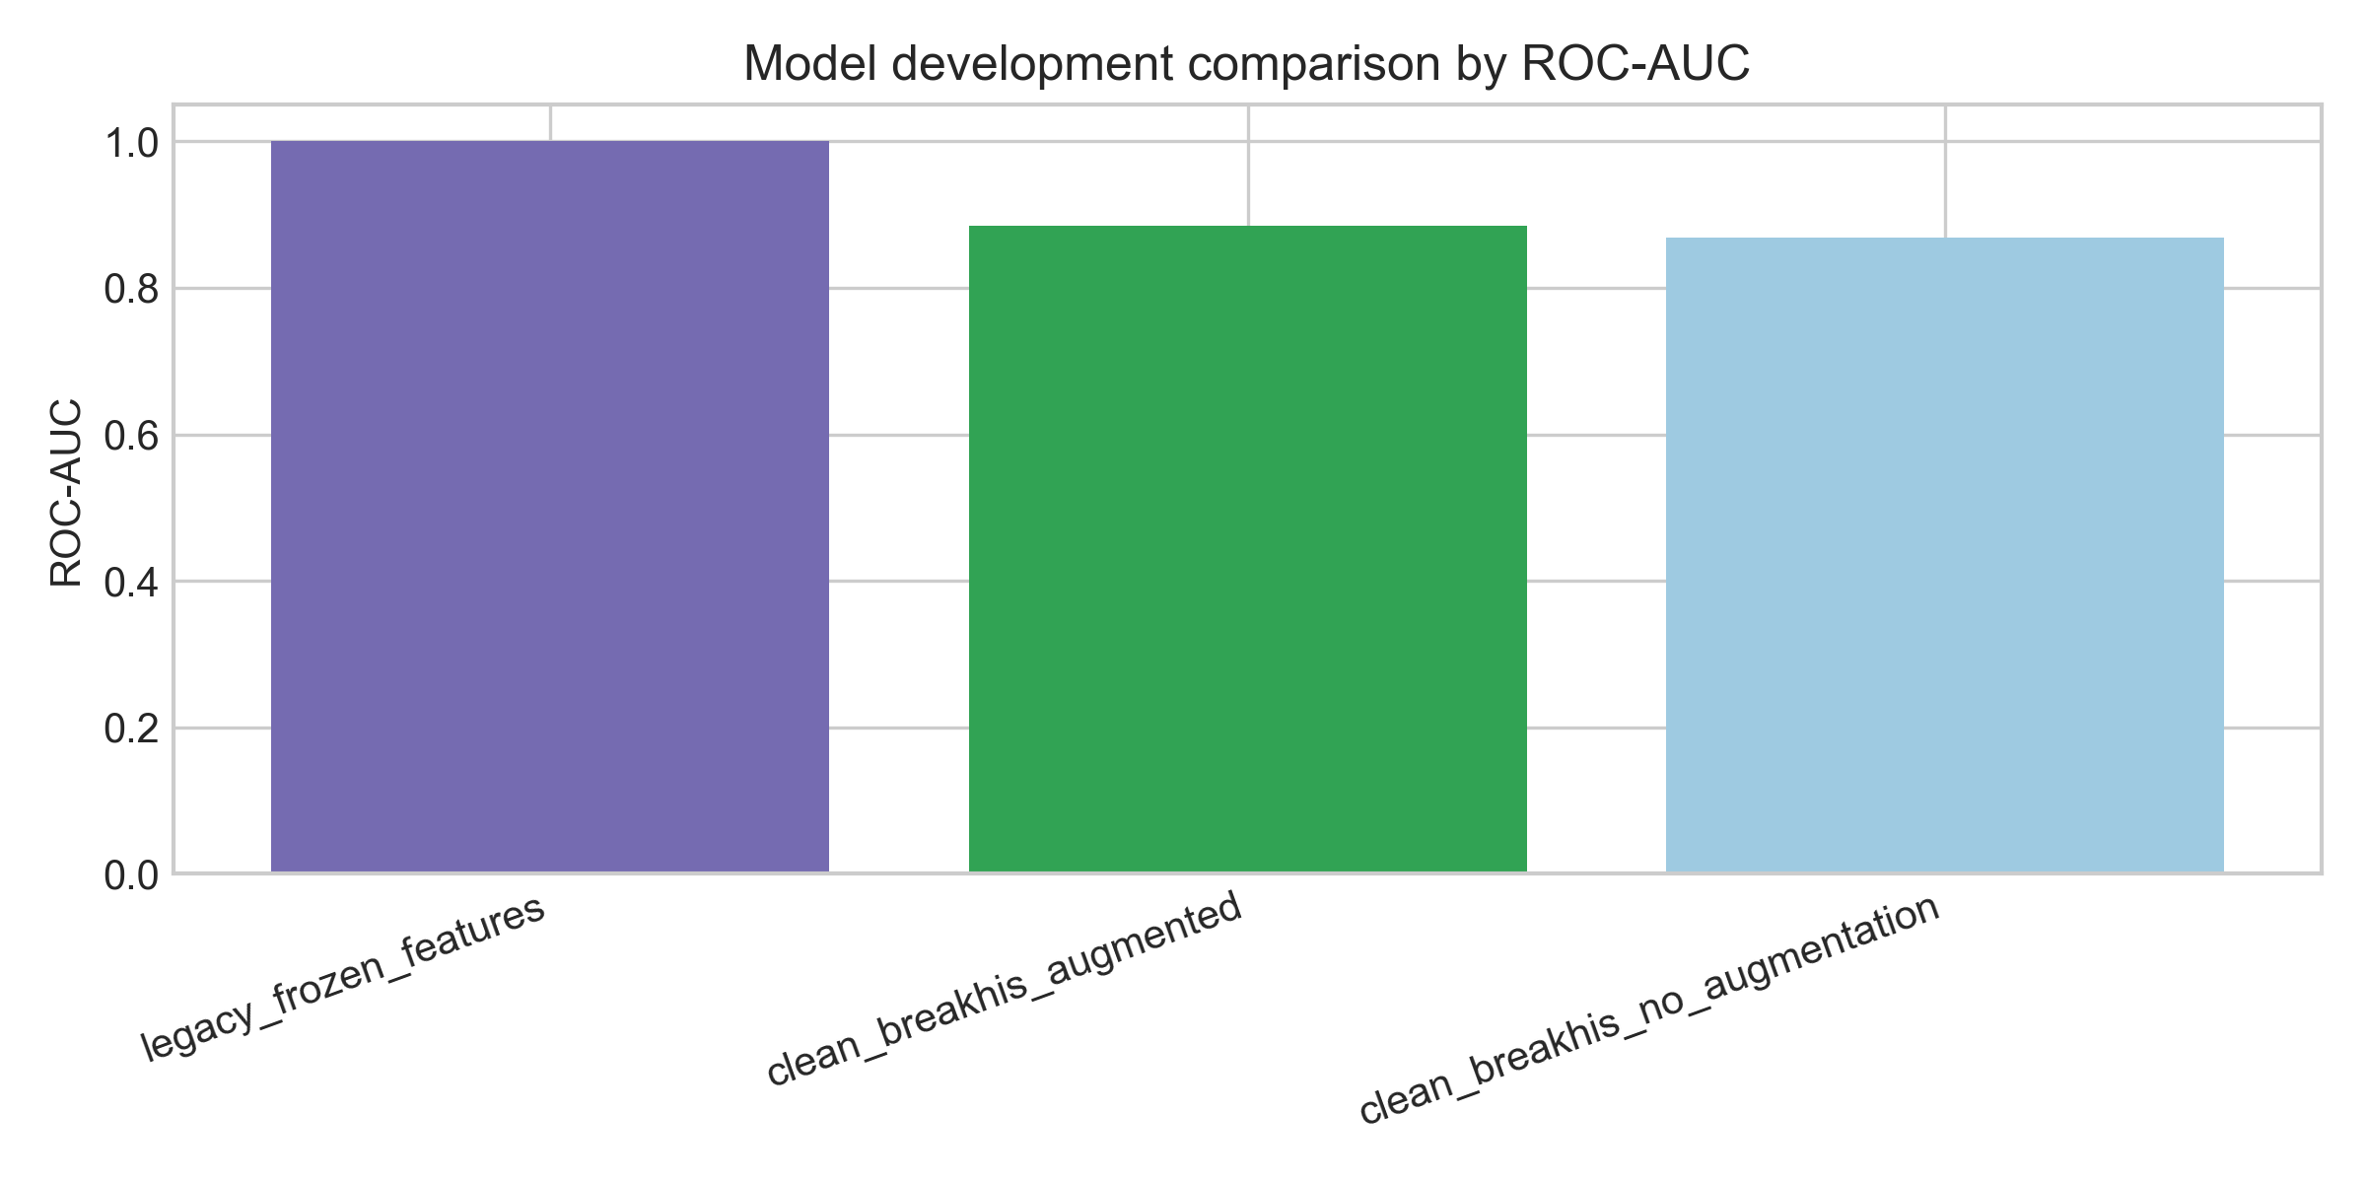
Figure 3: BreaKHis model-development comparison across corrected patient-level experiments.

3.4 Wisconsin branch implementation
The Wisconsin branch was treated differently because it already existed as a branch published by me earlier. The implementation decision was to preserve it and document it, not to retrain or alter it. The relevant notebook, dataset, model and scaler live under dissertation_project/notebook_Wisconsin. The project exported a Wisconsin integration contract, feature summary, label counts and reported metrics. The branch uses the 30 WDBC diagnostic features and reports benign or malignant predictions with a malignant probability.
This read-only treatment has two benefits. First, it avoids accidental changes to a branch that was already part of the project history. Second, it gives the dissertation a clear distinction between newly rebuilt work and inherited comparator work. The BreaKHis branch is the main newly corrected image result; the Wisconsin branch is a frozen tabular comparator. The report states this distinction explicitly to prevent the reader from assuming that all metrics were produced under identical development conditions.
The Wisconsin dataset contains 357 benign and 212 malignant samples in the local branch. The reported branch metrics are accuracy 0.96 and ROC-AUC 0.997. These metrics are high, but they are not surprising for WDBC-style feature data, where engineered nuclear measurements often support strong supervised classification. The important implementation point is that this branch supplies tabular evidence for comparison and synthetic fusion, while its patient records remain independent from BreaKHis.

3.5 Synthetic pairing and fusion implementation
The synthetic pairing implementation created artificial multimodal rows by combining Wisconsin tabular samples with BreaKHis image-derived records. Same-label pairing matched benign tabular samples with benign image records and malignant tabular samples with malignant image records. Random pairing ignored this label alignment and acted as a control. Repeated seeds were used so that the result did not depend on one arbitrary pairing sample. The exported pairing consistency summary shows a match rate of 1.0 for same-label pairing and approximately 0.429 for random pairing.
The early-fusion implementation concatenated tabular features with image-derived embedding features before fitting a logistic classifier. The late-fusion implementation trained separate tabular and image logistic models and averaged predicted probabilities. These choices were intentionally simple. The purpose was not to build a complex state-of-the-art fusion network, but to compare two interpretable fusion families under controlled synthetic conditions. This aligns with the literature distinction between feature-level and decision-level fusion (Dimitri, 2022; Li et al., 2025).
The implementation also evaluated tabular-only and image-only baselines within the same synthetic pairing frames. This mattered because a fusion model can appear strong simply because one modality is already strong. In this project, the tabular signal is much stronger than the random-pair image signal. Without unimodal baselines, the fusion comparison would be misleading. The implementation stored repeated-seed metrics for tabular-only, image-only, early-fusion and late-fusion models under both same-label and random pairing.
The implementation deliberately kept the fusion models simple. Logistic baselines make it easier to see whether the paired evidence is helping, while deep fusion models would add complexity that could hide the effect of the synthetic pairing design. This choice matches the dissertation's methodological purpose.

3.6 Web app and transfer-ready artefacts
The web app workspace translates the project into a demonstrable interface. The FastAPI service exposes health, demo-case and prediction endpoints. The Next.js frontend provides pages for the landing experience, testing workbench and notebook archive. It also includes local routes that expose figures, demo cases, animation assets and prediction proxies. The frontend reads figures and notebooks from the dissertation project, so the app can present the same evidence used in the written report.
The transfer-ready inference notes define the expected inputs and outputs for each branch. The tabular branch expects the 30 Wisconsin diagnostic features and outputs benign or malignant prediction with malignant probability. The image branch uses the corrected BreaKHis model artefact and documented preprocessing. The synthetic fusion branch expects a tabular record and an image-derived record, but it must always be described as exploratory. The app reinforces the same non-clinical disclaimer as the dissertation.
This implementation demonstrates software engineering beyond notebook execution. It shows that the artefacts were prepared for reuse, with model loading, feature ordering, demo presets and API routes separated from the experimental notebooks. At the same time, the report does not overstate the app. It is a communication and testing interface, not a validated decision-support system.
The app is valuable because it shows the project as software, not only as a set of notebooks. However, its role is communication and reproducibility support. It should help a reader inspect predictions, figures and artefacts.

3.7 Version control, testing hooks and reproducibility
Reproducibility was supported through saved notebooks, source modules and exported artefacts. The project stores split summaries, leakage reports, metrics, figures, pairing CSV files and comparison tables under “outputs”. These files make the report traceable because each claim can be linked to a concrete artefact rather than to transient notebook state.
Repeated seeds were used for synthetic pairing so that the result did not depend on one arbitrary construction.

3.8 Implementation traceability and quality controls
Implementation quality was managed by separating responsibilities. The source modules keep data parsing, image modelling, metrics, pairing, fusion and inference separate, which reduces hidden coupling. Patient splitting happens before training, and pairing happens before fusion evaluation, so the modelling code can be compared across controlled conditions.
Naming was also used as a quality control. Files such as breakhis_patient_level_metrics.csv, wisconsin_published_metrics.csv and synthetic_fusion_summary.csv preserve the distinction between image evidence, frozen tabular evidence and exploratory fusion evidence. That distinction is part of responsible medical-AI implementation.

Chapter 4: Evaluation
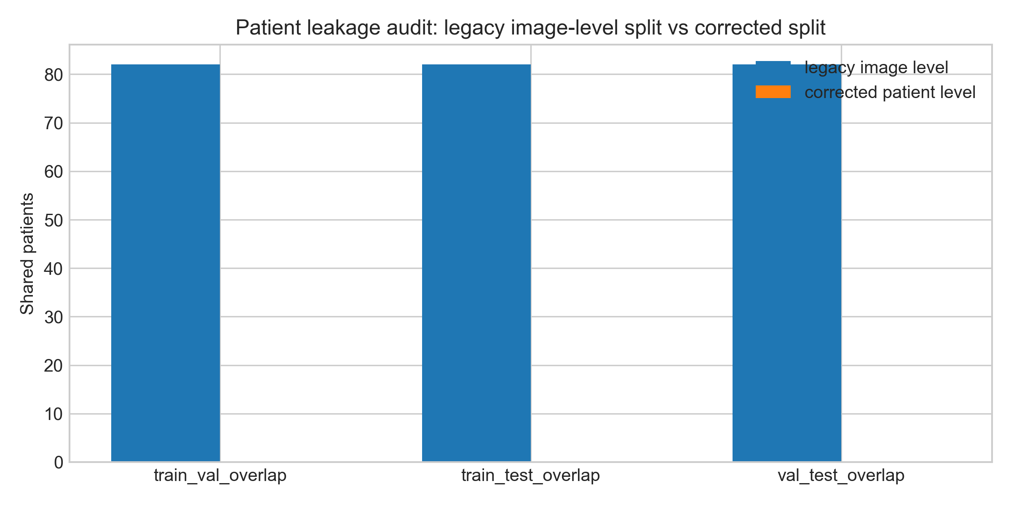
Figure 2: Leakage audit showing why image-level splitting was replaced by patient-level splitting.

Leakage audit summary
Split type: image_level_initial_attempt; Subset pair: train_val_overlap; Patient overlap: 82
Split type: image_level_initial_attempt; Subset pair: train_test_overlap; Patient overlap: 82
Split type: image_level_initial_attempt; Subset pair: val_test_overlap; Patient overlap: 82
Split type: corrected_patient_level; Subset pair: train_val_overlap; Patient overlap: 0
Split type: corrected_patient_level; Subset pair: train_test_overlap; Patient overlap: 0
Split type: corrected_patient_level; Subset pair: val_test_overlap; Patient overlap: 0

4.1 Testing methodology
The testing methodology had four layers. The first layer tested data integrity, especially whether the split avoided patient leakage. The second layer tested model performance using held-out metrics. The third layer tested synthetic-pairing logic by comparing same-label and random pairing. The fourth layer tested communication and integration by checking that exported artefacts and web-app routes aligned with the implemented branches. This layered approach is appropriate because the project could fail in several ways: a model could be accurate under leakage, a fusion experiment could be misinterpreted, or a demo could present exploratory outputs as clinical predictions.
Functional testing focused on whether each pipeline produced the expected artefacts: split CSVs, metrics, figures, model checkpoints, pairing tables and demo presets. Structural testing focused on code paths and reusable modules. Error-oriented testing focused on leakage, missing artefacts, inconsistent labels and incorrect feature order. The project did not use playtesting in a game-development sense, but the web app workbench served a communication role by allowing prediction flows to be exercised through an interface.
The evaluation criteria were therefore broader than a single accuracy score. A successful result needed to be reproducible, traceable, honestly interpreted and aligned with the research questions. This is consistent with clinical-AI reporting guidance, where transparent data partitions, model use, limitations and applicability are part of responsible reporting (Tejani et al., 2024; Collins et al., 2024).

4.2 Leakage audit and split evaluation
The most important testing result was the leakage audit. The initial image-level split produced 82 overlapping patients in train-validation, 82 in train-test and 82 in validation-test comparisons. This means the same patients were represented across all subsets, making the evaluation unsuitable as a patient-level generalisation test. After correction, the patient-level split produced zero overlap across every subset pair.
The corrected split also changed how performance should be read. A lower but leakage-free metric is more valuable than a high metric produced by contaminated partitions. In a dataset such as BreaKHis, where multiple images are associated with each patient, a model can benefit from patient-specific visual patterns if those patients appear in both training and testing. The corrected split removes that shortcut. This aligns with the broader leakage literature, which argues that flawed evaluation design can undermine reproducibility even when model code is technically correct (Kapoor and Narayanan, 2023).
The split summary also shows class imbalance and patient scarcity. The training set contains 5,403 images from only 57 patients, while the test set contains 1,335 images from 13 patients. The number of images is much larger than the number of independent patient units. This difference is central to the interpretation: image count alone can make the dataset look larger than it is from a generalisation perspective.
The leakage result is therefore not just a preprocessing observation; it is an evaluation finding. It explains why earlier image-level metrics would be unsuitable for the final argument and why the corrected result deserves more weight even if it is numerically lower.

4.3 Corrected BreaKHis image-model results
The corrected BreaKHis model achieved patient-level accuracy of 0.769, precision of 0.875, recall of 0.778, F1-score of 0.824 and ROC-AUC of 0.889. These results indicate that the image model learned useful malignant-versus-benign signal under the corrected patient-level split. The ROC-AUC is stronger than the accuracy, suggesting that the ranking of malignant probability contains information even though thresholded predictions still produce errors. The result is credible as a baseline because it was evaluated on held-out patients rather than leaked images.
The confusion matrix and error panel show that the model is not clinically reliable. A medical classifier must be judged partly by false negatives, because missed malignancy can be more serious than false positives. The recall of 0.778 means that the model still misses a meaningful proportion of malignant cases. This is not a failure of the project; it is evidence that the project is being reported honestly. Recent literature on breast histopathology deep learning often reports advanced methods and strong metrics, but those studies also depend on architecture, preprocessing, validation protocol and dataset scale (Liu et al., 2022; Wang et al., 2024; Zhou et al., 2025).
The calibration result is also important. The Brier score was 0.150 and expected calibration error was 0.235. This suggests that probability outputs should not be treated as dependable clinical confidence. Calibration work in medical image classification shows why this matters: a model can discriminate between classes while still producing poorly calibrated probabilities (Sambyal et al., 2023). The dissertation therefore reports calibration as a limitation rather than hiding it behind accuracy.

BreaKHis patient-level metrics
Accuracy: 0.769
Precision: 0.875
Recall: 0.778
F1 Score: 0.824
Roc Auc: 0.889
Brier Score: 0.150
Ece: 0.235

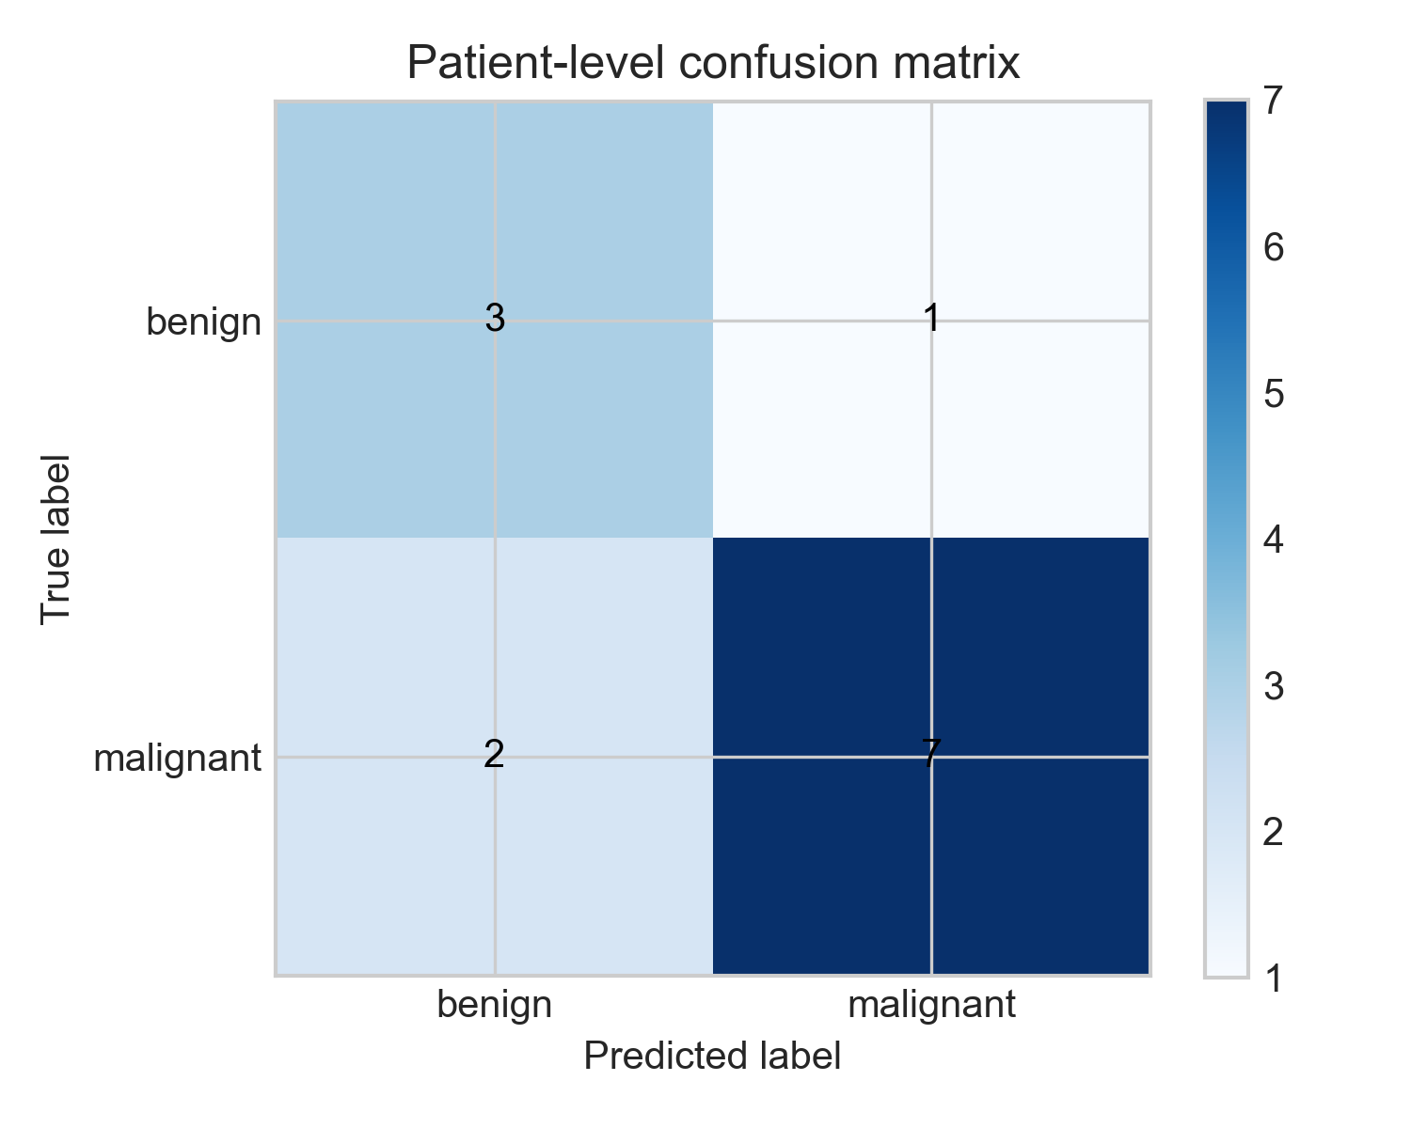
Figure 4: Corrected BreaKHis patient-level confusion matrix on the holdout test set.
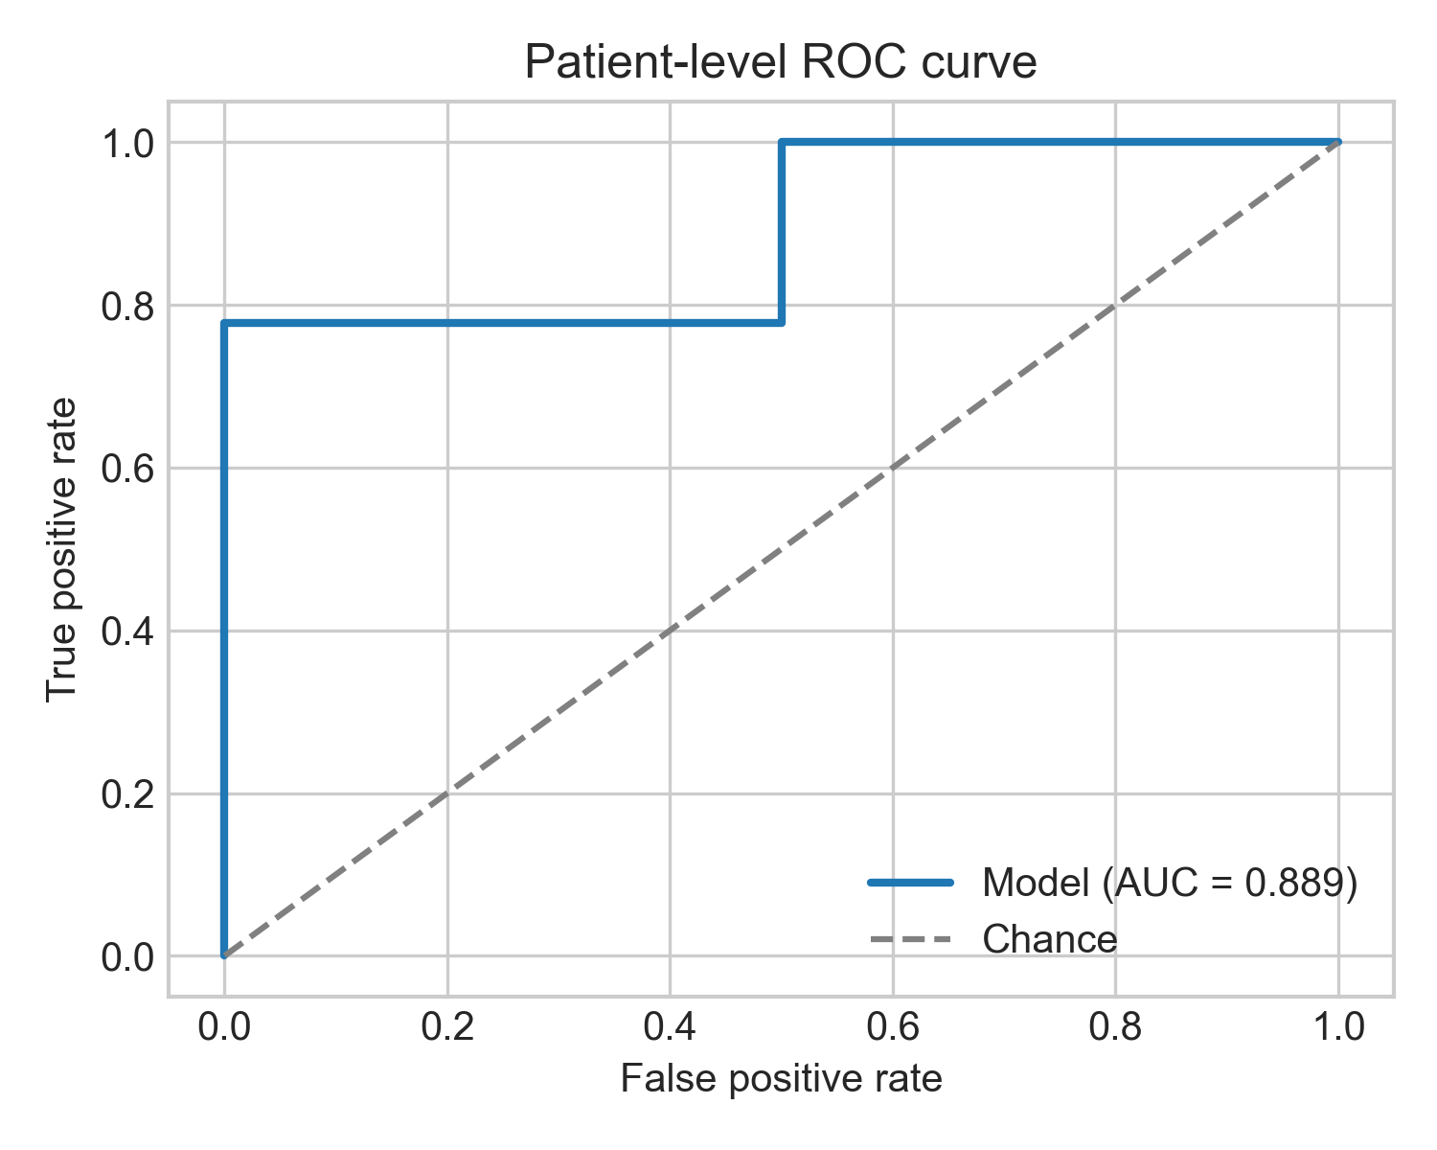
Figure 5: Corrected BreaKHis patient-level ROC curve.
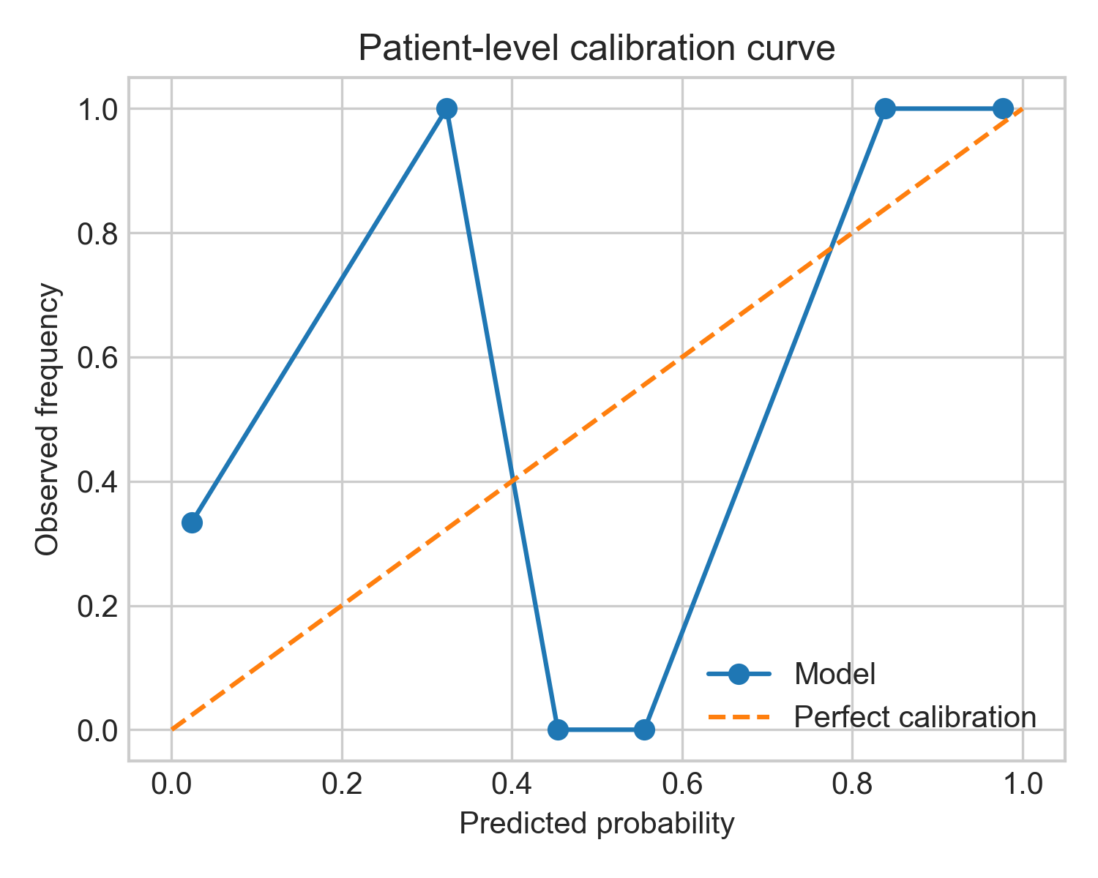
Figure 6: BreaKHis calibration plot for probability reliability discussion.
The result also needs to be interpreted against patient scarcity. The test set contains many images, but only a small number of independent patients, so the reported metrics are a useful project-level estimate rather than a stable clinical benchmark. Reporting ROC-AUC, F1-score and calibration alongside accuracy reduces the risk of over-reading a single number.

4.4 Wisconsin tabular comparator results
The Wisconsin branch reported accuracy of 0.96 and ROC-AUC of 0.997. This result is much stronger than the corrected BreaKHis image result, but the comparison must be interpreted carefully. WDBC tabular features are engineered measurements derived from diagnostic images and are often highly predictive in supervised machine-learning studies (Wolberg, Mangasarian, Street and Street, 1993; Aamir et al., 2022). BreaKHis histopathology images require the model to learn visual features directly from image data and generalise across patients. The two branches are therefore not equivalent difficulty settings.
The stronger Wisconsin result is useful because it shows that the fusion branch includes a high-performing tabular signal. This helps explain why random-pair early and late fusion can remain strong even when the image branch is weak under random pairing. The model may effectively lean on tabular features. That interpretation is more plausible than claiming that synthetic random pairs create true multimodal complementarity.
The Wisconsin branch also included uncertainty notes in its original notebook context. The dissertation treats those as branch-specific evidence, not as a full uncertainty evaluation of the whole system. A complete clinical prediction study would require standardised uncertainty reporting, calibration and external validation. For this project, the Wisconsin result functions as a comparator and a component in the synthetic experiment.

4.5 Synthetic fusion results
The same-label synthetic fusion result was very high. Same-label early fusion achieved mean accuracy and ROC-AUC of 1.000 across the repeated seeds. Same-label late fusion achieved mean accuracy of 0.998 and ROC-AUC of 1.000. If these numbers were presented without context, they would look like a major multimodal success. In this dissertation, they are interpreted more cautiously. Same-label pairing directly aligns labels across independent datasets. The result may therefore reflect artificial class reinforcement rather than genuine patient-level multimodal complementarity.
The random-pairing controls are essential. Under random pairing, early fusion achieved mean accuracy of 0.970 and ROC-AUC of 0.995, while late fusion achieved mean accuracy of 0.972 and ROC-AUC of 0.990. The tabular-only random baseline achieved mean accuracy of 0.982 and ROC-AUC of 0.995. This shows that much of the high performance can be explained by the strong tabular signal rather than by meaningful image-tabular integration. The random image-only baseline was much weaker, with mean accuracy of 0.586 and ROC-AUC of 0.492, because random pairing breaks the relationship between image evidence and the paired label.
This pattern answers the central methodological question. Synthetic label-aligned pairing can be useful for testing a fusion pipeline, but it is dangerous as evidence of clinical multimodal benefit. The same-label condition verifies that the pipeline can combine class-consistent signals, while the random condition reveals how easily performance can be dominated by one modality. The experiment therefore produces a useful negative constraint: fusion metrics must be interpreted alongside unimodal baselines and pairing controls.

Selected synthetic fusion metrics
Pairing: same_label; Experiment: early_fusion; Accuracy: 1.000; ROC-AUC: 1.000; F1-score: 1.000
Pairing: same_label; Experiment: late_fusion; Accuracy: 0.998; ROC-AUC: 1.000; F1-score: 0.998
Pairing: random; Experiment: tabular_only; Accuracy: 0.982; ROC-AUC: 0.995; F1-score: 0.976
Pairing: random; Experiment: image_only; Accuracy: 0.586; ROC-AUC: 0.492; F1-score: 0.347
Pairing: random; Experiment: early_fusion; Accuracy: 0.970; ROC-AUC: 0.995; F1-score: 0.959
Pairing: random; Experiment: late_fusion; Accuracy: 0.972; ROC-AUC: 0.990; F1-score: 0.960

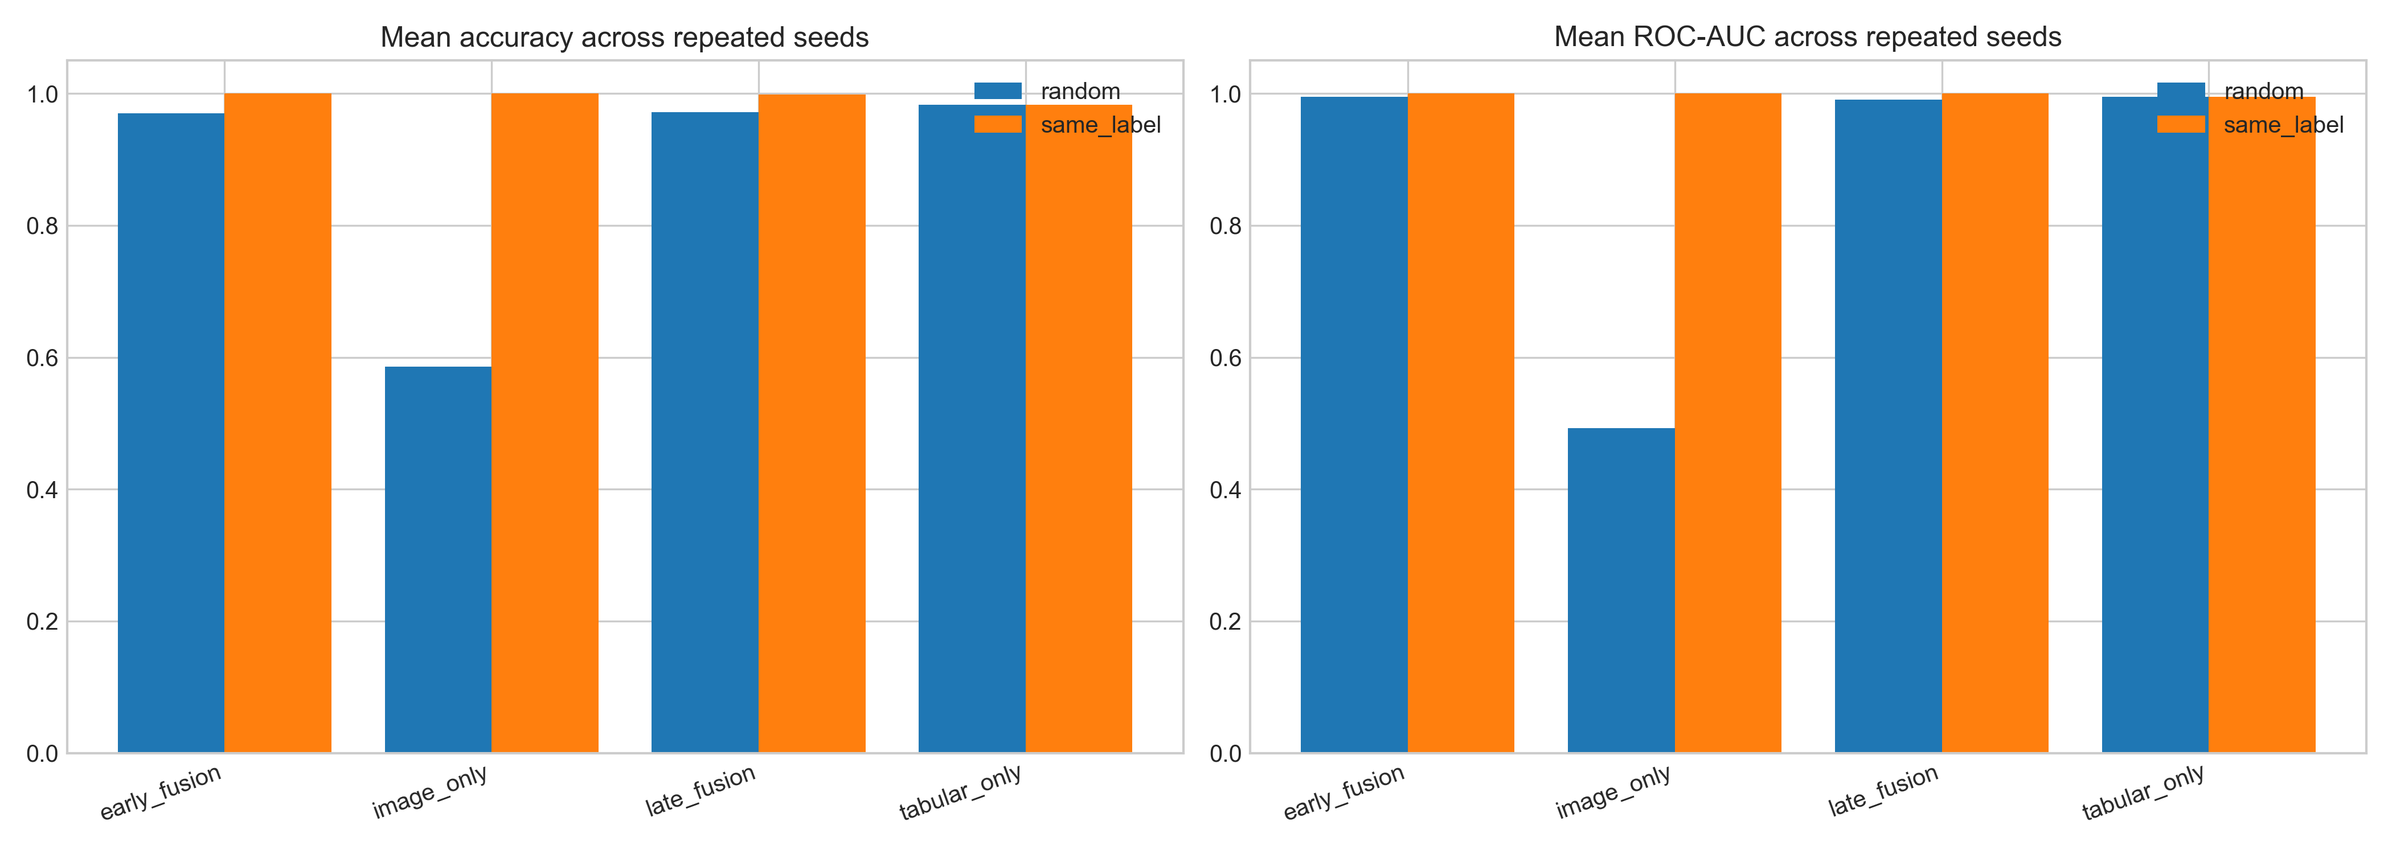
Figure 7: Synthetic fusion experiment comparison across pairing and model families.
The most useful comparison is not same-label fusion versus random fusion in isolation, but fusion versus the unimodal baselines inside each pairing condition. In the random condition, tabular-only performance is already very high, while image-only performance is close to chance. This shows that fusion metrics can be dominated by the stronger modality.
This is why the report keeps both the same-label and random conditions in the main evaluation. Same-label pairing shows the upper-bound behaviour of an artificially aligned pipeline, while random pairing shows how fragile image evidence becomes when correspondence is removed. The contrast gives the fusion chapter its critical value.

4.6 Joint model comparison
The joint comparison table clarifies the hierarchy of evidence. The BreaKHis model is the main new image result. The Wisconsin branch is a frozen tabular comparator. The synthetic fusion experiments are exploratory only. This separation prevents the report from merging incompatible claims. BreaKHis patient-level accuracy of 0.769 is a real corrected image-model result within this project. Wisconsin accuracy of 0.96 is a strong branch result from the protected tabular workflow. Same-label fusion accuracy of 1.000 is an artificial pairing result and cannot be ranked as a clinical model above the others.
The comparison also shows why multimodal claims require matched data. In a genuine multimodal dataset, improvements could indicate that the modalities provide complementary patient information. In this project, the modalities are independent. The model can learn patterns associated with benign or malignant labels in each dataset, but it cannot learn how a particular patient's histopathology corresponds to that patient's tabular measurements. That missing correspondence is the core limitation.
The practical value of the joint comparison is that it turns a potential weakness into an explicit conclusion. The project does not hide the synthetic design; it uses controls to show what the design can and cannot support. This is aligned with recent evaluation literature warning that multimodal AI in diagnostics needs careful assessment of data alignment and applicability (Kaczmarczyk et al., 2024; Moons et al., 2025).

Joint model comparison summary
Family: monomodel; Model: BreaKHis patient-level model; Accuracy: 0.769; ROC-AUC: 0.889; Status: main new image result
Family: monomodel; Model: Wisconsin published branch; Accuracy: 0.960; ROC-AUC: 0.997; Status: published branch
Family: synthetic_fusion; Model: random | early_fusion; Accuracy: 0.970; ROC-AUC: 0.995; Status: exploratory only
Family: synthetic_fusion; Model: random | late_fusion; Accuracy: 0.972; ROC-AUC: 0.990; Status: exploratory only
Family: synthetic_fusion; Model: same_label | early_fusion; Accuracy: 1.000; ROC-AUC: 1.000; Status: exploratory only

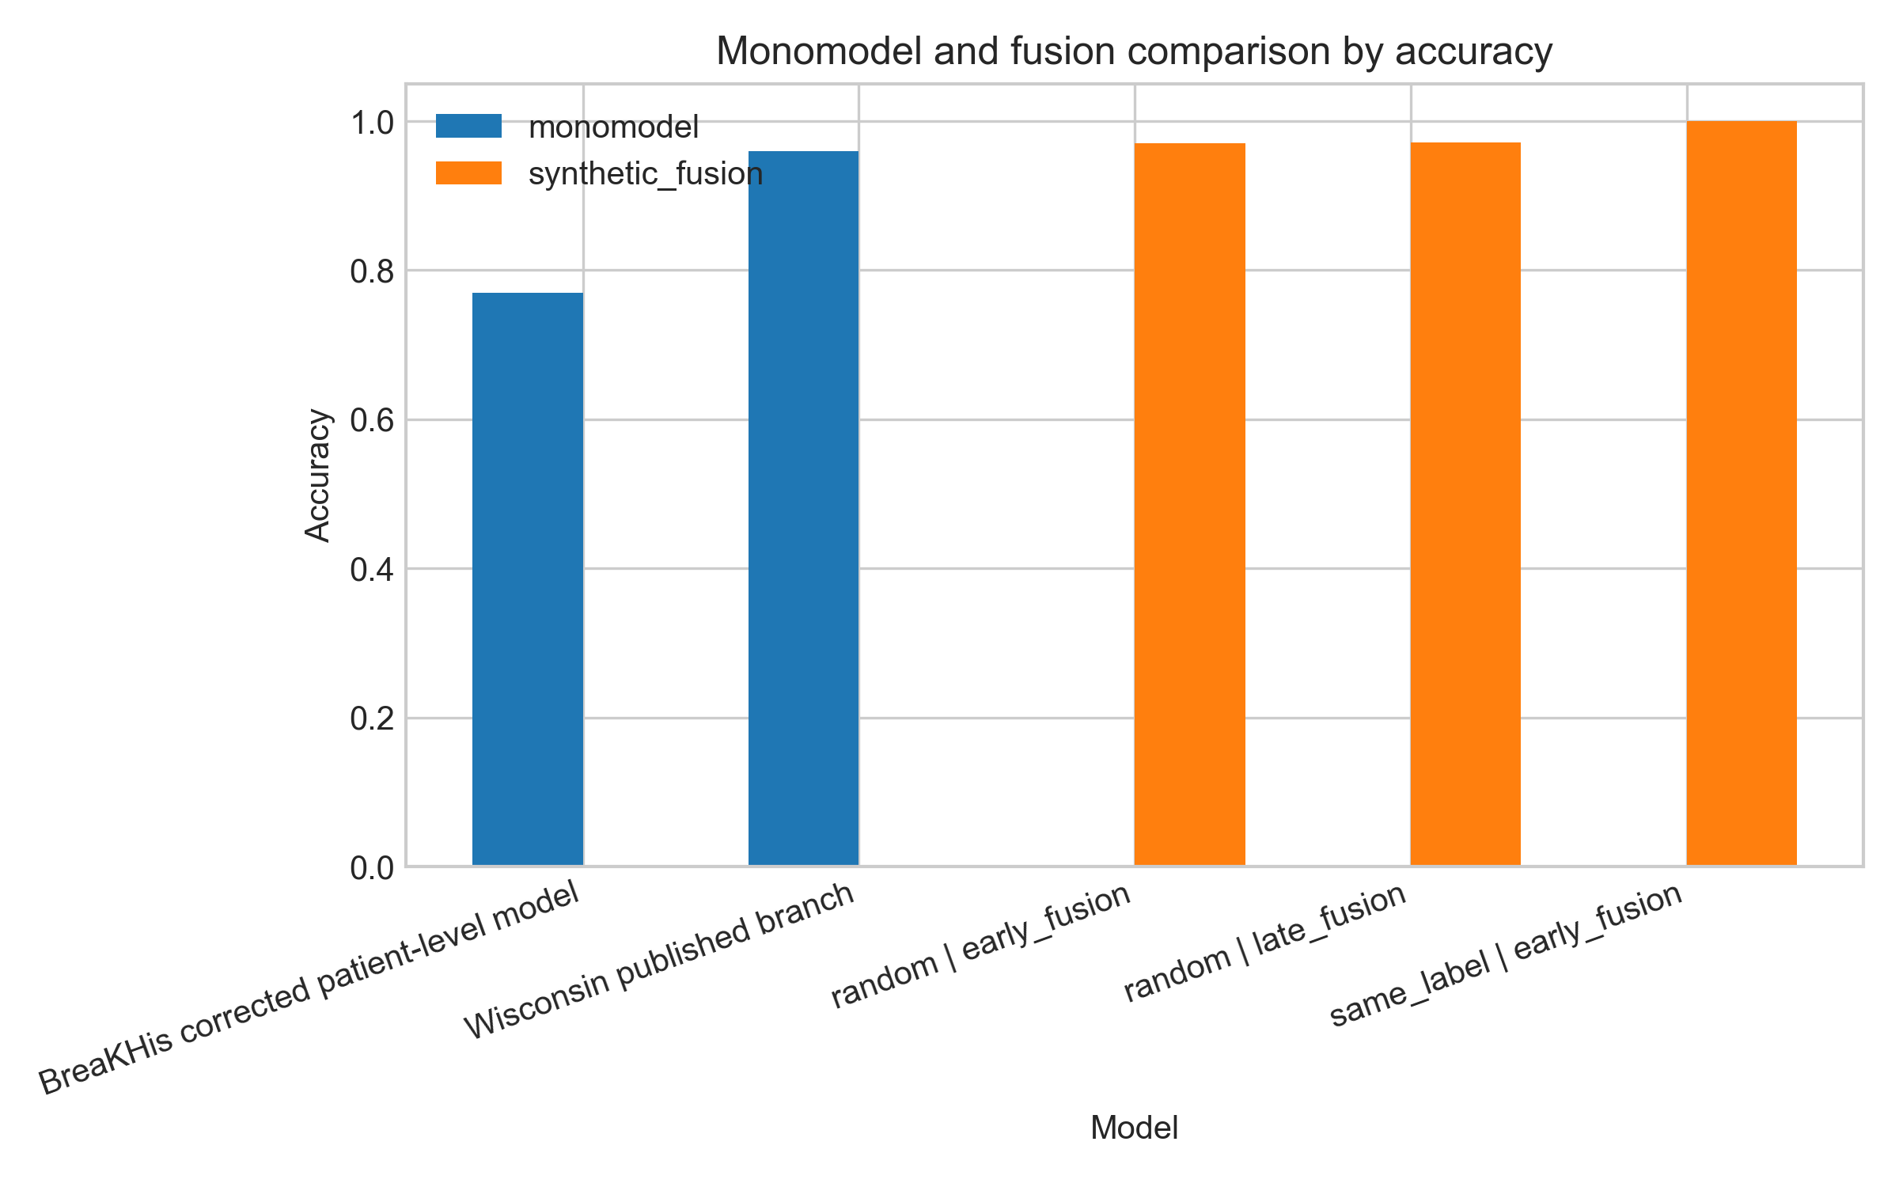
Figure 8: Joint model accuracy comparison across unimodal and exploratory fusion results.
This separation also helps answer the dissertation's research questions without contradiction. The image branch demonstrates patient-level modelling, the tabular branch demonstrates a strong protected comparator, and the fusion branch demonstrates how synthetic pairing behaves. They are connected parts of one project, but they do not carry the same evidential status.

4.7 Discussion against literature
The findings are consistent with the literature in three ways. First, they confirm that histopathology image classification is feasible but sensitive to evaluation design. BreaKHis has been used by many high-performing studies, including attention, multiscale, transfer-learning and hybrid approaches (Aldakhil, Alhasson and Alharbi, 2024; Islam et al., 2024; Wang et al., 2024). This dissertation did not attempt to beat those methods. Its contribution is the corrected patient-level workflow and honest reporting under local constraints.
Second, the results confirm that WDBC-style tabular classification can be very strong. Engineered nuclear features are informative, and recent machine-learning studies continue to report high performance on breast cancer tabular datasets (Aamir et al., 2022; Saharan et al., 2025). The dissertation uses that strength responsibly by treating the Wisconsin branch as a comparator rather than claiming that it validates BreaKHis or fusion performance.
Third, the fusion results confirm the promise and risk of multimodal AI. Multimodal fusion can be powerful when data are matched, complementary and well validated (Li et al., 2025; Jandoubi and Akhloufi, 2025). The synthetic experiment shows that a fusion pipeline can produce impressive scores even when correspondence is artificial. That does not discredit multimodal AI. It shows why rigorous pairing, controls and clinical context are necessary before strong claims are made.
The project also agrees with reporting-guideline literature. A strong medical-AI report should describe data partitions, model inputs, outcome definitions and applicability limits (Tejani et al., 2024; Collins et al., 2024). The dissertation does this by foregrounding patient-level splitting and by separating corrected, frozen and exploratory evidence.

4.8 Limitations
The main limitation is that the tabular and image datasets are independent. No patient-level correspondence exists between Wisconsin and BreaKHis records. Pairing is artificial and based only on class labels. Observed fusion performance does not imply real clinical multimodal validity. This limitation is fundamental and cannot be fixed by more complex models or more attractive figures. It requires different data: a matched dataset containing both modalities for the same patients.
The second limitation is dataset size at patient level. Although BreaKHis contains thousands of images, the split contains a much smaller number of independent patients. This increases uncertainty around generalisation. The test set contains 13 patients, which is enough for a dissertation experiment but not enough for clinical claims. A stronger study would use external validation, more patients, and possibly cross-institutional data.
The third limitation is model simplicity. ResNet18 and logistic fusion baselines are interpretable and feasible, but they do not represent the full state of the art. Vision transformers, pathology-specific pretraining, colour normalisation studies, attention mechanisms and explainability tools could improve or better explain performance (Baroni et al., 2024; Azad et al., 2024; Selvaraju et al., 2017). The final limitation is calibration. The image model's ECE indicates that probability outputs require caution. The demo interface should therefore avoid presenting probabilities as clinical certainty.
A further limitation is that the web app can make exploratory results look more complete than they are. Any final demonstration should keep the non-clinical wording close to the prediction outputs and should avoid language such as diagnosis, screening recommendation or clinical decision.
These limits do not undermine the project; they define its correct scope. The dissertation presents synthetic fusion as a controlled prototype for thinking about multimodal design, not as a substitute for matched clinical data.

4.9 Evaluation conclusion
The evaluation supports a balanced answer to the research questions. The project successfully prepared two defensible unimodal branches, produced a patient-level image baseline, preserved the Wisconsin tabular comparator, implemented synthetic pair construction, and compared early and late fusion under same-label and random controls. The results show that synthetic fusion can produce very high metrics, but the controls show why those metrics must be interpreted as exploratory.
The strongest technical finding is the leakage correction. The strongest modelling result is the Wisconsin tabular comparator. The most important methodological finding is that same-label synthetic fusion can be useful as an engineering test but cannot validate clinical multimodal performance. The web app and inference artefacts improve communication and reuse, but they do not change the evidential status of the models. Overall, the project demonstrates disciplined applied ML work: it builds, tests, explains and limits its claims.
The workflow is technically coherent and evidence-based, but the synthetic fusion branch remains a methodological test. That balance is the main academic value of the project.

4.10 Broader evaluation of validity and reliability
The project improves internal validity by random pairing as a control for synthetic fusion. Repeated seeds improve reliability by reducing dependence on one random pairing sample. These choices make the engineering conclusions credible, but they do not create clinical validity.
External validity remains limited. BreaKHis is one public histopathology dataset, the patient-level test set is small, and the Wisconsin branch is a clean benchmark rather than messy clinical deployment data. Most importantly, the synthetic fusion branch lacks true patient correspondence. A same-label fusion model may perform well while still failing to represent actual multimodal diagnosis.
The web app and figures improve communication, but they also risk overconfidence if users see predictions without limitations. The safest interpretation is that the app demonstrates model behaviour and evidence flow, not clinical decision support (Vasey et al., 2022).

Chapter 5: Conclusions

5.1 Main findings
This dissertation investigated synthetic label-aligned multimodal fusion for breast cancer classification under data scarcity. It is built on two independent datasets: BreaKHis histopathology images and Wisconsin tabular diagnostic features. The project corrected a major evaluation problem in the BreaKHis branch by replacing image-level splitting with patient-level splitting. The corrected split removed patient overlap and produced a more trustworthy image baseline. The final BreaKHis patient-level model achieved accuracy of 0.769 and ROC-AUC of 0.889, with calibration limitations that were reported rather than hidden.
The Wisconsin branch was preserved as a frozen tabular comparator and reported stronger metrics, with accuracy of 0.96 and ROC-AUC of 0.997. Synthetic same-label fusion produced near-perfect results, but random-pairing controls and unimodal baselines showed that these results should not be interpreted as clinical multimodal validation. The central conclusion is therefore methodological: synthetic label-aligned pairing can help test fusion workflows, but it cannot replace real matched multimodal data.

5.2 Answers to the research questions
RQ1 asked how independent BreaKHis and Wisconsin data could be prepared as defensible unimodal baselines. The answer is to keep their provenance separate, preserve the Wisconsin branch as a read-only comparator, and build BreaKHis around patient-level evaluation. RQ2 asked how patient-level splitting affects BreaKHis reliability. The answer is that it removes leakage and makes the result lower but more meaningful. RQ3 asked how unimodal and fusion models compare. The answer is that tabular-only performance is strong, corrected image-only performance is moderate, same-label fusion is artificially excellent, and random controls reveal tabular dominance. RQ4 asked what prevents synthetic pairing from being clinically valid. The answer is the absence of patient-level correspondence between modalities.
These answers show that the project succeeded because it did not chase the largest possible metric. It built an explanation of why some results are trustworthy, why others are exploratory, and where the evidence stops.
The answers are therefore deliberately cautious. The dissertation supports a workflow for responsible exploration under data scarcity, not a claim that synthetic multimodal learning is clinically effective. That distinction is the main defence of the project.

5.3 Recommendations and future work
Future work should start with real matched multimodal data. A stronger study would collect or obtain records where each patient has histopathology images and corresponding tabular or clinical measurements. That would allow a genuine test of whether modalities complement each other. The next step would be external validation across institutions, improved calibration, explainability through methods such as Grad-CAM, and comparison with more advanced image architectures such as DenseNet, attention models or vision transformers.
For the current project artefacts, the recommendation is to keep the web app clearly labelled as non-clinical and exploratory. The tabular and image demos can be useful for explaining model behaviour, but the fusion demo must keep the synthetic-pairing disclaimer visible. The final academic value of the dissertation is not that it produced a clinical model, but that it demonstrates careful data handling, responsible evaluation and honest interpretation in a constrained medical-AI project.
Future work should also improve reporting automation. A reproducible pipeline that regenerates figures, tables and model cards from the same outputs would reduce manual reporting risk. This would make later clinical or external-validation work easier to audit.

5.4 Closing conclusion
The project began with an attractive idea: combine image and tabular breast cancer evidence into a multimodal classifier. The final dissertation shows why that idea is technically possible but scientifically delicate. Without matched patients, fusion is an exploratory exercise. With leakage, image metrics are unreliable. With weak calibration, probabilities require caution. Addressing those issues made the dissertation stronger, because the final report explains not only what was built but what can be believed.
The main contribution is therefore a responsible applied-computing workflow for breast cancer AI under data scarcity. It includes a BreaKHis image pipeline, a preserved Wisconsin comparator, controlled synthetic pairing, early and late fusion experiments, web-app transfer artefacts, and a written evaluation that keeps clinical claims within the evidence.
That boundary is important for academic integrity. The final model evidence is useful because it is specific, traceable and limited, not because it claims more than the data can support.

5.5 Reflective learning and dissertation closure
The project shifted from simply building a multimodal classifier to deciding what could honestly be claimed. The discovery of BreaKHis leakage and the absence of matched multimodal patients made the methodology stronger, because the final work separates corrected image evidence, protected tabular comparison and exploratory synthetic fusion.
The main learning is that medical-domain computer science requires restraint as well as implementation skill. A lower leakage-free result can be more valuable than a high contaminated score. The study closes as a responsible applied-AI workflow under data scarcity, not as a clinical diagnostic claim.

Bibliography
Aamir, S. et al. (2022) 'Predicting breast cancer leveraging supervised machine learning techniques', Computational and Mathematical Methods in Medicine, DOI: 10.1155/2022/5869529.

Aldakhil, L., Alhasson, H. and Alharbi, S. (2024) 'Attention-based deep learning approach for breast cancer histopathological image multi-classification', Diagnostics, DOI: 10.3390/diagnostics14131402.

Arravalli, T. et al. (2025) 'Detection of breast cancer using machine learning and explainable artificial intelligence', Scientific Reports, DOI: 10.1038/s41598-025-12644-w.

Arshad Choudhry, I. et al. (2025) 'A novel interpretable graph convolutional neural network for multimodal brain tumor segmentation', Cognitive Computation, DOI: 10.1007/s12559-024-10387-w.

Azad, R. et al. (2024) 'Advances in medical image analysis with vision transformers: a comprehensive review', Medical Image Analysis, DOI: 10.1016/j.media.2023.103000.

Baroni, G. L. et al. (2024) 'Optimizing vision transformers for histopathology: pretraining and normalization in breast cancer classification', Journal of Imaging, DOI: 10.3390/jimaging10050108.

Chae, J. and Kim, J. (2023) 'An investigation of transfer learning approaches to overcome limited labeled data in medical image analysis', Applied Sciences, DOI: 10.3390/app13158671.

Chawla, N. V. et al. (2002) 'SMOTE: synthetic minority over-sampling technique', Journal of Artificial Intelligence Research, DOI: 10.1613/jair.953.

Collins, G. S. et al. (2024) 'TRIPOD+AI statement: updated guidance for reporting clinical prediction models that use regression or machine learning methods', BMJ, DOI: 10.1136/bmj-2023-078378.

Dimitri, G. M. (2022) 'A short survey on deep learning for multimodal integration: applications, future perspectives and challenges', Computers, DOI: 10.3390/computers11110163.

Han, H., Wang, W. Y. and Mao, B. H. (2005) 'Borderline-SMOTE: a new over-sampling method in imbalanced data sets learning', Lecture Notes in Computer Science, DOI: 10.1007/11538059_91.

Haq, I. et al. (2025) 'A review of breast cancer histopathology image analysis with deep learning: challenges, innovations, and clinical integration', Image and Vision Computing, DOI: 10.1016/j.imavis.2025.105708.

He, K. et al. (2016) 'Deep residual learning for image recognition', 2016 IEEE Conference on Computer Vision and Pattern Recognition (CVPR), DOI: 10.1109/cvpr.2016.90.

Iqbal, S. and Qureshi, A. N. (2022) 'A heteromorphous deep CNN framework for medical image segmentation using local binary pattern', IEEE Access, DOI: 10.1109/access.2022.3183331.

Iqbal, S. et al. (2022) 'Improving the robustness and quality of biomedical CNN models through adaptive hyperparameter tuning', Applied Sciences, DOI: 10.3390/app122211870.

Iqbal, S. et al. (2023) 'Dynamic learning for imbalanced data in learning chest X-ray and CT images', Heliyon, DOI: 10.1016/j.heliyon.2023.e16807.

Iqbal, S. et al. (2023) 'Fusion of textural and visual information for medical image modality retrieval using deep learning-based feature engineering', IEEE Access, DOI: 10.1109/access.2023.3310245.

Iqbal, S. et al. (2023) 'On the analyses of medical images using traditional machine learning techniques and convolutional neural networks', Archives of Computational Methods in Engineering, DOI: 10.1007/s11831-023-09899-9.

Iqbal, S. et al. (2024) 'AD-CAM: enhancing interpretability of convolutional neural networks with a lightweight framework - from black box to glass box', IEEE Journal of Biomedical and Health Informatics, DOI: 10.1109/jbhi.2023.3329231.

Iqbal, S. et al. (2024) 'Hybrid deep spatial and statistical feature fusion for accurate MRI brain tumor classification', Frontiers in Computational Neuroscience, DOI: 10.3389/fncom.2024.1423051.

Islam, N. et al. (2024) 'Fusing global context with multiscale context for enhanced breast cancer classification', Scientific Reports, DOI: 10.1038/s41598-024-78363-w.

Islam, T. et al. (2024) 'A systematic review of deep learning data augmentation in medical imaging: recent advances and future research directions', Healthcare Analytics, DOI: 10.1016/j.health.2024.100340.

Jandoubi, B. and Akhloufi, M. A. (2025) 'Multimodal artificial intelligence in medical diagnostics', Information, DOI: 10.3390/info16070591.

Javaeed, A. and Schuh, A. (2025) 'Artificial intelligence in breast cancer diagnosis: a systematic literature review', Cambridge Prisms: Precision Medicine, DOI: 10.1017/pcm.2025.10006.

Jiang, B. et al. (2024) 'Deep learning applications in breast cancer histopathological imaging: diagnosis, treatment, and prognosis', Breast Cancer Research, DOI: 10.1186/s13058-024-01895-6.

Kaczmarczyk, R. et al. (2024) 'Evaluating multimodal AI in medical diagnostics', npj Digital Medicine, DOI: 10.1038/s41746-024-01208-3.

Kapoor, S. and Narayanan, A. (2023) 'Leakage and the reproducibility crisis in machine-learning-based science', Patterns, DOI: 10.1016/j.patter.2023.100804.

Karimi, D. and Gholipour, A. (2023) 'Improving calibration and out-of-distribution detection in deep models for medical image segmentation', IEEE Transactions on Artificial Intelligence, DOI: 10.1109/tai.2022.3159510.

Kim, H. E. et al. (2022) 'Transfer learning for medical image classification: a literature review', BMC Medical Imaging, DOI: 10.1186/s12880-022-00793-7.

Kora, P. et al. (2022) 'Transfer learning techniques for medical image analysis: a review', Biocybernetics and Biomedical Engineering, DOI: 10.1016/j.bbe.2021.11.004.

Li, Y. et al. (2025) 'Application of deep learning-based multimodal fusion technology in cancer diagnosis: a survey', Engineering Applications of Artificial Intelligence, DOI: 10.1016/j.engappai.2024.109972.

Liu, M. et al. (2022) 'A deep learning method for breast cancer classification in the pathology images', IEEE Journal of Biomedical and Health Informatics, DOI: 10.1109/jbhi.2022.3187765.

Matsoukas, C. et al. (2022) 'What makes transfer learning work for medical images: feature reuse and other factors', 2022 IEEE/CVF Conference on Computer Vision and Pattern Recognition (CVPR), DOI: 10.1109/cvpr52688.2022.00901.

Moons, K. G. M. et al. (2025) 'PROBAST+AI: an updated quality, risk of bias, and applicability assessment tool for prediction models using regression or artificial intelligence methods', BMJ, DOI: 10.1136/bmj-2024-082505.

Nassif, A. B. et al. (2022) 'Breast cancer detection using artificial intelligence techniques: a systematic literature review', Artificial Intelligence in Medicine, DOI: 10.1016/j.artmed.2022.102276.

Pei, X. et al. (2023) 'A review of the application of multi-modal deep learning in medicine: bibliometrics and future directions', International Journal of Computational Intelligence Systems, DOI: 10.1007/s44196-023-00225-6.

Potsangbam, J. and Shuleenda Devi, S. (2024) 'Classification of breast cancer histopathological images using transfer learning with DenseNet121', Procedia Computer Science, DOI: 10.1016/j.procs.2024.04.188.

Priya C V, L. et al. (2024) 'Deep learning approaches for breast cancer detection in histopathology images: a review', Cancer Biomarkers, DOI: 10.3233/cbm-230251.

Qiu, S. et al. (2022) 'Multimodal deep learning for Alzheimer’s disease dementia assessment', Nature Communications, DOI: 10.1038/s41467-022-31037-5.

Saharan, S. et al. (2025) 'A deep learning and explainable artificial intelligence based scheme for breast cancer detection', Scientific Reports, DOI: 10.1038/s41598-024-80535-7.

Salmi, M. et al. (2024) 'Handling imbalanced medical datasets: review of a decade of research', Artificial Intelligence Review, DOI: 10.1007/s10462-024-10884-2.

Sambyal, A. S. et al. (2023) 'Understanding calibration of deep neural networks for medical image classification', Computer Methods and Programs in Biomedicine, DOI: 10.1016/j.cmpb.2023.107816.

Selvaraju, R. R. et al. (2017) 'Grad-CAM: visual explanations from deep networks via gradient-based localization', 2017 IEEE International Conference on Computer Vision (ICCV), DOI: 10.1109/iccv.2017.74.

Sounderajah, V. et al. (2025) 'The STARD-AI reporting guideline for diagnostic accuracy studies using artificial intelligence', Nature Medicine, DOI: 10.1038/s41591-025-03953-8.

Spanhol, F. A. et al. (2016) 'A dataset for breast cancer histopathological image classification', IEEE Transactions on Biomedical Engineering, DOI: 10.1109/tbme.2015.2496264.

Street, W. N., Wolberg, W. H. and Mangasarian, O. L. (1993) 'Nuclear feature extraction for breast tumor diagnosis', SPIE Proceedings, DOI: 10.1117/12.148698.

Tejani, A. S. et al. (2024) 'Checklist for artificial intelligence in medical imaging (CLAIM): 2024 update', Radiology: Artificial Intelligence, DOI: 10.1148/ryai.240300.

Vasey, B. et al. (2022) 'Reporting guideline for the early stage clinical evaluation of decision support systems driven by artificial intelligence: DECIDE-AI', BMJ, DOI: 10.1136/bmj-2022-070904.

Wang, G. et al. (2024) 'Multi-classification of breast cancer pathology images based on a two-stage hybrid network', Journal of Cancer Research and Clinical Oncology, DOI: 10.1007/s00432-024-06002-y.

Wolberg, W., Mangasarian, O., Street, N. and Street, W. (1993) 'Breast cancer Wisconsin (Diagnostic)' [Dataset]. UCI Machine Learning Repository. DOI: 10.24432/C5DW2B. Available at: https://archive.ics.uci.edu/dataset/17/breast-cancer-wisconsin-diagnostic.

Yang, Y., Khorshidi, H. A. and Aickelin, U. (2024) 'A review on over-sampling techniques in classification of multi-class imbalanced datasets: insights for medical problems', Frontiers in Digital Health, DOI: 10.3389/fdgth.2024.1430245.

Zhao, Y. et al. (2022) 'Application of deep learning in histopathology images of breast cancer: a review', Micromachines, DOI: 10.3390/mi13122197.

Zhou, Y. et al. (2025) 'ResViT-GANNet: a deep learning framework for classifying breast cancer histopathology images using multimodal attention and GAN-based augmentation', BMC Medical Imaging, DOI: 10.1186/s12880-025-01940-6.

Zou, K. et al. (2023) 'A review of uncertainty estimation and its application in medical imaging', Meta-Radiology, DOI: 10.1016/j.metrad.2023.100003.

Appendices

Appendix A: Project Artefact Map

Project artefact map
Artefact group: Current notebooks; Location: dissertation_project/notebooks/; Purpose: Executed research workflow and embedded outputs.
Artefact group: Reusable source modules; Location: dissertation_project/src/; Purpose: BreaKHis, image pipeline, fusion, metrics, pairing and inference logic.
Artefact group: Figures; Location: dissertation_project/outputs/figures/; Purpose: Figures used in the report and supporting analysis.
Artefact group: Metrics; Location: dissertation_project/outputs /metrics/; Purpose: CSV metrics for BreaKHis and synthetic fusion.
Artefact group: Reports; Location: dissertation_project/outputs /reports/; Purpose: Split summaries, pairing outputs, claims and integration notes.
Artefact group: Web app; Location: webapp/frontend and webapp/api; Purpose: Demo interface and inference service.

Appendix B: Ethics and Data Handling
The project uses public or locally supplied academic datasets and does not collect new primary patient data. The report avoids direct personal identifiers and treats all outputs as academic research evidence only. No model in the project should be used for clinical diagnosis.

Ethics Approval Certificate
The ethics approval certificate is included below as supporting evidence.
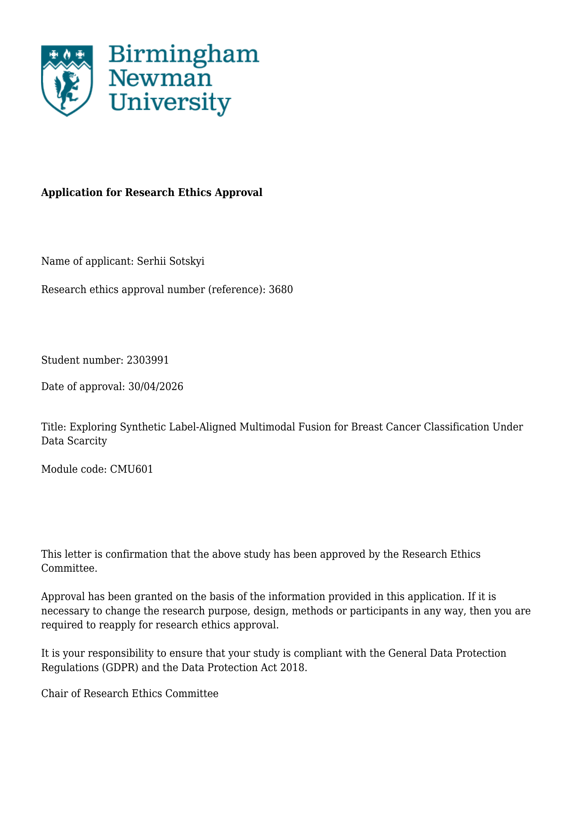
Ethics approval certificate, page 1.

Appendix C: Usage of Generative AI Tools
Generative AI tools were used as a supporting aid during the project, mainly for web application development, technical troubleshooting, organisation of research notes, and exploration of relevant background concepts. They were not used as academic sources and were not relied on to replace independent research, experimentation, analysis, or decision-making.

Appendix D: Supporting Project Evidence
Local project evidence: dissertation_project/notebooks/01_scope_and_research_questions.ipynb to 12_demo_preset_generation.ipynb.
Local project evidence: dissertation_project/outputs metrics, figures and reports generated during the implemented workflow.
Local project evidence: dissertation_project/src modules for BreaKHis processing, image training, metrics, pairing, fusion and inference.
The deployed web application is available at: https://dissertation-nu.vercel.app/. The deployed API service is available at: https://dissertation-production-fce9.up.railway.app/. The local implementation files are stored in webapp/frontend/ and webapp/api/.

Appendix E: Literature Review
The literature review examined breast cancer classification, histopathology image analysis, tabular diagnostic data, transfer learning, data imbalance, leakage, multimodal fusion and responsible medical AI evaluation. It helped justify the use of patient-level splitting, cautious interpretation of model performance, and the treatment of synthetic label-aligned fusion as exploratory rather than clinical evidence.

Appendix F: Data Sets
The project used two datasets: BreaKHis histopathology images and the Breast Cancer Wisconsin Diagnostic tabular dataset. BreaKHis supported the image-classification branch and required patient-level splitting to avoid leakage, while the Wisconsin dataset supported the tabular comparator and synthetic fusion experiments. Because the datasets did not contain matched patients, fusion results were interpreted as exploratory.

