Personal Contribution: Movement Detection TinyML
Standalone IoT Report Section for Joel Shore
Contribution focus: I developed and integrated the movement-recognition stage of the demo. This stage uses IMU data from the Arduino Nano 33 BLE Sense to classify pick-handling movements after the voice and colour authentication gates have succeeded.

Field | Detail
Student | Joel Shore
Component | Movement detection TinyML model and firmware integration
Edge Impulse project | Movement model 928825
Target hardware | Arduino Nano 33 BLE Sense / nRF52840 Cortex-M4F
Report date | 29 April 2026

1. Aim and Role in the IoT Workflow
My contribution was the TinyML movement-recognition stage used at the end of the group IoT workflow. The full demo only begins movement tracking after the operator says "Start" and the colour sensor confirms a green package tag. Once those gates are complete, my model interprets inertial movement from the board and sends the dashboard a live handling direction.
The movement stage matters because it turns raw accelerometer and gyroscope readings into a simple operational signal that can be shown to a warehouse operator. In the final dashboard this appears as the handling-motion step and a movement-confidence chart, while the bridge forwards the classified JSON events to the web API.

2. Dataset Construction and Expansion
I collected a labelled movement dataset for five classes: down, idle, left, right, and up. The first dataset was deliberately small, with about thirty examples per movement, so that I could validate the capture workflow and quickly compare basic model designs. The final dataset was expanded to 19 minutes and 17 seconds of IMU data, split into 287 training windows and 95 held-out test windows using a 76/24 train-test split.
The extra data was important because left, right, and down movements were easy to confuse when the model only saw a small number of examples. Expanding the dataset gave the classifier more varied movement windows and made the final accuracy numbers more representative of the physical demo.
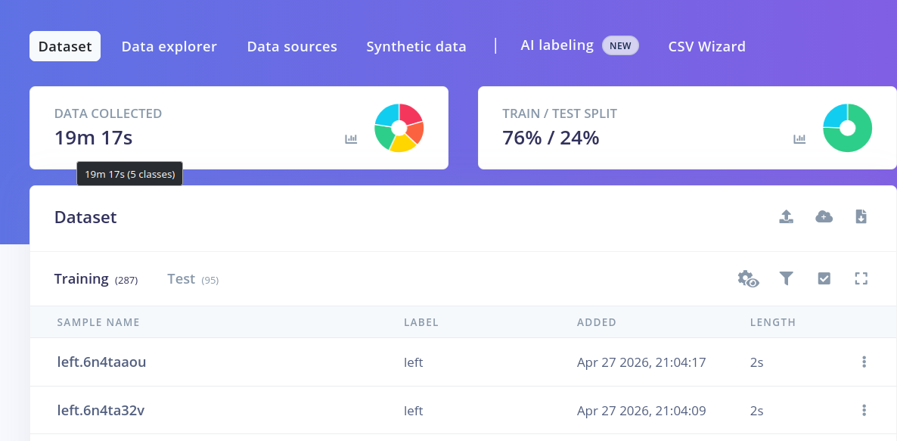
Figure J1. Final Edge Impulse data collection view showing the expanded movement dataset.

3. Model Experiments and Baselines
I did not use the first working model as the final model. I compared four Edge Impulse configurations to understand which feature pipeline gave the best separation between movement classes. The main difference was whether the model used raw IMU axes, spectral features, and a flattening stage.

Model | Input / block design | Result | Decision
1 | Raw accelerometer / gyroscope axes, no flatten block | About 54% accuracy | Baseline only; too much class confusion
2 | Flatten block with IMU input | About 54% accuracy | No meaningful improvement over the baseline
3 | Spectral analysis only | About 84% accuracy | Strong candidate; spectral features helped separate movement patterns
4 | Flatten block plus spectral features | 83.8% validation accuracy | Selected final model because it was accurate and suitable for embedded deployment

The weakest classifier reached only 54% accuracy, with a weighted F1 score of 0.55, precision of 0.63, and recall of 0.54. Its confusion matrix showed that left, right, and down were frequently mixed up. This confirmed that the raw or weakly processed IMU signal did not provide enough separation for reliable movement detection.
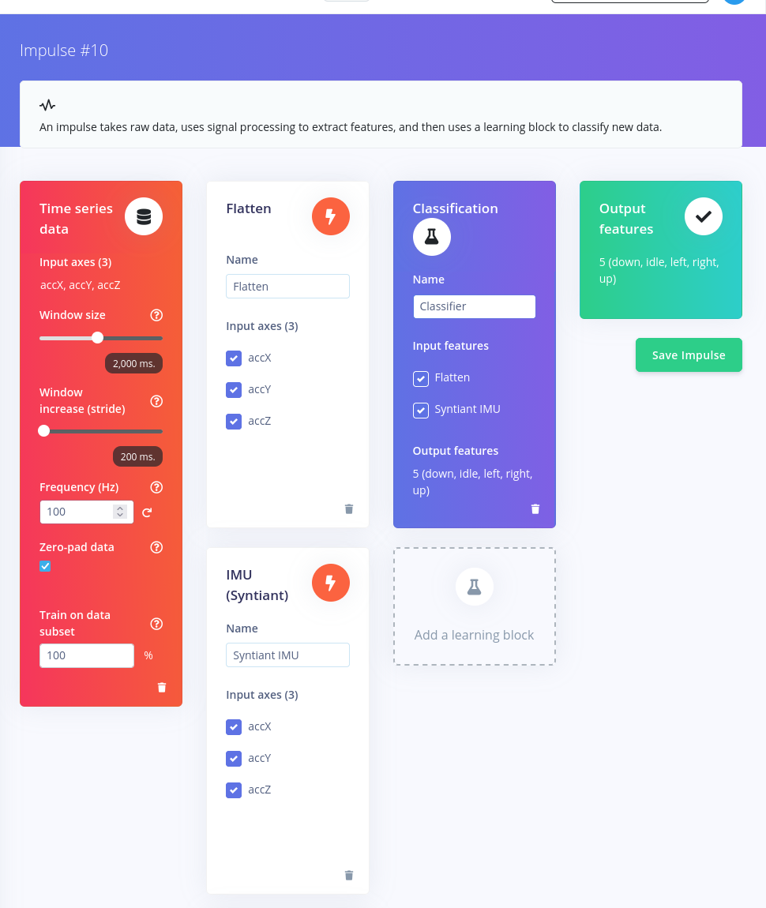
Figure J2. Low-rated Edge Impulse block design used as a movement baseline.
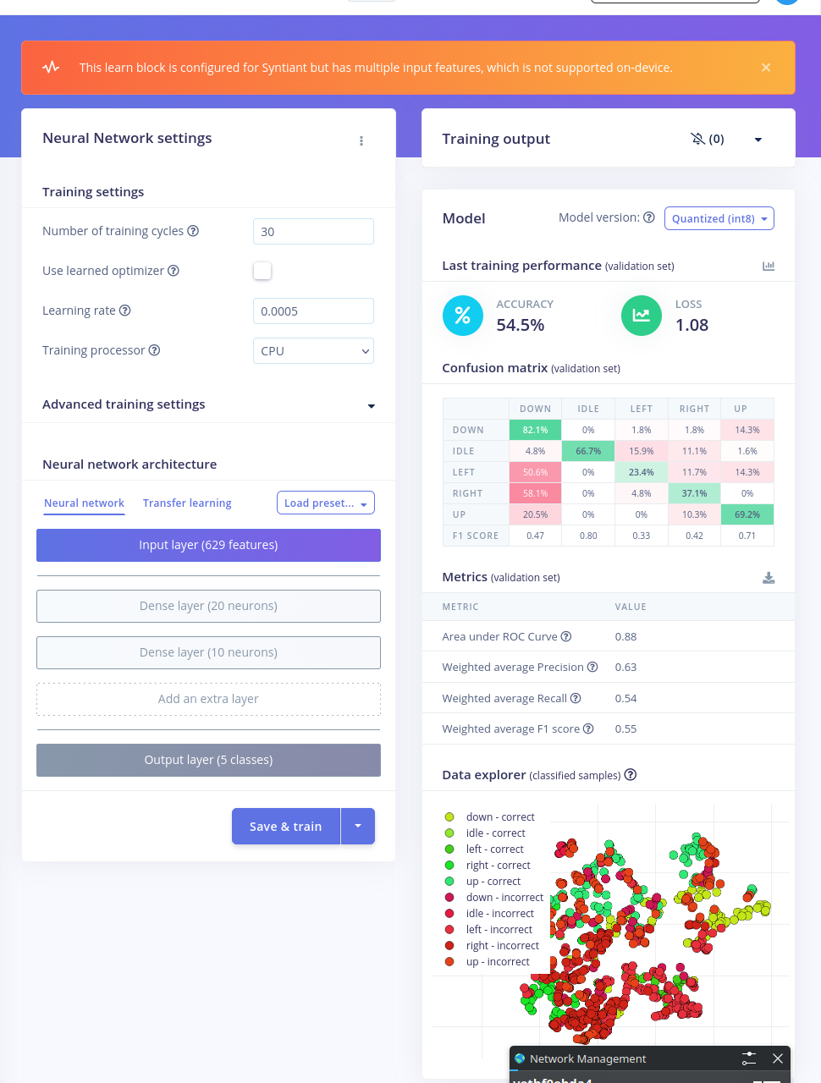
Figure J3. Low-rated classifier results showing weak class separation and low overall accuracy.

4. Final Model and Performance
The final model used a flattening step with spectral analysis. This made the classifier more sensitive to the shape and frequency content of the movement window, rather than treating each raw sensor axis independently. On the training and validation split, the selected model achieved 83.8% classifier accuracy with a loss of 0.43.
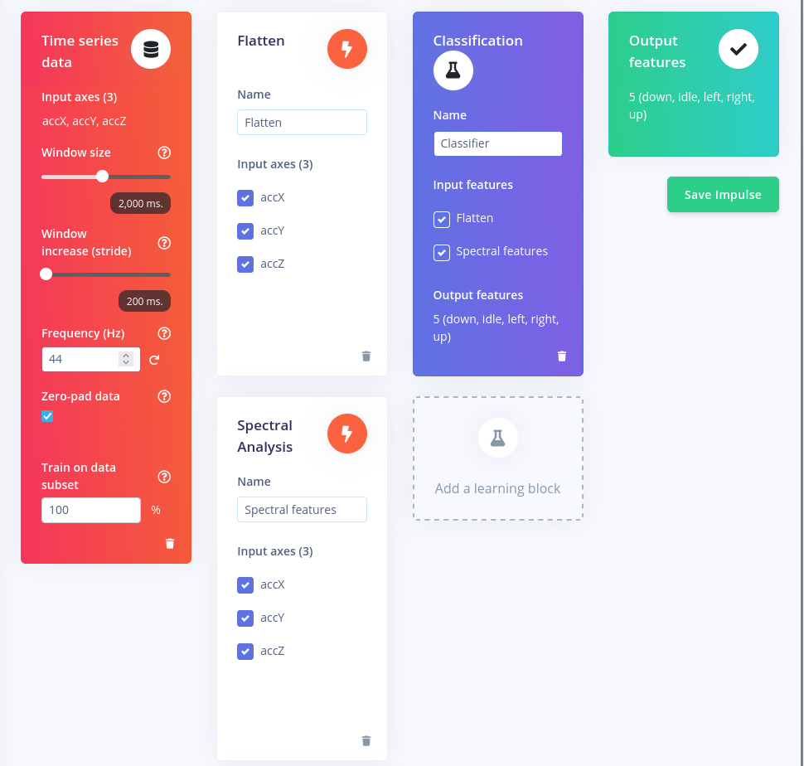
Figure J4. Final selected block design combining flattening and spectral analysis.
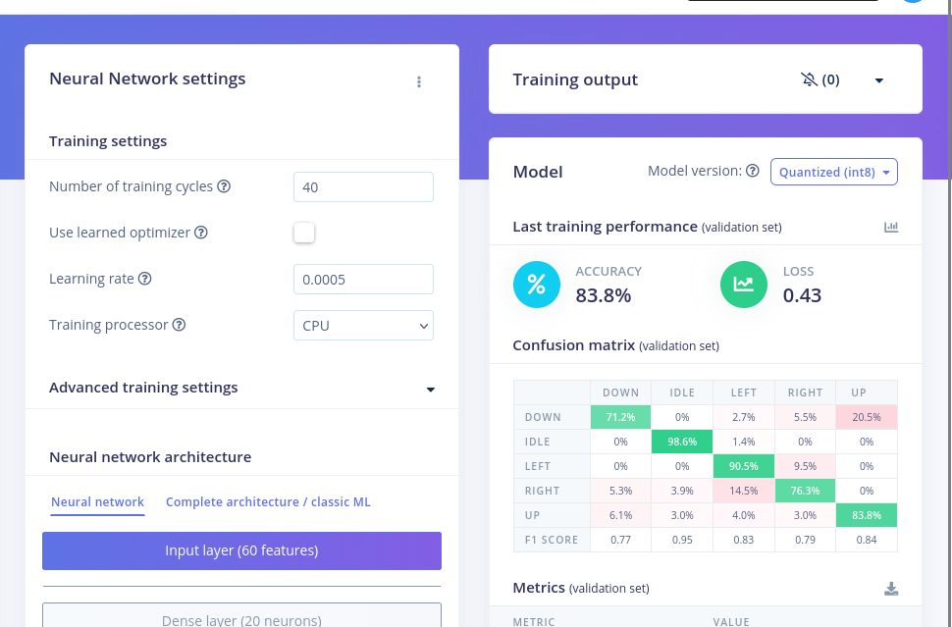
Figure J5. Final classifier performance view from Edge Impulse.
I then checked the model on the held-out test set. The test result was 73.36% accuracy, with weighted precision, recall, and F1 all reported as 0.83. This gap between validation and test accuracy shows that the model was useful for the demo but still limited by the size and variety of the coursework dataset.
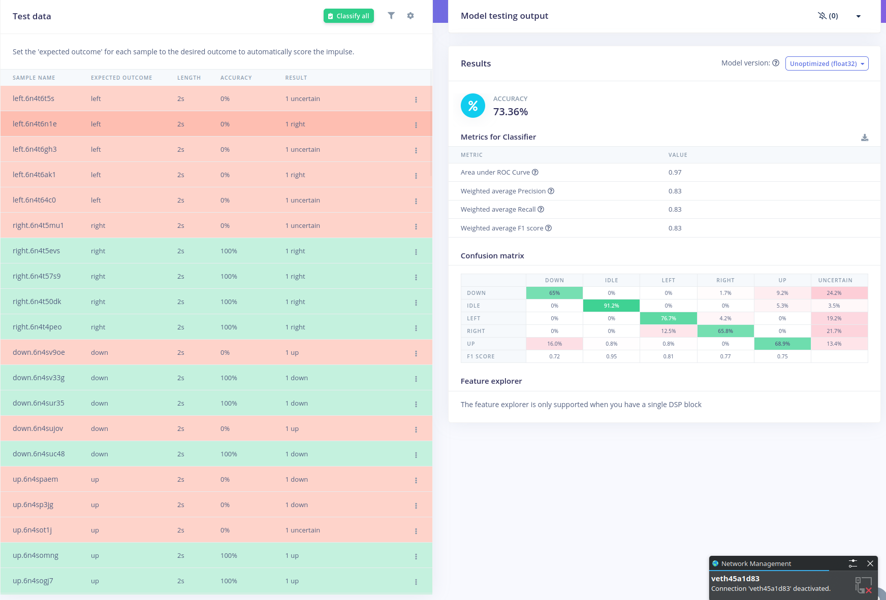
Figure J6. Held-out model-testing result for the selected movement classifier.
Class | F1 score | Interpretation
Down | 0.72 | Usable, but still one of the more confused movement classes
Idle | 0.95 | Strongest class because stationary windows are easier to separate
Left | 0.81 | Good performance after dataset expansion
Right | 0.77 | Acceptable, but close to left/down in some windows
Up | 0.75 | Acceptable for the demo, with room for more varied training data
Weighted average | 0.83 | Overall balanced performance across the test set

5. On-Device Suitability
The selected model was also practical for the Arduino target. Edge Impulse reported approximately 1 ms inference time, 1.4 KB peak RAM use, and 15.5 KB flash use for the quantised model. Those figures fit comfortably within the Nano 33 BLE Sense resources, so the movement classifier could run locally on the board instead of depending on cloud inference.
Running the model on-device is important for this IoT design because the board only needs to send compact JSON classifications over USB serial. The bridge and dashboard receive the movement result, confidence value, and raw IMU fields, but the actual TinyML inference remains local to the device.

6. Firmware Integration
For integration, I adapted the firmware to feed the movement model with 88 accelerometer samples at 44 Hz, giving a window of about two seconds. The original longer movement window was reduced so the dashboard could respond more quickly during manual testing. The firmware also converts accelerometer readings from g into m/s² before inference, matching the model input expected by the Edge Impulse export.
The sketch keeps a rolling movement buffer once the state machine reaches TRACKING_MOVEMENT. Each inference produces a movement class and confidence value, and the board emits JSON events such as movementClass and direction roughly every 250 ms. The Python bridge forwards those events to the dashboard, where they appear in the session timeline and movement-confidence chart.
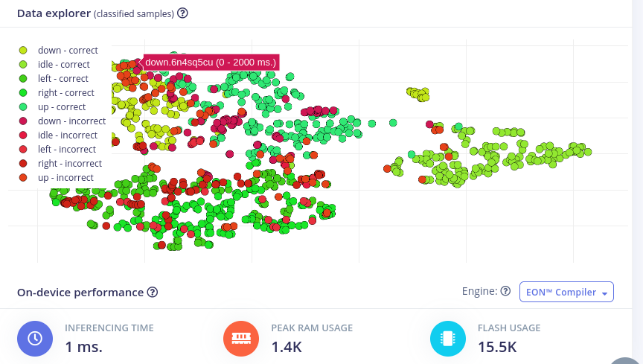
Figure J7. Edge Impulse data-explorer view used to inspect movement samples and class coverage.

7. Limitations and Future Work
The model is suitable for demonstrating the group system, but it should not be treated as a production-grade warehouse movement classifier. The dataset is still coursework-scale and was collected under limited physical conditions. Different users, speeds, board orientations, and mounting positions would probably reduce accuracy unless they were included in training.
The main future improvement would be to collect more examples from multiple operators and test sessions, especially for the left, right, up, and down classes. I would also add temporal smoothing or majority voting across consecutive predictions so that the dashboard only changes direction when the model is consistently confident.

References
- Arduino. (n.d.). Nano 33 BLE Sense documentation. https://docs.arduino.cc/hardware/nano-33-ble-sense/
- Edge Impulse. (n.d.). Running your impulse locally on Arduino. https://docs.edgeimpulse.com/docs/run-inference/arduino-library
- Google. (n.d.). LiteRT for Microcontrollers. https://ai.google.dev/edge/litert/microcontrollers/overview

