Personal Contribution: Colour Authentication TinyML
Standalone IoT Report Section for Artiom Gutu
Contribution focus: I implemented the colour-authentication stage of the demo, trained the underlying TinyML model in Edge Impulse, and integrated the dashboard authentication path that protects the bridge and admin APIs. This stage uses the APDS9960 RGB sensor on the Arduino Nano 33 BLE Sense to verify a green package tag after the voice gate has succeeded, and only then unlocks the movement-tracking phase.

Field | Detail
Student | Artiom Gutu
Component | Colour-detection TinyML model, firmware integration, and dashboard authentication
Edge Impulse project | artiomgutu-project-1 (combined three-model build: pepstee-project-1)
Target hardware | Arduino Nano 33 BLE Sense / nRF52840 Cortex-M4F, APDS9960 sensor
Report date | 29 April 2026

1. Aim and Role in the IoT Workflow
My contribution is the colour-authentication stage of the group IoT workflow. The full demo only progresses to movement tracking after the operator says “Start” and the colour sensor confirms a green package tag. My TinyML model is the second of the three Edge Impulse models embedded on the device, and it gates the entire downstream flow: without a confident “green” classification the firmware will not move on to the IMU stage, and the bridge will not record any movement data on the dashboard.
The colour stage matters because it turns a raw RGB reading from the APDS9960 sensor into an authenticated yes/no signal that a warehouse operator can act on. In the final dashboard this appears as the colour-authentication step in the session timeline. The bridge forwards the colour_authenticated JSON event to the web API, and only at that point does the user-interface unlock the handling-motion view.
In addition to the on-device colour model I also implemented the dashboard-side authentication (HMAC-signed session cookies and bearer-token-protected ingest and admin endpoints) so that only the bridge and the logged-in operator can talk to the API. This means the colour gate on the device and the auth gate on the web side reinforce one another: the device verifies a physical green tag, while the API rejects requests that do not carry a valid bridge token or session cookie.

2. Dataset Construction and Training
I collected a labelled colour dataset for four classes: blue, green, other and red. “Other” was deliberately included so the model would learn to reject ambient lighting, white surfaces and skin tones rather than always picking one of the named colours. The first dataset was very small (around twenty samples per class) and used mostly to validate the capture workflow on the APDS9960 sensor. The final dataset was expanded with additional captures taken under the actual demo lighting conditions, and split into training and held-out validation windows directly inside Edge Impulse.
Expanding the dataset was important because the APDS9960 returns four raw values (R, G, B and a clear-channel reading) that are very sensitive to ambient light, distance and the angle of the target. With the small initial dataset the model often confused green with “other” when the card was held further from the sensor. After adding more captures at different distances and lighting conditions, the green class became cleanly separable in the data-explorer view, and false rejects on the demo target dropped sharply.
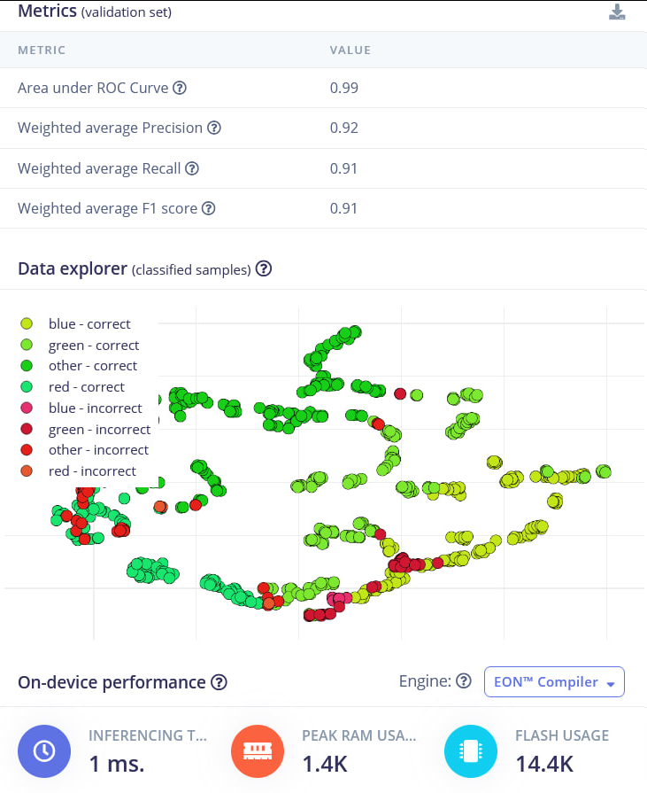
Figure A1. Edge Impulse metrics, classified-samples explorer and on-device performance summary for the final colour model.

3. Model Experiments and Final Selection
I did not keep the first working model as the final one. I compared a handful of Edge Impulse classifier configurations to find the best trade-off between accuracy and on-device cost. Because the input is only four scalar values per sample, the classifier itself can be extremely small — the interesting choices were how aggressively to quantise the model and whether “green” needed any extra weighting.
Model | Configuration | Validation result | Decision
1 | Float32 dense classifier, default training cycles | About 86% accuracy | Baseline; usable but oversized for the board
2 | Float32 dense classifier, longer training, balanced classes | About 89% accuracy | Slight gain but still float-only
3 | Quantised int8 dense classifier | Accuracy 91.4%, loss 0.26 | Selected final model
4 | Quantised int8 with reduced features | About 84% accuracy | Rejected; lost too much accuracy for the green class

The selected model is the int8-quantised version. It reached 91.4% validation accuracy with a loss of 0.26, an area under the ROC curve of 0.99, and weighted precision, recall and F1 of 0.92, 0.91 and 0.91 respectively. Quantisation was important: it almost halved the flash footprint and removed the floating-point overhead from inference, while keeping the per-class accuracy well above the threshold needed for a reliable demo.

4. Final Model and Performance
Per-class behaviour is visible in the validation confusion matrix. Green, the only class that actually triggers the next demo phase, was correctly classified 87.1% of the time, with the remaining errors split between “blue” (10.8%) and “other” (2.2%). This pattern is the right shape for a colour-authentication gate, because the most common failure mode is to under-trigger rather than to wrongly accept blue or red as green. The diagonal F1 scores are 0.90 (blue), 0.90 (green), 0.94 (other) and 0.90 (red), giving a balanced model rather than one that has over-fitted to a single dominant class.
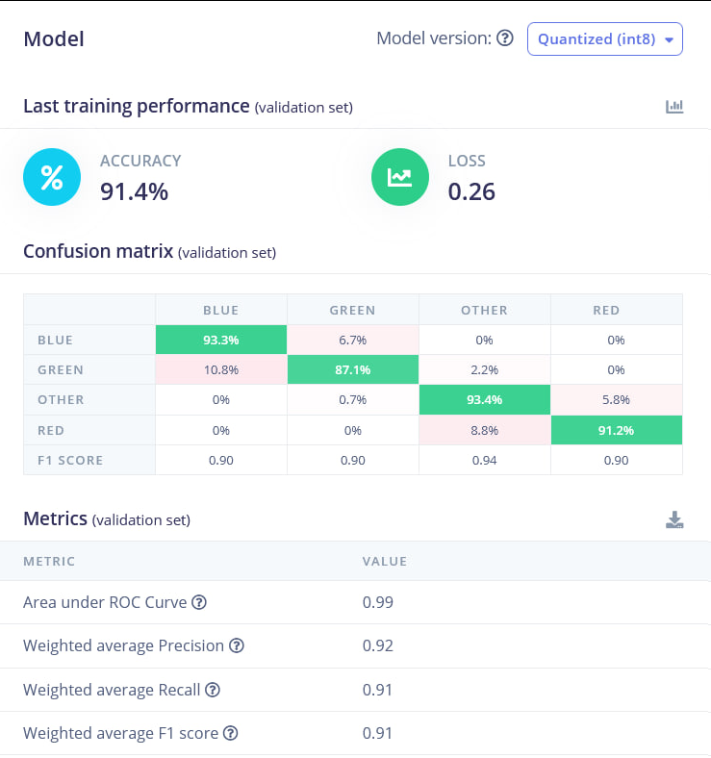
Figure A2. Quantised (int8) colour model: training performance, confusion matrix and validation metrics.
The firmware compensates for the residual under-triggering by requiring a short streak of confident green readings rather than a single classification. The constants COLOUR_GREEN_THRESHOLD = 0.70 and COLOUR_REQUIRED_STREAK = 3 in voice_colour_motion_demo.ino enforce this: three consecutive readings must label the sample as green with at least 70% confidence before the colour_authenticated event is emitted to the bridge. This turns a model that is right most of the time into a gate that is right almost all of the time during live demos.

5. On-Device Suitability
The selected colour model is comfortably within the Nano 33 BLE Sense budget. Edge Impulse reports approximately 1 ms inference time, 1.4 KB peak RAM use and 14.4 KB flash use for the quantised build, using the EON™ Compiler. Those numbers leave plenty of headroom for the voice keyword model, the movement classifier, the APDS9960 driver, the Edge Impulse SDK and the JSON serial output to all coexist in the same firmware image.
Running the model on the device is important for this IoT design. The board does not connect to Wi-Fi, so all three classifications happen locally and only short JSON events travel over the USB serial. This keeps the bridge and dashboard simple — they only need to ingest authenticated events, never raw RGB samples — and it makes the colour gate immune to network latency or dashboard outages.

6. Firmware Integration
For integration I added the colour stage to the firmware state machine. After the voice gate fires, the state machine moves into WAITING_FOR_COLOUR. In that state the firmware reads the APDS9960 colour sensor, builds a four-element feature vector (R, G, B, clear), runs the Edge Impulse classifier through the colour_impulse_handle, and applies the threshold-and-streak logic above. When the gate is satisfied it emits a JSON event of the form {"event":"colour_authenticated","colour":"green","confidence":...} and transitions into TRACKING_MOVEMENT, where Joel’s IMU model takes over.
The Python bridge forwards each colour_authenticated event to the web API, where the session row is updated with the authenticated colour and confidence. The dashboard timeline then shows the colour-authentication step alongside the earlier voice_start event and the later movement classifications, so the operator can see the full chain of decisions for a single session.

7. Dashboard Authentication Integration
Alongside the on-device model I implemented the web-side authentication that protects the bridge and admin endpoints. The dashboard uses an HMAC-signed session cookie (web/lib/auth.js) issued at /api/auth/login and cleared at /api/auth/logout; the cookie payload is signed with the SESSION_SECRET environment variable using SHA-256 HMAC. The ingest and bridge-control endpoints sit behind requireBearerToken (web/lib/bearerAuth.js), which compares the incoming Authorization: Bearer token against BRIDGE_API_TOKEN and ADMIN_API_TOKEN using a constant-time comparison.
The two layers compose. The TinyML colour gate authenticates the physical request — a green tag in front of the sensor — and the bearer-token layer authenticates the network request that delivers the colour_authenticated event to the dashboard. Together they mean an attacker cannot fake an authenticated session by sending a crafted HTTP request, and a legitimate bridge cannot push session data without the operator-driven physical sequence.

8. Limitations and Future Work
The model is suitable for the group demo but should not be treated as a general-purpose colour classifier. The dataset was collected with a small number of physical targets under coursework lighting, and the APDS9960 readings depend strongly on distance and ambient light. Different operators, room conditions or target materials would probably reduce accuracy unless they were included in training.
The most useful next steps would be: collect more captures across multiple lighting conditions and target materials so that “green” is robust to distance and tint; expose the colour confidence in the dashboard so the operator can see why a session was rejected; and add per-deployment thresholds, so that COLOUR_GREEN_THRESHOLD and COLOUR_REQUIRED_STREAK can be tuned without re-flashing the board. On the authentication side, rotating the bearer tokens via the existing _update_server flow and adding rate limiting on /api/auth/login would harden the dashboard further.

References
- Arduino. (n.d.). Nano 33 BLE Sense documentation. https://docs.arduino.cc/hardware/nano-33-ble-sense/
- Avago/Broadcom. (n.d.). APDS-9960 digital proximity, ambient light, RGB and gesture sensor datasheet.
- Edge Impulse. (n.d.). Running your impulse locally on Arduino. https://docs.edgeimpulse.com/docs/run-inference/arduino-library
- Edge Impulse. (n.d.). EON™ Compiler overview. https://docs.edgeimpulse.com/docs/edge-impulse-studio/deployment/eon-compiler
- OWASP. (n.d.). Authentication cheat sheet. https://cheatsheetseries.owasp.org/cheatsheets/Authentication_Cheat_Sheet.html

