MINISTRY OF EDUCATION AND SCIENCE OF UKRAINE
ODESA POLYTECHNIC NATIONAL UNIVERSITY
[Institute / Faculty to be completed]
[Department to be completed]
DIPLOMA THESIS
Creating a service-oriented architecture for scalable use of language models in commercial solutions
Prototype: ModelWeave, an AI workforce platform for PPC and SEO agency operations
Student: Serhii Sotskyi
Group / specialty: [to be completed]
Supervisor: Грішина Віра Олександрівна
Odesa - 2026

ABSTRACT
This diploma thesis presents the design, implementation, and evaluation of ModelWeave, a service-oriented prototype for scalable use of language models in commercial solutions. The practical domain is a fictional PPC and SEO agency, selected because agency operations require document retrieval, specialist reasoning, task planning, human approval, and client-ready reporting.
The work investigates how large language model capabilities can be decomposed into services: authentication, document processing, vector retrieval, agent orchestration, workflow management, approval control, evaluation, and document export. The implemented prototype uses Next.js on Vercel, FastAPI on Railway, Supabase Auth and Postgres, Qdrant Cloud, and user-provided Anthropic API keys. The system supports document upload in PDF, TXT, Markdown, and DOCX formats; indexing into a vector database; creation of role-based agents; visual workflow composition; approval-gated execution; and DOCX report generation.
The theoretical contribution is a formal model of retrieval-augmented generation, vector similarity search, workflow graphs, approval states, and run quality evaluation. The experimental part uses only synthetic enterprise data and verifies the system through local and production smoke tests. The results demonstrate that the proposed architecture is suitable for an academic proof of concept and provides a foundation for a more complete commercial platform.
Keywords: service-oriented architecture, large language models, retrieval-augmented generation, vector database, embeddings, multi-agent systems, workflow automation, PPC, SEO, Supabase, Qdrant, FastAPI, Next.js.

АНОТАЦІЯ
У дипломній роботі розглянуто проєктування, реалізацію та перевірку прототипу ModelWeave - сервісно-орієнтованої системи для масштабованого використання мовних моделей у комерційних рішеннях. Практичний приклад побудовано на повністю синтетичному сценарії PPC/SEO агенції, де потрібні пошук у документах, кооперація спеціалізованих агентів, формування задач, контроль погоджень і створення звітів.
Робота виконана англійською мовою, однак анотація українською додана для перегляду керівником. Дані демонстраційного корпусу не містять реальної інформації компаній.

CONTENTS
List of abbreviations
Introduction
1. Literature and technology review
2. Problem statement and requirements
3. Mathematical model
4. Service-oriented architecture
5. Implementation of ModelWeave
6. Testing and evaluation
7. Deployment and operation
8. Economic and commercial relevance
9. Limitations and future work
10. Detailed design and discussion
General conclusions
References
Appendices

LIST OF ABBREVIATIONS
Abbreviation | Meaning
API | Application Programming Interface
BYOK | Bring Your Own Key
DOCX | Microsoft Word Open XML document format
LLM | Large Language Model
PPC | Pay-Per-Click advertising
RAG | Retrieval-Augmented Generation
SEO | Search Engine Optimization
SOA | Service-Oriented Architecture
UI | User Interface
JWT | JSON Web Token

INTRODUCTION
Modern commercial software increasingly uses large language models to automate knowledge work: reading documents, summarizing evidence, planning actions, and producing deliverables. However, a single chatbot interface is not enough for realistic business use. Commercial workflows usually involve authentication, private data storage, retrieval from enterprise documents, audit trails, user-specific model credentials, human approval, and integration with existing operational records.
The relevance of the topic is determined by the gap between general-purpose language model capabilities and the requirements of commercial information systems. A company does not only need a model that can write text; it needs an architecture that can safely route user requests, retrieve relevant context, separate responsibilities, record decisions, and produce outputs that can be reviewed and reused. Service-oriented architecture is a suitable approach because it decomposes the system into independently understandable services with explicit contracts.
The practical system developed in this work is ModelWeave. It demonstrates how a vertical AI workforce can be implemented for a fictional PPC and SEO agency. This domain was chosen because agency work is document-heavy, repetitive, and dependent on specialist roles. A monthly operations review requires an account manager, PPC strategist, SEO strategist, analyst, content strategist, quality reviewer, supervisor, and reporting specialist. ModelWeave models these roles as configurable agents connected by a visual workflow.
The purpose of the work is to design and implement a service-oriented architecture for scalable use of language models in commercial solutions, and to validate it with a deployed prototype. The object of research is the process of applying language models to commercial knowledge workflows. The subject of research is the architecture, data flow, and implementation of a multi-agent RAG system with human approval gates.
The main tasks are: analyze current approaches to RAG and agent workflows; define requirements for a commercial prototype; formalize document retrieval and workflow execution; design the service-oriented architecture; implement the prototype; verify it with synthetic data; and evaluate the system according to citation coverage, actionability, risk control, and completeness.
Research element | Definition in this thesis
Purpose | Design and implement a service-oriented architecture for scalable use of language models in commercial solutions.
Object | Commercial knowledge workflows that combine documents, tasks, approvals, and reports.
Subject | A multi-agent RAG architecture with workflow orchestration and approval-gated state changes.
Practical domain | A fictional PPC/SEO agency using synthetic data only.
Prototype | ModelWeave web application deployed on Vercel and Railway.

1 LITERATURE AND TECHNOLOGY REVIEW

1.1 Retrieval-augmented generation
Retrieval-augmented generation combines a parametric language model with an external retrieval system. Lewis et al. introduced RAG as a method for knowledge-intensive NLP tasks and showed that grounding generation in retrieved passages can improve factual specificity compared with purely parametric generation [1]. Recent surveys describe RAG as a central pattern for improving factuality, domain adaptation, and maintainability because knowledge can be updated in the external corpus without retraining the model [2].
For commercial systems, the most important property of RAG is not only better answers, but controllability. The system can store documents under user ownership, retrieve top-ranked chunks, pass them to a model, and preserve citations. This makes the output auditable: a manager can see which documents influenced the answer. ModelWeave implements this idea by chunking uploaded documents, embedding each chunk, storing vectors in Qdrant, and attaching retrieved chunk citations to workflow runs and DOCX reports.

1.2 Vector search and embeddings
An embedding model maps text into a high-dimensional vector space. Semantically similar text fragments are expected to be closer in that space than unrelated fragments. In production, exact nearest-neighbor search can become expensive as the corpus grows; therefore vector databases commonly use approximate indexes such as HNSW, introduced by Malkov and Yashunin for efficient nearest-neighbor search in high-dimensional spaces [4].
Qdrant provides vector storage, search, filtering, and payload indexes. Payload filtering is important in a multi-user application because each query must be restricted to the current user and sometimes to a particular document. Qdrant documentation describes payload indexes as structures that speed up filtering and help the query planner estimate cardinality [5]. ModelWeave creates payload indexes for user_id and document_id so retrieval and deletion are tenant-aware.

1.3 Service-oriented web architecture
Service-oriented architecture separates responsibilities into services with explicit interfaces. In ModelWeave the frontend service is responsible for interaction, the backend API service enforces business rules, Supabase stores identity and relational state, Qdrant stores vectorized knowledge, and Anthropic provides model inference through user-supplied credentials. This separation makes deployment, testing, and scaling easier than a monolithic local script.
FastAPI was selected because it is based on standard Python type declarations and automatically exposes OpenAPI documentation [8]. Next.js App Router was selected because it provides a modern React application structure using file-system routing and React features [9]. React Flow was selected for the visual workflow builder because it represents workflows as nodes connected by edges [10].

1.4 Security and governance of LLM systems
Commercial LLM systems introduce risks that are different from ordinary web forms. Retrieved documents may contain misleading instructions, agents may overstep their authority, and generated recommendations may be accepted too quickly. OWASP identifies LLM-specific risks such as prompt injection, sensitive information disclosure, and excessive agency [14].
The prototype therefore applies three design controls: user isolation by Supabase Auth and backend user_id checks; BYOK model access so one user does not consume another user’s key; and mandatory human approval for persistent business changes. Agents may draft recommendations, but proposed tasks and campaign updates remain pending until a user approves them.

2 PROBLEM STATEMENT AND REQUIREMENTS
The problem addressed by this thesis is how to turn language model capabilities into a reusable commercial system rather than a one-off prompt. The target system must allow users to upload private documents, retrieve relevant knowledge, configure agents, compose workflows, execute domain operations, review proposed actions, and export client-ready reports.
The selected demo scenario is a fictional agency client named Harbor Homeware. A user asks: “Prepare next month’s PPC and SEO execution plan for Harbor Homeware.” The system must retrieve agency knowledge, route the work through specialist agents, create proposed PPC and SEO tasks, queue campaign updates for approval, produce a DOCX report, and evaluate the run.
Requirement | Implementation status | Evidence
Open registration and login | Implemented with Supabase Auth | Production login and dashboard screenshots
User-provided Anthropic key | Implemented; encrypted server-side | Setup tab shows configured key status
Upload PDF/TXT/MD/DOCX | Implemented | Documents tab and backend parser
Synthetic enterprise corpus | Implemented; 16 fictional PPC/SEO documents | Production seed smoke test
Vector RAG retrieval | Implemented with Qdrant | Run citations and vector payload filters
Create agents | Implemented | Agents API and UI
Visual drag-and-drop workflow builder | Implemented with React Flow | Workflow screenshot
Predefined cooperative pipeline | Implemented as Monthly PPC/SEO Operations Review | Bootstrap workflow
Human approvals | Implemented | Approvals tab and approval API
DOCX reports | Implemented | Reports tab and DOCX endpoint
Real external ad connectors | Out of scope for academic MVP | Future work

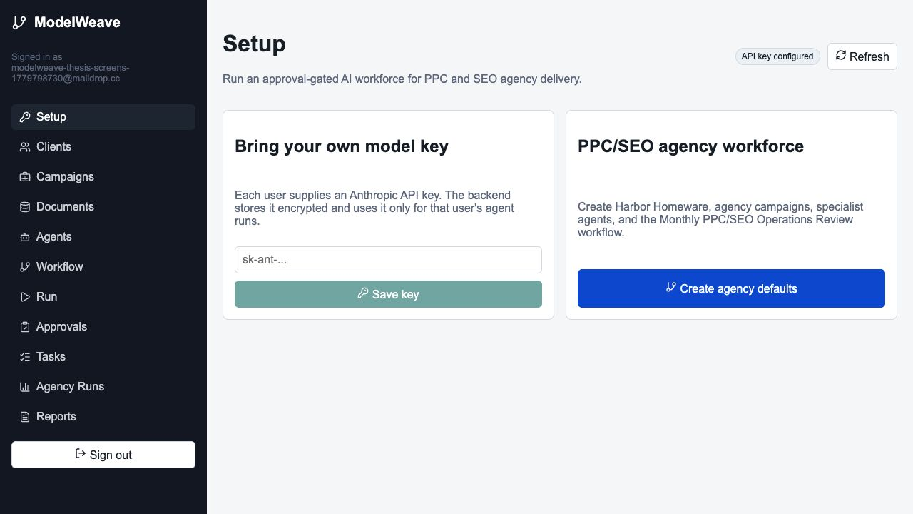
Figure 1 - ModelWeave setup dashboard with BYOK status.

3 MATHEMATICAL MODEL

3.1 Document representation
Let the uploaded enterprise corpus be represented as a finite set of documents:
D = {d_1, d_2, ..., d_n}.
Each document is parsed and divided into chunks. For document d_i, chunking produces:
C_i = {c_{i,1}, c_{i,2}, ..., c_{i,m_i}}.
The full chunk collection is therefore:
C = ⋃_{i=1}^{n} C_i.

3.2 Embedding and vectorization
An embedding function E maps each text chunk into a d-dimensional vector space:
E: C -> R^d, v_{i,j} = E(c_{i,j}).
The query q is embedded by the same function:
v_q = E(q).

3.3 Similarity and retrieval
ModelWeave uses vector similarity to rank candidate chunks. The cosine similarity between the query vector and a stored chunk vector is:
cos(v_q, v_{i,j}) = (v_q · v_{i,j}) / (||v_q|| ||v_{i,j}||).
For a user u, retrieval must be filtered by ownership. The filtered top-k result set is:
R_k(q,u) = top_k { c ∈ C | owner(c)=u } by cos(E(q), E(c)).

3.4 Workflow graph
A workflow is modeled as a directed graph:
G = (V, E_g),
where V is the set of workflow nodes and E_g is the set of directed edges between nodes. Nodes may be retrieval nodes, agent nodes, task creation nodes, campaign update nodes, approval gates, evaluation nodes, and export nodes. Execution follows a topological order when the graph is acyclic:
τ = topological_sort(G).

3.5 Evaluation model
The prototype computes a heuristic quality score from four normalized components: citation coverage, actionability, risk control, and completeness. The overall score is calculated as:
S = (w_c C + w_a A + w_r R + w_m M) / (w_c + w_a + w_r + w_m).
For the MVP all weights are equal. This makes the evaluation transparent and easy to explain in an academic setting, while leaving room for later replacement by learned or human-calibrated evaluation metrics.
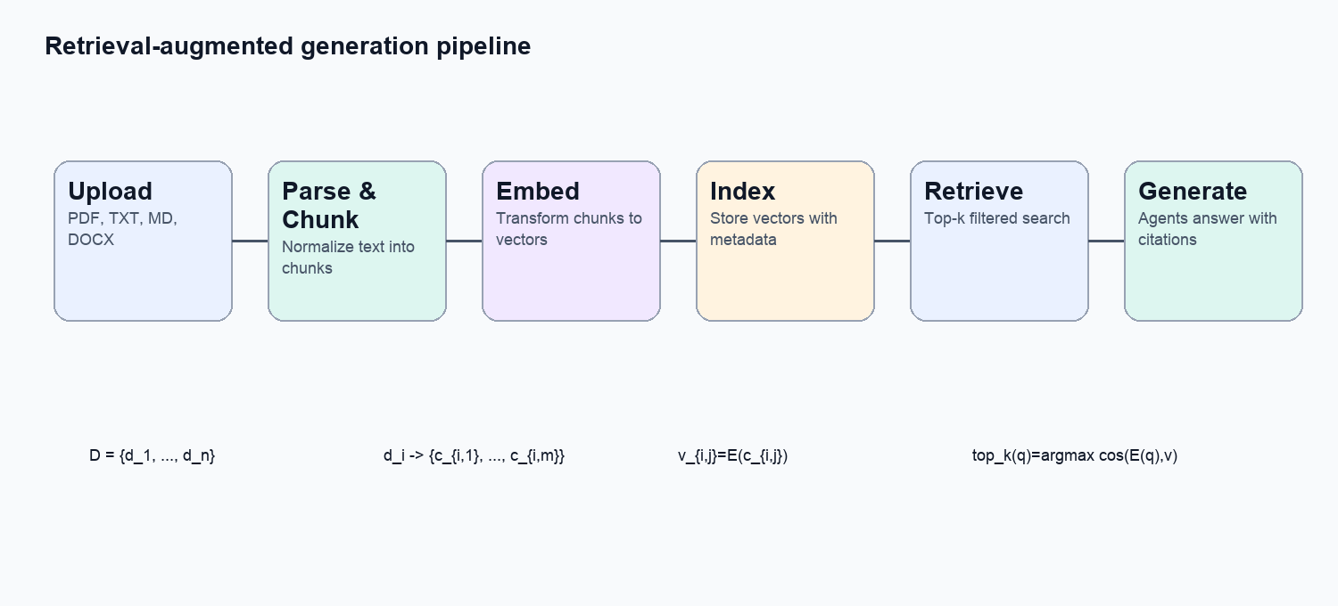
Figure 2 - Formal RAG pipeline implemented in ModelWeave.

4 SERVICE-ORIENTED ARCHITECTURE
The system is divided into services so that each responsibility has a clear deployment boundary and interface. This is central to the thesis title: scalable use of language models requires more than a prompt; it requires service decomposition, state management, authentication, and integration with external infrastructure.
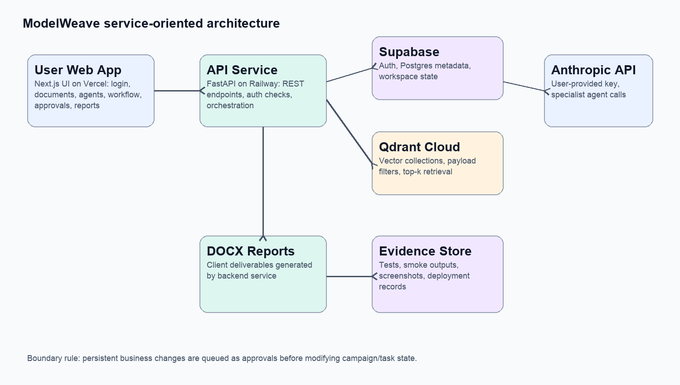
Figure 3 - Service-oriented architecture of ModelWeave.
Service | Technology | Responsibility | Scalability role
Frontend service | Next.js, React, React Flow, Vercel | User interface for auth, documents, agents, workflow, approvals, reports | Can scale independently as static/server-rendered web frontend
Backend API | FastAPI, Railway | Business logic, auth validation, orchestration, document parsing, report generation | Horizontal API boundary for future worker queues
Identity service | Supabase Auth | Registration, login, JWT user identity | External managed auth
Relational state | Supabase Postgres | Agents, workflows, clients, campaigns, tasks, approvals, runs | Structured source of truth
Vector store | Qdrant Cloud | Embeddings, payload filters, retrieval, vector deletion | Specialized retrieval layer
LLM provider | Anthropic API | Agent inference through user-provided key | Replaceable model service boundary
Report exporter | python-docx backend module | DOCX generation for client-ready output | Output service for deliverables

4.1 Data flow
- The user authenticates in the frontend through Supabase Auth.
- The frontend sends API requests with the user JWT.
- The backend validates the JWT and checks that the session is active.
- Uploaded documents are parsed into text, chunked, stored in Postgres, embedded, and indexed in Qdrant.
- A workflow run retrieves context from Qdrant and sends structured prompts to Anthropic using the user’s encrypted key.
- Agent outputs are recorded in the run trace, while persistent business changes become approval records.
- The user approves or rejects proposed actions.
- A DOCX report is generated from the run output, citations, approvals, and evaluation data.

4.2 Database model
Entity | Purpose
provider_keys | Encrypted user model credentials.
agents | Configurable role-based agents.
workflows | Visual graph of execution nodes and edges.
documents | Uploaded or synthetic documents.
document_chunks | Parsed text chunks and metadata.
runs | Workflow execution records.
clients | Fictional agency client profiles.
campaigns | PPC/SEO initiatives linked to clients.
agency_tasks | Approval-gated work items proposed by agents.
approvals | Human approval queue.
action_events | Audit timeline of agent/tool activity.
run_evaluations | Quality scores for workflow runs.

5 IMPLEMENTATION OF MODELWEAVE

5.1 Frontend implementation
The frontend is implemented as a Next.js application. It provides a single dashboard with tabs for Setup, Clients, Campaigns, Documents, Agents, Workflow, Run, Approvals, Tasks, Agency Runs, and Reports. Supabase client SDK manages session state, while the backend API is called through a small wrapper that attaches the user token to every request.
The workflow builder uses React Flow. Users can add specialist agents and typed execution nodes to a canvas, connect them with edges, and save the resulting graph. In the MVP, workflow nodes are stored as JSON in Postgres and executed by the backend in topological order.
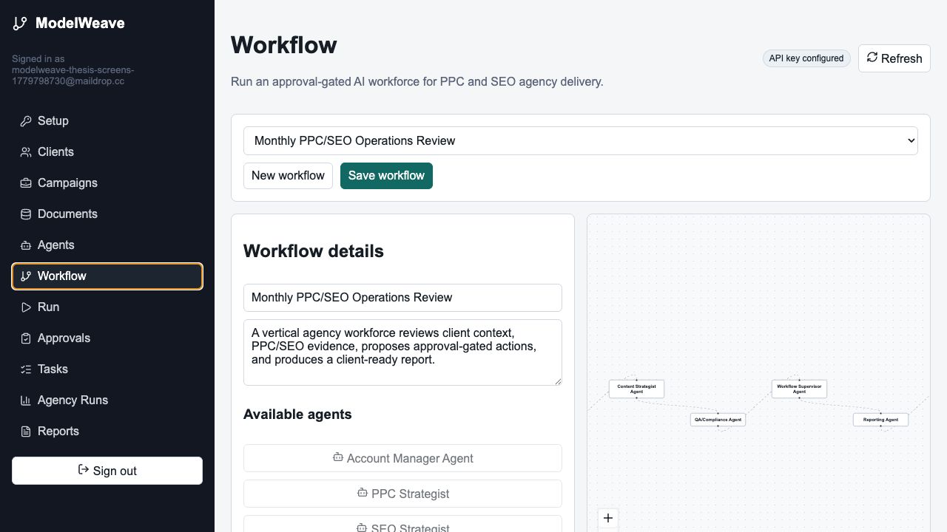
Figure 4 - Visual workflow builder with specialist agents and execution nodes.

5.2 Backend implementation
The backend is a FastAPI service. API routes are grouped in a single router for MVP simplicity, while business logic is separated into services: documents, embeddings, vector store, agents, agency workspace, provider keys, and reports. This separation gives the implementation the same conceptual boundaries as the service-oriented architecture.
Backend module | Role
api/routes.py | REST endpoints for auth-protected operations.
services/documents.py | Parsing PDF, TXT, Markdown, and DOCX files.
services/vector_store.py | Qdrant collection setup, indexing, retrieval, vector deletion.
services/agents.py | Default workforce bootstrap and workflow execution.
services/agency.py | Clients, campaigns, task proposals, approvals, evaluations, action events.
services/provider_keys.py | Encrypted user Anthropic key storage.
services/reports.py | DOCX report generation.

5.3 Document management and RAG
The Documents tab supports uploading files, loading the synthetic PPC/SEO corpus, opening indexed document content, editing metadata, and deleting documents. Deletion removes both relational rows in Postgres and matching vectors in Qdrant. This prevents stale retrieved context after a user removes a document.
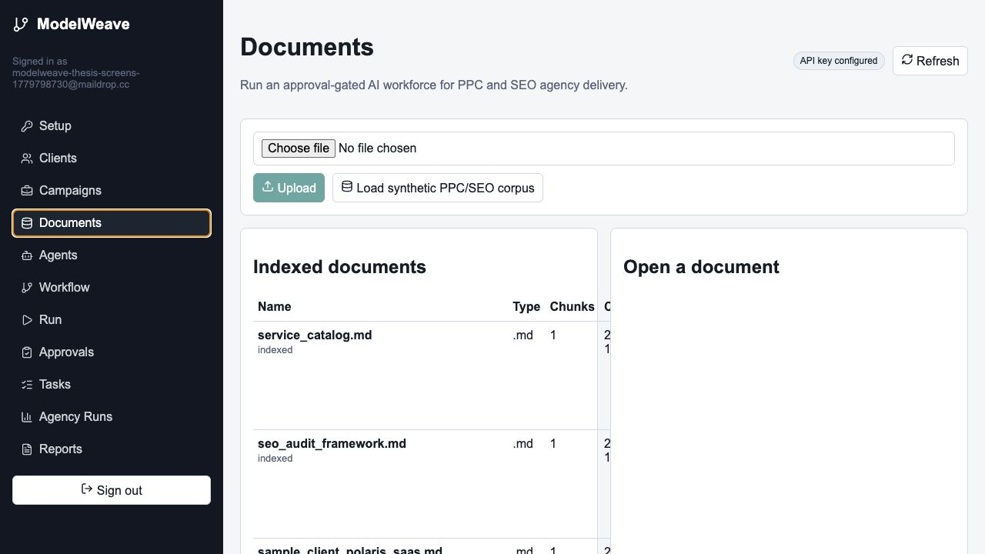
Figure 5 - Document upload, synthetic corpus loading, and document management.

5.4 Agent workforce
The default workforce contains eight agents. Their cooperation is implemented by passing the original user prompt, retrieved source context, agency workspace state, and accumulated notes from previous agents to each subsequent agent. This gives each role visibility into prior reasoning while keeping the execution trace auditable.
Agent | Commercial role in the workflow
Account Manager Agent | Frames client goals, constraints, and delivery expectations.
Data Analyst Agent | Detects trends and weak spots in performance notes.
SEO Strategist | Proposes technical, content, and organic growth actions.
PPC Strategist | Proposes budget, keyword, negative keyword, and ad copy actions.
Content Strategist Agent | Transforms findings into content briefs and messaging tasks.
QA/Compliance Agent | Checks grounding, risk, and client-facing consistency.
Workflow Supervisor Agent | Resolves conflicts and selects priorities.
Reporting Agent | Writes the client-ready report output.

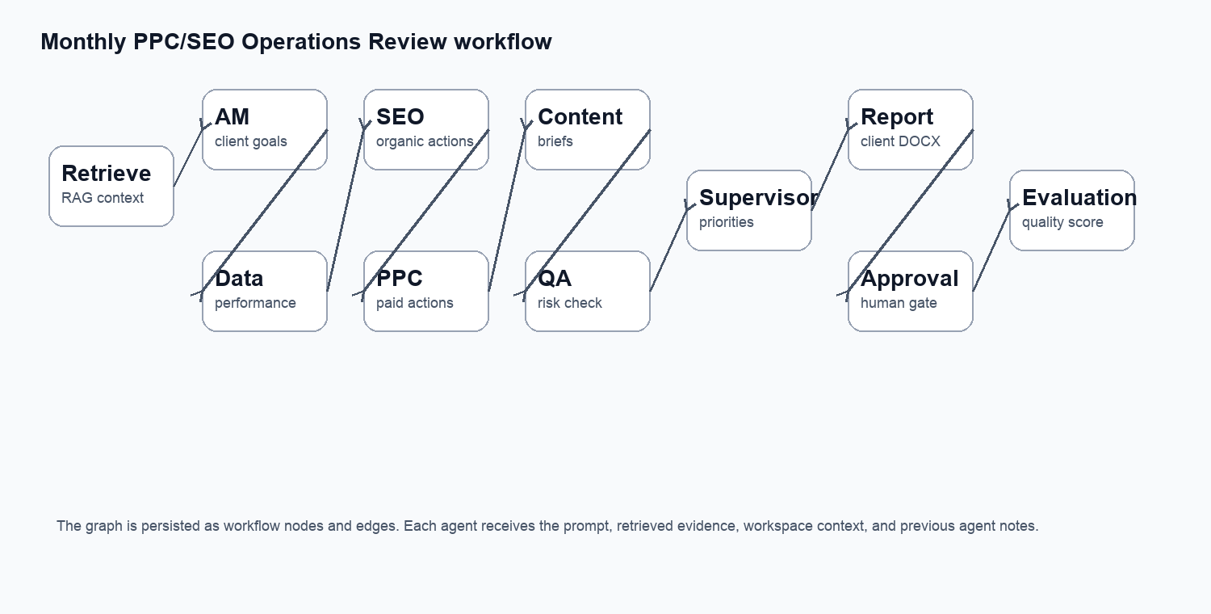
Figure 6 - Cooperative PPC/SEO workflow graph.

5.5 Approval-gated execution
The most important domain-specific behavior is that agents do not directly mutate business state. They can draft recommendations and proposed actions, but tasks and campaign changes start as pending approvals. If the user approves a task proposal, the task becomes approved. If the user rejects it, the proposal remains in the audit history but does not affect final workspace state.
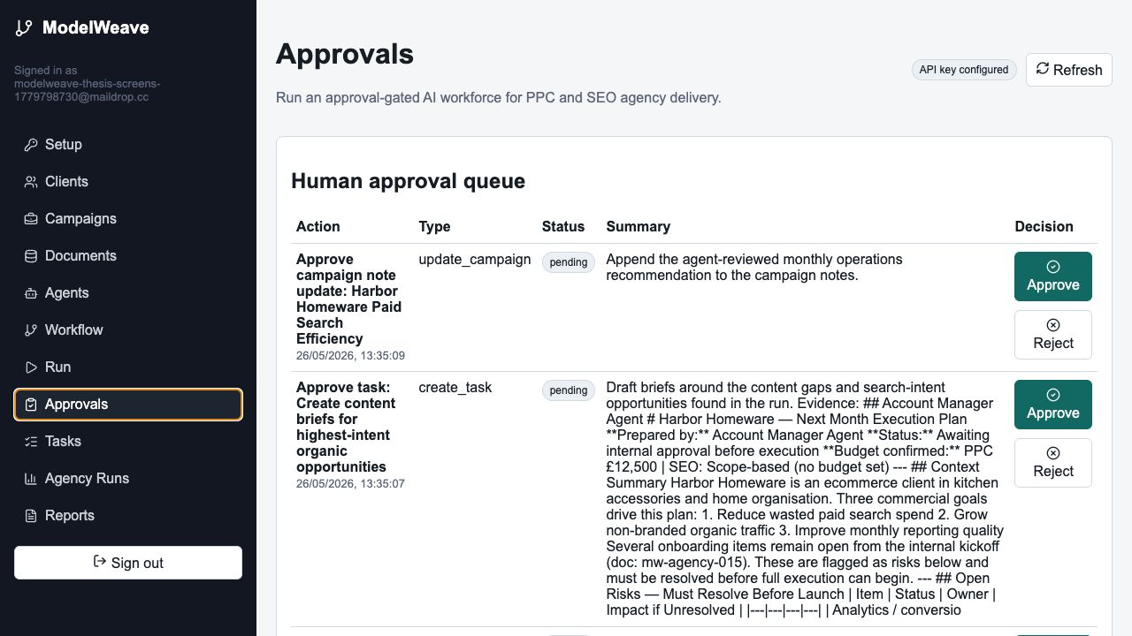
Figure 7 - Human approval queue for proposed campaign and task changes.

6 TESTING AND EVALUATION
Testing focused on the acceptance scenario agreed for the project: a new user registers, configures an Anthropic key, loads the synthetic corpus, bootstraps the agency workforce, runs the Harbor Homeware monthly workflow, receives approvals, sees trace events and evaluation scores, and downloads a DOCX report.
Test artifact | Result
e2e-local-summary.json | Local authenticated end-to-end flow passed.
agency-workforce-smoke-2026-05-25.json | Default PPC/SEO workforce run passed.
seed-synthetic-production-2026-05-26.json | Production synthetic corpus loader indexed 16 documents.
document-management-production-2026-05-26.json | Production open, rename, delete, and 404-after-delete passed.
thesis-demo-production-state-2026-05-26.json | Production thesis demo state collected: 16 documents, 17 events, 4 approvals.

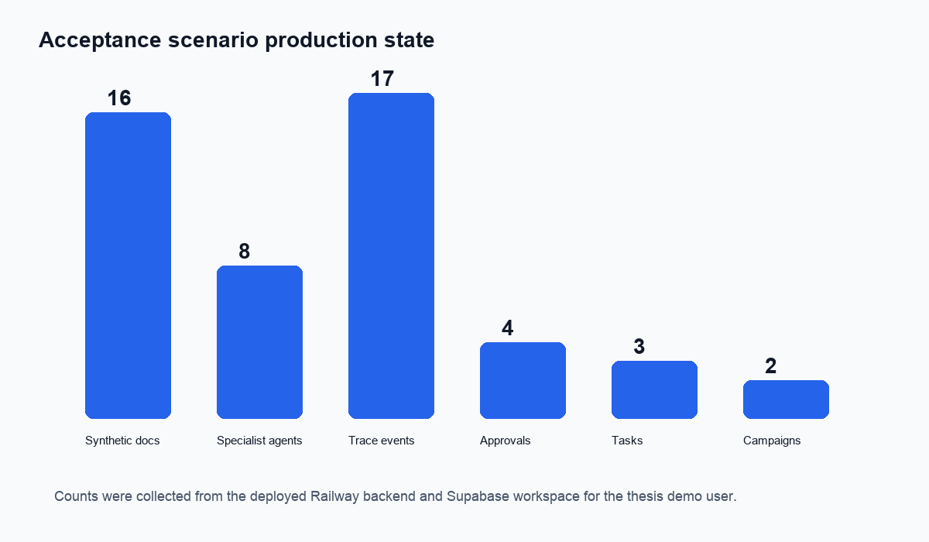
Figure 8 - Production state counts for the acceptance scenario.

6.1 Evaluation metrics
The run evaluation is intentionally transparent. It is not presented as a scientific benchmark of model intelligence. Instead, it checks whether the run contains the minimum characteristics needed for a commercial workflow: citations, actionable outputs, risk awareness, and completeness of the multi-agent process.
Metric | Meaning | Observed value
Citation coverage | Whether retrieval supplied source context and citations. | 1.00
Actionability | Whether the workflow produced concrete proposed actions. | 1.00
Risk control | Whether approval/risk/constraint language is present. | 1.00
Completeness | Whether the required specialist steps executed. | 1.00
Overall score | Average of the four metric components. | 1.00

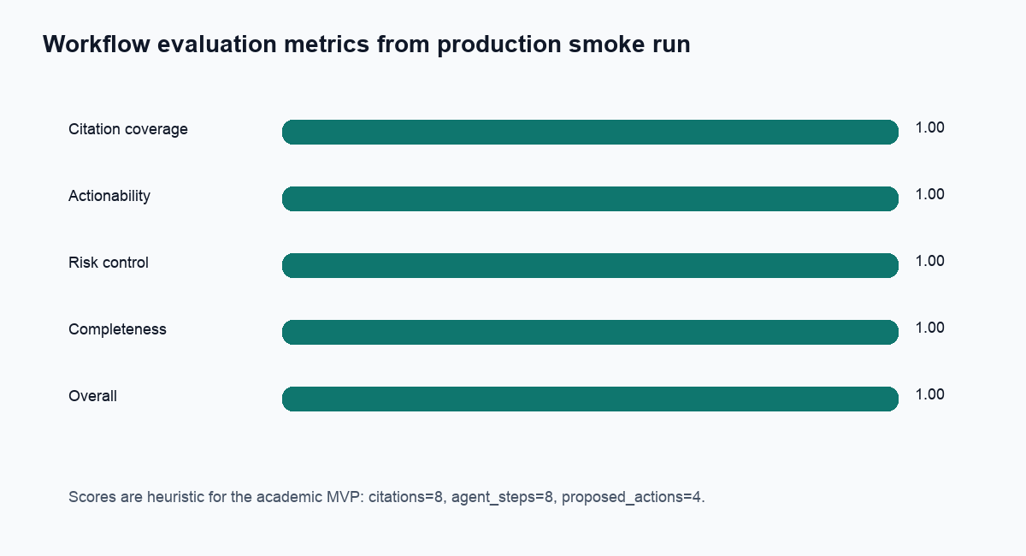
Figure 9 - Production run evaluation metrics.

6.2 Interpretation
The production demo run generated eight retrieved citations, eight agent steps, seventeen trace events, four approval records, three proposed tasks, and one campaign update proposal. These results show that the architecture supports more than a static report: it executes a controlled business workflow and records the intermediate state needed for auditability.
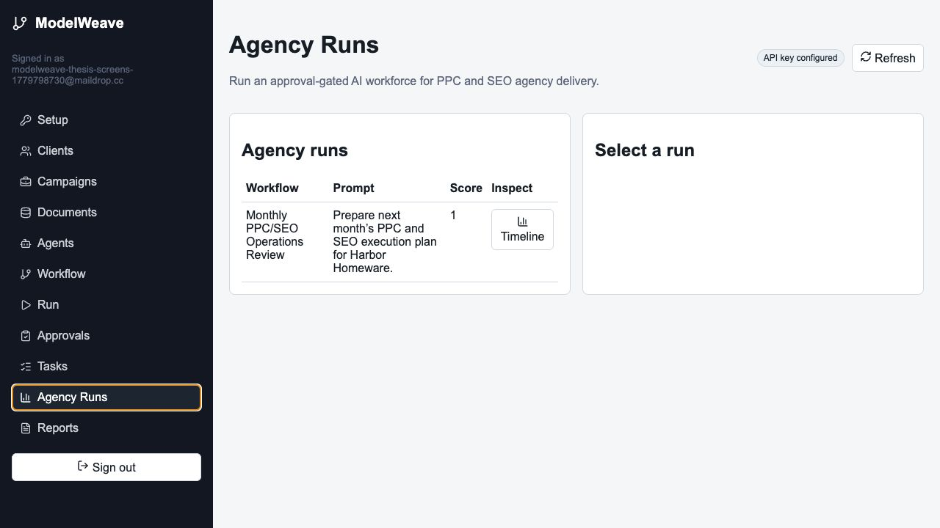
Figure 10 - Agency Runs tab showing run history.
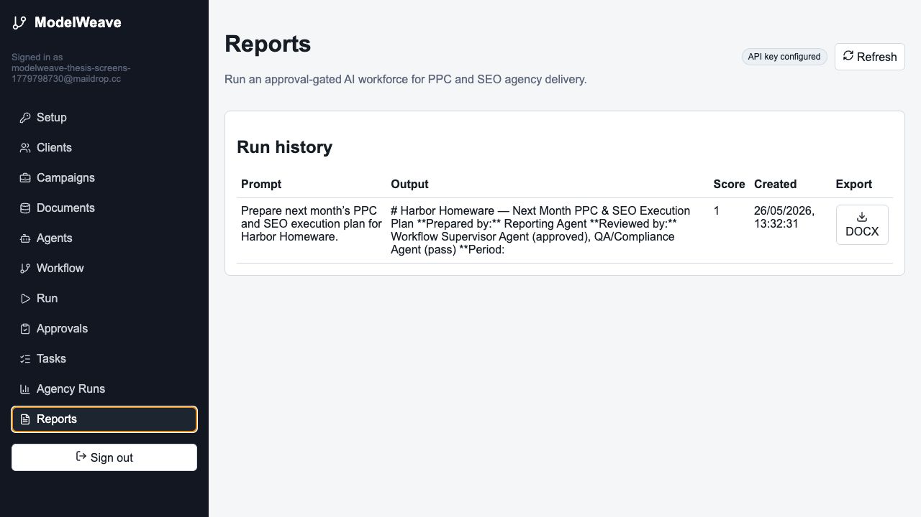
Figure 11 - Reports tab with DOCX download action.

7 DEPLOYMENT AND OPERATION
The final prototype is deployed as two public services. The frontend is deployed to Vercel at https://modelweave-six.vercel.app. The backend is deployed to Railway at https://api-production-e70a9.up.railway.app. Supabase and Qdrant are managed cloud services. This deployment split demonstrates the thesis argument that language model applications should be designed as service compositions rather than single-process scripts.
Deployment component | Current production status
Frontend | Vercel production deployment dpl_H2Nc3uNaaEvY3nSwumyu3QrA3gnV.
Backend | Railway deployment 006ab577-d40c-4636-b030-f9ba0bc1b651.
Database/auth | Supabase Postgres and Auth configured with JWT validation.
Vector database | Qdrant Cloud collection with user_id and document_id payload indexes.
Repository | Public GitHub repository: serhiiSotskyi/multi-agent-knowledge-platform.

Operationally, the most important controls are environment separation and secret management. The local .env file is ignored by git. The owner’s Anthropic key is not used as a shared production key for all users. Each user provides their own key, and the backend encrypts it before storage.

8 ECONOMIC AND COMMERCIAL RELEVANCE
The commercial value of the proposed architecture is that it targets repetitive, document-heavy agency operations. A PPC/SEO agency repeatedly prepares monthly plans, audits weak performance areas, writes briefs, checks risks, asks for approvals, and generates reports. These processes are suitable for automation because they combine structured records with natural language evidence.
Compared with a generic chatbot, the ModelWeave approach provides a workflow surface that can be inspected and modified. Compared with a simple report generator, it creates internal tasks and campaign proposals. Compared with fully autonomous agents, it preserves human approval for persistent state changes. This combination is realistic for commercial adoption because it improves productivity without removing accountability.
Commercial capability | Prototype demonstration | Future commercial extension
Knowledge onboarding | Upload and index agency documents | Connect Google Drive, Notion, Slack, CMS, CRM
Specialist work | Eight predefined PPC/SEO agents | Role templates per vertical industry
Action execution | Approval-gated task/campaign updates | Real integrations with Google Ads and Search Console
Reporting | DOCX monthly report export | Client portals, scheduled delivery, branded templates
Governance | Trace events, approvals, evaluation | Admin review, audit exports, policy rules

9 LIMITATIONS AND FUTURE WORK
The implemented system is an academic MVP. It proves that the architecture can support authenticated users, document indexing, RAG, cooperative agents, workflow graphs, approvals, and DOCX reports. It is not yet a complete commercial product that can replace a full agency team in production.
The main limitation is the absence of real external connectors. Google Ads, Google Search Console, GA4, Slack, Jira, and CMS integrations were intentionally excluded because the diploma version uses synthetic data only. The second limitation is that workflow execution is currently a custom sequential/topological executor rather than a durable workflow engine with background retries and long-running state. The third limitation is that document editing supports metadata and deletion, while full content editing would require re-chunking and re-embedding.
Future improvement | Reason
Durable workflow engine | Support long-running jobs, retries, worker queues, and asynchronous approvals.
Real ad/SEO connectors | Move from synthetic evidence to authorized live operational data.
Full document re-indexing editor | Allow users to change document text and regenerate embeddings.
Role and team management | Support agencies with multiple employees and clients.
Advanced evaluation | Add human-labeled evaluation sets and LLM-as-judge with calibration.
Template-based DOCX branding | Support agency/client report templates.

10 DETAILED DESIGN AND DISCUSSION

10.1 Why a service-oriented architecture is required
A language model application can be built as a single script that sends a prompt to a model and prints the result. Such a design is useful for experimentation, but it does not satisfy commercial requirements. Commercial users need identity management, access control, data ownership, operational logs, reproducible outputs, user-specific credentials, and clear boundaries between temporary reasoning and persistent business state. A service-oriented architecture answers these needs by separating the user interface, API policy layer, relational state, vector retrieval, model inference, and reporting output.
The central architectural decision in ModelWeave is to treat the language model as one service among several, not as the entire system. The model does not store users, own the corpus, decide access rights, or directly mutate agency records. It receives a controlled prompt prepared by the backend and returns text that is stored as a trace. This makes the model replaceable: a later version could route to another Anthropic model, an OpenAI model, or a private model service without redesigning the database and workflow surface.
The service boundary is also important for academic scalability. Scaling language model systems is not only a question of larger models. It includes scaling the number of users, documents, workflow runs, approvals, and reports. The frontend can scale separately from the backend. Qdrant can scale retrieval independently of Postgres. Supabase handles authentication and relational state without being overloaded by vector operations. Railway hosts the API layer and can later be extended with background workers.

10.2 RAG lifecycle in the implemented system
The implemented RAG lifecycle starts with document ingestion. A user uploads a PDF, TXT, Markdown, or DOCX file. The backend validates the extension, extracts readable text, and rejects files without usable text. Synthetic documents are loaded through the same indexing path so that the demo corpus and user-uploaded documents follow the same processing model.
After parsing, the backend divides text into chunks. Chunking is necessary because documents are usually longer than the useful context window for one retrieval item. Small chunks improve precision because the vector search can return a specific passage. Very small chunks, however, may lose surrounding context. The MVP therefore uses a pragmatic chunking strategy suitable for short agency documents. A production extension would add configurable chunk sizes, overlap, and document-type-specific parsing rules.
Each chunk is embedded and stored twice: relationally in Postgres and semantically in Qdrant. Postgres stores the canonical text, document id, user id, chunk index, and metadata. Qdrant stores the embedding vector and enough payload metadata to filter by user_id and document_id. This dual-storage pattern is common in RAG systems: the relational database preserves durable application state, while the vector store provides fast semantic retrieval.
Deletion is part of the lifecycle and is important for correctness. If a user deletes a document only from Postgres while vectors remain in Qdrant, later RAG calls may retrieve stale or unauthorized context. ModelWeave therefore deletes matching vectors when a document is deleted. Renaming a document updates relational metadata and Qdrant payload metadata so citations remain understandable in later runs.
storage(D) = storage_relational(C, metadata) + storage_vector(E(C), payload).
This expression summarizes the implemented persistence design: document chunks are useful only when their original text, metadata, and vector representation remain synchronized.

10.3 Agent role separation
The agent design follows a role-specialization pattern. Instead of asking one model call to perform all work, ModelWeave decomposes the monthly agency review into several perspectives. The account manager frames client goals and constraints. The analyst reads performance-oriented context. SEO and PPC strategists propose channel-specific actions. The content strategist converts findings into content briefs. The QA agent checks risk and grounding. The supervisor resolves priorities. The reporting agent writes the final client-facing output.
This design has two advantages. First, it mirrors how commercial teams already work, which makes the demo easier to understand for a business reader. Second, it improves traceability. If a final recommendation is weak, the user can inspect which agent produced it and which previous notes influenced it. Traceability is especially important in academic evaluation because it shows that the result was produced by a workflow, not a hidden single prompt.
The agents are cooperative but not fully autonomous. They do not independently call arbitrary external tools, send messages, or modify business records. Their cooperation is implemented through structured context passing. Every agent receives the user prompt, retrieved evidence, workspace context, and previous notes. This creates a controlled chain of reasoning while avoiding the risks of unconstrained agent autonomy.
context_t = prompt + R_k(q,u) + workspace(u) + trace_{1:t-1}.
In this formula, the context for agent step t is composed of the original prompt, retrieved evidence, current workspace state, and all previous agent outputs. The formula describes the implemented execution pattern directly.

10.4 Approval-gated mutation model
A key difference between a report generator and an operational workforce platform is the ability to create or update internal work objects. However, direct model-driven mutation is risky. A model may misunderstand evidence, overstate confidence, or propose an action that conflicts with business policy. ModelWeave therefore implements approval-gated mutation: agents can propose tasks and campaign updates, but those proposals become final only after human approval.
The approval model can be represented as a finite state machine. Every proposed action starts in the pending state. From pending it may move to approved or rejected. Approved task proposals update the task status, while approved campaign proposals append the generated recommendation to campaign notes. Rejected proposals are preserved for audit but do not mutate final campaign or task state.
A = {pending, approved, rejected}, δ(pending, approve)=approved, δ(pending, reject)=rejected.
persistent_change(x) is allowed iff approval_state(x)=approved.
This state machine is intentionally simple. Its value is not mathematical complexity but governance clarity. It creates a visible point where a human remains accountable for business state changes. This is useful for the diploma argument because it shows how language models can be used in commercial workflows without giving them unlimited agency.
The audit trail records action events for retrieval, agent completion, proposal creation, approval gates, evaluation, and report availability. These records support debugging and supervision. In a production version, the same event stream could be sent to observability tools or used to reconstruct a run for compliance review.

10.5 Security model
The security model combines managed authentication with application-level authorization. Supabase Auth issues JWTs after login. The frontend attaches the token to backend requests. The backend validates the token and checks that the session still exists. This second check was added after a real issue during development: a pasted email confirmation link exposed a refresh token in the chat, so the session was revoked and the backend was hardened to reject revoked sessions immediately.
Authorization is enforced with the user_id field on application records. Agents, workflows, documents, chunks, runs, clients, campaigns, tasks, approvals, action events, and evaluations are queried with the current user id. Qdrant retrieval also uses payload filtering by user_id. This means a user should not retrieve another user’s indexed chunks even if vectors are stored in a shared collection.
The BYOK model is another security decision. The application owner does not provide a shared Anthropic key for all users. Each user supplies their own key. The backend stores it encrypted using a server-side encryption secret and uses it only for that user’s agent runs. This reduces shared billing risk and fits the academic requirement that registration is open but model usage belongs to the individual user.
Prompt injection remains a limitation that requires future work. The synthetic corpus is controlled, but real commercial documents may contain malicious or misleading instructions. Future versions should add document-level trust labels, prompt-injection classifiers, system prompt hardening, allow-listed tools, and stricter separation between retrieved text and executable instructions.

10.6 Scalability and complexity considerations
The scalability of the architecture can be analyzed through the main operations. Let N be the number of indexed chunks, d the embedding dimension, k the number of retrieved chunks, a the number of agent nodes, and r the number of run records. Storage for vectors grows approximately as O(Nd). Relational storage grows as O(N + r + business_state). The cost of a workflow run is dominated by model inference over a agent calls and by the prompt length created from retrieved context and prior notes.
Vector retrieval is designed to avoid scanning all chunks directly. With approximate nearest-neighbor indexing, retrieval is sublinear in practice, although exact complexity depends on index parameters and implementation details. Payload filters restrict search to one user, which improves correctness and may reduce the effective search space. The MVP uses Qdrant indexes for user_id and document_id to support filtered retrieval and deletion.
The backend currently executes workflow runs synchronously. This is acceptable for a diploma prototype and a small demo, but it is not ideal for production. A commercial version should move workflow execution into a background worker queue. The API would create a run record and return immediately, while workers would process agent steps, update events, pause for approvals, resume after approval, and handle retries. This would make long workflows more reliable and improve user experience.
T_run ≈ T_retrieve(N,k) + Σ_{i=1}^{a} T_LLM(prompt_i) + T_persist(events, approvals, report).
This expression describes why model calls dominate latency while storage and retrieval remain important for scale. It also explains why future work should include queues and durable workflow state.

10.7 Practical value of the vertical agency scenario
The PPC/SEO agency scenario makes the thesis more concrete than a generic chatbot demonstration. PPC and SEO agencies already divide work into roles, maintain client records, read performance evidence, produce recurring monthly plans, and require approval before changing campaigns. This makes the domain a natural fit for a multi-agent workflow platform.
The fictional Harbor Homeware scenario demonstrates end-to-end value: documents are loaded, the client and campaigns exist as internal workspace objects, the user asks for next month’s plan, the system retrieves relevant evidence, specialists produce outputs, proposed tasks and campaign changes enter the approval queue, and a report becomes available as DOCX. This is closer to real commercial work than a simple question-answering demo.
The system is still intentionally synthetic. This is important ethically and academically. The thesis demonstrates architecture and engineering without exposing real company information. The synthetic corpus is sufficient to show retrieval, grounding, role cooperation, and approval flow, while avoiding confidentiality problems.

10.8 Threats to validity
Several threats to validity must be acknowledged. First, the evaluation is based on smoke tests and heuristic quality metrics, not a large human-labeled benchmark. The results prove that the implemented workflow functions, but they do not prove that the agents always produce optimal PPC or SEO strategy. Second, synthetic documents are cleaner than real agency data. Real data would include inconsistent naming, outdated policies, screenshots, tables, spreadsheet exports, and conflicting stakeholder notes.
Third, the run evaluation currently uses simple rules. Citation coverage, actionability, risk control, and completeness are useful for an MVP, but production evaluation should include human review, comparison against expert baselines, and regression datasets. Fourth, screenshot evidence proves user-visible functionality at the time of testing, but it is not a replacement for continuous integration. A mature version should include automated browser tests and backend integration tests in CI.
Despite these limitations, the prototype satisfies the research purpose. It demonstrates that service-oriented architecture can organize language model functionality into a scalable commercial system with clear data boundaries, retrieval, agent roles, approval gates, traceability, and document export.

GENERAL CONCLUSIONS
The thesis designed and implemented a service-oriented architecture for scalable use of language models in commercial solutions. The result is ModelWeave, a deployed prototype that demonstrates how language models can be integrated into a business workflow rather than used only as a chat interface.
The work shows that RAG, vector search, agent workflows, approval gates, and report generation can be decomposed into services with clear responsibilities. The implemented system supports authentication, user-specific model keys, document upload, vector indexing, specialist agents, visual workflow composition, approval-gated task creation, campaign update proposals, run trace events, evaluation scores, and DOCX exports.
The synthetic PPC/SEO agency scenario demonstrates a realistic commercial pattern: a user asks for a monthly execution plan, the system retrieves relevant context, multiple agents cooperate, proposed actions are queued for approval, and a client-ready report is produced. The production smoke tests confirm that the core acceptance scenario works on the deployed infrastructure.
The prototype is not a final commercial replacement for an agency team, but it provides a defensible academic proof of concept. It also creates a foundation for future work with real connectors, durable workflow infrastructure, richer evaluation, and multi-user agency operations.

REFERENCES
[1] Lewis, P., Perez, E., Piktus, A., et al. Retrieval-Augmented Generation for Knowledge-Intensive NLP Tasks. arXiv:2005.11401, 2020. URL: https://arxiv.org/abs/2005.11401
[2] Gupta, S., Ranjan, R., Singh, S. N. A Comprehensive Survey of Retrieval-Augmented Generation (RAG): Evolution, Current Landscape and Future Directions. arXiv:2410.12837, 2024. URL: https://arxiv.org/abs/2410.12837
[3] Yu, H., Gan, A., Zhang, K., Tong, S., Liu, Q., Liu, Z. Evaluation of Retrieval-Augmented Generation: A Survey. arXiv:2405.07437, 2024. URL: https://arxiv.org/abs/2405.07437
[4] Malkov, Y. A., Yashunin, D. A. Efficient and Robust Approximate Nearest Neighbor Search Using Hierarchical Navigable Small World Graphs. IEEE TPAMI, 42(4), 824-836, 2018. DOI: 10.1109/TPAMI.2018.2889473.
[5] Qdrant. Indexing documentation. URL: https://qdrant.tech/documentation/manage-data/indexing/
[6] Qdrant. Filtering documentation. URL: https://qdrant.tech/documentation/search/filtering/
[7] Supabase. Auth documentation. URL: https://supabase.com/docs/guides/auth
[8] Anthropic. Working with the Messages API. URL: https://platform.claude.com/docs/en/build-with-claude/working-with-messages
[9] FastAPI. Features and automatic documentation. URL: https://fastapi.tiangolo.com/features/
[10] Next.js. App Router documentation. URL: https://nextjs.org/docs/app
[11] React Flow. Core concepts: nodes and edges. URL: https://reactflow.dev/learn/concepts/terms-and-definitions
[12] Railway. Deploy a FastAPI App. URL: https://docs.railway.com/guides/fastapi
[13] Vercel. Deployments documentation. URL: https://vercel.com/docs/deployments
[14] PostgreSQL. JSON Types documentation, version 18. URL: https://www.postgresql.org/docs/18/datatype-json.html
[15] OWASP Foundation. Top 10 for Large Language Model Applications / GenAI Security Project. URL: https://owasp.org/www-project-top-10-for-large-language-model-applications/

APPENDIX A. API ENDPOINTS
Endpoint group | Representative endpoints
Authentication context | GET /api/me, GET /api/provider-key/status, PUT /api/provider-key
Agency workspace | GET/POST/PUT /api/clients, /api/campaigns, /api/tasks
Approvals | GET/POST /api/approvals, POST /api/approvals/{id}/approve, POST /api/approvals/{id}/reject
Documents | GET/POST /api/documents, GET/PUT/DELETE /api/documents/{id}, POST /api/documents/seed-synthetic
Agents and workflows | GET/POST/PUT /api/agents, GET/POST/PUT /api/workflows
Runs and reports | POST /api/runs, GET /api/runs, GET /api/runs/{id}/events, GET /api/runs/{id}/evaluation, GET /api/runs/{id}/docx

APPENDIX B. SYNTHETIC CORPUS
The synthetic corpus contains sixteen fictional PPC/SEO agency documents, including service catalog, onboarding checklist, monthly reporting policy, QA guidelines, risk register template, SEO audit framework, PPC setup standard, analytics notes, and fictional client profiles. No real company data is included.
Example document | Purpose
sample_client_harbor_homeware.md | Fictional client profile used in the flagship demo.
ppc_campaign_setup_standard.md | Agency standard for paid search setup.
seo_audit_framework.md | Organic search review framework.
monthly_reporting_policy.md | Report structure and client communication standard.
quality_assurance_guidelines.md | Risk, grounding, and QA expectations.

APPENDIX C. PROJECT EVIDENCE
Evidence file | Meaning
evidence/tests/e2e-local-summary.json | Local end-to-end verification summary.
evidence/tests/agency-workforce-smoke-2026-05-25.json | Agency workforce smoke-test result.
evidence/tests/seed-synthetic-production-2026-05-26.json | Production corpus seeding fix verification.
evidence/tests/document-management-production-2026-05-26.json | Production document management verification.
evidence/tests/thesis-demo-production-state-2026-05-26.json | Production state used for thesis figures.
evidence/screenshots/*.png | Screenshots inserted into the thesis.

