Міністерство освіти і науки України

Національний університет „Львівська політехніка”

Кафедра ЕОМ



**Звіт**

З лабораторної роботи № 2

З дисципліни “Моделювання комп’ютерних систем”

На тему: “Структурний опис цифрового автомата. Перевірка роботи автомата за допомогою стенда”

**Варіант - 2**

**Виконав:**

ст.гр. КІ-202

Бажулін С.В.

Перевірив:

Козак Н.Б.

**Львів 2023**

**Мета роботи :** На базі стенда Elbert V2 – Spartan 3A FPGA, реалізувати цифровий автомат світлових ефектів.

**Завдання**

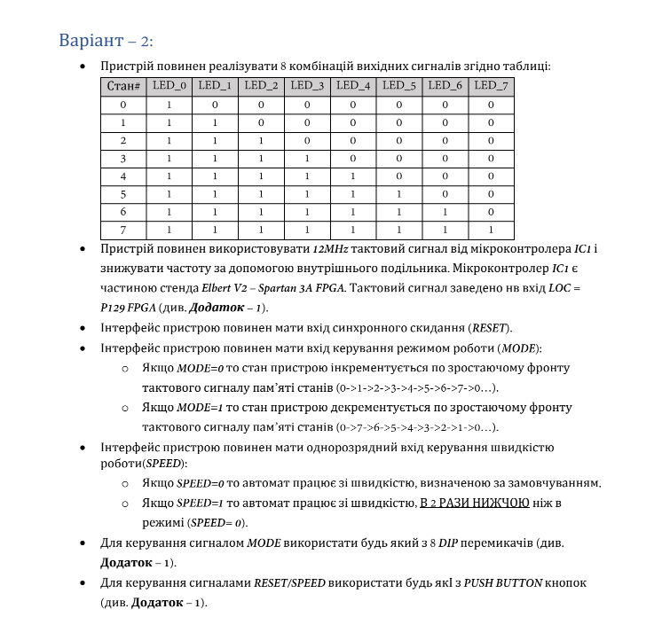

**Виконання роботи:**

**Файл OutputLogic:**

----------------------------------------------------------------------------------

-- Company:

-- Engineer:

--

-- Create Date: 11:41:55 04/08/2023

-- Design Name:

-- Module Name: out_logic_intf - out_logic_arch

-- Project Name:

-- Target Devices:

-- Tool versions:

-- Description:

--

-- Dependencies:

--

-- Revision:

-- Revision 0.01 - File Created

-- Additional Comments:

--

----------------------------------------------------------------------------------

library IEEE;

use IEEE.STD_LOGIC_1164.ALL;

-- Uncomment the following library declaration if using

-- arithmetic functions with Signed or Unsigned values

--use IEEE.NUMERIC_STD.ALL;

-- Uncomment the following library declaration if instantiating

-- any Xilinx primitives in this code.

--library UNISIM;

--use UNISIM.VComponents.all;

entity out_logic_intf is

Port ( IN_BUS : in std_logic_vector(2 downto 0);

OUT_BUS : out std_logic_vector(7 downto 0)

);

end out_logic_intf;

architecture out_logic_arch of out_logic_intf is

begin

OUT_BUS(0) <= ((not(IN_BUS(2)) and not(IN_BUS(1)) and not(IN_BUS(0))) or(not(IN_BUS(2)) and not(IN_BUS(1)) and IN_BUS(0)) or (not(IN_BUS(2)) and IN_BUS(1) and not(IN_BUS(0))) or (not(IN_BUS(2)) and IN_BUS(1) and IN_BUS(0)) or (IN_BUS(2) and not(IN_BUS(1)) and not(IN_BUS(0))) or (IN_BUS(2) and not (IN_BUS(1)) and IN_BUS(0)) or (IN_BUS(2) and IN_BUS(1) and not(IN_BUS(0))) or (IN_BUS(2) and IN_BUS(1) and IN_BUS(0)));

OUT_BUS(1) <= ((not(IN_BUS(2)) and not(IN_BUS(1)) and IN_BUS(0)) or (not(IN_BUS(2)) and IN_BUS(1) and not(IN_BUS(0))) or (not(IN_BUS(2)) and IN_BUS(1) and IN_BUS(0)) or (IN_BUS(2) and not(IN_BUS(1)) and not(IN_BUS(0))) or (IN_BUS(2) and not (IN_BUS(1)) and IN_BUS(0)) or (IN_BUS(2) and IN_BUS(1) and not(IN_BUS(0))) or (IN_BUS(2) and IN_BUS(1) and IN_BUS(0)));

OUT_BUS(2) <= ((not(IN_BUS(2)) and IN_BUS(1) and not(IN_BUS(0))) or (not(IN_BUS(2)) and IN_BUS(1) and IN_BUS(0)) or (IN_BUS(2) and not(IN_BUS(1)) and not(IN_BUS(0))) or (IN_BUS(2) and not (IN_BUS(1)) and IN_BUS(0)) or (IN_BUS(2) and IN_BUS(1) and not(IN_BUS(0))) or (IN_BUS(2) and IN_BUS(1) and IN_BUS(0)));

OUT_BUS(3) <= (((not(IN_BUS(2)) and IN_BUS(1) and IN_BUS(0))) or ((IN_BUS(2) and not(IN_BUS(1)) and not(IN_BUS(0)))) or ((IN_BUS(2) and not (IN_BUS(1)) and IN_BUS(0))) or ((IN_BUS(2) and IN_BUS(1) and not(IN_BUS(0)))) or ((IN_BUS(2) and IN_BUS(1) and IN_BUS(0))));

OUT_BUS(4) <= ((IN_BUS(2) and not(IN_BUS(1)) and not(IN_BUS(0))) or (IN_BUS(2) and not (IN_BUS(1)) and IN_BUS(0)) or (IN_BUS(2) and IN_BUS(1) and not(IN_BUS(0))) or (IN_BUS(2) and IN_BUS(1) and IN_BUS(0)));

OUT_BUS(5) <= ((IN_BUS(2) and not (IN_BUS(1)) and IN_BUS(0)) or ((IN_BUS(2)) and IN_BUS(1) and not(IN_BUS(0))) or (IN_BUS(2) and IN_BUS(1) and IN_BUS(0)));

OUT_BUS(6) <= ((IN_BUS(2) and IN_BUS(1) and not(IN_BUS(0))) or (IN_BUS(2) and IN_BUS(1) and IN_BUS(0)));

OUT_BUS(7) <= (IN_BUS(2) and IN_BUS(1) and IN_BUS(0));

end out_logic_arch;

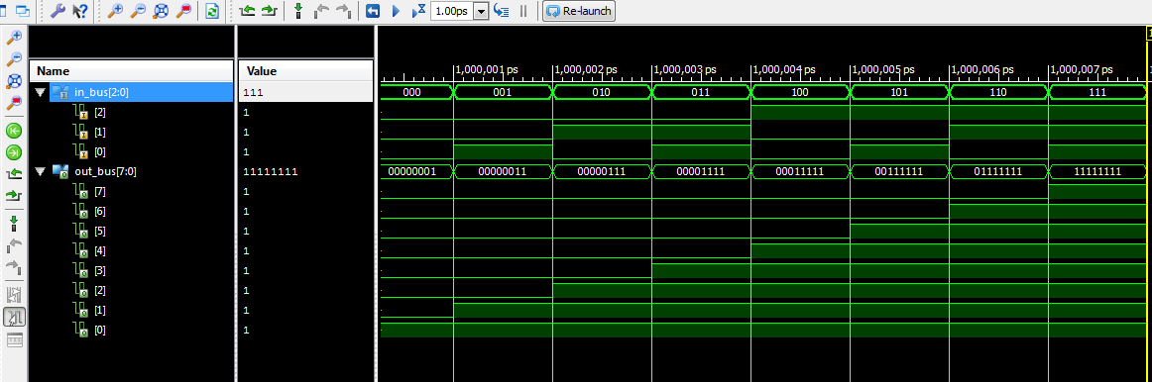

*Рис. 1 Діаграма проведеної симуляції для OutputLogic*

**Файл TransitionLogic:**

----------------------------------------------------------------------------------

-- Company:

-- Engineer:

--

-- Create Date: 16:13:21 02/23/2020

-- Design Name:

-- Module Name: transition_logic_intf - transition_logic_arch

-- Project Name:

-- Target Devices:

-- Tool versions:

-- Description:

--

-- Dependencies:

--

-- Revision:

-- Revision 0.01 - File Created

-- Additional Comments:

--

----------------------------------------------------------------------------------

library IEEE;

use IEEE.STD_LOGIC_1164.ALL;

-- Uncomment the following library declaration if using

-- arithmetic functions with Signed or Unsigned values

--use IEEE.NUMERIC_STD.ALL;

-- Uncomment the following library declaration if instantiating

-- any Xilinx primitives in this code.

--library UNISIM;

--use UNISIM.VComponents.all;

entity transition_logic_intf is

Port ( CUR_STATE : in std_logic_vector(2 downto 0);

MODE : in std_logic;

NEXT_STATE : out std_logic_vector(2 downto 0);

RESET : in std_logic

);

end transition_logic_intf;

architecture transition_logic_arch of transition_logic_intf is

begin

NEXT_STATE(0) <= (not(RESET) and not(MODE) and not(CUR_STATE(2)) and not(CUR_STATE(1)) and not(CUR_STATE(0))) or -- 000 -> 001

(not(RESET) and not(MODE) and not(CUR_STATE(2)) and CUR_STATE(1) and not(CUR_STATE(0))) or -- 010 -> 011

(not(RESET) and not(MODE) and CUR_STATE(2) and not(CUR_STATE(1)) and not(CUR_STATE(0))) or -- 100 -> 101

(not(RESET) and not(MODE) and CUR_STATE(2) and CUR_STATE(1) and not(CUR_STATE(0))) or -- 110 -> 111

(not(RESET) and MODE and not(CUR_STATE(2)) and (CUR_STATE(1)) and not(CUR_STATE(0))) or -- 001 <- 010

(not(RESET) and MODE and (CUR_STATE(2)) and not(CUR_STATE(1)) and not(CUR_STATE(0))) or -- 011 <- 100

(not(RESET) and MODE and CUR_STATE(2) and (CUR_STATE(1)) and not(CUR_STATE(0))) or -- 101 <- 110

(not(RESET) and MODE and not(CUR_STATE(2)) and not(CUR_STATE(1)) and not(CUR_STATE(0))); -- 111 <- 000

NEXT_STATE(1) <= (not(RESET) and not(MODE) and not(CUR_STATE(2)) and not(CUR_STATE(1)) and CUR_STATE(0)) or -- 001 -> 010

(not(RESET) and not(MODE) and not(CUR_STATE(2)) and CUR_STATE(1) and not(CUR_STATE(0))) or -- 010 -> 011

(not(RESET) and not(MODE) and CUR_STATE(2) and not(CUR_STATE(1)) and CUR_STATE(0)) or -- 101 -> 110

(not(RESET) and not(MODE) and CUR_STATE(2) and CUR_STATE(1) and not(CUR_STATE(0))) or -- 110 -> 111

(not(RESET) and MODE and not(CUR_STATE(2)) and (CUR_STATE(1)) and (CUR_STATE(0))) or -- 010 <- 011

(not(RESET) and MODE and CUR_STATE(2) and not(CUR_STATE(1)) and not(CUR_STATE(0))) or -- 011 <- 100

(not(RESET) and MODE and CUR_STATE(2) and CUR_STATE(1) and CUR_STATE(0)) or -- 110 <- 111

(not(RESET) and MODE and not(CUR_STATE(2)) and not(CUR_STATE(1)) and not(CUR_STATE(0))); -- 111 <- 000

NEXT_STATE(2) <= (not(RESET) and not(MODE) and not(CUR_STATE(2)) and CUR_STATE(1) and CUR_STATE(0)) or -- 011 -> 100

(not(RESET) and not(MODE) and CUR_STATE(2) and not(CUR_STATE(1)) and not(CUR_STATE(0))) or -- 100 -> 101

(not(RESET) and not(MODE) and CUR_STATE(2) and not(CUR_STATE(1)) and CUR_STATE(0)) or -- 101 -> 110

(not(RESET) and not(MODE) and CUR_STATE(2) and CUR_STATE(1) and not(CUR_STATE(0))) or -- 110 -> 111

(not(RESET) and MODE and CUR_STATE(2) and not(CUR_STATE(1)) and CUR_STATE(0)) or -- 100 <- 101

(not(RESET) and MODE and CUR_STATE(2) and CUR_STATE(1) and not(CUR_STATE(0))) or -- 101 <- 110

(not(RESET) and MODE and CUR_STATE(2) and CUR_STATE(1) and CUR_STATE(0)) or -- 110 <- 111

(not(RESET) and MODE and not(CUR_STATE(2)) and not(CUR_STATE(1)) and not(CUR_STATE(0))); -- 111 <- 000

end transition_logic_arch;

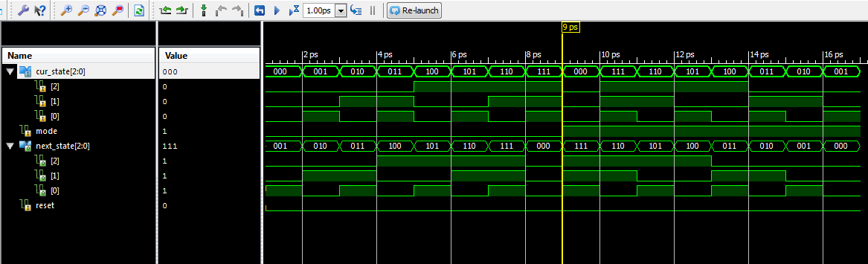

*Рис. 2 Діаграма проведеної симуляції для TransitionLogic*

**Схема для Light controller**

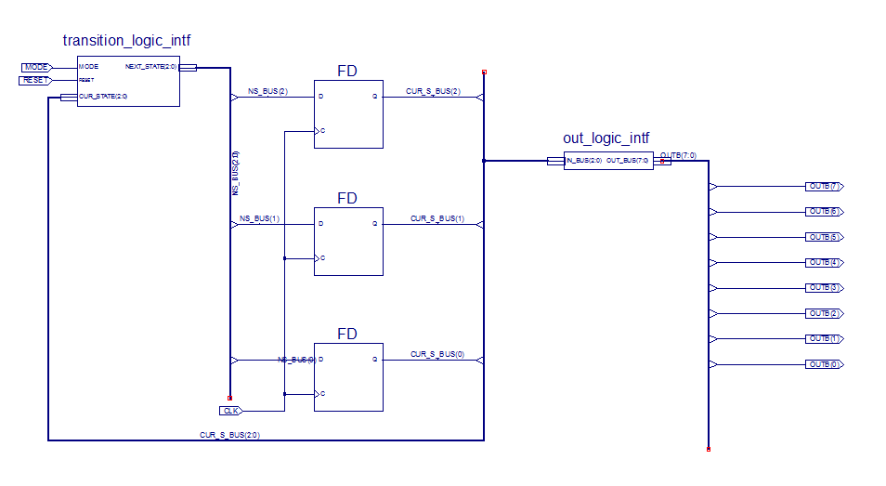

*Рис. 3 Схема LightController*

*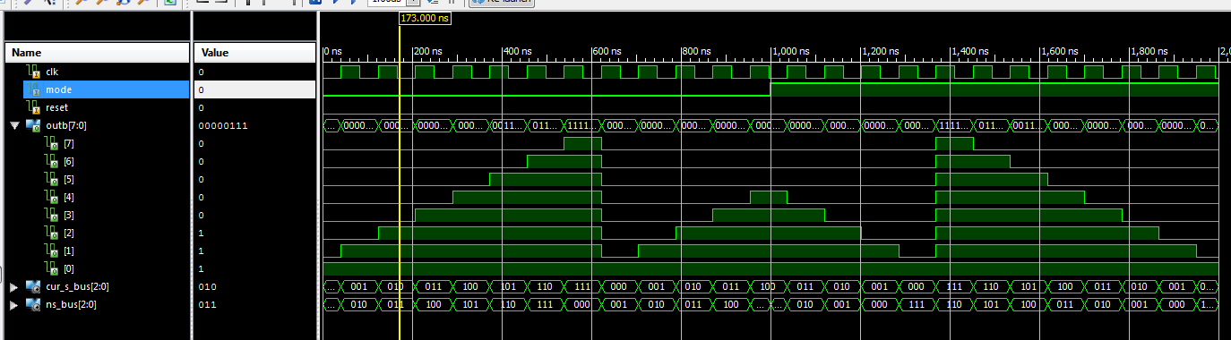 Рис. 4 Діаграма проведеної симуляції для LightController*

**Файл TestBench:**

LIBRARY ieee;

USE ieee.std_logic_1164.ALL;

USE ieee.numeric_std.ALL;

LIBRARY UNISIM;

USE UNISIM.Vcomponents.ALL;

ENTITY TopLevel_TopLevel_sch_tb IS

END TopLevel_TopLevel_sch_tb;

ARCHITECTURE behavioral OF TopLevel_TopLevel_sch_tb IS

COMPONENT TopLevel

PORT( SPEED : IN STD_LOGIC;

RESET : IN STD_LOGIC;

MODE : IN STD_LOGIC;

OUT_BUS : OUT STD_LOGIC_VECTOR (7 DOWNTO 0);

CLOCK : IN STD_LOGIC);

END COMPONENT;

SIGNAL SPEED : STD_LOGIC;

SIGNAL RESET : STD_LOGIC;

SIGNAL MODE : STD_LOGIC;

SIGNAL OUT_BUS : STD_LOGIC_VECTOR (7 DOWNTO 0);

SIGNAL CLOCK : STD_LOGIC := '0';

BEGIN

UUT: TopLevel PORT MAP(

SPEED => SPEED,

RESET => RESET,

MODE => MODE,

OUT_BUS => OUT_BUS,

CLOCK => CLOCK

);

-- *** Test Bench - User Defined Section ***

tb : PROCESS

BEGIN

RESET <= '0';

MODE <= '1';

SPEED <= '0';

wait for 10 ms;

RESET <= '0';

MODE <= '1';

SPEED <= '0';

wait for 10 ms;

RESET <= '0';

MODE <= '1';

SPEED <= '0';

wait for 10 ms;

RESET <= '0';

MODE <= '1';

SPEED <= '0';

wait for 10 ms;

RESET <= '0';

MODE <= '1';

SPEED <= '0';

wait for 10 ms;

RESET <= '0';

MODE <= '1';

SPEED <= '1';

wait for 10 ms;

RESET <= '0';

MODE <= '1';

SPEED <= '1';

wait for 10 ms;

RESET <= '0';

MODE <= '1';

SPEED <= '1';

wait for 10 ms;

RESET <= '0';

MODE <= '1';

SPEED <= '1';

wait for 10 ms;

WAIT; -- will wait forever

END PROCESS;

-- *** End Test Bench - User Defined Section ***

tb_clk: PROCESS

BEGIN

CLOCK <= not CLOCK;

wait for 0.83 ns;

END PROCESS;

END;

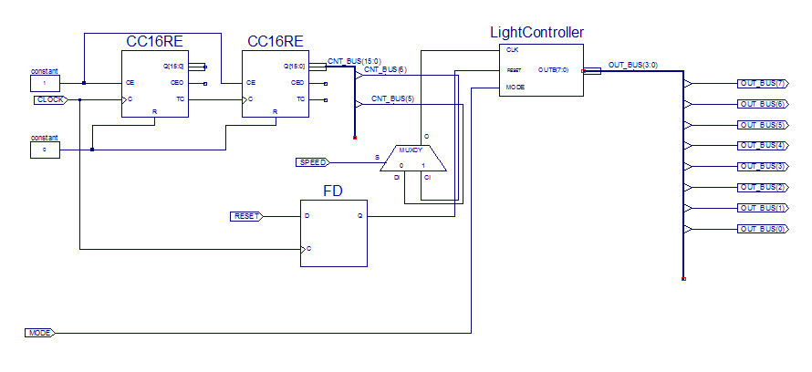

*Рис. 5 Схема TopLevel*

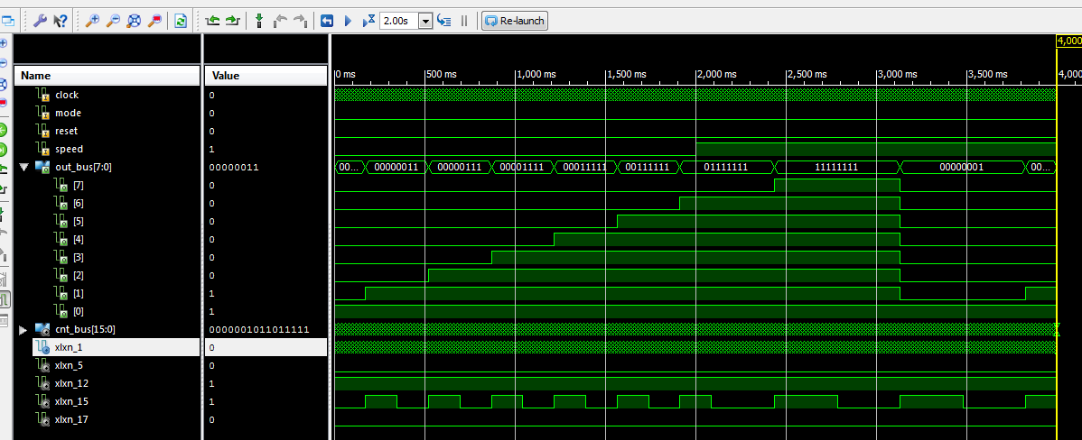

*Рис. 6 Діаграма проведеної симуляції для TopLevel*

**Створення Constant файлу:**

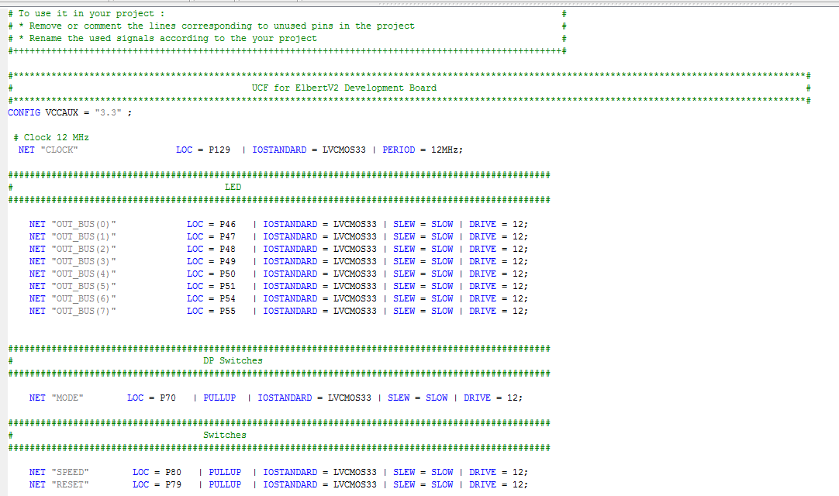

**Висновок:** на цій лабораторній роботі, я на базі стенда Elbert V2 – Spartan 3A FPGA, реалізував цифровий автомат світлових ефектів.