Mutual Information (MI) is a measure of the mutual dependence between two variables. It quantifies how much knowing one variable reduces the uncertainty of the other. MI is widely used in statistics, machine learning, and information theory for feature selection, understanding relationships between variables, and evaluating the information shared between random variables.

Key Concepts
- Information Gain:
  - MI tells us how much information about one variable (e.g., the target variable) is gained by knowing the other variable (e.g., a predictor).
- Nonlinear Relationships:
- Unlike correlation, MI captures both linear and nonlinear dependencies. Even if variables are not linearly related, MI can still detect their association.
- Range:
- MI is non-negative: MI (X, Y) ≥ 0.
- MI (X, Y) = 0 implies the variables are completely independent.
- Higher MI values indicate stronger dependency.
- Interpretation:
- MI does not have a fixed scale like correlation coefficients (which range from -1 to 1). It depends on the distributions of the variables and their entropy (uncertainty).

Formula for Mutual Information
Mutual Information between two discrete variables X and Y is defined as:
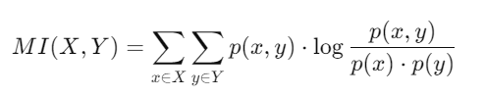
Where:
- 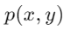: Joint probability distribution of X and Y
- 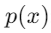: Marginal probability distribution of X.
- : Marginal probability distribution of Y.
For continuous variables, MI is computed using density estimates or discretization.

Applications of Mutual Information
- Feature Selection:
  - Identify the most informative features for predicting the target variable.
- Dependency Detection:
  - Detect nonlinear or complex relationships between variables.
- Clustering:
  - Evaluate the similarity between data partitions.
- Entropy-Based Measures:
  - Used in areas like signal processing and cryptography to analyze the uncertainty or randomness in data.

Example: Intuition
- Imagine you are predicting house prices based on features like the number of bedrooms.
- If MI (Number of Bedrooms, House Price) is high, knowing the number of bedrooms significantly reduces the uncertainty in predicting house prices.

