Deep Learning-Based Prediction of Coronary Heart Disease
Serin Shabu, Dr.Neenu Kuriakose
Undergraduate Student, Department of BCA, Rajagiri College of Management and Applied Sciences, Kakkanad
Assistant Professor, Department of BCA, Rajagiri College of Management and Applied Sciences, Kakkanad
serinshabu@gmail.com

Abstract
Coronary Heart Disease (CHD) remains a major contributor to global mortality, demanding accurate and early risk prediction strategies. Traditional statistical models struggle to capture nonlinear relationships among diverse clinical and lifestyle factors, whereas machine learning and deep learning methods can extract richer patterns. However, the performance of such models is often limited by imbalanced datasets, especially when the number of CHD-positive patients is significantly lower than that of the CHD-negative group. This study proposes a deep learning-based approach enhanced with Generative Adversarial Networks (GANs) to balance the Framingham Heart Study dataset. Synthetic CHD-positive samples were generated to address class imbalance and improve minority class detection. The deep learning model trained on the GAN-augmented dataset demonstrates improved accuracy, recall, and F1-score, reflecting its potential for reliable early prediction of 10-year CHD risk. The results highlight the effectiveness of GAN-based balancing for developing clinically meaningful and robust risk prediction systems.
Keywords: Cardiovascular Risk Assessment, Class Imbalance Handling, Coronary Heart Disease (CHD), Deep Learning, Framingham Heart Study, Generative Adversarial Network (GAN).

1. INTRODUCTION
Coronary Heart Disease (CHD) is caused by the narrowing or blockage of coronary arteries due to plaque accumulation, leading to reduced blood flow and increased risk of heart attacks [1]. CHD continues to be one of the leading causes of death globally, imposing a major burden on healthcare systems. Early identification of high-risk individuals is crucial to initiate timely interventions, prevent disease progression, and reduce mortality.
Over the past few decades, researchers have increasingly focused on computational and data-driven approaches to assist medical professionals in understanding cardiovascular disease patterns, predicting risk levels, and optimising preventive care. We have used the longitudinal dataset namely the Framingham Heart Study dataset, which has enabled the development of models based on demographic, lifestyle, and clinical variables [2].
Traditional CHD prediction models offer limited performance because they assume linear relationships among variables. In reality, CHD risk is influenced by complex interactions between age, cholesterol levels, blood pressure, glucose, smoking status, diabetes, and other lifestyle factors. As a solution for this deep learning models with non-linear relationships provides better solutions [3]. Machine learning and deep learning models improve predictive accuracy but often suffer from imbalanced datasets, where the number of CHD-positive samples is considerably smaller than CHD-negative samples.
Deep learning models, particularly neural networks, are capable of capturing nonlinear relationships and complex feature interactions. However, their performance also decreases when trained on imbalanced data. Generative Adversarial Networks (GANs), a class of deep generative models, have emerged as a promising approach to synthesising high-quality minority class samples. By generating realistic CHD-positive records, GANs can significantly improve model performance and support accurate risk classification.
This study integrates deep learning methods with GAN-based data balancing to improve CHD prediction performance. The proposed approach leverages both real and synthetic patient data to build a more representative dataset, ensuring robust and reliable prediction outcomes.

2. LITERATURE STUDY
Several studies have explored CHD prediction using statistical and machine learning approaches. The more relevant works are explored here.
[4] et. al. in their introduction, GANs have been adapted from image domains to tabular and electronic-health-record (EHR) data. Early work, such as medGAN, introduced an autoencoder-GAN hybrid specifically to synthesise high-dimensional discrete patient records, demonstrating that realistic EHR-style binary count features can be generated and used for downstream predictive tasks. medGAN also introduced practical strategies like minibatch averaging to avoid mode collapse in healthcare data. This line of work established that GANs can create synthetic health records with utility comparable to real data for some tasks. [5] et.al. proposed that the tabular data presents distinct challenges such as mixed continuous categorical features, multimodal continuous distributions, imbalanced categories. CTGAN, the Conditional Tabular GAN proposed mechanisms to model discrete and continuous columns and to condition generation on categorical values, becoming a go-to baseline for tabular synthesis. Later models such as CTAB-GAN and CTAB-GAN+ extended these ideas by introducing improved conditional vectors, auxiliary classification losses, and mechanisms to better handle skewed/long-tail and highly imbalanced variables; they report substantially improved statistical similarity and machine-learning utility over earlier baselines. These advances are directly relevant to balancing a clinical dataset like Framingham, where the minority, the CHD-positive class is underrepresented. [6] et. al studied recent literature reviews show a rapid growth of synthetic-data methods for healthcare, highlighting benefits (data augmentation, privacy, improved minority-class learning) as well as caveats (distributional fidelity, privacy leakage risks, evaluation metrics). [7] et. al. introduced progressive works (TableGAN, CTAB variants, DP-CTGAN) that focus on utility-privacy trade-offs and robustness to imbalanced data. Several studies propose classifier-aware losses and distance-based privacy checks; others incorporate differential privacy to limit disclosure risk when publishing synthetic health data. This literature supplies practical choices (which GAN variant, evaluation metrics and privacy safeguards) when producing and publishing synthetic Framingham-style records. [8] et. al. used a broad set of works to compare logistic regression, tree ensembles, SVMs, and neural networks for CHD/CVD risk. Several recent papers apply ML/DL to the Framingham dataset or similar and some obtain improvements in AUC-recall by careful feature selection, ensemble learning, or data augmentation (SMOTE, GANs). Reviews of CHD prediction emphasise two recurrent issues: (a) class imbalance (low event rates) harms sensitivity for the positive class, and (b) explainability is critical for clinical acceptance. Applying GANs to balance training data has been shown to increase recall-F1 for minority events in multiple health-domain studies, supporting your approach. [9] et. al. proposed the use of CTGAN-CTAB, and emphasise two-pronged evaluation: (i) statistical similarity between real & synthetic distributions (marginal and conditional), and (ii) utility on downstream ML tasks (e.g., classification metrics on held-out real data). For CHD prediction, you should therefore report distributional checks for each major clinical feature and show how classifier performance (accuracy, recall, F1, AUC) improves when training on the GAN-augmented dataset versus unaugmented data.
This study shows that combining GANs with deep learning enhances minority-class prediction, improves recall, and reduces false negatives—an essential requirement in medical diagnostics.

3. MATERIALS AND METHODS
The methodology adopted in this study consists of a structured sequence of data preparation, synthetic data generation, model development, and experimental evaluation. Each stage is designed to address specific challenges in the Framingham Heart Study dataset, particularly missing values, heterogeneous feature types, and severe class imbalance.
- Dataset
The study uses data from the publicly available version of the Framingham Heart Study dataset, which comprises approximately 4,240 patient records [10]. Each record includes a combination of 15 input features and a binary outcome variable (TenYearCHD) indicating whether the subject developed Coronary Heart Disease within 10 years. The input features cover demographic attributes (age, sex, education), lifestyle factors (smoking status, cigarettes per day), medical history (hypertension, stroke history, diabetes, blood pressure medication), and clinical measurements (total cholesterol, systolic and diastolic blood pressure, BMI, heart rate, and glucose level). These features are widely recognized risk factors for CHD, making the dataset well-suited for predictive modeling. Given the mixture of categorical and continuous variables, preprocessing (encoding, normalization, handling missing data) is required. Because CHD-positive cases are often underrepresented, special attention must be paid to class imbalance during model training.
B) Data Preprocessing
Proper data preprocessing is essential to ensure the reliability and accuracy of any machine learning pipeline. The Framingham dataset contains both numerical and categorical variables, along with missing values that can affect model performance if not handled appropriately. To address missing values, numerical features such as age, serum cholesterol, systolic blood pressure, and glucose levels were imputed using the median, as it is robust to outliers and preserves the central tendency of the distribution. Categorical variables such as smoking status, diabetes, or sex were imputed using the mode, ensuring consistency in category representation. Following imputation, categorical variables were encoded using one-hot encoding, allowing them to be transformed into a format suitable for deep learning models that expect numerical input. Numerical features were normalised using either MinMaxScaler, ensuring that features operate on a comparable scale and improving neural network convergence. Finally, the cleaned dataset was divided into training and testing subsets using an 80–20 split, allowing for unbiased evaluation of model performance on unseen data.
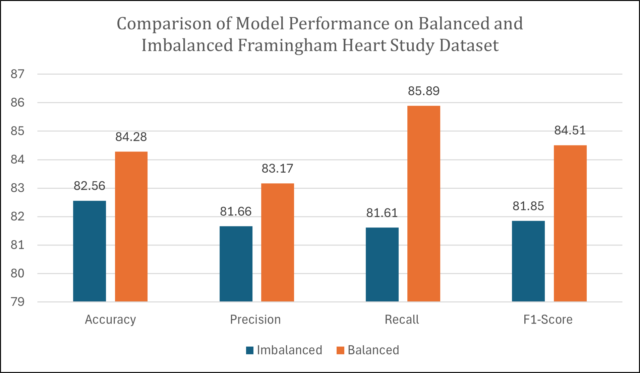
Figure 1
C) Handling Imbalanced Data Using GAN
One of the major challenges in predicting CHD is the imbalanced distribution of the target variable. In the Framingham dataset, CHD-positive samples constitute a small minority, resulting in models biased toward predicting the majority class. To address this, a generative approach using GANs was incorporated.
Generative Adversarial Networks (GANs)
A GAN consists of two competing neural networks.
Generator (G): Learns to create synthetic samples that mimic real CHD-positive cases. Takes random noise as input and produces records resembling the minority class.
Discriminator (D): Attempts to distinguish between real and synthetic samples. Provides feedback to the generator to improve its output. Through this adversarial training process, the generator gradually learns to create high-quality synthetic CHD-positive records.
Minority class extraction is done by using only 645 CHD-positive samples to train the GAN. GAN learns the distribution of minority samples. The trained generator produces synthetic CHD-positive records. Synthetic and real samples are combined with real CHD-negative samples to create a balanced dataset.
D) Deep Learning Model Architecture
The predictive model used in this study is a Multi-Layer Perceptron (MLP), a type of feedforward deep neural network capable of learning complex nonlinear interactions among clinical features.
Input Layer:
Receives normalised and encoded features such as age, cholesterol, blood pressure, diabetes, smoking status, and synthesised GAN features.
Hidden Layers:
Three dense layers with ReLU activation were used to capture nonlinear relationships.
Dropout layers or batch normalisation may also be added to prevent overfitting and stabilise training.
Output Layer:
Uses a sigmoid activation to output a probability between 0 and 1, representing the likelihood of CHD occurring within 10 years.
Training Configuration
Loss Function is Binary Cross-Entropy, which is appropriate for the two-class problems. Optimiser Adam is chosen for fast convergence and adaptive learning. The evaluation metrics used are Accuracy, Precision, Recall (critical for identifying CHD-positive cases) and F1-score. These metrics provide a comprehensive evaluation of model performance, including the ability to detect minority-class outcomes
E) Experimental Setup
The experimental setup for this study was implemented using a deep learning environment to ensure efficient data processing, model training, and performance evaluation. All experiments were conducted using the Python programming language, leveraging key libraries such as TensorFlow/Keras for building and training the deep learning models, Scikit-learn for data preprocessing, dataset splitting, and evaluation metrics, and the GAN library for generating high-quality synthetic data to balance the minority CHD-positive class. The entire workflow was executed on a GPU-enabled Google Colab environment, which provided accelerated computational capabilities necessary for training deep neural networks and GAN models efficiently. To ensure a rigorous evaluation, the deep learning model was trained and tested on the imbalanced dataset and the GAN-balanced dataset, allowing for a direct comparison of performance differences arising from synthetic augmentation. Multiple training iterations and validation cycles were performed to assess model stability, reduce variance, and ensure that the experimental results were robust and generalizable. This controlled and reproducible setup enabled a comprehensive assessment of the effectiveness of GAN-based data balancing in improving CHD prediction accuracy and reliability.
F) Results and Discussion
Figure 1 explains the performance of the deep learning model evaluated on the imbalanced dataset and the GAN-balanced dataset to determine the impact of synthetic data augmentation on Coronary Heart Disease prediction. The results demonstrate a substantial improvement in model performance after incorporating GAN-generated CHD-positive samples. When trained on the imbalanced dataset, the model achieved an accuracy of 82.56, with a precision of 81.66, recall of 81.61 and an F1-score of 81.85, indicating limited ability to correctly identify CHD-positive cases. However, after the dataset was balanced using synthetic minority samples generated through GANs, the model’s accuracy increased to 84.28, reflecting enhanced overall classification capability. More importantly, the recall improved significantly to 85.89, indicating a much stronger ability to detect true CHD-positive instances, while the precision improved to 83.17 and F1-score rose to 84.51, demonstrating a better balance between precision and recall. These improvements confirm that GAN-based data balancing effectively mitigates class imbalance and enhances the predictive performance of the deep learning model, particularly in identifying high-risk individuals who may otherwise be overlooked in clinical settings.
GAN-based balancing significantly improved recall and F1-score, indicating better detection of CHD-positive cases. The deep learning model achieved stable performance and reduced bias toward the majority class. The synthetic data generated by GAN closely resembled real-world patterns, supporting enhanced training quality. The improved model supports early CHD prediction, contributing to preventive healthcare and risk stratification.
4. CONCLUSION
This research demonstrates that integrating GAN-based data balancing with deep learning models improves CHD risk prediction significantly. The proposed approach addresses imbalanced datasets effectively, ensuring that minority class instances (CHD-positive patients) are identified more accurately. The enhanced performance highlights the potential of GAN-augmented deep learning models in medical diagnostics and early detection systems.
5. FURTHER ENHANCEMENT
Future improvements may include, advanced generative models such as CTGAN, TVAE, or diffusion models for better synthetic data quality. Implementing explainable AI techniques (SHAP, LIME) to interpret model decisions for clinical acceptance. Expanding the dataset to multi-centre, multi-ethnic populations for improved generalisation. Integrating the predictive model into a real-time clinical decision support system. Applying time-series health records for longitudinal CHD risk prediction.

REFERENCES
[1] Lawton, Jennifer S., et al. "2021 ACC/AHA/SCAI guideline for coronary artery revascularization: executive summary: a report of the American College of Cardiology/American Heart Association Joint Committee on Clinical Practice Guidelines." Circulation 145.3 (2022): e4-e17.
[2] Yuda, E., Itaru Kaneko, and Daisuke Hirahara. “Machine-Learning Insights from the Framingham Heart Study: Enhancing Cardiovascular Risk Prediction and Monitoring.” Applied Sciences 15.15 (2025): 8671. MDPI
[3] Rodrigues, L. L. R. “Machine learning in coronary heart disease prediction.” [Journal] (2020). Taylor & Francis Online
[4] Choi, Edward, et al. “Generating Multi-label Discrete Patient Records using Generative Adversarial Networks (medGAN).” Proceedings of the 2017 Machine Learning for Healthcare Conference, 2017. Proceedings of Machine Learning Research
[5] Xu, Lei, Maria Skoularidou, Alfredo Cuesta-Infante, and Kalyan Veeramachaneni. “Modeling Tabular Data using Conditional GAN.” arXiv preprint arXiv:1907.00503 (2019). arXiv
[6] Zhao, Zilong, et al. “CTAB-GAN: Effective Table Data Synthesizing.” Proceedings of the 2021 Asian Conference on Machine Learning / arXiv, 2021. arXiv
[7] Zhao, Zilong, et al. “CTAB-GAN+: Enhancing Tabular Data Synthesis.” Frontiers in Big Data (2024). PMC
[8] Pezoulas, V. C., et al. “Synthetic data generation methods in healthcare: A review.” [ScienceDirect / Journal] (2024). ScienceDirect
[9] Sun, C., et al. “Generating synthetic personal health data using generative models.” Information Systems / Elsevier (2023). ScienceDirect
[10] D. D. Lewis et al., “Framingham Heart Study: Dataset Overview,” Journal of Cardiovascular Research,
2018.

