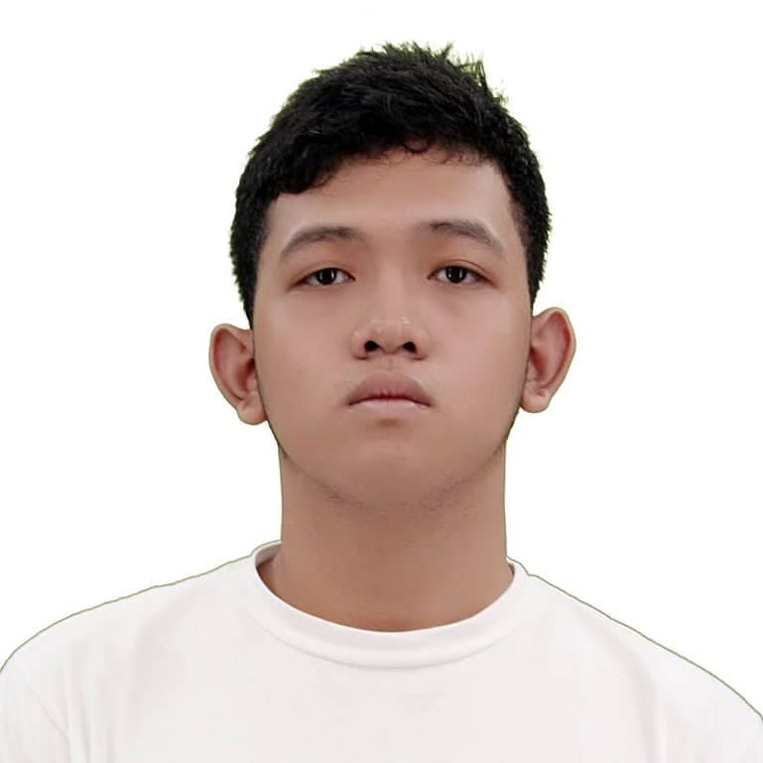
MARK JOHN V. SERIOS

182 A. Santos Subdivision, Pasolo, Valenzuela City
285-4561
+639478238252
mark_john_serios@dlsu.edu.ph

OBJECTIVE
To acquire a position in where I can showcase my skills as a mechanical engineer and to learn new things that will help me become a better mechanical engineer.

EDUCATION

de la salle university
Bachelor of Science in Mechanical Engineering with Specialization in Mechatronics Engineering, September 2018. Dean’s List: 1st Term, AY 2018-2019.

Pamantasan ng lugnsod ng valenzuela
Senior high school diploma, April 2018. With honors.

ST. MARY’S COLLEGE OF MEYCAUAYAN
Junior high school completion certificate.

WORK EXPERIENCE

January-March 2018 Building administration assistant
Assisted the engineers of Building Administration Department of Pamantasan ng Lungsod ng Valenzuela; handled the inventories of the newly made building of Pamantasan ng Lungsod ng Valenzuela Maysan campus.

SEMINARS ATTENDED

February 2017 Unshackling the poet within
Valenzuela City Amphitheater

September 2016 Astronomical events and geological activites
Valenzuela City Auditorium

August 2016 Dream, believe. soar high #lifegoals
Valenzuela City Auditorium

RESEARCH PAPERS PREPARED

March 2018 Understanding How Self-Efficacy Affects the Decidedness of Grade 11 STEM Students towards Their Course Choice
Analyzed the relationship between self-efficacy and the course choice of grade 11 STEM students of Pamantasan ng Lungsod ng Valenzuela.

PERSONAL BACKGROUND

Fluent in English and Filipino. Knowledgeable in Microsoft programs and Adobe Photoshop. Interests: Sleeping, playing Basketball, and playing video games. Adaptable, goal-oriented, hardworking, and quality oriented.

REFERENCES

Lodybella v. serios
Mom
+639199454865; seriosvia@gmail.com
182 A. Santos Subdivision, Pasolo, Valenzuela City.

