把fig,axs 改为fig,ax就可以

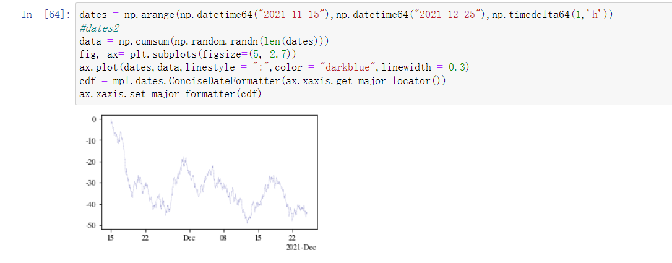

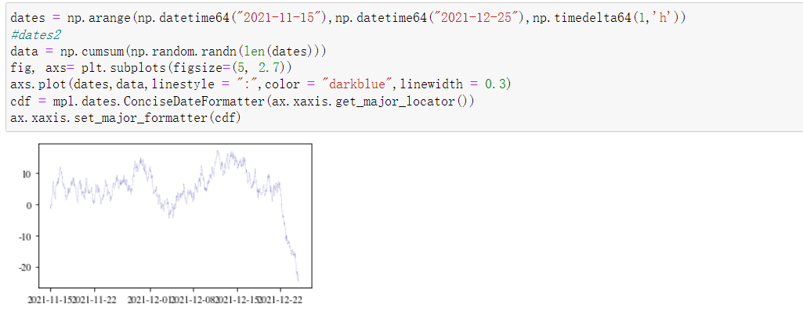

源代码

dates = np.arange(np.datetime64("2021-11-15"),np.datetime64("2021-12-25"),np.timedelta64(1,'h'))

#dates2

data = np.cumsum(np.random.randn(len(dates)))

fig, axs= plt.subplots(figsize=(5, 2.7))

axs.plot(dates,data,linestyle = ":",color = "darkblue",linewidth = 0.3)

cdf = mpl.dates.ConciseDateFormatter(ax.xaxis.get_major_locator())

ax.xaxis.set_major_formatter(cdf)

官方教程链接

<https://matplotlib.org/stable/tutorials/introductory/usage.html#axes>

