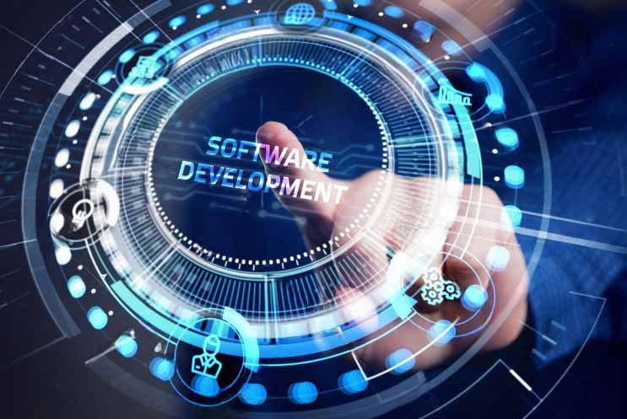

**SOFTWARE DEVELOPMENT**

Our proficiency in software development is such that we can deliver outstanding outcomes for even the most intricate project requirements. Keeping up with the swift advancements in the software realm and providing optimal technological solutions for our clients rank high among our commitments. The following outlines some of our technical capabilities in the software domain:

* Tailored Software Development
* Proficiency in Languages and Technologies
* Commitment to Data Security and Compliance
* Implementation of DevOps and Continuous Integration
* Specialization in Big Data and Analytics
* Development of Cloud Computing Applications



**GAME DESIGN**

Our firm is comprised of teams possessing vast expertise and substantial experience in the realm of game development. With our dedication to technology and a creative fervor, our objective is to provide distinctive and breath-taking experiences in the gaming domain. Below are some of our in-game technical proficiencies:

* Various Game Types
* Expertise in 3D and 2D Graphics
* Mastery of Game Physics and Simulation
* Ensuring Mobile and Platform Independence
* Implementation of Monetization Strategies
* Focus on User Experience Design
* Rigorous Game Testing and Quality Assurance



**EXPERTISE IN AVIATION SIMULATIONS**

Our company possesses extensive knowledge and hands-on experience in the field of aviation simulations. Our goal is to develop top-notch simulations that accurately capture the intricacies and precision of the aviation industry. Our capabilities include:

* Diverse Applications
* Expertise in Flight Dynamics and Modeling
* Integration in Education and Entertainment
* Emphasis on Realism and Security
* Real-Time Data Stream Implementation