**MARMARA UNIVERSITY**

**FACULTY OF ENGINEERING**

**COMPUTER ENGINEERING DEPARTMENT**

**CSE3033 OPERATING SYSTEMS**

**PROJECT-3**

|  |  |
| --- | --- |
| **Number First Name** | **Last Name** |
| 150119566 Müslim | Yılmaz |
| 150119037 Ömer | Kibar |
| 150119036 Serkan | Korkut |

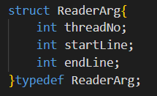**Structs**

ReaderArg is a struct to hold arguments for reader thread. Each reader threads reads it’s assigned lines.

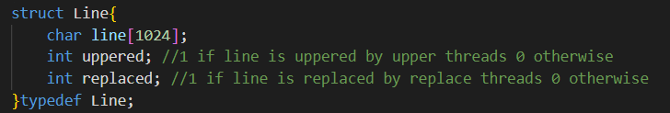

Line is a struct to hold line data and information if it is uppered and replaced.

**Global Variables Used By Threads**

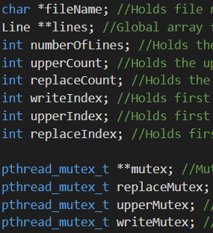

* **Line **lines** : It is a global array to hold lines each index is a struct of type Line.
* **pthread_mutex_t **mutex** : Mutex array. Each thread should lock corresponding mutex from mutex array before modifying lines array. So multiple threads can modify different indexes of lines array but can’t modify same index.
* **int writeIndex** : Holds the first index that isn’t written to the file. It can be modified only by locking writeMutex.
* **int upperIndex** : Holds the first index that isn’t uppered. It can be modified only by locking upperMutex.
* **int replaceIndex** : Holds the first index that isn’t replaced. It can be modified only by locking replaceMutex.

**Main Function**

Main function checks the input parameters and create each thread type accordingly. It initializes global lines array, mutexes and other global variables used by threads. After creation of threads is done, main thread waits for threads to complete their job. When threads completed their job main function destroys mutexes and terminates the program.

**Reader Function**

Reader threads starts from this function and reads from file according to it is assigned lines and write them to corresponding index of global lines array.

**Upper Function**

Upper threads starts from this function. Upper threads goes to infinite while loop until all the lines uppered. In each loop they lock the mutex for upperIndex then select it as index to upper then increments upperIndex and unlocks the upperIndex mutex. After they select the index to upper they wait it to be readed by reader threads. Then they lock the choosed index of lines array and upper the contents then unlock the mutex. Also they print information about their modification on the lines array.

**Write Function**

Write threads starts from this function. Write threads goes to infinite while loop until all the lines written to the file. In each loop they lock the mutex for writeIndex then select it as index to write then increments writeIndex and unlocks the writeIndex mutex. After they select the index to write they wait it to be readed,replaced and uppered by other threads. Then they lock the choosed index of lines array and write the contents to the file then unlock the mutex. Also they print information about their modification on the lines array.

**Replace Function**

Replace threads starts from this function. Replace threads goes to infinite while loop until all the lines replaced. In each loop they lock the mutex for replaceIndex then select it as index to upper then increments replaceIndex and unlocks the replaceIndex mutex. After they select the index to replace they wait it to be readed by reader threads. Then they lock the choosed index of lines array and replace ‘ ‘ with ‘_’ then unlock the mutex. Also they print information about their modification on the lines array.