 

**MARMARA UNIVERSITY**

**FACULTY OF ENGINEERING**

**COMPUTER ENGINEERING DEPARTMENT**

**CSE3055**

**DATABASE SYSTEMS**

**PRJOJECT STEP 3**

|  |  |  |
| --- | --- | --- |
| **Number** | **First Name** | **Last Name** |
| 150119566 | Müslim | Yılmaz |
| 150119037 | Ömer | Kibar |
| 150119036 | Serkan | Korkut |

**PROJECT NAME: UPS_DELIVERY**

# Introduction

The aim of this project is designing and creating database system related the production and selling phase of the Inform Technology. Our project supports the web-interface and implementing in MS SQL.

# Entities and Definitions

* **Employee:** Contains employee information. It has 2 disjoint subtypes.
* **BlueCollarEmployee:** Subtype of employee. keeps employees working directly in production.
* **WhiteCollarEmployee:** Subtype of employee. This entity is for the employees who will work in the office.
* **Department:** An entity used for department information.
* **Factory:** An entity belonging to the factory where products are made by assembly.
* **Customer:** It contains the information of the buyer who wants to buy the manufactured product.
* **UPSProduct:** An entity that holds the manufactured UPS product and their common properties.
* **ONE_ONE_PHASE:** Subtype of UPSProduct. Includes information about 2 ac wires UPS.
* **THREE_ONE_PHASE:** Subtype of UPSProduct. Includes information about 4 ac wires UPS.
* **THREE_THREE_PHASE:** Subtype of UPSProduct. Includes information about 6 ac wires UPS.
* **SupplierCompany:** An entity for the company that sells materials used in assembly.
* **Item:** It contains the parts used in assembly and information about them.
* **SupplyRecord:** An associative entity for supplying parts from the supplier to the factory.

## Business Processes and Definitions

Uninterruptible power supply (UPS shortly) is an electrical apparatus that provides emergency power to a load when the input power source or mains power fails. One of the biggest producer company of UPS in the Turkey is Inform Technology. The company has services and several products related to high electronic systems.

**Products:**

There are many high-level electronical products in the production part of the company. We consider three of them which is related to uninterruptible power supply types which are:

* 1 Phase in 1 Phase Out UPS
* 3 Phase in 1 Phase Out UPS
* 3 Phase in 3 Phase Out UPS

In electricity, the phase refers to the distribution of a load. Single-phase power is a two-wire alternating current (ac) power circuit. There is one power wire and one neutral wire, with current flowing between the power wire and the neutral wire.[1]

Residential homes are usually served by a single-phase in single phase out UPS, while commercial and industrial facilities usually use a three-phase in three-phase out UPS. Addition to that, three phase in one phase out is intermediate form between the other two UPS.

For each type of UPS mentioned above, there are a difference in features and prices. In each type, there are several sub-type UPS. This difference exists due to industrial features between them. Among these features, **conversion technology**, **energy saving mode**, frequency converter hertz, **environment** **friendly** **status** and **amount** **of** **voltage** it provides are the most important ones.

## Business Rules and Restrictions

* Before the starting design phase, requirement analysis will be done. In this analysis, we will provide information about business processes, functional, non-functional requirements, and general implementation.
* Several meetings will be done before each project phase. Also, detailed report will be submitted in each phase.
* There are many different parts in company. In project design we will focus on production and sales part.

# Functional Requirements

* Supplier company supplies items to factory and these supplies should be recorded. Each product needs different items to be produced in the factory.
* Customers can order product. If the product is in the stock, the order will be placed immediately otherwise order will wait until the product is produced.
* Employees should be classified as blue collar and white-collar employees. Blue collar employees have seniority attribute that is used when calculating new salary each year. White collar employees will work in different departments based on their university majors.
* Each employee should work in a different department.
* Each employee should be supervised by another employee.
* Each department should have a manager.

# Non-functional Requirements

* Database system should be implemented by using Microsoft SQL Server.
* A website should be deployed and using the website customer should interact with the database and perform CRUD operations on each table.
* An entity relation diagram that clearly shows all the entities and diagrams should be provided.
* Requirement analysis document that contains entities and their definitions, business processes, business rules, functional nonfunctional requirements, should be provided.
* Database system should include views, triggers, and stored procedures

**DATABASE DIAGRAM**

metin, iç mekan, ekran görüntüsü içeren bir resim

Açıklama otomatik olarak oluşturuldu

**TABLES**

* **EMPLOYEE**
* **Definition**
* Employee table holds information about employees in the working factory. Employee entity is a supertype of tables called ‘BLUECOLLAREMPLOYEE’ and ‘WHITECOLLAREMPLOYEE.’ Age is computed automatically with birthdate field.
* **Columns**
* **TCKN:** varchar (11)
* **FirstName:** nvarchar (20)
* **LastName:** nvarchar (20)
* **Address:** nvarchar (60)
* **Birthdate:** Date
* **Age:** int
* **Gende**r: char (1)
* **PhoneNumber:** varchar (14) UNIQUE
* **StartingDate:** Date
* **Salary:** float DEFAULT 0
* **EmployeeType:** char (1)
* **DepartmentNo:** smallint
* **Primary key:**
* TCKN
* **Foreign key:**
* **Indexes:**
* INDEX name_asc (LastName ASC)
* INDEX salary (Salary DESC)
* **Others:**
* PhoneNumber – **unique**, Age – **computed**, salary **– default**
* **BLUECOLLAREMPLOYEE**
* **Definition**
* This table holds TCKN and seniority information about the employees who called as ‘blue collar.’ Blue-collar worker is a working-class person who performs manual labor. Seniority column holds information about how many years he/she has been working in the factory.
* **Columns**
* **TCKN:** varchar (11)
* **Seniority:** smallint
* **Primary key:**
* TCKN
* **Foreign key:**
* TCKN
* **Indexes:**
* **Others:**
* seniority – **default**,
* **Trigger:** This table automatically filled by the trigger. **TCKN** column retrieved from **TCKN** field and **seniority** column retrieved from **StartingDate** field which both exist in the **EMPLOYEE** table.
* **WHITECOLLAREMPLOYEE**
* **Definition**
* This table holds TCKN and graduation information about the employees who called as ‘white collar.’ White-collar is a person who performs professional, desk work.
* **Columns**
* **TCKN:** varchar (11)
* **GraduationMajor:** nvarchar (75)
* **Primary key:**
* TCKN
* **Foreign key:**
* TCKN
* **Indexes:**
* **Others:**
* **DEPARTMENT**
* **Definition**
* This table holds department information in the factory. NoOfEmployees is calculated automatically by the trigger.
* **Columns**
* **Dno:** smallint
* **DField:** nvarchar (50)
* **NoOfEmployees:** int
* **ManagerTCKN:** varchar (11)
* **FactoryID:** varchar (11)
* **Primary key:**
* Dno
* **Foreign key:**
* FactoryID
* **Indexes:**
* dno_employees (Dno, NoOfEmployees)
* manager_list(ManagerTCKN, Dfield)
* **Others:**
* NoOfEmployees – **default**
* **Trigger:**
* When an employee is added into the EMPLOYEE table, the number of people in the relevant department is increased by one according to the DepartmentNo in the EMPLOYEE table.
* When a department deleted; employees in the deleted department automatically deleted from EMPLOYEE table.
* **FACTORY**
* **Definition**
* This table holds factory information. In this table we have just one field. It has been created due to the possible opening of new factories in the future.
* **Columns**
* **TradeRegistrationNumber:** varchar (11)
* **FactoryName:** nvarchar (100)
* **Address:** nvarchar (100)
* **PhoneNumber:** varchar (14)
* **Fax:** varchar (12)
* **Primary key:**
* TradeRegistrationNumber
* **Foreign key:**
* **Indexes:**
* **Others:**
* PhoneNumber -- **unique**, Fax – **unique**
* **SUPPLIER_COMPANY**
* **Definition**
* This table holds information about company which supplies to item to factory.
* **Columns**
* **CompanyID:** nvarchar (11)
* **CompanyName:** nvarchar (35)
* **Address:** nvarchar (60)
* **PhoneNumber:** varchar (14)
* **Primary key:**
* CompanyID
* **Foreign key:**
* **Indexes:**
* **Others:**
* PhoneNumber - **Unique**
* **ITEM**
* **Definition**
* This table holds information about items which produces in supplier company.
* **Columns**
* **ItemID:** varchar (11)
* **ItemType:** nvarchar (150)
* **UnitPrice:** float
* **CompanyId:** nvarchar (11)
* **Primary key:**
* ItemID
* **Foreign key:**
* CompanyID
* **Indexes:**
* Itemprice (ItemType, UnitPrice DESC)
* **Others:**
* check_contraints 🡪 (UnitPrice >= 0.5)
* **SUPPLY_RECORD**
* **Definition**
* This table holds records between supply company and items they supplied to factory.
* **Columns**
* **SupplyNo:** int
* **ItemId:** nvarchar (11)
* **FactoryTradeRegistrationNumber:** varchar (11)
* **Quantity:** int
* **SupplyDate:** Date
* **Primary key:**
* SupplyNo
* ItemID
* FactoryTradeRegistrationNumber
* **Foreign key:**
* ItemID
* FactoryTradeRegistrationNumber
* **Indexes:**
* **Others:**

* **CUSTOMER**
* **Definition**
* This table holds information about customer who purchase a UPS from factory. Customer might be person or a company.
* **Columns**
* **CustomerID:** varchar (11) PRIMARY KEY
* **ContactPersonName:** nvarchar (20)
* **PhoneNumber**: varchar (14)
* **Email:** nvarchar (35)
* **ShippingAdress:** nvarchar(60)
* **Primary key:**
* CustomerID
* **Foreign key:**
* **Indexes:**
* **Others:**
* **check_contraints** 🡪 (Email LIKE ‘%@%’.com)
* PhoneNumber - **Unique**
* **UPS_PRODUCT**
* **Definition**
* This table holds information about UPS which product by factory with several types. This table is supertype ‘**ONE_ONE_PHASE’**, **’THREE_ONE_PHASE’** and’ **THREE_THREE_PHASE’** tables. ProductType column hold information about what is the ups type.
* **Columns**
* **ProductID:** varchar (20) PRIMARY KEY
* **ProductName:** nvarchar (100)
* **ProductPrice:** float
* **Stock:** int
* **EnergySavingMode**: nvarchar (15)
* **ConversionTechnology:** nvarchar (30)
* **Standard:** nvarchar (60)
* **ProductType:** nvarchar (3)
* **Primary key:**
* ProductID
* **Foreign key:**
* **Indexes:**
* Product_stock (ProductID, Stock)
* Product_price (ProductName, ProductPrice DESC)
* **Others:**
* ProductType 🡪 NOT NULL
* **ONE_ONE_PHASE**
* **Definition**
* This table holds information about UPS ‘s which type is one-in-one-out phase.
* **Columns**
* **ProductID:** varchar (20) PRIMARY KEY
* **FrequencyConverterHZ:** float
* **Primary key:**
* ProductID
* **Foreign key:**
* ProductID
* **Indexes:**
* **Others:**
* **Constraint** 🡪 CheckFrequencyConverterHZ >= 50
* **THREE_ONE_PHASE**
* **Definition**
* This table holds information about UPS ‘s which type is three-in-one-out phase.
* **Columns**
* **ProductID:** varchar (20) PRIMARY KEY
* **InputPowerFactor:** float
* **InputVoltageRange:** float
* **Primary key:**
* ProductID
* **Foreign key:**
* ProductID
* **Indexes:**
* Input_voltage_range (ProductID, InputVoltageRange DESC)
* **Others:**
* **check_contraints** 🡪 CheckVoltages CHECK (InputPowerFactor >= 0.5 AND InputVoltageRange >= 35)
* **THREE_THREE_PHASE**
* **Definition**
* This table holds information about UPS ‘s which type is three-in-three-out phase.
* **Columns**
* **ProductID:** varchar (20) PRIMARY KEY
* **HarmonicDistortionLevel:** float
* **OptinalPart:** nvarchar (500)
* **Primary key:**
* ProductID
* **Foreign key:**
* ProductID
* **Indexes:**
* **Others:**
* **CUSTOMER_ORDER**
* **Definition**
* This table holds detailed information about UPS order. It includes information about the order both customer and factory perspective.
* **Columns**
* **OrderNo:**  int
* **CustomerID:** varchar (11)
* **ProductID:** varchar (20)
* **OrderInfo:** nvarchar (100)
* **Quantity:** int
* **DateSold:** Date
* **Isplaced:** bit
* **Primary key:**
* OrderNo
* CustomerID
* ProductID
* **Foreign key:**
* CustomerID
* ProductID
* **Indexes:**
* Order_view (OrderNo, ProductID, CustomerID)
* **Others:**
* **Identity 🡪** OrderNo
* **FACTORY_PRODUCT**
* **Definition**
* This table holds numerical (e.g., quantity) and some production related features about the UPS products.
* **Columns**
* **ID:**  int
* **TradeRegistartionNumber:** varchar (11)
* **ProductID:** varchar (20)
* **Quantity:** int
* **ProductionDate:** date
* **Primary key:**
* ID
* TradeRegistrationNumber
* ProductID
* **Foreign key:**
* TradeRegistrationNumber
* ProductID
* **Indexes:**
* **Others:**
* **Identity 🡪** ID

**VIEWS**

* **VIEW 1**
* **Name:** Manager_Details
* **Definition:** It gives detailed information about the managers.
* **View:**



* **Output:**

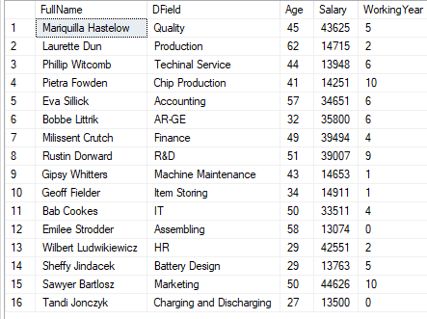

* **VIEW 2**
* **Name:** Department_Payment_Statistic
* **Definition:** It gives general salary statistic about departments. (Max payment- Min payment- Average payment)
* **View:**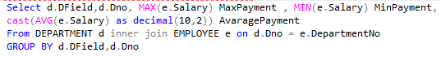
* **Output:**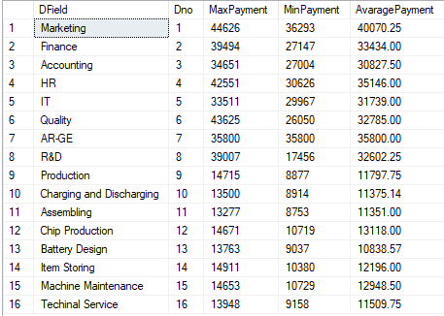
* **VIEW 3**
* **Name:** Ups_ProductType_Price_Statistic
* **Definition:** It gives price statistic about all type of UPS products in factory. (1-1, 3-1, 3,3)
* **View:**

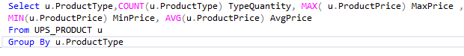

* **Output:**

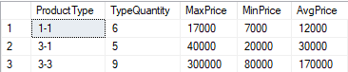

* **VIEW 4**
* **Name:** SupplierCompany_Payment
* **Definition:** It gives total payment for each supplier company for taken item. It also shows how many items taken from company and price for per item.
* **View:**

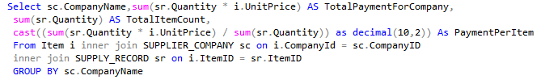

* **Output:**
* **VIEW 5**
* **Name:** BlueCollar_Department_Seniority
* **Definition:** It shows how many blue-collar employees exist in; his/her department includes more than 2 people and at the same time he/she works for the factory at least 5 years.
* **View:**

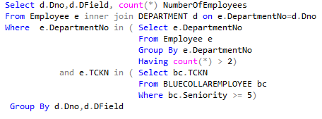

* **Output:**

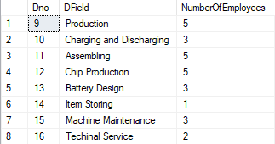

* **VIEW 6**
* **Name:** Detailed_Customer_Order
* **Definition:** It shows detailed information about accomplished successfully orders.
* **View:**

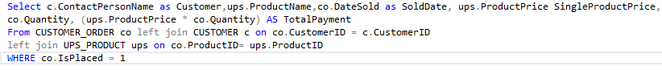

* **Output:**

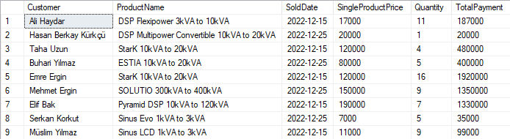

**PROCEDURES**

* **PROCEDURE 1**
* **Name:** sp**_**DeleteEmployee
* **Definition:** It takes employee id as a parameter. Firstly, procedure checks if given employee exist or is it manager. If these are in case, it gives warnings. If not, it first deletes the given employee record from **EMPLOYEE** table. Then according to the collar-type, it deletes related table record. At the end it decrements the NumberOfEmployee field in the **DEPARTMENT** table according to the deleted employee’s department number.
* **Procedure:** metin içeren bir resim

  Açıklama otomatik olarak oluşturuldu

**Before exec sp_DeleteEmployee ‘877-85-7367’:**

**🡪 EMPLOYEE TABLE**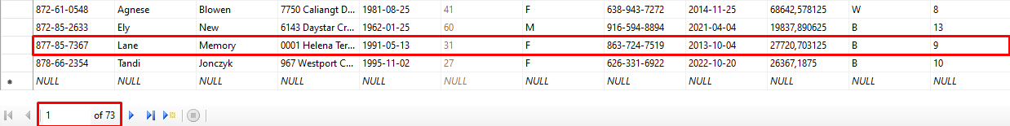

**🡪 BLUECOLLAR TABLE**

tablo içeren bir resim

Açıklama otomatik olarak oluşturuldu

**🡪 DEPARTMENT TABLE**

**tablo içeren bir resim

Açıklama otomatik olarak oluşturuldu**

* **After exec sp_DeleteEmployee ‘877-85-7367’:**

**🡪 EMPLOYEE TABLE**

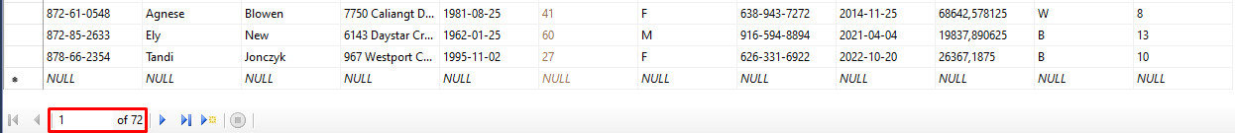

**🡪 BLUECOLLAR TABLE**

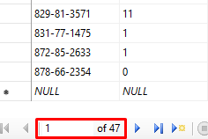

**🡪 DEPARTMENT TABLE**

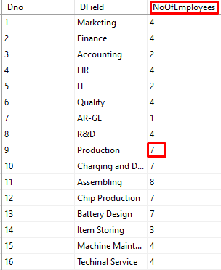

* **PROCEDURE 2**
* **Name:** sp_AddNewProduct
* **Definition:** It adds the given UPS to the UPS_PRODUCT table. In addition to that according to the UPS type it also create new record for related table.
* **Procedure:** metin içeren bir resim

  Açıklama otomatik olarak oluşturuldu
* **Before exec ‘3309’,’Pyramid DSP Premium-T 160kVA to 300kVA’,’300000,’GREEN MODE’, ‘TGG WP16 Double Conversion’, ‘SNMP’, ‘3-3’,0.04,’SNMP, Batter Block’**

**🡪 UPS_PRODUCT TABLE**

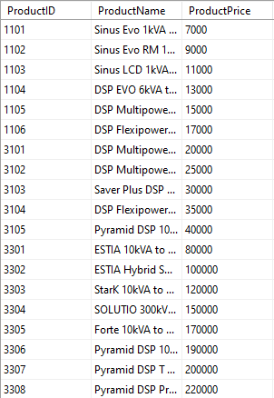

**🡪 THREE_THREE_PHASE TABLE**

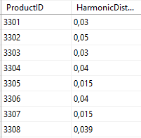

* **After exec ‘3309’,’Pyramid DSP Premium-T 160kVA to 300kVA’,’300000,’GREEN MODE’, ‘TGG WP16 Double Conversion’, ‘SNMP’, ‘3-3’,0.04,’SNMP, Batter Block’**

**🡪 UPS_PRODUCT TABLE**

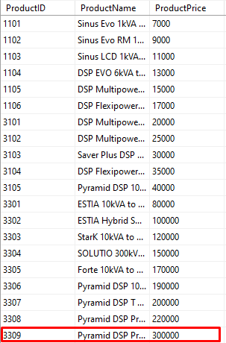

**🡪 THREE_THREE_PHASE TABLE**

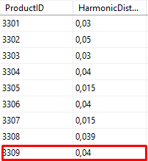

* **PROCEDURE 3**
* **Name:** sp_AddingProductToStock
* **Definition:** This procedure first creates record for the **FACTORY_PRODUCT** table with the given input values. Then it updates the stock field in the **UPS_PRODUCT** table with the given quantity value.
* **Procedure:**

metin içeren bir resim

Açıklama otomatik olarak oluşturuldu

* **Before exec sp_AddingProductToStock ‘2940035696’,’3309’,20,’2022-12-26’**

**🡪 FACTORY_PRODUCT TABLE**

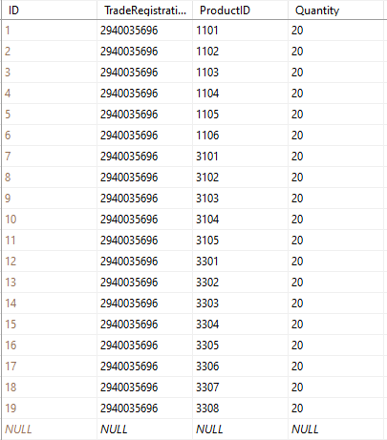

**🡪 UPS_PRODUCT TABLE**

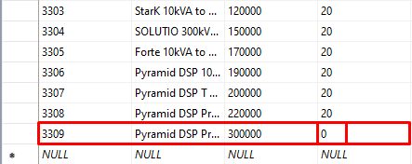

* **After exec sp_AddingProductToStock ‘2940035696’,’3309’,20,’2022-12-26’**

**🡪 FACTORY_PRODUCT TABLE**



**🡪 UPS_PRODUCT TABLE**

**tablo içeren bir resim

Açıklama otomatik olarak oluşturuldu**

* **PROCEDURE 4**
* **Name:** sp_AddEmployee
* **Definition:** This procedure creates an employee record using the employee information provided as input. It first creates record for EMPLOYEE table and according to the employee type it also creates record for relevant type table.
* **Procedure:**

metin içeren bir resim

Açıklama otomatik olarak oluşturuldu

* **Before exec sp_AddEmployee ‘999-99-999’,’John’,’Doe’,’somewhere,’**

**🡪 EMPLOYEE TABLE**

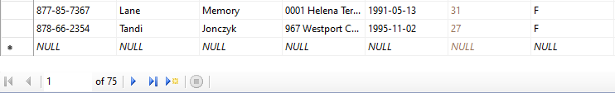

* **After exec sp_AddEmployee ‘999-99-999’,’John’,’Doe’,’somewhere,’**

**🡪 EMPLOYEE TABLE**

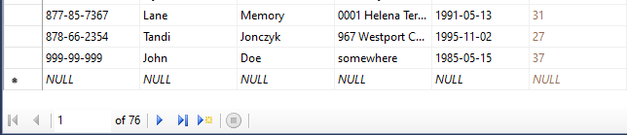

* **PROCEDURE 5**
* **Name:** sp_OrderProduct
* **Definition:** This procedure updates the transactions related to order. First, it created record for the CUSTOMER_ORDER table with using the given inputs. Then, it updates the remaining stock amount by deducting the ordered amount from the stock amount. Finally, it checks whether there is the desired stock in the order and updates IsPlaced field true or false accordingly.
* **Procedure:**

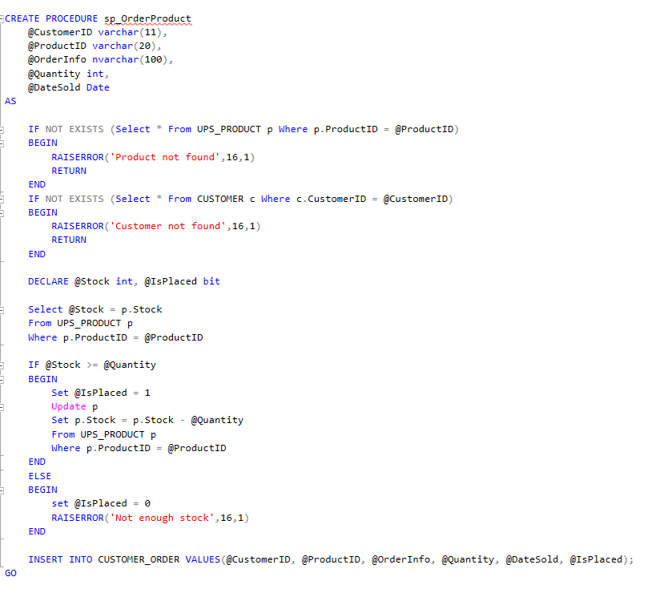

* **Before exec sp_OrderProduct ‘100000012’,3306,’…’,7,’2012-12-15’**

**🡪 CUSTOMER_ORDER TABLE**

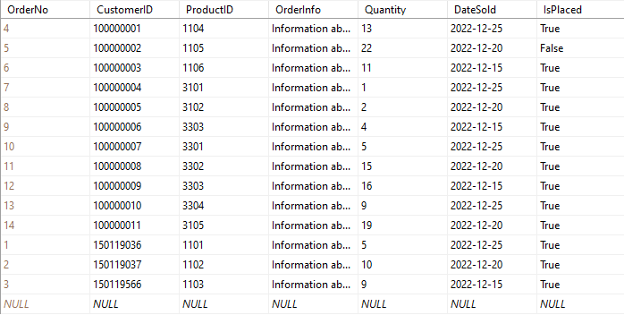

**🡪 CUSTOMER_ORDER TABLE**



* **After exec sp_OrderProduct ‘100000012’,3306,’…’,7,’2012-12-15’**

**🡪 CUSTOMER_ORDER TABLE**

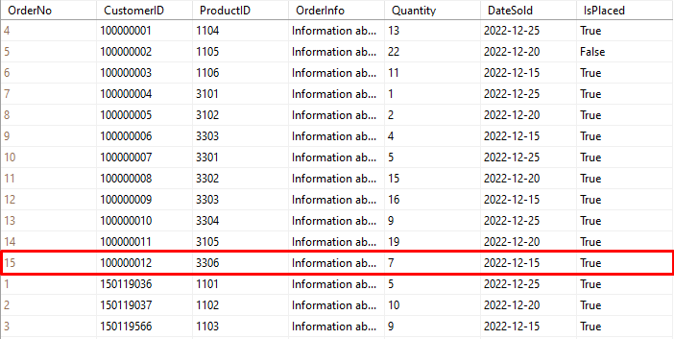

 **🡪 CUSTOMER_ORDER TABLE**

* **PROCEDURE 6**
* **Name:** sp_UpdateSalary
* **Definition:** This procedure updates the salary for the employees in the **EMPLOYEE** table. A fixed 25% raise is made for two types of employees working in the factory. Afterwards, an extra raise is made for blue-collar employees according to their seniority levels.
* **Procedure:**

metin içeren bir resim

Açıklama otomatik olarak oluşturuldu

* **Before exec sp_UpdateSalary**

**🡪 EMPLOYEE TABLE**

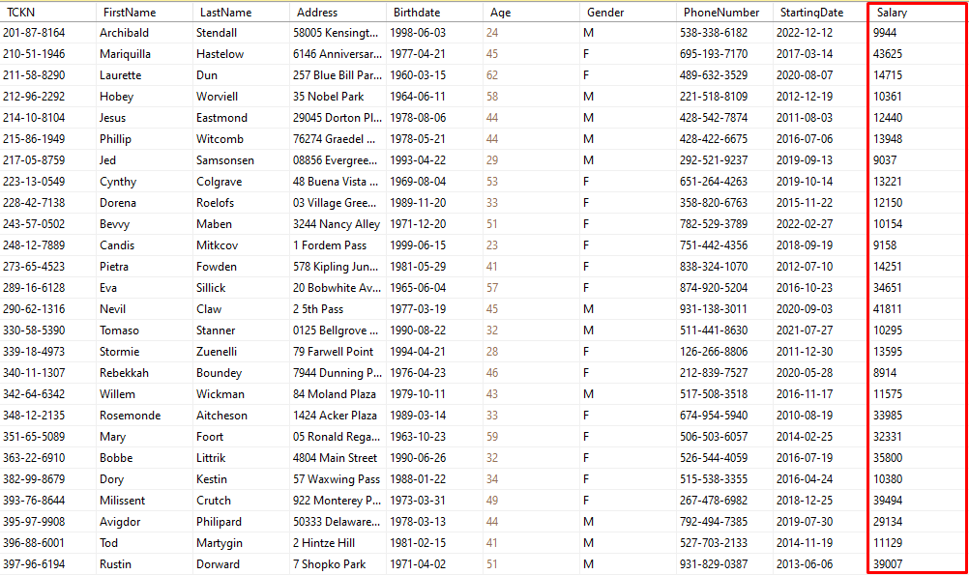

* **After exec sp_UpdateSalary**

**🡪 EMPLOYEE TABLE**

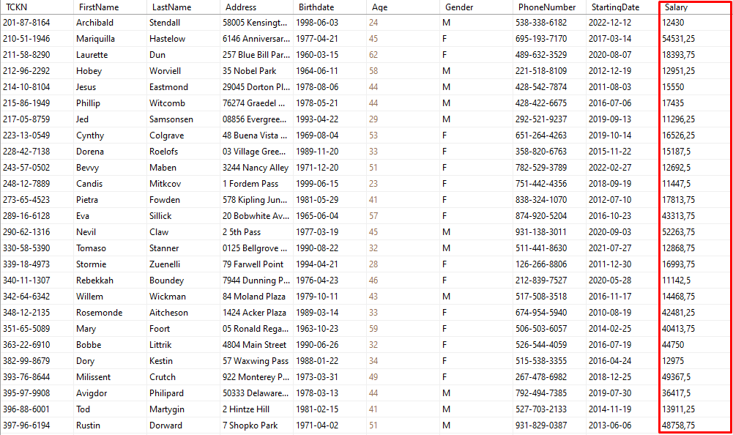

**TRIGGERS**

* **Name:** Fill_BlueColar_Update_Department
* **Definition:** Type of this trigger is ‘After insert’. When new employee added to the **EMPLOYEE** table, the NoOfEmployees field in the **DEPARTMENT** table is automatically increased by one according to the given employee’s department number. Then, if the added worker type is blue-collar, the columns in the **BLUECOLLAREMPLOYEE** table are automatically filled.
* **Trigger:**

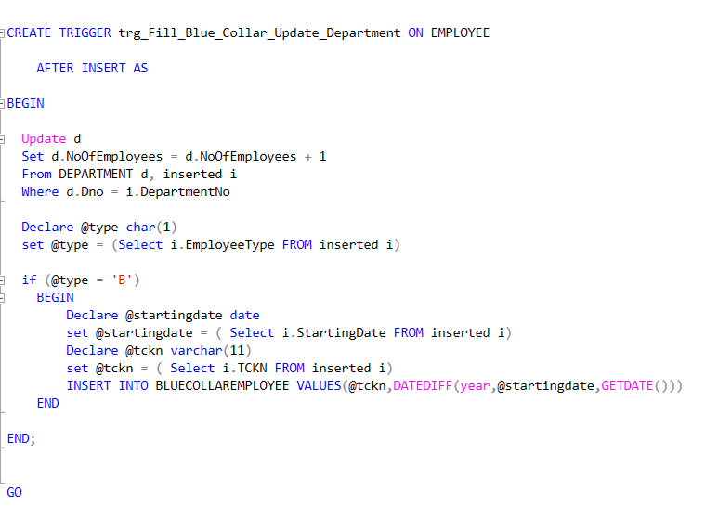

insert into EMPLOYEE (TCKN, FirstName, LastName, Address, Birthdate, Gender, PhoneNumber, StartingDate, Salary, EmployeeType, DepartmentNo) values ('111-11-1111', 'Fatih', 'Terim', 'Florya', '1953-03-15', 'M', '111-111-1905', '8/7/2015', 19050, 'B', 10);

* **Before insert:**

**🡪 BLUECOLLAR_TABLE**

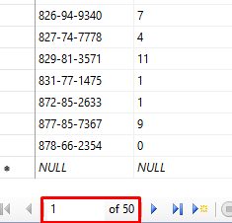

**🡪 DEPARTMENT_TABLE**

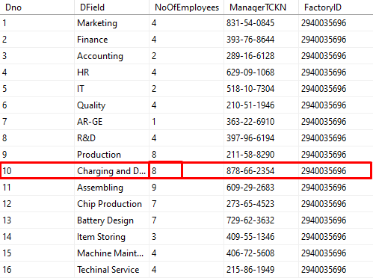

* **After trigger process:**

**🡪 BLUECOLLAR_TABLE**

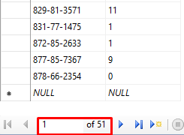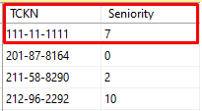

**🡪 DEPARTMENT_TABLE**

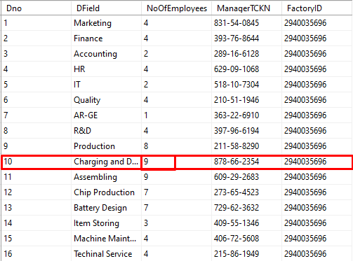

* **Name:** trg_DeleteDepartment
* **Definition:** Type of this trigger is ‘Instead of delete’.

When a department is deleted, firstly all employees working there are deleted from **EMPLOYEE** and its subtype tables. After that the department is deleted from the **DEPARTMENT** table.

* **Trigger:**

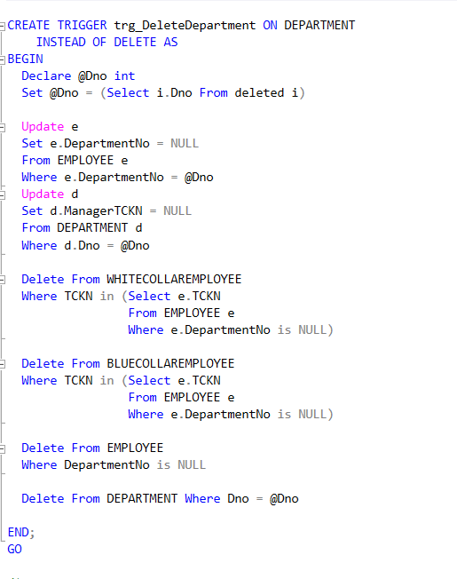

Delete From DEPARTMENT Where Dno = 1

* **Before delete:**

**🡪 DEPARTMENT_TABLE**

tablo içeren bir resim

Açıklama otomatik olarak oluşturuldu

**🡪 EMPLOYEE_TABLE**

tablo içeren bir resim

Açıklama otomatik olarak oluşturuldu

**…**

🡪 **WHITECOLLAREMPLOYEE_TABLE**

tablo içeren bir resim

Açıklama otomatik olarak oluşturuldu 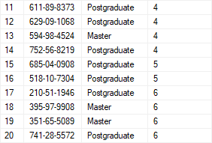

* **After trigger process:**

**🡪 DEPARTMENT_TABLE**

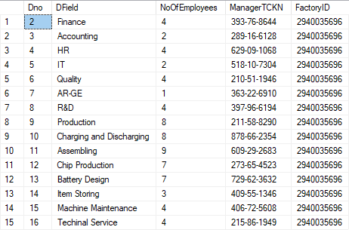

**🡪 EMPLOYEE_TABLE**

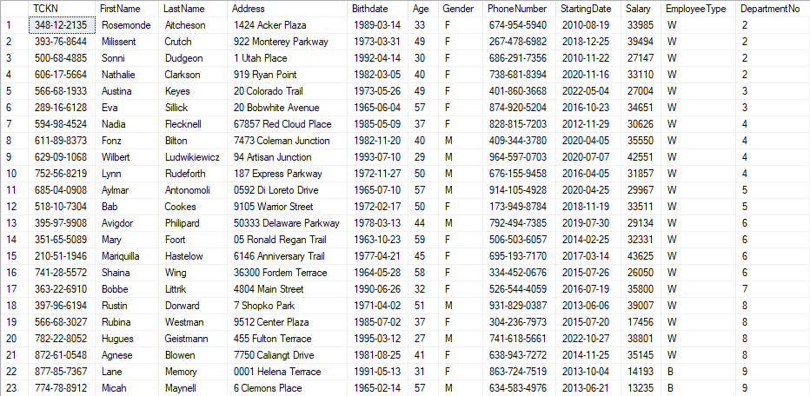

🡪 **WHITECOLLAREMPLOYEE_TABLE**

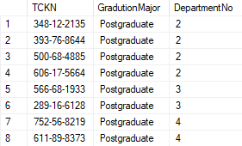 tablo içeren bir resim

Açıklama otomatik olarak oluşturuldu

1. https://www.fluke.com/en-us/learn/blog/power-quality/single-phase-vs-three-phase-power