The y-axis values on the charts in this file are the percentage values!!

-Participants who gave score 10 to the model 1 what kind of score they gave model 2&3

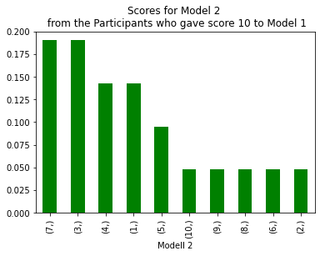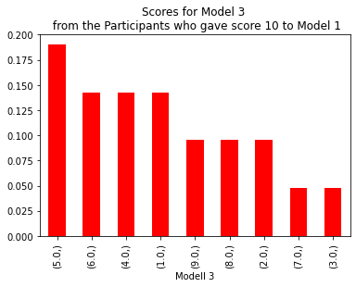

-Participants who gave score,9,10 to the model 2 what kind of score they gave model 1&3

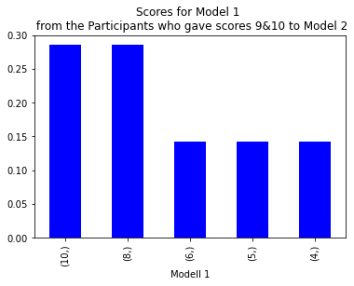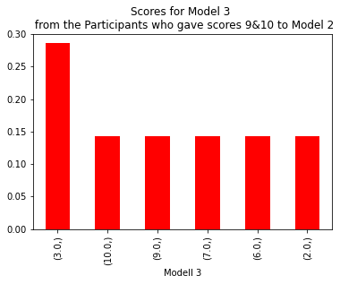

-Participants who gave score 9,10 to the model 1 what kind of score they gave model 2&3

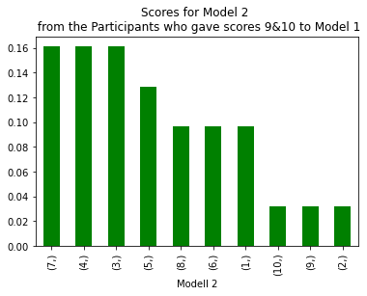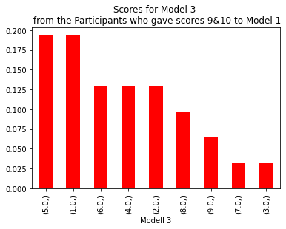

-Participants who gave score 1,2,3,4 to the model 1 what kind of score they gave model 2&3

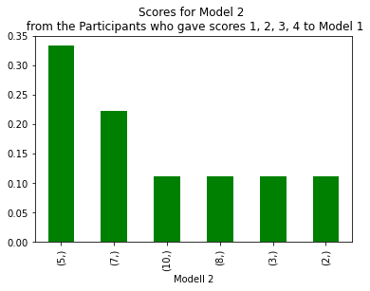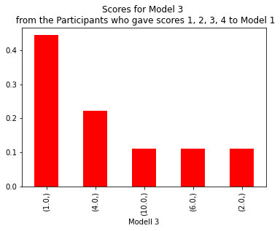

-Participants who gave score 1,2,3,4 to the model 3 what kind of score they gave model 1&2

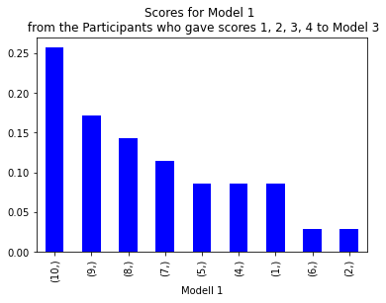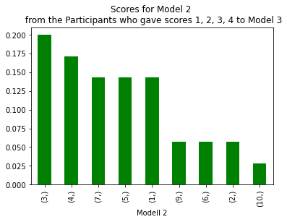

-Participants who gave score 1,2,3,4 to the model 2 what kind of score they gave model 1&3

