Sonar Qube
Report
For
- Security Labs
- Cyber Security
- Info Sec

by Anton Mykhalchuk

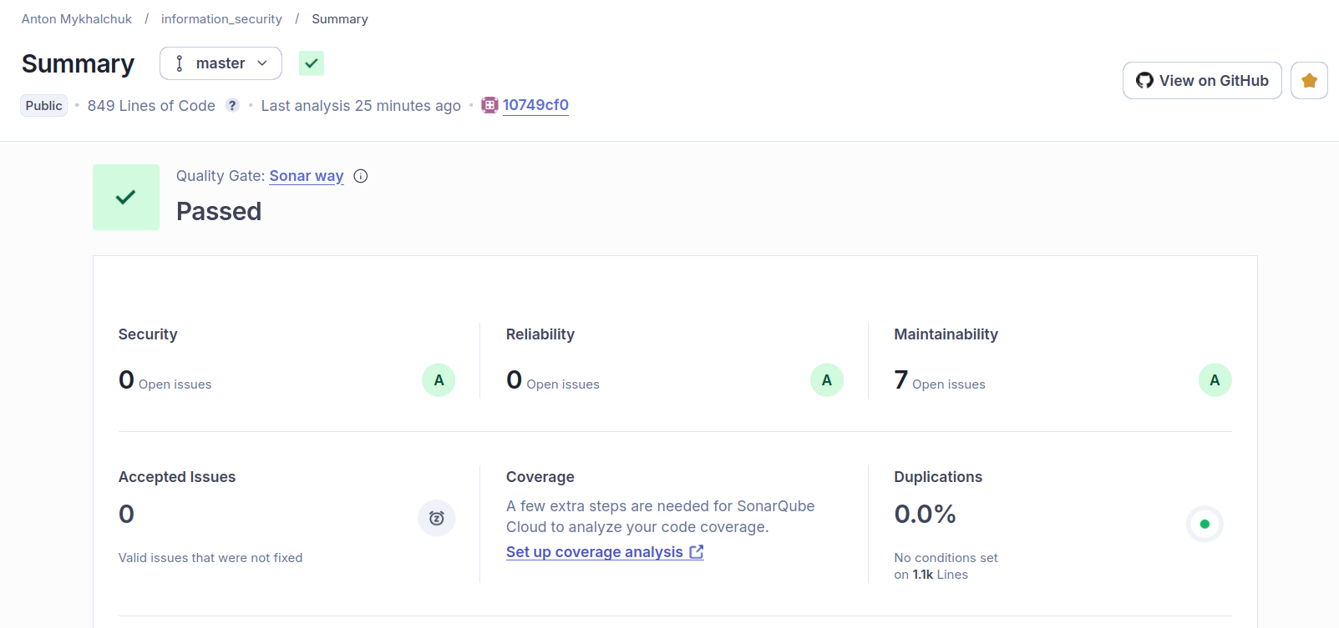
The SonarQube analysis for the information_security project (master branch) confirms that the codebase successfully passes the default "Sonar way" Quality Gate. The project consists of 849 lines of code and demonstrates excellent health across all configured metrics:
- Security: Rating A (0 open issues)
- Reliability: Rating A (0 open issues)
- Maintainability: Rating A (7 open issues)
- Duplications: 0.0%
- Accepted Issues: 0
The code is highly reliable and secure. The 7 open maintainability issues are minor enough that the project retains an overall 'A' rating in that category. The only missing metric is Test Coverage, which requires additional configuration to analyze.

