Sugar Rush
A N0mad! Studios Video Game Production

Setup Guide:

- https://unity.com/unity-hub
- https://unity.com/download
- https://docs.unity3d.com/hub/manual/index.html

We will be using the Unity Engine to Create our game. Dont worry about the cost, there are free versions though you might be required to sign up using an email.

Once you've downloaded the exe, go ahead and install the software onto the system and begin a new project. Make sure to select “3D” and give it the project name.

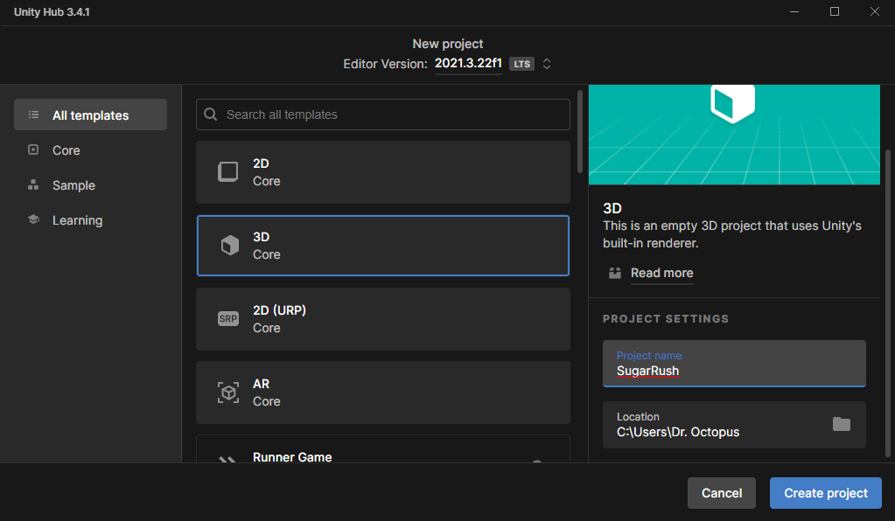
The Following window should be visible once you have completed the create new project step.

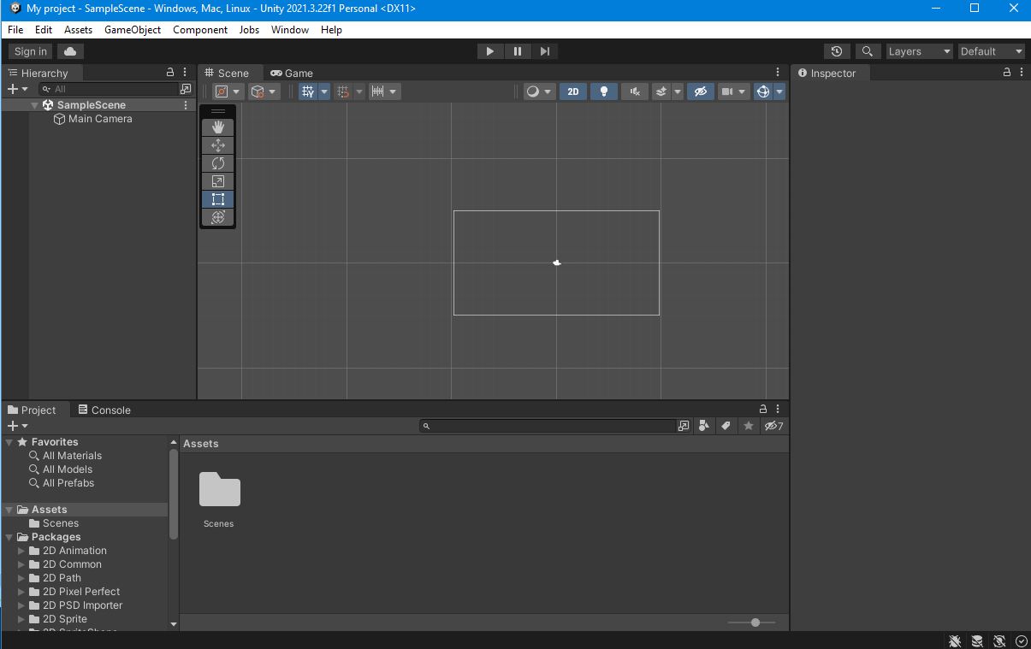
Like so

4. https://desktop.github.com/

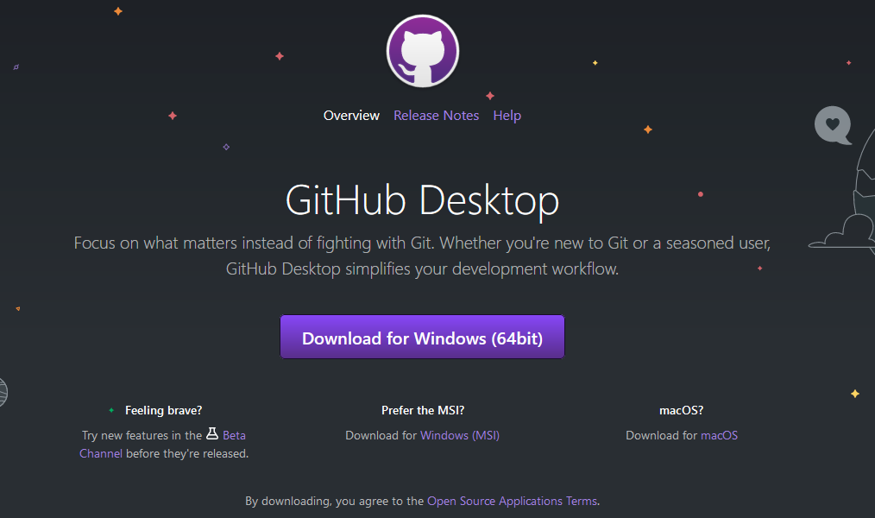
The next step is setting up the github. This is gonna allow us to have a centralized source code and folder structure.

Using Github Desktop Create a new Repository, i've given mine the name SugarRushUnity

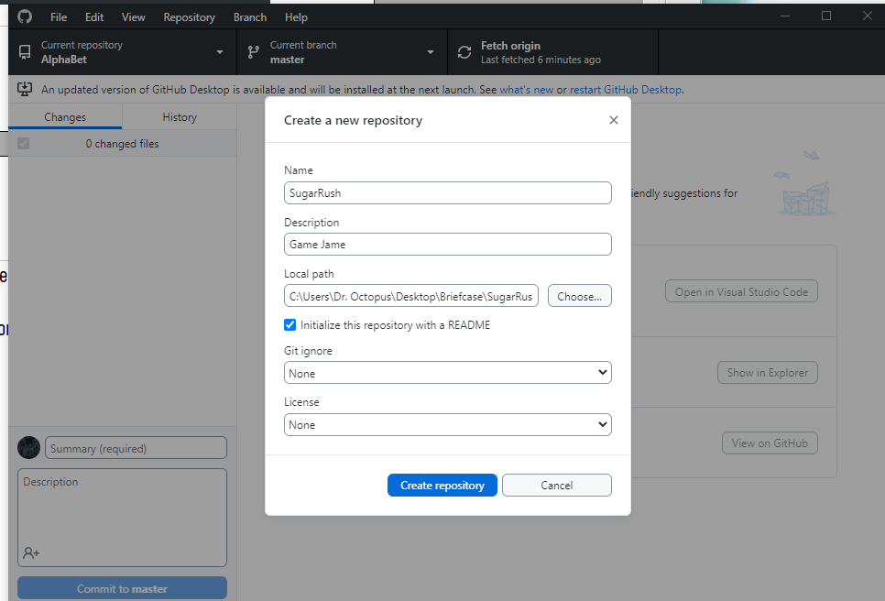
https://git-lfs.com/

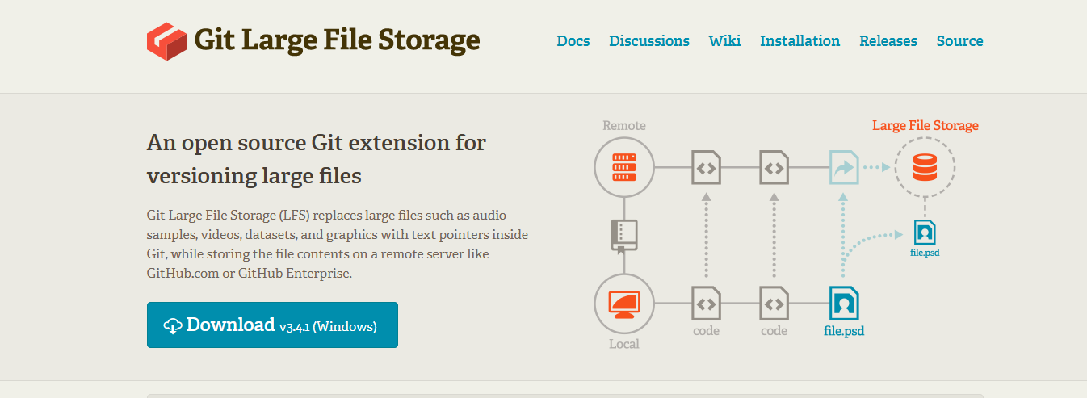
https://unityatscale.com/unity-version-control-guide/how-to-setup-unity-project-on-github/
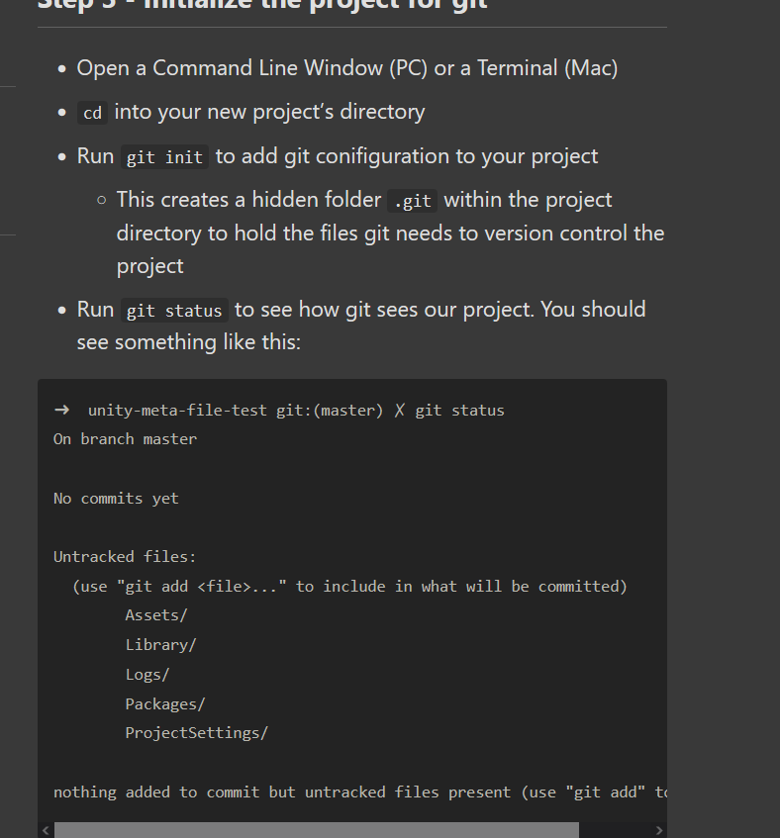
This step can be achieved through terminal first
Windows+R, type in CMD, then CD ____ to the correct directory.

This step is after setting up a new unity project.

Running the following Command Will remove the need to push any unnecessary files to the respository.
curl https://raw.githubusercontent.com/github/gitignore/master/Unity.gitignore --output .gitignore

