NAME | Jeet Patel
UID | 2023800080
Class and Batch | EA1
EXP NO | 2
DATE | 05/02/2026
AIM | To train a feedforward neural network using the backpropagation algorithm and gradient descent optimization on a standard dataset such as MNIST for handwritten digit classification.
Objective | - To understand supervised learning using neural networks  - To study forward propagation and error computation  - To implement backpropagation for weight updates  - To apply gradient descent for minimizing the loss function  - To evaluate classification performance on real-world data
THEORY: | A neural network learns by adjusting its weights to minimize the error between predicted output and actual target output. This is achieved using the backpropagation algorithm combined with gradient descent.  For a neuron, the net input is:  z=i=1∑n​wi​xi​+b  The activation output is:  a=f(z)  where f(⋅) is a nonlinear activation function such as ReLU or sigmoid.  For multi-class classification problems like MNIST, the softmax activation function is used in the output layer:  softmax(zi​)=∑j​ezj​ezi​​  The loss function commonly used is categorical cross-entropy:  L=−i=1∑C​yi​log(y^​i​)  Dataset  MNIST Dataset:  - Contains 70,000 grayscale images of handwritten digits (0–9)  - Each image size: 28 × 28 pixels  - Training set: 60,000 images  - Test set: 10,000 images  Each image is flattened into a feature vector of size 784.  Network Architecture  - Input Layer: 784 neurons (one for each pixel)  - Hidden Layer(s): Fully connected layers with ReLU activation  - Output Layer: 10 neurons with softmax activation  Backpropagation and Gradient Descent  Backpropagation computes the gradient of the loss function with respect to each weight using the chain rule. Gradient descent updates weights as:  w=w−η∂w∂L​  where:  - η is the learning rate  - ∂w∂L​ is the gradient of the loss
PROGRAM 1
PROBLEM STATEMENT: | To train a feedforward neural network using the backpropagation algorithm and gradient descent optimization on a standard dataset such as MNIST for handwritten digit classification.
Pseudo-Code/Algo: | - Load and preprocess the MNIST dataset  - Normalize input features  - Initialize network weights and biases  - Perform forward propagation  - Compute loss using categorical cross-entropy  - Perform backpropagation to compute gradients  - Update weights using gradient descent  - Repeat steps 4–7 for multiple epochs  - Evaluate the trained model on test data
PROGRAM: | import kagglehub  import numpy as np  import matplotlib.pyplot as plt  # -------------------------------  # Reproducibility  # -------------------------------  np.random.seed(42)  # -------------------------------  # Download MNIST dataset  # -------------------------------  path = kagglehub.dataset_download("hojjatk/mnist-dataset")  # -------------------------------  # Data loading functions  # -------------------------------  def load_images(file_path):  with open(file_path, 'rb') as f:  data = f.read()  num_images = int.from_bytes(data[4:8], 'big')  rows = int.from_bytes(data[8:12], 'big')  cols = int.from_bytes(data[12:16], 'big')  images = np.frombuffer(data[16:], dtype=np.uint8)  images = images.reshape(num_images, rows * cols)  images = images / 255.0 # normalize  return images  def load_labels(file_path):  with open(file_path, 'rb') as f:  data = f.read()  labels = np.frombuffer(data[8:], dtype=np.uint8)  return labels  def one_hot(labels, num_classes=10):  encoded = np.zeros((labels.size, num_classes))  encoded[np.arange(labels.size), labels] = 1  return encoded  # -------------------------------  # File paths  # -------------------------------  train_images_file = path + "/train-images-idx3-ubyte/train-images-idx3-ubyte"  train_labels_file = path + "/train-labels-idx1-ubyte/train-labels-idx1-ubyte"  test_images_file = path + "/t10k-images-idx3-ubyte/t10k-images-idx3-ubyte"  test_labels_file = path + "/t10k-labels-idx1-ubyte/t10k-labels-idx1-ubyte"  # -------------------------------  # Load data  # -------------------------------  train_images = load_images(train_images_file)  train_labels = load_labels(train_labels_file)  test_images = load_images(test_images_file)  test_labels = load_labels(test_labels_file)  train_labels_oh = one_hot(train_labels)  test_labels_oh = one_hot(test_labels)  # -------------------------------  # Dataset statistics  # -------------------------------  print(f"Shape of training images: {train_images.shape}")  print(f"Mean: {np.mean(train_images):.4f}")  print(f"Std Dev: {np.std(train_images):.4f}")  print(f"Min value: {np.min(train_images):.4f}")  print(f"Max value: {np.max(train_images):.4f}")  # -------------------------------  # Visualize samples  # -------------------------------  num_samples = 5  plt.figure(figsize=(10, 2))  for i in range(num_samples):  image = train_images[i].reshape(28, 28)  plt.subplot(1, num_samples, i + 1)  plt.imshow(image, cmap='gray')  plt.title(f"Label: {train_labels[i]}")  plt.axis('off')  plt.show()  # -------------------------------  # Neural Network Parameters  # -------------------------------  input_size = 784  hidden_size = 128  output_size = 10  learning_rate = 0.01  W1 = np.random.randn(input_size, hidden_size) * 0.01  b1 = np.zeros((1, hidden_size))  W2 = np.random.randn(hidden_size, output_size) * 0.01  b2 = np.zeros((1, output_size))  # -------------------------------  # Activation functions  # -------------------------------  def relu(z):  return np.maximum(0, z)  def relu_derivative(z):  return z > 0  def softmax(z):  exp_z = np.exp(z - np.max(z, axis=1, keepdims=True))  return exp_z / np.sum(exp_z, axis=1, keepdims=True)  # -------------------------------  # Forward propagation  # -------------------------------  def forward(X):  z1 = X @ W1 + b1  a1 = relu(z1)  z2 = a1 @ W2 + b2  a2 = softmax(z2)  return z1, a1, z2, a2  # -------------------------------  # Loss function  # -------------------------------  def cross_entropy(y_true, y_pred):  return -np.mean(np.sum(y_true * np.log(y_pred + 1e-8), axis=1))  # -------------------------------  # Backpropagation  # -------------------------------  def backward(X, y, z1, a1, a2):  global W1, b1, W2, b2  m = X.shape[0]  dz2 = a2 - y  dW2 = (a1.T @ dz2) / m  db2 = np.sum(dz2, axis=0, keepdims=True) / m  da1 = dz2 @ W2.T  dz1 = da1 * relu_derivative(z1)  dW1 = (X.T @ dz1) / m  db1 = np.sum(dz1, axis=0, keepdims=True) / m  W1 -= learning_rate * dW1  b1 -= learning_rate * db1  W2 -= learning_rate * dW2  b2 -= learning_rate * db2  # -------------------------------  # Training loop  # -------------------------------  epochs = 20  batch_size = 64  epoch_losses = []  for epoch in range(epochs):  perm = np.random.permutation(train_images.shape[0])  train_images_shuffled = train_images[perm]  train_labels_shuffled = train_labels_oh[perm]  epoch_loss = 0  batches = 0  for i in range(0, train_images.shape[0], batch_size):  X_batch = train_images_shuffled[i:i + batch_size]  y_batch = train_labels_shuffled[i:i + batch_size]  z1, a1, z2, a2 = forward(X_batch)  loss = cross_entropy(y_batch, a2)  backward(X_batch, y_batch, z1, a1, a2)  epoch_loss += loss  batches += 1  epoch_losses.append(epoch_loss / batches)  print(f"Epoch {epoch + 1}/{epochs}, Loss: {epoch_losses[-1]:.4f}")  # -------------------------------  # Evaluation  # -------------------------------  def accuracy(y_true, y_pred):  return np.mean(y_true == y_pred)  _, _, _, test_preds = forward(test_images)  predicted_labels = np.argmax(test_preds, axis=1)  print("Test Accuracy:", accuracy(test_labels, predicted_labels))  # -------------------------------  # Loss curve  # -------------------------------  plt.figure(figsize=(8, 5))  plt.plot(range(1, epochs + 1), epoch_losses, marker='o')  plt.xlabel("Epoch")  plt.ylabel("Loss")  plt.title("Training Loss per Epoch")  plt.grid(True)  plt.show()  num_display = 10 # Number of test images to display  plt.figure(figsize=(15, 3))  for i in range(num_display):  # Display the image  plt.subplot(1, num_display, i + 1)  plt.imshow(test_images[i].reshape(28, 28), cmap='gray')  # Set title with actual and predicted labels  actual_label = test_labels[i]  predicted_label = predicted_labels[i]  plt.title(f"Actual: {actual_label}\nPred: {predicted_label}", color='green' if actual_label == predicted_label else 'red')  plt.axis('off')  plt.suptitle('Test Images: Actual vs. Predicted Labels', fontsize=16, y=1.05)  plt.tight_layout()  plt.show()
RESULT:
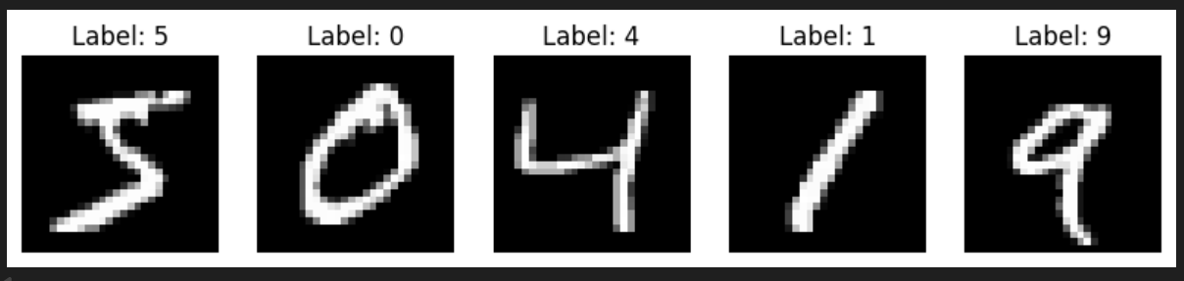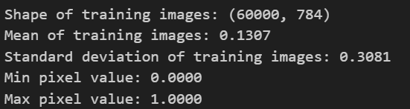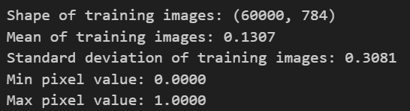
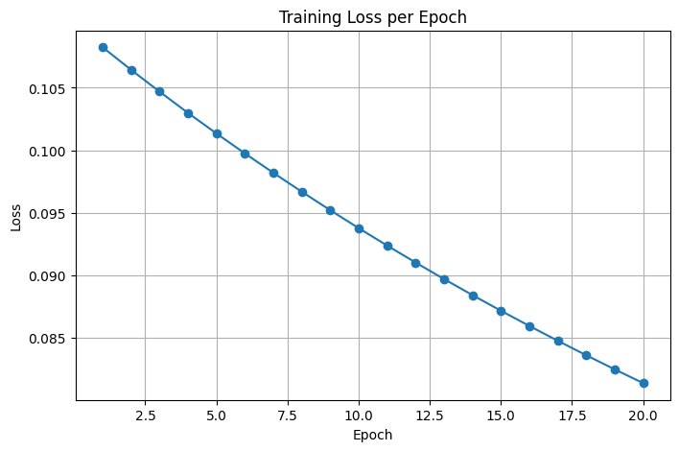
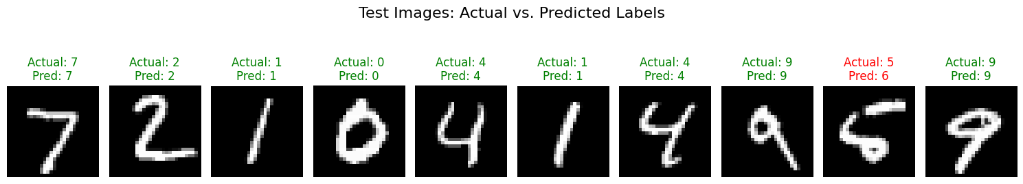
CONCLUSION:
In this experiment, a feedforward neural network was successfully trained using the
backpropagation algorithm with gradient descent optimization on the MNIST handwritten
digit dataset. The model effectively learned hierarchical features from pixel-level inputs and
demonstrated strong performance in classifying handwritten digits. The results validate the
effectiveness of backpropagation and gradient descent for supervised learning tasks and
highlight the suitability of feedforward neural networks for image classification problems
such as handwritten digit recognition.

