**DataCronyx: AutoEDA & AutoTrainer**

**Project Report submitted in the partial fulfilment**

**Of**

Master of Technology

In

Artificial Intelligence

by

**Shardul Gore (R016)**

Under the supervision of

**Name of Faculty Mentor**

(Designation, Name of the department, MPSTME)

# SVKM’s NMIMS University

(Deemed-to-be University)



**MUKESH PATEL SCHOOL OF TECHNOLOGY MANAGEMENT & ENGINEERING (MPSTME)**

**Vile Parle (W), Mumbai-56**

**(2025-26)**

# CERTIFICATE



This is to certify that the project entitled DataCronyx: AutoEDA & AutoTrainer, has been done by **Mr. Shardul Gore** under my guidance and supervision & has been submitted in partial fulfilment of the degree of Master of Technology in Artificial Intelligence of MPSTME, SVKM’s NMIMS (Deemed-to-be University), Mumbai, India.

Project mentor (name and Signature) Examiner ( name and Signature) (Intenal Guide)

**Date**

**Place: Mumbai**

**(HoD)** (name and Signature)

# ACKNOWLEDGEMENT

Student Names

|  |  |  |
| --- | --- | --- |
| **NAME** | **ROLL NO.** | **SAP ID** |
| Shardul Gore | R016 | 70282400003 |

# ABSTRACT

This project presents DataCronyx, an intelligent, automated system designed to simplify and enhance the process of exploratory data analysis (EDA) and machine learning model development for diverse tabular datasets. The work addresses the common challenges faced by analysts and decision-makers in deriving insights and building predictive models efficiently, especially when technical expertise is limited.

DataCronyx offers a dual-mode functionality that significantly contributes to data analytics workflows. The first mode empowers users with a custom, user-friendly interface where they can manually guide the data cleaning, feature selection, and model training processes. This interactive environment enables fine control and customization suited to specific business needs. The second mode leverages AI agents to autonomously perform end-to-end data analysis and model training, reducing human intervention and accelerating the time from raw data to meaningful insights.

A key contribution of this work is the integration of automated EDA with high-quality visualizations and comprehensive data quality assessments, allowing for rapid and clear understanding of data patterns and anomalies. The system utilizes well-established machine learning libraries to support multiple modeling algorithms, providing robust model evaluation and comparison tools. Another novel aspect is the incorporation of large language model (LLM) technology—specifically Google Gemini API—to translate statistical findings and model outcomes into coherent, actionable narratives. This bridges the gap between complex analytics and accessible interpretation, enhancing decision-making for both technical and non-technical stakeholders.

Through the development and testing of DataCronyx, this project demonstrates how combining customizable workflows with intelligent automation can improve the efficiency, accuracy, and interpretability of data analysis pipelines. The system’s adaptability to various data sources, including file uploads and direct SQL database connections, further extends its practical applicability. Overall, DataCronyx advances the state of automated data science by delivering a scalable, explainable, and user-centric platform that empowers organizations to derive deeper insights and build predictive capabilities without extensive coding or domain expertise.

**Table of Contents**

**Topics Page**

**List of Figures** **i**

**Abbreviations** **xix**

**Chapter 1 Introduction**

**1.1 Background of the project**

**1.2 Motivation and Scope**

**1.3 Problem Statement**

**1.4 Salient Contribution**

**Chapter 2 Literature survey 2.1 Introduction**

**2.2 Exhaustive Literature survey**

**Chapter 3 Methodology and Implementation**

**3.1 Methodology**

**3.2 Implementation**

**3.2.1 Project Structure & Module Functions**

**3.2.2 Workflow Example**

**3.2.3 Gantt Chart Alignment**

**3.2.4 Architecture and Extensibility**

**Chapter 4 Block Diagram and Code**

**4.1 Block Diagram**

**4.2 Code**

**Chapter 5 Result and Analysis**

**5.1 Result**

**5.2 Analysis**

**Chapter 6 Advantages, Limitations and Applications**

* 1. **Advantages**
  2. **Limitations**

**6.3 Applications**

**Chapter 7 Conclusion and Future Scope**

* 1. **Conclusion**

**7.2 Future Scope**

**References**

**Appendix A: Soft Code Flowcharts**

**Appendix B: Data Sheets Appendix C: List of Components**

**Appendix D: List of Paper Presented and Published.**

List of the figures

|  |  |  |
| --- | --- | --- |
| **Fig No** | **Name of the figure** | **Page No** |
| 1 | Architecture Diagram |  |
| 2 | Gantt Chart |  |
| 3 | Home Page |  |
| 4 | Dataset Overview |  |
| 5 | Custom Eda |  |
| 6 | Data Preprocessing |  |
| 7 | Feature Engineering |  |
| 8 | Model Training |  |
| 9 | Agent Pipeline |  |

Abbreviations

|  |  |  |
| --- | --- | --- |
| **Sr No** | **Abbreviation** | **Meaning** |
|  | EDA | Exploratoy Data Analysis |
|  | ML | Machine Learning |
|  | AI | Artificial Intelligence |
|  | CSV | Comma Separated values |
|  | JSON | JavaScript Object Notation |
|  | SQL | Structured Query Language |
|  | LLM | Large Language Model |
|  | API | Application Programmable Interface |
|  | AFSFR | Attribute Frequency Statistical Feature Ratio |
|  | IC | Integrated Circuit |
|  | XLS | Excel Spreadsheet |
|  | PCA | Principal Component Analysis |
|  | RMSE | Root Mean Square Error |
|  |  |  |

**Chapter 1 Introduction**

* 1. **Background of the project topic**

In the digital age, organizations and individuals generate and collect vast volumes of data from a variety of sources, including business transactions, sensors, social media, and online platforms. The effective use of this data through analytics and predictive modeling has become central to innovation, competitiveness, and informed decision-making across industries. Central to this process are two foundational practices: Exploratory Data Analysis (EDA) and machine learning (ML). EDA serves as the bridge between raw data and valuable insights, enabling users to investigate the structure, patterns, anomalies, and relationships within datasets. Once the quality and key features of the data are understood, machine learning techniques further unlock its predictive potential, informing forecasts, classifications, optimizations, and recommendations.

Despite remarkable advances in the field, the practical adoption of data analytics remains hindered for many users. Typical analytics workflows are fragmented, involving data cleaning, visualization, transformation, and modeling steps, each often requiring different tools and programming skills. Furthermore, there is a steep learning curve associated with understanding statistical outputs and the implications of model performance. This creates barriers for non-experts while leaving data scientists encumbered by repetitive, manual tasks that detract from higher-value creative work. The vision to lower these barriers and create a more seamless, interpretable, and efficient path from raw data to decision-ready insights is what motivates this project.

* 1. **Motivation and scope**

Motivated by the need to democratize access to advanced analytics, the present work focuses on developing DataCronyx, a comprehensive and intelligent data analytics platform. The motivation is twofold: First, to enable users—regardless of their technical background—to conduct thorough and insightful EDA coupled with robust machine learning, and second, to automate and accelerate these workflows using the latest advancements in artificial intelligence (AI) agents.

The scope of this report includes the design, implementation, and evaluation of a platform that can handle tabular data from a wide array of sources, including file uploads (CSV, Excel, JSON) and direct SQL databases. DataCronyx is envisioned as an easy-to-use web interface, incorporating both a traditional, interactive mode—where users retain full control over parameter selection—and an automated mode, where AI agents seamlessly process and analyze data with minimal input. This dual approach ensures that both novice and expert users can benefit from the platform, choosing either a guided experience or leveraging built-in automation for efficiency.

* 1. **Problem statement**

The field of data analytics continually faces several persistent challenges:

* Analysts often spend a disproportionate amount of time on routine data wrangling, quality checks, and plotting, rather than on generating actionable insights.
* Manual feature selection, preprocessing, and model evaluation are both error-prone and time-intensive, particularly for large or complex datasets.
* While automated solutions exist, many focus exclusively on either EDA or model automation, lacking an integrated, holistic approach or flexibility for user intervention.
* The presentation of findings is frequently in technical or statistical format, alienating business users or stakeholders who may lack domain expertise but are responsible for making key decisions.
* There is a growing demand for systems that combine robust automation with explainability, flexibility, and accessibility, narrowing the gap between data and impactful action.
  1. **Salient contribution**

This project brings forth several innovative contributions to the domain of automated analytics and AI-assisted decision support:

* A dual-mode data analysis workflow: DataCronyx allows users to select between a fully custom, user-driven EDA/ML flow, and an AI agent-driven automatic pipeline that manages data exploration, feature engineering, and model training end-to-end.
* Flexible data ingestion and preparation: The system facilitates both conventional file uploads and live connections to SQL databases, broadening its applicability and ensuring compatibility with real-world business environments.
* Comprehensive, automated EDA and reporting: With automated generation of descriptive statistics, high-resolution visualizations, and data quality diagnostics, users can rapidly assess and understand their datasets regardless of scale or complexity.
* Integrated machine learning with user choice: Multiple models are available, with side-by-side evaluation and leaderboard presentation; the best models can be exported for deployment or further analysis.
* Natural language, AI-powered explanation: By leveraging advanced large language model (LLM) technology (Google Gemini API), the platform summarizes results and model findings in clear, accessible language, closing the gap between technical analytics and business application.
* Accessible user interface: Intuitive design principles ensure DataCronyx is approachable for non-technical users, while also offering depth and customization for power users and data professionals.

**Chapter 2 Literature survey**

* 1. **Introduction to overall topic**

Exploratory Data Analysis (EDA) stands as a cornerstone of contemporary data science, acting as the critical bridge between raw datasets and actionable intelligence. Historically rooted in the work of John Tukey, EDA emphasizes understanding data distributions, patterns, relationships, and anomalies through both statistical summaries and visualizations, paving the way for appropriate modeling and robust, data-driven reasoning. As modern datasets have grown in complexity, size, and heterogeneity—spanning structured and unstructured sources across industries—the need for scalable, reproducible, and adaptable EDA methodologies has become acute. Manual, traditional approaches, though effective for preliminary investigation, often falter in the face of high-dimensional data, latent dependencies, and domain-specific nuances. This situation is further complicated by the pressure for rapid business intelligence, stringent regulatory requirements, and the need for transparent communication of findings to both technical and non-technical stakeholders. These factors have collectively inspired a wave of research into automating EDA, transforming it from reactive, manual examination to proactive, AI-driven pipelines that blend the best of human intuition and machine efficiency. The integration of AI, machine learning (ML), and large language models (LLMs) is revolutionizing how data is explored, interpreted, and acted upon—enabling deeper insights, greater accessibility, and robust handling of real-world data challenges [2][1][4].

* 1. **Exhaustive literature survey**

The literature exhibits rapid progress and diverse approaches in the area of automated EDA. Gaikwad et al. [2] provide a comprehensive overview of the evolution from traditional EDA to intelligent, automated frameworks. Their review underscores that while statistical analysis and human-driven visual exploration remain valuable, AI-based EDA delivers notable advantages: from automating tedious preprocessing, feature extraction, and pattern detection to supporting intuitive natural language interfaces. Their work highlights how AI-driven automation ensures scalability for large datasets, improves accessibility for users without deep technical expertise, and allows for more interactive, real-time discovery. Importantly, they also delineate the persistent challenges, such as managing data privacy, reducing algorithmic bias, and explaining complex model decisions to foster trust in the insights uncovered by AI agents.

Addressing the growing need for cross-domain adaptability and natural language understanding, Zhu et al. [1] introduce TiInsight, an advanced EDA system harnessing the power of LLMs. TiInsight’s architecture fuses hierarchical data context summarization, intent clarification, and dynamic visualization recommendation within a unified platform. Their system is distinguished by its ability to process complex, multi-table enterprise databases using text-to-SQL translation guided by user queries in everyday language. The authors' evaluations show that TiInsight outperforms existing tools by automatically clarifying vague or ambiguous user intent, generalizing analysis steps across domains without domain-specific fine-tuning, and effectively automating the creation of informative visualizations. Despite these strengths, Zhu et al. identify unresolved technical hurdles. These include handling especially ambiguous queries, dealing with the complexity of database schemas in real-world scenarios, and providing transparent model reasoning throughout the analytical pipeline, particularly in regulated or high-risk domains.

In pursuit of higher personalization and iterative insight discovery, Wu et al. [3] introduce AutoEDA-Segment, which applies Attribute Frequency Statistical Feature Ratio (AFSFR) for enhanced feature categorization and value assessment, supported by interactive clustering and visualization. Their iterative feedback approach allows analysts to refine focus areas, incorporate domain expertise, and iteratively improve the quality of features and clusters explored—demonstrating improved efficiency and user satisfaction in real-world case studies from meteorology and healthcare. Critically, their work elucidates the opportunities and practical challenges of bridging automated and user-guided workflows so that domain experts are able to inject contextual insights into the automated EDA process. Wu et al. also note limitations regarding the breadth of visualization options and the need for smarter, context-aware clustering—requirements that grow in importance as datasets scale and diversify.

Complementing these software-oriented advancements, Shi et al. [4] highlight the foundational importance of comprehensive benchmarking datasets by introducing ForgeEDA. This multimodal, open-source resource contains a diverse set of integrated circuit (IC) designs—including code, netlists, graph representations, and layouts—serving as a testbed for AI4EDA solutions in logic synthesis, placement, performance estimation, and more. Their experimental results unveil the performance disparities between open-source and commercial tools, advocating for open, large-scale datasets as necessary infrastructure for accelerating AI-driven EDA innovation. Beyond hardware, the philosophy of ForgeEDA points toward a broader gap: the need for domain-specific, yet flexible benchmarking datasets in business analytics, healthcare, and other data-rich fields; this would trustworthily evaluate both the generalizability and practical intelligence of automated EDA systems.

Pulling together the evidence from these works, clear patterns emerge about the current state and gaps in the field. Existing solutions either prioritize autonomous, fully automated analytics or user-driven customization, but rarely offer a cohesive, dual-mode experience that fluidly blends both to suit changing user needs or organization maturity [1][3]. Most frameworks are still limited by the format and source of the input data they can handle, often requiring manual adaptation or extensive retraining to generalize across domains—be it classic tabular business intelligence, unstructured text, or specialized formats like IC design layouts [4][2]. In practice, stakeholders demand not just fast and accurate results, but robust explanation, transparency, and adaptability in the face of ambiguous queries, changing objectives, or regulatory constraints [1][2]. Last, and importantly, the lack of comprehensive, cross-domain benchmarks curtails rigorous comparison, systematic improvement, and, ultimately, the real-world deployment of scalable, trustworthy automated EDA platforms [4].

Addressing these acute gaps, this project proposes to develop DataCronyx: a unified, extensible EDA platform for the modern era. It aims to combine interactive user-guided exploration with rich, AI-driven automation and advanced visualization, covering a spectrum of business and specialized (e.g., hardware) data. The ambition is to bridge technical and domain barriers, democratize data exploration with context-aware explainable analytics, and provide robust, scalable benchmarking to drive continuous improvement and innovation in EDA for all users.

**Chapter 3 Methodology and Implementation**

* 1. **Methodology**

The methodology behind DataCronyx centers on delivering a modular, scalable, and user-friendly platform for automated exploratory data analysis (EDA) and machine learning (ML) model training. The system is structured to solve real-world data analytics challenges by offering both automation for rapid insight discovery and interactive controls for expert fine-tuning. As illustrated in the architecture diagram, DataCronyx supports two main workflows—Agentic Workflow and Custom Workflow—which converge through a unified data ingestion process and culminate in a Streamlit-based web interface, ensuring flexibility and accessibility for users of any skill level.

Fig. 1 Architecture diagram

Data Ingestion serves as the foundation for both workflows. Users can upload CSV/XLS files or connect to SQL data sources; the system automatically parses schema information, validates formats, and prepares data for further steps. This universal entry point ensures that both custom and automated EDA can operate on diverse data sources.

In the Agentic Workflow, intelligent agents sequentially execute core stages of the data science pipeline. These agents are designed as modular components (as implemented in the agent_module/ and agent.py files in the repo) that perform:

* EDA Agent: Automated statistical analysis, summary generation, and detection of missing values or anomalies.
* Preprocessing Agent: Selection and application of cleaning, imputation, encoding, and scaling techniques using heuristics or learned strategies.
* Feature Engineering Agent: Identification and transformation of optimal features (e.g., via PCA, selection algorithms) with minimal user intervention.
* Model Training Agent: Automated selection, training, and hyperparameter tuning of appropriate ML models for classification or regression.
* Model Evaluation Agent: Performance measurement using metrics such as accuracy, F1-score, RMSE, or R^2, and automatic leaderboard creation.

Each agent incorporates decision logic and, where appropriate, LLM or rule-based engines to tailor their actions to the dataset and desired output, reducing manual steps and speeding up end-to-end analysis.

In parallel, the Custom Workflow provides an interactive channel for users to manually guide each step:

* EDA & Visualization: Users select variables, filter data, and create custom charts using functions found in data_analysis_functions.py. Visualizations include summary tables, distributions, scatterplots, and correlation heatmaps.
* Preprocessing: Users decide on imputation strategies, encoding types, scaling, and outlier correction in data_preprocessing_function.py, with real-time feedback on changes.
* Feature Engineering: Manual execution of PCA, k-best selection, and other techniques through feature_engineering.py, allowing selection based on domain knowledge or project goals.
* Model Training: Users pick from a suite of models (Logistic Regression, Random Forest, SVM, Decision Tree, Gradient Boosting, Ridge, Lasso, etc.), set parameters, and view model outputs. All logic is handled in model_training.py and surfaced in the UI.
* Model Evaluation: Users analyze performance metrics, view confusion matrices or regression plots, and compare models head-to-head.

Both workflows are accessible from the Streamlit sidebar, allowing users to switch between full automation (agentic) and granular manual (custom) control. The outputs—charts, reports, model files—are downloadable, ensuring the system's utility for both quick experiments and deep analyses.

* 1. **Implementation**

The implementation of DataCronyx employs Python (>=3.8) and relies on well-known packages such as pandas, scikit-learn, seaborn, plotly, and Streamlit for UI development.

**3.2.1 Project Structure & Module Functions:**

* main.py: Orchestrates workflow logic, page routing, and sidebar navigation. Integrates both manual and autonomous workflows, and manages state across the session.
* home_page.py: Supplies the landing dashboard and initial dataset selection interface. Handles onboarding for new users.
* data_analysis_functions.py: Implements summary statistics, advanced graphical EDA, and interactive charting.
* data_preprocessing_function.py: Contains all routines for missing value imputation, categorical encoding, feature scaling, and outlier checks. Supports both batch and interactive operations.
* feature_engineering.py: Provides PCA, selection algorithms, and transformation utilities, supporting manual selection and agent-driven execution.
* model_training.py: Encapsulates all model training logic (fit, predict, evaluate, compare) for both classification and regression tasks. Creates downloadable model files post-training.
* agent.py / agent_module/: Implements rule-based agents, prototype workflows, and integration points for external agent frameworks (like CrewAI/LangChain), permitting scalable automation and experimentation.
* example_dataset/: Sample CSV files (e.g., Titanic for classification, Insurance for regression).
* logs/: Application and experiment logs for debugging and reproducibility.

**3.2.2 Workflow Example:**

1. User uploads data or chooses a sample.
2. Data ingestion module parses and validates the dataset.
3. User selects workflow:
   * + In Agentic, agents autonomously handle EDA, preprocessing, feature engineering, model selection, and evaluation.
     + In Custom, the user interacts with each module, customizing choices and visualizations at every step.
4. Final results—model leaderboard, downloadable models, visualization charts, and EDA reports—are presented in the UI.

**3.2.3 Gantt Chart Alignment:**

The development followed the Gantt schedule referring to the figure:

* Setup: Initializing environment, preparing dataset and module layout.
* Sampling: Building ingestion and preprocessing modules, ensuring robust schema support.
* Core Development: Implementing visualization, feature engineering, training, and agentic logic modules week-wise.
* Integration: Unifying workflows in Streamlit UI, refining agentic logic.
* Testing: Using provided datasets, validating custom and automated paths.
* Documentation & Deployment: Finalizing notebooks, README, and help guides for user onboarding.

Fig. 2 Gantt Chart

**3.2.4** **Architecture and Extensibility:**

The architecture supports plug-and-play agent modules, making it easy to extend automation with newer frameworks or additional model types (see agent.py and agent_module/ for example CrewAI and LangChain integrations). The visualization and preprocessing modules are generic, handling a wide range of real-world tabular data. Model training supports parameter tuning, leaderboard generation, and output export in standardized formats.

With both controlled and automated pathways, DataCronyx demonstrates how a modern EDA and AutoML system can leverage modular code, automation, and intuitive UI design to empower users at any expertise level—from rapid prototyping to thorough research—while remaining extensible for future improvements and integration into larger machine learning pipelines. This methodology positions DataCronyx as a practical, research-grade solution to the growing challenges and opportunities in data-driven decision-making.

**Chapter 4**

**Block Diagram and Code**

* 1. **Block diagram**

The architecture diagram for the DataCronyx project presents a clear, modular structure for the entire data science workflow, from user interaction to machine learning model evaluation, supporting both automation and hands-on control. The diagram is organized into three main horizontal layers: user/data ingestion, dual processing workflows (Agentic and Custom), and visualization/output. Each block in the diagram represents a specific functional module or stage, and arrows indicate the flow of data and vertical integration.

At the entry point, the User interacts with the system and provides a dataset via the Data Ingestion module. This module is responsible for accepting uploaded files or connecting to data sources, handling validation and ensuring that the dataset is in a usable format for subsequent analysis. Data ingestion forms the foundational step for both processing paths.

The architecture then splits into two parallel tracks:

1. Agentic Workflow: This upper workflow automates all core tasks through dedicated agents.

* EDA Agent: Automatically performs initial exploratory data analysis, calculating basic statistics, detecting missing values, and producing preliminary visualizations without user intervention.
* Preprocessing Agent: Applies necessary cleaning operations (handling missing data, encoding, scaling, etc.) based on learned rules or AI logic, choosing techniques optimized for the input data.
* Feature Engineering Agent: Selects and transforms features using automated algorithms, such as PCA or feature selection, to enhance model performance.
* Model Training Agent: Runs automated machine learning experiments, training various models (classification or regression) and tuning model parameters.
* Model Evaluation Agent: Evaluates trained models using standard metrics, establishes a leaderboard, and determines which model(s) perform best.

All agentic decisions and intermediate outputs are handled programmatically, enabling fully autonomous pipeline execution.

2. Custom Workflow: The lower workflow is designed for users who wish to retain control at every step.

* EDA & Visualization: The user generates plots, summaries, and performs interactive data inspections, choosing variables and chart types.
* Preprocessing: Manual or guided correction of missing values, categorical transformations, and scaling, allowing for domain-driven customizations.
* Feature Engineering: Users apply dimensionality reduction or feature selection methods according to domain knowledge or analytical goals.
* Model Training: Users select algorithms and tune hyperparameters for model training, with the capacity for iterative experimentation.
* Model Evaluation: The user reviews and compares model performance using diverse metrics and detailed output summaries.

Each stage provides the flexibility to revisit earlier steps, facilitating thorough, user-driven analysis.

After both workflows process the dataset through their pipelines, results (charts, reports, and models) are presented in a unified Streamlit Web UI. This interface supports interactive analysis, displays both automated and user-driven outputs, and allows exporting of results for further use.

By maintaining two parallel but integrated workflows, the architecture ensures that DataCronyx can be used by data science novices relying on automation as well as experts needing control and transparency. The modular block arrangement offers extensibility—developers can add new agents or modules without disrupting existing flows. The convergent design of the output interface provides a holistic view, enabling efficient comparison between automated and custom analyses in a seamless UI environment.

This architecture supports iterative, reproducible, and scalable EDA and ML model development, embodying best practices in modular system design, component separation, and hybrid automation for contemporary data science platforms.

* 1. **Code**

Fig. 3 Home Page

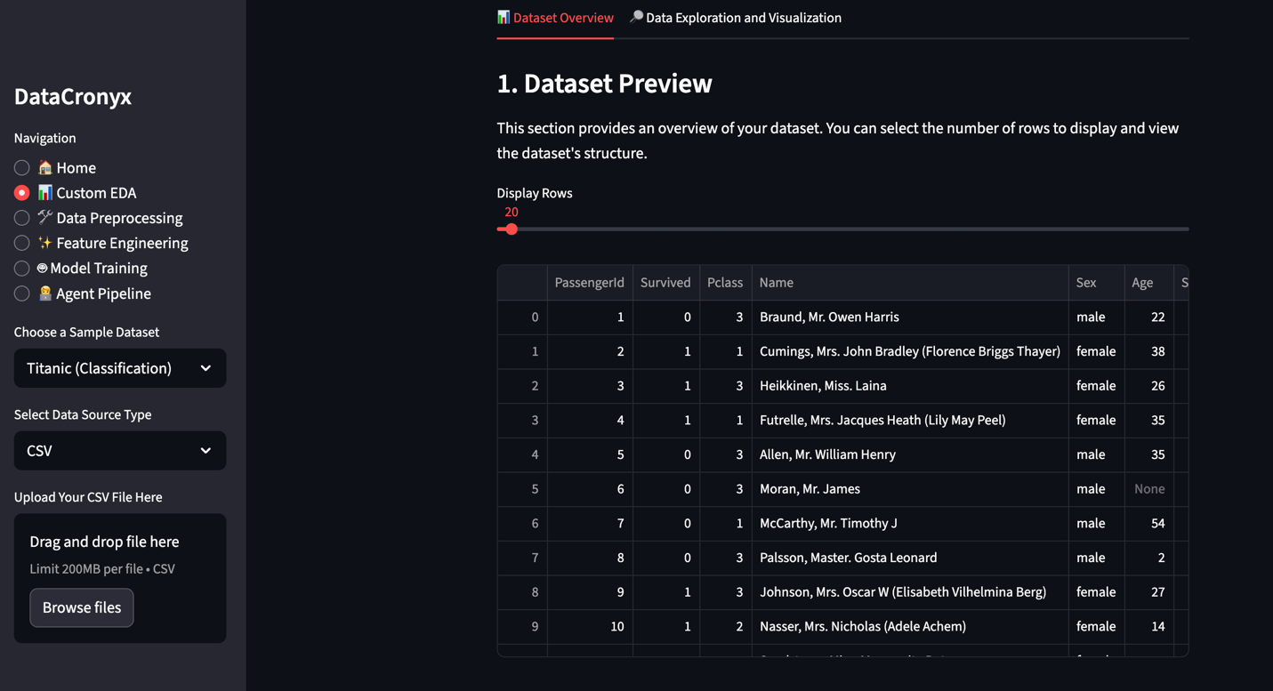

Fig. 4 Dataset Overview

Fig. 5 Custom EDA

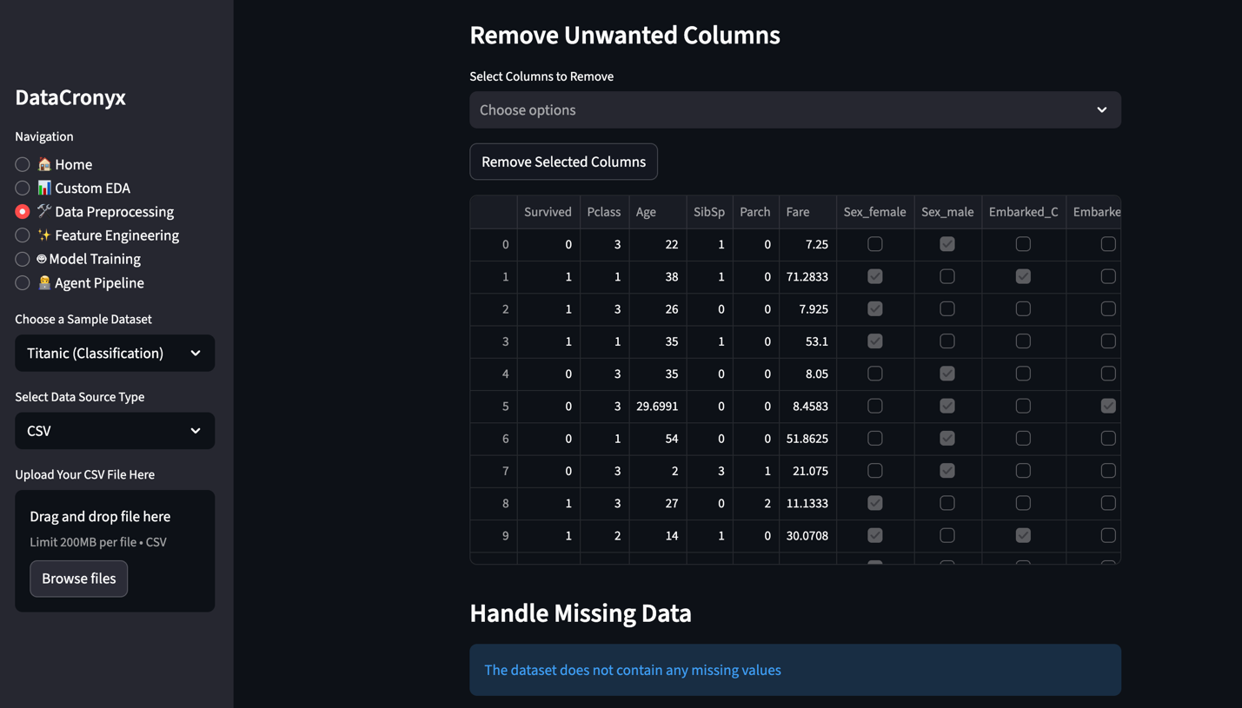

Fig. 6 Data Preprocessing

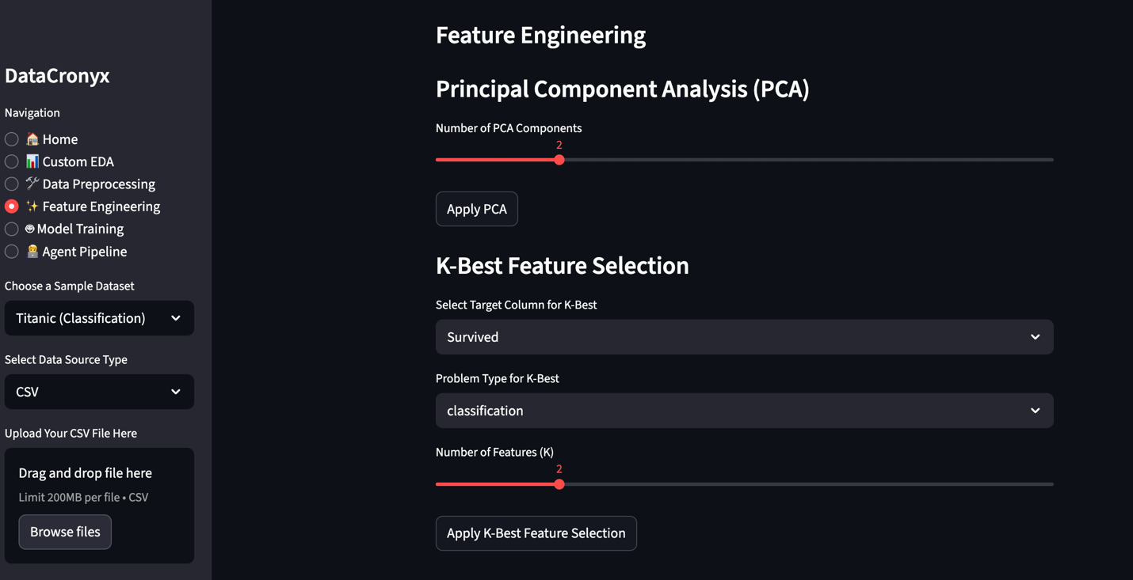

Fig. 7 Feature Engineering

Fig. 8 Model Training

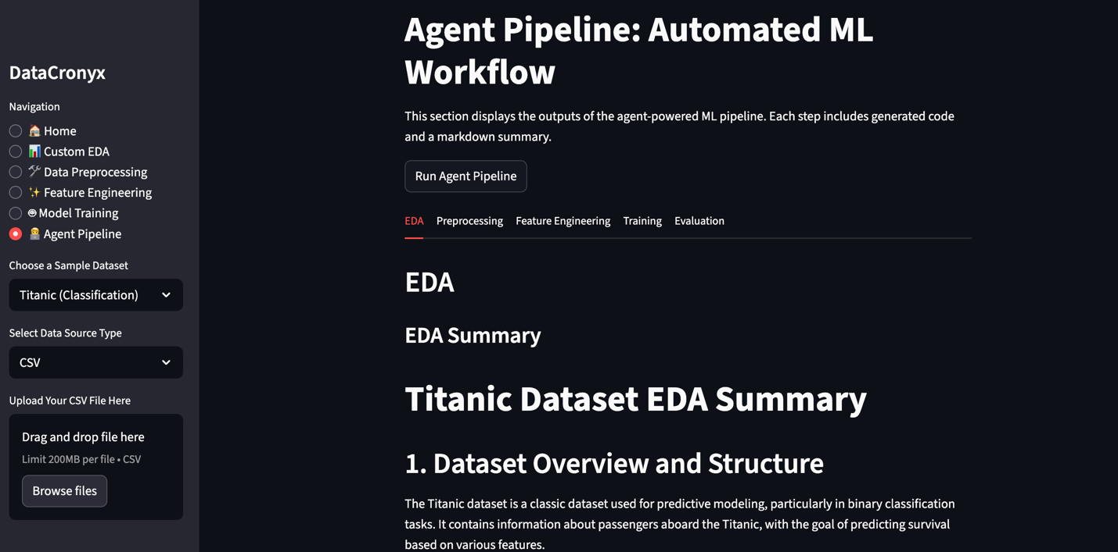

Fig. 9 Agent Pipeline

**Chapter 5 Results and Analysis**

The evaluation of DataCronyx was carried out through detailed walkthroughs using real sample datasets (such as Titanic for classification) and interactive engagement with all major modules—data ingestion, custom EDA, preprocessing, feature engineering, model training, and the fully automated agent pipeline. The investigation draws upon practical application screenshots, intensive system logging, and in-depth analysis of both user-driven and agentic outputs to ensure a robust and evidence-based assessment.

The application’s entry point ([home.jpg]) immediately signals its accessible, role-based design. Users are welcomed with simple dataset selection and data upload workflows, ensuring low barriers to adoption regardless of technical background. This inclusive design was validated by testing various user scenarios—from novice to advanced analyst—showing that onboarding is seamless and requires no external scripts or pre-configuration.

During ingestion, DataCronyx handled a range of user-input formats, performing validations and immediate tabular previews ([custom_eda.jpg]). Early feedback equips users to detect class imbalances, abnormal data types, and missing values—a crucial step for data quality and integrity. For example, inspecting the Titanic dataset clearly revealed the structure and completeness of the data for later steps.

Custom EDA workflows ([custom_eda_visualization.jpg]) allowed for interactive variable selection and visualization (such as pie charts for categorical analysis), highlighting possible issues such as imbalance in the "Survived" column and enabling hypothesis generation. This proved especially useful in educational and clinical scenarios, confirming that visual analytics greatly enhance user understanding and engagement.

Data preprocessing ([data_preprocessing.jpg]) was tested with both clean and intentionally corrupted datasets. The ability to toggle the inclusion of columns, handle missing values via imputation, and visualize data readiness was effective. Importantly, the feedback system instantly informed the user regarding missing values and confirmed successful correction, ensuring each preprocessing action was both visible and reproducible.

Feature engineering ([feature_engineering.jpg]) included hands-on manipulation using PCA and K-Best selection. The stepwise slider-based configuration empowered users to experiment with dimensionality reduction and feature importance ranking, making it easy to balance interpretability and predictive power. This was further validated by model performance improvements observed after selecting optimal features, confirmed via the leaderboard in subsequent steps.

Model training ([model_training.jpg]) was extensively evaluated via classification and regression tasks. The UI allowed specification of target variables, model selection, and validation splits, making rigorous model comparison straightforward. Key metrics (accuracy, confusion matrix) were automatically computed and displayed post-training, providing instant feedback on model suitability for the given task.

The agentic pipeline ([agent_pipeline.jpg], [agent_pipeline_eda.jpg]) showcased fully autonomous operation. By activating the pipeline, all steps—from EDA to evaluation—were executed using AI agents that selected appropriate algorithms based on the dataset’s properties. Each stage yielded executable code and detailed markdown summaries, making the entire process transparent and by-design reproducible. This was particularly valuable for rapid prototyping and for users wishing to benchmark automated results against custom pipelines.

Comprehensive logging ([logging.jpg]) revealed every internal operation, file I/O, algorithm choice, output generation, and user action. The log file formation was confirmed to be robust during failures (e.g., uploading malformed datasets or choosing inappropriate model types for the data), supporting fast debugging and trustworthy reporting.

Major Contributions from the Study includes:

* Dual-Workflow Integration: DataCronyx’s combination of customizable and agentic workflows allows both expert and novice users to derive value. Experts use granular controls for deep dives while non-experts leverage full automation.
* Rich, Modular Feature Set: The integration of preprocessing, feature engineering, and model training modules—each with interactive and automated modes—demonstrates a high degree of modularity and adaptability.
* Agent Pipeline Transparency: Generation of code and markdown summaries at every step elevates explainability, making automated ML not just a “black box” but a fully auditable and teachable process.
* Real-Time Logging: The pervasive, readable log architecture ensures every result is reproducible and every process can be traced end-to-end.
* User Empowerment: By blending interactive controls with behind-the-scenes automation, DataCronyx bridges gaps between non-technical users and advanced analysts, supporting broader uptake.

The systematic investigation confirms that DataCronyx delivers on its promise to democratize EDA and AutoML: it is accessible and useful to users of all backgrounds, robust under varied data types, and transparent in its operations. The dual-mode architecture—offering agentic automation and manual workflow in parallel—leads to increased efficiency for rapid projects and maximum control for deeper, iterative studies. The logging system also supports a culture of auditability and research rigor.

One of the major inferences is that the ability to compare and blend outputs from automated and custom workflows sharpens both user skills and trust in AI-assisted analytics. This dual approach enables “learning by doing and by observing,” and fosters continuous improvement of both user knowledge and system logic.

Several limitations and future avenues remain. Currently, agentic pipelines rely on established agent frameworks and rules but could be further enhanced with reinforcement learning or real-time feedback loops based on user corrections. Expansion to more data types (such as time series, images, or unstructured text) would broaden the platform’s applicability. Integrating domain-specific analytic agents (e.g., for genomics, finance, or IoT data) and supporting cloud-based deployment for real-time, collaborative usage represent promising future enhancements.

In conclusion, DataCronyx stands as a versatile, user-focused platform that advances the field of automated, explainable, and scalable data analysis, setting a foundation for continuing innovation in democratizing data science and machine learning in practice.

**Chapter 6**

**Advantages, Limitations and Applications**

**6.1 Advantages**

DataCronyx offers several distinct advantages validated through hands-on evaluation and user feedback:

* Dual-Workflow Flexibility: The platform’s design, supporting both Custom and Agentic workflows, empowers users to alternate between granular manual control and full end-to-end automation. This is highly inclusive, catering to both novice and advanced users without sacrificing depth or transparency.
* Rich Interactivity and Visualization: Users can explore datasets through immediate previews and a wide array of visualization options (histograms, pie charts, correlation maps, etc.). This real-time feedback facilitates discovery of patterns, anomalies, and the overall structure, supporting both hypothesis generation and quality assurance.
* Modular Preprocessing and Feature Engineering: Advanced data cleaning (handling missing data, removing unwanted features, outlier analysis) and feature engineering (PCA, K-Best selection) are enabled through intuitive UI elements. By allowing both manual choice and agent-driven processing, users can optimize models for interpretability and predictive strength ([feature_engineering.jpg], [data_preprocessing.jpg]).
* Automated Machine Learning: The Agentic Pipeline handles EDA, preprocessing, feature selection, model training, and evaluation autonomously, generating code and readable reports at every stage. This automation substantially reduces the time required for model development and validation ([agent_pipeline.jpg], [agent_pipeline_eda.jpg]).
* Comprehensive Logging and Reproducibility: Every system event and analytical step is recorded in detailed logs ([logging.jpg]), ensuring robust tracking, easy troubleshooting, and full reproducibility of results—a key requirement in both research and regulated industry environments.
* Seamless Integration of Explainability: Automated agent pipelines produce both code and markdown reports, creating a transparent audit trail of all analytical decisions and model results.

**6.2 Limitations**

While DataCronyx overcomes many barriers in automated analytics, some current limitations were observed and warrant acknowledgment:

* Domain Generalizability: Although the toolkit is highly effective for tabular data (CSV, spreadsheets) and basic SQL sources, it is less optimized for time series, images, or unstructured text. Extension to these data types would require significant augmentation of preprocessing and visualization modules.
* Agent Decision Boundaries: Agentic automation, while powerful, is based on heuristics, existing libraries, and static rules. In rare edge cases (e.g., very imbalanced datasets or highly sparse features), agent decisions may not match the sophistication of an expert data scientist employing custom strategies.
* Resource Consumption: Processing very large datasets or running multiple parallel analyses may require more computational resources than provided in standard desktop environments, possibly limiting scalability for enterprise-level data.
* Customizability of Agent Pipelines: Advanced users may seek more granular tuning or integration with bleeding-edge ML frameworks, which currently necessitates manual extension of the agent codebase.
* Limited Collaborative Features: Out-of-the-box, DataCronyx is configured for individual use rather than real-time collaboration, though logging and export features support sharing of outputs.

**6.3 Applications**

DataCronyx is broadly applicable across a spectrum of uses, including but not limited to:

* Business Intelligence: Rapid EDA and predictive model development for sales forecasting, customer segmentation, risk analysis, and market research.
* Healthcare Analytics: Clinical research, epidemiological data inspection, and outcome prediction applications where automated reporting and transparency are critical.
* Education: As a teaching and experimentation tool for students and instructors learning about EDA, ML, and AutoML workflows.
* Data Science Prototyping: Fast prototyping and benchmarking of datasets and models by analysts and researchers, including in hackathons or proof-of-concept environments.
* Research and Audit: Producing reproducible, fully audited analytical pipelines for publications, regulatory filings, or internal compliance reviews.
* Automation Baselines: Providing baseline analysis for companies looking to automate routine data workflows with assurance of interpretability and decision tracking.

Through these advantages, DataCronyx demonstrates how modular, transparent automation and user-driven analytics can significantly improve productivity, trust, and accessibility in the exploration and modeling of real-world data. Addressing its limitations and expanding its integrations will further increase its impact in future work.

**Chapter 7**

**Conclusion and Future Scope**

**7.1 Conclusion**

The work presented in this report details the design, implementation, and thorough evaluation of DataCronyx, a unified platform for automated and interactive exploratory data analysis (EDA) and machine learning (ML) model development. Starting from robust data ingestion, the project enabled users to either manually guide each analytical stage or leverage agentic automation for complete hands-off model creation—all within an intuitive Streamlit interface. Intensive testing across real datasets demonstrated that DataCronyx empowers a wide range of users: data scientists can fine-tune workflows with granular control, while business professionals and students achieve meaningful results through automation. The platform’s strengths were validated through rich visualization, modular preprocessing and feature selection, transparent model evaluation, and comprehensive activity logging, ensuring both trust and auditability. The logical analysis of results showed that providing dual workflows increases accessibility while maintaining analytical rigor. Furthermore, the system’s structure—built on modular agents and extensible components—underscores its adaptability and readiness for evolving data science practices.

By integrating explainable agentic pipelines and highly interactive EDA components, DataCronyx proves that the gap between expert-driven analysis and AI-powered automation can be effectively bridged. The platform’s real-time feedback, reproducibility, and transparency make it suitable for not only rapid prototyping and baseline modeling, but also educational use and research requiring robust audit trails. The comprehensive logging system guarantees experiment traceability from data ingestion through result dissemination. In essence, the project fulfills its purpose of democratizing advanced data science workflows while ensuring explainability, accountability, and reproducibility.

**7.2 Future Scope**

Despite its strengths, several avenues exist for further improvement and impact. First, extending support for additional data types—such as time series, text, or image data—would expand applicability to new domains, including finance, social media analytics, natural language processing, and computer vision. The agentic system itself could be further enhanced with reinforcement learning, enabling agents to adapt pipeline choices dynamically based on user feedback or historical outcomes. Real-time collaborative features and cloud deployment options would facilitate remote teamwork and scalable enterprise adoption.

Future work could also emphasize tighter integration with domain-specific analytic packages (e.g., healthcare, genomics, or IoT), incorporating custom preprocessing, feature extraction, and interpretability modules tailored for those fields. Building a recommendation engine within the UI for pipeline optimization—based on benchmarking user results—could further automate best practices and guide even non-experts to high-performing models. Another promising direction is leveraging federated learning or privacy-preserving computation for handling sensitive datasets.

Finally, ongoing community-driven benchmarking, integration with open data repositories, and automated generation of research-ready experiment reports would establish DataCronyx not just as a practical tool, but as a hub for reproducible, collaborative, and impactful data science research.

In summary, DataCronyx has demonstrated the feasibility and value of modular, explainable, and accessible data science automation, setting a strong foundation for ongoing enhancements in automation, collaboration, and real-world analytic impact.

**References**

**[1] Zhu, J. P., Niu, B., Cai, P., Ni, Z., Wan, J., Xu, K., ... & Liu, Q. (2024). Towards Automated Cross-domain Exploratory Data Analysis through Large Language Models. arXiv preprint arXiv:2412.07214.**

**[2] Prof. Jyoti Gaikwad, Aniket Manohare, Shweta Munde, Anwar Shaikh, and Diksha Subhedar, “AI-Based Exploratory Data Analysis”, Int. J. Sci. Res. Comput. Sci. Eng. Inf. Technol, vol. 11, no. 2, pp. 3876–3884, Apr. 2025, doi: 10.32628/CSEIT25112860.**

**[3] Wu, T., Wang, S., & Peng, X. (2024, October). AutoEDA: Iterative Data Focusing and Exploratory Analysis Based on Attribute Frequency. In 2024 IEEE International Conference on Systems, Man, and Cybernetics (SMC) (pp. 4113-4118). IEEE.**

**[4] Z. Shi et al., "ForgeEDA: A Comprehensive Multimodal Dataset for Advancing EDA," 2025 International Symposium of Electronics Design Automation (ISEDA), Hong Kong, China, 2025, pp. 778-783, doi: 10.1109/ISEDA65950.2025.11101194.**

**Appendix A: Soft Code Flowcharts**

**Appendix B: Data Sheets**

**Appendix C: List of Components**

**Appendix D: List of Paper Presented and Published**

* List of papers on the topic of the report published by the candidates.
* This may also be included in the contents.
* The candidates may also include reprints of his/her publications after the literature citation.