VIRTUAL
INTELLIGENCE
ENVIRONMENT

ILKNUR SERRA OZTURK
s87919

Introduction and Overview
This VRML (Virtual Reality Modeling Language) project represents a virtual classroom environment. The primary purpose of this environment is to simulate a classroom setting, including structural elements such as walls, floors, and ceilings, as well as interactive components like students, teachers, windows, lights, board, clock and various classroom objects. The project aims to provide an immersive and interactive experience that can be utilized for various educational purposes, including virtual learning and classroom management simulations.

Classroom Layout
- Floor: A large rectangular floor spanning the classroom, providing a foundation for all other objects.
- Walls: The classroom is surrounded by walls on all sides. These walls are detailed to include windows and frames for added realism.
- Ceiling: The ceiling completes the enclosed space of the classroom.
- Windows: Two windows are placed on the left wall, designed to be interactive with transparency effects.
- Frames: Three picture frames are hung on the right wall, each displaying a different image.
- Board: A multimedia board is placed at the front of the classroom, capable of displaying videos.
- Clock: A pendular clock mechanism is included for both aesthetic and functional purposes.
- Lights: Two interactive lights are placed within the classroom, which can be turned on and off.

Characters
- Teacher: A teacher model is present at the front of the classroom, programmed to move and rotate, simulating teaching actions.
- Students: Seven student models are scattered throughout the classroom. Each student can be interacted with to initiate movement animations.

Interactive Elements
- Windows: The windows can change their transparency, simulating opening and closing.
- Lights: The lights can be toggled on and off, altering the lighting conditions in the classroom.
- Board: The board can play a video when interacted with.
- Clock: The pendulum of the clock swings continuously, adding a dynamic element to the scene.
- Students: A few of the students can be made to stand up whenever the user wishes.

Detailed Description of Static Elements
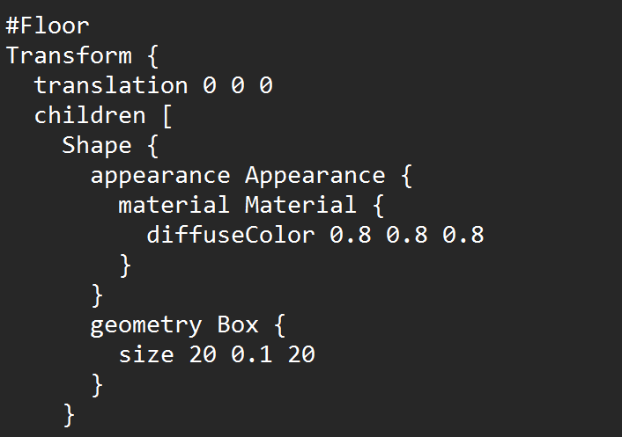
Floor
The floor of the classroom is created using a Box geometry with a size of 20 units by 0.1 units by 20 units. The floor's appearance is defined by a diffuse color of light grey (0.8, 0.8, 0.8).

Walls
The classroom walls are constructed using multiple Box geometries. The back wall, side walls, and front wall are placed using Transform nodes with appropriate translations and sizes. In the picture we can see only Back Wall.
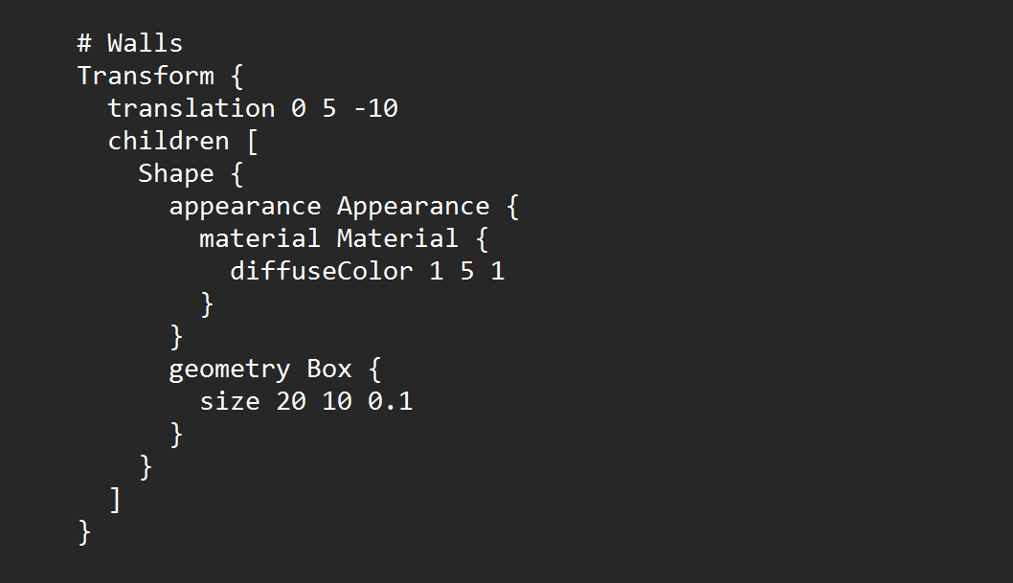
- Back Wall: Positioned at (0, 5, -10) with dimensions 20x10x0.1 and a green color.
- Side Walls: Left and right side walls have different sections to accommodate windows and other elements.

Ceiling
The ceiling is constructed similarly to the floor, with a Box geometry and a diffuse color matching the walls.

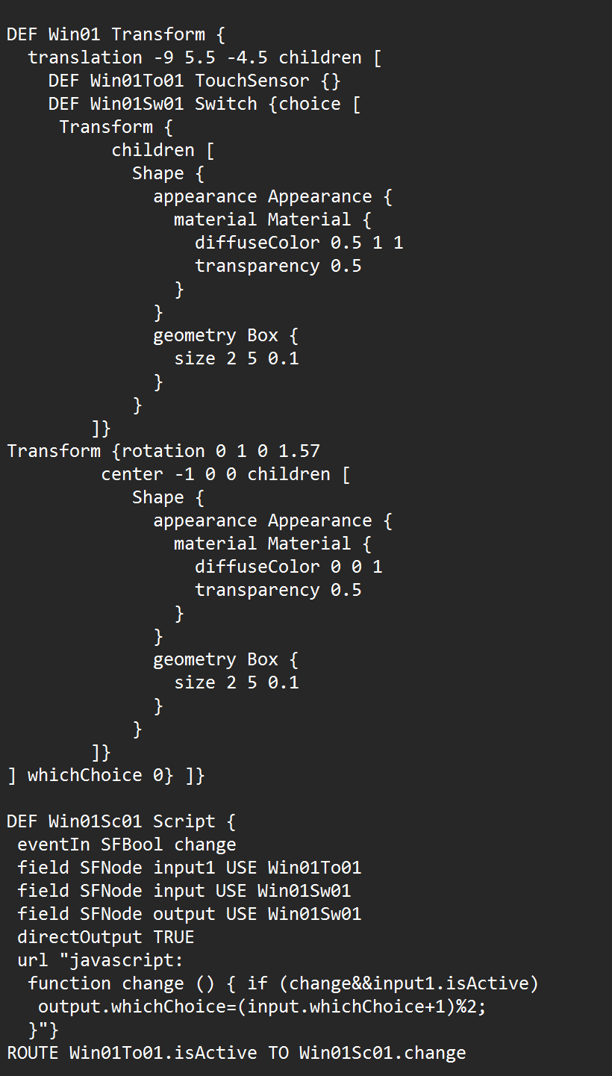
Frames
Three picture frames are displayed on the right wall, each showcasing a unique image. The frames are positioned at different heights to create visual interest.

Windows
The classroom has two interactive windows placed on the left wall. Each window has two states, open and closed, represented by different levels of transparency. The windows switch states when clicked. User can close and open whenever he wants. I can only add one of the window code here. But same code for the other window. Only the difference between two windows is translation. Window 1 positioned at (-9, 5.5, -4.5), includes a switch mechanism to change its appearance between two states. And Window 2 positioned at (-9, 5.5, 2.5), also includes a switch mechanism similar to Window 1.

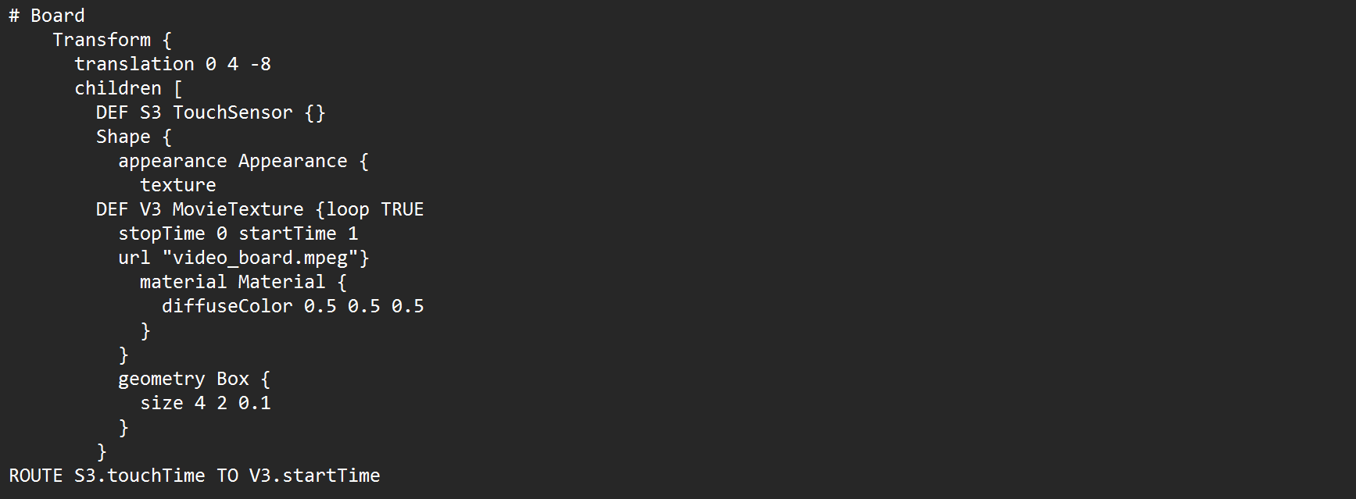
Detailed Description of Interactive Elements

Board
The classroom is equipped with a multimedia board that plays video content upon user interaction. This feature is implemented using a MovieTexture node linked to a TouchSensor. And positioned at (0, 4, -8) with dimensions 4x2x0.1. My aim was to demonstrate that the blackboard can also work while the teacher is teaching. We can both see the video on the board and there is a sound behind it that we can hear.

Clock
A pendulum clock, with a continuously swinging pendulum, is included in the classroom for both functional and aesthetic purposes. The clock base is represented by a small Box geometry, positioned at the top to serve as the anchor for the pendulum. The pendulum rod is modeled using another Box geometry.The pendulum bob is represented by a Sphere geometry.The animation of the pendulum involves two primary nodes: TimeSensor and OrientationInterpolator.

Lights
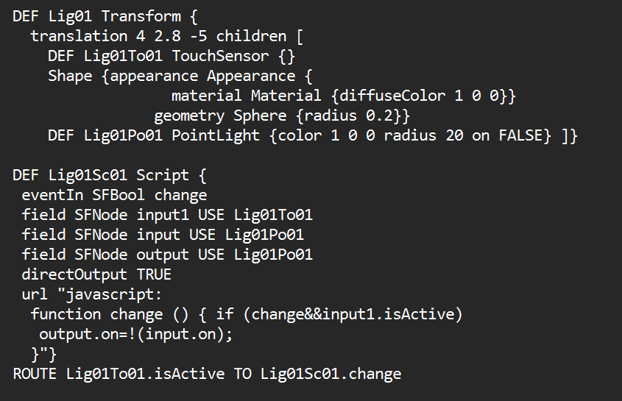
The classroom contains two interactive lights, each controlled by a touch sensor that toggles the light on and off. The lights are represented by PointLight nodes within the VRML scene. We can see the codes for the first light, for the second one it is the same, but with different colour. Light 1 positioned at (4, 2.8, -5), red light with an interactive toggle (Lig01). And Light 2 positioned at (-4, 2.8, -5), blue light with an interactive toggle (Lig02).
Lig01Sc01: This defines a script (Script) node named Lig01Sc01 responsible for controlling the state of Lig01Po01 based on user interaction.
- eventIn SFBool change: Declares an input event (change) that triggers the script.
- field SFNode input1 USE Lig01To01: References the Lig01To01 TouchSensor as input to detect user interaction.
- field SFNode input USE Lig01Po01: References the Lig01Po01 PointLight as input to control its state.
- field SFNode output USE Lig01Po01: References the same Lig01Po01 PointLight as output to change its properties.

Detailed Description of Characters

Students
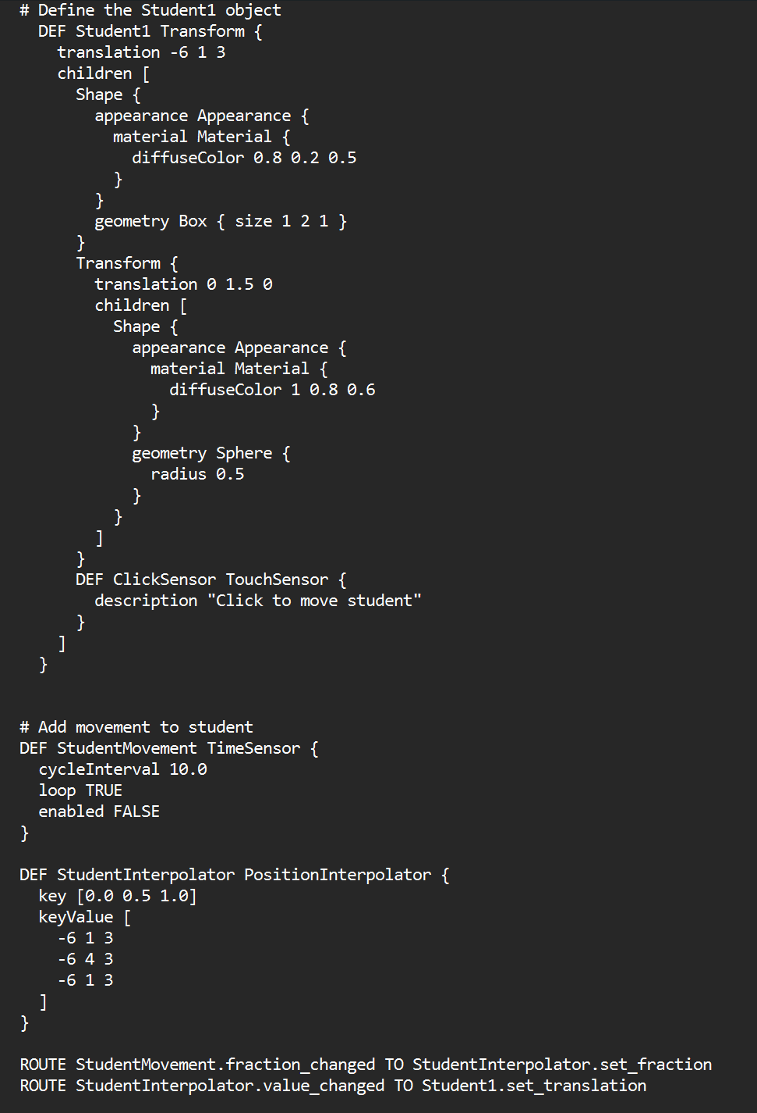
Multiple student avatars are positioned throughout the classroom. Each student consists of a box for the body and a sphere for the head, with unique colors to differentiate them.
Student 1: Positioned at (-6, 1, 3), interactive movement and rotation
Student 2: Positioned at (0, 1, 0), interactive movement and rotation
Student 3: Positioned at (6, 1, 0), interactive movement and rotation
Student 3: Positioned at (-6, 1, 6), interaction with this student starts music playback
Additional Students: Positioned at (0, 1, 3), (6, 1, 3), (-6, 1, 0), (0, 1, 6), and (6, 1, 6), static

The student avatars also have interactive movements similar to the teacher. Each student can
move up and down when clicked, facilitated by TouchSensor, TimeSensor, PositionInterpolator, and OrientationInterpolator.

Interaction and Animation
ClickSensor: Positioned within Student 1, triggers movement when clicked.
BooleanToggle Script: Toggles the enabled state of the TimeSensor, initiating or stopping the movement upon interaction.

ROUTE Statements
Translation: ROUTE StudentMovement.fraction_changed TO StudentInterpolator.set_fraction and ROUTE StudentInterpolator.value_changed TO Student1.set_translation
Rotation: ROUTE StudentMovement.fraction_changed TO StudentRotationInterpolator.set_fraction and ROUTE StudentRotationInterpolator.value_changed TO Student1.set_rotation
BooleanToggle: ROUTE ClickSensor.touchTime TO BooleanToggle.set_toggle and ROUTE BooleanToggle.booleanOutput TO StudentMovement.set_enabled interactive movements and rotations.

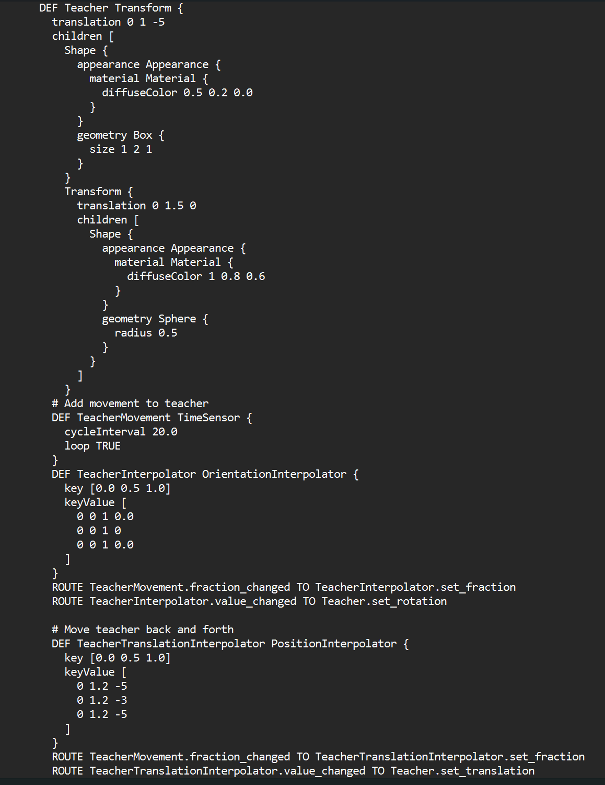
Teacher
The teacher is represented by a box for the body and a sphere for the head, with simple material properties. The teacher can move and rotate within the classroom. The teacher's movement is seamlessly integrated to simulate a realistic back-and-forth pacing behavior, which adds dynamism to the virtual classroom.
PositionInterpolator (TeacherTranslationInterpolator): Defines the keyframes for the teacher's position, moving back and forth between coordinates (0, 1.2, -5) and (0, 1.2, -3).

Teacher's Desk
Desk Body: The main body of the desk is a large box with a diffuse color of dark brown (0.4, 0.2, 0.1). It is positioned towards the front of the classroom, slightly to the left of the teacher.

Conclusion
The virtual classroom project effectively simulates a dynamic and interactive learning environment using VRML. It includes detailed elements such as students, a teacher, interactive windows, a video board, and lighting. The use of sensors, video, photos, sound, movements and scripts to create interactivity enhances the realism and user engagement within the virtual classroom.

Classroom Management System in Common Lisp

Introduction
The Classroom Management System is a comprehensive application written in Common Lisp, designed to simulate and manage various elements within a classroom setting. This system allows users to interact with and manipulate the classroom environment, including details about students, the teacher, the board, windows, and lights. The following documentation provides an in-depth look into the system, detailing its components, functionalities, and how users can interact with it.

Content Overview
Student 1: The classroom contains nine students with varying attributes such as name, age, grade, position (x, y, z coordinates), and movability status. These attributes are stored in a structured format using the student struct.
Teacher: There is one teacher in the classroom, Mr. Smith, who teaches Math and has 15 years of experience. The teacher's attributes include name, subject, years of experience, and position (x, y, z coordinates).
Board: The classroom has one whiteboard made of porcelain, positioned at specific coordinates. The board's attributes include description, material, and position (x, y, z coordinates).
Clock: There is an analog wall clock in the classroom, described and positioned using specific attributes.
Windows: The classroom features two windows, each with a description, status (open or closed), and position (x, y, z coordinates).
Lights: The classroom is equipped with two ceiling lights, each with a description and status (on or off).

Structures
In Common Lisp, structures are used to define data objects with multiple attributes. The defstruct macro is used for this purpose. For example, the student structure is defined with attributes such as name, age, grade, and position coordinates (x, y, z), along with a boolean movable attribute.

Student Structure
Here is the student structure definition:
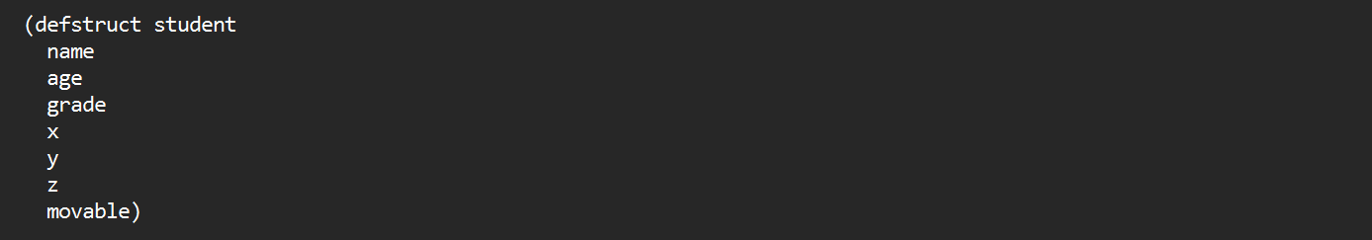
Each attribute is defined within the defstruct form. This structure allows for easy creation and manipulation of student objects with specified attributes. Similarly, structures for teacher, board, clock, window, and light are defined with relevant attributes.

Creating Instances
Once the structures are defined, instances of these structures can be created using the make- prefix followed by the structure name. This allows for initializing objects with specific values. Similarly, instances for the teacher, board, clock, windows, and lights, for example, to create student instances:
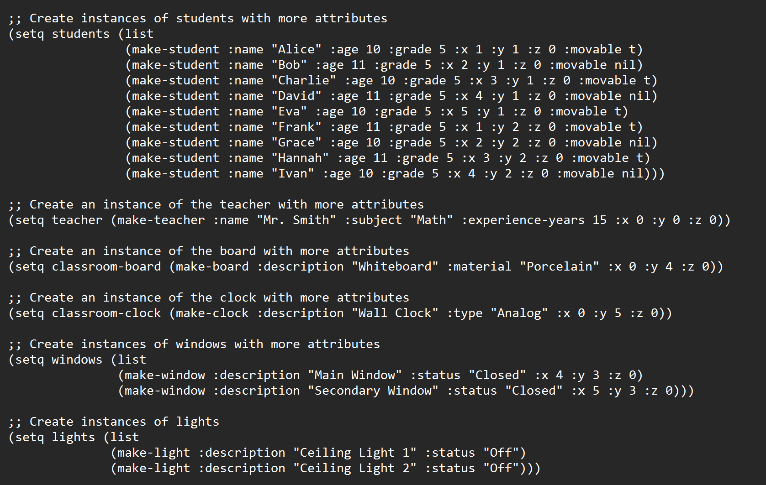

Functions for Displaying Details
To display detailed information about the classroom elements, functions are defined using defun. For example, the display-students-details function iterates over the list of students and prints their details:
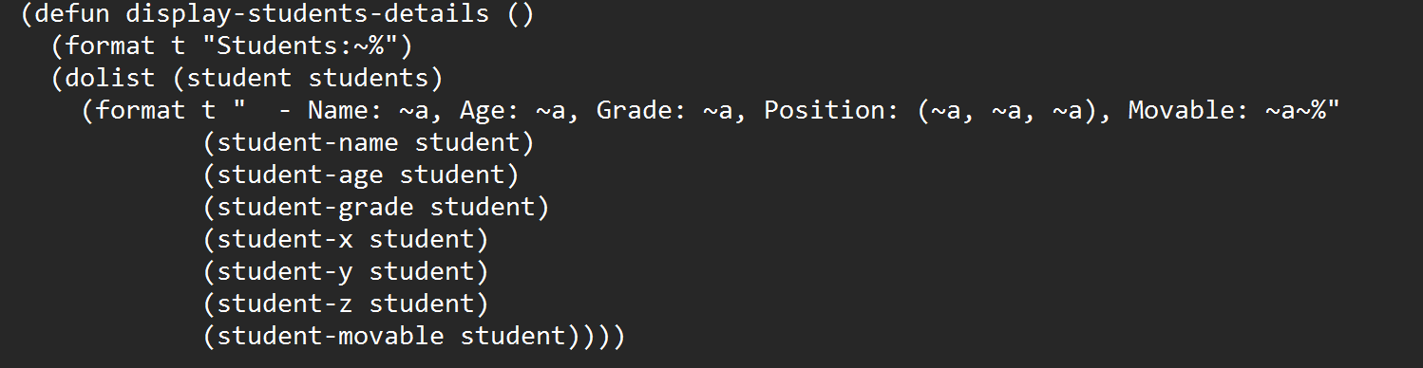
Similarly, functions are created to display details for the teacher, board, clock, windows, and lights.

Functions for Modifying Elements
Functions are also provided to modify the state or position of elements. For example, the change-window-status function changes the status of a specified window:
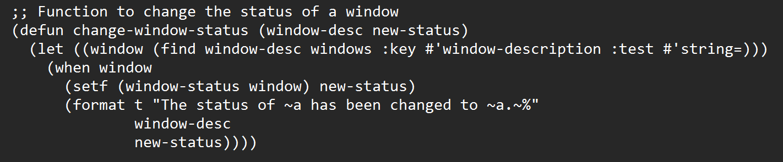
Similarly, the change-light-status function changes the status of a specified light. And similarly, the move-student function moves a student to a new position if the student is movable.

Main Function
The main function controls user interaction, allowing users to input commands to view or modify the classroom elements:
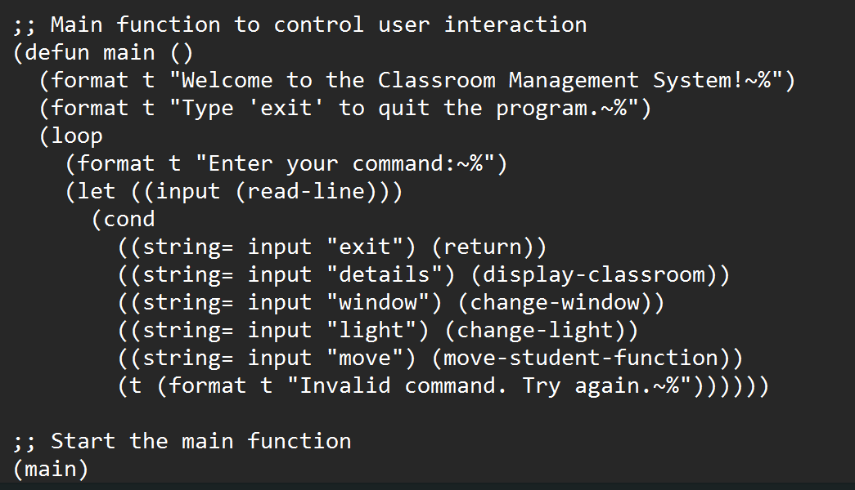

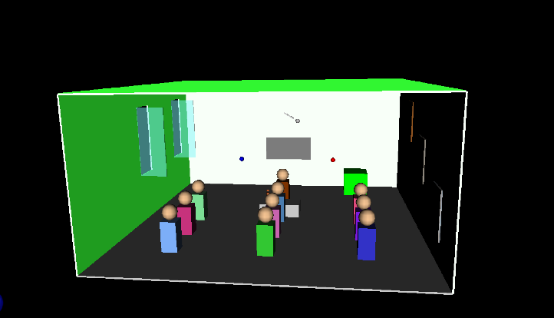
Visual Overview of VRML Project

Scene Composition
The scene is structured with a floor (Box) and walls (Box) defining a 20x20 unit space. These elements use materials (diffuseColor) to establish a basic visual layout.

Objects and Shapes
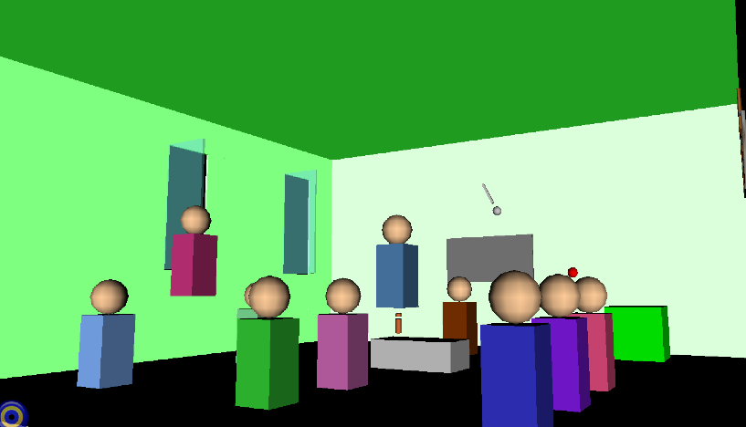
Various objects such as cubes (Box) and spheres (Sphere) populate the scene. Each object is positioned (translation) and colored (diffuseColor) to differentiate them within the environment.

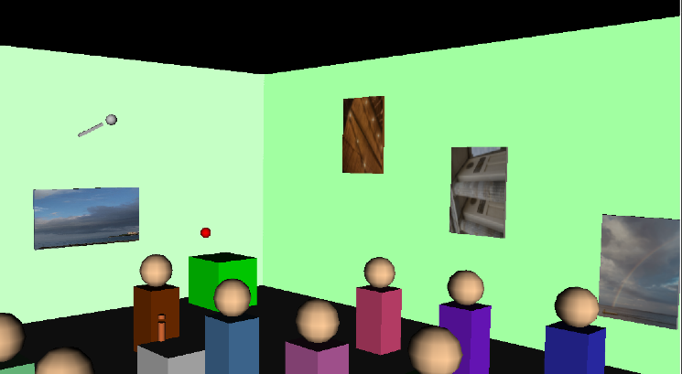
Textures and Materials
Frames (Frame 1, Frame 2, Frame 3) incorporate textures (ImageTexture) applied to Box shapes, enhancing visual realism and providing interactive elements for users.

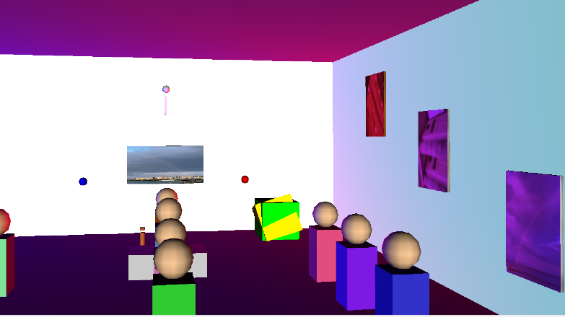

Lighting and Ambiance
Point lights (Lig01, Lig02) are strategically placed to illuminate specific areas, such as highlighting the Teacher and Student objects, contributing to the overall ambiance and immersion. In the picture we can also see shape-changing cube.

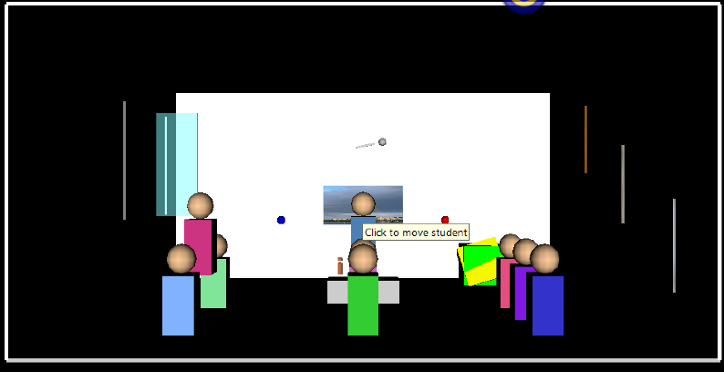
User Interaction
Interactive elements like TouchSensor and SphereSensor enable user engagement. Scripts (Script nodes) control interactive behaviors, such as toggling object states (BooleanToggle), adding depth to user interaction. Also, when the user touches one of the students, he starts singing.

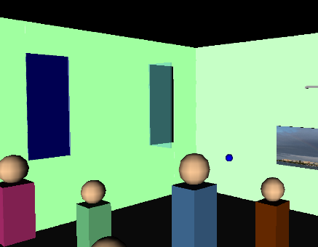
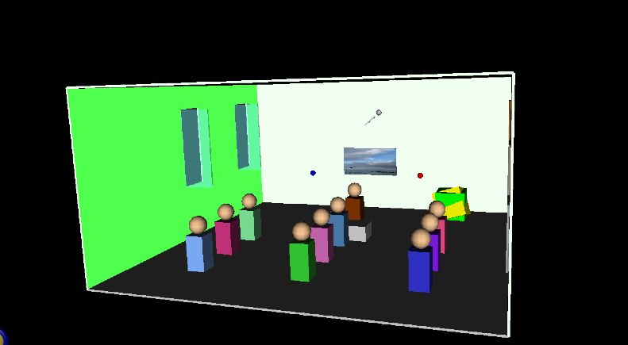
Window Frames
Each window (Win01, Win02) is defined with a frame (Switch with Box geometry), simulating realistic window structures within the virtual space. The frames are textured (ImageTexture with transparency) to mimic glass panels, enhancing visual fidelity and realism.

Classroom Management System in CLISP

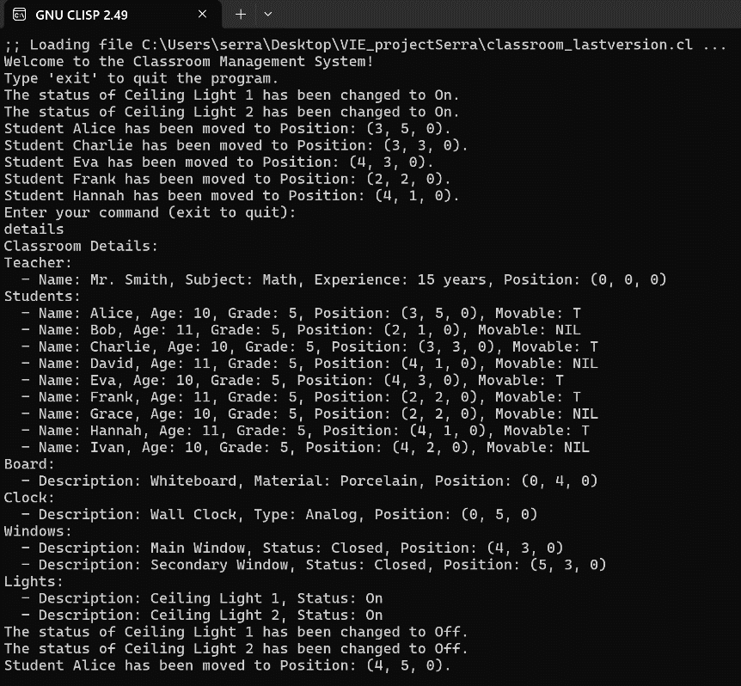
Main Functions and Actions
Display Functions: The system continuously waits for user input during each iteration of the loop. And in the picture we can see ‘details’ command displays information about the classroom. It supports the following commands:
details: Displays detailed information about the classroom, including students, teacher, board, clock, windows, and lights.
window: Prompts the user to change the status (open/closed) of a specific window by entering its description.
light: Prompts the user to change the status (on/off) of a specific light by entering its description.

move: Allows the user to specify a student's name and new coordinates (x, y, z) to move them within the classroom.

Change Functions:
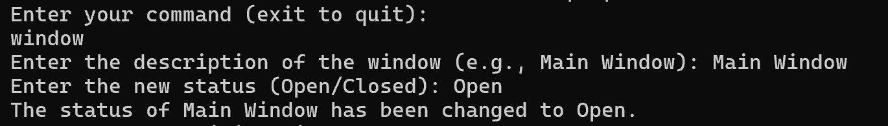
With change-window() and change-light() functions, we can easily close and open windows and lights.
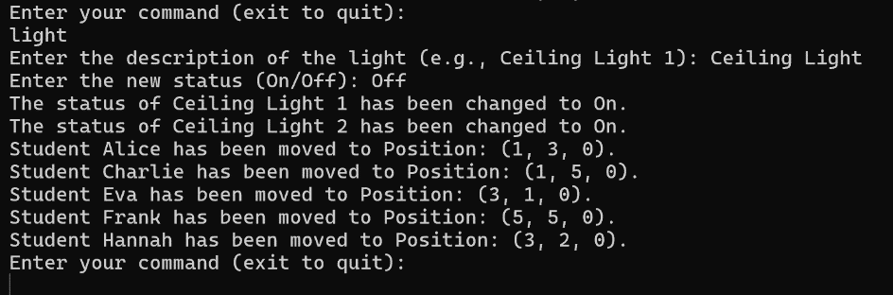

Periodic Actions
After executing periodic actions, the system checks for changes in the state of movable objects (students) and lights compared to their previous states.
Every 2 seconds, the system executes the following actions:
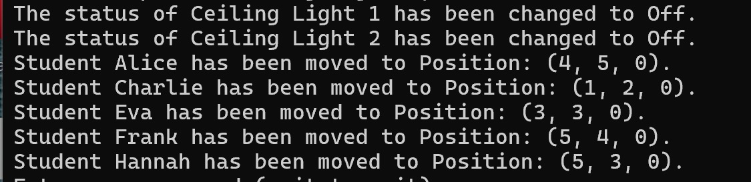
Toggle Lights: Alternates the status (on/off) of all lights in the classroom.
Randomly Move Students: Moves movable students to new positions within predefined coordinates in the classroom.

Exiting Program
To exit the Virtual Classroom Management System, simply type "exit" when prompted for a command. Upon typing "exit," the program will stop any ongoing periodic actions, if applicable, and cleanly exit the main loop.
